MARKETING CAMPAIGN
DATA ANALYSIS REPORT
SkillCraft Technology Internship | Task 04
Exploratory data analysis of customer purchasing behaviour and campaign response.

1. Executive Summary
The dataset contains 2,240 customer records. The campaign response field records 334 positive responses, representing 14.91% of customers. Average recorded product spend is 605.80 per customer. The analysis examines product spending, purchase channels and customer segments.

2. Dataset Overview
The source file contains customer profile attributes, household composition, recency, product-category spend, purchase counts by channel, campaign acceptance flags and a final campaign response indicator.
Records analyzed: 2,240. Original columns: 29. Duplicate customer IDs removed: 0. Missing Income values: 24, imputed using the median (51,381.50); an Income_Missing_Flag is retained.

3. Key Performance Indicators
Metric | Result
Total customers | 2,240
Positive campaign responses | 334
Campaign response rate | 14.91%
Average spend per customer | 605.80
Total recorded spend | 1,356,988.00
Average income after documented imputation | 52,237.98

4. Product Category Analysis
Product spending is calculated by summing the six Mnt* fields. The chart below compares total recorded spend across categories.
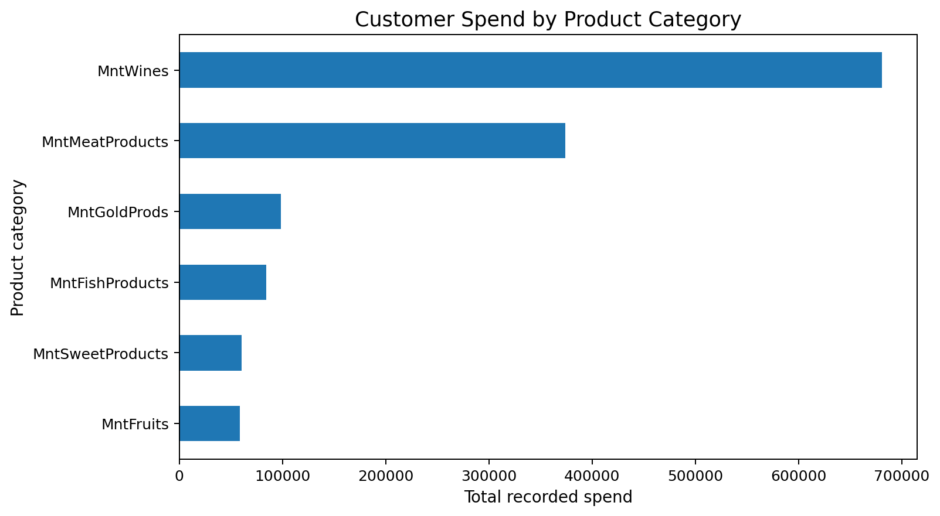
Highest spend category: MntWines (680,816).

5. Shopping Channel Analysis
Channel performance is compared using purchase counts, not sales value or profit.
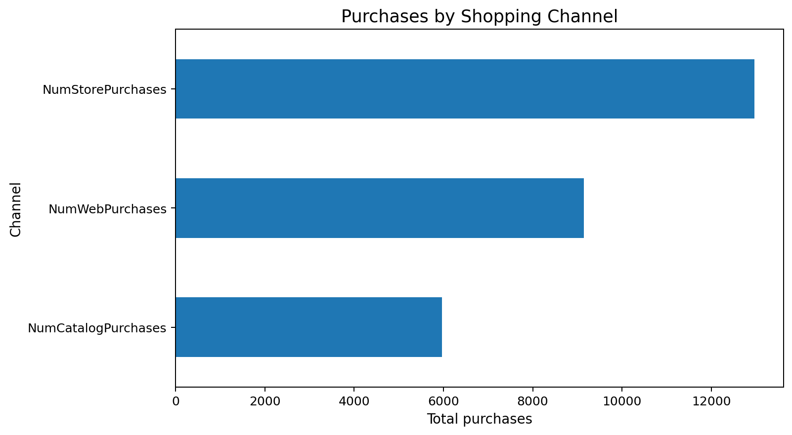
Most frequently used purchase channel by recorded transaction count: NumStorePurchases (12,970 purchases).

6. Customer Segment Analysis
Average spend and response rates can be compared across customer education and marital-status groups. These are descriptive associations and do not establish causality.
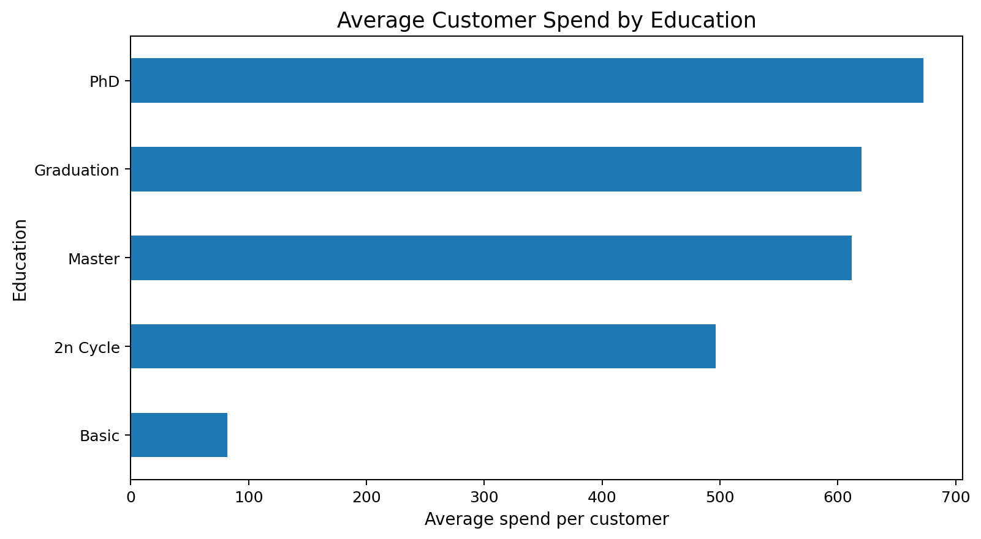
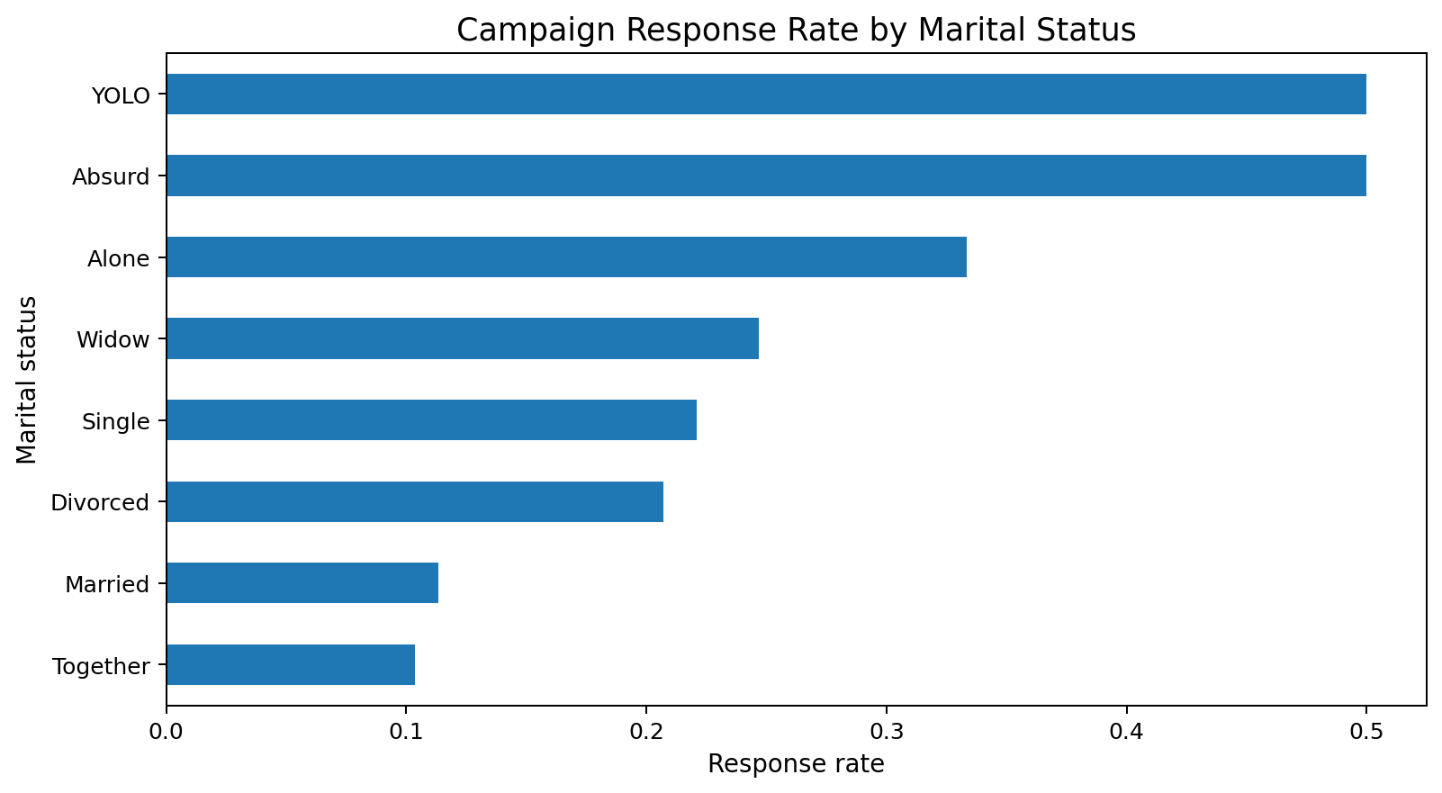

7. Campaign Response
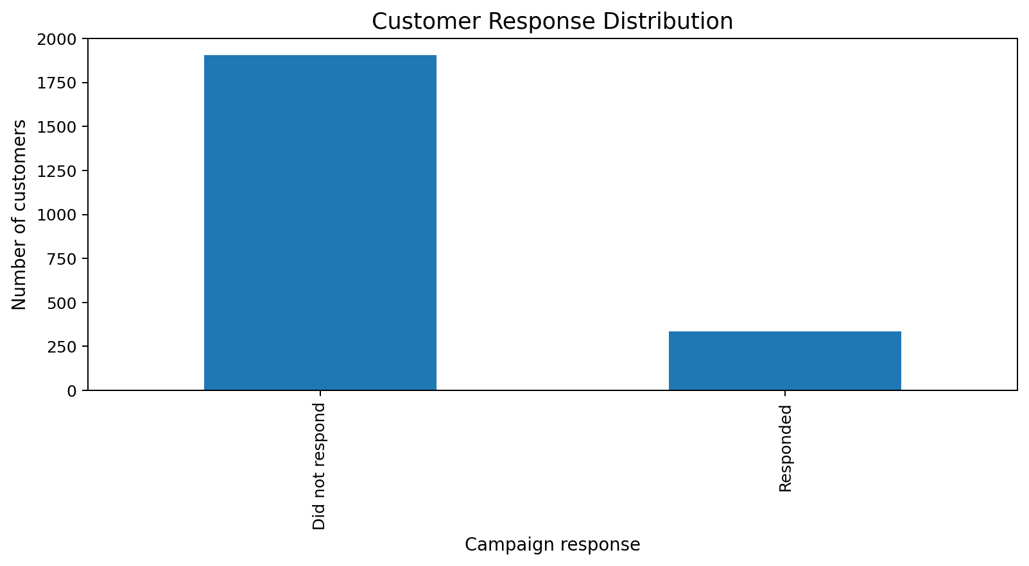
Positive responses: 334; non-responses: 1,906. Overall response rate: 14.91%.

8. Business Recommendations
- Prioritize product-category merchandising using the observed customer spend mix, while validating margin data before making profitability decisions.
- Use channel purchase counts to understand customer channel preference; test channel-specific campaigns before reallocating marketing budgets.
- Compare response rates across customer segments and validate differences with a controlled campaign experiment.
- Track campaign cost, attributed revenue and customer-level exposure in future data collection so ROI can be calculated.
- Maintain explicit missing-data flags and validate customer records before future campaign modelling.

9. Limitations
The dataset does not include channel-level advertising expenditure, campaign cost, attributed revenue or profit margin. Therefore, marketing ROI, channel profitability and causal campaign impact cannot be calculated. The response indicator is treated as a binary outcome. Age derived from Year_Birth requires a reference date and is not used as a current-age measure. Income imputation is disclosed and flagged.

10. Conclusion
The analysis provides a structured view of recorded customer spending, channel purchase behaviour and campaign response. It supports descriptive customer and campaign insights while identifying the additional cost and attribution data required for reliable ROI evaluation.

