Electronic Voting System
Software Requirements Specification

Version 1.0
Revision History
Date | Version | Description | Author
16/Nov/06 | 0.1 | Initial Draft | McElrath, Marc  Moloche, Samuel  Morris, Patrick  Murphy, Kenn  Roman, Victor  Slomka, Mikolaj
21/Nov/06 | 0.2 | Hefty revisions following peer review. Significant formatting changes. | McElrath, Marc  Moloche, Samuel  Morris, Patrick  Murphy, Kenn  Roman, Victor  Slomka, Mikolaj
11/Dec/06 | 1.0 | Minor revisions following software design document creation. Corrections to formatting. | McElrath, Marc  Moloche, Samuel  Morris, Patrick  Murphy, Kenn  Roman, Victor  Slomka, Mikolaj

Table of Contents
1. Introduction 4
1.1 Purpose 4
1.2 Scope 4
1.3 Definitions, Acronyms and Abbreviations 4
1.4 References 4
1.5 Overview 4
2. Overall Description 5
2.1 Use-Case Model Survey 5
2.1.1 Actors 8
2.1.2 Use-Cases 8
2.1.3 Use-Case Risk List 8
2.1.4 Use-Case Specifications 8
2.1.4.1 Vote 8
2.1.4.2 Save 10
2.1.4.3 Update 11
2.2 Assumptions and Dependencies 12
3. Specific Requirements 12
3.1 Functionality 12
3.2 Usability 12
3.3 Reliability 12
3.4 Performance 12
3.5 Supportability 12
3.6 Design Constraints 12
3.7 Online User Documentation and Help System Requirements 13
3.8 Purchased Components 13
3.9 Interfaces 13
3.9.1 User Interfaces 13
3.9.2 Hardware Interfaces 13
3.9.3 Software Interfaces 13
3.9.4 Communications Interfaces 13
3.10 Licensing Requirements 13
3.11 Legal, Copyright and Other Notices 13
3.12 Applicable Standards 13
4. Product Acceptance Criteria 13
4.1 Functionality Available In Version 1.0 13

Software Requirements Specification

Introduction

Purpose
Thisweb Requirements Specification (hitherto referenced as SRS) document describes the behavior and requirements of the “Online Voting System” software package.

Scope
This SRS document applies to the “Online Voting System” web application.

Definitions, Acronyms and Abbreviations
The following is a list of terms, acronyms and abbreviations used by the “Electronic Voting System” software package and related documentation.
Admin: An administrator.
Ballot: A round of voting, or the particular record of a voter’s choices.
Candidate: A person who seeks or is nominated for an office.

Database: A collection of data arranged for ease and speed of retrieval or search.
Election: The selection of a person or persons for office by vote, or a public vote on a proposed submittal.
Electorate: The body of persons enlisted to vote in an election.
Initiative: A publicly proposed statute, constitutional amendment, or ordinance to be voted upon for adoption.
Jurisdiction: The territory over which an election occurs.
Poll: The place where votes are taken.
Referendum: A measure proposed or passed by a legislative body to the vote of the electorate for approval or rejection.
Tabulate: To count votes.
Voter: One who votes, a member of the electorate, or a citizen with the right to vote.

References
None.

Overview
The remainder of this document identifies the actors, use-cases, use-case scenarios, activity diagrams, assumptions and dependencies needed for the analysis and design of the “Electronic Voting System” software package. All diagrams conform to UML standards.

Overall Description

Use-Case Model Survey
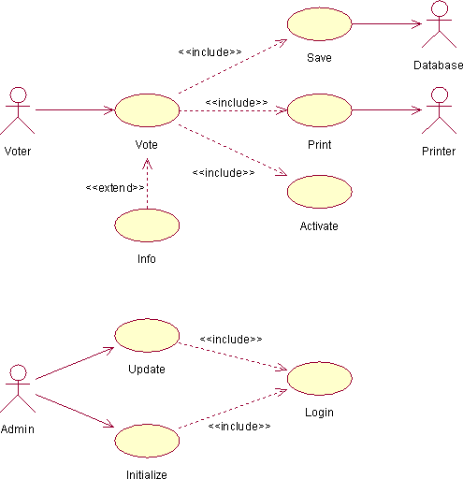
Figure 1 - Electronic Voting System Use-Case Diagram

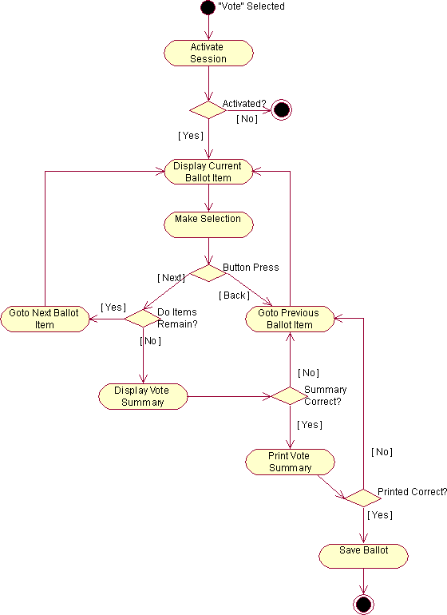
Figure 2 - Vote Activity Diagram

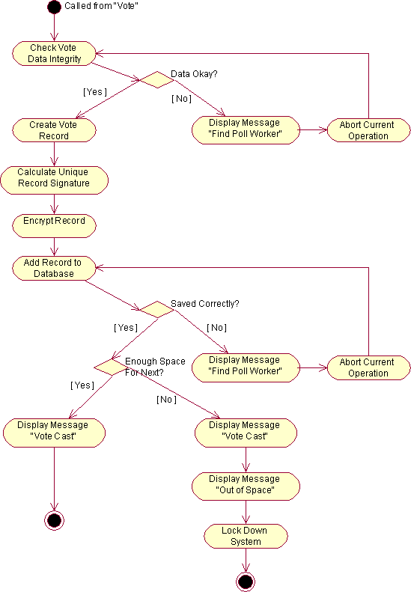
Figure 3 - Save Activity Diagram

Actors
Voter: One who uses the “Online Voting System” web application.
Admin: A hired employee or volunteer for the agency sponsoring a vote, one who administrates the “Online Voting System” web application.
Database: A database for storing of sensitive vote information.

Use-Cases
Vote: This use-case describes the process by which a voter casts a ballot.
Activate: This use-case describes the process of verifying a voter’s eligibility to vote. It ensures the voter is a member of the electorate.
Save: This use-case describes the process by which the system securely records a voter’s ballot information to the database.
Print: This use-case describes the process the system uses to print a paper record, or audit trail, of a voter’s ballot information.
Info: This use-case describes the process through which a voter may obtain vote-specific information during the general voting procedure.
Update: This use-case describes the process by which an admin may add, remove or update ballot items.
Initialize: This use-case describes the process through which the system first initializes during startup.
Login: This use-case describes the process of verifying an administrator’s identity. It ensures that the admin is allowed access to the non-voting capabilities of the “Electronic Voting System” software package.

Use-Case Risk List
Highest: Vote, Save
Average: Update, Info, Print
Lowest: Initialize, Activate, Login

Use-Case Specifications

Vote
- Brief Description
This use-case describes the process by which a voter casts a ballot.
- Actors
Voter
- Dependencies
Activate, Save, Print, Info
- Basic Flow of Events: Voting, No Changes
- The use-case begins when a voter selects “Vote”.
  - The system verifies the voter through the “Activate” use-case.
- While there are more items on the ballot:
  - The system displays the current ballot item and options.
  - The voter selects an option.
  - The voter presses the “Next” button.
  - The system retrieves the next ballot item.
- The system displays a summary of ballot items and choices made.
- The voter presses the “Summary Correct” button.
- The system prints a physical copy of the selections made through the “Print” use-case.
  - The system prompts the voter to review the printed ballot.
- The voter presses the “Cast Ballot” button.
- The system records the ballot through the “Save” use-case.
- The use-case ends.
- Alternate Flow of Events #1: Voting, Changes To Previous Selection
This flow of events describes the process of making changes to a previous selection. It follows the basic flow up to step two (2):
- While there are more items on the ballot:
  - The system displays the current ballot item and options.
  - The voter presses the “Go Back” button.
  - The system displays the previous ballot item and options.
  - The voter selects an option.
  - The voter presses the “Next” button.
  - The system retrieves the next ballot item.
This alternate flow continues at step three (3) of the basic flow.
- Alternate Flow of Events #2: Voting, Printed Summary Incorrect
This flow of events describes the process of making changes to a previous selection after a summary is printed for review. It follows the basic flow up to step six (6):
- The voter presses the “Print Record Incorrect, Go Back” button.
- While the voter has not reached the incorrect ballot item:
  - The system displays the previous ballot item and options.
  - The voter presses the “Go Back” button.
This alternate flow continues at step two (2) of the basic flow.

Save
- Brief Description
This use-case describes the process by which the system securely records a voter’s ballot information to the database.
- Actors
Database
- Dependencies
None.
- Basic Flow of Events: Saving, No Errors
- The use-case begins when called from the “Vote” use-case.
- The system checks the ballot items and choices for data integrity.
- The system creates a vote record.
  - The system calculates a unique record signature.
- The system encrypts the record.
- The system adds the record to the Database.
  - The system checks to verify that the record was saved correctly.
  - The system checks the Database to ensure there is enough space for the next record.
- The system displays a message confirming the voter’s ballot has been cast.
- The use-case ends.
- Alternate Flow of Events #1: Saving, No Space In Database For Next Record
This flow of events describes the steps taken if the database encounters a lack of space for the next record. It follows the basic flow up to step five (5):
- The system adds the record to the Database.
  - The system checks to verify that the record was saved correctly.
  - The system checks the Database to ensure there is enough space for the next record.
    - The system is unable to store further records in the Database.
- The system displays a message confirming the voter’s ballot has been cast.
- The system displays a message detailing the fact that it is out of storage space.
- The system locks itself down, preventing any further votes.
- The use-case ends.
- Alternate Flow of Events #2: Saving, Corrupt Vote Record Recovery
This flow of events describes the recovery steps taken if the system discovers a corrupt record. It follows the basic flow up to step five (5):
- The system adds the record to the Database.
  - The system checks to verify that the record was saved correctly.
    - The system is finds the record corrupt in the Database.
    - The system displays a message prompting the voter to find a poll worker.
    - The system aborts the current save attempt.
- The system attempts to add the record to the Database again.
  - The system checks to verify that the record was saved correctly.
  - The system checks the Database to ensure there is enough space for the next record.
This alternate flow continues at step six (6) of the basic flow.

Update
- Brief Description
This use-case describes the process by which an admin may add, remove or update ballot items.
- Actors
Administrator
- Dependencies
Login
- Basic Flow of Events: Update, Multiple Ballot Items
- The use-case begins when an admin selects “Update”.
  - The system verifies the admin through the “Login” use-case.
- While the admin does not press the “Logout” button:
  - The system displays options for possible administrative action.
  - The admin presses the “Update Ballot Item” button.
  - The system displays a list of ballot items to be updated.
  - The admin chooses a ballot item.
  - The admin enters new information for the ballot item.
  - The admin presses the “Update” button.
    - The system updates the ballot item information.
- The system closes the session.
- The use-case ends.
- Alternate Flow of Events #1: Update, Error on Update
This flow of events describes the recovery steps taken if the system fails to properly perform the tasks assigned. It follows the basic flow up to step two (2):
- While the admin does not press the “Logout” button:
  - The system displays options for possible administrative action.
  - The admin presses the “Update Ballot Item” button.
  - The system displays a list of ballot items to be updated.
  - The admin chooses a ballot item.
  - The admin enters new information for the ballot item.
  - The admin presses the “Update” button.
    - The system is unable to update the ballot item information.
    - The system displays a message that the operation failed.
    - The admin presses the “Retry” button.
    - The system updates the ballot item information.
This alternate flow continues at step three (3) of the basic flow.

Assumptions and Dependencies
- The Database system is fully functional and has enough space for at least one vote.

Specific Requirements

Functionality
- Activation will not be explicitly required for access to online help and voter information. Both options shall be available at any time during the general use of the system by a voter.
- The system will not allow multiple selections for the same ballot question
- During the voting process, the system will not provide a means by which a voter may go back to amend previous choices.
- The administrative functions of the system will not be visible to the voter at any time. Access to such information, and the related login screens, will only be possible through special means.

Usability
- A voters may only ballot if they are eligible to vote.
- A voter may only one ballot per post.

Reliability
- The “Online Voting System” website will be available for voter use only during normal poll hours. During this time it shall be operational for as long as is possible.
- Administrators will have 24 hour access to the system.

Performance
- The “Online Voting System” website package will perform all functions with minimal delay from the time of the initial request.
- The website will accommodate multiple user at a time.

Supportability
The “Online Voting System” website shall have a clear and easily maintainable interface for managing election specific updates.

Design Constraints
Due to the sensitive nature of the information handled by the “Online Voting System” website, a good deal of specific design constraints will be taken into consideration:
- The system shall only have the ability to write vote data and to see results.
- The system shall not have the ability to overwrite any previously written vote data.
- Ballot information cannot be changed once a vote has been cast.

Purchased Components
Domain should be purchased to use it.

Interfaces

User Interfaces
The “Online Voting System” website will be easy to use.

Hardware Interfaces
There is no need of special hardware.

Licensing Requirements
None.

Legal, Copyright and Other Notices
None.

Applicable Standards
None.

Some Specific Diagrams

Login Process

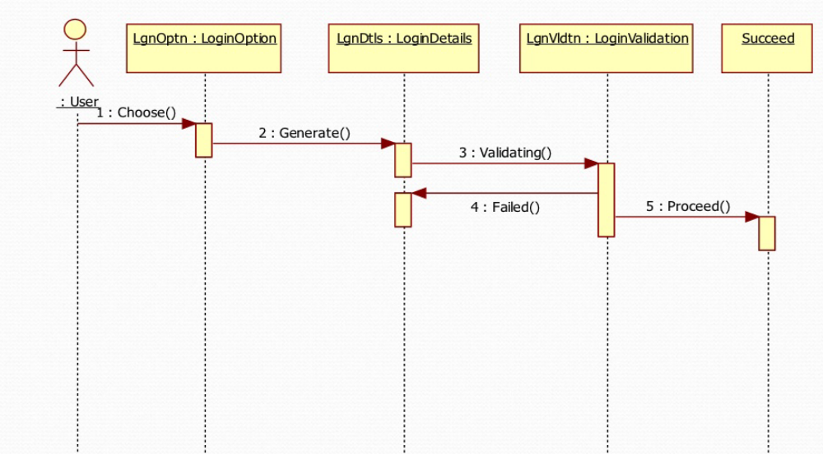

Firstly user will visit on online voting web site and there he/she will see login option for ballot.
Now user will fill required entries to login. Then browser will request to validate filled entries.
Now back end side will check validation then corresponding message will be displayed at end user side.

Voting Process

Now after validation, if user is valid then voting process comes under process. Voter will vote for all nominees to whom he/she wants to vote for all the posts. In this process user will submit voted form and the website will take all the data entered by voter. This data will be entered in database automatically.
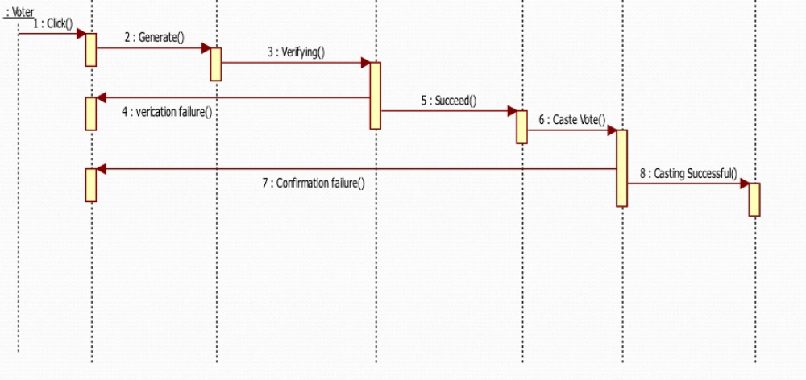4.3 Reporting Suspected Users
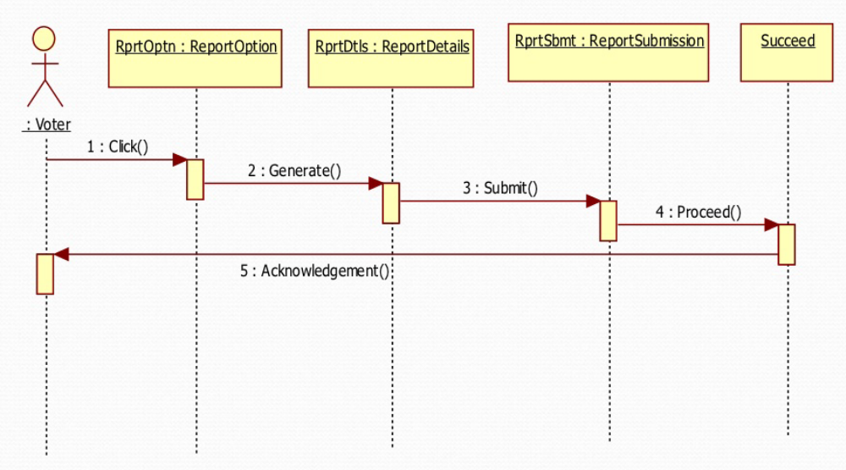
For example, if any student tries to access an identity which was enrolled but student left college after enrollment, now this roll no. does not exist then we have to report for this user.

Updating Result

Our website will be able to view result during voting process. When a user wants to check total no. of votes, then he/she can check result by clicking a button “See Current Results”.

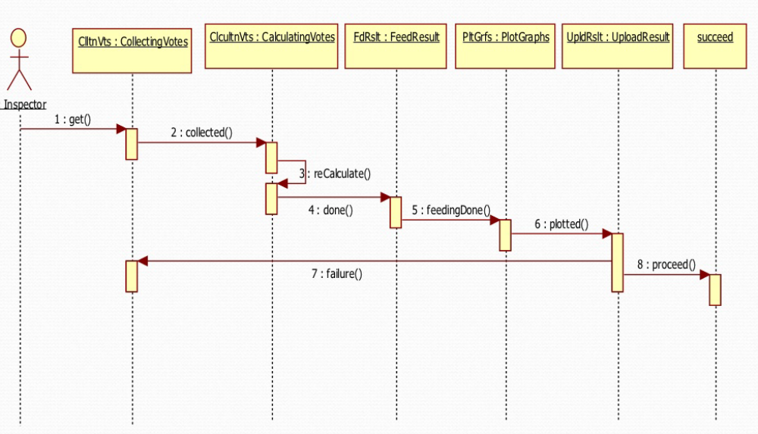

Result Viewing

So far if all the processes have been completed successfully. Now the time is to increase heartbeat of nominees, that is result announcement of whole process. Results will also be shown during voting. This will be final result.

