
National College of Information Technology (NACIT)
(Blantyre Campus)
Advanced Diploma in Computing (Level5DC)
Computing Project Analysis Document

Title: Sales and Inventory Management System for Entyre Limited Company

Name: FARAI MZUMARA
Student ID Number: P00205641
Email Address: mzkfaraimzk@gmail.com
Phone Number: 0981474654
Project Coordinator: Ms. Mwausegha
Project Supervisor: Mr. Banda

Table of Contents
1. Literature Review 3
Introduction 3
Similar Systems 3
Technological Review 6
Frontend Technologies 6
Development Environment 7
Architecture Pattern 7
2. Requirements 8
Analysis and Information Gathering 8
Functional Requirements 8
Non-Functional Requirements 10
Use case diagram 11
Architecture 12
Class diagram 14
References 15

1. Literature Review

Introduction
Entyre Limited Company, established in 1994 and headquartered in Blantyre with branches in Lilongwe, Salima, and Nkhotakota, specializes in tire distribution and automotive services. The company operates with fewer than 50 employees per branch and provides comprehensive automotive solutions including Bridgestone and Firestone tire products, vehicle breakdown assistance, fleet solutions, and maintenance services (Mangochi, 2025).
The current manual system at Entyre Limited presents significant operational challenges that hinder business efficiency and growth. Sales and inventory management represents a critical business function that directly impacts organizational performance, profitability, and customer satisfaction. Effective inventory management systems are essential for maintaining optimal stock levels, reducing carrying costs, and ensuring product availability to meet customer demand. Sales and inventory management encompasses the systematic tracking of products from procurement to sale, including stock level monitoring, sales transaction processing, and financial reporting. This business function is crucial for several reasons: it ensures adequate stock availability to meet customer demand, minimizes carrying costs through optimal inventory levels, provides accurate financial data for decision-making, and improves customer satisfaction through reliable product availability (Mangochi, 2025).
The importance of integrated sales and inventory management systems has been further emphasized by the digital transformation trends accelerated by global events. Businesses that adopted digital inventory management solutions during the pandemic showed 15% better resilience and faster recovery compared to those relying on manual processes.

Similar Systems
1. QuickBooks Enterprise
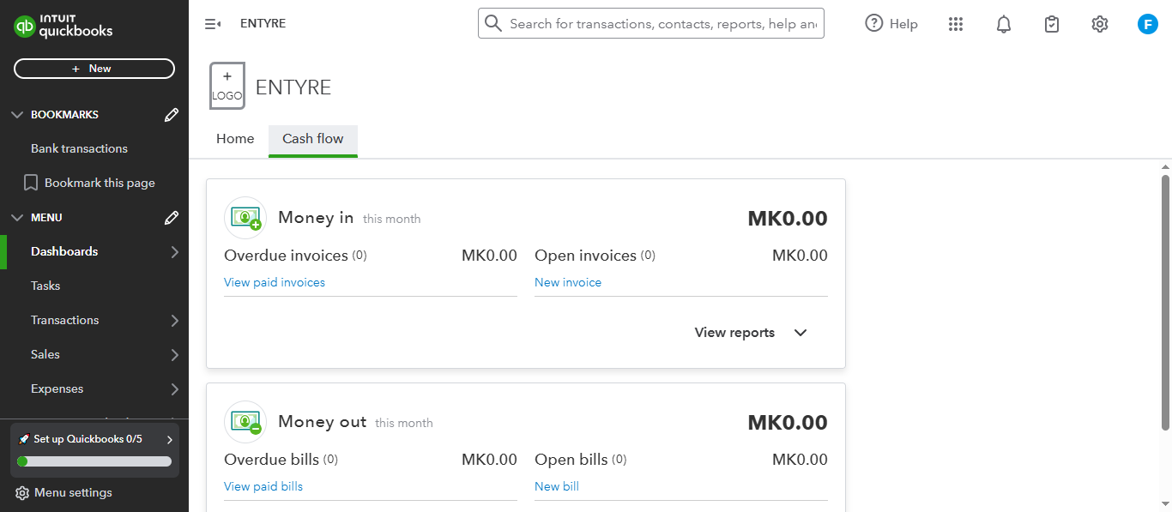

Figure 1QuickBooks

QuickBooks Enterprise provides comprehensive inventory and sales management functionality suitable for medium-sized businesses. The system offers real-time inventory tracking, automated reordering, and integrated financial reporting.
Accessibility
The system provides web-based access with mobile applications, allowing users to access data from multiple devices. However, it requires stable internet connectivity for optimal performance.
Navigation
Features an intuitive dashboard with customizable modules. The user interface follows standard business application conventions, making it relatively easy for new users to adapt.
Appearance
Modern, professional interface with clean design elements. The system uses consistent color schemes and typography, though some users find the interface cluttered due to extensive functionality.
2. SAP Business One


Figure 2 SAP Business one

SAP Business One is an enterprise resource planning solution that includes robust inventory and sales management capabilities designed for small to medium enterprises.
Accessibility
Offers both cloud-based and on premise deployment options. The system supports multiple languages and currencies, making it suitable for international operations.
Navigation
Uses a traditional ERP interface structure with menu-driven navigation. The learning curve is steeper compared to simpler systems, but provides comprehensive functionality once mastered.
Appearance
Professional, business-oriented design with emphasis on functionality over aesthetics. The interface can appear complex to non-technical users.
3. Zoho Inventory
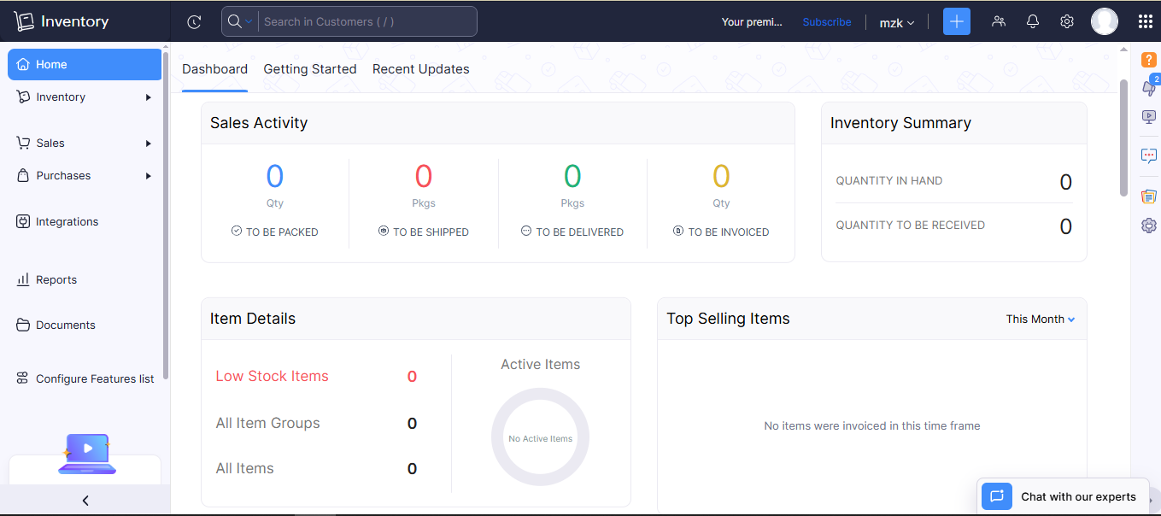

Figure 3 Zoho Inventory

Zoho Inventory is a cloud-based inventory management system that integrates with other Zoho business applications and third-party e-commerce platforms.
Accessibility
Fully web-based with responsive design supporting mobile access. Offers offline synchronization capabilities for areas with limited connectivity.
Navigation
Simple, user-friendly navigation with clear menu structures. The system provides contextual help and guided setup processes.
Appearance
Modern, clean interface with customizable dashboards. Uses contemporary web design principles with good use of white space and clear visual hierarchy.

Technological Review

Frontend Technologies
HTML
Html is semantic markup capabilities and improved form handling features essential for data entry interfaces. HTML5's offline application cache will support system functionality during network interruptions, which is crucial given Malawi's connectivity challenges.
CSS3
Chosen for advanced styling capabilities including responsive design features necessary for multi-device access. CSS3's media queries will ensure optimal display across desktop, tablet, and mobile devices used by Entyre Limited's field staff.
JavaScript
Essential for client-side interactivity and real-time data validation. Modern JavaScript frameworks provide enhanced user experience through dynamic content updates without full page reloads, improving system responsiveness.
Backend Technologies
PHP
Selected for its mature ecosystem, extensive documentation, and strong database integration capabilities. PHP's cross-platform compatibility ensures deployment flexibility, while its interpreted nature allows for rapid development and testing cycles.
MySQL
Chosen for its reliability, ACID compliance, and excellent performance with business applications. MySQL's JSON data type support will accommodate flexible data structures for varying product specifications, while its replication features will support future multi-branch deployments.

Development Environment
XAMPP
Provides integrated Apache, MySQL, and PHP environment for local development and testing. This choice ensures consistency between development and production environments while simplifying deployment processes.

Architecture Pattern
N-tier Architecture
Implemented to separate presentation, business logic, and data access layers. This separation improves maintainability, scalability, and security while allowing independent development of different system components.

2. Requirements

Analysis and Information Gathering
Requirements analysis is a critical phase in software development that involves systematic identification, documentation, and validation of system requirements. Effective requirements analysis ensures that the developed system meets stakeholder needs while remaining technically feasible and economically viable.
Information Gathering Methods
Information gathering methods are systematic approaches used to collect data about user needs, business processes, and system requirements from various stakeholders. These methods help analysts understand the problem domain and define appropriate solutions.
For this project, the following information gathering methods were employed:
Interviews
Structured interviews were conducted with key stakeholders including the company manager, accountant, technicians, and selected customers. These interviews provided detailed insights into current business processes, pain points, and desired system functionality.
Document Analysis
Existing business documents including invoices, inventory records, financial reports, and procedural manuals were analyzed to understand current data structures and workflow patterns.
Observation
Direct observation of daily operations at Entyre Limited's Blantyre branch provided valuable insights into actual work practices, system interactions, and inefficiencies not captured through interviews or document analysis.

Functional Requirements
Functional requirements specify what the system must do in terms of specific behaviors, functions, and capabilities. These requirements define the core functionality that users will interact with directly.
- User Registration and Authentication
The system must allow administrators to register new users with appropriate role assignments. User accounts must include personal information, access credentials, and role-based permissions to ensure secure system access.

- Customer Management
The system must enable staff to register new customers with complete contact information, service history, and payment preferences. Customer records should support both individual and corporate client types with relevant business details.

- Product Inventory Management
The system must maintain comprehensive product catalogs including tire specifications, pricing, supplier information, and current stock levels. The system should automatically track inventory movements and calculate available quantities in real-time.

- Sales Transaction Processing
The system must process sales transactions including product selection, quantity specification, pricing calculation, and payment method selection. Transaction records should capture complete audit trails for financial reporting and analysis.

- Invoice Generation
The system must automatically generate professional invoices based on completed transactions. Invoices should include company branding, itemized services, applicable taxes, and multiple format options for printing or electronic delivery.

- Payment Processing The system should integrate with mobile payment platforms including Mpamba and Airtel Money to process electronic payments. The system must also support cash and bank transfer payment methods with appropriate record-keeping.

- Stock Level Monitoring
The system must continuously monitor inventory levels and generate automated alerts when stock quantities fall below predetermined minimum levels. Alert notifications should be sent to relevant staff members via email or system notifications.

- Financial Reporting
The system must generate financial reports including daily sales summaries, monthly income statements, inventory valuation reports, and customer payment histories. Reports should be available in multiple formats including PDF and Excel.

- Quotation Management
The system should allow staff to create and manage customer quotations for requested services. Quotations must include detailed service descriptions, pricing, validity periods, and conversion capabilities to actual sales orders.

Non-Functional Requirements
- Performance Requirements
The system must respond to user interactions within 3 seconds under normal load conditions. Database queries should complete within 2 seconds for standard operations and within 5 seconds for complex reporting functions.

- Scalability Requirements
The system should support concurrent access by up to 50 users without performance degradation. The architecture must accommodate future expansion to additional company branches without requiring complete system redesign.

- Security Requirements
The system must implement secure user authentication using encrypted password storage and session management. All financial data must be encrypted during transmission and storage, with audit logs maintaining records of all system access and modifications.

- Reliability Requirements
The system must maintain 99% uptime during business hours with automated backup procedures ensuring data recovery within 24 hours of any system failure. Regular database backups should be performed daily with weekly full system backups.

- Usability Requirements
The system must provide intuitive navigation suitable for users with basic computer skills. Training requirements should not exceed 4 hours for basic system operations, with comprehensive help documentation available within the system.

- Compatibility Requirements
The system must function properly on modern web browsers including Chrome, Firefox, and Edge. The interface must be responsive and functional on desktop computers, tablets, and smartphones commonly used by staff.

- Data Integrity Requirements
The system must maintain referential integrity across all database relationships with validation rules preventing inconsistent data entry. All financial calculations must be accurate to two decimal places with audit trails for all modifications.

Use case diagram
A user case is a method in a way that we are able to define and describe a system and arrange it. A diagram illustrates the user case below.
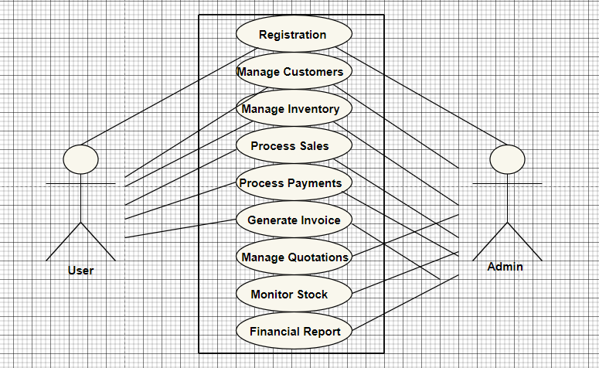

Figure 4 Use Case

Architecture

System Architecture
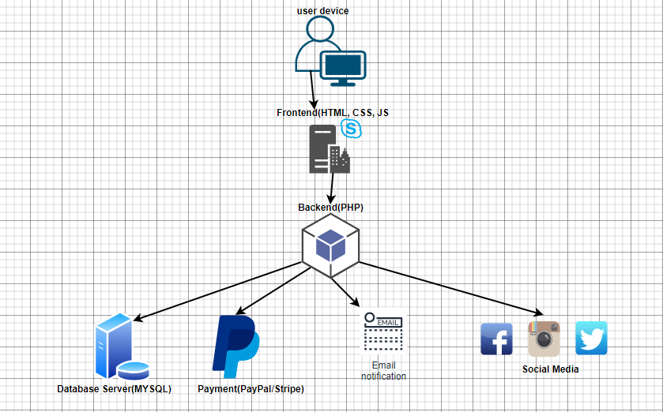
Figure 5 System Architecture

Presentation layer:
- User devices: The user interface that ensures users to access around the systems using web browser such as Microsoft edge and google chrome.
- Frontend (HTML, CSS, JS): As the client-side technologies used in defining the style, structure and webpage interactivity.

Application layer:
- PHP: a server-side scripting language that is used in improving webpage interactivity and dynamic.

Data layer:
- MYSQL: the database management system tool used in managing system data.

Payment Gateway:
- The system connects with payment platforms such as stripe to ensure payment processing.

Email notification service:
- Offer and provides real-time updates to users.

- Social media
- Allows users to share their views and ideas on updates and products.

Class diagram
A class diagram may be defined as a structure that illustrates the systems classes and the attributes and the relationships between them. An initial diagram is a simple draft of the systems classes and their relationships (Visual Paradigm, 2025).
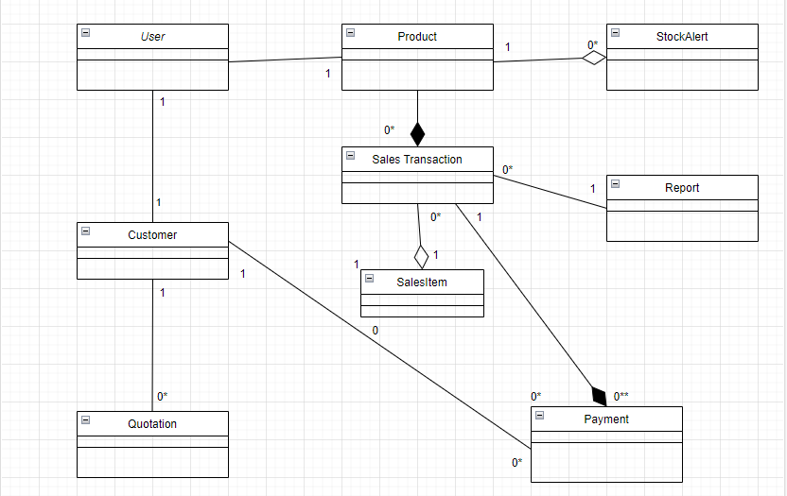

Figure 6 class diagram

References
Mangochi, V., 2025. analysis for entyre limited [Interview] (27 April 2025).
Visual Paradigm, 2025. Visual Paradigm. [Online]
Available at: https://www.visual-paradigm.com/guide/uml-unified-modeling-language/what-is-class-diagram/
[Accessed 27 July 2025].

Appendix
Use Case description
- Actor
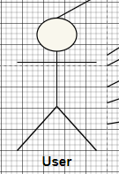
The system users
- User case
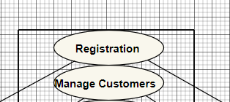
Represents the system functionality
- Association
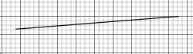
This shows the connection between components
- System boarder
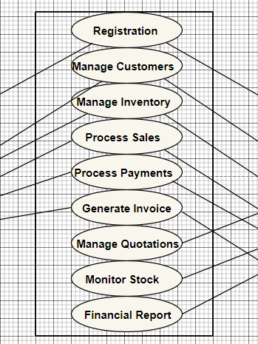
This is the system processes

