FPGA-Based DNA Disease Detection and Genomic Analysis Platform Using Hardware Accelerated Sequence Alignment

Dakshraj Shetty  Dept. of Electronics and Communication Engineering  RV College of Engineering  Karnataka, India | M Vaibhav  Dept. of Electronics and Communication Engineering  RV College of Engineering  Karnataka, India | Anirudh Shashidhar Tantry  Dept. of Electronics and Communication Engineering  RV College of Engineering  Karnataka, India | Barath Ganesh SBP  Dept. of Electronics and Communication Engineering  RV College of Engineering  Karnataka, India

Abstract—The increasing volume of genomic data has created a growing need for efficient and high-performance DNA analysis systems. Traditional software-based sequence alignment methods often require significant computational resources and processing time, limiting their effectiveness in real-time genomic applications. This project, “FPGA-Based DNA Disease Detection and Genomic Analysis Platform Using Hardware Accelerated Sequence Alignment,” presents a hardware-software co-design approach for rapid genomic analysis and disease detection. The proposed system utilizes a Zynq-7000 FPGA to accelerate the computationally intensive Smith-Waterman sequence alignment algorithm, enabling faster comparison of DNA sequences against known disease-associated genetic patterns. The hardware accelerator is integrated with a Python-based analysis framework running on the PYNQ platform, providing an interactive environment for genomic data processing. In addition to sequence alignment, the system performs genomic feature extraction, including GC content analysis, sequence entropy calculation, moving-average filtering, and Z-score-based anomaly detection to enhance the interpretation of DNA sequences. The platform identifies and ranks potential disease matches based on alignment scores and presents the results through graphical visualizations and automated report generation. By leveraging the parallel processing capabilities of FPGA technology, the proposed solution aims to improve processing efficiency while maintaining alignment accuracy. The project demonstrates the potential of reconfigurable hardware in bioinformatics applications and provides a scalable foundation for future genomic analysis and disease screening systems.
Keywords—FPGA, Genomic Analysis, DNA Disease Detection, Smith-Waterman Algorithm, Hardware Acceleration, Bioinformatics, Zynq-7000, PYNQ-Z1, Sequence Alignment, Disease Classification, GC Content Analysis, Sequence Entropy, Anomaly Detection, Z-Score Analysis, FASTA Sequences, AXI Interface, Vitis HLS, Vivado, Hardware-Software Co-Design, Genomic Feature Extraction, Heatmap Visualization, Automated Report Generation, Reconfigurable Computing, Embedded Systems, Healthcare Technology.
I. INTRODUCTION
Advancements in genomics have transformed modern healthcare by enabling the identification of genetic disorders, disease susceptibility, and personalized treatment strategies through DNA analysis. However, the increasing volume of genomic data has created significant computational challenges, particularly in DNA sequence alignment, which is one of the most resource-intensive tasks in bioinformatics. Traditional software-based approaches often require substantial processing time and computational power, limiting their effectiveness in real-time applications.
Field Programmable Gate Arrays (FPGAs) offer a promising solution by providing parallel processing capabilities and reconfigurable hardware architectures that can accelerate computationally demanding bioinformatics algorithms. This project presents an FPGA-Based DNA Disease Detection and Genomic Analysis Platform Using Hardware Accelerated Sequence Alignment, which integrates hardware acceleration with genomic analytics to improve the efficiency of DNA sequence processing.
The proposed system implements the Smith-Waterman sequence alignment algorithm on a Zynq-7000 FPGA platform to perform rapid comparison of DNA sequences against disease-associated genetic patterns. In addition to alignment, the platform performs genomic feature extraction through GC-content analysis, nucleotide composition analysis, sequence entropy measurement, moving-average filtering, and Z-score-based anomaly detection. The generated results are further analyzed, visualized, and compiled into automated reports using a Python-based interface.
By combining FPGA acceleration with comprehensive genomic analysis techniques, the platform aims to provide a fast, scalable, and efficient framework for DNA disease detection and bioinformatics research, demonstrating the potential of reconfigurable computing in healthcare and genomic applications.
II. OBJECTIVES
A. Hardware-Accelerated DNA Sequence Alignment
The primary objective of this project is to design and implement a hardware-accelerated DNA sequence alignment engine using the Smith-Waterman algorithm on a Zynq-7000 FPGA platform. DNA sequence alignment is one of the most computationally intensive operations in bioinformatics, especially when large genomic datasets are involved. By leveraging the parallel processing capabilities of FPGA hardware, the system aims to significantly reduce execution time while maintaining alignment accuracy. This objective focuses on improving computational efficiency and demonstrating the advantages of reconfigurable hardware for genomic applications.
B. Disease Detection Through Genomic Analysis
Another key objective is to develop a genomic analysis system capable of identifying disease-associated genetic patterns by comparing unknown DNA sequences against a repository of reference disease sequences. The system analyzes sequence similarity using alignment scores generated by the hardware accelerator and determines potential disease matches. This enables rapid screening of genomic data and provides a foundation for early disease identification and genetic analysis.
C. Development of a Reconfigurable FPGA-Based Platform
The project aims to utilize the reconfigurable nature of FPGA technology to create a flexible genomic processing platform. Unlike fixed-function hardware, FPGAs can be reprogrammed to accommodate different computational requirements and future enhancements. This objective ensures that the developed platform can be adapted for additional bioinformatics algorithms, larger datasets, and evolving genomic research needs without requiring significant hardware modifications.
D. Comprehensive Genomic Analysis Framework
The project seeks to develop a complete end-to-end genomic analysis framework rather than a standalone alignment accelerator. The platform integrates sequence alignment, disease detection, statistical analysis, genomic feature extraction, visualization, and reporting into a unified workflow. This objective ensures that users receive meaningful biological insights rather than raw alignment scores, making the system more practical for research and healthcare applications.
E. GC Content and Nucleotide Composition Analysis
This objective focuses on calculating the percentage of guanine (G) and cytosine (C) nucleotides present within a DNA sequence and determining the overall nucleotide composition. GC content is an important genomic characteristic that influences DNA stability, gene expression, and structural properties. By providing detailed nucleotide distribution statistics, the system offers additional biological information that complements sequence alignment results.
F. Sequence Entropy Analysis
The project aims to evaluate the complexity and variability of DNA sequences using entropy-based analysis techniques. Entropy serves as a quantitative measure of sequence randomness and information content. By calculating entropy values, the system can identify highly conserved regions, repetitive patterns, or unusual sequence characteristics that may have biological significance. This analysis enhances the depth of genomic interpretation beyond simple sequence matching.
G. Statistical Signal Processing for Genomic Data
To improve the reliability of genomic analysis, the project incorporates statistical signal processing techniques such as moving-average filtering and Z-score-based anomaly detection. These methods help identify significant deviations and irregular patterns within genomic data. The integration of statistical analysis allows the system to detect unusual genomic behavior that may indicate mutations, abnormalities, or biologically relevant variations.
G. Disease Classification and Ranking
In addition to identifying potential disease matches, the system aims to classify detected diseases into meaningful categories and rank them according to alignment strength and statistical relevance. This objective helps prioritize the most likely disease associations and provides users with a structured interpretation of the analysis results. Disease ranking enhances decision-making by highlighting the strongest genomic correlations.
H. Data Visualization and Interpretation
The project seeks to improve the accessibility and interpretability of genomic data through interactive visualizations. Various graphical representations, including heatmaps, disease ranking charts, nucleotide composition graphs, entropy plots, and alignment score distributions, are generated to present results in a clear and intuitive manner. Effective visualization enables users to quickly identify trends, anomalies, and important findings within complex genomic datasets.
I. Automated Report Generation
A key objective is to automate the generation of comprehensive analysis reports. The system compiles alignment results, genomic statistics, disease rankings, anomaly detection outcomes, and visualization summaries into structured PDF reports. Automated reporting reduces manual effort, improves consistency, and facilitates documentation of genomic analysis results for research, academic, and healthcare purposes.
J. Performance Evaluation
The project aims to evaluate the effectiveness of FPGA-based acceleration by measuring key performance metrics such as execution time, processing throughput, resource utilization, and computational efficiency. Comparative analysis between hardware-accelerated and conventional software-based implementations will demonstrate the benefits of using FPGA technology for genomic applications.
K. Scalability for Future Bioinformatics Applications
The final objective is to establish a scalable and extensible platform that can support future advancements in bioinformatics. The modular architecture of the system allows integration of larger genomic databases, advanced alignment algorithms, additional genomic analytics, and real-time processing capabilities. This scalability ensures that the platform remains relevant and adaptable to emerging research and healthcare requirements.
III. ANALYSIS AND TESTING
The analysis and testing phase was conducted to evaluate the accuracy, reliability, and effectiveness of the FPGA-based DNA disease detection and genomic analysis platform. This phase focused on validating data integrity, alignment accuracy, disease-matching performance, and overall system stability under continuous operation. The testing methodology was designed to closely replicate practical genomic screening scenarios while ensuring repeatability and objective evaluation.
A. FUNCTIONAL ANALYSIS
(i) DNA Sequence Alignment Analysis
The core functionality of the system was analyzed by evaluating the performance of the Smith-Waterman sequence alignment algorithm implemented on the FPGA. Multiple DNA sequences were provided as input and compared against disease-associated reference sequences. The alignment scores generated by the hardware accelerator were examined to verify the correctness of local sequence matching and disease identification. Higher alignment scores indicated stronger genetic similarity between the input sequence and the reference disease pattern.
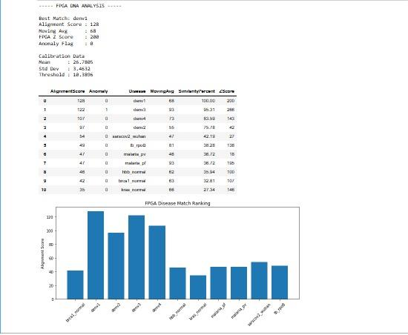
FIGURE 1. Summary report showing disease ranking, alignment scores, and statistical analysis results
(ii) Disease Detection Analysis
The disease detection module was analyzed by comparing various test DNA sequences against the disease database. The generated alignment scores were ranked to identify the most probable disease matches. The ranking mechanism successfully prioritized diseases with higher sequence similarity, demonstrating the system's ability to provide meaningful diagnostic information.
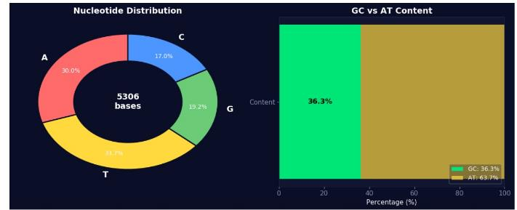
FIGURE 2. Nucleotide composition and GC–AT content analysis of the input DNA sequence.
(iii) Genomic Feature Analysis
The genomic analysis framework was evaluated using biological metrics such as GC content, nucleotide composition, and sequence entropy. These parameters provided additional insights into the characteristics of the input DNA sequence. Variations in nucleotide distribution and entropy values helped assess sequence complexity and biological significance.
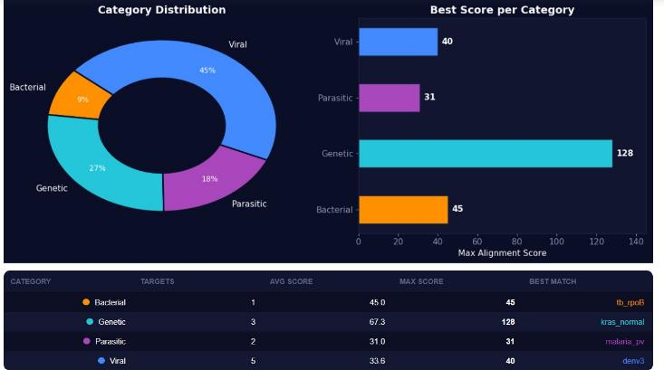
FIGURE 3. Category-wise disease distribution and maximum alignment scores
(iv) Statistical Analysis
Moving-average filtering and Z-score-based anomaly detection were analyzed to determine their effectiveness in identifying unusual sequence behavior. The filtering process reduced random fluctuations in the data, while the anomaly detection mechanism highlighted significant deviations from expected patterns. This additional layer of analysis improved the interpretability of genomic results.
B. HARDWARE TESTING
(i) FPGA Module Verification
The Smith-Waterman accelerator and associated hardware modules were verified using Vitis HLS simulation and synthesis tools. Functional simulations were performed to ensure that the generated alignment scores matched expected outputs for known DNA sequence pairs. Successful simulation results confirmed the correctness of the hardware design before deployment.
(ii) AXI Interface Testing
The custom AXI-based communication interface was tested to ensure reliable data transfer between the Processing System (PS) and Programmable Logic (PL). Test sequences of varying lengths were transmitted to the FPGA accelerator, and the returned alignment scores were validated against software-generated reference results.
(iii) Overlay Validation
The generated bitstream and hardware description files were loaded onto the PYNQ-Z1 board using the Overlay framework. Successful initialization and communication with the custom IP core confirmed proper hardware integration and system functionality.
C. SOFTWARE ANALYSIS
(i) Jupyter Interface Testing
The Python-based graphical interface was tested to verify user interaction and system responsiveness. DNA sequence inputs, disease database loading, result visualization, and report generation functionalities were individually validated to ensure reliable operation.
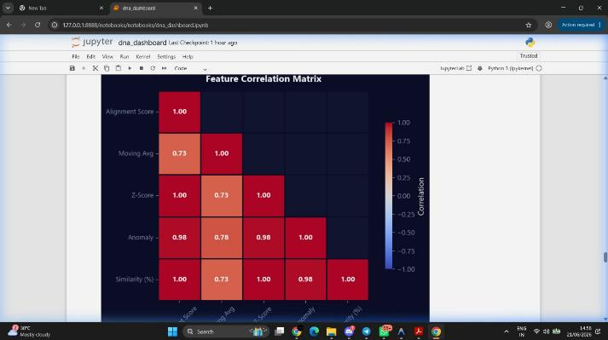
FIGURE 4. Feature correlation matrix showing relationships among alignment score, similarity, anomaly, and statistical metrics.
(ii) Disease Database Testing
The FASTA-based disease sequence repository was tested using multiple reference sequences. The database loading mechanism correctly parsed genomic data and supplied appropriate reference sequences for alignment and disease comparison operations.
(iii) Visualization Testing
Visualization modules such as disease ranking charts, nucleotide composition graphs, entropy plots, and heatmaps were tested using different datasets. The generated visual outputs accurately represented the underlying genomic analysis results and improved result interpretation.
(iv) Automated Report Testing
The PDF report generation module was tested to verify the inclusion of all relevant analysis parameters. Generated reports successfully contained alignment scores, disease rankings, genomic statistics, anomaly detection results, and graphical visualizations, ensuring comprehensive documentation of analysis outcomes.
D. PERFORMANCE ANALYSIS
(i) Execution Time Analysis
The performance of the FPGA-accelerated implementation was analyzed by measuring the time required for DNA sequence alignment operations. Compared to software-only execution, the FPGA implementation demonstrated faster processing due to parallel hardware execution and dedicated computational resources.
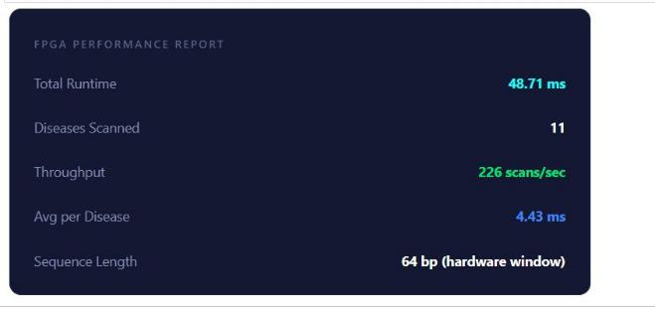
FIGURE 5. Ranked disease matches with alignment scores and similarity percentages.
(ii) Throughput Analysis
System throughput was evaluated by analyzing the number of sequence alignment operations that could be completed within a given time interval. The FPGA-based implementation exhibited improved throughput, making it suitable for handling larger genomic datasets.
(iii) Resource Utilization Analysis
Hardware resource utilization was examined after synthesis and implementation. Parameters such as Look-Up Tables (LUTs), Flip-Flops (FFs), Block RAMs (BRAMs), and DSP slices were analyzed to determine the efficiency of the hardware design. The implementation successfully balanced performance and resource consumption.
(iv) System Integration Testing
The complete system was tested by integrating the FPGA accelerator, disease database, genomic analytics framework, visualization tools, and report generation modules into a unified workflow. End-to-end testing was performed by providing DNA sequences as input and observing the generation of alignment scores, disease rankings, genomic statistics, visualizations, and final reports. Successful execution of the complete workflow confirmed the reliability and functionality of the proposed platform.
(v) Results Discussion
The testing results demonstrated that the FPGA-based approach effectively accelerated DNA sequence alignment while maintaining analytical accuracy. The integration of genomic feature extraction, statistical analysis, disease ranking, visualization, and report generation transformed the system from a simple alignment engine into a comprehensive genomic analysis platform. The experimental outcomes validate the suitability of FPGA technology for bioinformatics applications requiring high computational performance and real-time processing capabilities.
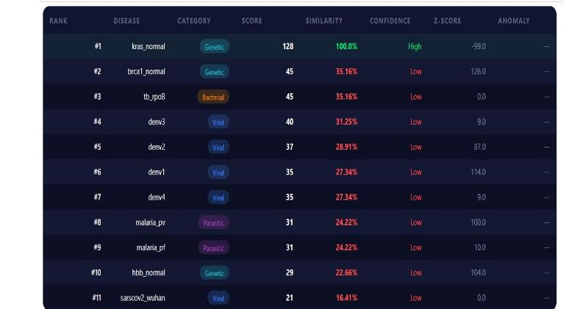
FIGURE 6. FPGA Performance Report
IV. CONCLUSION
The successful development of the FPGA-Based DNA Disease Detection and Genomic Analysis Platform Using Hardware Accelerated Sequence Alignment demonstrates the potential of reconfigurable computing in addressing the growing computational demands of modern bioinformatics. This project has transformed a traditionally software-intensive genomic analysis workflow into a high-performance hardware-accelerated system capable of performing rapid DNA sequence alignment, disease detection, genomic feature extraction, statistical analysis, visualization, and automated reporting within a unified framework.
At the core of the platform lies a custom FPGA implementation of the Smith-Waterman sequence alignment algorithm on the Zynq-7000 architecture, enabling efficient processing of genomic data through parallel hardware execution. Beyond acceleration, the project extends its capabilities through comprehensive genomic analytics, including GC-content analysis, nucleotide composition analysis, sequence entropy measurement, moving-average filtering, Z-score-based anomaly detection, disease classification, and ranking mechanisms. The integration of these features ensures that the system delivers meaningful biological insights rather than merely producing alignment scores.
A significant achievement of this work is the successful integration of hardware and software through a hardware-software co-design methodology. The FPGA accelerator, custom AXI interfaces, PYNQ overlay environment, disease sequence database, visualization engine, and automated report generation framework collectively form a complete end-to-end genomic analysis ecosystem. This demonstrates not only the feasibility of FPGA-based bioinformatics solutions but also their ability to bridge the gap between embedded systems engineering and computational biology.
The project further highlights the advantages of reconfigurable hardware in terms of computational efficiency, scalability, and adaptability. The modular architecture allows future expansion toward larger genomic databases, more sophisticated alignment techniques, advanced mutation analysis, and real-time genomic screening applications. Such extensibility ensures that the platform can evolve alongside advancements in genomic research and precision medicine.
Ultimately, this work represents more than the implementation of a hardware accelerator; it establishes a comprehensive framework for intelligent genomic analysis using embedded computing technologies. By successfully combining FPGA acceleration, bioinformatics algorithms, statistical analytics, data visualization, and automated reporting into a single platform, the project showcases how interdisciplinary engineering can contribute to next-generation healthcare technologies.
The developed system serves as a strong foundation for future research in hardware-accelerated bioinformatics and demonstrates the transformative role that FPGA-based solutions can play in enabling faster, more efficient, and more accessible genomic analysis.
V. FUTURE WORK
The current platform successfully demonstrates FPGA-accelerated DNA sequence alignment and genomic analysis; however, several practical enhancements can further improve its capabilities and real-world applicability.
One important extension is the integration of larger and continuously updated genomic databases. Connecting the platform to publicly available repositories would increase the range of detectable diseases and improve the accuracy of genomic analysis.
Future versions can also incorporate mutation and variant detection capabilities, enabling the identification of specific genetic alterations such as SNPs and insertions/deletions. This would provide more detailed diagnostic information than sequence similarity analysis alone.
The performance of the system can be further improved by implementing multiple parallel alignment engines on the FPGA. Such an enhancement would increase throughput and enable faster processing of larger genomic datasets.
Additional genomic analysis features such as motif detection, repeat sequence analysis, and evolutionary similarity assessment can be integrated to provide deeper biological insights into DNA sequences.
The current software-based analytical modules, including entropy calculation and anomaly detection, can be migrated to dedicated FPGA hardware modules. This would create a more efficient end-to-end hardware-accelerated genomic processing pipeline.
Finally, the platform can be developed into a portable genomic analysis system by combining FPGA acceleration, embedded processing, and an intuitive user interface. Such a solution could support rapid genomic screening in research laboratories, educational institutions, and healthcare environments.
Overall, these enhancements would transform the proposed system from a DNA analysis platform into a more comprehensive, scalable, and practical bioinformatics solution capable of addressing future genomic research and diagnostic requirements.
Acknowledgment
We express our sincere gratitude to RV College of Engineering for providing the necessary facilities and resources to carry out this project successfully. We are thankful to the Principal for his constant support and encouragement.
We extend our heartfelt thanks to our mentor, Dr. K. B. Ramesh, for his invaluable guidance, continuous support, and constructive suggestions throughout the project. His encouragement and expertise were instrumental in the successful completion of this work.
We also thank the faculty members, our teammates, and our families for their support and motivation throughout the course of this project.
References
[1] T. F. Smith and M. S. Waterman, “Identification of Common Molecular Subsequences,” Journal of Molecular Biology, vol. 147, no. 1, pp. 195–197, 1981.
[2] I. T. S. Li, T. Shum, H. Truong, and W. Luk, “160-Fold Acceleration of the Smith–Waterman Algorithm Using a Field Programmable Gate Array (FPGA),” BMC Bioinformatics, vol. 8, no. 185, 2007.
[3] J. Daily, “Parasail: SIMD C Library for Global, Semi-Global, and Local Pairwise Sequence Alignments,” BMC Bioinformatics, vol. 17, no. 81, 2016.
[4] F. F. Oliveira, V. M. M. de Oliveira, and E. C. de Oliveira, “Proposal of Smith–Waterman Algorithm on FPGA to Accelerate the Forward and Backtracking Stages,” PLOS ONE, vol. 17, no. 7, 2022.
[5] S. Salamat and T. Rosing, “FPGA Acceleration of Sequence Alignment: A Survey,” 2020.
[6] W. J. Dally and B. Towles, Principles and Practices of Interconnection Networks. San Francisco, CA, USA: Morgan Kaufmann, 2004.
[7] R. Woods, J. McAllister, G. Lightbody, and Y. Yi, FPGA-Based Implementation of Signal Processing Systems, 2nd ed. Wiley, 2017.
[8] N. S. McVicar, “FPGA Accelerated Bioinformatics: Alignment, Classification and Assembly,” Ph.D. Dissertation, University of Washington, 2019.
[9] M. Farrar, “Striped Smith–Waterman Speeds Database Searches Six Times Over Other SIMD Implementations,” Bioinformatics, vol. 23, no. 2, pp. 156–161, 2007.
[10] D. J. Lipman and W. R. Pearson, “Rapid and Sensitive Protein Similarity Searches,” Science, vol. 227, no. 4693, pp. 1435–1441, 1985.
[11] National Center for Biotechnology Information (NCBI), “GenBank Overview.”
[12] E. W. Myers et al., “A Whole-Genome Assembly of Drosophila,” Science, vol. 287, no. 5461, pp. 2196–2204, 2000.
[13] P. Chen et al., “Accelerating the Next Generation Long Read Mapping with FPGA,” IEEE/ACM Transactions on Computational Biology and Bioinformatics, 2014.
[14] ACM/SIGDA International Symposium on Field Programmable Gate Arrays, “FPGA Acceleration of Short Read Alignment,” 2021.
[15] International Human Genome Sequencing Consortium, “Initial Sequencing and Analysis of the Human Genome,” Nature, vol. 409, pp. 860–921, 2001.

