Date of publication xxxx 00, 0000, date of current version xxxx 00, 0000.
Digital Object Identifier 10.1109/ACCESS.2017.Doi Number
Lithium Nanoparticle Based Energy Storage (June 2025)
Dakshraj Shetty, Abhinav Mallela, Manoj Gupta D B, and Vaibhav M
RV College of Engineering, Karnataka, India
ABSTRACT In this study, we report the synthesis and electrochemical analysis of the lithium based nanomaterials - Li₂ZnSiO₄, Li₂Al₂Si₃O₁₀, and LiAlSiO₄ as potential electrode and solid state electrolyte materials for energy storage applications. Li₂ZnSiO₄, was synthesized using solution combustion method with ascorbic as a fuel, electrochemical performance was tested using 6M and 3M KOH aqueous electrolytes. To address the need for a robust solid-state electrolyte, Li₂Al₂Si₃O₁₀ and LiAlSiO₄ were synthesized via solution combustion using ascorbic acid and glycine fuels respectively, followed by calcination to improve crystallinity. Structural properties were analyzed using X-ray diffraction (XRD), and electrochemical properties were assessed via cyclic voltammetry (CV), chronopotentiometry, and electrochemical impedance spectroscopy (EIS). LiAlSiO₄ exhibited higher crystallinity and phase purity compared to Li₂Al₂Si₃O₁₀, and the Li₂ZnSiO₄ electrode showed improved performance with 6M KOH, reaching a specific capacitance of 104.76 F/g. These findings demonstrate the promise of these synthesized materials for supercapacitor and battery-type energy storage systems.
INDEX TERMS Activated carbon, chronopotentiometry, cyclic voltammetry, energy density, energy storage, electrochemical impedance spectroscopy, nanomaterials, power density, self-discharge rates, solution combustion method, XRD graph, Galvanostatic Charge/Discharge
I. INTRODUCTION
With the shift to more renewable sources of energy, we as a society find ourselves in the need of energy storage devices. As renewable sources of energy are abundant, they are not continually available; for example, solar energy is not available during cloudy weather or at night. Thus, we need to store energy to be able to use it when there is no continual supply. Super capacitors have shown themselves to be immensely helpful in this field and if optimized properly can become a standard in energy storage globally.
Batteries tend to have higher energy density while they have lower power densities and capacitors tend to have higher power density while lower energy densities. To increase the charge storage mechanism in these energy storage devices we are employing Lithium based nanoparticles in the electrodes, namely a nanomaterial of Li₂ZnSiO₄, which is an orthosilicate compound where each tetrahedra unit of SiO4 is held together by metal ions such as Li+ and Zn2+ with properties which are suitable for energy storage applications. The lithium ions in the compound facilitate ionic conductivity by enabling lithium-ion transport within the electrode. Zinc provides structural stability and contributes to the electronic properties of the material. Acts as a stabilizer in the crystal lattice and can improve redox activity. Silicon forms the SiO4 tetrahedral framework, which provides mechanical and chemical stability and enhances the overall thermal stability. To test the electrodes, we have tested our electrodes by performing Cyclic voltammetry, Chronopotentiometry and Electrochemical Impedance Spectroscopy
For the electrolyte we have manufactured both Li₂Al₂Si₃O₁₀ and LiAlSiO₄ in the solid state. Solid state electrolytes tend to have higher thermal stability and have very high surface area. We calcinated these compounds to increase their overall crystalline hence allowing for doping sites.

II. EXPERIMENTAL
A. MATERIALS
Lithium Nitrate, Zinc Nitrate, Silicic Acid, were used as substrate to synthesize Li₂ZnSiO₄, and Oxalic Acid was used as the fuel.6M KOH/3M KOH were used as the electrolyte. Carbon black:0.5mg NMP(N-Methyl-2-Pyrrolidone)-polar aprotic solvent: 1-2 drops PVDF(polyvinylidene fluoride

binder)-Binder used: 1-2 drops were used along with the synthesized material to create a slurry for the electrode. For the solid state electrolyte synthesis Lithium Nitrate, Aluminium Nitrate, Silicic Acid and Glycine as fuel.

B. SYNTHESIS OF Li₂ZnSiO₄,
The synthesis of Li₂ZnSiO₄, was carried out by employing fuel combustion method to obtain nano compound. 4.024g of lithium nitrate, 8.6809g of zinc nitrate and 1.7531g of silicic acid were added into a beaker along with 4.5529g of ascorbic acid and dissolved in 100ml of double distilled water and placed in a muffler furnace which was preheated up to a temperature of 500ºC and was left in the furnace for thirty minutes. Then the beaker was carefully extracted from the furnace and the yield was then grinded and then transferred into a closed container.

TABLE I
Amount of compounds added
Compound | Weight added
Lithium Nitrate | 4.024g
Zinc Nitrate | 8.6809g
Silicic Acid | 1.7531g
Ascorbic Acid | 4.5529g

C. SYNTHESIS OF ELECTROLYTE FOR PRELIMINARY TESTING
6.73296g of KOH crystals were weighed and transferred into a breaker. 20ml of double distilled water was poured into the beaker and crystals were dissolved to make the 6M electrolyte of KOH.
3.36648g of KOH crystals were weighed and transferred into a breaker. 20ml oh double distilled water was poured and crystals were dissolved to make the 3M electrolyte KOH.

D. SYNTHESIS OF SOLID-STATE ELECTROLYTE
First, we synthesized Li₂Al₂Si₃O₁₀ nanomaterials as the solid-state electrolyte and we employed solution combustion method by using Ascorbic Acid as the fuel. The compounds we weighed in order to synthesize 5g of the compound and then heated it in a muffle furnace at 450 degrees Celsius for 35 minutes.

TABLE 2
Amount of compounds added
Compound | Weight added
Lithium Nitrate | 1.4107g
Aluminium Nitrate | 4.2323g
Silicic Acid | 0.9625g
Ascorbic Acid | 5.6430g

To increase the crystallinity of Li₂Al₂Si₃O₁₀ we then performed calcination on the compound at 900 degrees Celsius for 2 hours. The calcinated compound was then crushed and grinded into a fine powder and sent for XRD

A problem we faced with the 1st compound is that we were finding impurities and hence could not match the XRD effectively, A few peeks seemed to be matching those of LiAlSiO₄, but a few peeks didn’t match any standard ICDD graphs, hence we decided to synthesize another compound as our solid state electrolyte.

Due to impurities being present in the first compound, we also synthesized LiAlSiO₄ this time employing glycine as the fuel. Stoichiometric calculations were performed for 5g of yield and then measurements were done. The compound was dissolved in 100 cm3 of water and then heated it in the muffle furnace
TABLE 3
Amount of compounds added
Compound | Weight added
Lithium Nitrate | 2.737g
Aluminium Nitrate | 14.893g
Silicic Acid | 2.385g
Glycine | 6.6227g

The obtained compound was then calcinated in the tubular furnace at 950 degrees Celsius for 2 hours and then the obtained compound was retrieved from the tubular furnace and crushed and then sent for XRD.

E. SYNTHESIS OF ELECTRODE
2.5mg of synthesized compound was weighed and added along with 0.5mg of carbon black and activated carbon mixture. It was then transferred into a mortar and 1 or 2 drops of PVDF which was used as a binder and 1 or 2 drops of NMP which is an aprotic polar solvent were added and the slurry was then mixed and coated over a Toray carbon sheet of dimensions 2cm x 1cm. The coating is applied only on half of the sheet.
III. ANALYSIS AND TESTING
A. XRD of Li₂ZnSiO₄,
The electrode material (Li₂ZnSiO₄, ) was sent for XRD and the following pattern was received as shown(see Fig.1). X-ray diffraction (XRD) is a non-destructive technique that analyzes the structure, composition, and physical properties of materials
F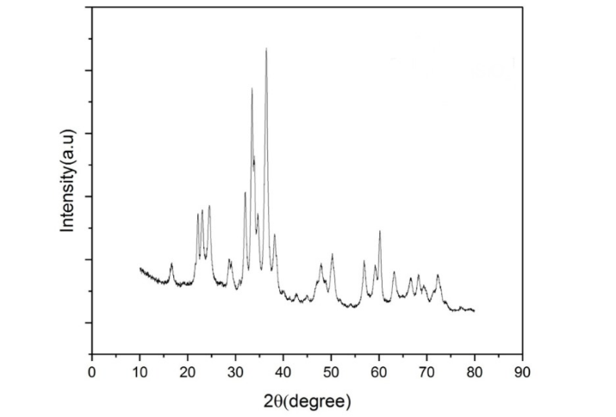
FIGURE 1. XRD graph of Li₂ZnSiO₄,

From the above XRD the properties of Li₂ZnSiO₄, were retrieved and electrodes were prepared and electrochemical testing was conducted. For the electrochemical testing, synthesized electrode was used as working electrode, platinum electrode was used as counter electrode and Hg/HgO electrode was used as reference electrode. Two separate sets of electrochemical tests were conducted one with using 6M KOH electrolyte and another using 3M KOH electrolyte. The electrochemical tests conducted were Cyclic voltammetry, chronopotentiometry and electrochemical impedance spectroscopy.

B. XRD of Li₂Al₂Si₃O₁₀
After the compound was prepared a batch was sent for XRD and the following graph was obtained(see Fig.2).

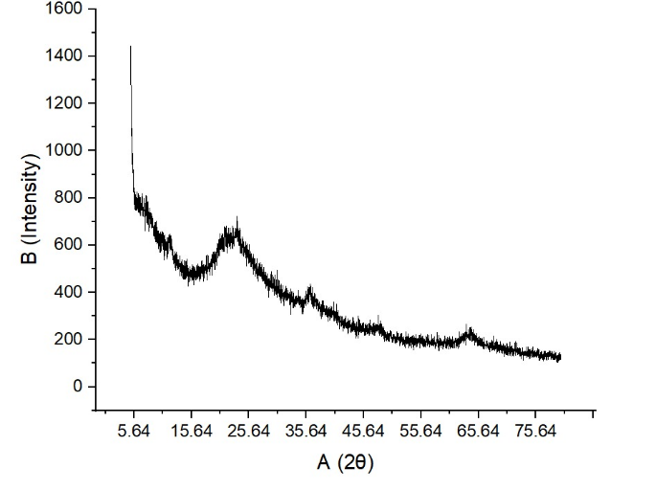
FIGURE 2. XRD graph of Li₂Al₂Si₃O₁₀ before calcination

As the peaks were not very steep, we were able to conclude that the formed compound was amorphous, hence to increase the crystallinity of the compound in order to obtain more sites for doping atoms, the compound was calcinated in a tubular furnace at 900 degrees Celsius for 2 hours. After doing so the calcinated compound was sent for XRD and the following graph was obtained (see Fig.3)

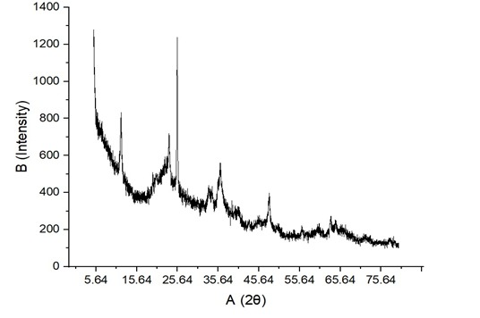

FIGURE 3. XRD graph of Li₂Al₂Si₃O₁₀ after calcination

As we can see the peaks are much steeper which imply the increase in crystallinity of the compound, which means the goal was reached. But a problem we faced was that not all the peaks were matching with the peaks from the ICDD database which implied the presence of impurities.
Due to this setback it was decided to synthesize another Lithium based nanomaterial, namely LiAlSiO₄.

C. XRD of LiAlSiO₄
The LiAlSiO₄ nanomaterial was synthesized using solution combustion method using glycine as the fuel. The obtained compound was then calcinated and the calcinated material was sent for XRD. The following graph was plotted (see Fig4)

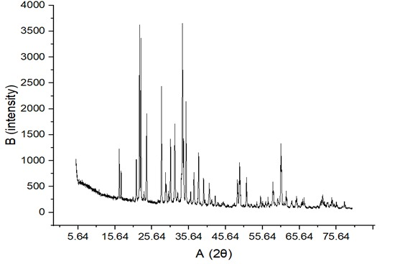

FIGURE 4 XRD graph of LiAlSiO₄
As seen in the figure (Fig.4) the XRD resulted in narrow and steep peaks indicating the high crystallinity of the compound which was good as this meant the compound would have multiple dopant sites. The XRD was matched with that of the ICDD standard and multiple peaks matched, hence the synthesized compound was deemed worthy of further consideration and examination as a solid state electrolyte for our device.
Taking this compound further studies, namely Cyclic Voltammetry and Galvanostatic Charge-Discharge was performed.

D. ELECTROCHEMICAL TESTING ON ELECTRODE

D.1 CYCLIC VOLTAMMETRY
Cyclic voltammetry (CV) is an electrochemical technique used to study the redox behavior of molecules and materials. It involves sweeping the potential of a working electrode linearly back and forth between two limits while measuring the resulting current. Using the 6M electrolyte highest voltage obtained was 0.43V and lowest voltage was -0.2V (see Fig.5)

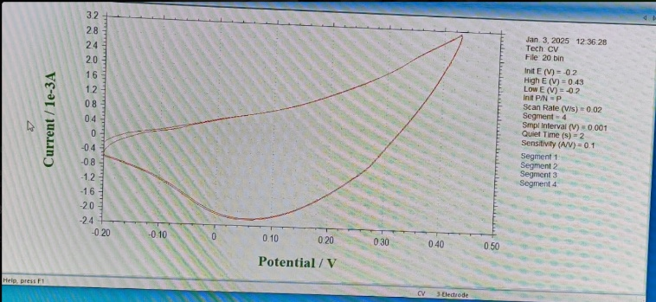
FIGURE 5. Cyclic Voltammetry for 6M
When cyclic voltammetry was conducted using a 3M electrolyte the highest voltage obtained was 0.6V and lowest voltage obtained was -0.2V (see Fig.6)

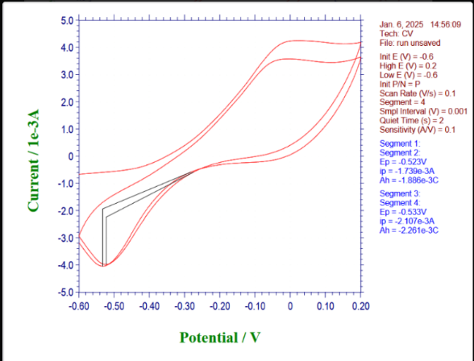
FIGURE 6. Cyclic Voltammetry for 3M

D.2 CHRONOPOTENTIOMETRY FOR ELECTRODE
Chronopotentiometry is an electrochemical technique used to study materials and reactions by applying a constant current to an electrochemical system and monitoring the resulting potential over time. When the chronopotentiometry was conducted using the 6M KOH electrolyte the time gap between the start and end of the curves were 66s(see Fig.7). Using this the specific capacitance of the compound was found to be 104.76 F/g

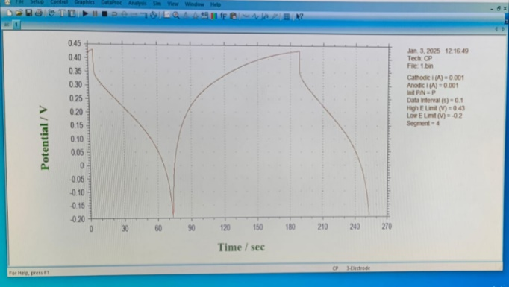

FIGURE 7. Chronopotentiometry for 6M
Chronopotentiometric tests on using the 3M KOH solution gave rise to a time difference of 28s (see Fig.8)leading to a specific capacitance of 35F/g.

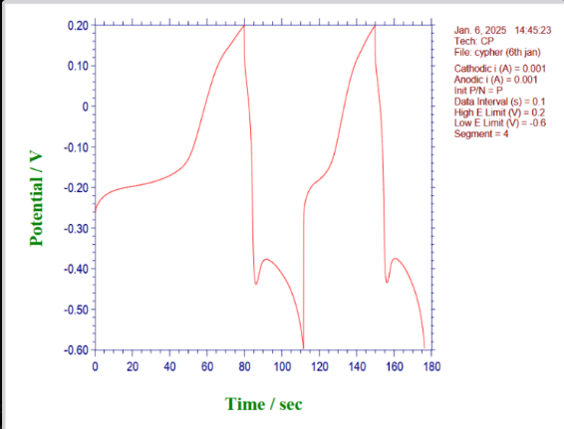
FIGURE 8. Chronopotentiometry for 3M

D.3 ELECTROCHEMICAL IMPEDANCE SPECTROSCOPY
Electrochemical Impedance Spectroscopy (EIS) is an advanced electrochemical technique used to study the response of an electrochemical system to a small, alternating sinusoidal voltage over a range of frequencies. It provides information about the system's resistance, capacitance, inductance, and other electrochemical properties. EIS was conducted with the 6M KOH electrolyte and the following graph was obtained (see Fig.9)

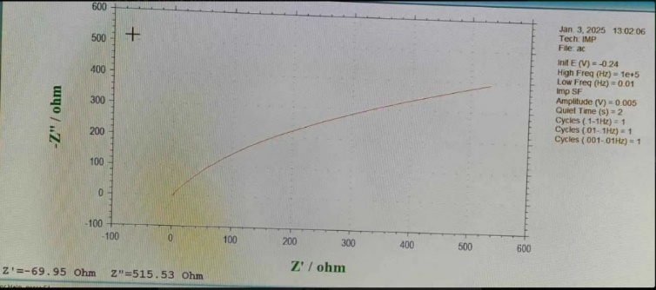

FIGURE 9. EIC for 6M

E. ELECTROCHEMICAL TESTING ON ELECTROLYTE

Since Li₂Al₂Si₃O₁₀ compound was not giving the required peaks, we decided to conduct all the testing with just the LiAlSiO₄ and use that compound as the electrolyte rather than Li₂Al₂Si₃O₁₀.
For the electrochemical testing the synthesized electrolyte, a slurry was prepared using the nanomaterial which was applied to a Toray carbon sheet along with Carbon black:0.5mg NMP(N-Methyl-2-Pyrrolidone)-polar aprotic solvent: 1-2 drops PVDF(polyvinylidene fluoride) as the binder, the slurry was applied to only half of the sheet and then the electrode was dried for 2 hours at 65 degrees Celsius. This electrode was then used for testing using a 3M KOH electrolyte and Cyclic voltammetry(CV) and Galvanostatic Charge/Discharge.

E.1 CYCLIC VOLTAMMETRY
Cyclic voltammetry (CV) is an electrochemical technique used to study the redox behavior of molecules and materials. It involves sweeping the potential of a working electrode linearly back and forth between two limits while measuring the resulting current.
3M KOH was used and the following graph was obtained
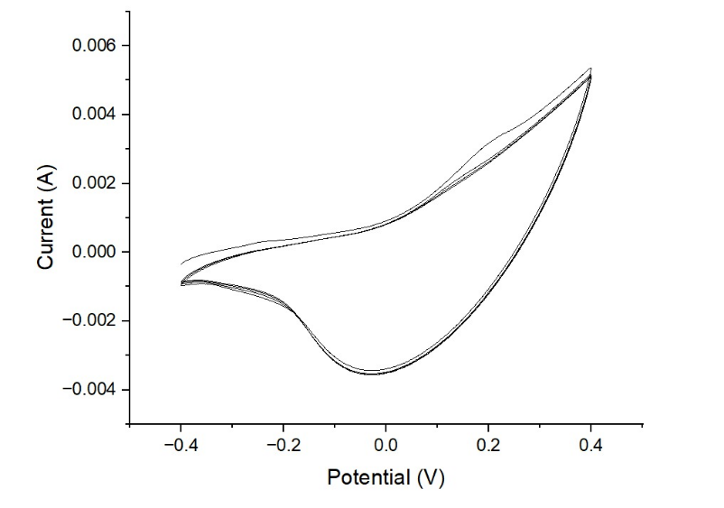

FIGURE 10 CV for Electrolyte
The voltage range that was obtained was from -0.4 to 0.4V.

E.2 GALVANOSTATIC CHARGE/DISCHARGE
The electrode was then subject to Galvanostatic charge/Discharge which is an electrochemical test where technique used to evaluate the performance of energy storage materials and devices like batteries and supercapacitors. It involves charging and discharging a material at a constant current while measuring the voltage as a function of time.
The following graph was obtained when GCD was performed on the compound
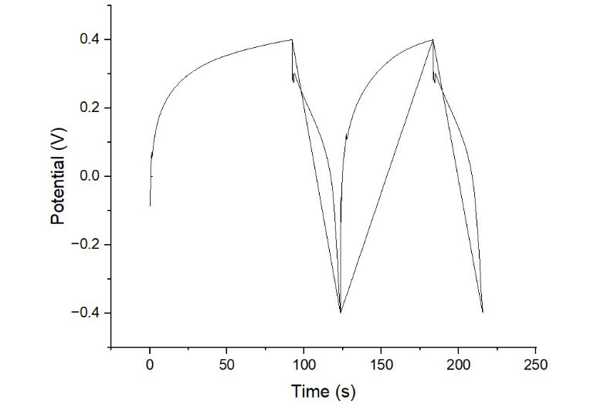

FIGURE 11 GCD for Electrolyte

CONCLUSION
This research project aimed to develop a high-performance hybrid supercapacitor by synthesizing and characterizing a novel electrode material, Li₂ZnSiO₄. The solution combustion method was successfully employed to synthesize the material, and its structural properties were confirmed through X-ray diffraction (XRD) analysis. Electrochemical characterization of the Li₂ZnSiO₄ electrode in 6M KOH electrolyte demonstrated promising results,

with a specific capacitance of 104.76 F/g obtained from chronopotentiometry. These results indicate good ionic conductivity, structural stability, and redox activity of the synthesized nanomaterial, suggesting its strong potential as an electrode for high-energy density supercapacitors.
Future work will focus on optimizing the synthesis process to further enhance the material’s electrochemical properties. This will involve detailed parametric studies, including

variations in precursor ratios, calcination temperature, dwell time, and fuel-to-oxidizer ratios to tune morphology, particle size, and crystallinity. Surface modifications such as doping with transition metals or integration with conductive additives like graphene or carbon nanotubes will be explored to improve electrical conductivity and expand electrochemical surface area.
Additionally, the electrochemical performance of Li₂ZnSiO₄ will be further assessed through galvanostatic charge–discharge (GCD) analysis, rate capability studies, and long-term cyclic stability under different current densities and electrolyte compositions (aqueous and non-aqueous). This will provide a more comprehensive understanding of its behaviour under practical operating conditions.
Parallel to this, the integration of Li₂ZnSiO₄ as a positive electrode with a compatible negative electrode material such as activated carbon or reduced graphene oxide will be undertaken. A complete hybrid supercapacitor device will be assembled and evaluated in terms of energy density, power density, and coulombic efficiency. Practical parameters such as device durability, thermal stability, and scalability of the synthesis method will also be analysed to assess suitability for real-world deployment.
In summary, this work lays a strong foundation for the use of Li₂ZnSiO₄ and related lithium-based orthosilicates in next-generation electrochemical energy storage devices. With continued development and optimization, these materials could play a vital role in meeting the growing global demand for safe, efficient, and environmentally friendly energy storage systems, especially in fields such as renewable energy integration, electric mobility, and portable electronics.

FUTURE WORK
Now that we have prepared the materials for both the electrode and the electrolyte and the required testing has been completed we now have to perform the required calculations for making the coin cell and manufacture the cell.

ACKNOWLEDGMENT
We would like to express our sincere gratitude to RV College of Engineering for providing the necessary resources and infrastructure for this research. We extend our heartfelt thanks to the principal for his constant support
and encouragement. We are deeply indebted to our esteemed mentors, Dr. Manjunatha C Sir, Dr Sham Aan MP, Prof. Shweta Ma'am, and Prof. Prasana Ma'am for their invaluable guidance, constructive criticism, and unwavering belief in our abilities. We also acknowledge the significant
contributions of Prof. Sudha Ma'am, Head of the Physics Department, for her support and valuable insights.

REFERENCES AND FOOTNOTES
[1]Dan Gao, Zhiling Luo, Changhong Liu, Shoushan Fan – “A survey of hybrid energy devices based on supercapacitors” Green Energy and Environment Volume 8, Issue 4, August 2023, Pages 972-988
[2]Minju Thomas, Svetlana Veleva, Boriana Karamanova, Antonino Brigandì, Natalia Rey-Raap, Ana Arenillas,
Antonia Stoyanova, Francesco Lufrano - “Highly stable and reliable asymmetric solid-state supercapacitors with low self-discharge rates” Sustainable Materials and Technologies Volume 38, December 2023, e00770
[3]G Gautham Prasad, Nidheesh Shetty, Simran Thakur, Rakshitha and K B Bommegowda – “Supercapacitor technology and its applications: a review” ce by IOP Publishing Ltd
IOP Conference Series: Materials Science and Engineering, Volume 56, 2019
[4]S.E. Umoru – “Hybrid Supercapacitor For Energy Storage Devices: A Review” Journal of Physics and Chemistry of Materials Vol.10, Issue.4, pp.24-35, December 2023
[5] Shuzhi Zhao, Haiying Che, Suli Chen3, Haixiang Tao, Jianping Liao, Xiao Zhen Liao, Zi Feng Ma1-” Research Progress on the Solid Electrolyte of Solid State Sodium Ion Batteries" Electrochemical Energy Reviews · January 2024
[6] M.M. Hasan, R. Haque, M.I. Jahirul, M.G. Rasul, I.M.R. Fattah, N.M.S. Hassan, M. Mofijur-“Advancing energy storage: The future trajectory of lithium-ion battery technologies” Journal of Energy Storage Volume 120, 1 June 2025, 116511

