RV College of Engineering
Experiential Learning
Synopsis
2024-25

Energy Storage Using Lithium based Nanomaterials

Theme: Advanced Materials
Team No: 21
Team Details

Sl.No. | USN | Name
1 | 1RV24EC059 | Dakshraj Shetty
2 | 1RV24CI006 | Abhinav Mallela
3 | 1RV24EC108 | Vaibhav M
4 | 1RV24CD029 | Manoj Gupta D B

Mentor
Name: Dr Sham Aan M P
Designation: Assistant Professor
Department: Chemistry Signature

- Introduction
As the demand for efficient, sustainable, and portable energy solutions continues to grow, energy storage technologies particularly batteries and supercapacitors have become increasingly important. These devices are essential for a wide range of applications, from powering electric vehicles and portable electronics to supporting renewable energy systems and stabilizing the electrical grid. Batteries, known for their high energy density, provide long-term storage capabilities, while supercapacitors offer rapid charge and discharge cycles and exceptional power density. Together, these technologies play complementary roles in addressing the challenges of modern energy storage.

- Problem Definition
  - Problem Statement:
Despite significant advancements in lithium-ion battery technology, traditional electrode materials face limitations in energy density, charging speed, cycle life, and safety. Using Lithium based nanomaterials can help enhance charge storage due to the high surface area and improved conductivity.
  - Background Information: (literature review)
- Dan Gao, Zhiling Luo, Changhong Liu, Shoushan Fan – “A survey of hybrid energy devices based on supercapacitors”: The study highlights how hybrid devices combining supercapacitors with batteries or fuel cells significantly enhance energy and power density.
- Minju Thomas, Svetlana Veleva, Boriana Karamanova, Antonino Brigandì, Natalia Rey-Raap, Ana Arenillas, Antonia Stoyanova, Francesco Lufrano - “Highly stable and reliable asymmetric solid-state supercapacitors with low self-discharge rates”: Study talks about how these devices demonstrate long cycle life, excellent capacitance retention, and enhanced reliability, making them suitable for long-term energy storage applications.
- Shuzhi Zhao, Haiying Che, Suli Chen3, Haixiang Tao, Jianping Liao, Xiao-Zhen Liao, Zi-Feng Ma1” Research Progress on the Solid Electrolyte of Solid-State Sodium-Ion Batteries”: The paper reviews recent advances in solid electrolytes for solid-state sodium-ion batteries, focusing on improving ionic conductivity, stability, and interface performance.
- M.M. Hasan, R. Haque, M.I. Jahirul, M.G. Rasul, I.M.R. Fattah, N.M.S. Hassan, M. Mofijur-“Advancing energy storage: The future trajectory of lithium-ion battery technologies”: The future of lithium-ion batteries involves advancements in energy density, faster charging times, and improved safety, driven by innovations in materials like silicon anodes and solid-state technologies
- Objectives
  - Primary Objectives:
- To synthesize Li2ZnSiO4 using solution combustion method
- To synthesize electrodes of the prepared nanomaterial using toray carbon sheets
- To perform electrochemical testing on the prepared electrodes
- To prepare a solid-state electrolyte by synthesizing Li2Al2Si3O10
- To manufacture coin cell
  - Secondary Objectives:
- Conduct research on possible applications of the coin cell
- Publish a research paper that includes all the relevant findings from this project
- Methodology
4.1
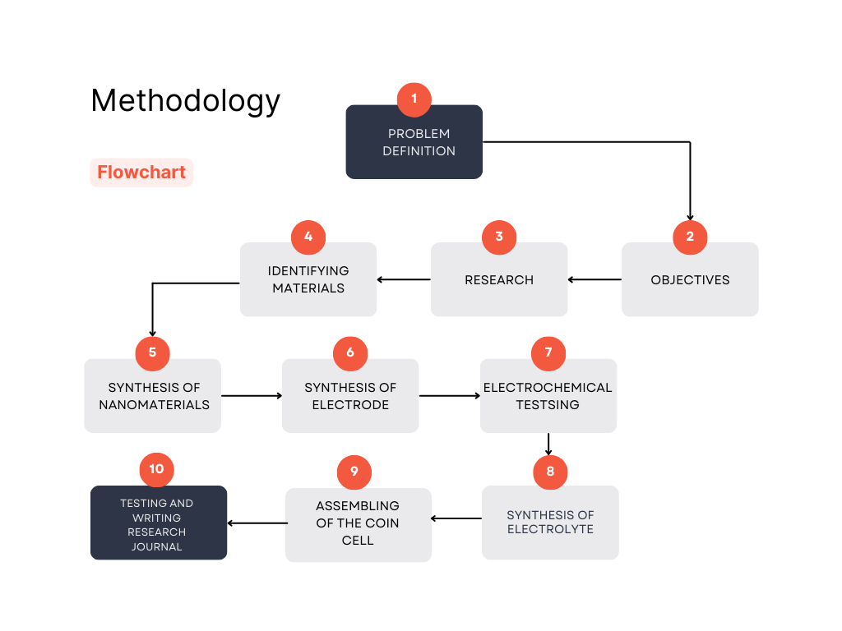

4.2 Procedures
Solution combustion method:
The solution combustion method was used to synthesize Li2ZnSiO4. The steps included
- Calculating required amount of compounds required for synthesis of Li2ZnSiO4
Name of Compound | Formula | Weight added
Lithium Nitrate | LiNO₃ | 4.024g
Zinc Nitrate | Zn(NO₃)₂.6H₂O | 8.6809g
Silicic Acid | H₂SiO₃ | 1.7531g

2. Measurement of compounds precisely.
3.Heating mixture of measured compounds at high temperature.
4.Li2ZnSiO4 synthesized:
- Batch 1 : 0.568g
- Batch 2: 2.818g
- Batch 3: 0.533g
The compound was verified by XRD.

Electrode:
- Slurry of nanomaterial is prepared.
- Slurry is applied to toray carbon sheet.
- Electrode is left in an oven to dry.
Three electrodes synthesized on a toray carbon sheet of dimensions 2cm x 1cm by applying a slurry of 0.5 mg of activated carbon, 2.5mg of compound synthesized along with NMP as polar aprotic solvent and PVDF as binder.

Electrochemical Testing:
The electrochemical testing were conducted on the 1st batch of compounds by using 6M KOH and 3M KOH electrolyte respectively
- Cyclic voltammetry
- Chronopotentiometry
- Electrochemical Impedance Spectroscopy

Electrolyte:
We have decided to use a solid-state electrolyte with our energy storage device and have completed the necessary calculations for the solution combustion method.

5.Expected Outcome
- Manufacturing an energy storage device made of Lithium nanomaterials and solid-state electrolyte
- Improvement in charge storage as we are implementing nanoparticles to increase the surface area of the electrode materials.
- Improvement of lifespan and safety of the charge storage device by implementing a solid-state electrolyte
- Contribution to academic or professional knowledge through:
- Journal Publication

