1. Code.xlsx

**a. Description**

This dataset consists of 2 sheets and the first sheet contains 2815 observations with 8 variables and the second sheet is empty (so we will ignore this). There are few duplicated values in “Inbred line” and “Accesion N.” We may need to remove them before performing “join” (merge) two datasets. Currently, I did not drop any observations and perform “join.” Please see below to see detail.

*Variable Description*

|  |  |
| --- | --- |
| Inbred line | The homozygous genotypes. |
| Accesion N (Accession name) | A unique identifier given to a DNA or protein sequence record to allow for tracking of different versions of that sequence record. |
| N GBS samples | Number of Genotyping By Sequencing (GBS) Sample (simply number of samples). |
| N Plants | Number of plants |
| Avg. IBS (Identical By State) | Average IBS value for all the samples. (IBS: measurement to describe how similar two sequences of DNA between 0 and 1)  * NA if N GBS samples = N plants = 1. |
| % missing | Percentage of missing data |
| Breeding program | Breeding program |
| Pop structure (Population structure) | Pedigree group; the organization of genetic variation. |

**b. Duplicated Values**

In the “Inbred Line,” “PHW86” has 2 observations (2304th and 2305th).

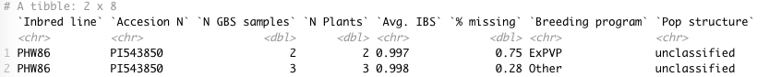

In the “Accesion N,” “Landraces” has 4 observations, “Ames27101” has 2 observations, “Ames27260” has 2 observations, and “PI543850” has 2 observations (their inbred lines are “PHW86”).

*Landraces*

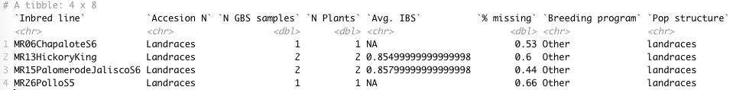

*Ames27101*

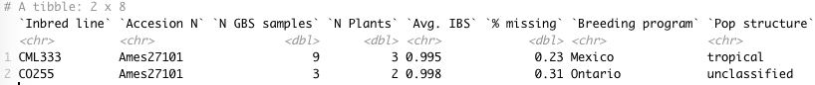

*Ames27260*

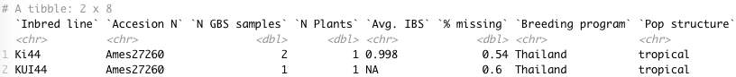

*PI543850*

See above “Inbred Line” = “PHW86”.

2. Kernel_Color_Data.xlsx

**a. Description**

This dataset consists of 4 sheets and

1) the first sheet contains 1547 observations with 26 variables – Final_Product

2) the second sheet contains 1595 observations with 26 variables – Heavy_Lfiting

3) the third sheet contains 4476 observations with 25 variables – Genotype_Data

4) the fourth sheet contains 2648 observations with 4 variables – Phenotype_Data.

We can see “Complete_name” has three parts divided by “:” (colon). We assume the first part corresponds to the “Accesion N” in Code.xlsx.

**b. Duplicated Values**

Final_Product, Heavy_Lfiting, and Phenotype_data do not have duplicated value.

For Genotype_data, out of 4476 observations, 1864 observations are duplicated.

E.g. Top 10 duplicated Accesion Name in Genotype_data:



(Continue on the next page)

3. Join Process

a. Duplicated value from Code.xlsx in each sheet from Kernel_Color_Data.xlsx

|  |  |  |  |  |
| --- | --- | --- | --- | --- |
|  | Landraces | Ames27101 | Ames27260 | PI543850 |
| Final_Proudct | NO | NO | YES | YES |
| Heavy_Lfiting | NO | NO | YES | YES |
| Genotype | NO | YES | YES | YES |
| Phenotype | NO | NO | YES | YES |

Since Genotype and Code have duplicated, we need a rule for join (i.e. how we will handle duplicated values).

For Final_Product, Heavy_Lfiting, and Phenotype_Data, we can perform a join in this way:

E.g. Joining Code and Final_Product:

|  |  |  |  |  |
| --- | --- | --- | --- | --- |
| Code.xlsx | | | | |
| Inbred line | Accesion N | Column 1 | Column 2 | … |
| Ki44 | Ames27260 | A | C | … |
| KUI44 | Ames27260 | B | D | … |

+ (Inner Join)

|  |  |  |  |
| --- | --- | --- | --- |
| Final_Product sheet | | | |
| Complete_name | Column 1.1 | Column 2.1 | … |
| Ames27260 | a | b | … |

=

|  |  |  |  |  |  |  |
| --- | --- | --- | --- | --- | --- | --- |
| Code_Final_Product.xlsx | | | | | | |
| Inbred line | Accesion N | Column 1 | Column 2 | Column 1.1 | Column 2.1 | … |
| Ki44 | Ames27260 | A | C | a | b | … |
| KUI44 | Ames27260 | B | D | a | b | … |

* Based on “Accesion N” in Code.xlsx, performed inner join. That is, if there is a observation presents in Final_Product sheet but not in the Code.xlsx, this observaition will be removed in the combined dataset.

4. Combined data

Combined_Final_Product.xlsx: 1547 x 34

Combined_Heavy_Lfiting.xlsx: 1595 x 34

Combined_Phenotype_Data.xlsx: 2316 x 12