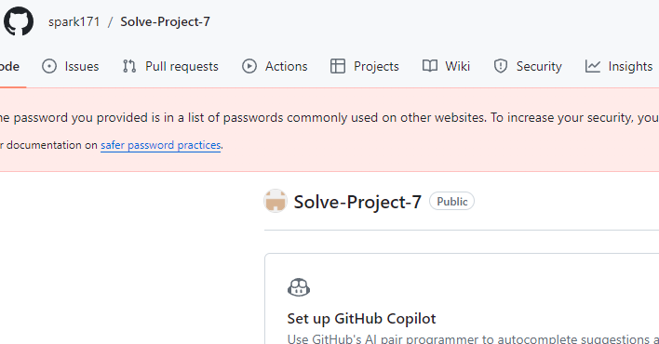In this project, I have learned to create and utilize GitHub. The platform is mainly used to allow host to share and collaborate with other users. It is online base and you can link your repository to your local PC to work at anytime and anywhere without worrying about losing the data.

1. Creating your account
2. GitHub repository

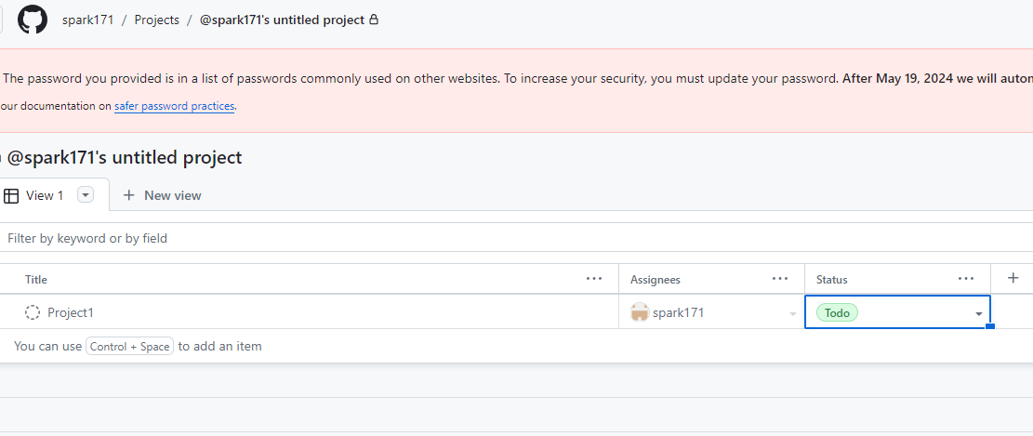

1. Connecting two different platforms

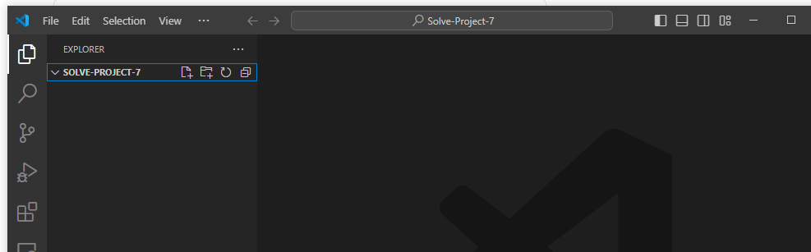

GitHub gives you flexibility to extend the use of GitHub by connecting with your favorite IDLE software to share and modify by collaborating and pulling data from other’s repository.

It is very accessible but I’m not sure if it’s user friendly. GitHub is actually hard for me to follow and understand the use of each functions given. Such as, Pull requests, Actions, Projects, and many more.

GitHub offers variety of ways to secure your data and share the data as you please. You can access your repository and download at anywhere at anytime to stay in the loop to check the progress and status of each project when working with multiple co-workers.