**Project Report** **INT 375**

**EDA Project**

**LOVELY PROFESSIONAL UNIVERSITY PHAGWARA, PUNJAB**



# Insights from Stack Overflow Developer Survey

**SUBMITTED BY -** Awaneesh S

**Registration Number:** 12314062

**Section** – K23GW

**Roll no**- 65

**DECLARATION**

I, Awaneesh Singh, hereby declare that the work done by me on “Insights from Stack Overflow Developer Survey”, is a record of original work for the partial fulfilment of the requirements for the award of the degree of Bachelor of Technology in Computer Science - Data Science, Lovely Professional University, Phagwara.

Signature Signature

Name: Awaneesh K Singh Mrs. Meneet Kaur

Reg: No: 12314062 UID: 15709

# ACKNOWLEDGMENT

First and foremost, I would like to express my deepest gratitude to my college for providing me with the opportunity and resources to undertake this project.

I extend my sincere thanks to my teacher, Miss. Maneet Kaur**,** for her invaluable guidance, constructive feedback, and constant encouragement throughout the project. Her expertise and support were instrumental in achieving the objectives of this work.

Thank you all

# Table of content

* **Abstract**
* **Introduction**
* **Methodology**
* **Results and analysis**
  + Key Findings
  + Visualizations and Tables
  + Interpretation of Results
* **Conclusion**
* **References**
  + Cited Papers, Articles, and Resources

**GitHub Repository:** https://github.com/sparkawaneesh/eda-stackoverflow

8. Dataset link: https://survey.stackoverflow.co/

9.LinkedIn Link: https://www.linkedin.com/posts/sparkawaneesh_datascience-eda-stackoverflowsurvey-activity-7316884212840636416-Zgx4?utm_source=social_share_send&utm_medium=member_desktop_web&rcm=ACoAADq0YxABUN5n0giR9wPPthGXdsU3-2JqtCI

# Abstract

This analysis explores the 2023 Stack Overflow Developer Survey, covering over 65,000 responses. We investigate developer demographics, education, work preferences, technologies, and compensation using Python. The goal is to uncover insights into global developer trends and professional experiences.

# Introduction

The Stack Overflow Developer Survey is a yearly snapshot of the global developer community. It collects data on skills, tools, education, and work conditions. This EDA aims to summarize and interpret this rich dataset for better understanding of developer preferences and industry trends.

# Methodology

Tools Used: Python Pandas, Matplotlib, Plotly, Seaborn

**Steps:** Loaded dataset → removed nulls → cleaned columns → grouped/analyzed by categories like age, country, salary, tools.

**Focus:** Demographics, tech stack, salaries, job satisfaction.

# Objectives

* Understand global developer distribution by age and country
* Identify top programming languages and tools
* Analyze salary variation by region and education
* Explore remote work and employment types
* Examine job satisfaction levels

# Results and Analysis

* **Demographics:** Most respondents are aged 25–34; top countries: USA, India, Germany.
* **Tech Stack:** Python, JavaScript, and SQL dominate. Rust and TypeScript are rising.
* **Salaries:** Highest in the U.S. and Western Europe; large gap exists across countries.
* **Work:** Majority prefer remote or hybrid work; full-time employment is the norm.
* **Education:** Many developers are self-taught or have bachelor’s degrees.
* **Satisfaction:** Most are satisfied, but burnout and work-life balance issues persist.

# Visualizations and Descriptions

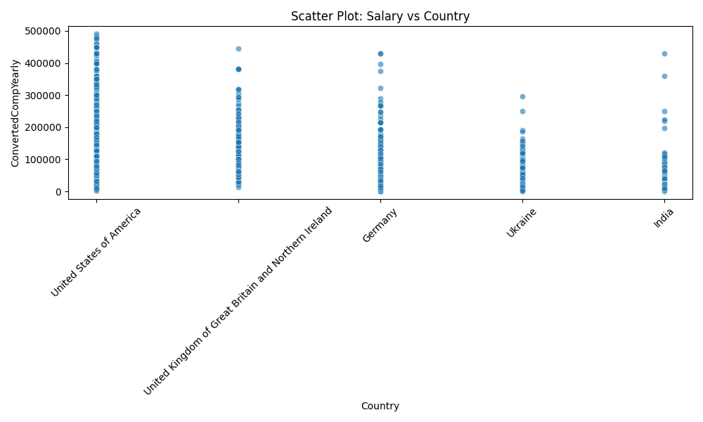

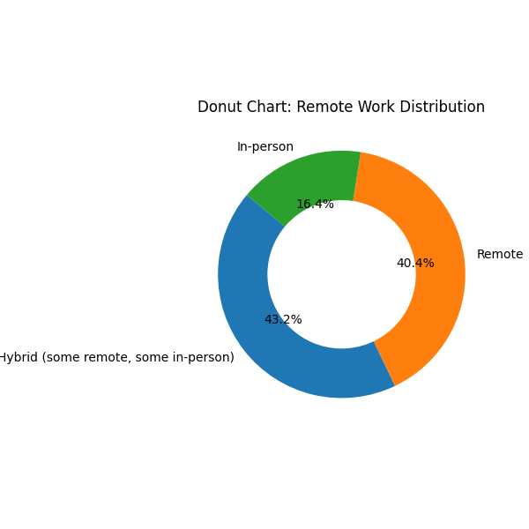

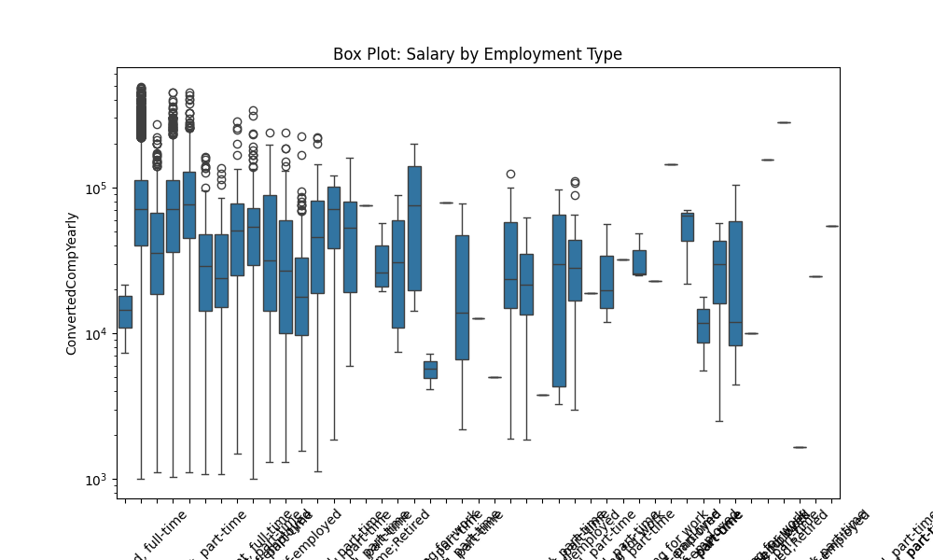

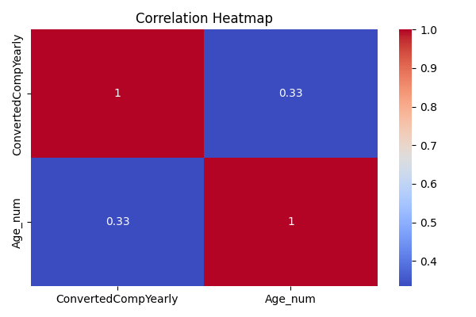

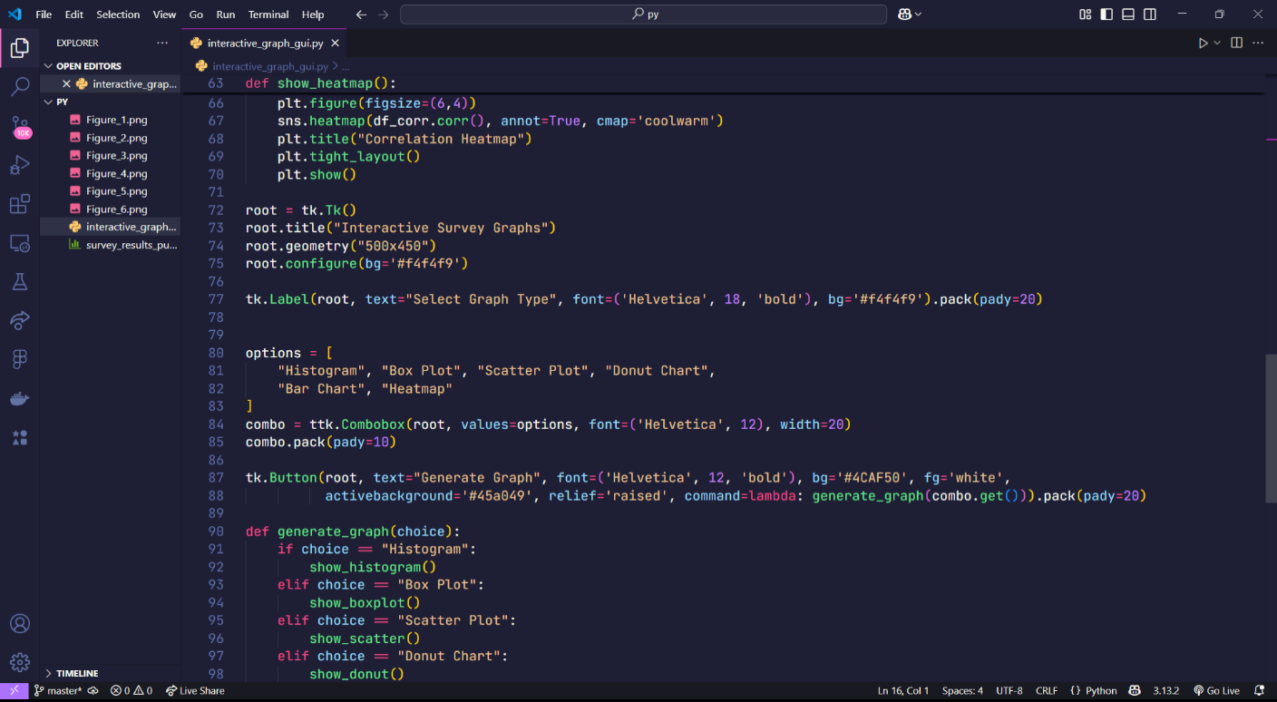

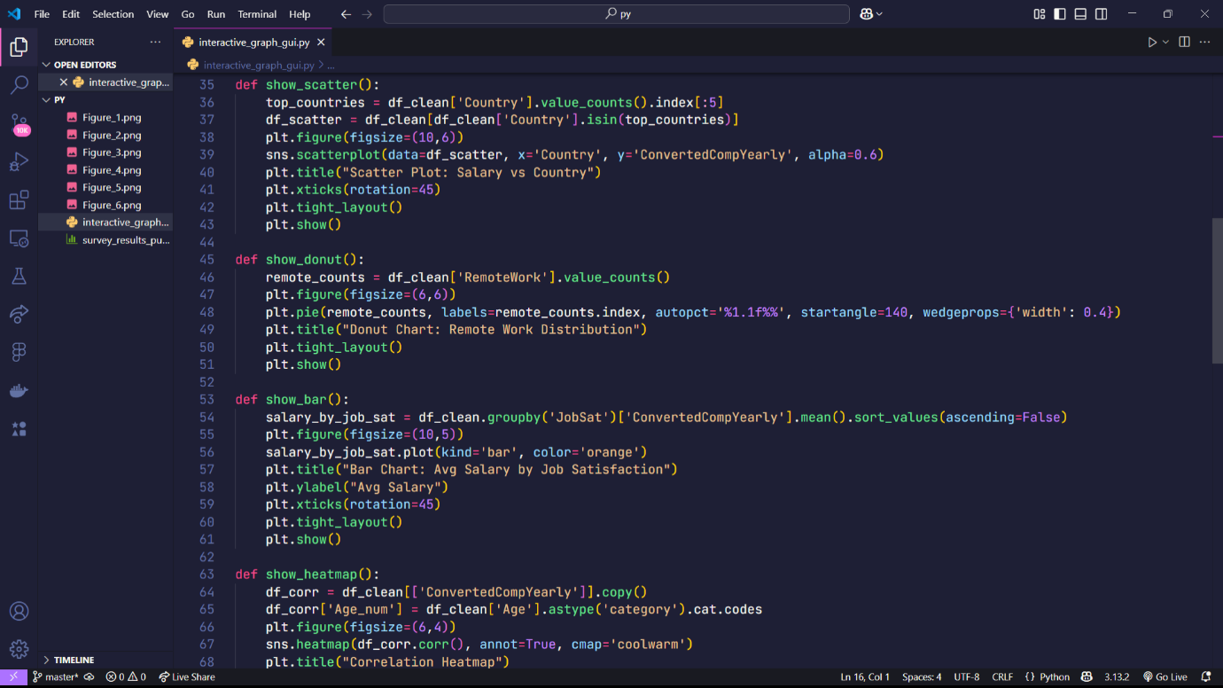

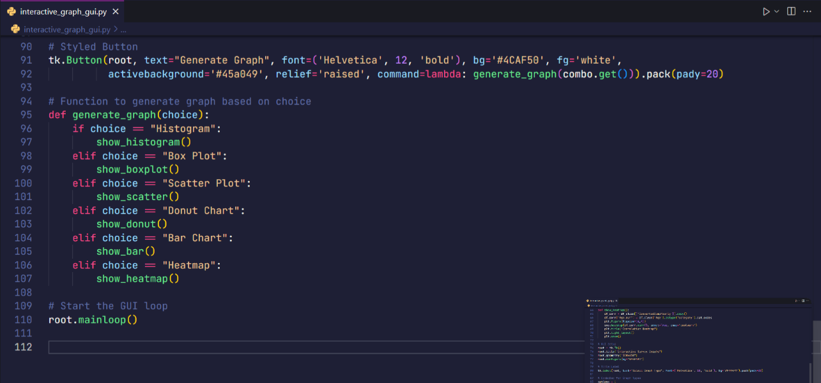

# Conclusion

The Stack Overflow Developer Survey offers a comprehensive view of the global developer ecosystem. Through this EDA, we observed key trends in demographics, technology preferences, work environments, and compensation. The data reveals a strong shift toward remote work, increasing popularity of languages like Python and TypeScript, and a diverse mix of formal and self-taught education paths. Despite regional disparities in salary, overall job satisfaction remains relatively high. These insights are valuable for tech companies, educators, and developers to understand the evolving landscape and make informed decisions in hiring, learning, and career planning.

# References

* Pandas Documentation <https://pandas.pydata.org/docs/>
* NumPy Documentation <https://numpy.org/doc/>
* Matplotlib Documentation <https://matplotlib.org/stable/contents.html>
* Seaborn Documentation <https://seaborn.pydata.org/>
* Scikit-learn Documentation

<https://scikit-learn.org/stable/documentation.html>