Xchecklist

Ver 1.26

Michal & Bill

History

Xchecklist started out as a Linux checklist program to fill a void that was there in fall of 2010. Michal and I worked on it and initially was only in the forums and then it was in the download section. It looks like there is another void as there is no 64 bit checklist program.

In the beginning of August 2013 I contacted Michal and told him I would like to port our Xchecklist to be multi-platform and 32/64 bit. He was on board and now we have a version that does work on all three platforms and is 32/64bit.

Feature List

- Drop-in replacement for snailpup's checklister plugin

- Win/Mac/Lin 32/64 bit & 9.70 compatible

- Features speaking "copilot" saying checklist items for you

- Features native speech for each platform to allow more options

- Copilot may also check some actions for you as you perform them

- Actions (Check, Prev, Next, Hide, Reload) can be mapped to key/joystick button of choice

- Enforces strictly sequential checklist flow

Installation Instructions

Unpack the archive and place the folder Xchecklist to '.../Resources/plugins' then fire up XPlane and if the plane you fly has a checklist, you should see it..

The checklist file is called clist.txt and should be put in the aircraft folder which is the same place the *.acf file resides.

You may also have a checklist file named aircraftname_clist.txt which will be searched for first then it will search for clist.txt. The default Cessna would be Cessna_172SP_clist.txt. This allows you to have multiple aircraft in one folder like a float and a wheeled version.

Also in the archive is a folder called Checker that has test programs for your platform and bitsize.

Paths are bgood/xchecklist/check_item, bgood/xchecklist/next_checklist, bgood/xchecklist/prev_checklist, bgood/xchecklist/hide_checklist and bgood/xchecklist/reload_checklist.

If you have any ideas, comments or bug reports, don't hesitate and let us know...

Kind regards,

Michal & Bill

Xchecklist Setup

The "Xchecklist Setup" dialog box will be explained first and can be found by clicking on the Plugins
menu item and selecting Xchecklist from the drop down list.

Translucent Window when checked makes the checklist translucent.

Unchecked the checklist is solid.

Show Checklist if Checklist exist when checked if there is a clist.txt for the aircraft loaded it will
display the checklist.

Unchecked it will not display the checklist.

Turn Copilot On when checked will automatically check in order items that have data refs in the
clist.txt. These items are marked with a + sign in front of the check box.

Unchecked you have to check each item yourself.

Voice Prompt when checked will speak a prompt for the upcoming item.

Unchecked it is quiet.

Auto Hide when checked will automatically hide the checklist after it is complete and a small delay.

Unchecked it will not hide.

Move Checklist Window Down will move the checklist window down so you can grab it with the mouse if it is up under the top menu bar.

Save Settings will save your settings including the window position of the checklist in a preference file.

X-Plane 10 Joystick buttons setup

Joystick buttons are setup using Buttons : Adv pane in the Joystick & Equipment window, that is
accessible through Settings / Joystick, Keys & Equipment menu.

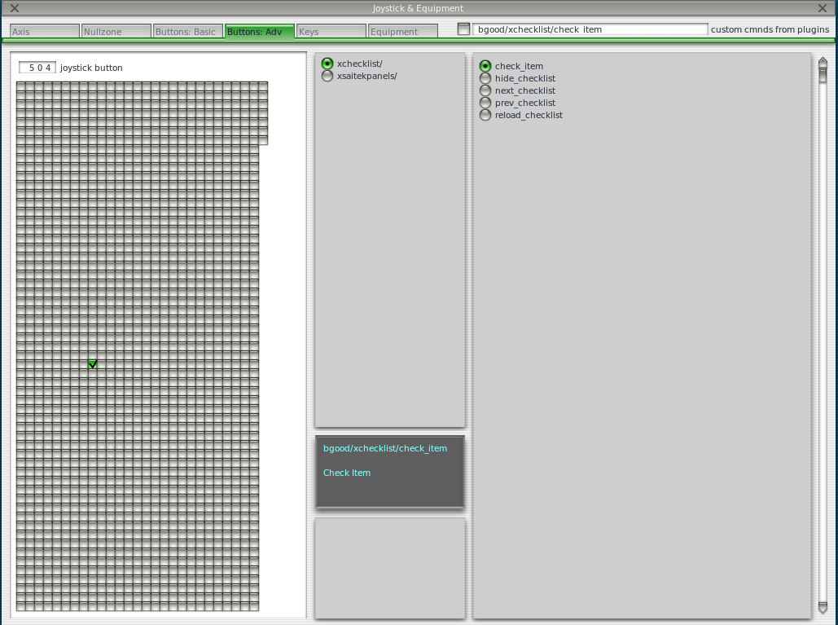
Please note the four items in the right box - these are the four actions, that allow you to control the
Xchecklist.

Now just press the desired joystick button, in the upper middle box select xchecklist/ and in the right
box select the appropriate action.

Repeat those steps and when done, just close the window and the new bindings should be active.
First item is 'check_item' that checks a item.

Next item is 'next_checklist' that moves to the next page of the checklist. If the checklist is hidden it
will also un hide it without moving to the next page.

Next item is 'prev_checklist' that moves to the prev page of the checklist.

Next item is 'hide_checklist' as it says hides the checklist.

Reload item is 'reload_checklist' as it says reloads the checklist.
X-Plane 10 Keystrokes setup

Keystrokes are setup using Keys pane in the Joystick & Equipment window, that is accessible through
Settings / Joystick, Keys & Equipment menu.
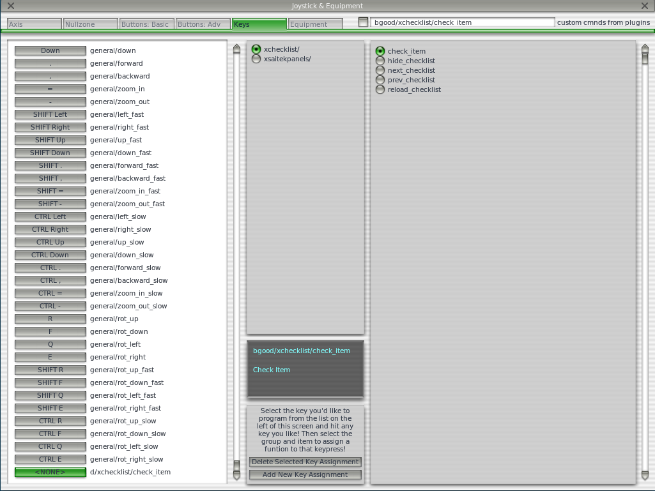
Please note the four items in the right box - these are the four actions, that allow you to control the
Xchecklist.

Now just press the desired keystroke, in the left box select xchecklist/ and in the right box select the
appropriate action.

Repeat those steps and when done, just close the window and the new bindings should be active.

First item is 'check_item' that checks a item.

Next item is 'next_checklist' that moves to the next page of the checklist. If the checklist is hidden it
will also un hide it without moving to the next page.

Next item is 'prev_checklist' that moves to the next page of the checklist.

Next item is 'hide_checklist' as it says hides the checklist.

Last item is 'reload_checklist' as it says reloads the checklist.
X-Plane 11 Joystick buttons setup

Joystick buttons are setup using Settings dialog window which can be accessed through the Settings button on the first screen. Use the Joystick menu.

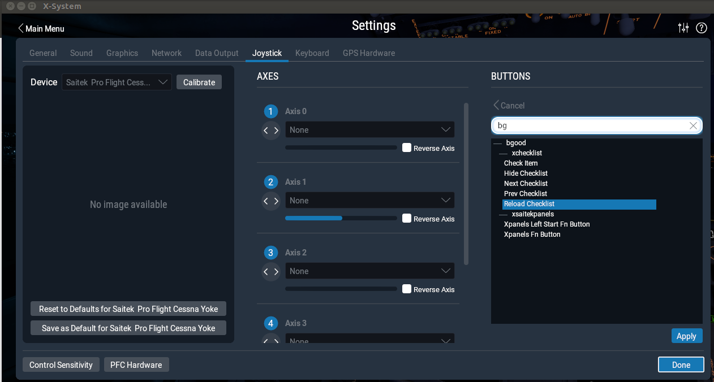
Please note the four items in the right box - these are the four actions, that allow you to control the
Xchecklist.

Now just press the desired joystick button, on the right hand side you will see the button hi light. Click on the Edit button and type bg in the search box. Select the action you want to map and then click on the Apply button. Repeat these steps for the remaining actions. When you are done press the Done button.

First item is 'check_item' that checks a item.

Next item is 'next_checklist' that moves to the next page of the checklist. If the checklist is hidden it
will also un hide it without moving to the next page.

Next item is 'prev_checklist' that moves to the prev page of the checklist.

Next item is 'hide_checklist' as it says hides the checklist.

Reload item is 'reload_checklist' as it says reloads the checklist.
X-Plane 11 Keystrokes setup

Keystrokes are setup using Settings dialog window which can be accessed through the Settings button on the first screen. Use the Keyboard menu.
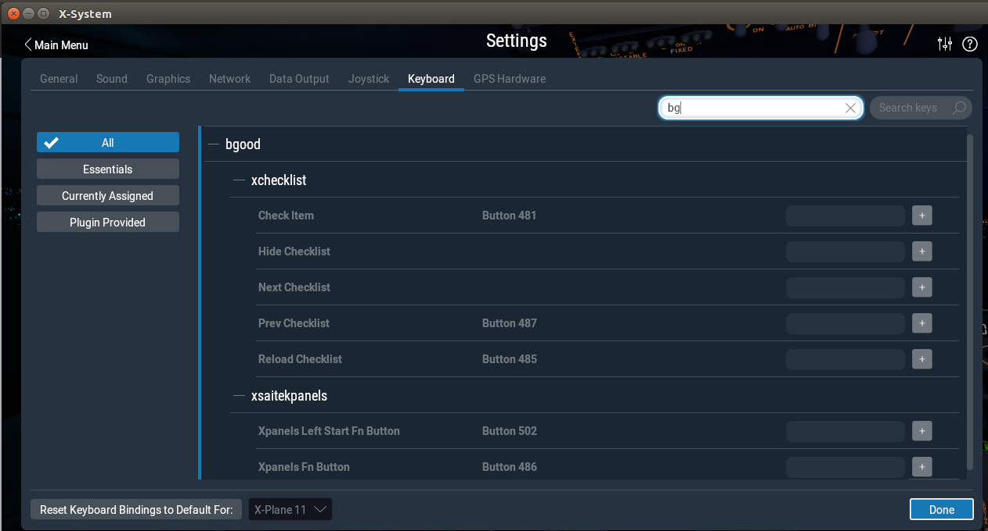
After typing bg in the search box you should see the items you can map to Xchecklist.

Now just click on the gray box to the left of the + sign of the item you want to map. When you do this the gray box will turn white and will say “Record keystroke(s)” . Record your keystrokes and the box will turn gray again with your recorded keystrokes in the gray box. You will now also see a + sign and a – sign.

Repeat those steps and when done, press the done button.

First item is 'check_item' that checks a item.

Next item is 'next_checklist' that moves to the next page of the checklist. If the checklist is hidden it
will also un hide it without moving to the next page.

Next item is 'prev_checklist' that moves to the next page of the checklist.

Next item is 'hide_checklist' as it says hides the checklist.

Last item is 'reload_checklist' as it says reloads the checklist.
Xchecklist Commands

1) sw_checklist:displaytext:menutext Orange = Optional
Initialize and name your checklist page. There is no limit in the number of pages per clist.txt file.

displaytext = Displayed name of checklist page
menutext = Jump to checklist page from pluginmenu

Examples:
sw_checklist:Preflight Inspection Default Cessna 172SP
sw_checklist:Before Engine Start
sw_checklist:Engine Start
sw_checklist:Recieving Aircraft (1/2)
sw_checklist:Recieving Aircraft Cont (2/2)
sw_checklist:Startup Engines

2) sw_rcolsize:num
Use this command to set the specific width of the right hand column if you are using the pipe | with the command sw_item:displaytext. You can use this once per checklist page.

Example:
sw_rcolsize:100

3) sw_itemvoid:random text|right colum text Orange = Optional
Using this command no checkboxes will be shown so write whatever you want. A good use for this command is welcome messages.

Example:
sw_itemvoid:Exterior Preflight-Knock knock the fuselage
sw_itemvoid:Welcome to the Cessna 172SP.
sw_itemvoid:-------------------------------------------------
sw_itemvoid:Power|MAX
sw_itemvoid:Flaps|APP
sw_itemvoid:Gear|UP

4) sw_remark:random text
Using this command to speak whatever you want. A can also be used for welcome messages.

Example:
sw_remark:Exterior Preflight-Knock knock the fuselage
sw_remark:Welcome to the Cessna 172SP.

5) sw_item:displayname:dataref:refvalue
This is the most used command and comes with some powerful operators to control what the copilot can help you. You can also check it two datarefs are true using && or if either dataref is true using ||

displayname = The text visible to the user that can be split with a | (pipe).
dataref = Datareference the copilot uses to help with checks.
refvalue = The value of the datareference plus operators listed below if used.

! NOT The current dataref is not equal to the refvalue.
> GREATER THAN The current dataref is greater than the refvalue.
< LESS THAN The current dataref is less than the refvalue
| BETWEEN The current dataref is in between the two refvalue's.
+> TRIGGERS if the dataref increases more than given number.
-> TRIGGERS if the dataref decreases more than given number.
>< TRIGGERS if the dataref changes by more than given number.

Arithmetric operators:
+ Add
- Subtract
* Multiply
/ Divide
** Raises a number to the given power

Parentheses can be used to override the priority (otherwise the standard rules should work)

A dataref value can be used by enclosing the dataref name in the curly braces.

Examples:
sw_item:Parking Brake|SET:sim/flightmodel/controls/parkbrake:1

sw_item:Brakes|Test/Set:sim/flightmodel/controls/parkbrake:>0

sw_item:Throttle|IDLE:sim/flightmodel/engine/ENGN_thro:0.000

sw_item:Throttle|Open 1/4 Inch:sim/flightmodel/engine/ENGN_thro:.2:.3

sw_item:Propeller|High RPM:sim/flightmodel/engine/ENGN_prop[0]:>250

sw_item:Mixture|Rich:sim/flightmodel/engine/ENGN_mixt:>0.98

sw_item:Throttle 800-1000RPM|
Set:sim/flightmodel/engine/ENGN_thro:<0.15

sw_item:Both Engine start levers|CUTOFF:(x737/cockpit/tq/leftFwdThrotteRat:<.001)&&(x737/cockpit/tq/rightFwdThrotteRat:<.001)

sw_item:Both Engine start levers|CUTOFF:(x737/cockpit/tq/leftFwdThrotteRat:<.001)||(x737/cockpit/tq/rightFwdThrotteRat:<.001)

sw_item: Barometer|increase 1 or more:sim/cockpit2/gauges/actuators/barometer_setting_in_hg_pilot:+>0.01

sw_item: Barometer|decrease 1 or more:sim/cockpit2/gauges/actuators/barometer_setting_in_hg_pilot:-<0.01

sw_item: Barometer|change more than 3 in any direction:sim/cockpit2/gauges/actuators/barometer_setting_in_hg_pilot:><0.03
sw_item:Dataref test:clist/test/dataref:>{clist/test/dataref1}
sw_item:Power test:clist/test/dataref:2**3 | 3 ** 2
sw_item:Priority test:clist/test/dataref:2 + 3 * 4 | 2 + (3 * 4)
sw_item:Expression test:clist/test/dataref:-2 + -3e-2

sw_item:Function test:clist/test/dataref:-round(0.63)|round(0.49)

sw_item:Cast test:clist/test/dataref:(int)-(4)|-(double)(+round(7.4))

6) sw_iteminfo:displayname:dataref:refvalue Orange = Optional
This is the same as sw_item but the check boxes cannot be clicked by the user. You can also check it two datarefs are true using && or if either dataref is true using ||

displayname = The text visible to the user that can be split with a | (pipe).
dataref = Datareference the copilot uses to help with checks.
refvalue = The value of the datareference plus operators listed above if used.

Example:
sw_iteminfo:Magneto/Starter Switch|OFF:sim/cockpit/engine/ignition_on:0
sw_iteminfo:Alternator|OFF:sim/cockpit/electrical/generator_on:0
sw_iteminfo:Battery|OFF:sim/cockpit/electrical/battery_on:0
sw_iteminfo:Avionics Switch|OFF:sim/cockpit/electrical/avionics_on:0
sw_iteminfo:Fuel Pump|OFF:sim/cockpit/engine/fuel_pump_on:0
sw_iteminfo:Mixture|CUTOFF:sim/flightmodel/engine/ENGN_mixt:0.0
sw_iteminfo:Hobbs Meter|CHECK:sim/time/hobbs_time:>0.0
sw_iteminfo:Transponder|OFF:sim/cockpit/radios/transponder_mode:0
sw_iteminfo:Battery|ON:sim/cockpit/electrical/battery_on:1
sw_iteminfo:Both Engine start levers|CUTOFF:(x737/cockpit/tq/leftFwdThrotteRat:<.001)&&(x737/cockpit/tq/rightFwdThrotteRat:<.001)
sw_iteminfo:Both Engine start levers|CUTOFF:(x737/cockpit/tq/leftFwdThrotteRat:<.001)||(x737/cockpit/tq/rightFwdThrotteRat:<.001)

7) sw_show:dataref:initvalue:triggervalue Orange = Optional
Use this command to force people to use the checklist because if the checklist is hidden when this command is triggered the checklist will be unhidden.

dataref = The datareference to be monitored.
initvalue = This is the starting value
triggervalue = This is the value that when meet will unhide the checklist if hidden.

Example:
sw_show:sim/cockpit/electrical/battery_on:0:1
sw_show:sim/flightmodel/position/y_agl:152:260
sw_show:sim/flightmodel/position/elevation:6000:5486
sw_show:sim/flightmodel/engine/ENGN_mixt:<0.1
sw_show:sim/cockpit/autopilot/autopilot_mode:0
sw_show:sim/cockpit/radios/gps_dme_speed_kts:0

8) sw_continue: menutext Orange = Optional
Using this command at the end of a checklist page will continue on to the next checklist page automaticly.

menutext = Jump to checklist page

Example:

sw_checklist:Preflight Inspection Default Cessna 172SP
sw_rcolsize:100
sw_item:Parking Brake|SET:sim/flightmodel/controls/parkbrake:1
sw_item:Brakes|Test/Set:sim/flightmodel/controls/parkbrake:>0
sw_continue
sw_continue:Startup Engines

9) #
Any line starting with a # will be treated like a comment and not processed.

Checker

Checker is a command line program that allows you to make sure your clist.txt has the proper syntax so it will work correctly with Xchecklist. This is a stand alone program so it can be run anywhere you like. It comes in three versions to match the platform and bit size you are running.

On 64 bit Linux the syntax would be “lin_checker_64bit clist.txt 1”

The first argument is the name of the checklist you want to check.

The second argument is a number 1 – 3.

1 Will print out parser internal working (good for parser/lexer development).

2 Will evaluate expressions.

3 Will do both.

Troubleshooting

In writing Xchecklist we tried to mimic checklister so most clist.txt checklists should work but if the one you are trying to use did not follow the syntax of checklister there may issues. We will be trying to improve the parsing to remove many of these but in the meanwhile please use the following information to help you resolve them yourself.

If you are having a issue please look in your Log.txt file and search for Xchecklist: to find any errors that might have been logged.

Errors about "unexpected TOKEN_ITEM, expecting TOKEN_STRING" mean that there is some issue with the syntax so look at the line it is pointing to and compare it to the examples of syntax in the section above.

Remove extraneous text that is obviously not part of the script. To quickly do this you can put a # as the first character on a line and that line will not be processed.

