Xsaitekpanels

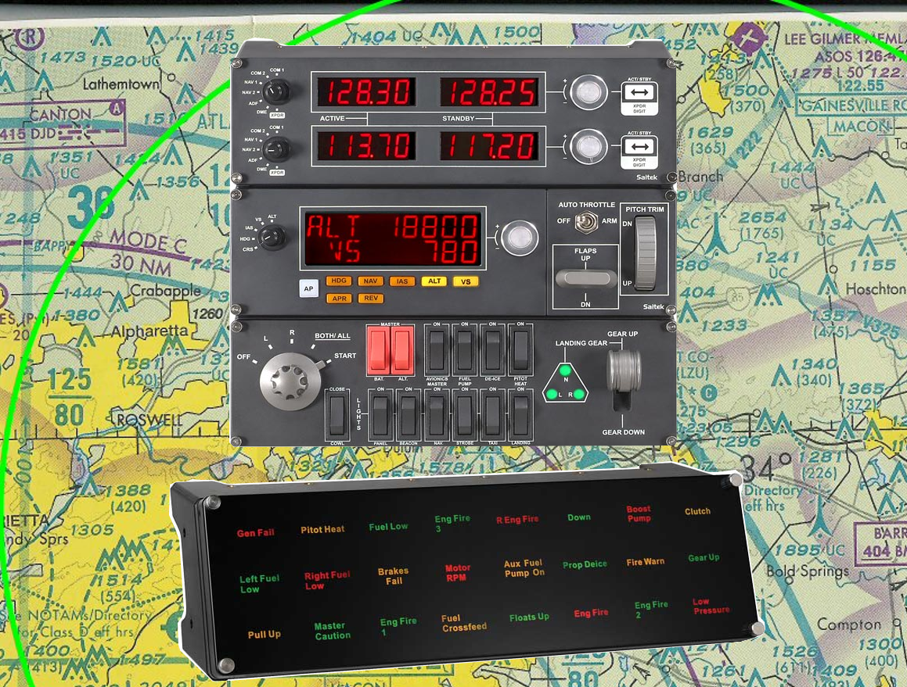

William R Good

Xsaitekpanels Users Manual

Ver 1.42

Purpose - One plugin to allow support for multiple Saitek Pro Flight panels in X-Plane using Linux, Windows and the Mac.

Thanks to Alan Ott's HIDAPI (https://github.com/signal11/hidapi) I am able to now support Linux, Windows and Mac with my plugin Xsaitekpanels.

Many thanks go to the following people who throughout this long process allowed me to get my plugin to this point. Sandy Barbour, Tom Sedge, Michal (uglyDwarf), Philipp, Stefan Oberender, Andy Goldstein, Bernhard (JaXXoN), Fabio, Marcos Lemos, Steven King and Chris Strosser.

With this plugin I am supporting the switch, radio, multi and BIP panels.

Added X737 support, including independent switches for wing and engine de-icing, pitot heat, and custom auto pilot functionality. Disabled unused switches to prevent conflicts (battery, alt., avionics, and panel light). The x737 autopilot is much different from the native X-Plane autopilot and is supported on the multi panel as best we can.

There is a preference file called xsaitekpanels.ini located in the Xsaitekpanels plugins folder and on the next page will explain it in detail.

I will also list the data reference that I am using for each item.

* = X-Plane normal data reference and command reference.
** = x737 data reference and command reference.

**********************************************************************************

How to install

This is a fat plugin so the folder named Xsaitekpanels which have a lin.xpl, win.xpl, mac.xpl, xsaitekpanels.ini and D2B_config.txt in it and needs to reside in /Resources/plugins/ folder.

If you use Linux you will need to install a new 51-Xsaitekpanels.rules in /lib/udev/rules.d for these Saitek panels to be seen by this plugin. It is included in this archive.

**********************************************************************************

xsaitekpanels.ini

xsaitekpanels.ini is configuration file for Xsaitekpanels that allows your menu selections to stick and much more.

xsaitekpanels.ini comes from the archive residing in the plugin folder but can also reside in the aircraft folder to allow different configurations for different aircraft. I first look in the current aircraft folder and if I cannot find it I will look in the Xsaitekpanels plugin folder.

The second function of the configuration file is to disable – enable – remap all switches on the switch panel. Another change is the use of sections in the xsaitekpanels.ini to allow a better organized configuration file. This is a work in progress and will be expanding with other features in later releases and am looking forward to suggestions on where to go.

You can edit xsaitekpanels.ini while X-Plane is running and then if you select a different plane or use the reload button it will reflect the changes you made.

Now some detail

0 = disable = This function turns off Xsaitekpanels hold on the switch so you can do what you want with it.

1 = enable = the function tells Xsaitekpanels to map the switch is the same as it always has been.

2 = remapable = allows you to remap a switch to a command you might want the switch to do.

There are four sections and there is a bracket around the name. They are

[switch]

[radio]

[multi]

[switch commands]

Look into the xsaitekpanels.ini in the archive for a better idea of how this all works.

This is hard to explain but if you come up with better words please let me know and they will be in the manual.

Plugin Menu Selections

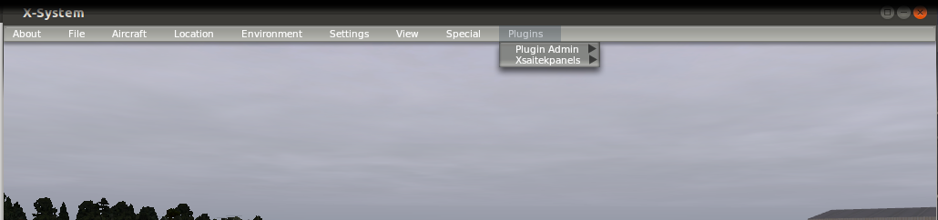

Xsaitekpanels Menu Selections

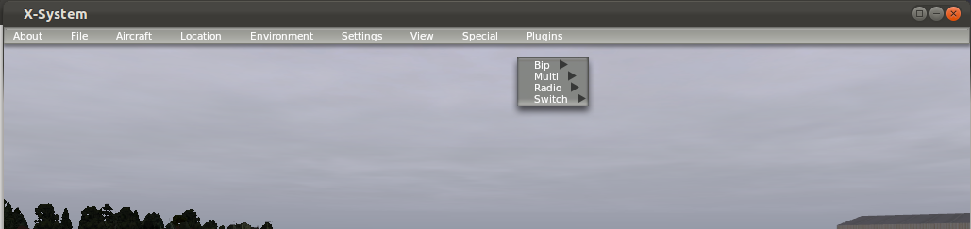

Xsaitekpanels Multipanel Menu

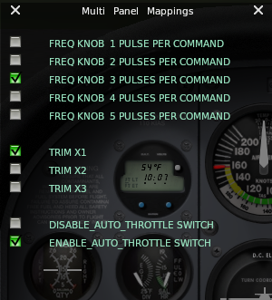

Top Section

Allows control of the sensitivity of the silver knob.

This is the number of switch pulses from the knob per command.

The default is 3 switch pulses per command.

Middle Section

Allows control of the sensitivity of the trim.

The default is 1

Lower Section

Allows you to enable of disable the auto throttle switch.

Xsaitekpanels Switchpanel Menu

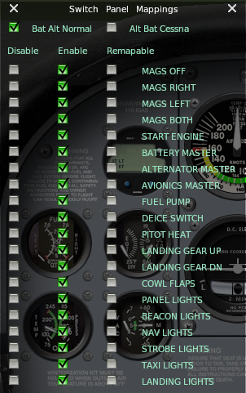

Bat Alt Normal matches the labels on the switch panel.

Alt Bat Cessna matches the position of a Cessna 172.

As you can see the complete switch panel can be enabled – disabled - remapable.

This widget allows a quick method to test out what you want to do before changing the xsaitekpanels.ini file.

Xsaitekpanels Radiopanel Menu

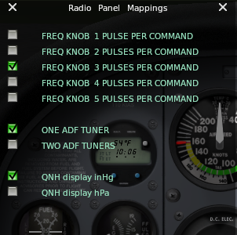

Top Section

Allows control of the sensitivity of the silver knob.

This is the number of switch pulses from the knob per command.

The default is 3 switch pulses per command.

Middle Section

Allows selection of one or two ADF Tuners

Lower Section

Allows selection of QNH in inHg or hPa.

There is a Fn key that allows expanded use of the switches on the panels.
It can be mapped for a joystick button or a keyboard key combo.
The path is xplugins/xsaitekpanels/x_panels_fn_button.

Joystick buttons are setup using Buttons:Adv pane in the Joystick & Equipment window, that is accessible through Settings / Joystick, Keys & Equipment menu.

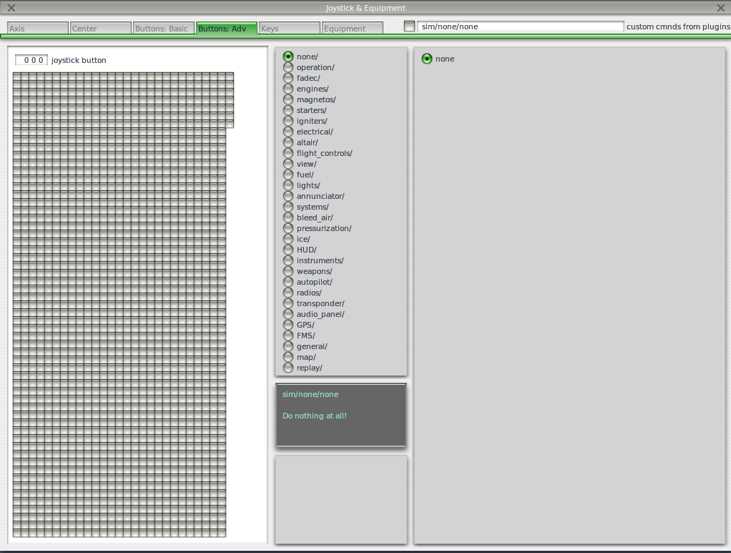

Press the desired joystick button, and now check the check-box next to the tabs. An Open dialog will appear.

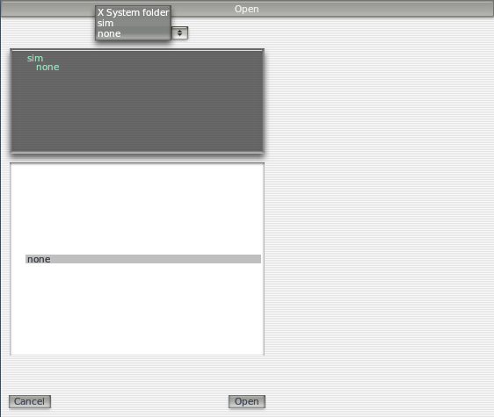

Click the combo-box in the upper part of the dialog and select X System folder.

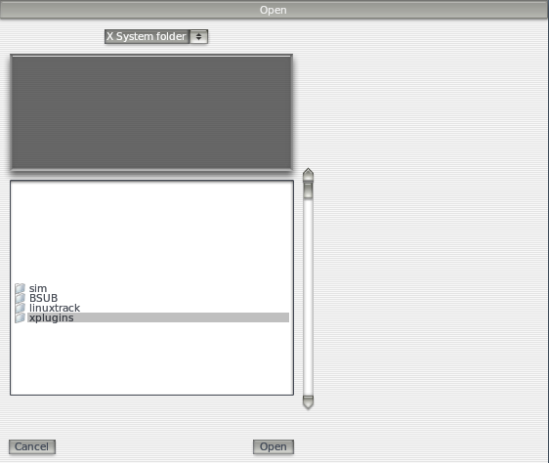

Select the x_panels_fn_button line in the lower part of the dialog.

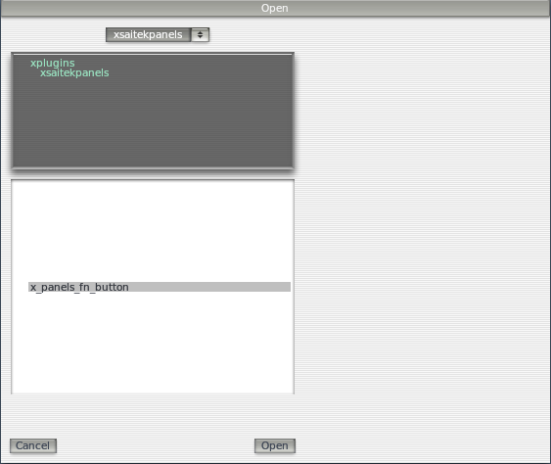

Finally select the desired command (x_panels_fn_button).

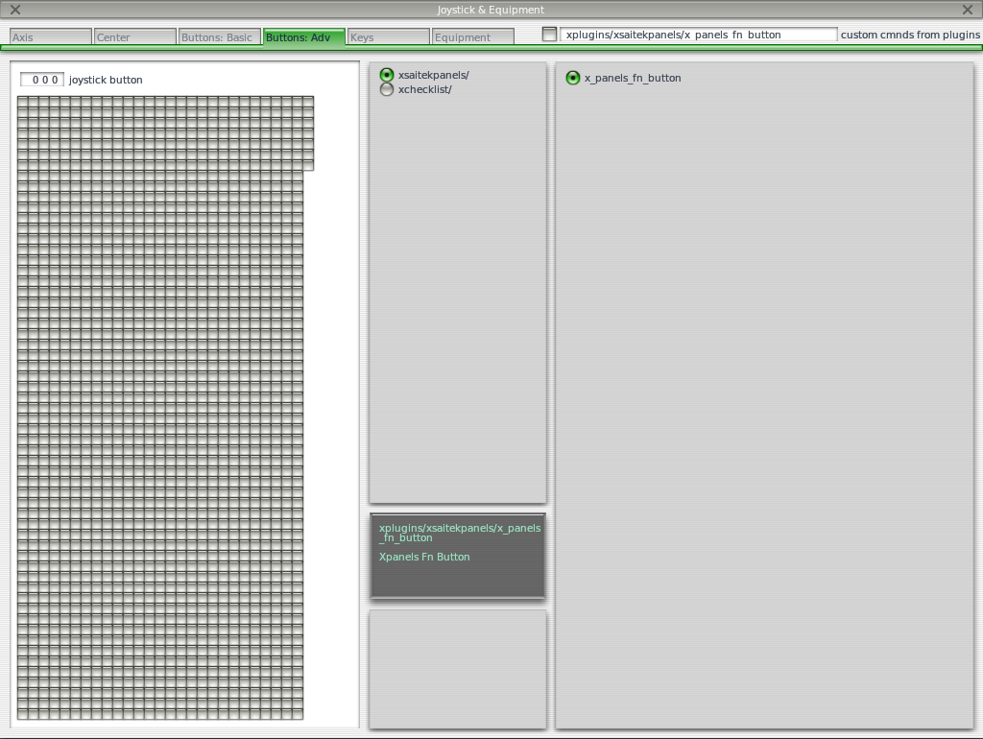

**********************************************************************************

Switch Panel (http://www.saitek.com/uk/prod/switch.html)

**********************************************************************************
The Xsaitekpanels plugin has been modified to support several custom features of the x737 aircraft. Unlike the native implementation, the BAT and ALT switches control generator one and two, respectively. In addition, several deicing systems are supported. The DE-ICE switch controls wing deicing, and the COWL switch controls engine heat. Wen COWL is switched to open, The engine heat will be on, and the overhead VALVE OPEN light should be illuminated. Lastly, the PITOT HEAT switch controls the custom pitot heat implementation offered by the x737. The AVIONICS MASTER, FUEL PUMP, and PANEL switches have been disabled to prevent conflicts with x737 functionality.

The switches are mapped in the following manner.

For the engine I look at the number of engines and control that many.
In the present version I support four engines.

Engine mags off switch
This grounds out the mags and stops the engine.
X = 1 thru 4
* MagOffX = XPLMFindCommand("sim/magnetos/magnetos_off_X")

Engine mags right switch
This selects only the right mags to test in run up.
X = 1 thru 4
* MagRightX = XPLMFindCommand("sim/magnetos/magnetos_right_X")

Engine mags left switch
This select only the left mags to test in run-up.
X = 1 thru 4
* MagLeftX = XPLMFindCommand("sim/magnetos/magnetos_left_X")

Engine mags both switch
This selects both mags and is the normal position when the engine is running.
X = 1 thru 4
* MagBothX = XPLMFindCommand("sim/magnetos/magnetos_both_X")

Engine start switch
This engages the starter.
X = 1 thru 4
* EngStartX = XPLMFindCommand("sim/starters/engage_starter_X")

There is a menu selection called "Bat Alt Normal or Alt Bat Cessna"
In normal it is as labeled on the panel.
In Cessna match the position of a Cessna 172SP

Master Battery switch
In on position turns on the number of batteries in the plane.
* BatOnX = XPLMFindCommand("sim/electrical/battery_X_on")

In off position turns off the number of batteries in the plane.
X = 1 thru 2
* BatOffX = XPLMFindCommand("sim/electrical/battery_X_off")

Master Alternator switch
In on position turns on the number of generators as engines.
* GenOnX = XPLMFindCommand("sim/electrical/generator_X_on")

In off position turns off the number of generators as engines.
X = 1 thru 4
* GenOffX = XPLMFindCommand("sim/electrical/generator_X_off")

Avionics master switch
In the on position turns on all radio equipment.
* AvLtOn = XPLMFindCommand("sim/systems/avionics_on")

In the off position turns off all radio equipment.
* AvLtOff = XPLMFindCommand("sim/systems/avionics_off")

Fuel pump switch
In on position turns on the same number of fuel pumps as engines.
* FuelPumpOnX = XPLMFindCommand("sim/fuel/fuel_pump_X_on")

In off position turns off the same number of fuel pumps as engines.
X = 1 thru 4
* FuelPumpOffX = XPLMFindCommand("sim/fuel/fuel_pump_X_off")

De-Ice switch
Turns on anti-ice.
* AntiIce = XPLMFindDataRef("sim/cockpit/switches/anti_ice_on")
** x737ice_wing_on = XPLMFindCommand("x737/ice_and_rain/WAI_ON")

Pitot heat switch
In on position turns on pitot tube heat.
* PtHtOn = XPLMFindCommand("sim/ice/pitot_heat_on")
** x737ice_pitot1_on = XPLMFindCommand("x737/ice_and_rain/PITOTHEAT1_ON")
** x737ice_pitot2_on = XPLMFindCommand("x737/ice_and_rain/PITOTHEAT2_ON")

In off position turns off pitot tube heat.
* PtHtOff = XPLMFindCommand("sim/ice/pitot_heat_off")
** x737ice_pitot1_off = XPLMFindCommand("x737/ice_and_rain/PITOTHEAT1_OFF")
** x737ice_pitot2_off = XPLMFindCommand("x737/ice_and_rain/PITOTHEAT2_OFF")

Cowl Flaps switch
For this to work turn off auto cowl flaps in plane maker.
In the open position opens the number of cowl flaps as engines.
* ClFlOpn = XPLMFindCommand("sim/flight_controls/cowl_flaps_open")
** x737ice_engine1_on = XPLMFindCommand("x737/ice_and_rain/EAI1_ON")
** x737ice_engine2_on = XPLMFindCommand("x737/ice_and_rain/EAI2_ON")

In close position closes the number of cowl flaps as engines.
* ClFlCls = XPLMFindCommand("sim/flight_controls/cowl_flaps_closed")
** x737ice_engine1_off = XPLMFindCommand("x737/ice_and_rain/EAI1_OFF")
** x737ice_engine2_off = XPLMFindCommand("x737/ice_and_rain/EAI2_OFF")

Panel lights switch
Turns on the panel lights.
* CockpitLights = XPLMFindDataRef("sim/cockpit/electrical/cockpit_lights")

Beacon switch
In the on position turns on the beacon lights.
* BcLtOn = XPLMFindCommand("sim/lights/beacon_lights_on")

In the off position turns off the becon lights.
* BcLtOff = XPLMFindCommand("sim/lights/beacon_lights_off")

Nav switch
In the on position turns on the navagation lights.
* NvLtOn = XPLMFindCommand("sim/lights/nav_lights_on")

In the off position turns off the navagation lights.
* NvLtOff = XPLMFindCommand("sim/lights/nav_lights_off")

Strobe switch
In the on position turns on the strobe lights.
* StLtOn = XPLMFindCommand("sim/lights/strobe_lights_on")

In off position turns off the strobe lights.
* StLtOff = XPLMFindCommand("sim/lights/strobe_lights_off")

Taxi switch
In the on position turns on the taxi lights.
* TxLtOn = XPLMFindCommand("sim/lights/taxi_lights_on")

In the off position turns off the taxi lights.
* TxLtOff = XPLMFindCommand("sim/lights/taxi_lights_off")

Landing switch
In the on position turns on the landing lights.
* LnLtOn = XPLMFindCommand("sim/lights/landing_lights_on")

In the off position turns off the landing lights.
* LnLtOff = XPLMFindCommand("sim/lights/landing_lights_off")

Gear Indicator Lights
Off: Undercarriage Retracted
Green: Undercarriage Deployed
Red: Undercarriage In-Transition or Faulted
* GearRetract = XPLMFindDataRef("sim/aircraft/gear/acf_gear_retract")
* LandingGearStatus = XPLMFindDataRef("sim/aircraft/parts/acf_gear_deploy")
* Gear1Fail = XPLMFindDataRef("sim/operation/failures/rel_lagear1")
* Gear2Fail = XPLMFindDataRef("sim/operation/failures/rel_lagear2")
* Gear3Fail = XPLMFindDataRef("sim/operation/failures/rel_lagear3")

Landing Gear Switch
Gear Up or Down
* GearRetract = XPLMFindDataRef("sim/aircraft/gear/acf_gear_retract")

**********************************************************************************

Radio Panel (http://www.saitek.com/uk/prod/radio.html)

**********************************************************************************

The radio panel uses the Fn key to expanded use of some of the switches.
I will explain in detail where that is true.
I support up to four radio panels.

The switches are mapped in the following manner.

There is a upper and lower section and are completely independent of each other.
I will show the mapping for the upper.

COM1 switch position
Left display is COM1 Active.
* Com1ActFreq = XPLMFindDataRef("sim/cockpit/radios/com1_freq_hz")

Right display is COM1 Stanby
* Com1StbyFreq = XPLMFindDataRef("sim/cockpit/radios/com1_stdby_freq_hz")

Large silver knob controls the whole numbers
* Com1StbyCorseUp = XPLMFindCommand("sim/radios/stby_com1_coarse_up")
* Com1StbyCorseDn = XPLMFindCommand("sim/radios/stby_com1_coarse_down")

Small silver knob controls the fractional numbers
* Com1StbyFineUp = XPLMFindCommand("sim/radios/stby_com1_fine_up")
* Com1StbyFineDn = XPLMFindCommand("sim/radios/stby_com1_fine_down")

ACT/STBY moves the left and right display
* Com1ActStby = XPLMFindCommand("sim/radios/com1_standy_flip")

COM2 switch position
Left display is COM2 Active
* Com2ActFreq = XPLMFindDataRef("sim/cockpit/radios/com2_freq_hz")

Right display is COM2 Stanby
* Com2StbyFreq = XPLMFindDataRef("sim/cockpit/radios/com2_stdby_freq_hz")

Large silver knob controls the whole numbers
* Com2StbyCorseUp = XPLMFindCommand("sim/radios/stby_com2_coarse_up")
* Com2StbyCorseDn = XPLMFindCommand("sim/radios/stby_com2_coarse_down")

Small silver know controls the fractional numbers
* Com2StbyFineUp = XPLMFindCommand("sim/radios/stby_com2_fine_up")
* Com2StbyFineDn = XPLMFindCommand("sim/radios/stby_com2_fine_down")

ACT/STBY moves the left and right display
* Com2ActStby = XPLMFindCommand("sim/radios/com2_standy_flip")

NAV1 switch position
Left display is NAV1 Active
* Nav1ActFreq = XPLMFindDataRef("sim/cockpit/radios/nav1_freq_hz")

Right display is NAV1 Stanby
* Nav1StbyFreq = XPLMFindDataRef("sim/cockpit/radios/nav1_stdby_freq_hz")

Large silver knob controls the whole numbers
* Nav1StbyCorseUp = XPLMFindCommand("sim/radios/stby_nav1_coarse_up")
* Nav1StbyCorseDn = XPLMFindCommand("sim/radios/stby_nav1_coarse_down")

Small silver know controls the fractional numbers
* Nav1StbyFineUp = XPLMFindCommand("sim/radios/stby_nav1_fine_up")
* Nav1StbyFineDn = XPLMFindCommand("sim/radios/stby_nav1_fine_down")

ACT/STBY moves the left and right display
* Nav1ActStby = XPLMFindCommand("sim/radios/nav1_standy_flip")

NAV2 switch position
Left display is NAV2 Active
* Nav2ActFreq = XPLMFindDataRef("sim/cockpit/radios/nav2_freq_hz")

Right display is NAV2 Stanby
* Nav2StbyFreq = XPLMFindDataRef("sim/cockpit/radios/nav2_stdby_freq_hz")

Large silver knob controls the whole numbers
* Nav2StbyCorseUp = XPLMFindCommand("sim/radios/stby_nav2_coarse_up")
* Nav2StbyCorseDn = XPLMFindCommand("sim/radios/stby_nav2_coarse_down")

Small silver know controls the fractional numbers
* Nav2StbyFineUp = XPLMFindCommand("sim/radios/stby_nav2_fine_up")
* Nav2StbyFineDn = XPLMFindCommand("sim/radios/stby_nav2_fine_down")

ACT/STBY moves the left and right display
* Nav2ActStby = XPLMFindCommand("sim/radios/nav2_standy_flip")

Upper ADF switch position
If one ADF selected from menu upper and lower are as shown.

Left display is ADF Active
* Adf1ActFreq = XPLMFindDataRef("sim/cockpit/radios/adf1_freq_hz")

Right display is ADF Standby
* Adf1StbyFreq = XPLMFindDataRef("sim/cockpit/radios/adf1_stdby_freq_hz")

Large silver knob controls the selected number to increase or decrease.
The position is marked with a decimal point.
Small silver knob controls increase of decrease of the selected digit.

Ones selected
* Afd1StbyOnesUp = XPLMFindCommand("sim/radios/stby_adf1_ones_up")
* Afd1StbyOnesDn = XPLMFindCommand("sim/radios/stby_adf1_ones_down")

Tens selected
* Afd1StbyTensUp = XPLMFindCommand("sim/radios/stby_adf1_tens_up")
* Afd1StbyTensDn = XPLMFindCommand("sim/radios/stby_adf1_tens_down")

Hundereds selected
* Afd1StbyHunUp = XPLMFindCommand("sim/radios/stby_adf1_hundreds_up")
* Afd1StbyHunDn = XPLMFindCommand("sim/radios/stby_adf1_hundreds_down")

ACT/STBY moves the right and left display
* Adf1ActStby = XPLMFindCommand("sim/radios/adf1_standy_flip")

Lower ADF switch position
If two ADF's selected from menu upper is the same and lower are as shown below.

Left display is ADF Active
* Adf1ActFreq = XPLMFindDataRef("sim/cockpit/radios/adf2_freq_hz")

Right display is ADF Standby
* Adf1StbyFreq = XPLMFindDataRef("sim/cockpit/radios/adf2_stdby_freq_hz")

Large silver knob controls the selected number to increase or decrease.
The position is marked with a decimal point.
Small silver knob controls increase of decrease of the selected digit.

Ones selected
* Afd1StbyOnesUp = XPLMFindCommand("sim/radios/stby_adf2_ones_up")
* Afd1StbyOnesDn = XPLMFindCommand("sim/radios/stby_adf2_ones_down")

Tens selected
* Afd1StbyTensUp = XPLMFindCommand("sim/radios/stby_adf2_tens_up")
* Afd1StbyTensDn = XPLMFindCommand("sim/radios/stby_adf2_tens_down")

Hundereds selected
* Afd1StbyHunUp = XPLMFindCommand("sim/radios/stby_adf2_hundreds_up")
* Afd1StbyHunDn = XPLMFindCommand("sim/radios/stby_adf2_hundreds_down")

ACT/STBY moves the right and left display
* Adf1ActStby = XPLMFindCommand("sim/radios/adf2_standy_flip")

DME switch position
Left display depends on the mode selected

RMT selected displays speed in knots
* Nav1DmeSpeed = XPLMFindDataRef("sim/cockpit2/radios/indicators/nav1_dme_speed_kts")
* Nav2DmeSpeed = XPLMFindDataRef("sim/cockpit2/radios/indicators/nav2_dme_speed_kts")

FRQ selected displays frequency
* DmeFreq = XPLMFindDataRef("sim/cockpit2/radios/actuators/dme_frequency_hz")

GS/T selected displays Ground speed in knots
* DmeSpeed = XPLMFindDataRef("sim/cockpit2/radios/indicators/dme_dme_speed_kts

Right display depends in the mode selected

RMT selected displays distance in nautical miles
*Nav1DmeNmDist=XPLMFindDataRef("sim/cockpit2/radios/indicators/nav1_dme_distance_nm")
*Nav2DmeNmDist=XPLMFindDataRef("sim/cockpit2/radios/indicators/nav2_dme_distance_nm")

FRQ selected displays time in minutes
* DmeTime = XPLMFindDataRef("sim/cockpit2/radios/indicators/dme_dme_time_min")

GS/T selected displays time in minutes
* DmeTime = XPLMFindDataRef("sim/cockpit2/radios/indicators/dme_dme_time_min")

Large silver knob depends on mode selected
RMT selected has no operation
FRQ selected adjusts the whole numbers on the display on the left GS/T selected has no operation

Small silver knob depends on mode selected
RMT selected has no operation
FRQ selected adjust the fractional numbers on the display on the left
GS/T selected has no operation

If Fn key is not pressed.
ACT/STBY selects the three modes of the DME
RMT Remote DME channels when you select your NAV frequency on the Nav receiver.
FRQ Frequency DMT displays distance and selected frequency adjusted by silver knobs
GS/T Groundspeed/Time-to-Station

If Fn key is pressed.
ACT/STBY selects N1 or N2

XPDR switch position
The Fn key is used here to add functionality to this position.

Left display is the barometer setting for the altimeter.
A menu selection allows you to select inHg or hPa to be used in setting the altimeter.
There is also a xsaitekpanels.ini setting to change the default.
If the Fn key is pushed a decimal point is displayed in the left hand side.
* BaroSetting = XPLMFindDataRef("sim/cockpit/misc/barometer_setting")

Right display is the Xtronsponder code.
There is a decimal point at the digit that can be adjusted
* XpdrCode = XPLMFindDataRef("sim/cockpit/radios/transponder_code")

Large silver knob depends on the function button.
If the Fn key is not pushed.
Adjusts the selected digit to be changed for the transponder.

If the Fn key is pushed.
Adjusts the barometer in X 10 adjustments.

Small silver knob depends on the function button
If the Fn key is not pushed.
Adjust the selected digit for the Transponder.

If the Fn key is pushed.
Adjusts the barometer in X 1 adjustments.

ACT/STBY depends on the function button
If the Fn key is not pushed.
Selects the modes of the transponder.

If the Fn key is pushed.
Sets the barometer setting to 29.92

**********************************************************************************

Multi Panel (http://www.saitek.com/uk/prod/multi.html)

**********************************************************************************

The multi panel uses the Fn key to expanded use of some of the switches.
I will explain in detail where that is true.

The x737 autopilot is much different from the native X-Plane autopilot. While the HDG, IAS (LVLCHG), ALT, VS, and APR (APP) buttons match the functionality seen in the x737, the NAV button has been tweaked to allow users to control VORLOC and LNAV. The behavior of the NAV button is dependent upon the HSI selector. If NAV1 or NAV2 is selected, the NAV button and LED are associated with VORLOC; otherwise, it is linked to LNAV. Lastly, the FN+IAS button controls the IAS-to-Mach changeover.

ALT switch position
Upper display is the auto pilot altitude
* ApAlt = XPLMFindDataRef("sim/cockpit/autopilot/altitude")

Lower display is the auto pilot vertical speed
* ApVs = XPLMFindDataRef("sim/cockpit/autopilot/vertical_velocity")

Silver knob adjusts the altitude up and down
If the Fn key is not pushed.
Adjust in 100 foot increments
* ApAlt = XPLMFindDataRef("sim/cockpit/autopilot/altitude")
** x737mcp_alt = XPLMFindDataRef("x737/systems/afds/ALTHLD_baroalt")

If the Fn key is pushed.
Adjusts in 1000 foot increments

VS switch position
Upper display in the auto pilot alititude
* ApAlt = XPLMFindDataRef("sim/cockpit/autopilot/altitude")

Lower display is the auto pilot vertical speed
* ApVs = XPLMFindDataRef("sim/cockpit/autopilot/vertical_velocity")

Silver knob adjusts vertical speed up and down
If the Fn key is not pushed.
Adjusts in 100 foot increments.
* ApVsUp = XPLMFindCommand("sim/autopilot/vertical_speed_up")
* ApVsDn = XPLMFindCommand("sim/autopilot/vertical_speed_down")
** x737mcp_vvi_up = XPLMFindCommand("x737/mcp/VVI+100");
** x737mcp_vvi_down = XPLMFindCommand("x737/mcp/VVI-100")

If the Fn key is pushed.
Adjusts in 1000 foot increments.
* ApVsUp = XPLMFindCommand("sim/autopilot/vertical_speed_up")
* ApVsDn = XPLMFindCommand("sim/autopilot/vertical_speed_down")
** x737mcp_vvi_up_fast = XPLMFindCommand("x737/mcp/VVI+500")
** x737mcp_vvi_down_fast = XPLMFindCommand("x737/mcp/VVI-500")

IAS switch position
Upper display is the auto pilot indicated air speed
* ApAs = XPLMFindDataRef("sim/cockpit/autopilot/airspeed")

Lower display is blank

Silver knob adjusts indicated air speed up and down
If the Fn key is not pushed.
Adjusts by a factor of 1
* AirspeedIsMach = XPLMFindDataRef("sim/cockpit/autopilot/airspeed_is_mach")
* Airspeed = XPLMFindDataRef("sim/cockpit/autopilot/airspeed")
* ApAsUp = XPLMFindCommand("sim/autopilot/airspeed_up")
* ApAsDn = XPLMFindCommand("sim/autopilot/airspeed_down")
** x737mcp_spd_up = XPLMFindCommand("x737/mcp/MCPSPD+1")
** x737mcp_spd_down = XPLMFindCommand("x737/mcp/MCPSPD-1")

If the Fn key is pushed.
Adjusts by a factor of 10
* AirspeedIsMach = XPLMFindDataRef("sim/cockpit/autopilot/airspeed_is_mach")
* Airspeed = XPLMFindDataRef("sim/cockpit/autopilot/airspeed")
* ApAsUp = XPLMFindCommand("sim/autopilot/airspeed_up")
* ApAsDn = XPLMFindCommand("sim/autopilot/airspeed_down")
** x737mcp_spd_up_fast = XPLMFindCommand("x737/mcp/MCPSPD+10")
** x737mcp_spd_down_fast = XPLMFindCommand("x737/mcp/MCPSPD-10")

HDG switch position
Upper display is the auto pilot heading.
* ApHdg = XPLMFindDataRef("sim/cockpit/autopilot/heading_mag")

Lower display is blank

Silver knob adjusts the heading up and down
If the Fn key is not pushed.
Adjusts by a factor of 1.
* ApHdg = XPLMFindDataRef("sim/cockpit/autopilot/heading_mag")
** x737mcp_hdg_up = XPLMFindCommand("x737/mcp/HDG+1")
** x737mcp_hdg_down = XPLMFindCommand("x737/mcp/HDG-1")

If the Fn key is pushed.
Adjusts by a factor of 10.
* ApHdg = XPLMFindDataRef("sim/cockpit/autopilot/heading_mag")
** x737mcp_hdg_up_fast = XPLMFindCommand("x737/mcp/HDG+6")
** x737mcp_hdg_down_fast = XPLMFindCommand("x737/mcp/HDG-6")

CRS switch position
Upper display is the auto pilot course
* ApCrs = XPLMFindDataRef("sim/cockpit2/radios/actuators/hsi_obs_deg_mag_pilot")

Lower display is blank

Silver knob adjusts the course
If the Fn key is not pushed.
Adjusts by a factor of 1.

If the Fn key is pushed.
Adjusts by a factor of 10

AP Button
Selects flight director modes.
Off = 0
On = 1
Auto = 2
* ApMstrStat = XPLMFindDataRef("sim/cockpit2/autopilot/flight_director_mode")
** x737mcp_cmd_a_toggle = XPLMFindCommand("x737/mcp/CMDA_TOGGLE")

AP Indicator Light
Flight director mode
Off = light is off = 0
On = light is flashing = 1
Auto = light is on = 2
* ApMstrStat = XPLMFindDataRef("sim/cockpit2/autopilot/flight_director_mode")
** x737mcp_cmd_a_led = XPLMFindDataRef("x737/systems/MCP/LED_CMDA_on")

HDG Button
Toggle On or Off Autopilot heading-hold
* ApHdgBtn = XPLMFindCommand("sim/autopilot/heading");
** x737mcp_hdg_toggle = XPLMFindCommand("x737/mcp/HDGSEL_TOGGLE")

If the Fn key is pushed Heading is synced to magnetic heading

HDG Indicator Light
Heading Status
Off: Auto Pilot off or Autopilot Heading Status > off = 0
Flashing: Autopilot Heading Status > armed = 1
On: Autopilot Heading Status > captured = 2
* ApHdgStat = XPLMFindDataRef("sim/cockpit2/autopilot/heading_status")
** x737mcp_hdg_led = XPLMFindDataRef("x737/systems/MCP/LED_HDG_on")

NAV Button
Toggle On or Off Autopilot VOR/LOC arm
* ApNavBtn = XPLMFindCommand("sim/autopilot/NAV")
** x737mcp_vorloc_toggle = XPLMFindCommand("x737/mcp/VORLOC_TOGGLE")
** x737mcp_lnav_toggle = XPLMFindCommand("x737/mcp/LNAV_TOGGLE")

If the Fn key is pushed NAV Button toggles OSB1 and OBS2

NAV Indicator Light
Nav mode
Off: Autopilot off or Autopilot Nav Status > off = 0
Flashing: Autopilot Nav Status > armed = 1
On: Autopilot Nav Status > captured = 2
* ApNavBtn = XPLMFindCommand("sim/autopilot/NAV")
** x737mcp_vorloc_led = XPLMFindDataRef("x737/systems/afds/VORLOC")
** x737mcp_vorloc_armed = XPLMFindDataRef("x737/systems/afds/VORLOC_armed")
** x737mcp_lnav = XPLMFindDataRef("x737/systems/afds/LNAV")
** x737mcp_lnav_armed = XPLMFindDataRef("x737/systems/afds/LNAV_arm")

IAS Button
Toggle On or Off Auto pilot IAS guidance mode
* ApIasBtn = XPLMFindCommand("sim/autopilot/level_change")
** x737mcp_spd_changeover = XPLMFindCommand("x737/mcp/CHANGEOVER")
** x737mcp_lvlchange_toggle = XPLMFindCommand("x737/mcp/LVLCHANGE_TOGGLE")

IAS Indicator Light
Off: Autopilot Speed-hold (via pitch) status > off = 0
Flashing: Autopilot Speed-hold (via pitch) status > armed = 1
On: Autopilot Speed-hold (via pitch) status > captured = 2
* ApIasStat = XPLMFindDataRef("sim/cockpit2/autopilot/speed_status")
** x737mcp_lvlchange_led = XPLMFindDataRef("x737/systems/MCP/LED_LVLCHG_on")

ALT Button
Toggle On or Off Autopilot altitude select or hold
* ApAltBtn = XPLMFindCommand("sim/autopilot/altitude_hold")
** x737mcp_alt_toggle = XPLMFindCommand("x737/mcp/ALTHLD_TOGGLE")

ALT Indicator Light
Off: Autopilot Altitude hold status > off = 0
Flashing: Autopilot Altitude hold status > armed = 1
On: Autopilot Altitude hold status > captured = 2
* ApAltStat = XPLMFindDataRef("sim/cockpit2/autopilot/altitude_hold_status")
** x737mcp_alt_toggle = XPLMFindCommand("x737/mcp/ALTHLD_TOGGLE")

VS Button
Toggle On or Off Autopilot vertical speed
* ApVsBtn = XPLMFindCommand("sim/autopilot/vertical_speed")
** x737mcp_vs_toggle = XPLMFindCommand("x737/mcp/VS_TOGGLE")

VS Indicator Light
Off: Autopilot VVI Status > off = 0
Flashing: Autopilot VVI Status > armed = 1
On: Autopilot VVI Status > captured = 2
* ApVsStat = XPLMFindDataRef("sim/cockpit2/autopilot/vvi_status")
** x737mcp_vvi_led = XPLMFindDataRef("x737/systems/MCP/LED_VVI_on")
** x737mcp_vvi_armed_led = XPLMFindDataRef("x737/systems/MCP/LED_VVIARMED_on")
APR Button
Toggle On or Off Autopilot approach
* ApAprBtn = XPLMFindCommand("sim/autopilot/approach")
** x737mcp_app_toggle = XPLMFindCommand("x737/mcp/APP_TOGGLE")

If the Fn key is pushed CRS is synced to magnetic heading

APR Indicator Light
Off: Autopilot approach status > off = 0
Flashing: Autopilot approach status > armed = 1
On: Autopilot approach status > captured = 2
* ApAprStat = XPLMFindDataRef("sim/cockpit2/autopilot/approach_status")
** x737mcp_app_led = XPLMFindDataRef("x737/systems/MCP/LED_APP_on")

REV Button
Toggle On or Off Autopilot back-course
* ApRevBtn = XPLMFindCommand("sim/autopilot/back_course")

REV Indicator Light
Off: Autopilot Back-course Status > off = 0
Flashing: Autopilot Back-course Status > armed = 1
On: Autopilot Back-course Status > captured = 2
* ApRevStat = XPLMFindDataRef("sim/cockpit2/autopilot/backcourse_status")

Flaps
Up: Retracts flaps by one notch from current position
* FlapsUp = XPLMFindCommand("sim/flight_controls/flaps_up")
Down: Extends flaps by one notch from current position
*FlapsDn = XPLMFindCommand("sim/flight_controls/flaps_down")
Fn Key: No Special Effect

Auto Throttle Switch
Off: Auto-throttle off = 0
Arm: Auto-throttle on = 1
* ApAutThr = XPLMFindDataRef("sim/cockpit2/autopilot/autothrottle_enabled")
boolean Auto-throttle on, 0 or 1. This is the switch.
** x737athr_armed = XPLMFindDataRef("x737/systems/athr/athr_armed")

Pitch Trim Wheel
DN: Moves the trim wheel in the down direction
* PitchTrimDn = XPLMFindCommand("sim/flight_controls/pitch_trim_down")
UP: Moves the trim wheel in the up direction
* PitchTrimUp = XPLMFindCommand("sim/flight_controls/pitch_trim_up")
**********************************************************************************

Backlight Information Panel (http://www.saitek.com/uk/prod/bip.html)

**********************************************************************************
It uses a Config file that resides in /Resources/plugins/Xsaitekpanels/D2B_config.txt is for the first BIP. It may also reside in the aircraft folder and I will look in the current aircrafts folder first and if not found revert back to the Xsaitekpanels plugin folder.

If you have a second BIP it uses the Config file that resides in /Resources/plugins/Xsaitekpanels/D2B_config2.txt. It may also reside in the aircraft folder and I will look in the current aircrafts folder first and if not found revert back to the Xsaitekpanels plugin folder.

-------------------------------------------------------------------------------------------------
To make it very easy to edit the files please look at D2B-Tool for Xsaitekpanels BIP 1.0.rc2
located at http://forums.x-plane.org/index.php?app=downloads&showfile=16139 by CouchPilot. It creates the text files in a GUI way but also allows you to print your own template so you can have as many different tiles as you would like. Thanks for this great new tool.
-------------------------------------------------------------------------------------------------

Look at as a example of what is possible. The D2B_config.txt has two parts a default section and a test section.

The default section mimics the annunciator panel in a Cessna 172.

The test section test all the indicators when you select test and click on the annunciator test button.

Look at your /Resources/plugins/DataRefs.txt to see what data reference's are available to you.

The config file structure is as follows

Every line not starting with # is ignored. So please fill it with comments.

You can use the following commands in the config file:

**********************************************************************************
#SET BIP A 0 G FROM DATAREF sim/cockpit/warnings/annunciator_test_pressed RANGE 1 TO 1
#SET BIP A 1 R FROM DATAREF sim/cockpit/warnings/annunciators/low_voltage RANGE 1 TO 1
#SET BIP A 2 R FROM DATAREF sim/cockpit2/annunciators/fuel_quantity RANGE 1 TO 1
#SET BIP A 3 R FROM DATAREF sim/cockpit2/controls/parking_brake_ratio RANGE 1 TO 1
#SET BIP B 2 R FROM DATAREF sim/cockpit2/annunciators/low_vacuum RANGE 1 TO 1
#SET BIP B 3 R FROM DATAREF sim/cockpit2/annunciators/autopilot_disconnect RANGE 1 TO 1

#SET BIP <a> <b> <c> FROM DATAREF <d> RANGE <e> TO <f>

a) Which row with A being the top row A, B, C.
b) Position on the Row starting with 0. (0 - 7).
c) Which color do you want to display. G = Green, R = Red, A = Amber.
d) Data Reference to tell the indicator to turn on.
e) First number to check.
f) Second number to check.

**********************************************************************************
#SET BIP B 0 R FROM ARRAY sim/cockpit2/annunciators/oil_pressure_low 0 RANGE 1 TO 1
#SET BIP A 0 R FROM ARRAY sim/cockpit2/annunciators/generator_off 0 RANGE 1 TO 1
#SET BIP B 1 R FROM ARRAY sim/cockpit2/annunciators/oil_temperature_high 0 RANGE 1 TO 1

#SET BIP <a> <b> <c> FROM ARRAY <d> <e> RANGE <f> <g>
a) Which row with A being the top row A, B, C.
b) Position on the Row starting with 0. (0 - 7).
c) Which color do you want to display. G = Green, R = Red, A = Amber.
d) Data Reference to tell the indicator to turn on.
e) Array position. For multi engine 0 = first engine.
f) First number to check.
g) Second number to check.

