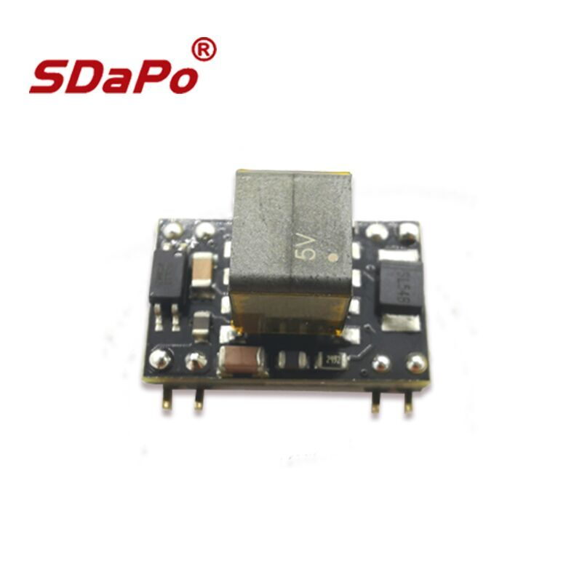
DESCRIPTION

PD(Powered Device) Integrated Module (Isolation Type)

FEATURES

- IEEE802.3af compliant，class 0 (0.44 Watts to 12.95 Watts).
- Low cost.
- Support PoE applications in both of Fast / Gigabit Ethernet environments.
- Support wide input voltage range 36Vdc to 57Vdc.
- Thermal cut off.
- Short circuit protection.
- Over current protection
- High DC/DC converting efficiency.
- Isolation level 1.5KVrms.
- Enhanced surge protection

Product List

Part Number | Nominal Output Voltage / Current | Maximum Output Power | Nominal Input Voltage
DP9905 | 5Vdc / 1.8A | 9W @ 25℃ | 48Vdc
DP9912 | 12Vdc / 1A | 12W @ 25℃ | 48Vdc
DP9924 | 24Vdc / 0.5A | 12W @ 25℃ | 48Vdc

PIN ASSIGNMENT

Pin # | Name | Description
1 | +VDC | DC Output. This pin provides the regulated output from the DC/DC converter.
2 | +VDC
3 | -VDC | DC Return. This pin is the return path for the +VDC output.
4 | ADJ | Output Adjust. The output voltage can be adjusted from is nominal value, by connecting an external resistor from this pin to either the +VDC pin or the -VDC pin.
5 | VIN+ | Direct Input +. This pin connects to the positive (+) output of the input bridge rectifiers.
6 | VIN+
7 | VIN- | Direct Input -. This pin connects to the negative (-) output of the input bridge rectifiers.
8 | VIN-

Typical Application

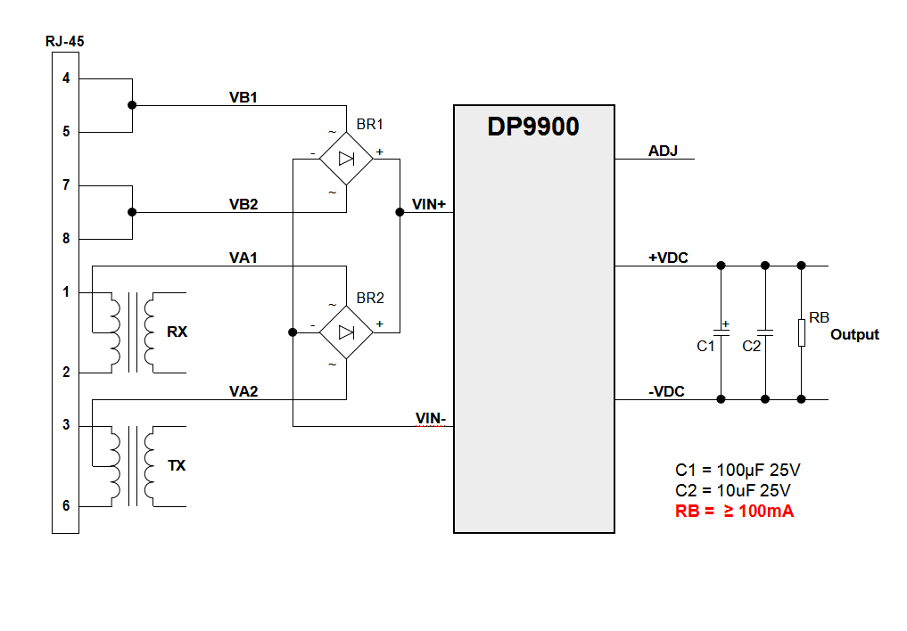

Output Filtering
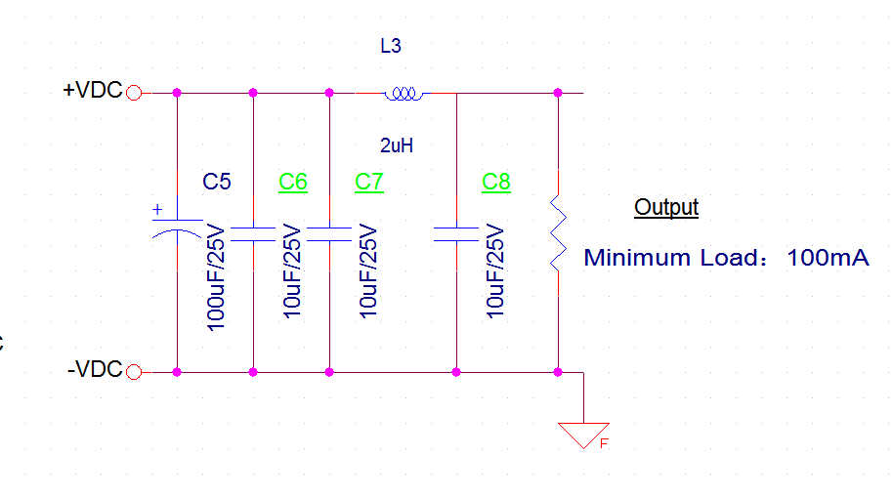

Operating Temperature Range

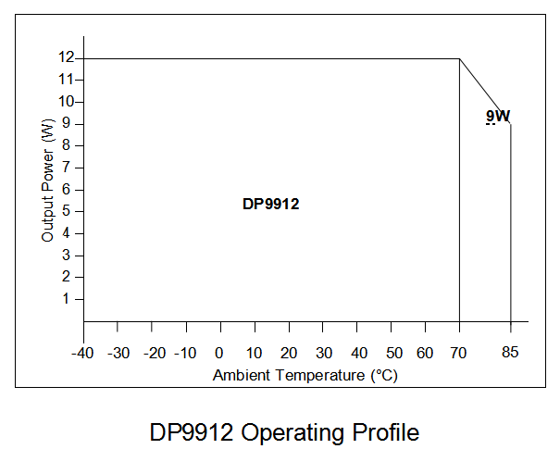
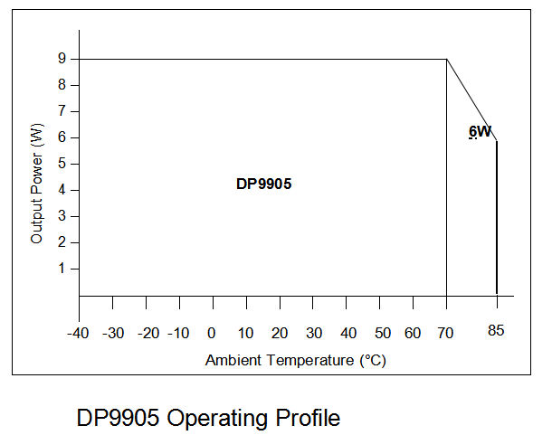

Recommended Operating Conditions
 | Parameter | Min | Typ | Max | Units
1 | Input Supply Voltage | 36 | 48 | 57 | V
2 | Under Voltage Lockout | 28 |  | 36 | V
3 | Operating Temperature | -40 | 25 | 85 | ℃

Package

