HEX File Snipping Instructions
PL 6/13/2017

Summary:
This guide will show how to remove unnecessary “blank” space in a hex file. This is useful when you want to keep the hex file as small as possible.

Why would you need this:
When a product has a bootloader and some “sketch code”, we will read back the entire flash space and use this as our “combined” HEX file for programming in production. Often times, this also includes a lot of blank space in the HEX file (between the sketch code and the bootloader).

- Read the entire flash space of your IC. ATMEGA328s should come in at 91KB.

- Open HEX file in a text editor. Here, I use Programmer Notepad.

- Scroll up and down in the HEX file and notice the three sections:

- “good stuff” up top. (Sketch code). | 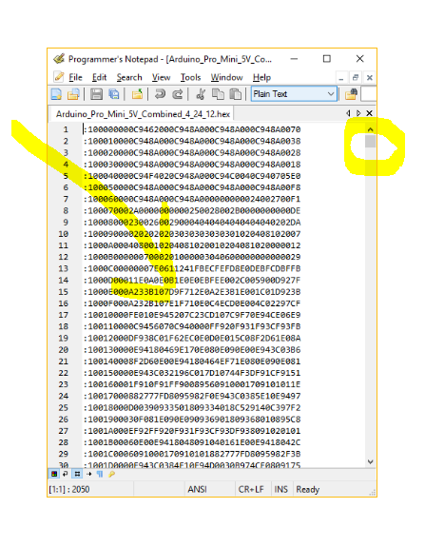
- Blank writes in the middle.  (all “FFFFFFFFFFF….”) | 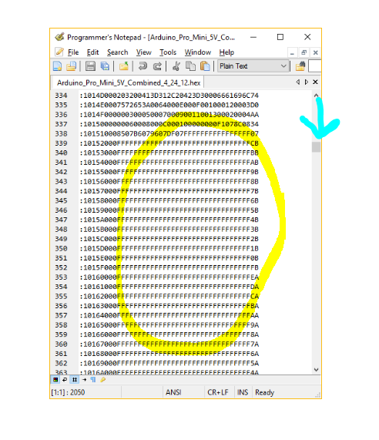
- “good stuff at bottom. (bootloader). | 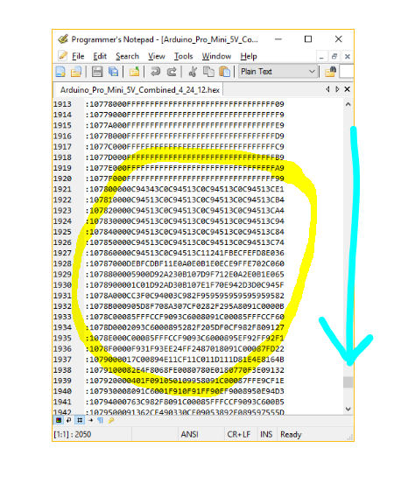

- Delete the blank writes in the file.

Do not accidentally delete any of the good stuff. To avoid this, I leave one line of complete “FFFFFFFFF” after the sketch code and before the bootloader.

Buffer above selection. | 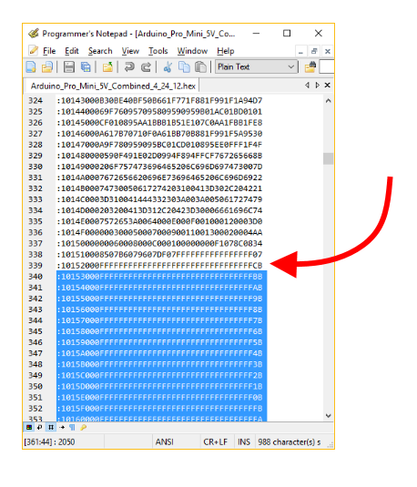
Buffer below selection. | 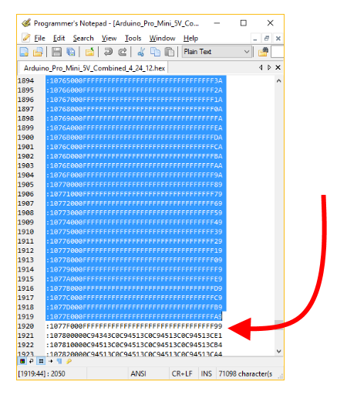
What it looks like after deletion. | 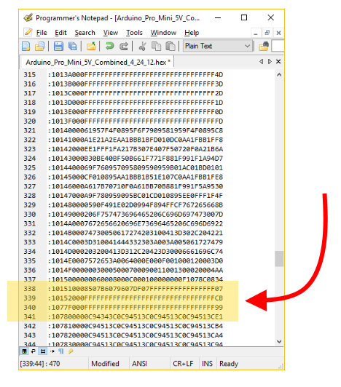

- Save new version for programming. Hell yeah! We just dropped this file size from 91KB to 21KB.

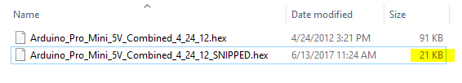

- Verify your work. To do this properly, please follow these steps carefully and in order:
  - Erase chip.
  - Program new snipped HEX file.
  - Verify against the original (aka complete) combined HEX.
  - If it verifies properly, then you are good to go. Rock on.

