Pi_Grammer Setup Instructions
PL 8/26/2016

This guide will show how to setup a Pi_Grammer for production.

- Grab a Raspi 2, a micro SD card (with generic Pi_grammer image pre-programmed) Pi_grammer Shield, 1x6 cable and adapter.

- Create a bash file with proper fuse/ext/lock bits.
  - Note, this can be done on your “usual” computer to avoid having to setup the Pi with a screen/mouse/keyboard each setup.
  - Please start with the example “pi_program.sh” file that lives in the repo.
    - Most of the time, you should only need to adjust the fuse/ext/lock bits. These are variables at the top of the bash file, for ease of editing.
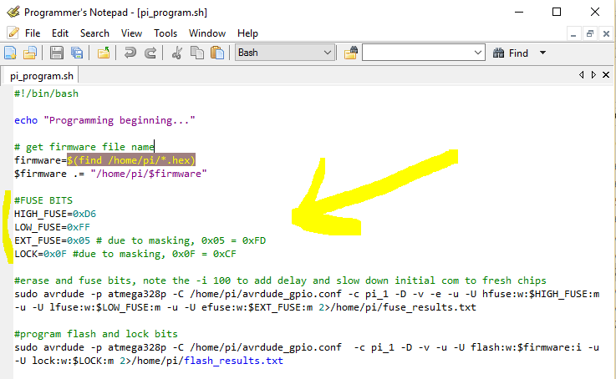

  - Note, AVRDUDE will not let you write to “unused” bits. This effects how we write to the EXT and LOCK bits:
        - If you want to write the value “0xFD” to the EXT bit (which is a common value we write on a lot of 328 based arduino products), then use the value “0x05” in AVRDUDE.
          - The 3 bits on the right are the only ones we care about.
          - “0xFD” = 1111 1101
          - “0x05” = 0000 0101
        - If you want to write the usual “0xCF” to LOCK, then write 0x0F” in AVRDUDE.
          - The 4 bits on the right are the only ones we care about.
          - “0xCF” = 1100 1111
          - “0x0F” = 0000 1111

- Go get the hex file from the product folder.

- Copy the hex file and bash file onto your thumb drive.

Note, the hex file can be named anything (and so should be left the same as it was – for traceability). The bash file must be named exactly “pi_program.sh”. These should be the only two files on the thumb drive.
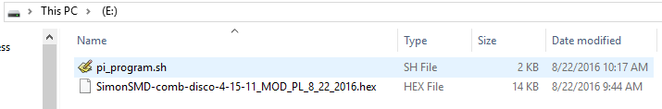

- Plug in the uSD card (with generic image) into your Pi.

- Power up your Pi with a microB USB cable (either a computer hub or wall wort).

- Wait for blinking stat LED. This indicates that bootup is complete and the python script is running.

- Take your prepared thumb drive (with hex and bash files) from your windows machine, and plug in your thumb drive into USB on the Pi.

- Verify the circular LED sequence happens twice.
  - One for hex file.
  - Second for bash file.
  - This verifies that the python script recognized the “media” device, found a “.hex” and a “pi_program.sh” file on it., and copied it to the local folder successfully.

- Remove thumb drive.
- Shutdown the Pi.
  - Press and hold the “SHUTDOWN” button.
  - All LEDs begin blinking.
  - When blinking stops, that means it has fully shut down.
  - Unplug power.

