

Index
Index 1
Features 2
Basic Ideas 3
Operational Description 4
Electrical properties 6
Absolute maximums 6
Thermal 6
Pin functions 10
Communication interfaces 10
User port I2C 10
User port SPI 13
User Port UART and Command Set 16
Expansion port 18
Arduino Library API Reference 20
Control registers 21
Memory map 21
Descriptions 24
Program Architecture 31
Slave Address Enumeration 33
State diagrams 34
Boot timing 35
re-enumeration timing 36
System Schematic 37
File Descriptions 39

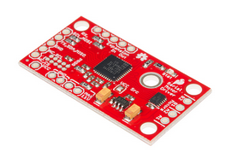
Serial Controlled Motor Driver (SCMD) Datasheet and Manual

This motor driver is intended to control small DC motors from microcontrollers and other small computers. It can be used alone or with other masters on a shared bus, or attached slaves. By controlling only the master, slaves receive data simplifying multi-motor designs.
The User Port is selectable to many modes by jumper, with additional settings available by register control.
The SCMD is designed to emulate a typical register-based device in operation. I2C, SPI, or UART can be used to directly operate on the registers, or, either the Arduino library or built-in UART parser can be used to deliver higher-level motor control.

Features
- 1.5 A peak drive per channel, 1.2 A steady state
- Operates from 3 to 11 volts with 12v absolute max
- 3.3v default VCC and logic
- Max VCC in of 5.5v
- 127 levels of DC drive strength.
- Controllable by I2C, SPI, or TTL UART signals
- Direction inversion on a per motor basis
- Global Drive enable
- Expansion port utilizing I2C, allows 16 additional drivers
- Exposed TO-220 heat sink shape
- Several I2C addresses, default UART bauds available
- Bridgeable outputs
- Optional fail-safe and diagnostics available.
- Configurable expansion bus bit rate to 50, 100, or 400 kHz.
- Configurable expansion bus update rate from 1ms to 255ms, or by command only

Basic Ideas
Communication Perspective
A single driver board is capable of being expanded by adding one or more slaves. Illustration 1 shows a master connected to a slave, with the user controlling by microcontroller or computer.
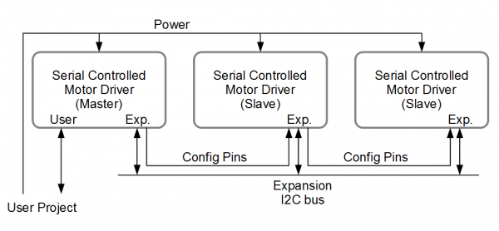Illustration 1: A basic topology

To avoid confusion, a few terms are defined here.
User Port – Connects the user’s project to the master SCMD and is unused on slaves.
Expansion Port – Connects a single master and up to 16 slaves, and should never be connected to the user’s project.
Master – The SCMD which is connected to the user’s project. Also, it is the I2C master on the expansion port
Slave – A SCMD which is only connected to a master SCMD by way of the expansion port.
Note: The config in and out pins of the expansion port may sometimes be connected to the user’s project for error checking and mitigation purposes.

Motor Polarity – The driver and this document often omit motor polarity. This is because polarity to spin direction is not standardized, and it is assumed the user will attach them backwards 50% of the time. Each motor channel is independently configurable for what is thought of as ‘forward’ spin by command. It is assumed that the user will first attach the motors, then decide which channels need to be inverted and issue inversion settings at boot time.

Numbering – Each SCMD has two channels, A and B. When they are bridged the B channel becomes a duplicate A, and the drive is doubled.
Motors in a chain of several motor drivers are all referenced by motor number, starting from master's A channel as zero, B as 1, then the first slave's A channel as 2, and so on up to motor 33. When a driver board is bridged, it still has both motor numbers associated with it, however controlling what was the B channel will have no effect.
When performing bridging, driver board are numbered 0 to 16. The master is driver number 0, the first slave is driver 1, etc.

Operational Description
Brief
The main elements of the motor driver are a microcontroller and dual H-bridge driver, with a voltage regulator for the logic end of things.
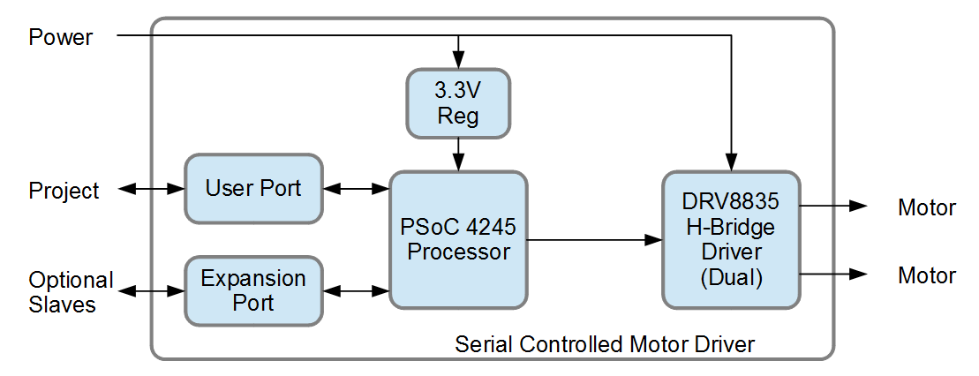
The SCMD has been designed to emulate a typical I2C or SPI peripheral. Inside, there is a set of memory locations named registers. By writing into some registers, the SCMD takes action. Other registers have data that can be used, but writing does not cause action within the SCMD. Generally, the SCMD sits idle waiting for changes to registers, then performs actions based on new data.
During boot, the SCMD captures the contents of the config jumpers into a register and uses that value to determine which serial configuration to choose. They are set by entering a number from 0 to 15 in 4 bit binary, with a solder jumper indicating a '1'.
The SCMDs are equipped with an expansion I2C bus, where they can be ganged to form a group of motors that can all be controlled by talking to the master only.
For I2C buses, pull-up resistors are provided and default disabled. The slave bus requires a single set enabled for any number of slaves. If I2C is used, the user pull-up jumper must be closed, or pull-up resistors supplied externally.
The SCMD has been released with an Arduino library that performs high level functions by writing the correct registers, and can ease demonstration. The library also has functions to read or write the registers directly.
Register access safeguards
Certain registers are designated "User unlockable". These registers contain configuration data for the current application. To prevent accidental writes a user lock register exists. When the user lock contains the user key byte, the user lock registers can be written to. The default is unlocked.
Registers that are designated read-only are actually also writable, to no documented end. A global lock exists to allow writes to these addresses. Note that the global lock is protected by the user lock, so both are needed to allow write access.
Slave operation
Multiple SCMDs can be connected to create a group of controllable motors. In this case, certain registers within the master cause changes to the slaves.
Writing to the drive registers in the master do not instantly update the drive levels. Instead, the master saves the new drive levels and sends them to the slaves on a periodic loop (configurable rate or by manual request). There are 34 registers that contain drive levels for each of the possible motor numbers. Writing to any of these registers in the master causes that motor in the slave chain to match the drive level after the next transmission.
Writing to the "Global setting" registers cause immediate action. The register contents will be applied locally and then sent out to the slaves.
H-Bridge driver control
The H-Bridge driver is essentially a dual, two leg totem pole drive with control logic. The default power-on state is to have the drives completely disabled with all 4 outputs at zero. Configuring the SCMD causes the driver to connect to two PWM generators, choosing polarity and source. They can be configured such that both outputs will be time and duty synchronized, allowing bridging of the output terminals for double current.
Power-on enumeration
When power is first applied, the master operates at the selected serial configuration and address, and all slaves exist on an address that is not used. When the master is ready, it triggers the first driver to move to a polling address, and accept an assigned address from there. In turn, each slave receives an address in this manner.
When the master can't get a response within a set number of tries, enumeration stops and the master is ready to accept control.
Fail safe operation
The default operation of the SCMD is to simply drive the motors at the last level indicated until another command come in. To prevent run-away situations a Fail safe is implemented. When configured, the drivers will remove power to the outputs if the serial bus remains inactive for a period of time, which can be set up to 2.5 seconds.
The config in pin on the master and slaves can also work as a reset line. For the slaves, bringing the line low. resets the device. For the master, pulsing the line can cause either low-level reboot or re-enumeration of the slaves.
Using these two features, a system can be made to recover from many situations.
Status LED
There is a single LED on the motor driver, that blinks to indicate status, and blips to indicate serial port activity. A normally operating blinks once with much space inbetween while an error state will be displayed as a fast group of flashing. Reception of data will cause a slight blip in the LED. When a steady stream of data is being received, the LED will display dim with the other status message overlaid.

Electrical properties

Absolute maximums
The data in Table 1 reflects a combination of the components on the SCMD.

Table 1

Thermal
The temperature rise of the driver IC is related to the current in the motors. To determine the load, attach motors directly to a power supply and apply torque to approximate the application conditions. Illustration 2 show measured steady state temperatures of three heat sink configurations at various loads. It can be used to approximate the operating temperature determine acceptable cooling.
It is foreseeable that the SCMD will be attached to something with a great thermal mass or chassis, but not have adequate airflow or outward conduction paths. To test this, a SCMD is attached to a 3/4 x 1/2 x 3 inch aluminum bar and is set to drive 2 amps total output current. Illustration 3 is a graph of the IC temperature. It is an emulation of a worst case chassis-mounted or semi insulated uncooled application.
Illustration 4, Illustration 5, Illustration 6, and Illustration 7 show the configurations for the tests. For steady state tests the hood was used to stabilize the air surrounding the EUT only, and had a large opening.

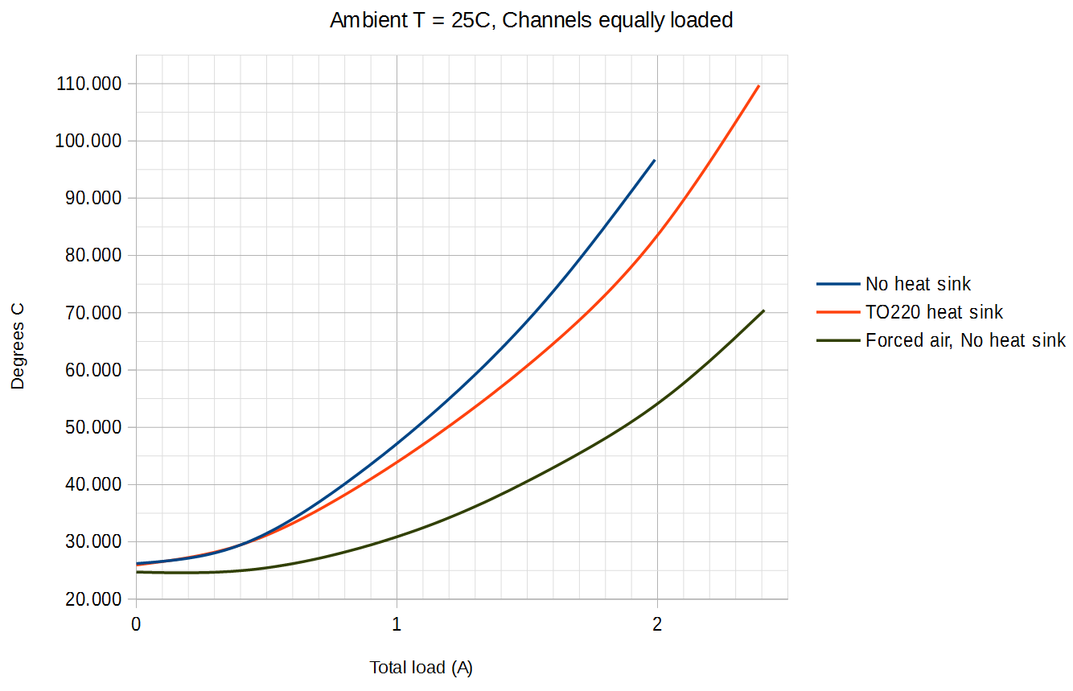Illustration 2: Temperature rise as a function of total driver load
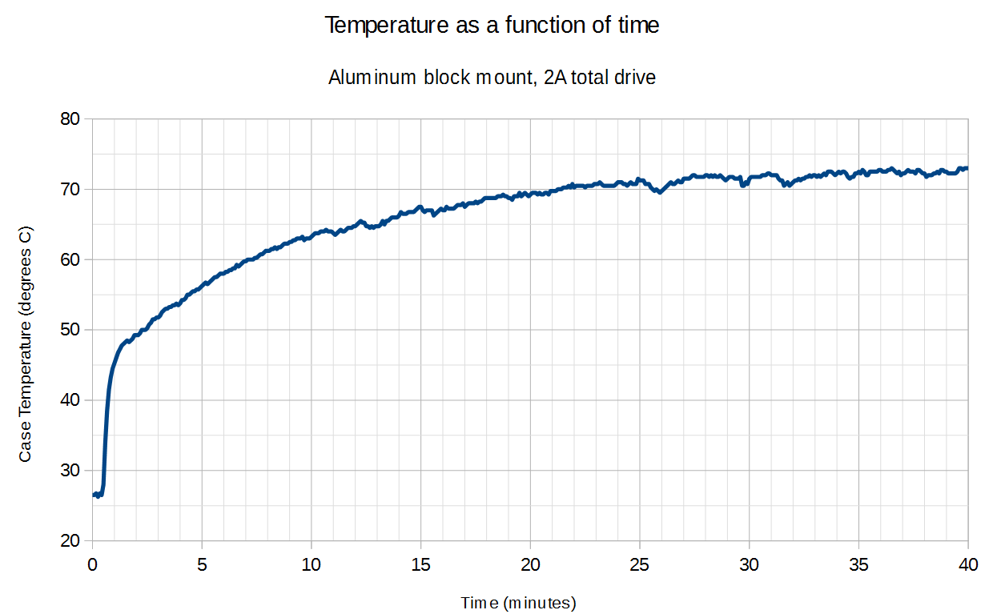Illustration 3: Using a thermal mass as heat sink

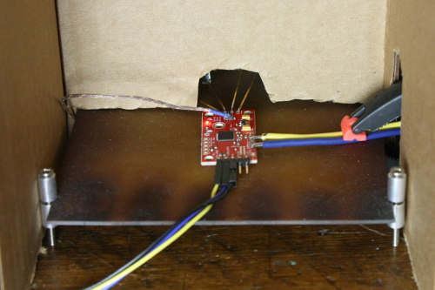Illustration 4: Uncooled test
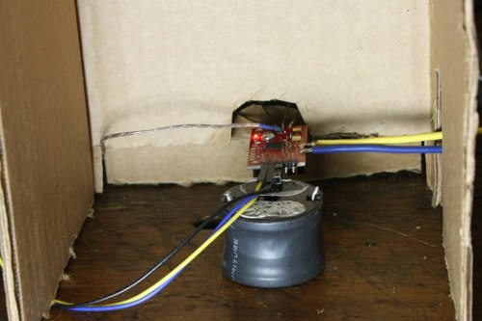Illustration 5: TO220 heat sink
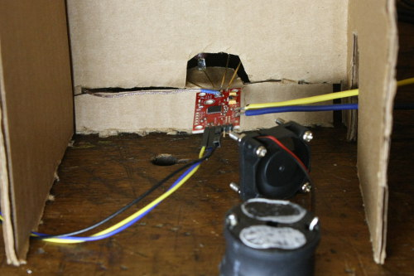Illustration 6: Forced air cooled test

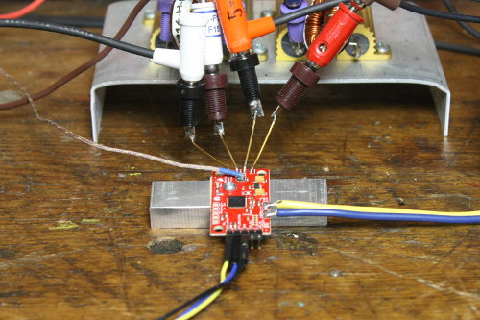Illustration 7: Thermal mass test

Pin functions
The 0.1” PTH on the board are described here.
Table 2: Pin functions

Communication interfaces
The user port can operate as I2C, SPI, or TTL UART.

User port I2C
In I2C mode, the SCMD emulates the standards for bus hardware and timing, but is a little different when it comes to actual getting data from the device. The PSoC is not configured to directly read from its memory with the serial peripheral, and the I2C busy is not used. Reading from the device requires two bus operations, one to set the address and prepare the data, and one to get the data back.
Write operation
Write operations are straightforward. To write a byte of data, send the write command with address (Address with cleared read bit), address to write, then data to write.
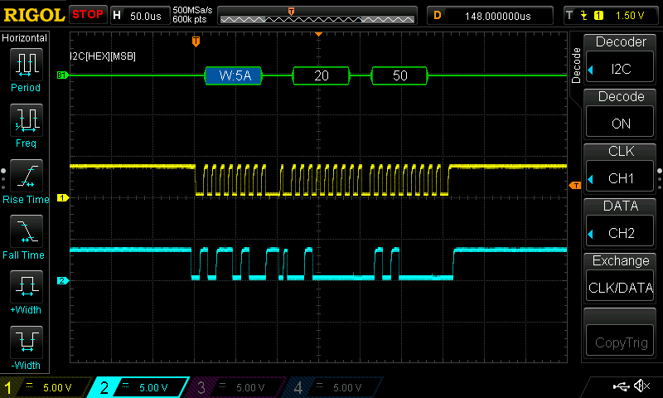Illustration 8: A write operation on the user port by I2C
//Write the byte
Wire.beginTransmission(settings.I2CAddress);
Wire.write(offset);
Wire.write(dataToWrite);
Wire.endTransmission();

Read operation
To read from the SCMD, send two commands. The first is a write command with address byte, but no data. The next is read command with set read bit, and 1 byte requested. The returned data will be at the data location specified in the previous write command.
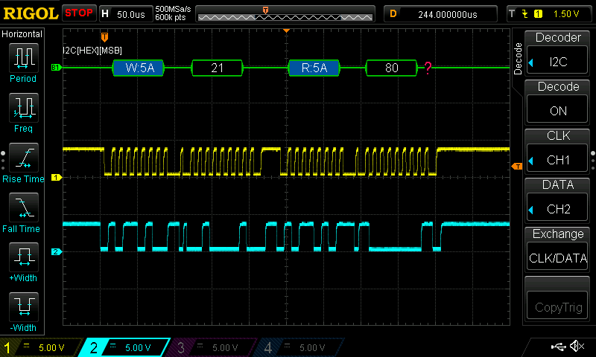Illustration 9: A read operation on the user port by I2C. Offset 21 is retrieved from I2C address 0x5a, and the data is 0x80
Wire.beginTransmission(settings.I2CAddress);
Wire.write(offset);
Wire.endTransmission();
Wire.requestFrom(settings.I2CAddress, numBytes);
while ( Wire.available() ) // slave may send less than requested
{
result = Wire.read(); // receive a byte as a proper uint8_t
}

User port SPI
Like SPI mode, the SCMD emulates the standards for bus hardware and timing, but is a little different when it comes to actual getting data from the device.
SPI mode can operate up to a 1 MHz bit rate, but requires 20 us delay between operations. The bus operates in SPI mode 0, with a low-idling clock and data being sampled on the rising edge.
Illustration 10 shows an example transfer at the max allowed speed, 1 MHz. It can be seen that MOSI data (trace 2) is asserted for the low period before the clock line is raised, and location 0x16 is being accessed for read. The MISO data (trace 3) shows data that was left over from a previous transfer (it will be discarded), but serves to illustrate that the SCMD sets bit values in response to a falling clock. The propagation delay can be seen well at the horizontal marker.

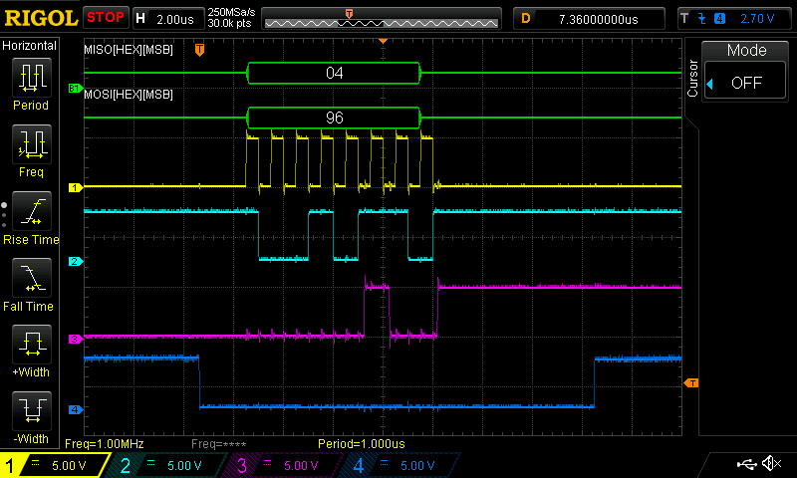Illustration 10: An example SPI transfer showing clock and data alignment
Write operation
Writing to the bus operates as would be expected for SPI, with memory address and mode combined into the first byte, and a following byte of data. After the transfer is initiated by the master, at least 20us should be given before attempting further access.
(Note: the Arduino library adds 50us delay by for-loop counting)
Illustration 11 shows a complete write operation. The master requests to write address 0x20 with data 0xA0. The returned data is discarded.
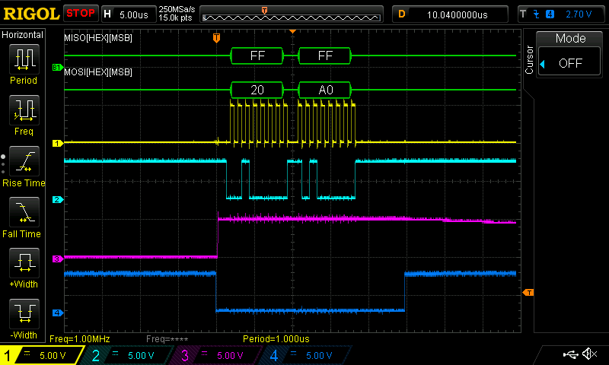Illustration 11: A complete SPI write operation
Read operation
Reading requires a read to the target address with the MISO data being discarded, then a second read to any address. The MISO data from the second read will be the data at the first location. Afterward, the master should wait 20us before further access.
(Note: the Arduino library adds 50us delay by for-loop counting)
Illustration 12 shows a complete read operation. The first transfer causes the SCMD to collect the data in the requested register (0x01, but with read bit set so it appears to be 0x81), which is available on the next read operation. The contents of 0x01 (the ID register) are then returned after the necessary delay.
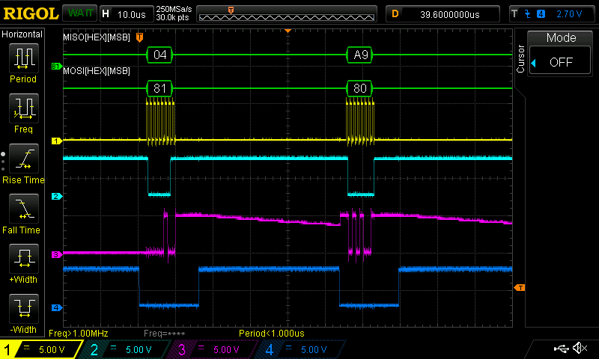Illustration 12: A complete SPI read operation

User Port UART and Command Set
The command parser is built to accept short strings of ascii data, compacted to reduce data transfer size while being easy to handle by standard UART hardware. The general form is a letter indicating which operation to perform followed by a series of numbers and letters, and finally a carriage return and line feed. As a string, an example command would be “M0F50\r\n”.
Return codes:
Overflow (“ovf”): The input buffer is filled. Send delimiter to clear buffer
Invalid Syntax (“inv”): The first character in the command is not one of the defined prefixes.
Formatting Error (“fmt”): There was something generally wrong with the command, like it had the wrong number of characters or an out of range value was detected.
No Motor (“nom”): The motor’s number is past the most downstream slave detected.
Drive motor:
Mndl
n = motor number, single or double digits
d = direction, R or F
l = level, 0 to 100

Example:
"M1F34\r\n" – Drive master motor B forward at 34%.
"M2R80\r\n" – Drive slave motor A reverse at 80%.

Invert motor polarity:
MnI
n = motor number, single or double digits

Example:
"M1S\r\n" – Invert the polarity of motor 1.

Un-invert motor polarity:
MnU
n = motor number, single or double digits

Example:
"M1U\r\n" – Set polarity of motor 1 to default.

Write register:
"Wrh"
r = two digit hex address
h = two digit hex data

Example:
"W20FF\r\n" – Write 0xFF to register 0x20 (MA_DRIVE).

Read register:
Rr
r = two digit hex address

Example:
"R01\r\n" – Read address 0x01 (ID), bus will display "A9", ID word of 0xA9

UART Baud:
Un
n = baud rate selection

Rates supported:
1 – 2400  2 – 4800  3 – 9600 (Default for config = “0000”)  4 – 14400 | 5 – 19200  6 – 38400  7 – 57600 (Default for config = “1101”)  8 – 115200 (Default for config = “1110”)

Example:
"U3\r\n" – Set baud rate to 9600
"U8\r\n" – Set baud rate to 115200

Bridge outputs:
Br
r = Motor driver number, 0 is master, 1-16 is slave

Example:
"B0\r\n" – Bridge master's outputs
"B2\r\n" – Bridge the 2nd physical slave's outputs (motors 4&5)

Un-bridge outputs:
Nr
r = Motor driver number, 0 is master, 1-16 is slave

Example:
"N0\r\n" – Un-bridge master's outputs
"N2\r\n" – Un-bridge the 2nd physical slave's outputs (motors 4&5)

Enable/disable outputs:
E

Example:
"E\r\n" – Enable all outputs

Disable outputs:
D

Example:
"D\r\n" – Disable all outputs

Expansion port
The expansion port is designed to allow addition of up to 16 slave SCMDs. It contains an I2C bus, enumeration control IO, and a ground.
The config in and out pins are used to signal to a slave that it's time to accept an address, and to signal to the next slave that it's done, and that the next slave should accept an address. See Slave Address Enumeration for a full explanation.
The I2C bus can operate at 50, 100, or 400 kHz based on user configuration. The default speed is 100 kHz. Table 3 Shows the length of data on the wire. Turn around time before sending the next packet is always 150 us.
Table 3: Typical slave packet duration
During regular operation, the master periodically sends motor drive data to the slaves as a two byte payload. Illustration 13 Shows a data transfer to a single slave. It can be seen that the master writes two values of 80 (center) to slave address 0x50, at data address 0x20. The duration the master waits before sending new data is dependent on the UPDATE_RATE register. Table 4 Shows time between slave transmissions.
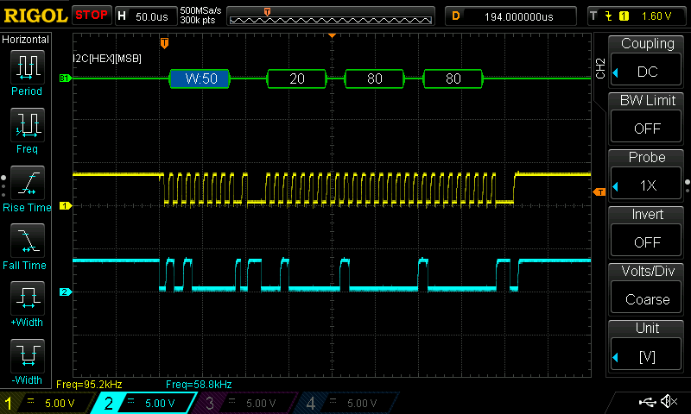Illustration 13: A single slave packet operating at 100kHz
FORCE_UPDATE can be used to send a packet at any time by writing a self clearing 0x01. When UPDATE_RATE is set to 0x00, this is the only way to update motor drivers, but it can be done during regular operation too, especially if long update times are used but more instant response is intermittently desired.

Table 4: Typical dead time between slave transmissions
To calculate max update rate for motors, use the following equation. It is important to note that the remote update loop is of low priority in the SCMD and that this is an approximation.:
T_cycle = (number_of_slaves * ( packet_time + 150us )) + idle_time
as an example, when 16 slaves are used at 400 khz at a UPDATE_RATE set to 0x01,
T_cycle = (16*(140 + 150) + 1500)us = 6.14ms
As seen in Illustration 14, the cycle count is close to the calculated approximation, but the dead time is longer than 1.5ms as expected.
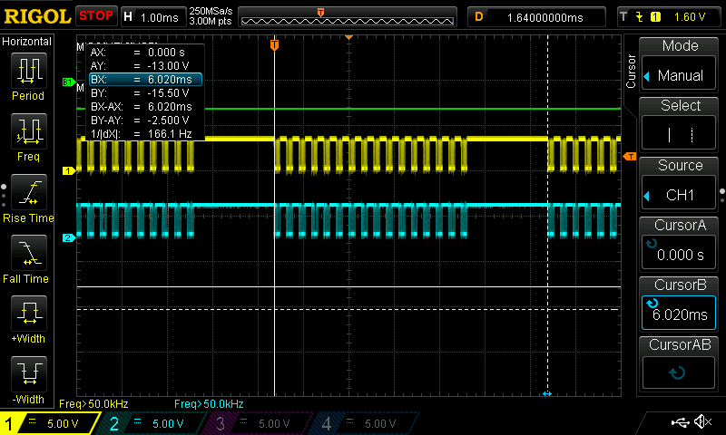Illustration 14: A complete cycle with 16 slaves attached, 400kHz bus speed, and 1ms dead time setting

Arduino Library API Reference

Control registers

Memory map
(Page 1 of 3)

(Page 2 of 3)

(Page 3 of 3)

Descriptions
0x00: FID
Reports firmware version. This corrisponds with the numbering within the gitub repository.
https://github.com/sparkfun/Serial_Controlled_Motor_Driver/tree/RevisionRepaired/Firmware/Releases
0x01: ID
Reports hard-coded ID byte of 0xA9
0x02: SLAVE_ADDR
This register reflects the driver's address as a slave on the expansion bus only. Writing to it changes the address of the slave. This register is used by the master during slave enumeration.
0x03: CONFIG_BITS
Reflects jumper position on bottom of board, and controls how the firmware behaves on a fundemental level. This value should not be changed during operation.
0x04: U_I2C_RD_ERR
This reports number of times the PSoC's USER PORT serial device had a read error while in I2C slave mode.
Write 0x00 to clear.
0x05: U_I2C_WR_ERR
This reports number of times the PSoC's USER PORT serial device had a write error while in I2C master mode.
Write 0x00 to clear.
0x06: U_BUF_DUMPED
This reports the number of times the USER PORT's RX buffer abandoned with data still in it, while in I2C or SPI mode. This can happen if data comes in too fast or if unformed garbage data is received.
Write 0x00 to clear.
0x07: E_I2C_RD_ERR
This reports number of times the PSoC's EXPANSION PORT serial device had a read error while in I2C slave mode.
Write 0x00 to clear.
0x08: E_I2C_WR_ERR
This reports number of times the PSoC's EXPANSION PORT serial device had a write error while in I2C slave mode.
Write 0x00 to clear.
0x09: LOOP_TIME
This register shows a measurement of internal processing loop time. It contains a peak value since last clear. The range is from 0 to 25.5ms, with a LSB worth 100 us.
Write 0x00 to clear.
0x0A: SLV_POLL_CNT
This register is used by the master to count the number of times it has polled for a slave. After enumeration is complete, this will read the max poll limit plus 1. (201)
0x0B: SLV_TOP_ADDR
This register reflects the address of the most down-stream slave, and is determined during slave enumeration. The master uses this value to determine how many slaves to broadcast to, and it is unused in the slaves. By comparing it with the #defined START_SLAVE_ADDR, the number of attached slaves can be determined by the user. Writing to this register will effect the depth of updates that occur, and should never need to be done.
If this register reads a value lower than the #defined START_SLAVE_ADDR, no slaves were detected.
0x0C: MST_E_ERR
Counts number of times a master had a general timeout on communication with the attached slaves.
Write 0x00 to clear.
0x0D: MST_E_STATUS
Reports the last error status response from writing a double value to the slaves.
0x0E: FSAFE_FAULTS
The failsafe ISR hit count. This is incremented every time the watchdog is not satisfied and the ISR is allowed to run.
Write 0x00 to clear.
0x0F: REG_OOR_CNT
This counts the number of times anybody tried to write outside of the range of available registers. This should always remain at 0.
Write 0x00 to clear.
0x10: REG_RO_WRITE_CNT
This reports the number of times anybody tried to write to a locked register. This is very useful to determine if the proper keys are being applied. If, after a program is run, this contains a non-zero value, the program is trying to write locked registers and is being denied.
Write 0x00 to reset.
0x11: GEN_TEST_WORD
This causes the current state of the config jumpers to be written to the REM_DATA_RD, for manufacturing test (but I suppose they could be used as general inputs if necessary.
Write any value to transfer the config jumper state once.
0x12: MOTOR_A_INVERT
0x13: MOTOR_B_INVERT
Motor inverts for the A and B channels. These are used on all boards, master and slave, to control the directions.
Writing 0x01 to either register causes the forward direction of that channel to be reversed
Writing 0x00 returns to the driver to default mode.
0x14: BRIDGE
This causes the channel B source mux to match channel A source in order to allow bridging.
Writing 0x01 to cause channel bridging.
Writing 0x00 to unbridge channels.
0x15: LOCAL_MASTER_LOCK
This register allows all other registers to be writable, for unknown effect.
Write 0x9B to allow free register use.
Write other values to lock read-only registers.
0x16: LOCAL_USER_LOCK
This register allows the configuration registers to be locked from inadvertent access. Anything that can change modes is protected by the user lock, and is unlocked by default. When locked, writing garbage data will invoke garbage motor movements but will not cause the configuration to be lost when correct data is returned. Any register with "USER LOCK" as "YES" can become read-only with this register. (Note: it is possible to accidentally write the user lock key to this register with garbage data.)
Write 0x5C to prevent writes to configuration registers
Write other values to allow writes.
0x17: MST_E_IN_FN
This sets the behavior of the master SCMD's config_in line, on the expansion bus. The user can attach a wire to config_in, program this register, and send a pulse to cause the following behaviors:
0x00: Config_in has no effect
0x01: Full restart – The SCMD will reboot.
0x02: Re-enumerate slaves and resend 'slave configuration' – The enumeration state machines will be restarted. When complete, the master's local copy of intended slave behavior will be vended to the slaves. This may be useful in a situation where slaves are dropping and reappearing on the bus, and a full reconfiguration is not desired.

0x18: U_PORT_CLKDIV_U
0x19: U_PORT_CLKDIV_L
These registers report the clock dividers applied to the serial component's input clock. The CLKDIV_U register contains the upper 8 bits of a 16 bit word, while the CLKDIV_L contains the lower.
Writing has no effect.
0x1A: U_PORT_CLKDIV_CTRL
This register controls the associated clock divider registers. Write any value to cause the values in the U and L registers to be combined and applied to the clock component. The associated serial device will be reinitialized.
0x1B: E_PORT_CLKDIV_U
0x1C: E_PORT_CLKDIV_L
These registers report the clock dividers applied to the serial component's input clock. The CLKDIV_U register contains the upper 8 bits of a 16 bit word, while the CLKDIV_L contains the lower.
Writing has no effect.
0x1D: E_PORT_CLKDIV_CTRL
This register controls the associated clock divider registers. Write any value to cause the values in the U and L registers to be combined and applied to the clock component. The associated serial device will be reinitialized.
0x1E: U_BUS_UART_BAUD
This register reports the current UART baud rate, as indicated by a number. This is used internally by the master, and is read when UART reinitialization occur. Writing has no immediate effect but may cause the baud rate to change during other operations. The UART "U" command should be used to change baud, and not be done here.
Modes:
0x00: 2400
0x01: 4800
0x02: 9600
0x03: 14400
0x04: 19200
0x05: 38400
0x06: 57600
0x07: 115200

0x1F: PAGE_SELECT
This register is reserved for future PSoC based components that may need to access multiple pages of register data. It currently has no effect.
0x20: MA_DRIVE
0x21: MB_DRIVE
The output driver PWMs are directly controlled by these registers.
Writing a value from 0 to 255 sets the duty cycle of the associated channels on any board, master or slave. Note: Writing a value of 0x80 sets the duty cycle to 50%, which will appear as off at the outputs. Write values up and down from there for forward and backwards drive.
0x22: S1A_DRIVE through 0x41: S16B_DRIVE
These registers are used by the master to hold the slave drive information. Setting these registers sets the next value the master will send to the slave's MA_DRIVE and MB_DRIVE registers. See UPDATE_RATE and FORCE_UPDATE to control how often this information is pushed out to the slaves.
This register is unused in the slaves.
0x50: INV_2_9
0x51: INV_10_17
0x52: INV_18_25
0x53: INV_26_33
These registers set the inversion mode for all slave motors, as a bit pattern.
Writing data to this register causes the data to be instantly transferred to the slaves. Setting a single bit in the register causes that motor number to be inverted.
When setting or clearing a single motor's inversion state, a read-modify-write operation should be done to maintain the existing configuration of other motors.
0x54: BRIDGE_SLV_L
0x55: BRIDGE_SLV_H
These registers set the bridging mode for all slave SCMDs, as a bit pattern.
Writing data to this register causes the data to be instantly transferred to the slaves. Setting a single bit in the register causes that slave number to be bridged.
When setting or clearing a single driver's bridging state, a read-modify-write operation should be done to maintain the existing configuration of other motors.
0x70: DRIVER_ENABLE
This register controls the driver enable line and can effectively remove all energy from the outputs.
Write 0x01: Enable this driver
Write 0x00: Disable this driver.
Writing data to this register as a master causes the master to send the configuration to the slaves. As a slave, writing data effects output drive only.
0x71: UPDATE_RATE
This register is used to determine how often to send data out to the slaves. The LSB is worth 1 ms, so the update rate can be set between 1 and 255 ms.
Write 0x00: Do not automatically update the slaves.
Write other values: Update at a rate of 1ms to 255 ms.
0x72: FORCE_UPDATE
When the UPDATE_RATE is set to 0x00, writing a non-zero value to this register causes the contents of the XXX_DRIVE registers to be send out to the slaves at the next available time (sent by enumeration state machines). This register is automatically cleared.
Write 0x01: Send the current drive values to the attached slaves
0x73: E_BUS_SPEED
Writing changes the expansion bus bit rate and reinitialize the bus for the master, and has no effect for the slaves.
Available speeds:
0x00: 50kHz
0x01: 100kHz
0x02: 400kHz

0x74: MASTER_LOCK
This is a global lock location for the LOCAL_MASTER_LOCK.
Writing a value to this register causes the master to apply that value to it's own LOCAL_MASTER_LOCK, and transmit the value to all attached slave LOCAL_MASTER_LOCK registers.
0x75: USER_LOCK
This is a global lock location for the LOCAL_USER_LOCK.
Writing a value to this register causes the master to apply that value to it's own LOCAL_USER_LOCK, and transmit the value to all attached slave LOCAL_USER_LOCK registers.
0x76: FSAFE_TIME
This register sets the watchdog timeout time, from 10 ms to 2.55 seconds. The LSB is worth 10 ms.
Write 0x00: Do not use the watchdog.
Write other values: Set the watchdog timeout time to 10ms * value.
0x77: STATUS_1
This register uses bits to show status. Currently, only b0 is used.
Bit 0: Enumeration complete. Reads 1 if the master state machine has reached the fully enumerated state.
Bit 1: Busy. Reads one if the master is doing operations on the slaves.
Registers that set and clear the busy bit
- INV_2_9
- INV_10_17
- INV_18_25
- INV_26_33
- BRIDGE_SLV_L
- BRIDGE_SLV_H
- DRIVER_ENABLE
- MASTER_LOCK
- USER_LOCK
- FSAFE_TIME
- REM_WRITE
- REM_READ

0x78: CONTROL_1
This register can be used to issue low level orders to the system.
Bit 0: Reset the processor now. The slave chain will also be reset, and all configuration is erased.
Bit 1: Initiate re-enumeration of the slave chain. Afterward, slave configuration data is delivered to the slaves. Current slave drive levels are lost.
0x79: REM_ADDR
Write the address of the slave to communicate with.
0x7A: REM_OFFSET
Write the register number to access of the slave.
0x7B: REM_DATA_WR
Write the data that will be written to the slave REM_OFFSET register, at the REM_ADDR.
0x7C: REM_DATA_RD
Read data from the slave REM_OFFSET register, at the REM_ADDR will be contained here.
0x7D: REM_WRITE
Write any value to initiate a remote write operation. The data in REM_DATA_WR will be written to the slave at REM_ADDR, at address REM_OFFSET. This register will be set to 0x00 automatically
0x7E: REM_READ
Write any value to initiate a remote read operation. The data in the slave at REM_ADDR, REM_OFFSET memory location will be copied to the REM_DATA_RD location, and this register will be automatically cleared.
Wait 5 ms before reading the REM_DATA_RD register to allow the expansion bus to fetch the data.

Program Architecture
The firmware is written to emulate a I2C or SPI peripheral. The register map is the core of the operation, and is surrounded by function calls that operate on the data. This allows the memory controller to report changed status of memory, and to record misuse of the memory.
During initialization, the SCMD:
- Clears and prepares the user space memory, setting default values and lock states
- reads the config jumpers
- Configures default hardware, isr and timer operation
- Initializes the PWM generators
- Calculates serial clock rates based on config jumpers
- Initializes its serial peripheral blocks based on config jumpers
After the SCMD is initialized by the boot and initialization calls, it runs a loop that takes the following actions:
- Calls appropriated serial reception parser (or leaves it up to the hardware ISRs to call)
- Steps the master or slave enumeration state machine
- Deals with changed register data
- Checks for, and deals with, changes to hardware reset functions
The config jumpers change the general behavior and role of the expansion port based on slave or master mode. Both roles function the same regarding memory access and H-Bridge driver operation, but the master has more registers that are checked for changed values, and transmits data to the slaves if necessary.
Illustration 15 shows how the master behaves. During master operation the user port directly controls the memory, and the master enumeration state machine is active. This state machine chooses how and when to deal with changing data and serves to look for slaves on the expansion bus.
Illustration 16 Shows how a slave behaves. The expansion bus then deals with the memory directly, and the slave enumeration state machine is active. It is a matching state machine to the master and waits to be discovered, then does things based on the data it has available.

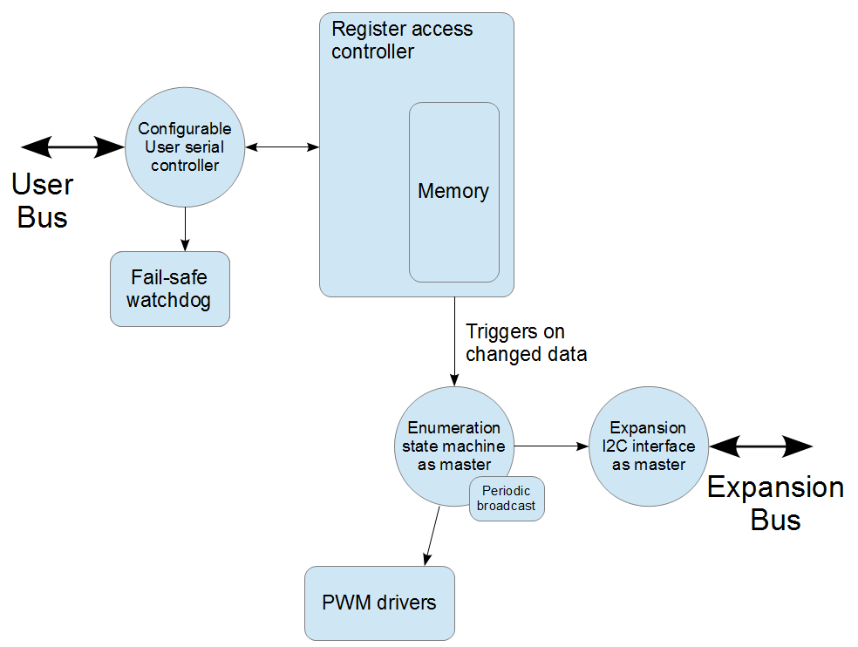Illustration 15: Topology of a SCMD as a master (or single)
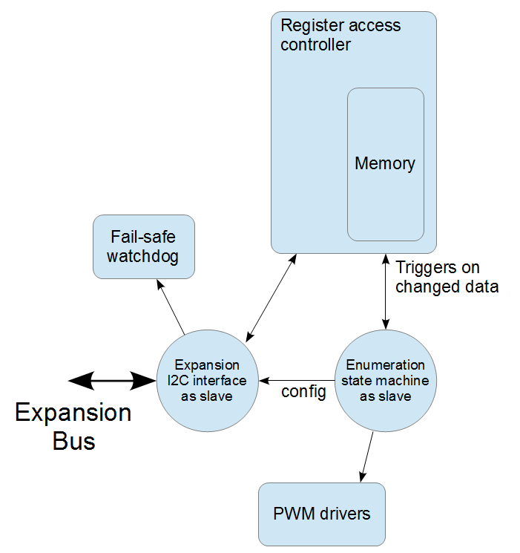Illustration 16: Topology of a SCMD as a slave

Slave Address Enumeration
When the master is explores the expansion bus, it assigns addresses to the attached slaves. This happens after a fresh power up, or by master config_in when MST_E_IN_FN is set to 0x02 for bus re-enumeration.
All slaves boot with the address 0x10 programmed into their I2C interfaces. 0x10 is reserved as an address that should never be accessed, it can have multiple devices with the same address at boot.
After a time delay, the master asserts the config_out line. Upon detection by the first slave, that slave switches address to 0x4A, the general poll address.
The master then polls 0x4A by looking for a valid ID word. When found, the master assigns an address to the slave at 0x4A. This causes that slave to assert their config_out line, readying the next slave. The master then assigns the next available address and the cycle continues.
The operation is complete when the master fails 200 times to get an ID word, or if the programmed max slave address is reached. The SLV_TOP_ADDR is programmed with the address of the last slave in the chain as a way of counting how many slaves are present.
Illustration 17 shows actions taken by the master and slaves during enumeration. Arrows indicate direction of information flow within the system.
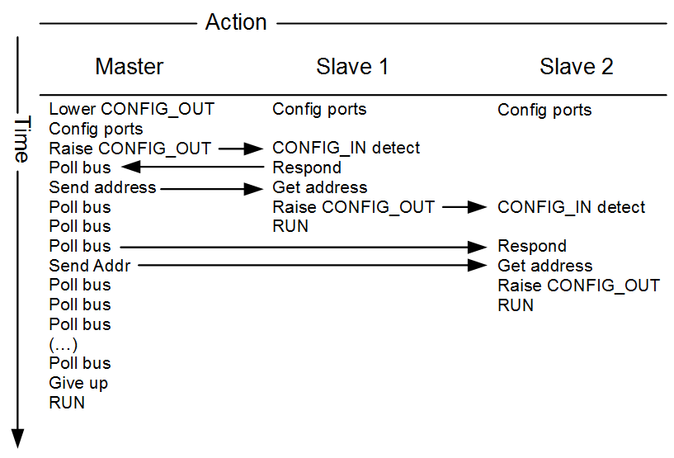Illustration 17: Actions and communication of the expansion bus

State diagrams
The master and slave state machines work together to accomplish I2C handshaking. These two diagrams implement the handshaking outlined in Illustration 17.
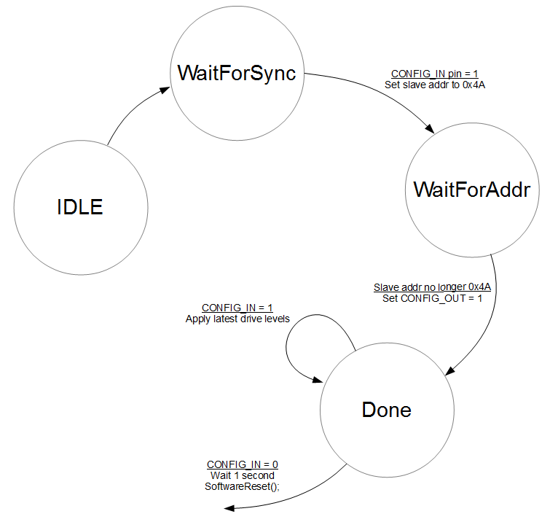Illustration 18: The slave enumeration state machine

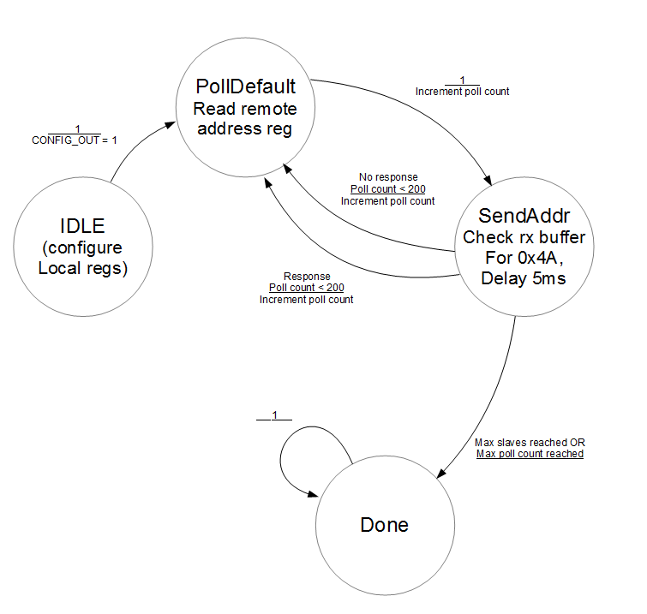Illustration 19: The master enumeration state machine

Boot timing
When the SCMD first receives power, the slaves get ready to accept a config in request as soon as possible, and the master waits 1 second before beginning to look for slaves. If the slave powers up more than a second before the master it will not be enumerated.
The behavior can be emulated by writing to the CONTROL_1 register's FULL_RESET_BIT.
Illustration 20 shows the timing of a master and 2 slaves power up and enumeration. The user should take care to not attempt to command the motor driver until it has reached completion of boot, while read access will be valid earlier.
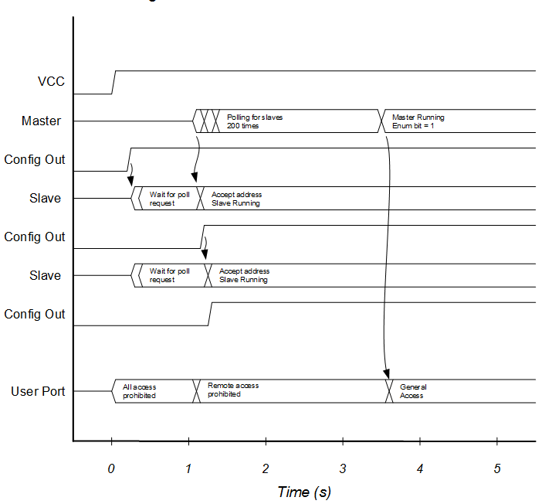Illustration 20: Power on and full reset enumeration behavior.

re-enumeration timing
CONTROL_1 register's RE_ENUMERATE_BIT causes the master to bring the config out line low to reset the slaves. Then it waits 1 second, resets its state machine, and enumerates the slaves.
After completion, the master vends the global configuration to the slaves, which should return the slaves to their pre-re-enumeration state.
Illustration 21 shows a pseudo-timing diagram of a master re-enumerating 2 slaves. During this process, the user should treat SCMD as if it was freshly booting, and not issue commands right away.
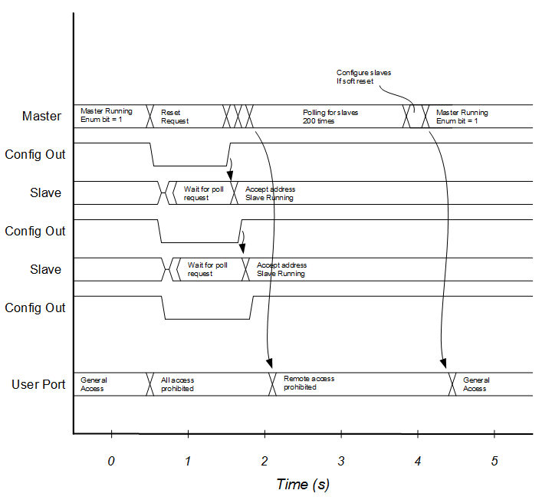Illustration 21: Re-enumeration behavior.

System Schematic
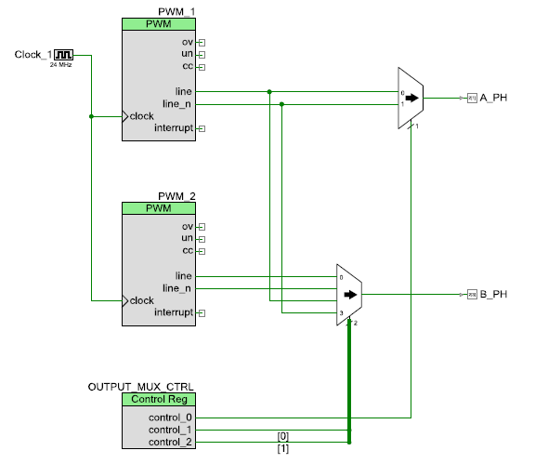
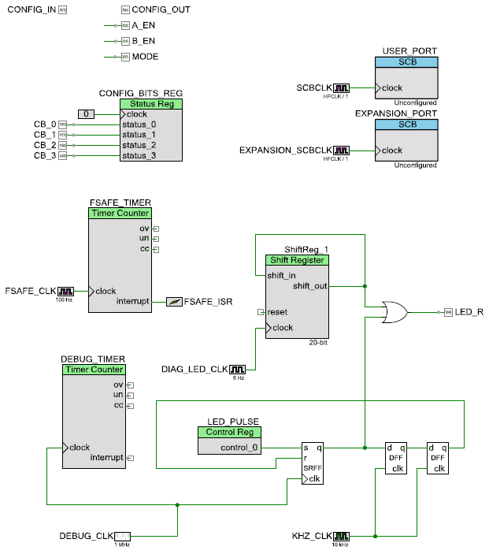

File Descriptions
registerHandlers.c
registerHandlers.h
Register handlers check for new changes to registers and take action accordingly. Each "active" register is checked, does its tasks, then resets the indicator.
devRegisters.c
devRegisters.h
The memory space used for the registers is defined here, along with a table of control bits for new data checking and lock control. Memory access happens through a set of functions that operate on the table, but prevent unauthorized access and report invalid counts.
serial.c
serial.h
Functions to configure and operate the serial. The serial dividers are calculated by one function, then initialized with another. Contains function to read and write slave data by address. Also contains PSoC configuration structures and application.
customSerialInterrupts.c
customSerialInterrupts.h
Contains routines for dealing with incoming data on each of the bus types. This includes parsing the UART data and taking appropriate actions. The SPI ISR redefines the generated API ISR at the hardware level but the others are called from within the stock ISRs.
SCMD_config.h
Register common names. These are named as in this document with a prefix of SCMD_. Some #define masks and defaults are also defined here. This file should be consistent to the one used by the Arduino library.
slaveEnumeration.c
slaveEnumeration.h
Master and slave state machines for enumeration. Contains code to self-reboot and reset.
main.c
Interrupts and initialization. The main processing loop is in this file.
charMath.c
charMath.h
Light weight ascii conversion.
diagLEDs.c
diagLEDs.h
Control functions for the LED digital logic.

