Module Six Milestone: Flip Phone Prototype

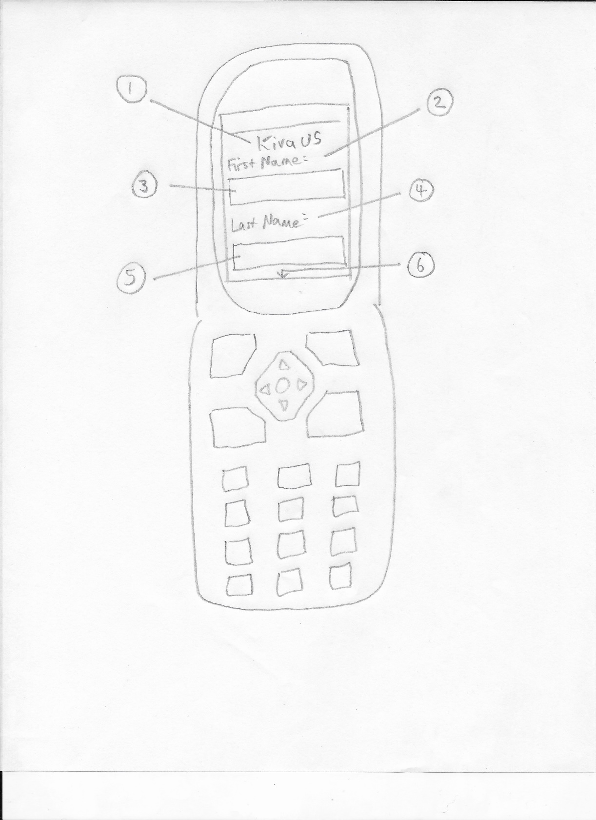

|  |  |
| --- | --- |
| 1. Title | 1. First Name Label |
| 1. First Name Text Entry Field | 1. Last Name Label |
| 1. Last Name Entry Field | 1. Additional Form Fields Below (Scroll) |

In the prototype picture above

For this prototype and app design I have considered the facts that the borrowers are most likely and unfortunately, quite poor. The main purpose for the borrower is simply to achieve a loan through crowd funding. It is unlikely that the borrower will be interested in the other borrowers. The lenders on the other hand will be interested in borrowers because the lenders will want to know where their loaned-out money is going.

The app for the flip phone is not suitable for the lenders as the amount of information the lenders want to see is larger than makes sense for such a small device.

Another issue is that in December 2022 the last 2g service provider stopped providing 2g service. This was T-Mobile. They stopped offering service for 2g only devices. Almost all flip phones are 2g only devices. The ones that aren’t usually run android or some other modern smart phone operating system. That being said, smart phones are readily available worldwide. I’ve been to Ghana I know this is the case.

But, going with the idea that the flip phone would be used, the ones that would use it are the borrowers and out of the data they would want to access the borrowers would most likely want to see their own loan status.

Beyond that they might want to see how much needs to be paid back and when it is due. They might want to see a graph which displays how many lenders participated in their loan once it has been funded. This can be accessed by way of a button which will then display a screen with the graph. The button would likely be on the screen with loan the loan information one the loan has been funded.

In the prototype picture above, I used information from the Kiva site to determine what the borrowers need to see in order to be able to apply for their loan. The title is necessary because it is important for the borrower to see that it is Kiva that is organizing the group fund. Then there are labels to show what each text field is for. The user would scroll down to enter other information such as loan amount and possibly time frame for paying back the loan. There would be a submit button at the bottom of the application.

Following Kiva’s code of conduct the app will keep data in sync with the API. The data can be stored locally by downloading from Kiva but will be updated regularly to keep the data up to date and in sync with Kiva.

Another code of conduct to follow is ‘Be Your Own Brand’. This will be accomplished by making sure the branding doesn’t make the app look like it is an official Kiva product. Their branding can be used in the app design but it will not look like it was made by Kiva.