Mini Colecovision Compatible Portable Console with Super Game Module Compatibility.

QUICK START GUIDE

Console Startup:
- Insert Cartridge into the console (figure 3) while powered off.
- Power on console using the power switch (figure 3). Power LED will illuminate.
- Enjoy the game.
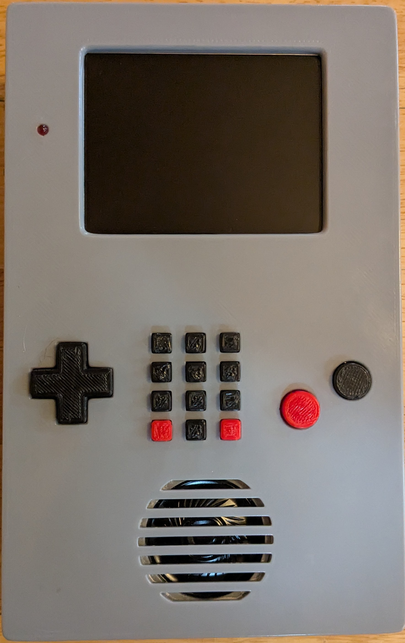Figure 1: FRONT
The front of the console (figure 1) has the 3.5 inch LCD screen, power LED, first player controller, and speaker.
When powered the LED will illuminate. The LCD screen will display graphics.
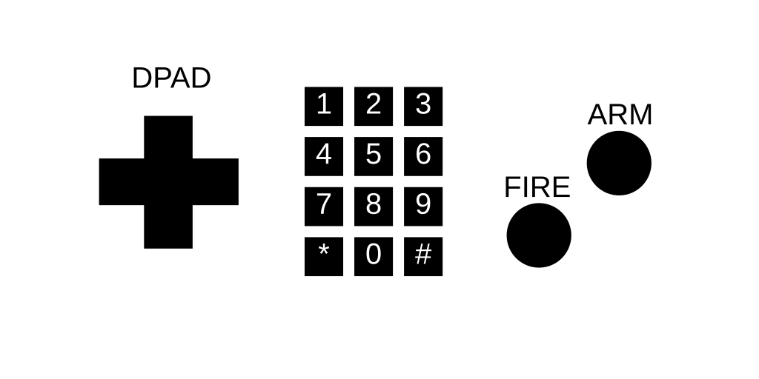Figure 2: CONTROLLER

Figure 2 is the first player controller layout. This is similar to the original controller.

Headphone jack, power switch, and cartridge port are located on the top of the console (figure 3).
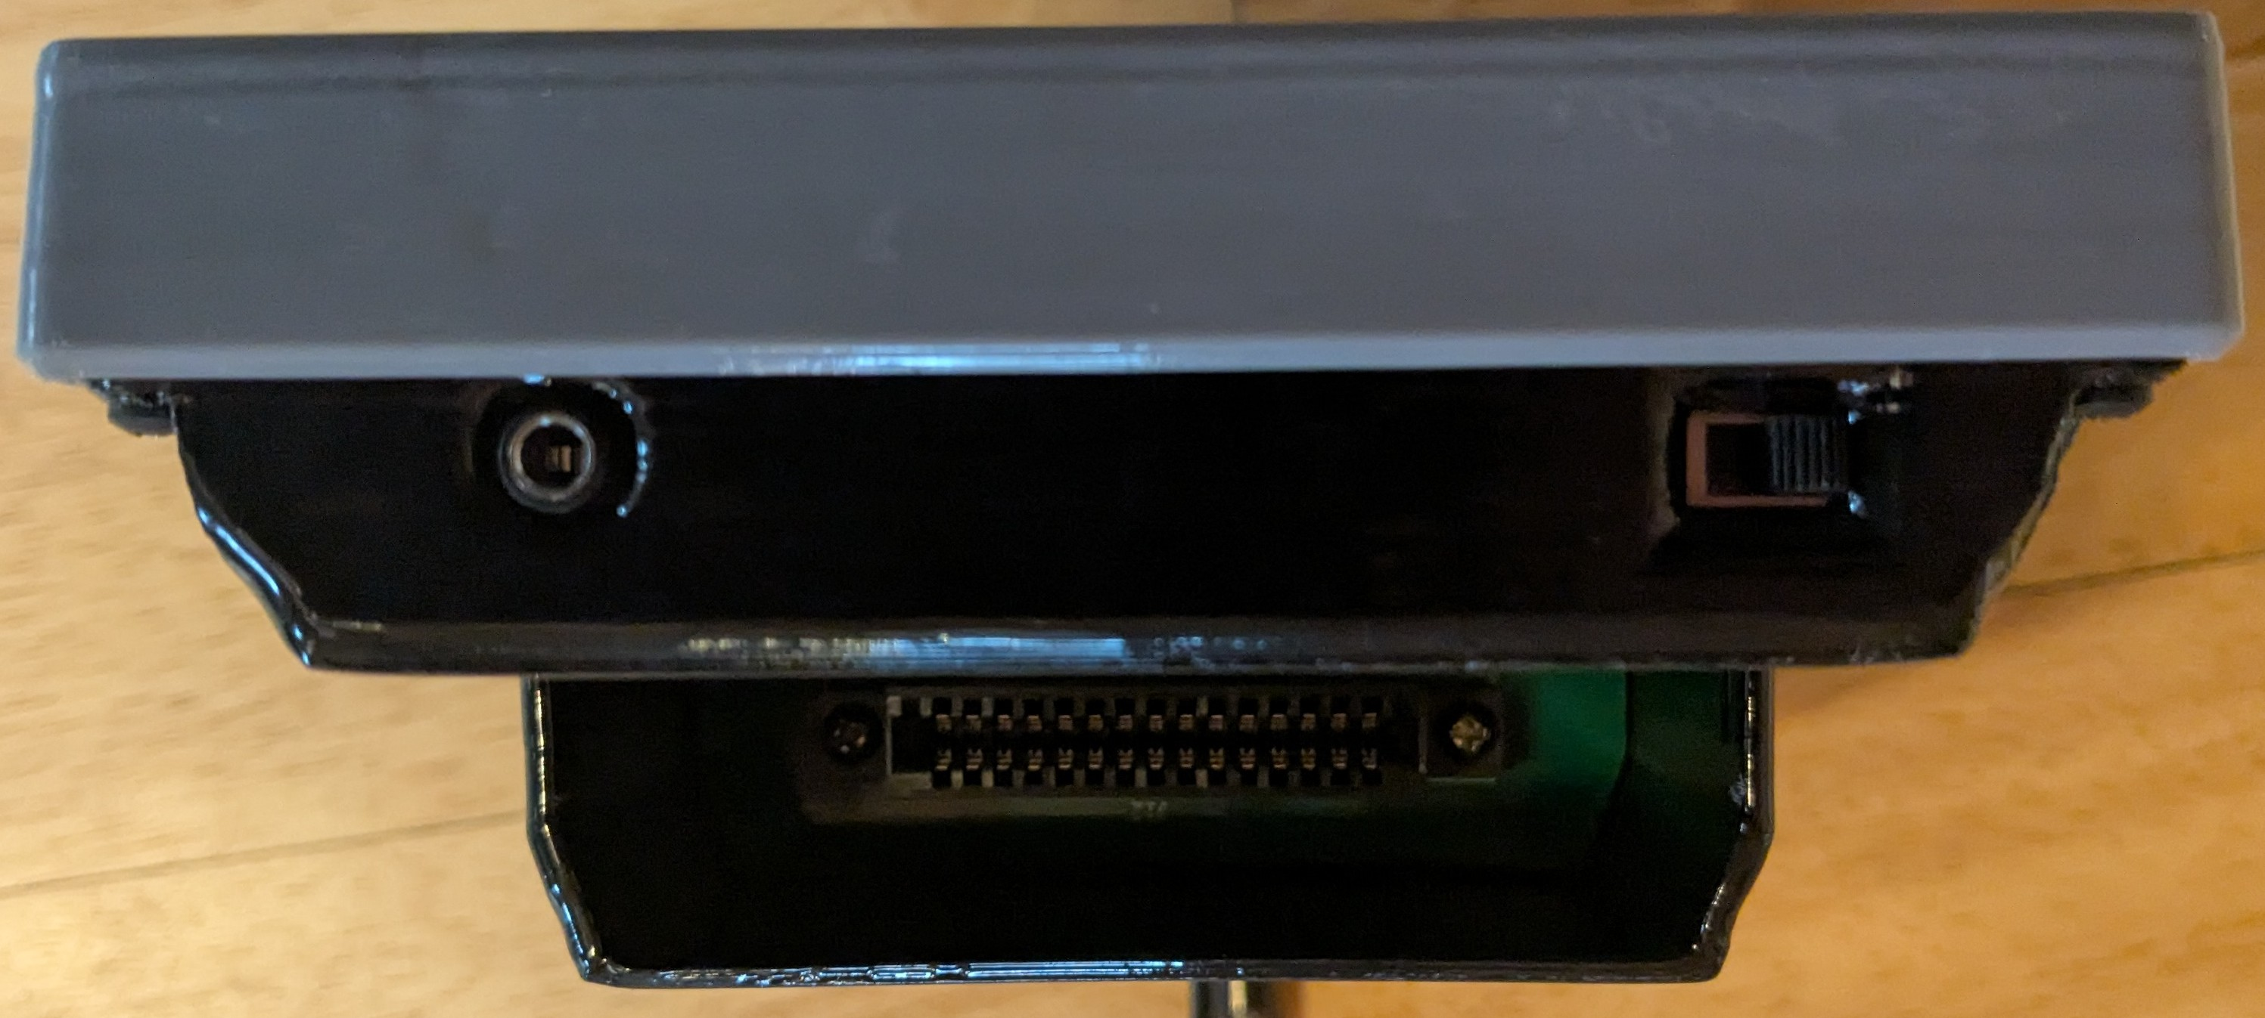Figure 3: TOP
The headphone jack, circular port to the left, is a stereo 1/8th inch jack. When headphones are plugged in the speaker will have no sound output
On the right side, is a power switch for turning the console on and off.

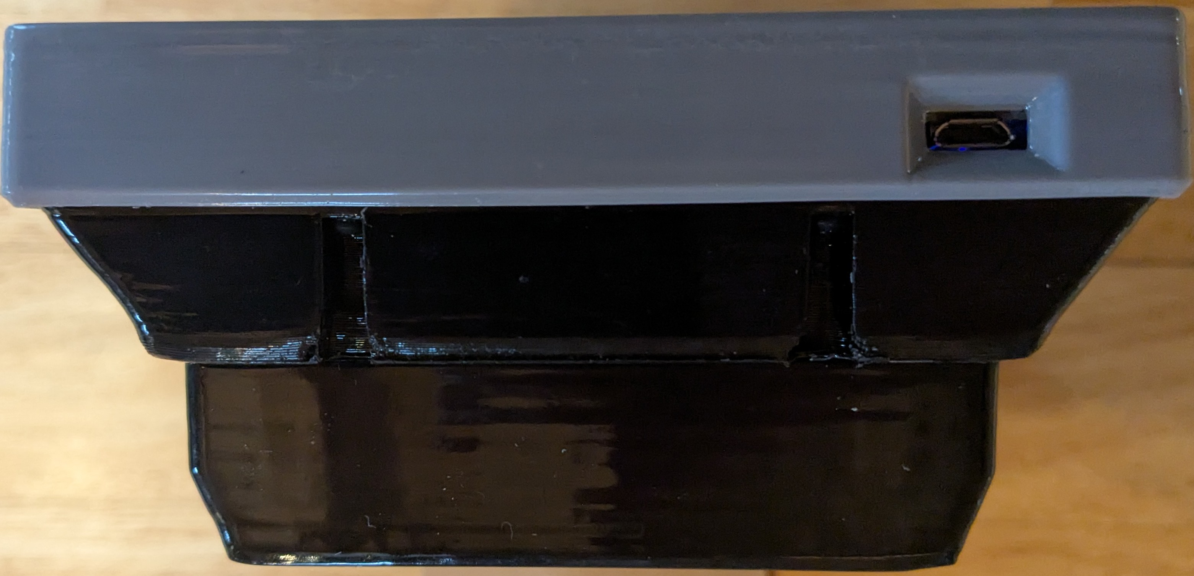Figure 4: BOTTOM
To charge the console, use the power connector on the bottom (figure 4). It is a mini-USB connector that uses a 5 volt 500 mA charger.

Console specific controls are located on the left side (figure 5). This includes a row of four round switches for adjusting the LCD screen. From left to right these are: Enter Menu/Select, Adjust Up, Adjust Down, Input Switch (useless, press if screen is black). The rest from left to right are a reset switch, controller select switch, and first player controller port.
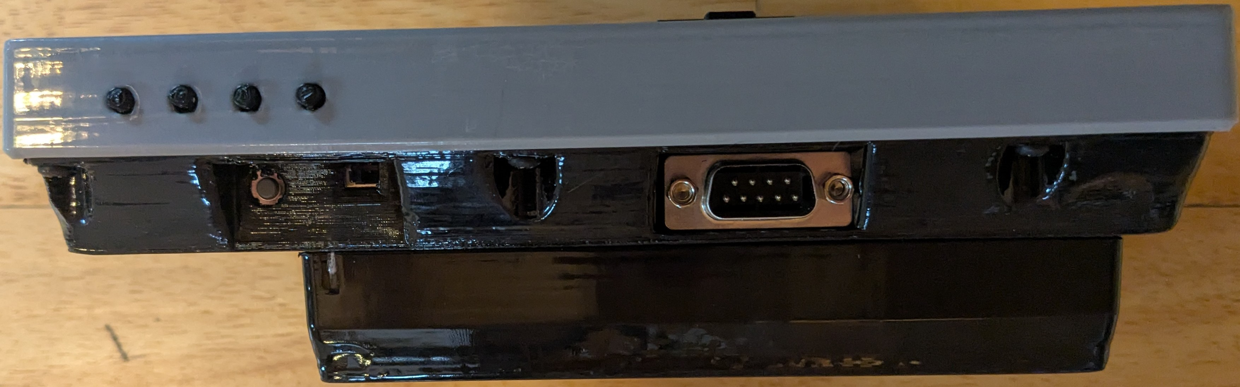Figure 5: LEFT SIDE
From the top, left side of figure 5, the round gray switch is for resetting the console. Next is the toggle switch for selecting the controller to use. When it is positioned towards the reset switch, it will use the internal controllers only. When positioned towards the controller port it will use the external controller ports only. Last is the left side controller port that is for the first player controller when the controller toggle switch is set to the external position.

The right side (figure 6) has few controls. The volume control thumb wheel, and second player controller port are located on this side. The volume control, at the top right, adjusts the sound level for the speaker and the headphones Second player controller port, at the bottom left, is only active when the controller toggle switch is set to external.
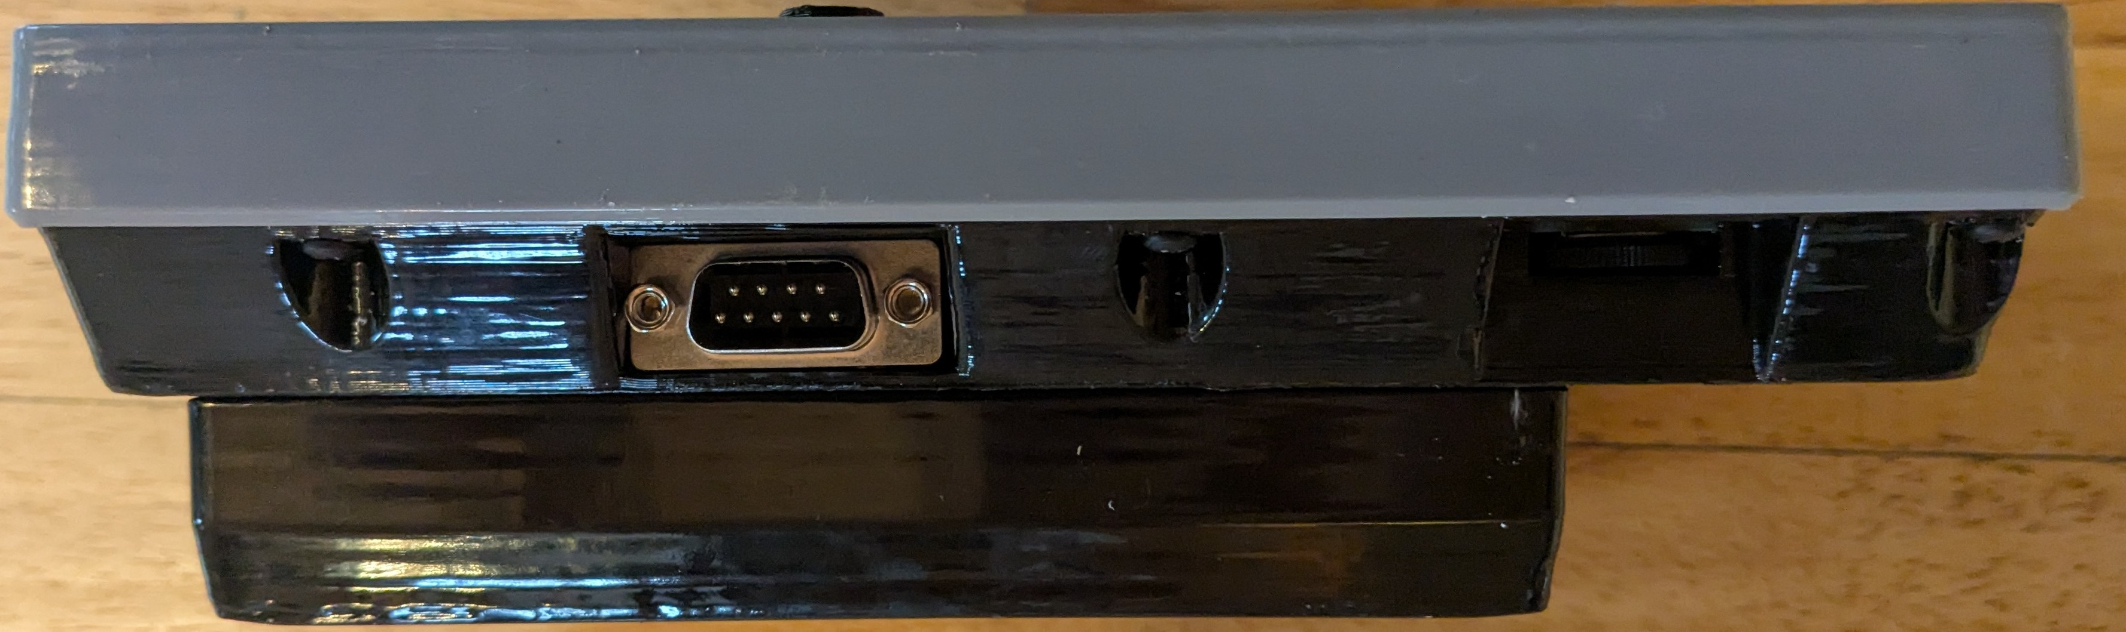Figure 6: RIGHT SIDE

SPECIFICATIONS:
- z80 CPU @ 3.56 MHz
- 32 KiB of RAM
- 8 KiB of ROM
- MAX7128 CPLD
- TMS9118 VDP
- SN76489 Sound Chip
- YMZ284 Sound Chip
- TPA711D Amplifier
- 3.5 inch LCD screen
- Colecovision Compatible
- Super Game Module Compatible

