Project Title | Reel Insights: An End-to-End Exploratory Data Analysis of the Global Movie Industry (TMDB)  SQL • Python (Pandas) • Visualization • Streamlit
Skills Takeaway | - Working with a multi-file relational CSV dataset (6 linked tables)  - Python (Pandas, NumPy) for data wrangling and feature engineering  - Data Cleaning & Relational Schema Design  - SQL & Relational Databases (MySQL / PostgreSQL / SQLite)  - Database connectivity using PyMySQL, mysql-connector-python, psycopg2, sqlite3  - Exploratory Data Analysis (EDA) — univariate, bivariate , multivariate  - Data Visualization with Matplotlib, Seaborn and Plotly  - Interactive multi-page dashboarding with Streamlit  - Insight generation, business storytelling & recommendation writing
Domain | Media & Entertainment Analytics (Box-Office / Content Analytics)

Problem Statement
As a Data Analyst, you have been provided with six relational CSV files covering ~2,500 movies from The Movie Database (TMDB) — movies, genres, cast, crew and keywords. Your task is to load and clean this dataset, structure it into a proper relational SQL database, and carry out a full end-to-end analysis pipeline — SQL querying, Pandas EDA, visualization, and a final multi-page dashboard built in Streamlit.

Real World Use Cases
Understanding why this kind of analysis matters in the industry helps connect the technical work to real business impact:
- Box-Office Forecasting Support — Studios use budget/genre/cast history to gauge a new film's commercial risk before greenlighting.
- Content Acquisition (Streaming Platforms) — Platforms like Netflix/Prime analyze genre performance and rating trends to decide what content to license or produce.
- Talent & Casting Analytics — Production companies evaluate an actor's or director's historical box-office/rating track record before casting decisions.
- Recommendation Engines — Genre, keyword and cast metadata (exactly what this project collects) power the similarity logic behind "movies you might like".
- Marketing Spend Optimization — Marketing teams correlate genre and rating patterns with audience reception to plan release-date and promotional strategy.
- Film Critique & Journalism — Entertainment journalists and review aggregators use rating/vote-count trends to write industry trend pieces.

Dataset Collection
You have been provided with six CSV files, already structured into a relational schema. Place all six in a data/ folder before starting.
File | Contents | Approx. Rows
Dataset Link | TMDB_data | -
movies.csv | One row per movie — title, release date, budget, revenue, runtime, popularity, rating, vote count, status and overview. | ≈ 2,500 rows
genres.csv | Reference list of all movie genres (e.g., Action, Drama, Comedy) and their IDs. | ≈ 19 rows
movie_genres.csv | Bridge table linking each movie to its genre(s) — a movie can have more than one genre. | ≈ 5,000–6,000 rows
cast.csv | Top-billed actors per movie, with character name and billing order. | ≈ 20,000+ rows
crew.csv | Director and writer credits per movie. | ≈ 4,000–5,000 rows
movie_keywords.csv | Thematic tags/keywords associated with each movie. | ≈ 8,000–10,000 rows

Steps to follow:
- Load all six CSVs into Pandas DataFrames and inspect each one's shape, column data types, and null counts.
- Clean each table — fix data types (e.g., parse release_date as a date, ensure IDs are integers), remove exact duplicate rows, and remove orphaned rows (e.g., a cast row referencing a movie_id that no longer exists in movies.csv after cleaning).
- Do not silently 'fix' budget/revenue values of 0 — TMDB uses 0 to mean the figure is unknown, not that the movie was free. How to handle this is something you'll decide as part of the Pandas analysis section.
- Once cleaned, load all six tables into a SQL database (SQLite /MySQL/PostgreSQL) using sqlite3, pymysql, mysql-connector-python or psycopg2, sqlalchemy.
- Run one simple test query (e.g., a JOIN across movies, movie_genres and genres) to confirm the database loaded correctly before moving on to the full SQL analysis section.

Table Schema Reference
The six tables below form the relational structure of the dataset. Use this as your reference when writing SQL joins and Pandas merges throughout the project.

movies
Provided file: movies.csv — target ≈ 2,500–3,000 rows
Column | Data Type | Description
movie_id | INT (PK) | Unique TMDB movie identifier
title | VARCHAR(255) | Movie title
original_language | VARCHAR(10) | ISO language code, e.g. 'en'
release_date | DATE | Theatrical release date
runtime | INT | Runtime in minutes
budget | BIGINT | Production budget in USD
revenue | BIGINT | Box-office revenue in USD
popularity | FLOAT | TMDB popularity score
vote_average | FLOAT | Average user rating (0–10)
vote_count | INT | Number of user votes
status | VARCHAR(50) | e.g. Released, Post Production
overview | TEXT | Short plot summary

genres
Provided file: genres.csv — static reference table, ≈ 19 rows
Column | Data Type | Description
genre_id | INT (PK) | Unique genre identifier
genre_name | VARCHAR(50) | e.g. Action, Drama, Comedy

movie_genres
Provided file: movie_genres.csv — ≈ 5,000–6,000 rows
Column | Data Type | Description
movie_id | INT (FK → movies) | References movies.movie_id
genre_id | INT (FK → genres) | References genres.genre_id

cast
Provided file: cast.csv (top 10 billed actors per movie) — ≈ 20,000–25,000 rows
Column | Data Type | Description
cast_row_id | INT (PK, auto-increment) | Surrogate row key
movie_id | INT (FK → movies) | References movies.movie_id
person_id | INT | TMDB person identifier
actor_name | VARCHAR(255) | Actor's name
character_name | VARCHAR(255) | Character played
cast_order | INT | Billing order (0 = top-billed)

crew
Provided file: crew.csv (Director + Writer credits per movie) — ≈ 4,000–5,000 rows
Column | Data Type | Description
crew_row_id | INT (PK, auto-increment) | Surrogate row key
movie_id | INT (FK → movies) | References movies.movie_id
person_id | INT | TMDB person identifier
person_name | VARCHAR(255) | Crew member's name
job | VARCHAR(100) | e.g. Director, Writer, Producer
department | VARCHAR(100) | e.g. Directing, Writing

movie_keywords
Provided file: movie_keywords.csv — ≈ 8,000–10,000 rows
Column | Data Type | Description
movie_id | INT (FK → movies) | References movies.movie_id
keyword_id | INT | TMDB keyword identifier
keyword_name | VARCHAR(100) | e.g. 'time travel', 'heist'

Project Flow
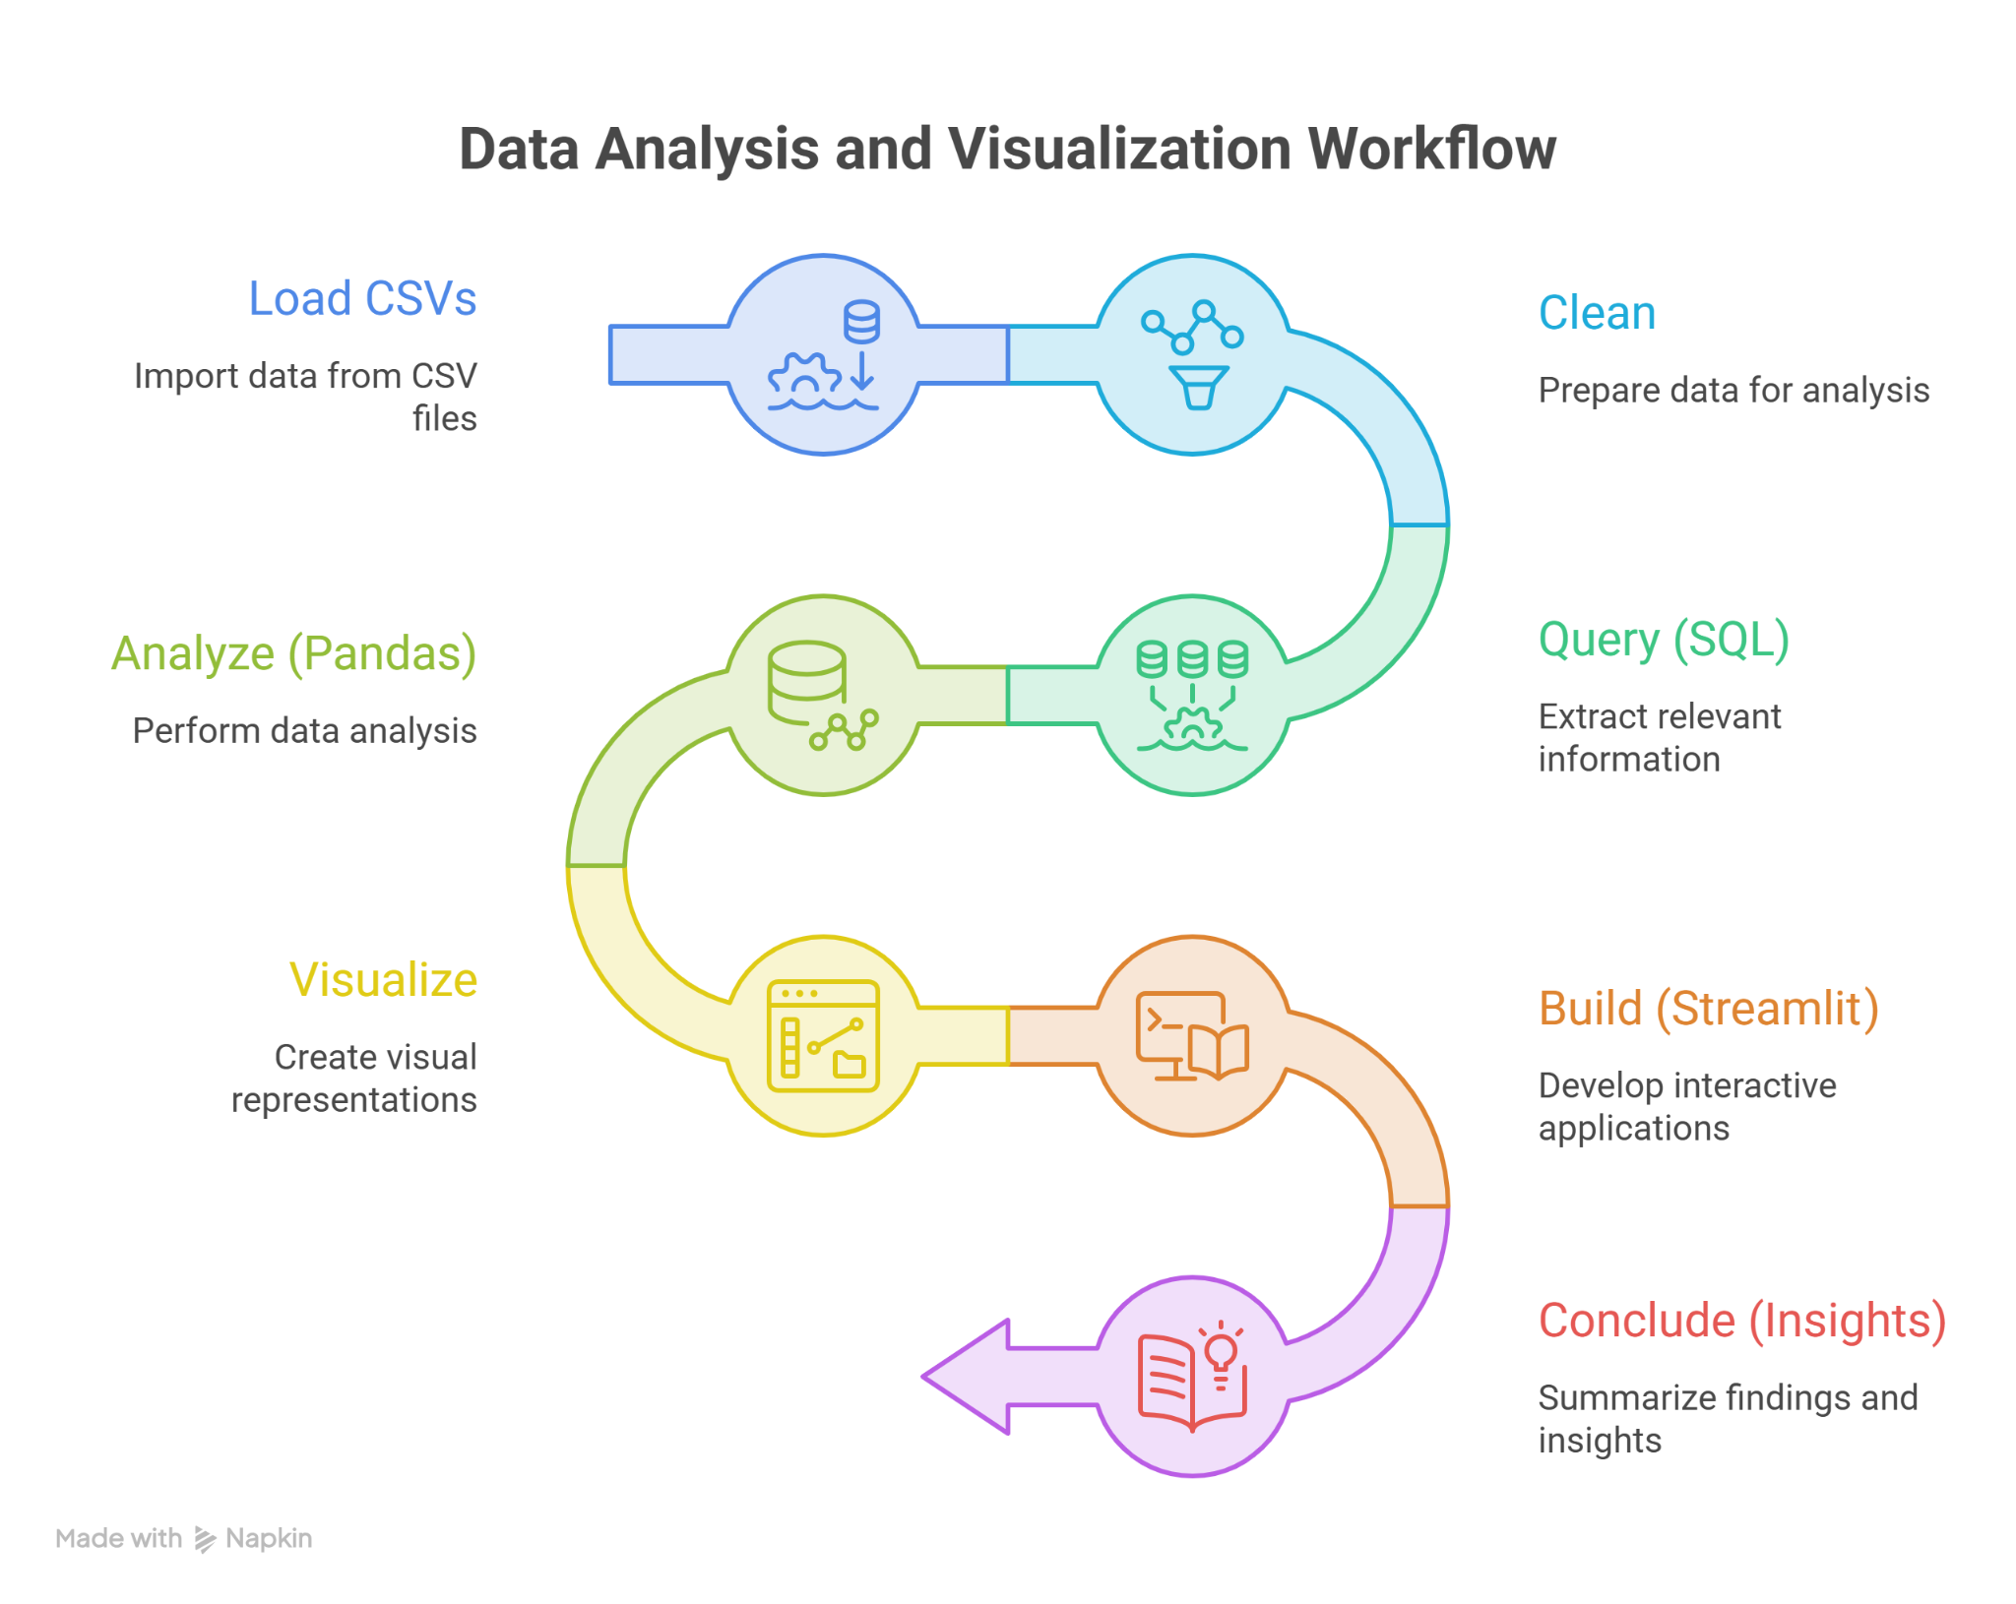

Notebook & File Structure
Submit a well-organized project folder. Every notebook must use markdown headers to separate sections, contain clear inline comments, and end each analysis with a short written insight/recommendation — not just code output.
- 01_data_cleaning.ipynb — Load the six provided CSVs, handle nulls/placeholder values, remove duplicates and orphaned rows, enforce data types, and load the cleaned tables into your SQL database.
- 02_sql_analysis.ipynb — Connect to your chosen database (sqlite3 / pymysql / mysql-connector-python / psycopg2), load the cleaned tables, and answer all 10 SQL questions
- 03_pandas_analysis.ipynb — Answer all 10 Pandas analysis questions, each followed by a short insight.
- 04_visualizations.ipynb — Univariate, bivariate and multivariate visualizations using Matplotlib/Seaborn/Plotly, each with a 2–4 sentence insight.
- app.py — final deliverable: a multi-page Streamlit app that reads from your SQL database, with Filters, Dashboard and Query Explorer pages
SQL Analysis — 10 Questions
Use sqlite3, pymysql, mysql-connector-python or psycopg2 (pick one database) to connect from Python and execute these queries. Questions progress from simple filtering/joins to multi-table joins, GROUP BY/HAVING, and subqueries.
# | Question | Concept Focus
1 | List all movies in the Action genre released after 2015, showing title and release date. | JOIN (movies ⋈ movie_genres ⋈ genres)
2 | Find the top 10 highest-grossing movies along with the genre(s) each belongs to. | JOIN + ORDER BY + LIMIT
3 | Calculate the average budget and average revenue for each genre, sorted by average revenue descending. | JOIN + GROUP BY + AVG()
4 | List the top 10 actors who have appeared in the most movies in the dataset.(cast) | GROUP BY + COUNT()
5 | Find all directors who have directed more than 3 movies, along with their movie count. | GROUP BY + HAVING
6 | List the top 10 most frequently used keywords across all movies. | GROUP BY + COUNT()
7 | Find movies where the budget was above the overall average budget but the revenue was below the overall average revenue. | Subquery comparison against AVG()
8 | List all actors who have appeared in a movie directed by a specific director (e.g., Christopher Nolan). | JOIN (cast ⋈ crew )
9 | Find the genre with the highest average rating, considering only genres with at least 20 movies. | JOIN + GROUP BY + HAVING + AVG()
10 | List the top 10 movies with the highest number of keywords tagged to them. | JOIN + GROUP BY

Pandas Analysis — 10 Questions

# | Question
1 | List the total number of unique movies, genres, cast members and crew members collected across all tables.
2 | List all movies with missing or zero budget/revenue values, and decide how these should be treated for the rest of the analysis.
3 | List the profit (revenue − budget) and return on investment for every movie that has valid budget and revenue figures.
4 | List the top 15 movies by return on investment, considering only movies with a budget of at least $1 million.
5 | List the number of movies released per year, and identify which year had the highest movie output in the dataset.
6 | List all movies whose runtime is a statistical outlier compared to the rest of the dataset.
7 | List each movie's primary genre (the first genre listed) and compare average popularity across primary genres.
8 | List the top 10 most prolific actors by number of movies, along with their average movie rating across those movies.
9 | List any movie titles that appear more than once in the dataset, along with their release years, to check for duplicates or remakes.
10 | List movies whose popularity score and vote count don't follow the general pattern between the two — i.e., unusually high popularity with a low vote count, or vice versa.

Visualization Tasks
Use Matplotlib, Seaborn and/or Plotly (any/all). Below are idea prompts only — explore broadly across univariate, bivariate and multivariate analysis, choosing appropriate chart types. For every chart, write insight — not axis descriptions.(8-12)

Univariate
- Distribution of movie budgets (histogram/KDE).
- Distribution of runtimes (box plot / violin plot).
- Distribution of vote_average scores (histogram).
- Count of movies per genre (bar/count plot).

Bivariate
- Budget vs revenue (scatter plot, with trend line).
- Popularity vs vote count (scatter plot).
- Average rating by genre (bar chart).
- Number of movies released per year (bar/column chart).

Multivariate
- Correlation heatmap of budget, revenue, runtime, popularity, vote_average and vote_count (heatmap).
- Pairplot of budget, revenue, popularity and vote_average, colored by primary genre (pairplot).
- Budget vs revenue colored by primary genre, with point size showing vote_count (scatter plot with hue and size).
- Distribution of vote_average for each genre in separate panels (FacetGrid with histograms).
- Average revenue by genre and release decade (heatmap of a pivot table).

Streamlit Application — Page Structure
Build a multi-page Streamlit app with three pages, all working off the same underlying database.

Page 1 — Filters
- A dedicated Filters page (or sidebar, shared across all pages) with: genre selectbox/multiselect, release-year range slider, minimum-rating slider, and language selectbox.
- Selected filter values should be stored in st.session_state so they persist and apply consistently across the Dashboard and Query Explorer pages.
- Show a live count of how many movies match the current filter selection.

Page 2 — Dashboard
- KPI cards (st.metric) for: total movies, total genres represented, total actors, and average rating — all reflecting the current filter selection.
- Top 10 movies by revenue (bar chart) for the filtered selection.
- Genre distribution (pie/donut or bar chart) for the filtered selection.
- Budget vs revenue scatter plot for the filtered selection.
- A short auto-generated text insight summarizing the filtered view (e.g., "highest grossing genre in this selection is...").
Page 3 — Query Explorer :
- Dropdown of saved queries
- Show results as st.dataframe and a chart
- Text insight box below

Submission Guidelines
- Submit app.py (the Streamlit app)
- Submit a single project folder containing all notebooks and app.py, named clearly as listed in the Notebook & File Structure section.
- Keep the data/ folder (all six CSVs plus your SQL database file) alongside your notebooks so the project runs end-to-end for anyone reviewing it.
- Every notebook must have markdown section headers, inline code comments, and a written insight/recommendation block after each analysis.
- Include a short README summarizing your top 5 overall insights and recommendations across the whole project.

Project Deliverables

Deliverables | Streamlit App
Notebooks (01–04) | Same — complete all 4
Final Tool | Streamlit app (app.py)
How Data Gets In(for queries) | App reads from your SQL database using Python
What You Build | 3 pages: Filters, Dashboard, Query Explorer
SQL Question Coverage | All 10 questions, shown as plain tables and charts in Query Explorer

Technical Tags
Python, Pandas, NumPy, Matplotlib, Seaborn, Plotly, SQL, PostgreSQL, MySQL, SQLite, Data Cleaning, EDA, Streamlit, Data Visualization, Feature Engineering, Relational Database Design, Media & Entertainment Analytics, Box-Office Analytics

⏳ Timeline
The project should be completed and submitted within 10 - 14 days from the date it is assigned.

Created By | Verified By | Approved By
Nilofer Mubeen | Selvamani A | Nehlath Harmain

