DES STUDIO
Visual Designer — Confirmed Design
Entity Lifecycle Designer · Phased Implementation Plan
Phase 1: Tab Editors · Phase 2: Split-Pane SVG · Phase 3: React Flow Canvas

Version  2.0 | Last updated  2026-04-30 | Status  Decision confirmed | Document owner  DES Studio Team

Version History
This table must be updated whenever a section of this document changes. Increment the version number, record the date and author, and summarise what changed. Do not delete previous rows — mark superseded decisions in the relevant section with [Superseded in vX.X — see Section Y].

Version | Date | Author | Change Summary
1.0 | 2026-04-30 | — | Initial design document — three options presented for review
2.0 | 2026-04-30 | — | Decision confirmed: phased approach. Tab editors (Phase 1) → Split-pane hybrid (Phase 2) → React Flow canvas (Phase 3). Coexistence documented.
 |  |  | (add a row each time this document is updated)

Update protocol
When a phase completes, a design decision changes, or a new constraint is identified: (1) add a row to the version history above, (2) update the version number and date on the cover page, (3) update the affected section status field, (4) if a Claude Code prompt changes, update Section 12.

Decision Record
Confirmed approach: support both the current tab-based editor and progressively develop the graphical visual designer. The two modes will coexist — modellers can use whichever they prefer, and the underlying model data is identical in both.

Alignment with audit
The audit stated: "A full rebuild would discard working, tested engine code in exchange for nothing." The same principle applies to the UI. The existing tab editors are working. They are completed and stabilised first. The visual designer is built as an additive layer — not a replacement.

1. The Phased Strategy
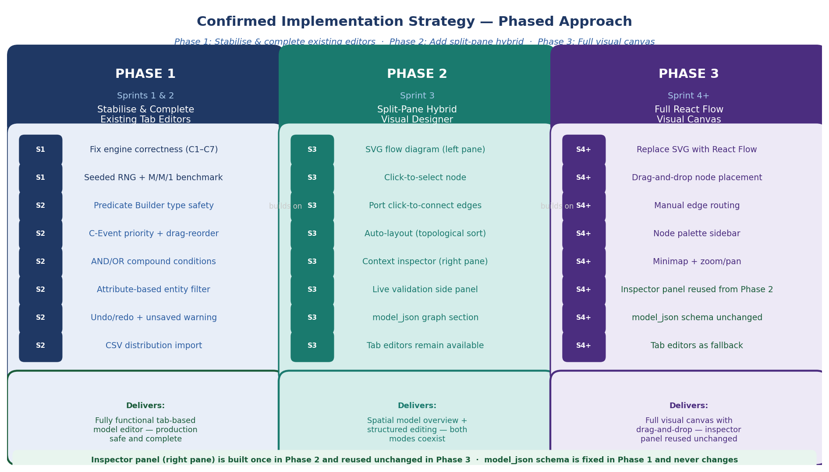
Figure 1: Three-phase implementation strategy. Inspector panel built once in Phase 2, reused unchanged in Phase 3.

PHASE  1 | Complete the Tab Editors  Sprints 1 and 2  Goal: Fix engine correctness issues and complete every missing editor feature.  Status: ⬜ Not started

The Predicate Builder, DistPicker, entity filter, and resource picker that the inspector panel will use are built and tested here. Building the inspector panel before these components are correct would mean rebuilding it.

PHASE  2 | Split-Pane Hybrid Designer  Sprint 3  Goal: Lightweight SVG flow diagram + context-sensitive inspector panel. Both modes coexist.  Status: ⬜ Not started — begins after Phase 1 exit gate passes

Delivers the spatial overview the specification requires without discarding the existing editors. The inspector panel reuses Phase 1 components — no duplication. The FlowDiagram props interface is designed to be renderer-agnostic so Phase 3 is a drop-in substitution.

PHASE  3 | Full React Flow Canvas  Sprint 4+  Goal: Replace SVG renderer with React Flow. Inspector panel reused unchanged. Tab editors remain.  Status: ⬜ Not started — begins after Phase 2 is complete and tested

React Flow integration is a significant dependency addition. By the time Phase 3 begins, the inspector panel is already complete and tested — only the diagram renderer changes. One import line in ModelDetail.

2. What Coexistence Means
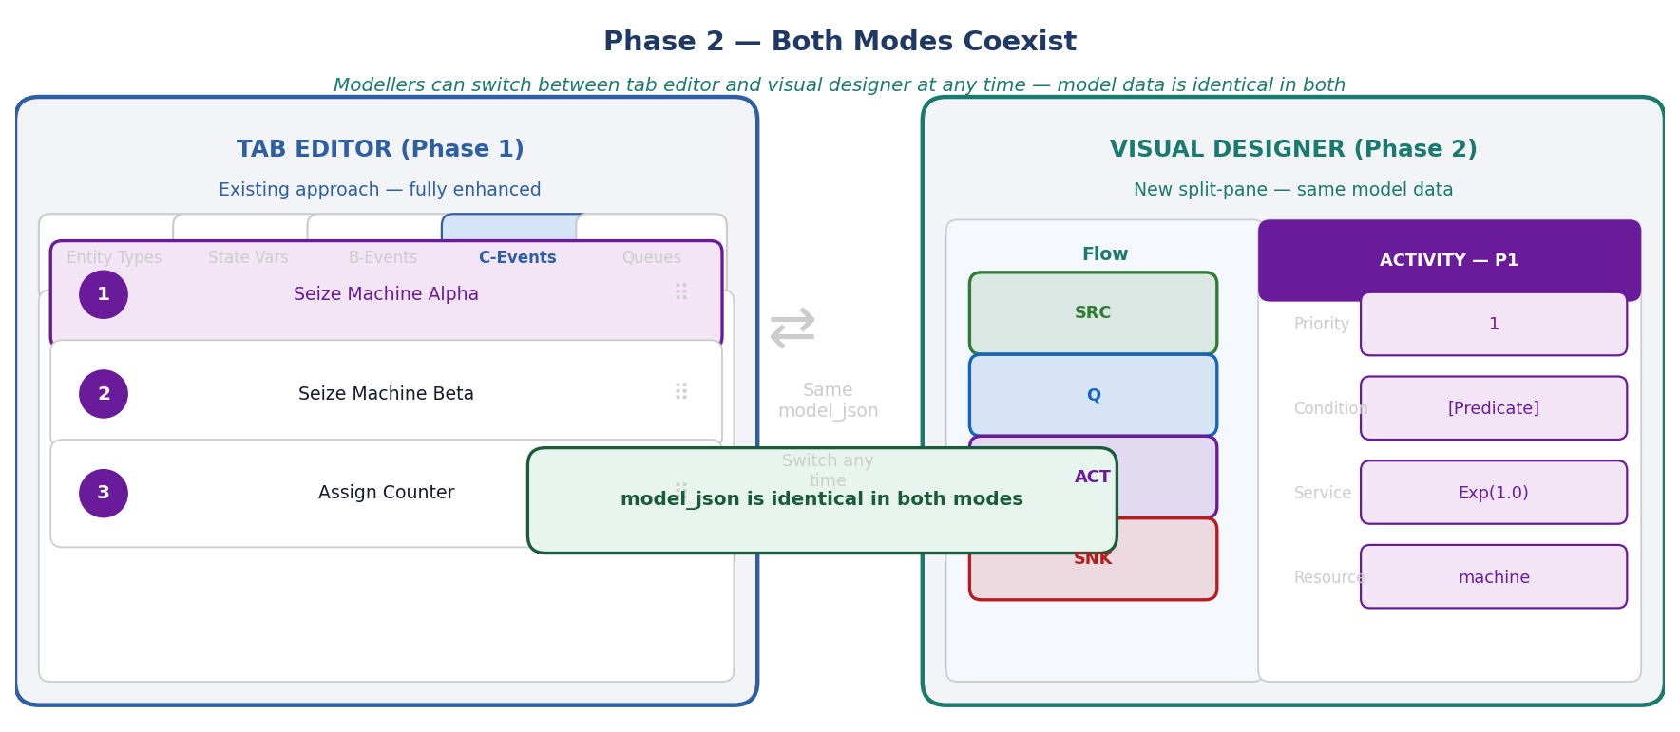
Figure 2: Both modes use identical model_json. Switching between them at any time preserves all model data.

The model data is the same
Whether a modeller uses the tab editor or the visual designer, they are reading and writing the same model_json object in Supabase. There is no conversion, no export/import, no format difference.

Both modes are always available
After Phase 2, a toggle in the ModelDetail view lets the modeller switch between tab editor and visual designer. They can start in the tab editor, switch to the visual designer, make a change, and switch back — the data is consistent throughout.

Neither mode is deprecated
Some modellers prefer the spatial visual approach. Others prefer the precision of the tab editors for complex C-Event conditions. Both remain first-class options.

3. The Four Node Types
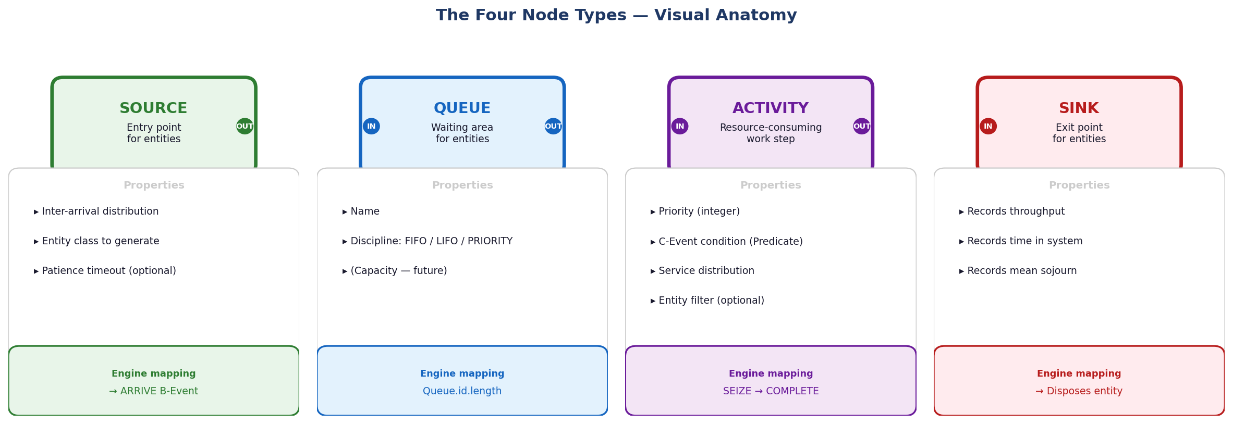
Figure 3: Visual anatomy of the four node types — each with its properties panel and engine mapping.

Node | Visual Identity | Engine Phase | Ports
Source | Green · rounded rectangle | B-Event: ARRIVE | Output only
Queue | Blue · rounded rectangle | Passive | Input + Output
Activity | Purple · rounded rectangle | C-Event: SEIZE + B-Event: COMPLETE | Input + Output
Sink | Red · rounded rectangle | Records KPIs · disposes entity | Input only

Port rules
- Source: one output port only — nothing connects to a Source input
- Sink: one input port only — nothing connects from a Sink output
- Queue and Activity: one input port + one output port each
- A single output port connects to exactly one input port
- Multiple Activities may route to the same Sink (fan-in to Sink is permitted)
- Activity to Activity direct connection is blocked — a Queue must sit between activities

4. DAG Rules and Validation
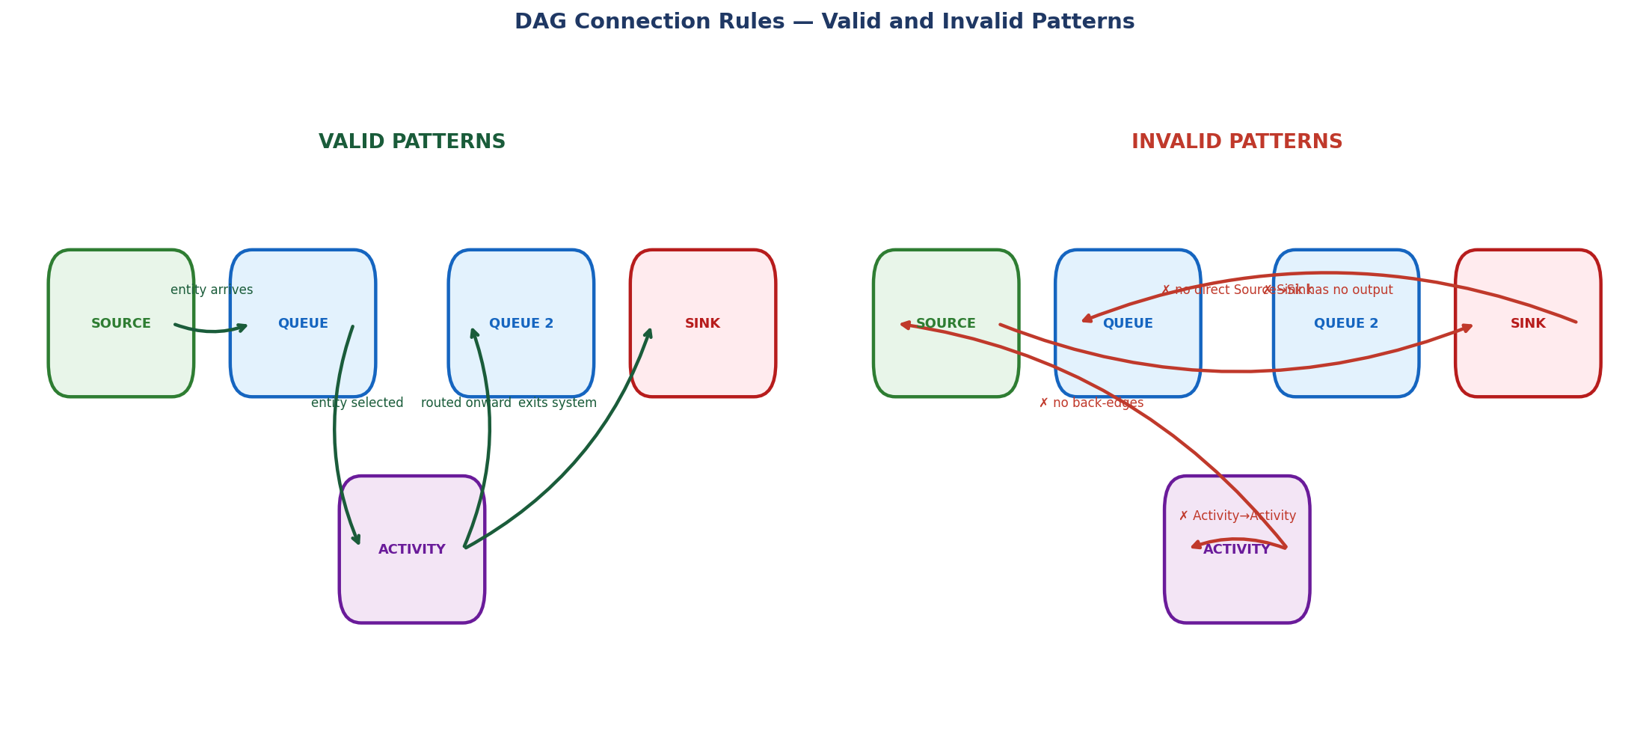
Figure 4: Valid and invalid DAG connection patterns. Invalid connections are blocked before drawn.

Blocking rules — connection is prevented
Rule | Reason
No back-edges (Activity → Source, Queue → Source) | Creates a cycle — engine loop
No Sink output connections | Sink is terminal
No Activity → Activity direct connection | Entities have nowhere to wait
No Source → Sink direct connection | Entity bypasses all processing
No disconnected nodes | Every node must be reachable from Source and reach Sink

Warning rules — flagged but run is not blocked
Rule | Reason
Activity with no condition set | C-Event will never fire
Queue with no Activity connected downstream | Entities fill queue with no service

5. Phase 1 — Complete the Tab Editors (Sprints 1 and 2)
Status  ⬜ Not started | Started  — | Completed  — | Exit gate  npm test + M/M/1 benchmark

Phase 1 is entirely covered by the existing sprint plan. Follow the prompts in docs/DES_Studio_Build_Plan.md for Sprints 1 and 2.

Sprint 1 — Engine safety
✓ | Task / Check | Status | Notes
⬜ | Replace new Function() eval — conditions.js, macros.js (C1) | ⬜ | —
⬜ | Fix C-scan restart rule — engine/index.js:121 (C3) | ⬜ | —
⬜ | Implement LIFO/Priority queue discipline — entities.js:84 (C2) | ⬜ | —
⬜ | Add seeded RNG mulberry32 — distributions.js (C7) | ⬜ | —
⬜ | Pre-run model validation V1–V11 — execute/index.jsx (C5) | ⬜ | —
⬜ | Surface Phase C truncation warning — engine/index.js (C4) | ⬜ | —
⬜ | Fix M/M/1 benchmark (Fixed → Exponential service dist) | ⬜ | —

Sprint 2 — Editor completeness
✓ | Task / Check | Status | Notes
⬜ | Predicate Builder operator filtering by valueType — editors/index.jsx | ⬜ | —
⬜ | Compound AND/OR conditions — editors/index.jsx | ⬜ | —
⬜ | Attribute-based entity filter — editors/index.jsx + entities.js | ⬜ | —
⬜ | Explicit C-Event priority field + drag-to-reorder — editors/index.jsx | ⬜ | —
⬜ | Undo/redo history stack — editors/index.jsx | ⬜ | —
⬜ | Unsaved-change warning on navigation — App.jsx | ⬜ | —
⬜ | DistPicker CSV import — shared/components.jsx | ⬜ | —

Phase 1 exit gate — must pass before Phase 2 begins
npm test -- --run (zero failures) · node tests/[benchmark] (exits 0) · npm run build (succeeds)

6. Phase 2 — Split-Pane Hybrid Designer (Sprint 3)
Status  ⬜ Not started | Started  — | Completed  — | Prerequisite  Phase 1 exit gate

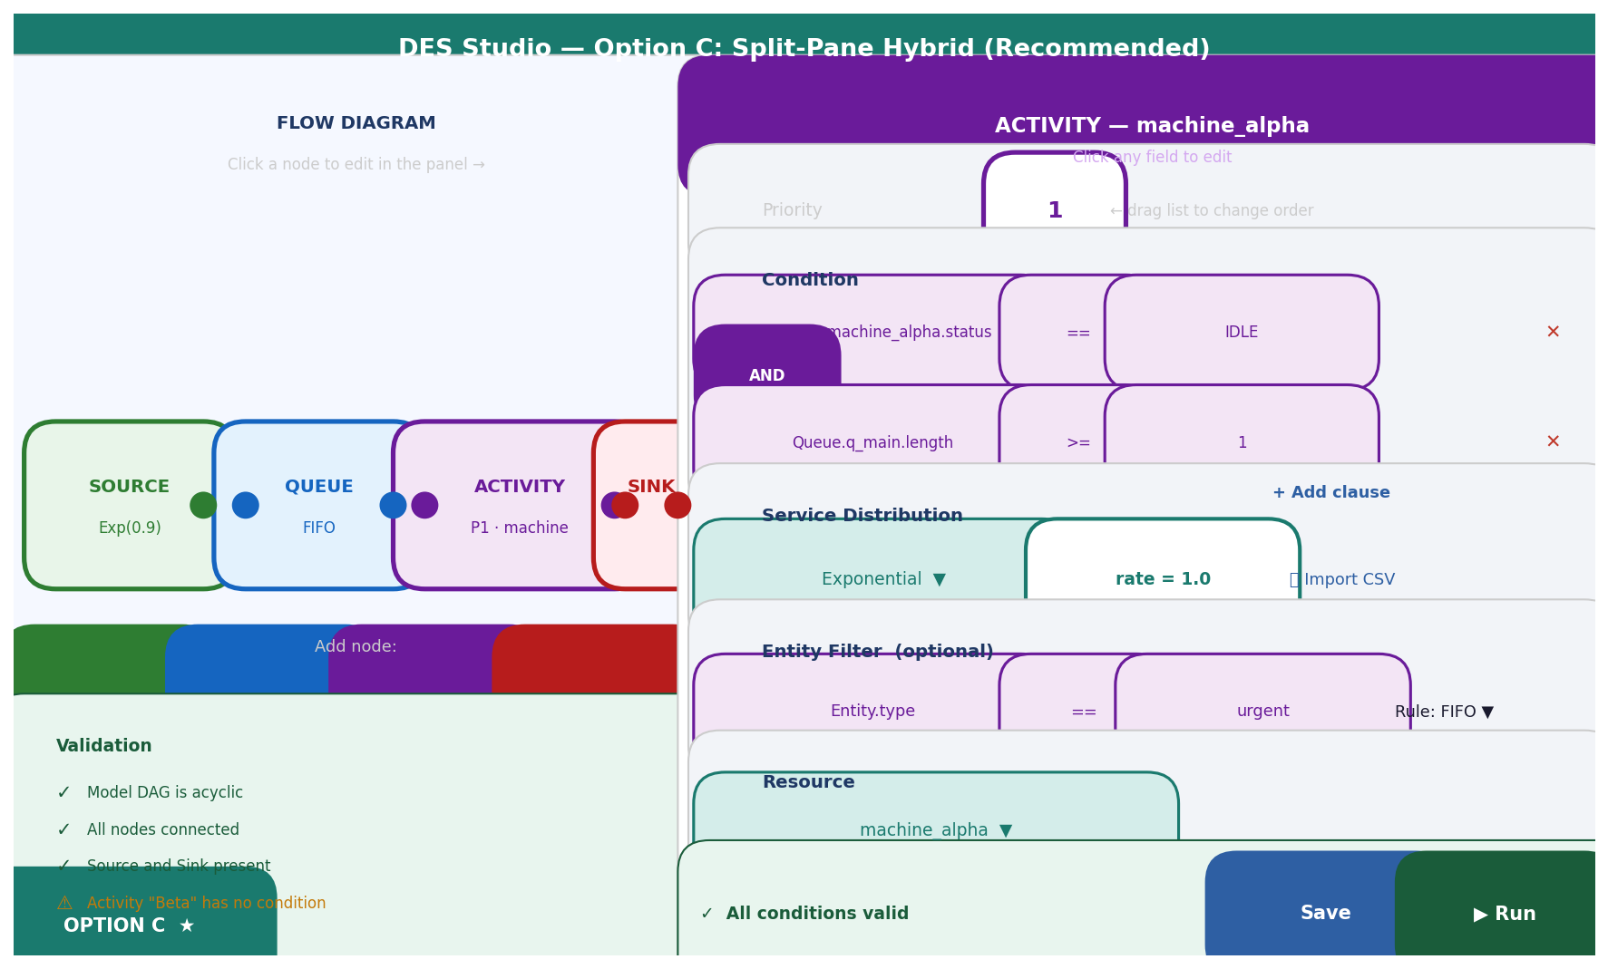
Figure 5: Phase 2 split-pane layout — SVG flow diagram (left) and inspector panel (right).

Features
✓ | Task / Check | Status | Notes
⬜ | F3.1 — graph section in model_json + migration for existing models | ⬜ | db/models.js
⬜ | F3.2 — SVG FlowDiagramSVG component with auto-layout | ⬜ | FlowDiagramSVG.jsx (new)
⬜ | F3.3 — Port click-to-connect with DAG validation | ⬜ | FlowDiagramSVG.jsx
⬜ | F3.4 — InspectorPanel component (reuses Phase 1 components) | ⬜ | InspectorPanel.jsx (new)
⬜ | F3.5 — Mode toggle (Tab / Visual) in ModelDetail header | ⬜ | editors/index.jsx
⬜ | F3.6 — Validation panel below flow diagram | ⬜ | FlowDiagramSVG.jsx

What is new vs what is reused
New in Phase 2 | Reused from Phase 1
SVG flow diagram component | Predicate Builder (complete, type-safe)
Auto-layout algorithm (BFS topological sort) | DistPicker (complete, with CSV import)
Mode toggle (Tab / Visual) | Entity filter picker
 | Validation logic (V1–V11)
 | ConditionBuilder (compound AND/OR)
 | All existing editor tab components

The FlowDiagram props interface — fixed in Phase 2 for Phase 3
The SVG diagram component uses a props interface identical to what the React Flow implementation will receive in Phase 3. Phase 3 is therefore a renderer substitution — the rest of the application does not change.

// This interface is FIXED in Phase 2 and never changes
<FlowDiagram
nodes={model.graph.nodes} // { id, type, x, y, label, sublabel }[]
edges={model.graph.edges} // { id, from, to }[]
selectedNodeId={selectedNodeId} // string | null
onNodeSelect={handleNodeSelect} // (nodeId) => void
onNodeAdd={handleNodeAdd} // (type) => void
onNodeDelete={handleNodeDelete} // (nodeId) => void
onEdgeAdd={handleEdgeAdd} // ({ from, to }) => void
onEdgeDelete={handleEdgeDelete} // (edgeId) => void
validationErrors={validationErrors} // { nodeId, message, severity }[]
/>

Auto-layout algorithm
- Find Source node (no incoming edges)
- BFS traversal from Source
- Assign column = BFS depth, row = order within column
- Multiply by spacing constants (220px horizontal, 120px vertical)
- Store x, y in model.graph.nodes

Manual node positioning is not supported in Phase 2 — added in Phase 3 via React Flow onNodeDragStop.

7. Phase 3 — Full React Flow Canvas (Sprint 4+)
Status  ⬜ Not started | Started  — | Completed  — | Prerequisite  Phase 2 exit gate

Phase 3 replaces the SVG FlowDiagram component with a React Flow canvas. Because the props interface was fixed in Phase 2, this is a contained substitution.

What changes and what does not
Changes in Phase 3 | Unchanged in Phase 3
FlowDiagramSVG.jsx → FlowDiagramReactFlow.jsx | FlowDiagram props interface
reactflow added to package.json | Inspector panel — identical
Drag-and-drop node placement | model_json schema
Manual edge routing | Predicate Builder
Node palette sidebar | DistPicker
MiniMap + zoom/pan | Validation logic
Manual node repositioning | Tab editors (remain as fallback)
 | All engine code · All DB layer code

One line change in the application
// Phase 2 import (in ModelDetail):
import { FlowDiagramSVG as FlowDiagram } from './FlowDiagramSVG';

// Phase 3 — replace the above line with:
import { FlowDiagramReactFlow as FlowDiagram } from './FlowDiagramReactFlow';

8. The Inspector Panel — Built Once, Reused Twice
The inspector panel is built in Phase 2 using existing Phase 1 components. It is reused unchanged in Phase 3. It is the bridge between both phases.

What the inspector panel shows by node type
Selected node | Components shown
None selected | "Click a node in the diagram to edit its properties."
Source | Entity class picker + DistPicker (inter-arrival) + optional DistPicker (patience)
Queue | Name field + discipline dropdown (FIFO / LIFO / PRIORITY)
Activity | Priority integer + ConditionBuilder + entity filter + queue rule + DistPicker + resource picker
Sink | Name field (read-only stats display)

Why it survives Phase 3 unchanged
The inspector panel receives selectedNodeId (a string) and model_json. It has no dependency on whether the diagram renderer is SVG or React Flow. Whether selectedNodeId is set by a click on an SVG rect or by React Flow's onSelectionChange is irrelevant. The interface contract is the same.

9. model_json Schema — Fixed in Phase 2, Never Changes
The graph section is added to model_json in Phase 2 Sprint 3. It does not change in Phase 3.

{
"entityClasses": [...],
"stateVariables": [...],
"bEvents": [...],
"cEvents": [...],
"queues": [...],

"graph": {
"nodes": [
{ "id": "src_01", "type": "source", "label": "Arrivals", "x": 80, "y": 240 },
{ "id": "q_main", "type": "queue", "label": "Queue", "x": 320, "y": 240 },
{ "id": "act_machine", "type": "activity", "label": "Machine", "x": 560, "y": 240 },
{ "id": "sink_01", "type": "sink", "label": "Exit", "x": 800, "y": 240 }
],
"edges": [
{ "id": "e1", "from": "src_01", "to": "q_main" },
{ "id": "e2", "from": "q_main", "to": "act_machine" },
{ "id": "e3", "from": "act_machine", "to": "sink_01" }
]
}
}

Migration for existing models
Models created before Phase 2 have no graph section. When the visual designer opens such a model, generateGraphFromModel() auto-generates the layout and saves it. This is transparent to the modeller.

10. Phase 2 — Detailed Design

Node visual specification
Node type | Border | Fill
Source | #2E7D32 | #E8F5E9
Queue | #1565C0 | #E3F2FD
Activity | #6A1B9A | #F3E5F5
Sink | #B71C1C | #FFEBEE

Selected state: 3px dashed border in node colour. Hover: 2px solid border, pointer cursor. Error: red dashed border with ✗ icon top-right.

Edge visual specification
- SVG cubic bezier paths from output port to input port
- Edge colour matches source node type
- 2px width, 8px arrowhead
- Selected edge: 3px width, delete button appears on hover

Validation panel specification
State | Display
All valid | Green background · "Model is valid — N nodes, N edges"
Warning | Amber background · "[node name]: [message]" · clicking highlights node
Error | Red background · "[node name]: [message]" · Run button disabled

11. Phase 3 — Detailed Design

New file: FlowDiagramReactFlow.jsx
import ReactFlow, { MiniMap, Controls, Background, Handle, Position } from 'reactflow';

export const FlowDiagramReactFlow = ({
nodes, edges, selectedNodeId,
onNodeSelect, onNodeAdd, onNodeDelete,
onEdgeAdd, onEdgeDelete, validationErrors
}) => {
const rfNodes = nodes.map(n => ({
id: n.id, type: n.type, position: { x: n.x, y: n.y },
data: { label: n.label, sublabel: n.sublabel,
error: validationErrors.find(e => e.nodeId === n.id) }
}));
const rfEdges = edges.map(e => ({ id: e.id, source: e.from, target: e.to }));
return (
<ReactFlow nodes={rfNodes} edges={rfEdges}
onSelectionChange={({ nodes }) => onNodeSelect(nodes[0]?.id ?? null)}
onConnect={({ source, target }) => onEdgeAdd({ from: source, to: target })}
onEdgesDelete={deleted => deleted.forEach(e => onEdgeDelete(e.id))}
onNodeDragStop={(_, node) => { /* update x,y in model.graph.nodes */ }}
nodeTypes={nodeTypes}>
<MiniMap /> <Controls /> <Background />
</ReactFlow>
);
};

12. Claude Code Prompts by Phase
Phase 1 uses the existing Sprint 1 and Sprint 2 prompts from docs/DES_Studio_Build_Plan.md. The prompts below cover Phase 2 and Phase 3 only.

Phase 2 — Sprint 3 Planning
▶ Sprint 3 Planning — Phase 2 Visual Designer [claude.ai]
We are starting Sprint 3 of DES Studio.
Completed in Sprints 1–2: [paste completed feature list]

Sprint 3 goal: Add split-pane visual designer alongside existing
tab editors. Both modes must coexist with identical model_json.

CONFIRMED DECISIONS:
1. Tab editors are NOT removed — remain fully functional
2. Mode toggle switches between Tab and Visual views
3. Visual designer uses SVG — NOT React Flow (Phase 3)
4. Inspector panel reuses Phase 1 components — not rewritten
5. Auto-layout only — no manual drag repositioning in Phase 2
6. FlowDiagram props interface is renderer-agnostic (fixed for Phase 3)
7. model_json graph section added in this sprint

Features: F3.1 graph section · F3.2 SVG FlowDiagramSVG
F3.3 DAG validation · F3.4 InspectorPanel
F3.5 mode toggle · F3.6 validation panel

Definition of done:
- Both modes show identical model data
- Switching modes preserves all edits
- DAG cycles cannot be created
- Activity inspector uses full Phase 1 Predicate Builder
- Tab editors remain fully functional and unchanged
- npm test -- --run passes · npm run build succeeds

F3.1 — graph section in model_json
▶ F3.1 — model_json graph section + migration [Claude Code (terminal)]
Re-read CLAUDE.md. Task F3.1 of Sprint 3.
Read src/db/models.js — show me the current model_json structure.

Add graph section to model_json:
{ "graph": {
"nodes": [{ "id": "string", "type": "source|queue|activity|sink",
"label": "string", "x": number, "y": number }],
"edges": [{ "id": "string", "from": "nodeId", "to": "nodeId" }]
}}

Also implement generateGraphFromModel(modelJson) → graph:
- BFS auto-layout: column = depth, row = position in column
- 220px horizontal · 120px vertical spacing
- Saves graph section to Supabase immediately

Data layer only — do not write FlowDiagram yet.
Show schema and function before implementing.

F3.2 — SVG FlowDiagramSVG component
▶ F3.2 — SVG FlowDiagramSVG (renderer-agnostic interface) [Claude Code (terminal)]
Task F3.2 of Sprint 3.
Build src/ui/editors/FlowDiagramSVG.jsx.
This props interface must not deviate — Phase 3 React Flow
will implement the same interface:

FlowDiagramSVG({ nodes, edges, selectedNodeId, onNodeSelect,
onNodeAdd, onNodeDelete, onEdgeAdd, onEdgeDelete,
validationErrors })

SVG rules: rounded rect nodes · port circles · cubic bezier edges
Selected: 3px dashed border · DAG validation before onEdgeAdd
[+ Source] [+ Queue] [+ Activity] [+ Sink] buttons below diagram

Before writing code, explain:
1. How you track pending edge connection state
2. How you validate DAG rules before calling onEdgeAdd

Do NOT use React Flow. SVG only.

F3.4 — InspectorPanel component
▶ F3.4 — InspectorPanel (reuses Phase 1 components) [Claude Code (terminal)]
Task F3.4 of Sprint 3.
Read src/ui/editors/index.jsx — identify Predicate Builder,
DistPicker, entity filter, resource dropdown, priority field.

Build src/ui/editors/InspectorPanel.jsx:
Props: { selectedNodeId, model, onChange }

Renders by selected node type:
null → "Click a node to edit its properties."
source → entity class picker + DistPicker (inter-arrival)
queue → name field + discipline dropdown
activity → priority + ConditionBuilder + entity filter
+ queue rule + DistPicker + resource picker
sink → name field (read-only)

CRITICAL: Reuse existing Phase 1 components. Do NOT rewrite them.
Show component tree before writing any code.

F3.5 — Mode Toggle
▶ F3.5 — Mode Toggle (Tab / Visual) [Claude Code (terminal)]
Task F3.5 of Sprint 3.
Read src/ui/editors/index.jsx — show ModelDetail tab structure.

Add toggle: [Tab Editor] [Visual Designer]
const [mode, setMode] = useState("tabs");

"tabs" mode: existing tab structure UNCHANGED
"visual" mode: FlowDiagramSVG (40%) + InspectorPanel (60%)

Toggle must NOT modify model_json.
Switching must NOT lose unsaved changes.
Tab editor must be pixel-identical in tabs mode.

Phase 3 — Planning Prompt
▶ Phase 3 Sprint Planning — React Flow Canvas [claude.ai]
We are planning Phase 3 of the DES Studio visual designer.

Phase 2 delivered:
- SVG FlowDiagramSVG with agreed props interface
- InspectorPanel reusing Phase 1 components
- Mode toggle (Tab / Visual) in ModelDetail
- Both modes coexist with identical model_json

Phase 3 replaces SVG renderer with React Flow.
Inspector panel, model_json, tab editors do NOT change.
This is a renderer substitution — not a redesign.

New in Phase 3 only:
- reactflow added to package.json
- FlowDiagramReactFlow.jsx (same props interface)
- Custom node components
- Node palette sidebar (drag-and-drop)
- MiniMap, zoom/pan, manual node repositioning
- One import line change in ModelDetail

Define sprint scope, risks, and React Flow version.

Phase 3 — Start Prompt for Claude Code
▶ Phase 3 Start — Replace SVG with React Flow [Claude Code (terminal)]
Re-read CLAUDE.md. Phase 3 of the visual designer.
Replacing FlowDiagramSVG with React Flow.
Inspector panel, tab editors, model_json, engine do NOT change.

Before writing any code:
1. Read FlowDiagramSVG.jsx — show the full props interface
2. Read InspectorPanel.jsx — confirm no SVG dependency
3. Read package.json — confirm reactflow not yet installed

Explain:
1. How FlowDiagramReactFlow.jsx implements the same props
2. How model.graph.nodes maps to React Flow node format
3. How model.graph.edges maps to React Flow edge format
4. How callbacks map to React Flow events
5. How onNodeDragStop updates model.graph.nodes[i].x and y

Show component signature before implementing.
The one-line import change in ModelDetail is the LAST thing.

