DES STUDIO
Visual Designer
Confirmed Design — Phased Implementation Plan
Phase 1: Tab Editors · Phase 2: Split-Pane Hybrid · Phase 3: Full Canvas

Version  2.0 | Date  2026-04-30 | Decision  Confirmed | Approach  Phased — coexist

Decision Record
Confirmed approach
Support both the current tab-based editor and progressively develop the graphical visual designer. The two modes coexist — modellers can use whichever they prefer, and the underlying model data is identical in both.

This is directly aligned with the audit recommendation:

"A full rebuild would discard working, tested engine code in exchange for nothing.
A selective rebuild... combined with adding the absent features in prioritised
sprints — is the correct path."
— Codebase Audit 2026-04-30, Section 5

The same principle applies to the UI. The existing tab editors are working. They are completed and stabilised first. The visual designer is built as an additive layer on top — not a replacement.

1. The Phased Strategy
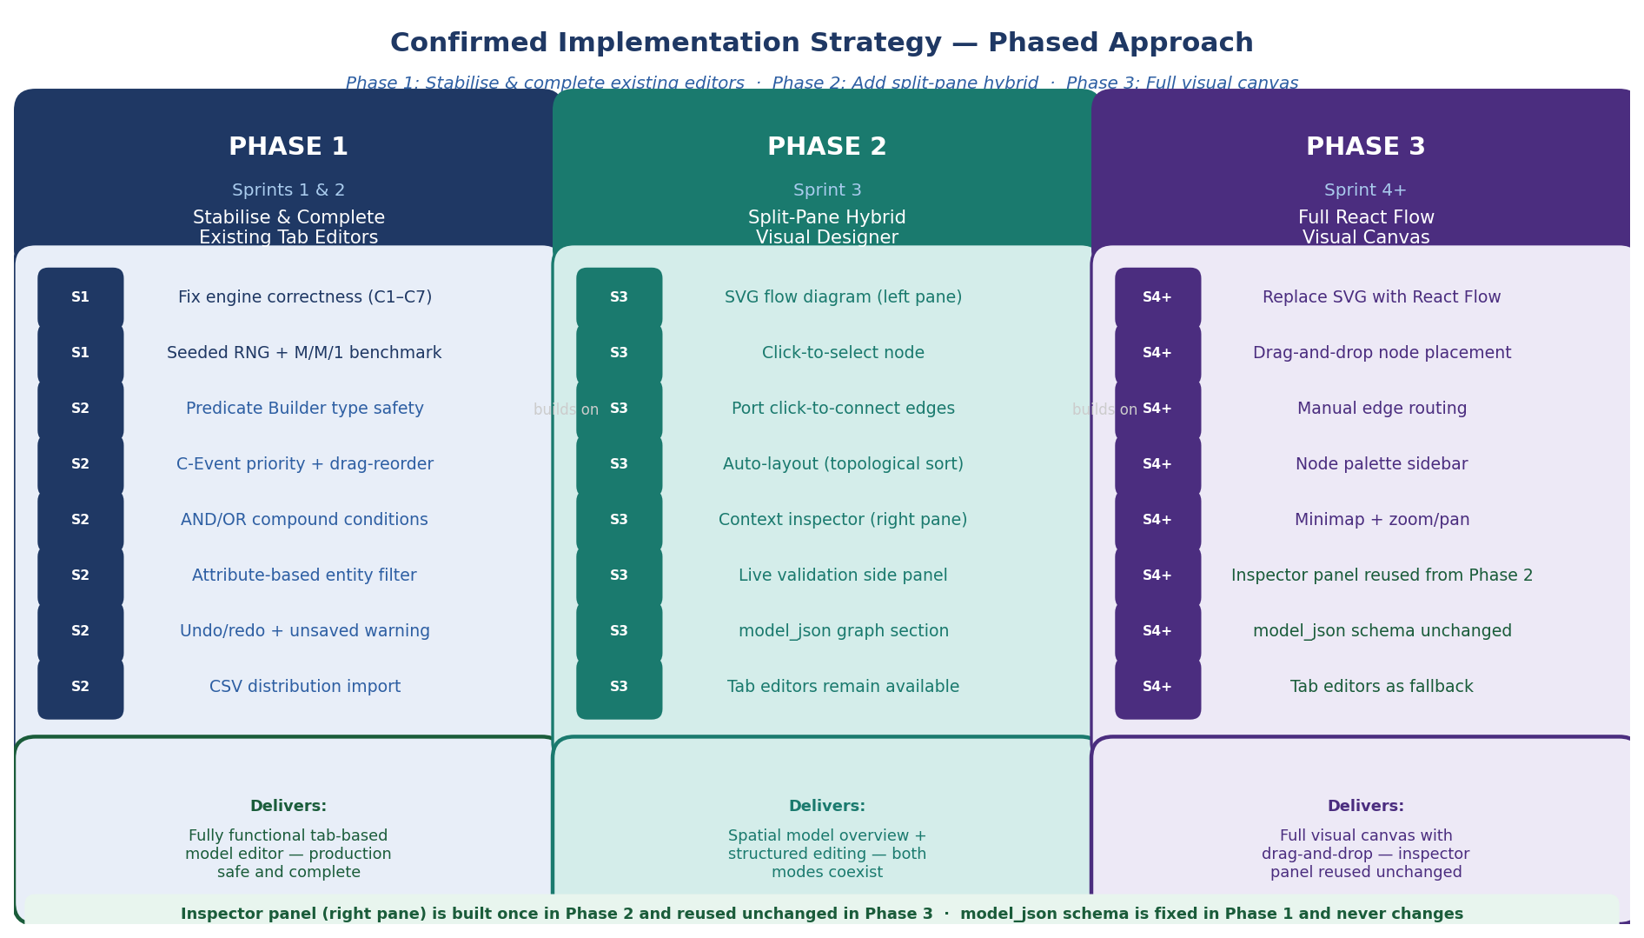
Figure 1: Three phases — each builds on the previous. The inspector panel is built once in Phase 2 and reused unchanged in Phase 3.

PHASE 1  1 | Complete the Tab Editors  Sprint: Sprints 1 & 2  Fix engine correctness. Complete every missing editor feature. Ship a production-quality form-based tool.

Fix all engine correctness issues (C1–C7) and complete every missing feature in the existing tab-based editors. At the end of Phase 1 the tab editors are production-quality. This is the foundation everything else builds on.

Why first: The Predicate Builder, DistPicker, entity filter, and resource picker that the visual designer's inspector panel will use are built and tested here. Building the inspector panel before the components it contains are correct would mean rebuilding it.

PHASE 2  2 | Split-Pane Hybrid Designer  Sprint: Sprint 3  Add a lightweight SVG flow diagram alongside the existing tab editors. Both modes coexist with identical model data.

Add a lightweight SVG flow diagram alongside the existing tab editors. The modeller can see the model as a connected graph and click any node to edit it in an inspector panel on the right. Both modes read and write the same model_json.

Why second: This delivers the spatial overview the specification requires without discarding the existing editors. The SVG diagram is simple enough to build in one sprint. The inspector panel reuses components built in Phase 1 — no duplication.

PHASE 3  3 | Full React Flow Canvas  Sprint: Sprint 4+  Replace the SVG renderer with React Flow. Inspector panel, model_json, and tab editors are unchanged.

Replace the SVG diagram with a full React Flow canvas — drag-and-drop node placement, manual edge routing, minimap, zoom/pan. The inspector panel from Phase 2 is reused unchanged. The model_json schema is identical. Tab editors remain as a fallback.

Why third: React Flow integration is a significant dependency addition. By the time Phase 3 begins, the inspector panel is already complete and tested — only the diagram renderer changes.

2. What Coexistence Means
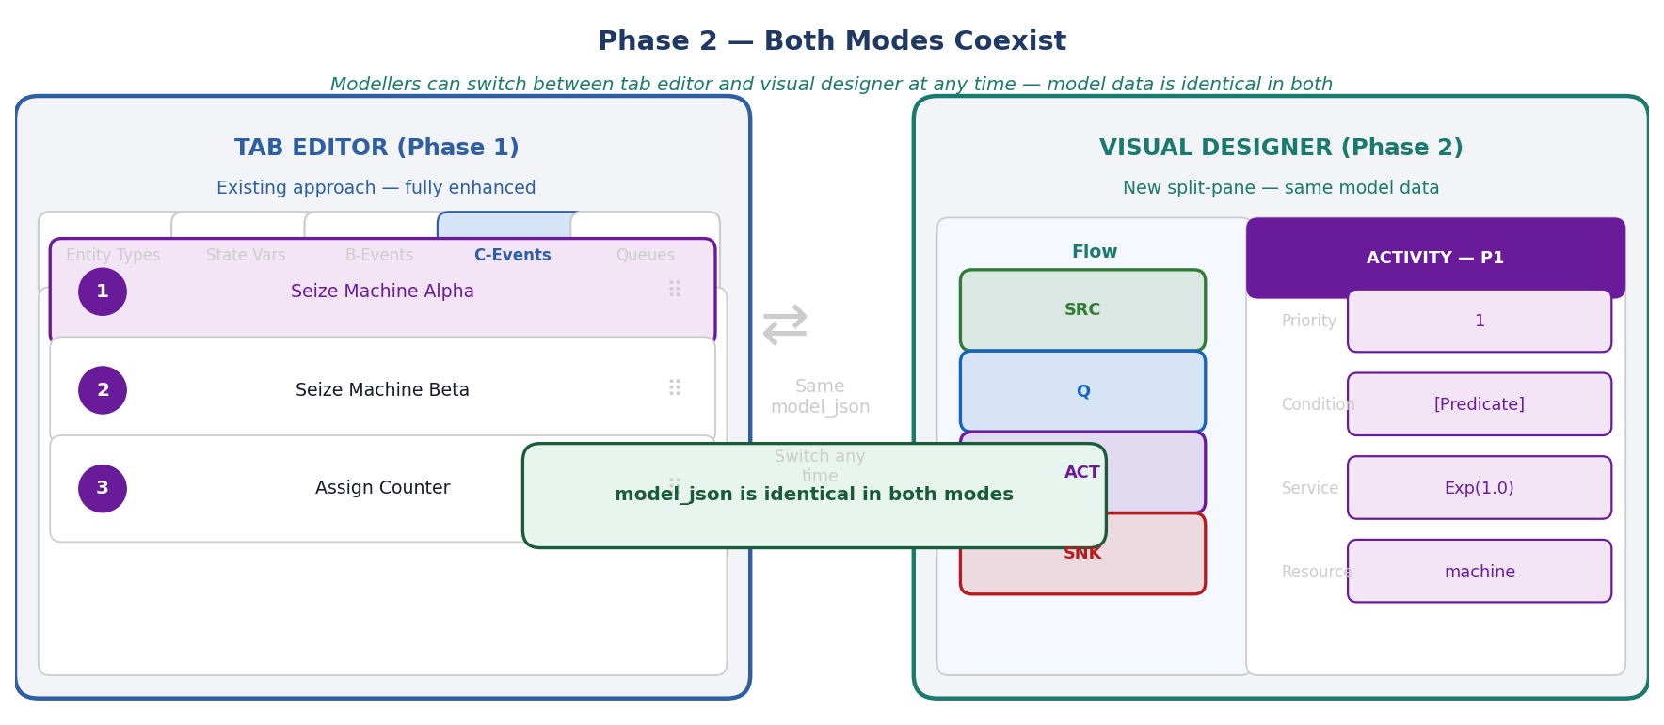
Figure 2: Both modes use identical model_json. Switching between them at any time preserves all model data.

The model data is the same. Whether a modeller uses the tab editor or the visual designer, they are reading and writing the same model_json object in Supabase. There is no conversion, no export/import, no format difference.

Both modes are always available. After Phase 2, a toggle in the ModelDetail view lets the modeller switch between tab editor and visual designer. They can switch at any time — data is consistent throughout.

Neither mode is deprecated. Some modellers prefer the spatial visual approach. Others prefer the precision of the tab editors for complex C-Event conditions. Both remain first-class options.

3. The Four Node Types
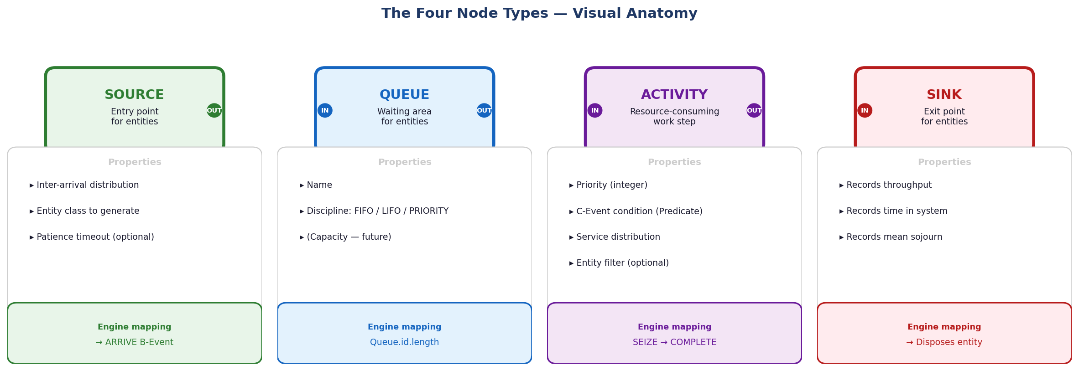
Figure 3: Visual anatomy of the four node types — each with its properties panel and engine mapping.

Node | Visual Identity | Engine Phase | Ports
Source | Green · rounded rectangle | B-Event: ARRIVE | Output only
Queue | Blue · rounded rectangle | Passive — no event fired | Input + Output
Activity | Purple · rounded rectangle | C-Event: SEIZE + B-Event: COMPLETE | Input + Output
Sink | Red · rounded rectangle | Records KPIs · disposes entity | Input only

Port Rules
- Source: one output port only — nothing connects to a Source input
- Sink: one input port only — nothing connects from a Sink output
- Queue and Activity: one input port + one output port each
- A single output port connects to exactly one input port
- Multiple Activities may route to the same Sink (fan-in to Sink is permitted)
- Activity to Activity direct connection is blocked — a Queue must sit between activities

4. DAG Rules and Validation
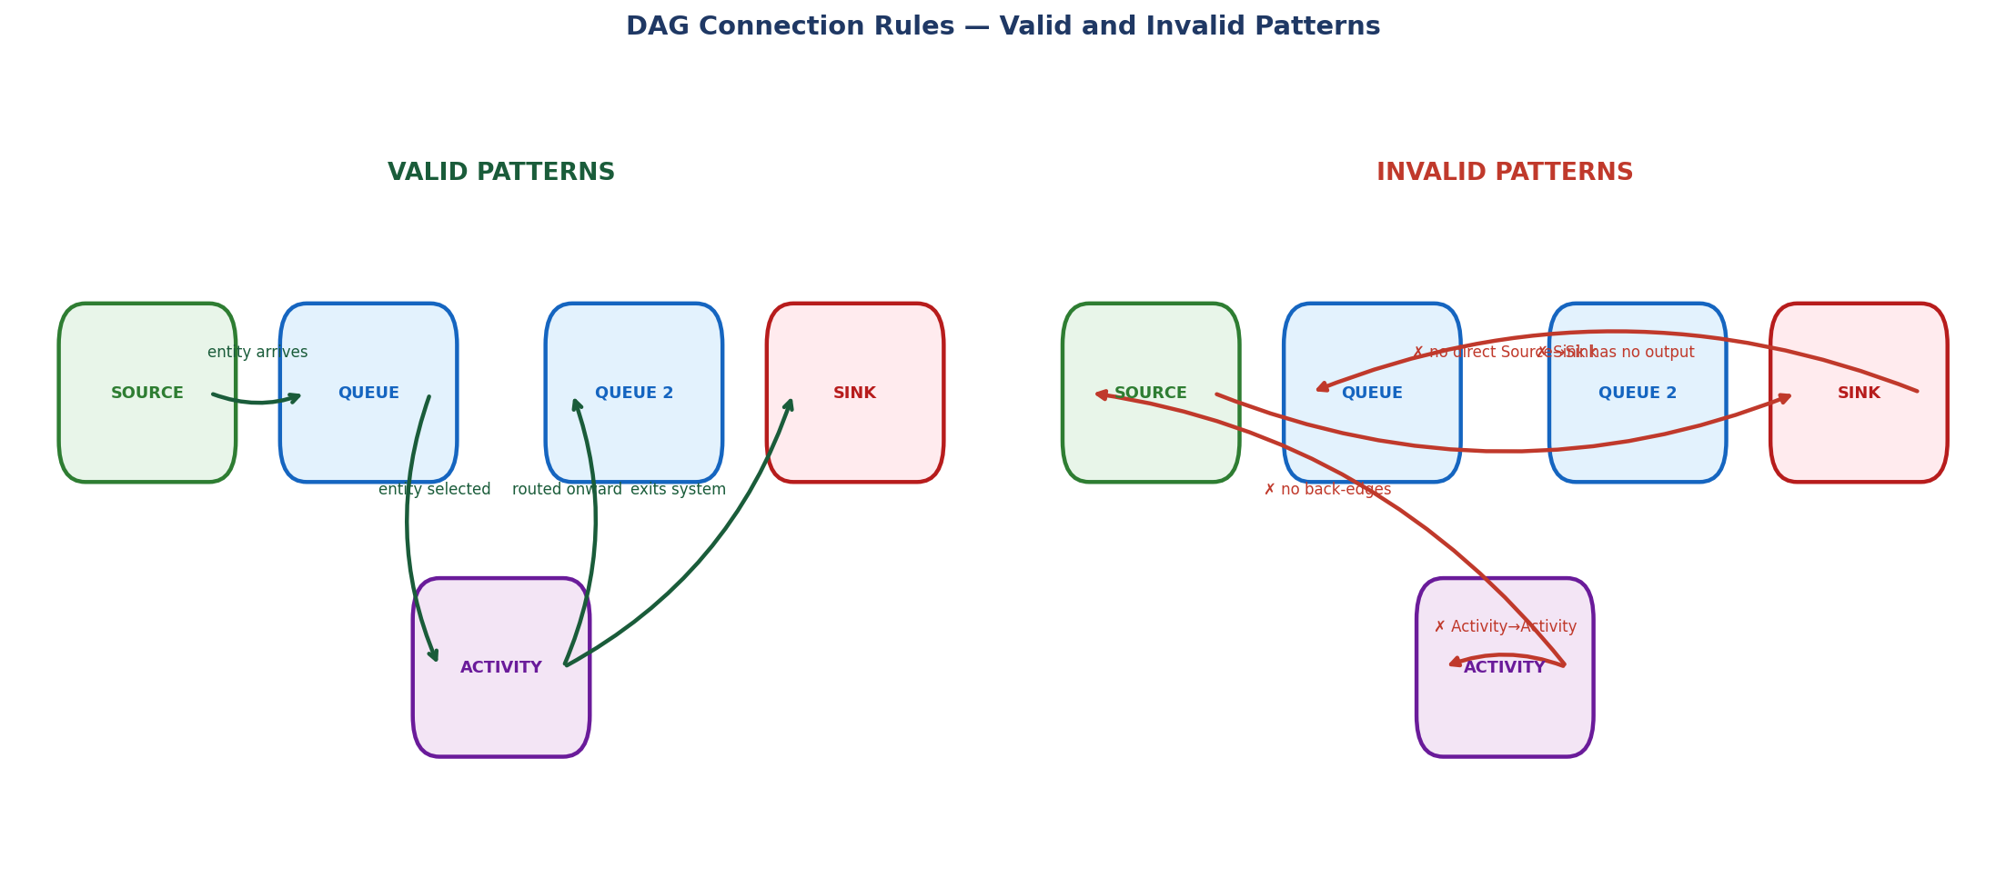
Figure 4: Valid and invalid DAG connection patterns. Invalid connections are blocked before they are drawn.

Blocking Rules — Connection is Prevented
Rule | Reason
No back-edges (Activity → Source, Queue → Source) | Creates a cycle — engine loop
No Sink output connections | Sink is terminal
No Activity → Activity direct connection | Entities have nowhere to wait
No Source → Sink direct connection | Entity bypasses all processing
No disconnected nodes | Every node must be reachable from Source and reach Sink

Warning Rules — Flagged but Run is Not Blocked
Rule | Reason
Activity with no condition set | C-Event will never fire
Queue with no Activity connected downstream | Entities fill queue with no service

5. Phase 1 — Complete the Tab Editors
No new prompts needed
Phase 1 is covered by the existing Sprint 1 and Sprint 2 build plan. Follow the prompts in docs/DES_Studio_Build_Plan.md exactly. No new design decisions are required.

Sprint 1 Deliverables — Engine Safety
✓ | Task / Check | File / Command
☐ | Replace new Function() eval with safe condition evaluator | conditions.js · macros.js
☐ | Fix C-scan restart rule — add break inside for-loop | engine/index.js:121
☐ | Implement LIFO and Priority queue discipline in engine | entities.js:84
☐ | Add seeded RNG (mulberry32) to buildEngine() | distributions.js
☐ | Pre-run model validation (V1–V11) | execute/index.jsx
☐ | Surface Phase C truncation warning | engine/index.js
☐ | Fix M/M/1 benchmark (change Fixed dist → Exponential) | tests/

Sprint 2 Deliverables — Editor Completeness
✓ | Task / Check | File / Command
☐ | Predicate Builder operator filtering by valueType | editors/index.jsx
☐ | Compound AND/OR conditions | editors/index.jsx
☐ | Attribute-based entity filter | editors/index.jsx + entities.js
☐ | Explicit C-Event priority field + drag-to-reorder | editors/index.jsx
☐ | Undo/redo history stack | editors/index.jsx
☐ | Unsaved-change warning on navigation | App.jsx
☐ | DistPicker CSV import | shared/components.jsx

Why Phase 1 must be complete before Phase 2
The Predicate Builder built in Sprint 2 is the central component of the visual designer's inspector panel. If it is not type-safe and fully functional before Phase 2 begins, the inspector panel will be built on a broken foundation.

6. Phase 2 — Split-Pane Hybrid Designer (Sprint 3)
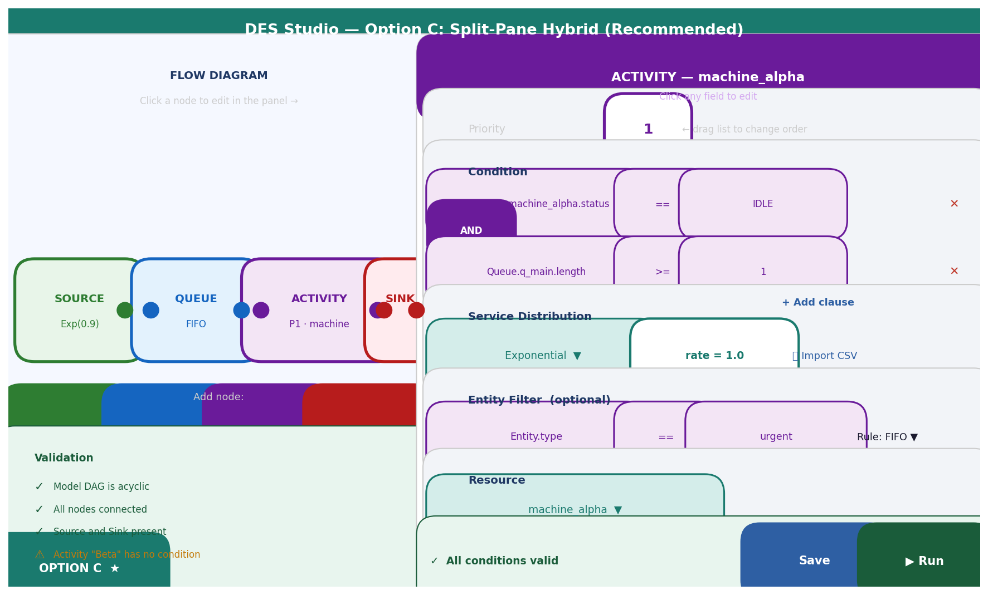
Figure 5: The split-pane hybrid — SVG flow diagram on the left, context-sensitive inspector panel on the right.

What is New in Phase 2
Only three things are genuinely new in Phase 2. Everything else reuses Phase 1 work.

New in Phase 2 | Reused from Phase 1
SVG flow diagram component | Predicate Builder (complete, type-safe)
Auto-layout algorithm (topological sort) | DistPicker (complete, with CSV import)
Mode toggle (Tab / Visual) | Entity filter picker
 | Validation logic (V1–V11)
 | ConditionBuilder (compound AND/OR)
 | All existing editor tab components

The FlowDiagram Props Interface — Designed for Phase 3 from the Start
The SVG diagram component uses a props interface that is identical to what the React Flow implementation will receive in Phase 3. This means Phase 3 is a renderer substitution — the rest of the application does not change.

// This interface is fixed in Phase 2 and never changes
<FlowDiagram
nodes={model.graph.nodes} // { id, type, x, y, label, sublabel }[]
edges={model.graph.edges} // { id, from, to }[]
selectedNodeId={selectedNodeId} // string | null
onNodeSelect={handleNodeSelect} // (nodeId) => void
onNodeAdd={handleNodeAdd} // (type) => void
onNodeDelete={handleNodeDelete} // (nodeId) => void
onEdgeAdd={handleEdgeAdd} // ({ from, to }) => void
onEdgeDelete={handleEdgeDelete} // (edgeId) => void
validationErrors={validationErrors} // { nodeId, message, severity }[]
/>

Auto-Layout Algorithm
The initial implementation uses a topological sort left-to-right:

1. Find Source node (no incoming edges)
2. BFS traversal from Source
3. Assign column = BFS depth, row = order within column
4. Multiply by spacing constants (220px horizontal, 120px vertical)
5. Store x, y in model.graph.nodes

Manual node positioning is not supported in Phase 2. Nodes snap back to auto-layout. Manual repositioning is added in Phase 3 via React Flow's onNodeDragStop.

Mode Toggle
// In ModelDetail — component state only, not persisted
const [mode, setMode] = useState('tabs'); // default: existing behaviour

// 'tabs' mode: existing tab structure (unchanged)
// 'visual' mode: split-pane with FlowDiagramSVG + InspectorPanel

Switching modes never causes model data changes. Both modes read the same model_json record from Supabase.

7. Phase 3 — Full React Flow Canvas (Sprint 4+)
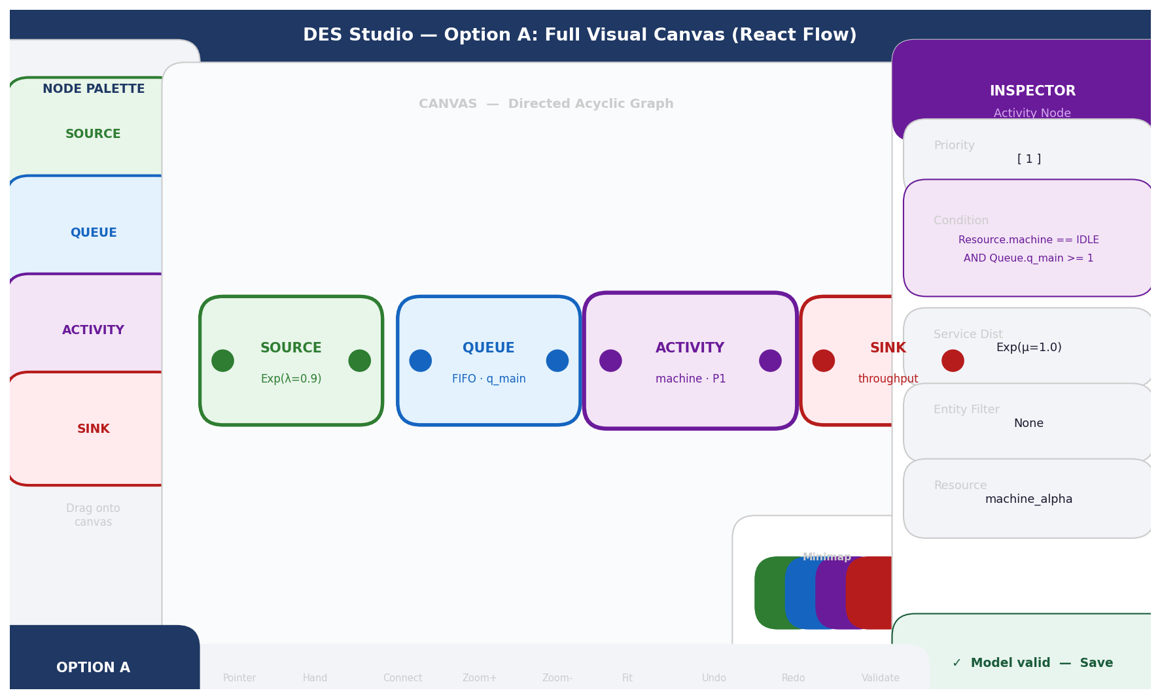
Figure 6: The target Phase 3 canvas — full React Flow with drag-and-drop, node palette, minimap, and inspector panel reused unchanged from Phase 2.

What Changes and What Does Not
Changes in Phase 3 | Unchanged in Phase 3
FlowDiagramSVG.jsx replaced with FlowDiagramReactFlow.jsx | FlowDiagram props interface — identical
reactflow added to package.json | Inspector panel — identical
Drag-and-drop node placement | model_json schema
Manual edge routing | Predicate Builder
Node palette sidebar | DistPicker
MiniMap + zoom/pan | Validation logic
Manual node repositioning (onNodeDragStop) | Tab editors (remain as fallback)
Custom node components (per node type) | All engine code
 | All DB layer code

One-Line Change in the Application
// Phase 2 import (in ModelDetail):
import { FlowDiagramSVG as FlowDiagram } from './FlowDiagramSVG';

// Phase 3 — replace the above line with:
import { FlowDiagramReactFlow as FlowDiagram } from './FlowDiagramReactFlow';

// Everything else in ModelDetail is identical.
// Inspector panel, validation panel, mode toggle — unchanged.

Custom Node Components (Phase 3)
React Flow renders nodes as custom React components using the same colour scheme from Phase 2:

const SourceNode = ({ data, selected }) => (
<div style={{
background: '#E8F5E9',
border: `${selected ? 3 : 2}px ${selected ? 'dashed' : 'solid'} #2E7D32`,
borderRadius: 8, padding: '8px 16px'
}}>
<strong style={{ color: '#2E7D32' }}>{data.label}</strong>
<div style={{ fontSize: 11, color: '#2E7D32' }}>{data.sublabel}</div>
<Handle type='source' position={Position.Right} />
</div>
);
// All styling uses inline objects — no CSS classes (CLAUDE.md rule)

8. The Inspector Panel — Built Once, Reused Twice
The inspector panel is the most important design decision in this phased approach. It is built in Phase 2 using existing Phase 1 components, and it survives Phase 3 completely unchanged.

What the Inspector Panel Mounts by Node Type
Selected node | Components shown in inspector
None selected | "Click a node in the diagram to edit its properties."
Source | Entity class picker + DistPicker (inter-arrival) + optional DistPicker (patience time)
Queue | Name field + discipline dropdown (FIFO / LIFO / PRIORITY)
Activity | Priority integer field + ConditionBuilder + entity filter Predicate + queue rule + DistPicker (service) + resource picker
Sink | Name field (read-only stats display)

All of these components are built in Phase 1. The inspector panel is a new mounting context. No sub-component is rewritten.

Why the Inspector Panel Survives Phase 3 Unchanged
The inspector panel receives selectedNodeId (a string) and model_json (the full model object). It has no dependency on how the flow diagram works — SVG or React Flow. Whether selectedNodeId is set by a click on an SVG rect or by React Flow's onSelectionChange event is irrelevant. The interface contract is the same.

9. model_json Schema — Fixed in Phase 2, Never Changes
The graph section is added to model_json in Phase 2 Sprint 3. It does not change in Phase 3.

{
"entityClasses": [...],
"stateVariables": [...],
"bEvents": [...],
"cEvents": [...],
"queues": [...],

"graph": {
"nodes": [
{ "id": "src_01", "type": "source", "label": "Customer Arrivals", "x": 80, "y": 240 },
{ "id": "q_main", "type": "queue", "label": "Main Queue", "x": 320, "y": 240 },
{ "id": "act_machine", "type": "activity", "label": "Machine Alpha", "x": 560, "y": 240 },
{ "id": "sink_01", "type": "sink", "label": "Exit", "x": 800, "y": 240 }
],
"edges": [
{ "id": "e1", "from": "src_01", "to": "q_main" },
{ "id": "e2", "from": "q_main", "to": "act_machine" },
{ "id": "e3", "from": "act_machine", "to": "sink_01" }
]
}
}

The graph section stores visual layout only. Model logic (conditions, distributions, macros) lives in the existing sections. node.id matches the corresponding element's id in cEvents, queues, etc.

Migration for Existing Models
Models created before Phase 2 have no graph section. When the visual designer opens such a model, generateGraphFromModel(modelJson) auto-generates the layout and saves it. This is transparent to the modeller — existing models continue to work in the tab editor unchanged.

10. Phase 2 — Detailed Visual Specification

Node Visual Specification
Node type | Border colour | Fill colour | Text colour
Source | #2E7D32 | #E8F5E9 | #2E7D32
Queue | #1565C0 | #E3F2FD | #1565C0
Activity | #6A1B9A | #F3E5F5 | #6A1B9A
Sink | #B71C1C | #FFEBEE | #B71C1C

State | Appearance
Default | 2px solid border in node colour
Selected | 3px dashed border in node colour
Hover | 2px solid border, pointer cursor
Error | Red dashed border, ✗ icon top-right

Edge Visual Specification
- SVG cubic bezier paths from output port to input port
- Edge colour matches the source node type
- 2px width, 8px arrowhead
- Selected edge: 3px width, delete button appears on hover

Validation Panel Specification
State | Display
All valid | Green background · "Model is valid — N nodes, N edges"
Warning | Amber background · "[node name]: [message]" · clicking highlights the node in the diagram
Error | Red background · "[node name]: [message]" · Run button is disabled

11. Phase 3 — Detailed Design

New file: FlowDiagramReactFlow.jsx
Implements the Phase 2 props interface using React Flow internals:

import ReactFlow, { MiniMap, Controls, Background, Handle, Position } from 'reactflow';

export const FlowDiagramReactFlow = ({
nodes, edges, selectedNodeId,
onNodeSelect, onNodeAdd, onNodeDelete,
onEdgeAdd, onEdgeDelete, validationErrors
}) => {
const rfNodes = nodes.map(n => ({
id: n.id, type: n.type, position: { x: n.x, y: n.y },
data: { label: n.label, sublabel: n.sublabel,
error: validationErrors.find(e => e.nodeId === n.id) }
}));
const rfEdges = edges.map(e => ({ id: e.id, source: e.from, target: e.to }));

return (
<ReactFlow nodes={rfNodes} edges={rfEdges}
onSelectionChange={({nodes}) => onNodeSelect(nodes[0]?.id ?? null)}
onConnect={({source,target}) => onEdgeAdd({from:source, to:target})}
onEdgesDelete={deleted => deleted.forEach(e => onEdgeDelete(e.id))}
onNodeDragStop={(_,node) => { /* update x,y in model.graph.nodes */ }}
nodeTypes={nodeTypes}
>
<MiniMap /> <Controls /> <Background />
</ReactFlow>
);
};

Node Palette (New in Phase 3)
A left sidebar with draggable node type tiles. React Flow's onDrop handler receives the drop position and node type, calls onNodeAdd(type, { x, y }). The palette collapses to an icon strip at narrower widths.

12. Claude Code Prompts by Phase

Phase 1 — Sprints 1 and 2
No new prompts
Phase 1 follows the existing Sprint 1 and Sprint 2 prompts in docs/DES_Studio_Build_Plan.md exactly. No new design decisions are required.

Phase 2 — Sprint 3 Planning Prompt
▶ Sprint 3 Planning — Visual Designer [claude.ai]
We are starting Sprint 3 of DES Studio.
Completed in Sprints 1–2: [paste completed feature list]

Sprint 3 goal: Add the split-pane visual designer alongside the
existing tab editors. Both modes must coexist — the same model_json
is read and written by both.

CONFIRMED DECISIONS:
1. Tab editors are NOT removed — they remain fully functional
2. A mode toggle in the header switches between Tab and Visual views
3. Visual designer uses SVG flow diagram — NOT React Flow yet
React Flow is Phase 3 — out of scope for Sprint 3
4. Inspector panel (right pane) reuses existing Phase 1 components:
Predicate Builder, DistPicker, entity filter, resource picker
5. Auto-layout only — no manual drag repositioning
6. FlowDiagram props interface must be renderer-agnostic —
identical to what React Flow will receive in Phase 3
7. model_json graph section is added in this sprint

Features for Sprint 3:
F3.1 — graph section added to model_json + migration function
F3.2 — SVG FlowDiagramSVG component with auto-layout
F3.3 — Port click-to-connect with DAG validation
F3.4 — InspectorPanel: context-sensitive right pane
F3.5 — Mode toggle (Tab / Visual) in ModelDetail header
F3.6 — Validation panel below flow diagram

Definition of done:
- Both modes show identical model data
- Switching between modes preserves all edits
- DAG cycles cannot be created
- Activity inspector shows full Predicate Builder from Sprint 2
- Tab editors remain fully functional and unchanged
- npm test -- --run passes
- npm run build succeeds

F3.1 — graph section in model_json
▶ F3.1 — graph section + migration function [Claude Code (terminal)]
Re-read CLAUDE.md. Task F3.1 of Sprint 3.

Read src/db/models.js — show me the current model_json structure.

Add a graph section to model_json with this exact schema:
{ "graph": {
"nodes": [ { "id": "string", "type": "source|queue|activity|sink",
"label": "string", "x": number, "y": number } ],
"edges": [ { "id": "string", "from": "nodeId", "to": "nodeId" } ]
} }

Also implement generateGraphFromModel(modelJson) → graph:
- Called when model_json has no graph section
- Creates nodes for each element using topological auto-layout:
BFS from Source → column = depth, row = order within column
spacing: 220px horizontal, 120px vertical
- Creates edges from logical connections already in model_json
- Returns a valid graph object ready to save

Update src/db/models.js to save the graph section when generated.
No new DB columns needed — graph lives inside model_json JSONB.

Do not write the FlowDiagram component yet — data layer only.
Show me the schema and generateGraphFromModel before implementing.

F3.2 — SVG FlowDiagramSVG component
▶ F3.2 — SVG FlowDiagramSVG [Claude Code (terminal)]
Task F3.2 of Sprint 3.

Read src/ui/editors/index.jsx — understand the current ModelDetail.

Build src/ui/editors/FlowDiagramSVG.jsx with this EXACT props interface.
This interface must not deviate — Phase 3 React Flow implements the same:

FlowDiagramSVG({
nodes, // { id, type, label, sublabel, x, y }[]
edges, // { id, from, to }[]
selectedNodeId, // string | null
onNodeSelect, // (nodeId: string | null) => void
onNodeAdd, // (type: 'source'|'queue'|'activity'|'sink') => void
onNodeDelete, // (nodeId: string) => void
onEdgeAdd, // ({ from: string, to: string }) => void
onEdgeDelete, // (edgeId: string) => void
validationErrors // { nodeId, message, severity }[]
})

SVG implementation rules:
- Nodes: rect with rounded corners, port circles on left/right
- Node colours: Source=#2E7D32, Queue=#1565C0, Activity=#6A1B9A, Sink=#B71C1C
- Selected node: dashed border 3px in node colour
- Edges: cubic bezier SVG paths, coloured by source node type
- Port click-to-connect: output port → input port calls onEdgeAdd
Use component state for pending connection + dashed preview line
- DAG validation before calling onEdgeAdd — block cycles
- Add node buttons below: [+ Source] [+ Queue] [+ Activity] [+ Sink]

Before writing code, explain:
1. How you will track pending edge connection state
2. How you will validate DAG rules before calling onEdgeAdd
3. How SVG coordinates map to x, y in model.graph.nodes

Do NOT use React Flow in this sprint. SVG only.

F3.4 — InspectorPanel component
▶ F3.4 — InspectorPanel (reuses Phase 1 components) [Claude Code (terminal)]
Task F3.4 of Sprint 3.

Read src/ui/editors/index.jsx in full. Identify:
1. The Predicate Builder component and its current props
2. The DistPicker component and its current props
3. The entity filter section in the C-Event editor
4. The resource dropdown and priority field

Build src/ui/editors/InspectorPanel.jsx:
Props: { selectedNodeId, model, onChange }
- model: full model_json object
- onChange: (updatedModel) => void

Renders by selected node type:
null → 'Click a node to edit its properties.'
source → entity class picker + DistPicker (inter-arrival)
+ optional DistPicker (patience time)
queue → name field + discipline dropdown
activity → priority integer field
+ ConditionBuilder (reuse — do not rewrite)
+ entity filter Predicate (Entity.* vars only)
+ queue rule dropdown
+ DistPicker (service time)
+ resource picker dropdown
sink → name field (read-only)

CRITICAL: Reuse existing Predicate Builder, DistPicker, ConditionBuilder.
Do NOT rewrite them. Only change where they are mounted.

Show me the component tree and which existing components you will
reuse before writing any code.

F3.5 — Mode Toggle
▶ F3.5 — Mode Toggle (Tab / Visual) [Claude Code (terminal)]
Task F3.5 of Sprint 3.

Read src/ui/editors/index.jsx — show me the current ModelDetail
component and its tab structure.

Add a mode toggle to the ModelDetail header:
[Tab Editor ⊞] [Visual Designer ⧉]

const [mode, setMode] = useState('tabs'); // default to existing behaviour

In 'tabs' mode: render existing tab structure UNCHANGED.
In 'visual' mode: render split-pane layout:
- Left pane (40%): FlowDiagramSVG
- Right pane (60%): InspectorPanel

The toggle must NOT modify model_json.
Switching modes must NOT lose any unsaved changes.
The existing tab editor must be pixel-identical in 'tabs' mode —
do not alter it while adding the toggle.

Phase 3 — Sprint Planning Prompt
▶ Phase 3 Planning — React Flow Canvas [claude.ai]
We are planning Phase 3 of the DES Studio visual designer.

Phase 2 is complete:
- SVG FlowDiagramSVG with agreed props interface
- InspectorPanel reusing Phase 1 components
- Mode toggle (Tab / Visual) in ModelDetail
- Both modes coexist with identical model_json

Phase 3 replaces the SVG renderer with React Flow.
Inspector panel, model_json, and tab editors do NOT change.

Key constraint: the FlowDiagram props interface is fixed.
Phase 3 is a renderer substitution — not a redesign.

New in Phase 3 only:
- reactflow added to package.json
- FlowDiagramReactFlow.jsx implements same props interface
- Custom node components (SourceNode, QueueNode, ActivityNode, SinkNode)
- Node palette sidebar (drag-and-drop)
- MiniMap, zoom/pan, manual node repositioning
- One import line change in ModelDetail

Define sprint scope, risks, and React Flow version.
Flag any cases where the existing props interface needs extending.

Phase 3 — Start Prompt for Claude Code
▶ Phase 3 — React Flow Renderer Substitution [Claude Code (terminal)]
Re-read CLAUDE.md. Phase 3 of the visual designer.

Phase 3 replaces FlowDiagramSVG with React Flow.
Inspector panel, tab editors, model_json, engine — NOT changed.

Before writing any code:
1. Read src/ui/editors/FlowDiagramSVG.jsx — show me the full
props interface from Phase 2
2. Read src/ui/editors/InspectorPanel.jsx — confirm it has no
dependency on SVG internals
3. Read package.json — confirm reactflow is not yet installed

Then explain:
1. How FlowDiagramReactFlow.jsx implements the same props interface
2. How model.graph.nodes maps to React Flow node format
3. How model.graph.edges maps to React Flow edge format
4. How onNodeSelect, onEdgeAdd, onEdgeDelete map to React Flow callbacks
5. How onNodeDragStop updates model.graph.nodes[i].x and y

Show component signature and data mapping before implementing.
The one-line import change in ModelDetail is the LAST step — not first.

