Eli pillar4 Generator

Eli pillar4 generator is a tool that will provide a sitemap xml file (Optional) and an Atom Feed RSS file, from input data such as a csv file or a sitemap file.

It is a portable and easy tool to use with command line, without the need to do a local installation.

For its execution, it must have an input data file (Mandatory), a URL link (Mandatory), a URL link (optional), a folder where the file or files will be deposited and an xml file with information to configure the Atom file.

Requeriments technique:

* Java VM
* API eli-pillar4-helper.jar

How to use:

Eli pillar4 Herlper has two options : **sitemap2atom** y **csv2pillar4**.

**sitemap2atom** – The functionality is to create an Atom Feed RSS file.

Use: **sitemap2atom [Opcion]**

Options:

-u, --baseurl : Base URL (mandatory)

-i, --input : Path to the input Sitemap file(s) (mandatory)

-o, --ouptut : Path to the output Atom feed (mandatory)

-iAtom, --inputAtom : Path to the input xml file (mandatory)

**csv2pillar4** – The functionality is to create two output files, a sitemap file and an Atom Feed file.

Use: **csv2pillar4 [Opcion]**

Options:

-i, --input : Path to the input CSV file (mandatory)

-u, --baseurl : Base URL (mandatory)

-uset, --baseurlset : Base URL

-o, --output : Path to the output directory (mandatory)

-iAtom, --inputAtom : Path to the input xml file (mandatory)

description of options :

* -i, --input
  + For the csv files, the must be structure:
    - Column Loc : the URL input (mandatory)
    - Column date : indicates the last modification date of the legal resource, This date should be in W3C Datetime format. This format allows you to omit the time portion, if desired, and use YYYY-MM-DD.
  + for the sitemap file, nothing is changed.
* -u, --baseurl (mandatory)
  + A base URL is, basically, the consistent part of your web address. It is a mandatory URL type input data.
* -uset, --baseurlset
  + An optional URL base, this option enriches the namespace (standard protocol) of a sitemap file and is added to the <urlset> tag.
* -o, --output (mandatory)
  + Path where the output file(s) are stored.
* -iAtom, --inputAtom (mandatory)
  + XML File for the contain mandatory Atom elements.

Informacion to xml File :



Processing Model Diagram :

**Diagram for the sitemap2atom generator.**

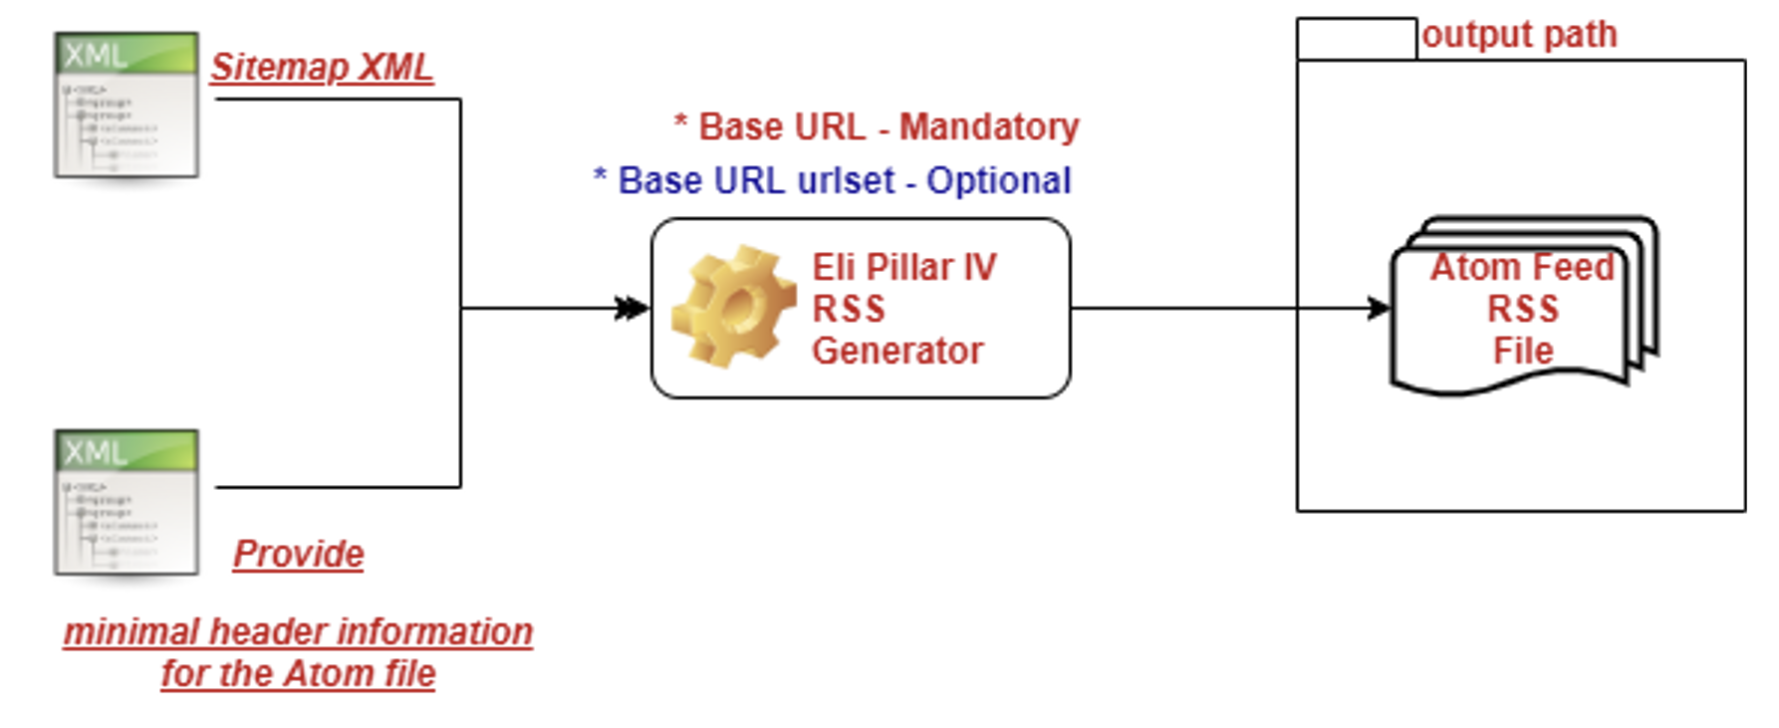

**Diagram for the csv2pillar4 generator.**

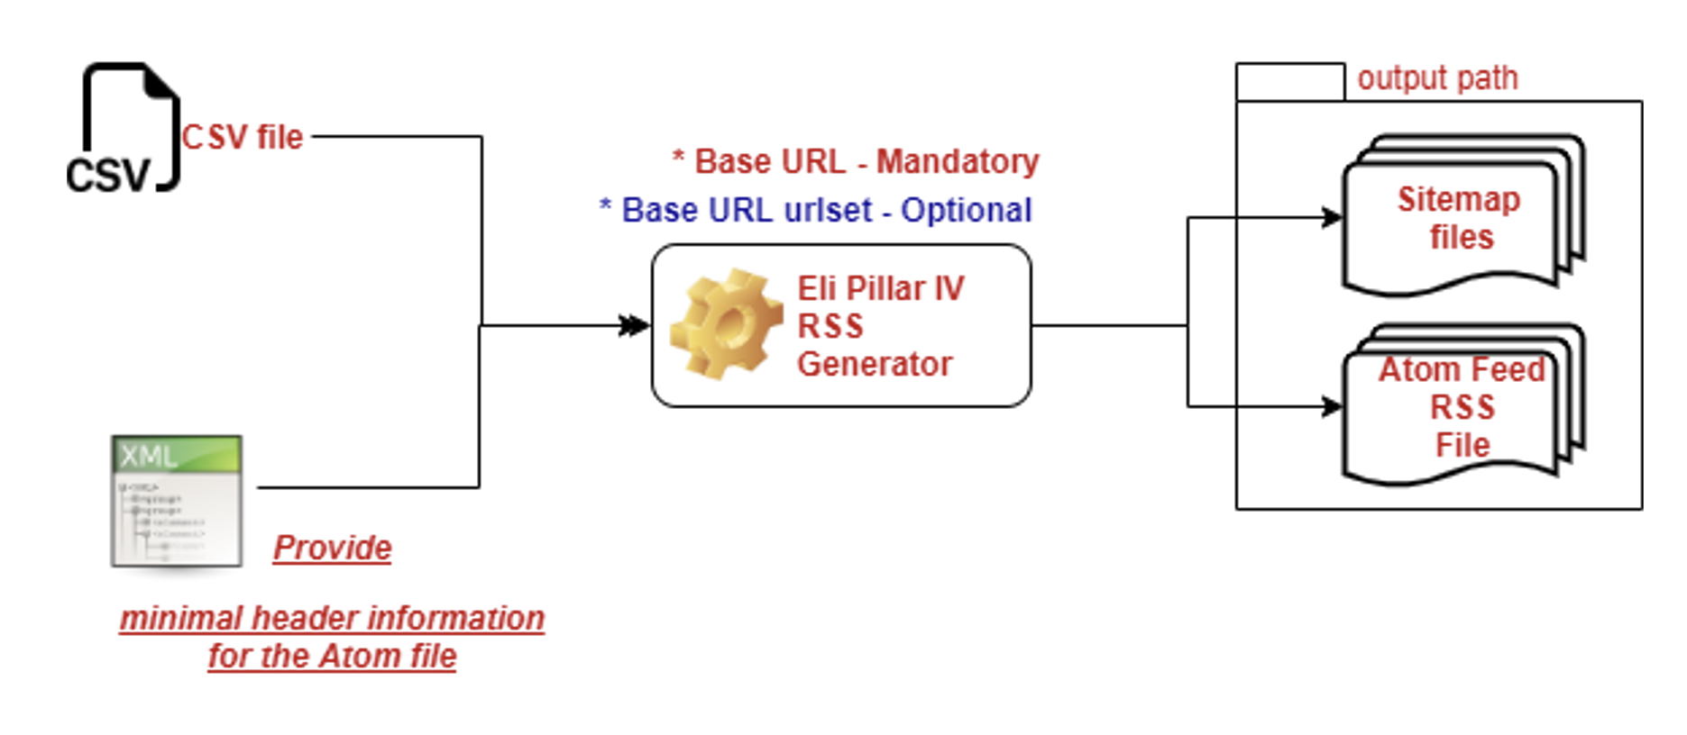

Command for the generated a sitemap file and an Atom Feed File :

**java -jar eli-pillar4-generator.jar** [**Option csv2pillar4 or sitemap2atom** ] -i [**Path file input**] -o [**Path output**] -u [**URL**] -uset [URL] –iAtom [**Path file input**]