ISSN linked data application profile

|  |  |  |  |
| --- | --- | --- | --- |
| **Revision history** | | | |
| **Version** | **Date** | **Author** | **Modifications** |
| V0.9 | 4/12/2017 | ISSN IC |  |
| V1.1 | 16/07/2020 | ISSN IC | *Page layout update to correct readability, minor edits* |
| V1.2 | 23/07/2020 | ISSN IC | *Added Keepers metadata and ISSN Centre’s description.*  *Set ISSNCentre’s URI to “…#ISSNCenter”* |
| v2 | 07/2024 | ISSN IC | *Update following the revamp of the ISSN portal and new JSON-LD formats* |

Introduction 4

Context 4

Prefixes used in this document 5

Overview of the ISSN linked data model 5

Naming conventions 6

ISSN URI templates 6

Relative URIs 7

Modelling choices 8

Reuse existing models 8

The ISSN resource distinct from the ISSN record 8

The ISSN resource considered both as a Bibframe Work and Instance 9

The ISSN resource typed with schema:Periodical 9

The ISSN-L described as an independent resource 10

KeyTitle and AbbreviatedKeyTitle considered both as Titles and Identifiers 10

Key Title and other titles as both literal values and title objects 10

A Reference Publication Event and a Publication Event history 11

The ISSN free linked data model 11

Free vs. Full model 11

Free model diagram 12

Free model diagram 13

Description 14

The ISSN full linked data model 15

Diagram legend 15

The ISSN, its Record and its identifiers 16

The ReferencePublicationEvent and the other Publication Events 20

Titles and classification 23

Links between ISSN 26

Keeper’s Archives 28

ISSN Centres 30

ISSN linked data entities detailed description 32

ISSN resource 32

ISSN resource links 41

Activity (Record Creation Event) 43

ISSN-L 44

ISSN record 45

Publication Events 46

Reproductions 50

Identifiers 51

Titles 52

Organizations (Publishers, Issuing Bodies, ISSN Centres) 53

Classifications 56

Notes 57

Keepers Archive 57

ISSN controlled vocabularies 59

List of record statuses 59

List of identifier statuses 60

List of media 60

**Erreur ! Référence de lien hypertexte non valide.Erreur ! Référence de lien hypertexte non valide.Erreur ! Référence de lien hypertexte non valide.Erreur ! Référence de lien hypertexte non valide.Erreur ! Référence de lien hypertexte non valide.Erreur ! Référence de lien hypertexte non valide.Erreur ! Référence de lien hypertexte non valide.Erreur ! Référence de lien hypertexte non valide.Erreur ! Référence de lien hypertexte non valide.Erreur ! Référence de lien hypertexte non valide.Erreur ! Référence de lien hypertexte non valide.Erreur ! Référence de lien hypertexte non valide.Erreur ! Référence de lien hypertexte non valide.Erreur ! Référence de lien hypertexte non valide.Erreur ! Référence de lien hypertexte non valide.Erreur ! Référence de lien hypertexte non valide.Erreur ! Référence de lien hypertexte non valide.Erreur ! Référence de lien hypertexte non valide.Erreur ! Référence de lien hypertexte non valide.Erreur ! Référence de lien hypertexte non valide.Erreur ! Référence de lien hypertexte non valide.Erreur ! Référence de lien hypertexte non valide.Erreur ! Référence de lien hypertexte non valide.Erreur ! Référence de lien hypertexte non valide.Erreur ! Référence de lien hypertexte non valide.Erreur ! Référence de lien hypertexte non valide.Erreur ! Référence de lien hypertexte non valide.Erreur ! Référence de lien hypertexte non valide.Erreur ! Référence de lien hypertexte non valide.Erreur ! Référence de lien hypertexte non valide.Erreur ! Référence de lien hypertexte non valide.Erreur ! Référence de lien hypertexte non valide.Erreur ! Référence de lien hypertexte non valide.Erreur ! Référence de lien hypertexte non valide.Erreur ! Référence de lien hypertexte non valide.Erreur ! Référence de lien hypertexte non valide.Erreur ! Référence de lien hypertexte non valide.Erreur ! Référence de lien hypertexte non valide.Erreur ! Référence de lien hypertexte non valide.Erreur ! Référence de lien hypertexte non valide.Erreur ! Référence de lien hypertexte non valide.Erreur ! Référence de lien hypertexte non valide.Erreur ! Référence de lien hypertexte non valide.Erreur ! Référence de lien hypertexte non valide.**

# Introduction

## Context

The ISSN is an identification system intended to reliably identify serials and other ongoing resources worldwide: it covers therefore not only periodicals, monographic series and newspapers, but also publications such as scholarly databases, websites and blogs. ISSN assignment is ensured by a network of ninety national centres. An intergovernmental organisation, the ISSN International Centre, is in charge of coordinating the network and ingesting ISSN records produced by National Centres. It manages a central database, the ISSN Register, and provides tools and services to access that information.

The need for standard, internationally recognized, and persistent identifiers has been recognized for many years – the ISSN system itself was established in 1975. This need has been dramatically increased by the emergence of linked data. Identifiers make it possible to link heterogeneous sets of metadata, which should be easily accessible and not stored in closed silos. The ISSN International Centre has thus developed a new Portal, intended on one hand to freely distribute a subpart of the ISSN Register; and on the other hand to provide linked and enriched information to its customers.

ISSN linked data will be stored and accessible to different kinds of users in different databases and applications:

* On the one hand, information from the ISSN Register is stored in a RDF triplestore, where it will be enriched by other sources of information. Access to this triplestore is provided to ISSN customers and partners through a SPARQL endpoint.
* On the other hand, information from an ISSN record or a set of ISSN records is downloadable from the ISSN Portal. ISSN customers and partners are able to access to full record information, while “free” (non-registered) users will only access a sub-part of the record, corresponding to the “essential” identification metadata. In addition, several APIs are provided to customers in order to automate metadata retrieval.

This document presents how bibliographic information from the ISSN Register is mapped in linked data. To that end, an ISSN data model and an ISSN application profile have been designed. The data model is intended to be consistent with the overarching models of the bibliographic communities (especially the IFLA-Library Reference Model), while taking into account the specificities of continuing resources – especially their dynamic and event-oriented nature. The ISSN application profile implementing this data model is based on popular and simple ontologies (mainly Schema.org and Dublin Core) for the most common metadata and on more specific ones (Bibframe, Marc21rdf.info) when it comes to detailed bibliographic information.

This application profile provides a support for the release of all ISSN Register information, including data provenance, as well as for the distribution of “essential” information as linked open data. It is also intended to be flexible and extensible enough to be enriched by new kinds of information (e.g. extended classification, geo-localisation…) as a support for new services.

## Prefixes used in this document

This document uses the namespace prefixes listed in the table below:

|  |  |
| --- | --- |
| **Prefix** | **URI** |
| bf | <http://id.loc.gov/ontologies/bibframe/> |
| bflc | http://id.loc.gov/ontologies/bflc/ |
| bfmarc | http://bibfra.me/vocab/marc/ |
| bfrel | http://id.loc.gov/vocabulary/relators/ |
| bibo | http://purl.org/ontology/bibo/ |
| dc | http://purl.org/dc/elements/1.1/ |
| dcam | http://purl.org/dc/dcam/ |
| dct | http://purl.org/dc/terms/ |
| dctype | http://purl.org/dc/dcmitype/ |
| gn | http://www.geonames.org/ontology# |
| m213XX | http://marc21rdf.info/elements/3XX/ |
| m21terms | http://marc21rdf.info/terms/ |
| prov | http://www.w3.org/ns/prov# |
| rdf | http://www.w3.org/1999/02/22-rdf-syntax-ns# |
| rdfs | http://www.w3.org/2000/01/rdf-schema# |
| schema | http://schema.org/ |
| ***ISSN specific vocabularies*** | |
| issnprop | http://issn.org/vocabularies/properties/ |
| idStatus | http://issn.org/vocabularies/IdentifierStatus# |
| media | http://issn.org/vocabularies/Medium# |
| recordStatus | http://issn.org/vocabularies/RecordStatus# |

## Overview of the ISSN linked data model

The ISSN Linked Data model is composed of the following entities:

* The **ISSN Resource**: identifies a continuing resource to which an ISSN has been assigned by the ISSN network. This is the central resource in the graph; in particular, it carries or links to the following information:
  + Identifiers of the continuing resource (the ISSN number itself and others);
  + Issuing bodies of the continuing resource;
  + Country and dates of publication;
  + Titles, classifications and notes;
  + Links to other resources;
* The **ISSN Record**: identifies the record/document created by an ISSN Centre when assigning an ISSN to a continuing resource;
* The **Record Creation Activity**: identifies the event of creation of the record by an ISSN Centre ;
* **Publication Events** in the publication history of an ISSN : each event identifies the publication of the continuing resource by a given publisher, in a given place, during a given date range ;

# Naming conventions

## ISSN URI templates

### URI template for resources

The URI template for ISSN resources is http://issn.org/resource/{identifier_type}/{resource_identifier}. The {identifier_type} URI component can have the following values:

* ISSN for resources identified by an ISSN; (e.g. http://issn.org/resource/ISSN/1683-4135);
* ISSN-L for resources identified by an ISSN-L (e.g. http://issn.org/resource/ISSN-L/1683-3775).

It is an open debate within institutions providing bibliographic information as linked data, if the main entity identified by an URI should be the resource itself, or the record corresponding to the resource within the institution. Libraries often prefer the latter solution. As a matter of fact, library catalogues provide records about a resource, not the original resource itself (even though the record may itself provide a link to the original resource).

The ISSN International Centre decided however to adopt the first solution, and to state that the main URI identifies the resource itself. ISSN identifiers are indeed not designed to be the identifiers of a resource within the ISSN Register only, but to serve as the reference identifier in any cases. The URI pattern http://issn.org/resource/{identifier_type}/{resource_identifier} can therefore serve in different circumstances and within various datasets to identify a specific continuing resource.

An ISSN identifies a specific continuing resource on a specific medium (print, online, digital carrier, other). The “Linking ISSN” or “ISSN-L”, on the other hand, provides a reference identifier to a title whatever its medium. It also provides a link between the different ISSN of the different medium editions. By convention, a continuing resource published on only one medium has also an ISSN-L but this ISSN-L does not link together several ISSN. The URI pattern http://issn.org/resource/ISSN-L/{resource_identifier} identifies therefore a specific continuing resource, on its different publication media, while http://issn.org/resource/ISSN/{resource_identifier} identifies a continuing resource on a specific medium.

As other groupings may be designed by future versions of the ISSN ISO standard, like “ISSN families”, other identifier types may be added in the future.

### URI template for organisations

The URI template for ISSN Centers is http://issn.org/organization/ISSNCenter#{CCID}. (note : “ISSNCenter”, final “er”) The CCID component is the ISSN Center code.

The URI templates for publishers or issuing bodies or reproduction agencies generated from the MARC 21 Record are:

* http://issn.org/resource/ISSN/{ISSN}#Publisher-{publisherName}
* http://issn.org/resource/ISSN/{ISSN}#IssuingBody-{issuingBodyName}
* http://issn.org/resource/ISSN/{ISSN}#ReproductionAgency-{reproductionAgencyName}

These resources may be linked with an owl:sameAs to URIs of organisations from a central ISSN organisation registry, following the pattern http://issn.org/organization/publisher/{PublisherID}

### URI template for controlled vocabularies

The URI template for controlled vocabularies defined in the ISSN model is http://issn.org/vocabularies/{vocabulary_identifier}#{concept_identifier}. The {vocabulary_identifier} URI component can have the following values :

* IdentifierStatus for the list of possible statuses of an identifier (e.g. http://issn.org/vocabularies/IdentifierStatus#Valid);
* RecordStatus for the list of possible statuses for an ISSN record (e.g. <http://issn.org/vocabularies/RecordStatus#Register>);
* Medium for the list of possible media of a continuing resource (e.g. http://issn.org/vocabularies/Medium#Print);

Other vocabularies may be added in the future.

## Relative URIs

The translation of the MARC21 record of an ISSN into RDF generates not only the ISSN resource, but a lot of other entities in a graph data structure (ISSN Record, Identifiers, Publication Events, etc.). A majority of these entities are assigned “#-URIs” relative to the (absolute) ISSN resource URI: http://issn.org/resource/ISSN/{ISSN}.

For example, the ISSN Record is identified by the URI http://issn.org/resource/ISSN/{ISSN}#Record, and the key title of the ISSN is identified by the URI http://issn.org/resource/ISSN/{ISSN}#KeyTitle, etc.

Doing so:

* Avoids creating (a lot of) anonymous nodes;
* Gives predictable URI patterns to derive the identifier of a specific entity from the ISSN resource URI; these URI patterns are described in the documentation below;

However, it should be noted that the ISSN records are dynamic, and that the statements made on an ISSN may change over time. For example, the #LatestPublicationEvent relative URI may identify, over time, different publication events: it will notably change in the case a new publisher is responsible for a continuing resource). Thus, users of the data should proceed with care when using these relative URIs in external references.

A few entities in the graph are created as blank nodes without identifiers (notably classifications, parallel titles, variant titles or reproduction events). It generally happens when the expressed information is repeatable: in that case, using a relative URI could be confusing as the same relative URI could be generated several times, with different values.

# Modelling choices

## Reuse existing models

A choice was made to rely exclusively on existing vocabularies to model the ISSN data in RDF, with the exception of a few controlled vocabularies or properties. Specifically, the following vocabularies are used:

* schema.org;
* Dublin Core and Dublin Core Terms;
* BibFrame;
* MARC21 RDF;

(See the introduction of this documentation for an exhaustive list of the vocabularies used).

The following precedence rule was applied when selecting a property to use in the RDF data graph :

* If the property exists in schema.org, use it;
* Otherwise use a Dublin Core property;
* Otherwise use a BibFrame property;
* Otherwise default to a property from the MARC21 RDF vocabulary;

The ISSN value itself is expressed multiple times for maximum dissemination, in schema:issn, bibo:issn and dc:identifier.

## The ISSN resource distinct from the ISSN record

The model makes a clear distinction between the ISSN resource, which identifies a continuing resource to which an ISSN is assigned by the ISSN Network, and the ISSN record, the document in which this ISSN was declared/created. The ISSN Record points to the ISSN resource with a schema:mainEntity property to state that the ISSN is the main focus of the record.

## The ISSN resource considered both as a Bibframe Work and Instance

Bibframe is a model which follows the hierarchy of bibliographic entities established by the FRBR model, while simplifying it: it distinguishes three high-level classes, namely Work, Instance and Item. Bibframe Work identifies the conceptual essence of something; a Bibframe Instance reflects the material embodiment of a Work. A Bibframe Item is an actual copy (physical or electronic) of an Instance[1]. Schematically, Bibframe Work corresponds to the FRBR Work and Expression levels; Bibframe Instance to FRBR Manifestation, and Bibframe Item to FRBR Item.

However, the FRBR model, on which Bibframe is built, does not perfectly fit with the characteristics of continuing resources[2]. The IFLA-Library Reference Model (LRM), which is about to replace the FRBR model, acknowledges the difficulty to reconcile the rigid structure of its own hierarchy with the dynamic nature of continuing resources. The different “manifestations” of a continuing resource may evolve over time[3]: therefore, the collocation, i.e. the grouping of different manifestations or different expressions under a same work is not possible for continuing resources. The IFLA-LRM states therefore that each new manifestation (i.e. each entity identified by an ISSN) should correspond to a new expression and a new work[4]. In Bibframe terms, it means that each continuing resource identified by an ISSN correspond to only one Instance and one Work. Therefore, each ISSN resource is systematically declared at the same time as a Bibframe Instance and a Bibframe Work.

## The ISSN resource typed with schema:Periodical

The ISSN resource is also assigned the type schema:Periodical. This is a pragmatic choice, as this is the only type of object in the schema.org vocabulary on which major search engines recognize the property “schema:issn”. In practice, an ISSN can be assigned to any type of continuing resource, not only periodicals, including book series, datasets, websites, etc. A suggestion was made to improve the schema.org vocabulary on this point[5].

## The ISSN-L described as an independent resource

The ISSN-L is considered as a separate resource with the URI template [http://issn.org/resource/ISSN-L/{ISSN-L}](http://issn.org/resource/ISSN-L/%7bISSN-L%7d). The ISSN resources are grouped into ISSN-L using a schema:isPartOf link.

## KeyTitle and AbbreviatedKeyTitle considered both as Titles and Identifiers

The ISSN International Centre considers that KeyTitle and AbbreviatedKeyTitle, by their very nature, are *titles and identifiers at the same time*. On one hand, they are titles because they are derived from the Title Proper given by the publisher. On the other hand, they are assigned by the ISSN network, as well as the ISSN itself, following internationally agreed rules; they are irreversibly linked to the ISSN, they are unique in the ISSN Register (if the Title Proper is not unique in the ISSN Register, a qualifier is added to the Key Title to make it unique), and they are persistent[6]: from that point of view, they are considered identifiers. Consequently they are created as independent objects in the graph:

* The Key Title is typed with the 2 classes bf:Identifier and bf:KeyTitle (subclass of bf:Title), and the Abbreviated Key Title is typed with the 2 classes bf:Identifier and bf:AbbreviatedTitle (subclass of bf:Title);
* The Key Title and the Abbreviated Key Title are being referred to from the ISSN resource with both a bf:identifiedBy property and a bf:title property;
* Their string value is expressed both in an rdf:value property (as a string), as with other identifiers, and in a bf:mainTitle property (as a language-typed literal) as with other titles.

## Key Title and other titles as both literal values and title objects

The Key Title and other titles from the original MARC record generate 2 values in the resulting RDF graph:

* + As simple literal properties on the ISSN resource :Key Titles and Titles Proper are encoded in schema:name;
  + Titles Proper are encoded in bf:mainTitle for consistency issues (as all other titles are expressed both through a schema.org and a Bibframe property)
  + Abbreviated Key Titles, Parallel Titles and Variant Titles are encoded in schema:alternateName;
* As reified objects :
  + Key Title and Abbreviated Key Titles are encoded as a resource of type bf:Identifier and (respectively)bf:KeyTitle and bf:AbbreviatedTitle, holding the title value in an rdf:value property as a string, and also in a bf:mainTitle property as a language-typed literal.They are referred to by the ISSN resource by a bf:title and a bf:identifier property;
  + Parallel Titles are encoded as resources of type bf:ParallelTitle, holding the title value in an bf:mainTitle property as a language-typed literal, and referred to by the ISSN resource by a bf:title property;
  + Variant titles follow the same pattern with resources of type bf:VariantTitle, and an additional property bf:variantType containing the type of the title.
  + Title propers are encoded as resources of type bf:Title, holding the title value in a bf:mainTitle property as language-typed literal, and referred to by the ISSN resource by a bf:title property;

## Expression of title transliterations

Titles Proper, Key Titles, Variant and Parallel titles can be the transliterated variant of another, original title in its original script. When it is indicated, the title entity will have a bf:translationOf link pointing to another bf:Title object, holding the title in its original script in a bf:mainTitle property.

## A Reference Publication Event and a Publication Event history

The schema.org vocabulary uses an event modelling pattern with the type schema:PublicationEvent to describe the publication information of a Continuing resource (date, place, publisher, etc.). In particular, the PublicationEvent object carries the publication place information in the schema:location property.

This PublicationEvent pattern is applied at 2 different places in the ISSN data graph :

* To describe the publication history of a continuing resource, from its earliest known publisher to its latest known publisher. Each phase in the publication history of the resource is described with a PublicationEvent. The PublicationEvents have the following (relative) URI templates :
  + #EarliestPublicationEvent for the first known publication event;
  + #InterveningPublicationEvent{n} for the subsequent publication events;{n} corresponds to the offset of the publication event in the ISSN record;
  + #LatestPublicationEvent for the latest known publication event;
* The National Centre in charge of ISSN assignment for a continuing resource is decided depending on the country of its publisher. The responsibility on publications of multinational publishers, active in several countries, is distributed according to agreements within the ISSN Network. Therefore, for every publication, a reference country is identified, which will generally decide on the responsibility for ISSN assignment and the maintenance of ISSN record. Since this is important information that the ISSN wants to expose as schema.org markup, a PublicationEvent, referred to as the #ReferencePublicationEvent, needs to be introduced to link the ISSN to the country in which it applies.

# The ISSN free linked data model

## Free vs. Full model

As stated in the introduction, the amount of information provided on each resource depends on the access context. Customers of ISSN services have access to all bibliographic information from all types of records, while “free” un-registered users are limited to a restricted set of metadata related only to “Register” records.

The open set of linked data is made available through a CC-by-NC license. They are considered the “essential” metadata, which allow for the precise and unambiguous identification of the resource: the different identifiers produced by the ISSN network (Key-Title, ISSN, ISSN-L, cancelled ISSN if any…), the title of the resource, its medium and URL (if any), the publication country. Few context information, such as the National Centre responsible for the resource or modification date of the record*,* is also provided.

## Free model diagram

The ISSN Free linked data model is depicted in the following diagram (Please refer to the following section of the documentation for the diagram legend.)

## Free model diagram

## Description

The following information are included in the free data:

1. ISSN identifier (in schema:issn, dc:identifier, bibo:issn) and as an independant #ISSN identifier resource;
2. The title proper and key title in schema:name;
3. The URL in schema:url and format in dc:format;
4. The link to the ISSN-L resource;
5. The #Record with its modification date (dc:modified), bf:status, and the centre responsible (prov:wasAttributedTo);
6. The country of publication with dc:spatial and the #ReferencePublicationEvent + schema:location;
7. The possible links to a cancelled ISSN (issnprop:hasCancelledIssn, issnprop:cancelledInFavorOf), along with the incorrect ISSN and cancelled ISSN-L as literals if any;
8. Link to an Keeper’s archive, if any (schema:subjectOf)

Users of the free data should refer to the corresponding sections of the full model below for more details.

# The ISSN full linked data model

## Diagram legend

The diagrams in the following documentation do not follow a typical UML representation, or a typical RDF graph representation. They use the formalism described in the legend below, intended to capture in concise representations the resource URI patterns, the resource class or classes and the structure of the data graph.

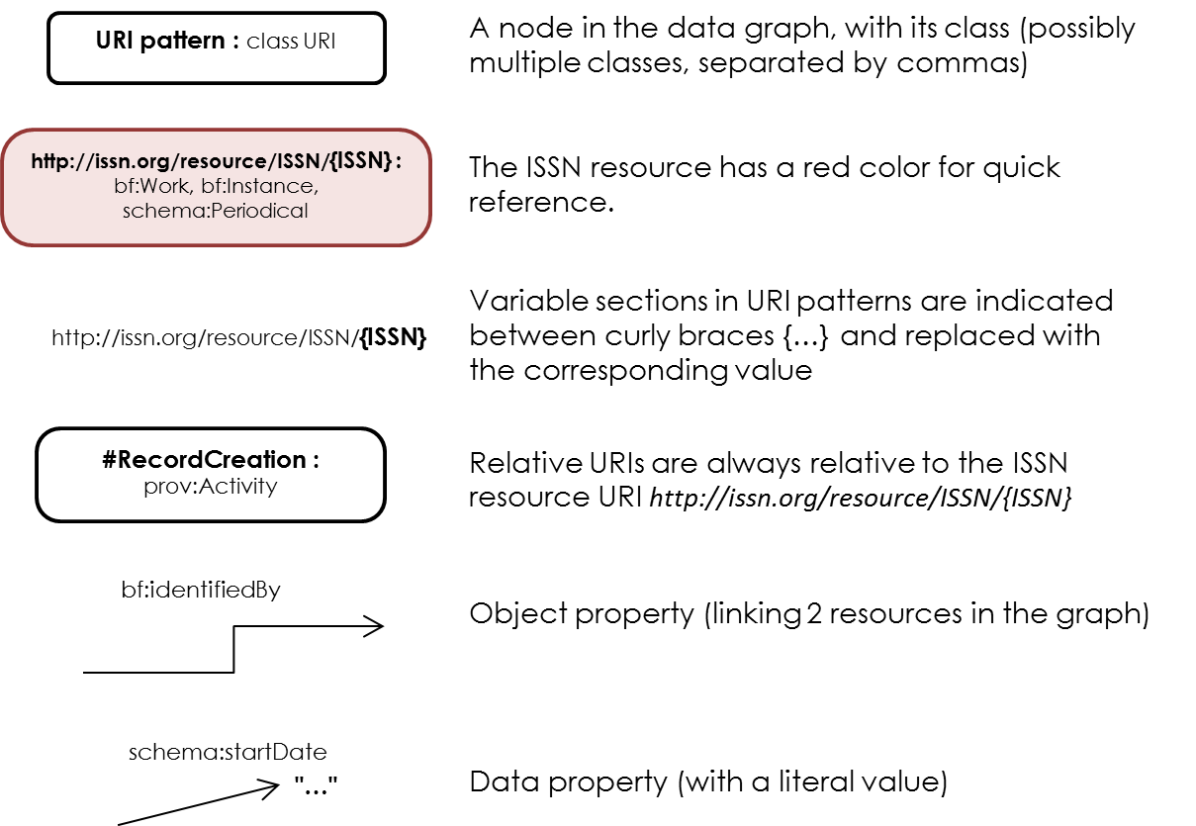

The diagrams are intended as overview maps for data consumers to explore the territory of the ISSN data graph; as such, **the diagrams do not depict all the properties in the model**. Data users should refer to the reference tables at the end of this documentation for the complete list of available properties in the model.

## The ISSN, its Record and its identifiers

### Overview diagram

### ISSN Resource, #Record and #RecordCreation

1. The ISSN resource is considered a bf:Instance, a bf:Work and a schema:Periodical at the same time (see above);
2. The ISSN resource itself is a separate resource from the #Record that describes this ISSN;
3. The ISSN Record is a schema:CreativeWork, and the ISSN resource is the “main entity” of the corresponding ISSN Record;
4. The Record was created (prov:generated) in a “Record creation activity”, the #RecordCreation. This activity was conducted (prov:wasAssociatedWith) by the ISSN centre that initially created the ISSN number;
5. The Record may be under the responsibility (prov:wasAttributedTo) of a different ISSN centre than the one which originally created it (record custody can be transferred between centres, especially in the case of a change of publisher); note that this is different from the notion of a “creator” / “author” of the record.

### Identifiers : #ISSN, #ISSN-L, #KeyTitle, #AbbreviatedKeyTitle

1. The ISSN resource holds its ISSN value as literals stored in the properties schema:issn, bibo:issn and dc:identifier (with the same value);
2. Every identifier of the ISSN resource (its ISSN, ISSN-L, KeyTitle, AbbreviatedKeyTitle, and Coden[7]) is described as an instance of bf:Identifier, or one of its subclass in the case of bf:Issn and bf:IssnL ;
3. Each identifier object holds the actual identifier value in the property rdf:value, as a string;
4. Each identifier identifies the ISSN resource[8] (bf:identifiedBy);
5. The #ISSN identifier holds a bf:status information that indicates if this identifier is idStatus:Valid, idStatus:Cancelled or idStatus:Suppressed (see section below for more details on the Cancelled or Suppressed ISSNs);
6. As with the #Record, each identifier object was created during the “Record creation activity” (prov:generated);

### ISSN-L

1. The ISSN-L is an independent resource of type schema:CreativeWork;
2. An ISSN resource is always part of an ISSN-L (schema:isPartOf), and an ISSN-L can be linked to one or several ISSN (schema:hasPart);
3. The #ISSN-L identifier identifies the ISSN resource *and* the ISSN-L resource at the same time;
4. The #ISSN-L identifier holds a bf:status information that indicates if this identifier is idStatus:Valid, idStatus:Cancelled or idStatus:Suppressed;

### Cancelled, Incorrect ISSN and ISSN-L

### Overview diagram

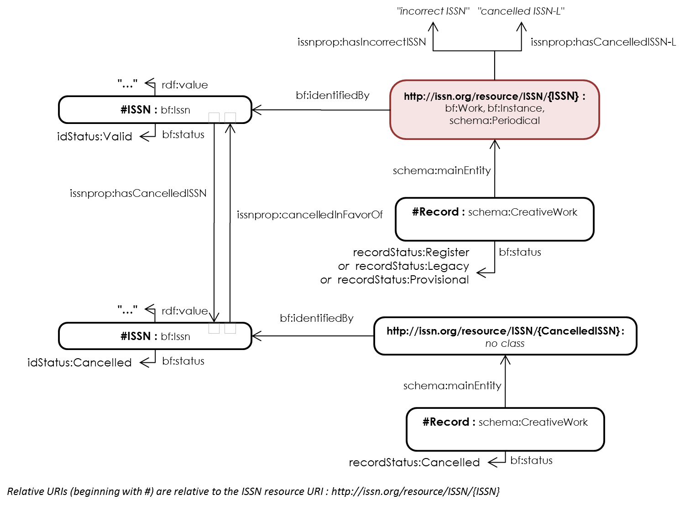

### Description

1. The ISSN resource may have incorrect ISSN, or cancelled ISSN-L, expressed as literal values through custom properties issnprop:hasIncorrectISSN and issnprop:hasCancelledISSN-L, respectively;
2. The #ISSN identifier holds a bf:status, either idStatus:Valid, idStatus:Cancelled or idStatus:Suppressed;
3. In the case of a ISSN with bf:status:Cancelled, there is a bidirectional link to the replacement ISSN : issnprop:cancelledInFavorOf / issnprop:hasCancelledISSN; note that this relates the 2 ISSN *identifiers*, and not the 2 ISSN *resources*, because it is a link between identifiers and not a link between continuing resources (such as “periodical A is a translation of periodical B”);
4. The #Record also holds a bf:status with the following possible values :
   1. recordStatus:Register : for a “normal” record, when the continuing resource is published.
   2. recordStatus:Provisional : for provisional ISSNs that are assigned to pre-publications (a publishers asks for an ISSN before a periodical is first issued);
   3. recordStatus:Legacy : for valid ISSN identifiers, but created at the beginning of the ISSN system (and for which the bibliographic information could be incomplete);
   4. recordStatus:Cancelled : for Cancelled ISSN e.g. an ISSN was assigned twice, it is then cancelled and a new ISSN is re-assigned;
   5. recordStatus:Suppressed : for ISSN that were deleted, typically an ISSN was given for a pre-publication but the periodical was never published;
   6. recordStatus:Unreported : identifiers that are reserved to an ISSN centre for future assignment;
5. In the case of Unreported , Cancelled or Suppressed ISSN, the corresponding resource does not have the types bf:Work, bf:Instance, schema:Periodical because it does not identify such an object (an Unreported ISSN is not yet assigned – or assigned but not yet know in the ISSN register, Cancelled ISSN were replaced by another one or other ones, and Suppressed ISSN were simply deleted because of an error).
6. (not depicted) The Unreported, Cancelled, or Suppressed Records contain very few information; in particular, to avoid confusion, they do *not* express the ISSN value in literal values schema:issn, bibo:issn, and dc:identifier;

The correspondence between the status of the identifier (#ISSN URI) and the status of the record (#Record URI) is as follow :

|  |  |
| --- | --- |
| **#Record status** | **#ISSN status** |
| recordStatus:Register | idStatus:Valid |
| recordStatus:Provisional | idStatus:Valid |
| recordStatus:Legacy | idStatus:Valid |
| recordStatus:Cancelled | idStatus:Cancelled |
| recordStatus:Suppressed | idStatus:Suppressed |
| recordStatus:Unreported | idStatus:Valid |

## The ReferencePublicationEvent and the other Publication Events

### Overview diagram

### Issuing Bodies

1. Each IssuingBody is a schema:Organization and is referred to from the resource by both schema:contributor and bf:isb;
2. One Issuing Body may be a schema:parentOrganization of the other, in the case of “subordinate units”, typically a research lab in a university;
3. (not depicted) An issuing body may have a schema:sameAs referring to an organization identifier (pattern http://issn.org/organization/publisher/{IssuingBodyID}) in the ISSN organization reference table;
4. (not depicted) As with titles, it can be the case that the name of the issuing body is a Latin transliteration of a name in another original script. In that case, the name in the original script is the schema:name value, and the transliterated one is in schema:alternateName. Otherwise the Latin-script name is in schema:name.

### The #ReferencePublicationEvent – dates and place of the resource

1. The publication dates of the ISSN resource are expressed in schema:startDate and schema:endDate; if the publication is still running, “9999” is used as end date;
2. The reference country of the publisher of the ISSN resource (see above) is indicated in dct:spatial and also through the #ReferencePublicationEvent. This schema:PublicationEvent is necessary to express the publication country of the resource in the schema.org vocabulary;
3. The reference country of publication is indicated by both a URI based on MARC country codes and a URI based on ISO Country codes. For some countries (especially English-speaking countries), their granularity differs (US States have separated MARC country codes);

### The publication history (#EarliestPublicationEvent, #InterveningPublicationEvent{n}, #LatestPublicationEvent)

Each phase in the publication history of the resource (#EarliestPublicationEvent, #InterveningPublicationEvent{n} and #LatestPublicationEvent) is modelled on the same pattern :

1. The event is a schema:PublicationEvent to which the ISSN resource refers in a schema:publication property;
2. The publication event holds its date information in a dct:temporal property; note that, contrary to the dates on the resource itself, it is currently not possible to parse this field to distinguish the start and end date (if any);
3. The publication event indicates the publisher (schema:publishedBy); the same publisher is referenced directly from the ISSN resource in a schema:publisher;
4. (not depicted) The publisher may have a schema:sameAs referring to an organization identifier (pattern http://issn.org/organization/publisher/{IssuingBodyID}) in the ISSN organization reference table;
5. The publication event also indicates the place of publication (schema:location);
6. The place of publication is a schema:Place that refers to a Geocoordinate object holding a latitude (schema:latitude),a longitude (schema:longitude), and a country (schema:addressCountry, not depicted). The place of publication if also linked to the Geonames URI of the city, if any (schema:sameAs).

### Reproductions (not depicted)

The modelling of the reproductions (e.g. electronic reproduction of a printed resource) is done in the following way:

1. The reproduction itself is an anonymous node of type schema:CreativeWork, linked from the ISSN resource with a bf:hasReproduction;
2. That reproduction refers to its publisher (schema:publisher), its publication place (dct:spatial), and its Reproduction Event (schema:publication), of type schema:PublicationEvent;
3. That reproduction event is modelled in the same way as a publication event from the resource publication history, with a place (schema:location), a publisher (schema:publishedBy), and dates (schema:temporal);

## Titles and classification

### Overview diagram

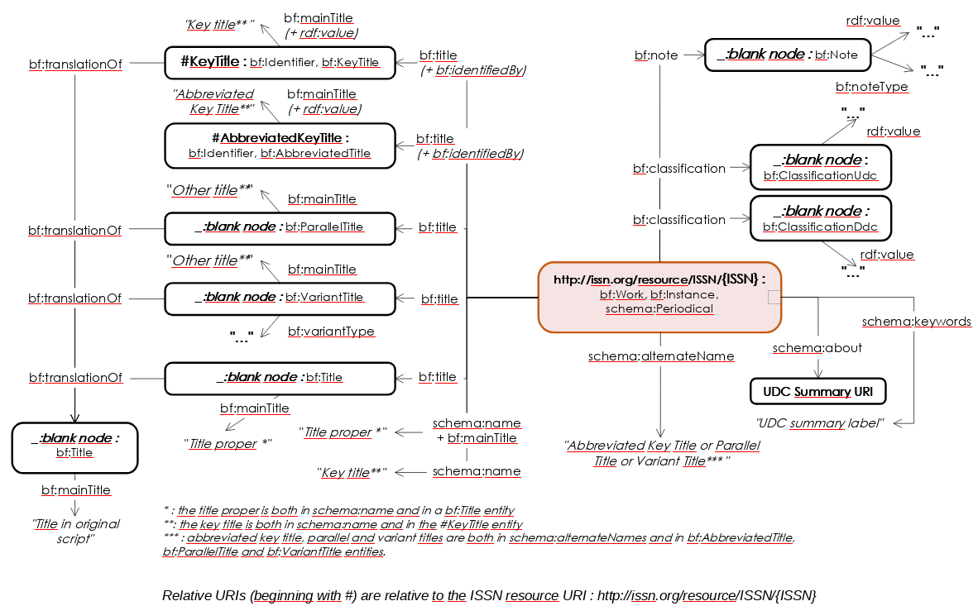

### Titles : #KeyTitle, #AbbreviatedKeyTitle, Title Proper, Parallel Titles, Variant Titles

1. The KeyTitle is an object of type bf:KeyTitle, linked from the ISSN resource with a bf:title property; it holds the key title value as a string in the rdf:value property, and as language-and-script-typed literal in the bf:mainTitle property. The language code holds the script of the title, even if the actual language is unknown (e.g. “und-Latn” indicates a latin script in an undefined language).
2. The same KeyTitle is also the schema:name of the ISSN resource, as a plain literal;
3. The AbbreviatedKeyTitle is an object of type bf:AbbreviatedTitle, linked from the ISSN resource with a bf:title property; it holds the abbreviated key title value as a string in the rdf:value property; the AbbreviatedKeyTitle is also a schema:alternateName of the ISSN resource, as a plain literal;
4. The TitleProper is an object of type bf:Title, linked from the ISSN resource with a bf:title property; it holds the title proper value as language-and-script-typed literal in the bf:mainTitle property. The language code holds the script of the title, even if the actual language is unknown (e.g. “und-Latn” indicates a latin script in an undefined language). The Title Proper is also a schema:name of the ISSN resource; this means the ISSN resource has 2 names : its TitleProper and its KeyTitle;
5. Parallel titles are object of type bf:ParallelTitle, linked from the ISSN resource with a bf:title property; they hold the title value as a language-and-script-typedin the bf:mainTitle property;
6. Variant titles are object of type bf:VariantTitle, linked from the ISSN resource with a bf:title property; they hold the title value as a language-and-script-typed literal in the bf:mainTitle property, and they hold the type of the title in the bf:variantType property;
7. Parallel and variant titles are also schema:alternateNames of the ISSN resource, as plain literals;

Titles Proper, Key Titles, Variant and Parallel titles can be the transliterated variant of another, original title in its original script. When it is indicated, the title entity will have a bf:translationOf link pointing to another bf:Title object, holding the title in its original script as a language-and-script-typed literal in a bf:mainTitle property.

We refer to “language-and-script-typed literals” as literals with a language code using a BCP47 code containing :

* a language code, potentially unknown with the value “und”
* a script indication, such as “Latn” for latin script, or “Cyrl” for Cyrilic
* Optionaly, if this literal was transliterated from another language, the separator “t”, followed by the original language code (potentially unknown “und”) and the original script indication

Examples of such codes are:

* “und-Latn” : undefined language, latin script
* “en-Latn” : English language, latin script
* “und-Latn-t-und-Cyrl” : undefined language, latin script, transliterated from undefined language, Cyrilic script
* “ru-Latn-t-ru-Cyrl” : russian language, latin script, transliterated from russian language, Cyrilic script

### Classification: #UDC, #DDC

1. Classification from the ISSN Register may be expressed following the Universal Decimal Classification or the Dewey Decimal Classification. There are sometimes several indices, in only one classification or in both. These classifications are provided by the National Centres;
2. Each classification information is a blank node of type bf:ClassificationUdc or bf:ClassificationDdc, respectively, that is linked from the ISSN resource by a bf:classification property; an rdf:value property relates the blank node to the classification keyword as a literal;
3. Besides, most records are enriched by an additional “UDC Summary” classification computed from the UDC or DDC classifications (it is available as linked data at <http://udcdata.info/>).

Each UDC Summary classification information is expressed in a schema:about that refers to the actual entry URI from the UDC Summary;

1. The property schema:keywords contains the English label of the UDC Summary class, in a literal;
2. Each classification information on the UDC Summary is also a blank node of type bf:ClassificationUdc that is linked from the ISSN resource by a bf:classification property; a rdf:value property relates the blank node to the classification keyword as a literal[9];

### Notes

1. Each note is an anonymous node with type bf:Note;
2. Each note holds the actual note as a literal in rdf:value;
3. Each note holds its type as a literal in bf:noteType;

## Links between ISSN

### Overview diagram

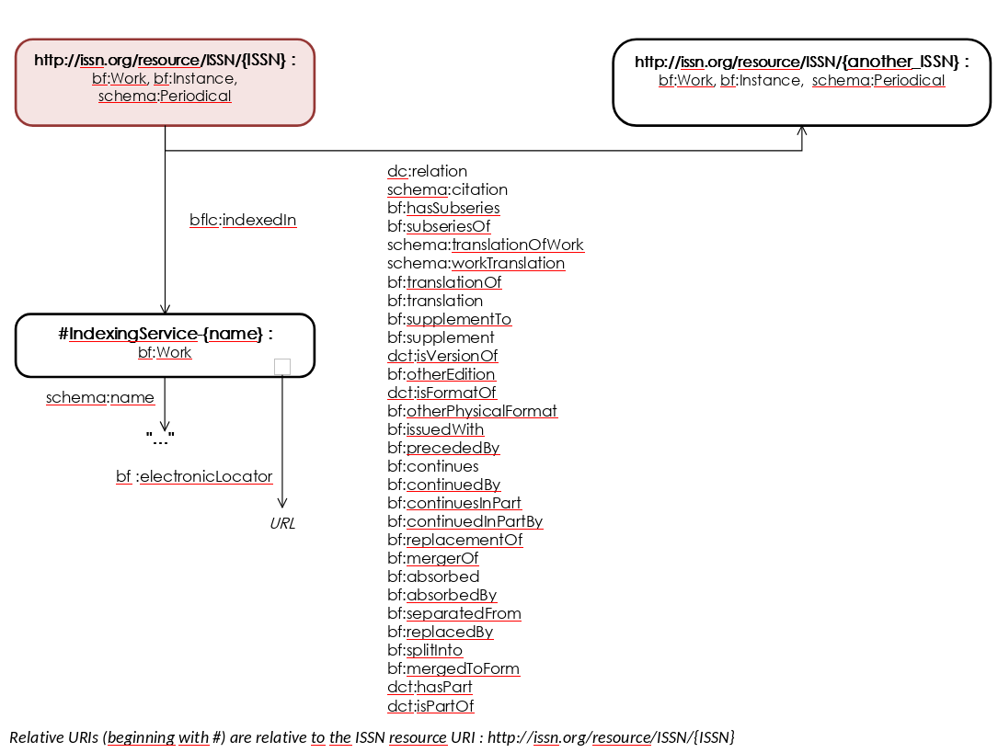

### Links between 2 ISSNs

1. 2 ISSN resources can be linked by a variety of links;
2. The links are not always expressed in both directions : the existence of “A schema:translationOfWork B” does not necessarily imply that the statement “B schema:workTranslation A” exists[10];
3. Each link is generated twice: once using a BibFrame property, and once using either schema.org or DublinCore;
4. The generic property dc:relation is used as default property when no corresponding property could be found in DublinCore or schema.org;
5. (not depicted) Some links can be expressed multiple times: bf:mergerOf and bf:splitInto are repeated to reflect the merge or split of a resource;

### Citation links

The links to external databases that refer to this publication is expressed using bflc:indexedIn (Library of Congress Bibfram extension). The Indexing Service has a local URI, relative to the ISSN resource, as there is no attempt to provide a deduplicated reference list of such indexing services. The indexing service holds its name, and the URL in which the citation to the ISSN resource is made, in the bf:electronicLocator property.

## Keeper’s Archives

### Overview diagram

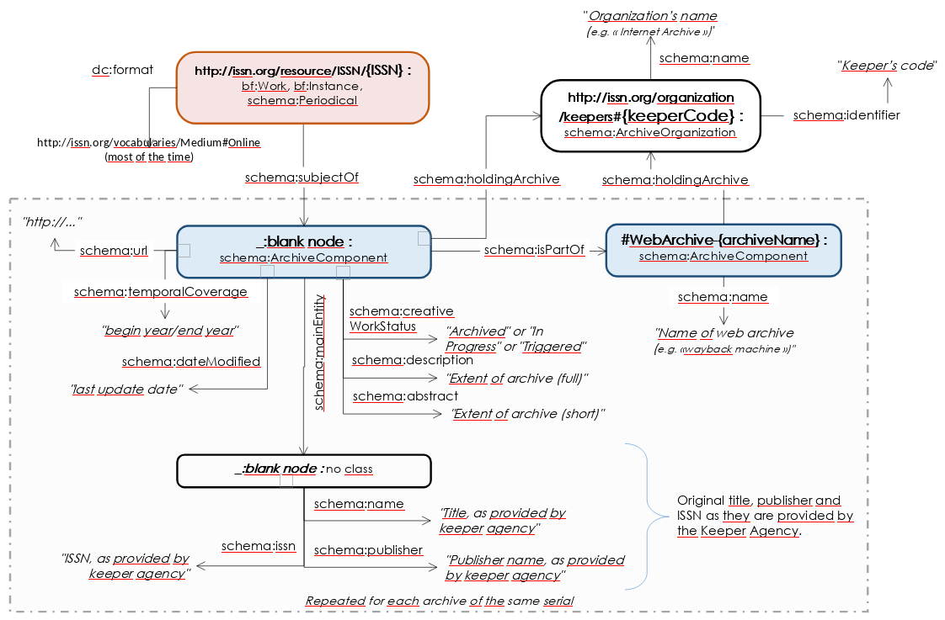

### Archive

1. ISSN resources can be linked to one or more archives using schema:subjectOf. Most of the times these are Online ISSN resources, but not necessarily;
2. The archive itself is a blank node with type schema:ArchiveComponent; it holds the following metadata :
   1. The status of the archive, which can hold the values “Archived”, “In Progress” or “Triggered” (schema:creativeWorkStatus);
   2. The extent of the archive, in full and short version (schema:description and schema:abstract);
   3. Its temporal coverage (optional), with a start and end year (schema:temporalCoverage);
   4. The last update date of the archive (schema:dateModified);
   5. The link to the archival organization (schema:holdingArchive);
   6. If it is accessible online, its online URL in schema:url;
   7. the link to the complete archive that holds this specific archive entry. The complete archive itself has a relative URI based on its name, holding the following properties :
      1. its name (schema:name)
      2. the link to the archival organization (schema:holdingArchive);
3. In addition, the archive links to an anonymous node, with no type, through schema:mainEntity, that describes the archived resource with few metadata as provided by the archival institution itself; so they can slightly differ from the metadata attached to the ISSN resource from the register. This node has no type so that it cannot be confused with the ISSN resource itself. This node holds :
   1. The title of the serial as provided by the archival institution (schema:name);
   2. The name of the publisher as provided by the archival institution (schema:publisher);
   3. 1 or 2 ISSN values, as provided by the archival institution; these ISSN can correspond to the online and print variant of the serial (schema:issn);

### Keeper (archival institution)

A Keeper institution is identified with a URI <http://issn.org/organization/keepers#{keeperCode}>, the type schema:ArchiveOrganization and simply contains a name (schema:name), the code of the institution (schema:identifier) and possibly a schema:sameAs with the URI of the corresponding Wikidata item.

## ISSN Centres

### Overview diagram

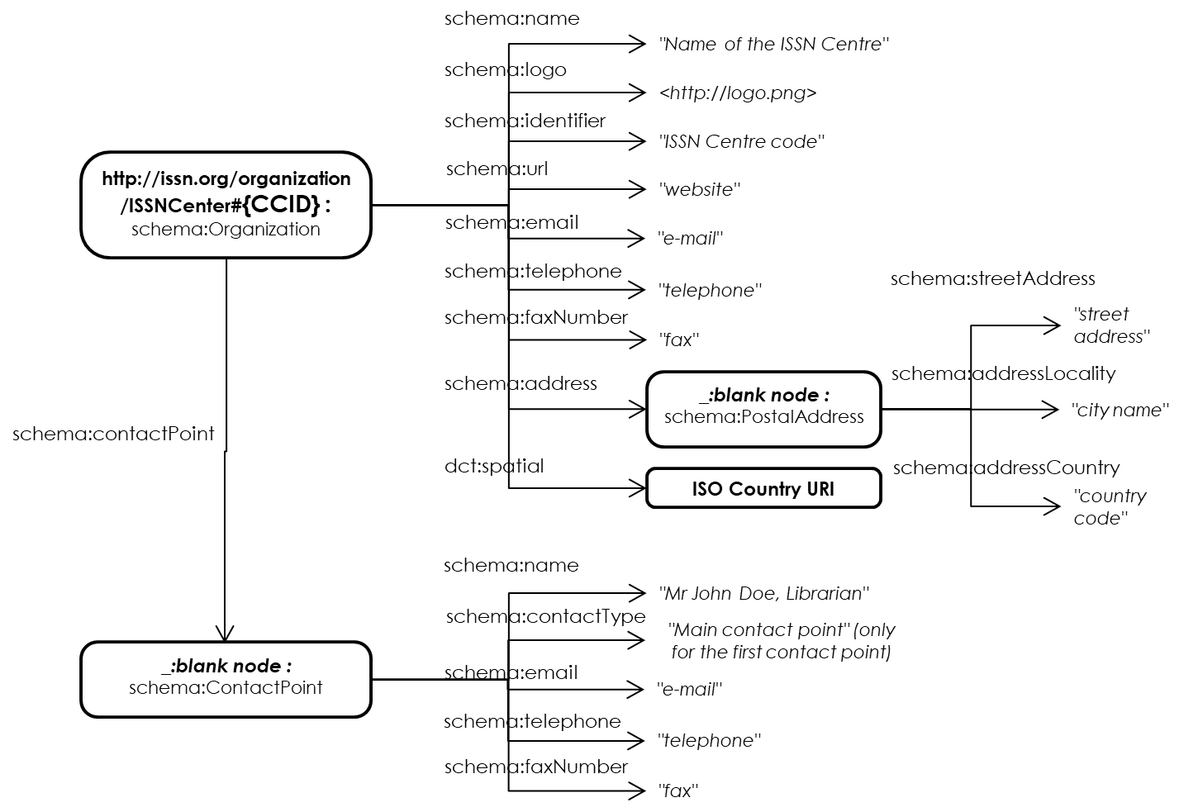

### ISSN Center description

ISSN Centers description map the information available at <https://www.issn.org/the-centre-and-the-network/members-countries/the-issn-network-today/#>

An ISSN Centre is described with straightforward descriptive properties. Note that:

* Not all properties are mandatory and might not be present for all centres;
* A Centre may be linked to multiple contact points;
* The contact persons:
  + are typed with schema:ContactPoint
  + have their civility, first name, last name, and job position concatenated in schema:name
  + the first contact point will have the value “Main contact point” in its schema:contactType property, others will not have anything in this property;

Refer to the table below for a detailed listing of the properties.

# ISSN linked data entities detailed description

## ISSN resource

|  |  |
| --- | --- |
| **Resource** | The ISSN resource |
| **Object class** | ISSN whose Record has the status Register, Work, Legacy will have the classes schema:Periodical , bf:Work and bf:Instance. |
| **Object class** | ISSN whose Record has the status Unreported, Cancelled, Suppressed or ValidationRequest don't have a class. |
| **URI pattern** | [http://issn.org/resource/ISSN/{ISSN}](http://issn.org/resource/ISSN/%7bISSN%7d) |

|  |  |  |  |  |  |
| --- | --- | --- | --- | --- | --- |
| **Property label** | **URI** | **Range** | **Usage note** | **Card.** | **MARC21** |
| **carrier type** | bf:carrier | http://id.loc.gov/vocabulary/carriers | "Categorization reflecting the format of the storage medium and housing of a carrier." | 0…* | 338$b |
| **classification** | bf:classification | bf:Classification | This property refers to a classification object giving the classification value and the classification scheme it comes from. | 0…* | 080$a, 082$a |
| **content type** | bf:content | http://id.loc.gov/vocabulary/contentTypes | "Categorization reflecting the fundamental form of communication in which the content is expressed and the human sense through which it is intended to be perceived." | 0…* | 336$b |
| **reproduced as** | bf:hasReproduction | schema:CreativeWork | This property refers to another resource that reproduces this resource (a blank node) | 0…* | 533 |
| **identified by** | bf:identifiedBy | bf:Identifier | This property refers to an identifier of the resource : an ISSN, ISSN-L, CODEN, key title or abbreviated key title. | 1…* | 022$a, 022$l, 030$a, 210$a, 222$a |
| **main title** | bf:mainTitle | xsd:string | This property contains the title proper of the resource. | 1…1 | 245$a + $n + $p if present |
| **media type** | bf:media | http://id.loc.gov/vocabulary/mediaTypes | "Categorization reflecting the general type of intermediation device required to view, play, run, etc., the content of a resource." | 0…* | 337$b |
| **note** | bf:note | bf:Note | This property refers to a note object (blank node) that gives additional descriptive information associated with the resource. | 0…* | 588$a |
| **provision activity statement** | bf:provisionActivityStatement | xsd:string | This property transcribes the statement relating to providers of a resource, generally known as “publication statement” | 1…* | 260#, 2602, 2603, 264#, 2642, 2643 |
| **title** | bf:title | bf:VariantTitle or bf:ParallelTitle or bf:KeyTitle or bf:AbbreviatedTitle or bf:Title | This property refers to one of the title object for the ISSN resource. | 0…* | 245$a, 246#$a, 2461$a, 2462$a, 2463$a, 2464$a, 2465$a, 2466$a, 2467$a, 2468$a |
| **regularity** | bfmarc:regularity | m21terms:continuingreg | The intended publication regularity of a continuing resource | 0…1 | 008/19 |
| **reproduction note** | bfmarc:reproductionNote | xsd:string | This property stores the reproduction note as a string literal. | 0…* | 533 |
| **issuing body** | bfrel:isb | schema:Organization | This property relates the resource to the organization in charge of editing its intellectual content (generally a university, a specific department within an internationalorganization…). In very rare cases, it may be an individual person. In the ISSN data model, this property is similar to schema:contributor but it is used in parallel as more precise. | 0…* | 710$a, 710$b, 711$a  720 |
| **issn** | bibo:issn | xsd:string | This property contains the ISSN string of the continuing resource. | 1…1 | 022$a |
| **format** | dc:format | One of media:Print (paper), media:Online (online publication), media:DigitalCarrier (CD-ROM, USB keys) or media:Other (Loose-leaf publications, braille, etc.) | Special information about the physical characteristics of the resource. They are often related to information in other parts of the MARC record especially from field 300 (Physical Description) or one of the 5XX note field | 1…* | 007 |
| **identifier** | dc:identifier | xsd:string | This property contains the ISSN string of the continuing resource. | 1…1 | 022$a |
| **accrual periodicity** | dct:accrualPeriodicity | http://purl.org/cld/freq/ or the literal values "unknown" or "other" that are not in this table. | This property contains the publication frequency of the continuing resource, from the Dublin Core Collection Description Frequency Namespace, or as the literal values "unknown" or "other". | 1…1 | 008/18 |
| **spatial** | dct:spatial | MARC code lists for countries (http://id.loc.gov/vocabulary/countries), and ISO code list for countries (https://www.iso.org/obp/ui/#search) | This property links the resource to the reference country of its publisher, which is generally used to decide what National Centre is responsible for ISSN assignment | 2…2 | 008/15-17, 044$c |
| **type** | dct:type | m21terms:formofmaterial (see http://metadataregistry.org/concept/list/vocabulary_id/211.html) | This property indicates the type of material of the resource, which will decide on the type of record which will be used to describe it | 1…1 | LDR/06 |
| **has cancelled ISSN-L** | issnprop:hasCancelledISSN-L | xsd:string | This property indicates the value of a former ISSN-L of the resource, which has been cancelled. This generally happens when it is recognized that a link between two different medium versions of the same resource has not been recorded in the original record. | 0…* | 022$m |
| **has incorrect ISSN** | issnprop:hasIncorrectISSN | xsd:string | This property indicates the value of an incorrect ISSN wrongly displayed on the resource. The incorrect ISSN may be structurally invalid (e.g. wrong control number) or it may be a valid ISSN assigned to another resource. | 0…* | 022$y |
| **Type of date or Publication status of All materials** | m2100X:M00806 | m21terms:alltyp | This property indicates if the resource is currently published, ceased, or if its status is unknown | 1…1 | 008/06 |
| **Form of original item of Continuing Resources** | m2100X:M008CR22 | m21terms:continuingori | This property indicates the form of material in which an item was originally published | 0…1 | 008/22 |
| **Form of item of Continuing Resources** | m2100X:M008CR23 | m21terms:commonfor | This property indicates the form of material for the item being described | 1…1 | 008/23 |
| **Original alphabet or script of title of Continuing Resources** | m2100X:M008CR33 | m21terms:continuingscr | This property indicates the original alphabet or script of the language of the title on the source item upon which the key title is based | 1…1 | 008/33 |
| **Dates of publication and sequential designation in Dates of Publication and Sequential Designation (Formatted style)** | m213XX:M3620_a | xsd:string | This property indicates the beginning/ending date(s) of a resource and/or the sequential designations used on each part. The information is formatted. Dates in this field may be identical to the information in fields 008/07-10 (start date) and/or 008/11-14 (end date) | 0…* | 3620$a |
| **Source of information in Dates of Publication and Sequential Designation (Formatted style)** | m213XX:M3620_z | xsd:string | This property provides additional information about the source of information used to record the Dates of Publication and Sequential Designation | 0…* | 3620$z |
| **Dates of publication and sequential designation in Dates of Publication and Sequential Designation (Unformatted note)** | m213XX:M3621_a | xsd:string | This property indicates the beginning/ending date(s) of a resource and/or the sequential designations used on each part. The information is unformatted. | 0…* | 3621$a |
| **Source of information in Dates of Publication and Sequential Designation (Unformatted note)** | m213XX:M3621_z | xsd:string | This property  provides additional information about the source of information used to record the Dates of Publication and Sequential Designation | 0…* | 3621$z |
| **additionnal type** | rdf:type | One of schema:Dataset, schema:BookSeries, schema:WebSite, schema:Atlas, schema:Map, schema:AudioObject, schema:VideoObject, schema:Newspaper, bf:Tactile or dctype:Text | An additionnal rdf:type statement may be expressed on the resource depending on its characteristics. | 0…* | 007, 008/21 |
| **about** | schema:about | A URI in the UDC http://udcdata.info/udc-schema | This property refers to a classification URI value from the UDC Summary. | 0…* | 989$u |
| **alternate name** | schema:alternateName | xsd:string | This property contains an alternate title for the continuing resource i.e. any title other than the key title and title proper. | 0…* | 210$a+210$b, 222$a+222$b, 246a, 246$1, 246$2, 246$3, 246$4, 246$5, 246$6, 246$7, 246$8 |
| **contributor** | schema:contributor | schema:Organization | This property relates the resource to the organization in charge of editing its intellectual content (generally a university, a specific department within an international organization…). In very rare cases, it may be an individual person. In the ISSN data model, this property is similar to bfrel:isb but has been kept in parallel as it is a schema.org property. | 0…* | 710$a, 710$b, 711$a |
| **end date** | schema:endDate | xsd:string | This property contains the end date of the ISSN. The value "u" indicates that the date or a part of a date is unknown. Hence the datatype is kept as xsd:string. Value 9999 means that the resource is still running. | 1…1 | 008/11-14 |
| **in language** | schema:inLanguage | http://id.loc.gov/vocabulary/languages | This property refers to the language of the continuing resource. | 1…* | 008/35-37, 041$a |
| **is part of** | schema:isPartOf | An ISSN-L resource, URI http://issn.org/resource/ISSN-L/{ISSN-L} | This property refers to the ISSN-L of which this ISSN is part of (http://issn.org/resource/{ISSN-L}). | 1…1 | 022$l |
| **issn** | schema:issn | xsd:string | This property contains the ISSN string of the continuing resource. | 1…1 | 022$a |
| **keywords** | schema:keywords | xsd:string | The label of the UDC classification summary | 0…* | 989$a |
| **name** | schema:name | xsd:string | This property contains the key title and title proper of the continuing resource. | 2…2 | 222$a, 245$a |
| **publication** | schema:publication | schema:PublicationEvent | This property refers on one hand to the reference publication event of that ISSN resource (#ReferencePublicationEvent), and on the other hand to each of the publication event in the publication history (#EarliestPublicationEvent, #InterveningPublicationEvent{n}, #LatestPublicationEvent). | 1…* | 008/15-17, 260#, 2602, 2603, 264#, 2642, 2643 |
| **publisher** | schema:publisher | schema:Organization | This property refers to the publisher(s) of the resource (#Publisher-{publisherName}). In very rare cases, it may be an individual person even though the schema:Organization class is used, as this person is acting as an organization. | 1…* | 260#$b, 2602$b, 2603$b, 264#$b, 2642$b, 2643$b |
| **start date** | schema:startDate | xsd:string | This property contains the start date of the ISSN. The value "u" indicates that the date or a part of the date is unknown. Hence the datatype is kept as xsd:string | 1…1 | 008/07-10 |
| **url** | schema:url | xsd:string | This property indicates the URL address where the resource may be accessed or was previously accessible. It may also link to a web archive. | 0…* | 856$u |
| **subject of** | schema:subjectOf | schema:ArchiveComponent | This property links an Online ISSN to a record from the Keeper's registry indicating this serial is archived by an archiving institution | 0…* | 920 |

## ISSN resource links

|  |  |  |  |  |  |
| --- | --- | --- | --- | --- | --- |
| **Property label** | **URI** | **Range** | **Usage note** | **Card.** | **MARC21** |
| **absorbed** | bf:absorbed | An ISSN resource | *See Bibframe documentation* | 0…* | 78005$x, 78006$x |
| **absorbed by** | bf:absorbedBy | An ISSN resource | *See Bibframe documentation* | 0…* | 78504$x, 78505$x |
| **continued by** | bf:continuedBy | An ISSN resource | *See Bibframe documentation* | 0…* | 78500$x |
| **continued in part by** | bf:continuedInPartBy | An ISSN resource | *See Bibframe documentation* | 0…* | 78501$x |
| **continues** | bf:continues | An ISSN resource | *See Bibframe documentation* | 0…* | 78000$x |
| **continues in part** | bf:continuesInPart | An ISSN resource | *See Bibframe documentation* | 0…* | 78001$x |
| **hasSubseries** | bf:hasSubseries | An ISSN resource | *See Bibframe documentation* | 0…* | 762$x |
| **issuedWith** | bf:issuedWith | An ISSN resource | *See Bibframe documentation* | 0…* | 777$x |
| **merged to form** | bf:mergedToForm | An ISSN resource | *See Bibframe documentation* | 0…* | 78507$x |
| **merger of** | bf:mergerOf | An ISSN resource | The property is repeated to reflect the merge. | 0…* | 78004$x |
| **other edition** | bf:otherEdition | An ISSN resource | *See Bibframe documentation* | 0…* | 775$x |
| **other physical format** | bf:otherPhysicalFormat | An ISSN resource | *See Bibframe documentation* | 0…* | 776$x |
| **preceded by** | bf:precededBy | An ISSN resource | *See Bibframe documentation* | 0…* | 7800#$x |
| **replaced by** | bf:replacedBy | An ISSN resource | *See Bibframe documentation* | 0…* | 78502$x, 78503$x |
| **replacement of** | bf:replacementOf | An ISSN resource | *See Bibframe documentation* | 0…* | 78002$x, 78003$x |
| **separated form** | bf:separatedFrom | An ISSN resource | *See Bibframe documentation* | 0…* | 78007$x |
| **split into** | bf:splitInto | An ISSN resource | The property is repeated to reflect the split. | 0…* | 78506$x |
| **subseries of** | bf:subseriesOf | An ISSN resource | *See Bibframe documentation* | 0…* | 760$x |
| **supplement** | bf:supplement | An ISSN resource | *See Bibframe documentation* | 0…* | 772$x |
| **supplement to** | bf:supplementTo | An ISSN resource | *See Bibframe documentation* | 0…* | 770$x |
| **translation** | bf:translation | An ISSN resource | *See Bibframe documentation* | 0…* | 767$x |
| **translation of** | bf:translationOf | An ISSN resource | *See Bibframe documentation* | 0…* | 765$x |
| **translation of work** | schema:translationOfWork | An ISSN resource | *See schema.org documentation* | 0…* | 765$x |
| **work translation** | schema:workTranslation | An ISSN resource | *See schema.org documentation* | 0…* | 767$x |
| **relation** | dc:relation | An ISSN resource | *See DCMI documentation* | 0…* | 770$x, 772$x, 777$x, 787$x, 7800$x, 7850$x, 7870$x |
| **is format of** | dct:isFormatOf | An ISSN resource | *See DCMI documentation* | 0…* | 776$x |
| **is version of** | dct:isVersionOf | An ISSN resource | *See DCMI documentation* | 0…* | 775$x |
| **citation** | schema:citation | An ISSN resource | This property refers to another continuing resource that is cited by this one. | 0…* | 510$x |
| **has part** | dct:hasPart | An ISSN resource | *See DCMI documentation* | 0…* | 762$x |
| **is part of** | dct:isPartOf | An ISSN resource | *See DCMI documentation* | 0…* | 760$x |

## Activity (Record Creation Event)

|  |  |
| --- | --- |
| **Resource** | An activity in the provenance history of the record. |
| **Object class** | prov:Activity |
| **URI pattern** | [http://issn.org/resource/ISSN/{ISSN}#RecordCreation](http://issn.org/resource/%7bISSN%7d#RecordCreation) |

|  |  |  |  |  |  |
| --- | --- | --- | --- | --- | --- |
| **Property label** | **URI** | **Range** | **Usage note** | **Card.** | **MARC21** |
| **record creation date** | prov:startedAtTime | xsd:date | This property holds the date at which the record was created. It is set since 2004. | 0..1 | 039$v |
| **generated** | prov:generated | schema:CreativeWork or bf:Identifier | This property refers to the entities that the Activity generated : the ISSN Record (http://issn.org/resource/ISSN/{ISSN}#Record) and the identifiers ISSN, ISSN-L, Key title and Abbreviated key title (http://issn.org/resource/ISSN/{ISSN}#ISSN, http://issn.org/resource/ISSN/{ISSN}#ISSN-L, http://issn.org/resource/ISSN/{ISSN}#KeyTitle, http://issn.org/resource/ISSN/{ISSN}#AbbreviatedKeyTitle) | 1..* | 699$v |
| **was associated with** | prov:wasAssociatedWith | schema:Organization | This property refers to the ISSN Centre (including ISSN International Centre) that created the record (http://issn.org/organization/ISSNCentre#{CentreCode}) | 1..1 | 699$v |

## ISSN-L

|  |  |
| --- | --- |
| **Resource** | An ISSN-L resource |
| **Object class** | schema:CreativeWork |
| **URI pattern** | [http://issn.org/resource/ISSN-L/{ISSN-L}](http://issn.org/resource/ISSN-L/%7bISSN-L%7d) |

|  |  |  |  |  |  |
| --- | --- | --- | --- | --- | --- |
| **Property label** | **URI** | **Range** | **Usage note** | **Card.** | **MARC21** |
| **identified by** | bf:identifiedBy | bf:IssnL | This property refers to the ISSN-L that identifies this resource. | 1…1 | 022$l |
| **has part** | schema:hasPart | An ISSN resource | This property refers to the ISSN resources that are part of this ISSN-L. | 1…* | 022$l |

## ISSN record

|  |  |
| --- | --- |
| **Resource** | The ISSN record |
| **Object class** | schema:CreativeWork |
| **URI pattern** | [http://issn.org/resource/ISSN/{ISSN}#Record](http://issn.org/resource/%7bISSN%7d#Record) |

|  |  |  |  |  |  |
| --- | --- | --- | --- | --- | --- |
| **Property label** | **URI** | **Range** | **Usage note** | **Card.** | **MARC21** |
| **modified** | dct:modified | xsd:date | This property contains the date of last modification of the record. | 1…1 | 005 |
| **main entity** | schema:mainEntity | An ISSN resource (http://issn.org/resource/ISSN/{ISSN}) | This property refers to the ISSN resource that this record describes (http://issn.org/resource/ISSN/{ISSN}) | 1…1 | 022$2 |
| **was attributed to** | prov:wasAttributedTo | schema:Organization | This property refers to the centre that is responsible for the record. The PROV ontology indicates that "Attribution is the ascribing of an entity to an agent." This fits with the intended meaning of the link between the record and the ISSN centre, since ISSN records can be re-attributed between ISSN centres, so the ISSN centre referred to by this property cannot be said to be the "creator" or the "author" of the record. | 1…1 | 022$2 |
| **status** | bf:status | One of http://issn.org/vocabularies/RecordStatus#Register, ...#Unreported, ...#Provisional, ...#Legacy, ...#Cancelled, ...#Suppressed | This property refers to the status of this record. | 1..1 | 699$8 |

## Publication Events

### ReferencePublicationEvent, EarliestPublicationEvent, InterveningPublicationEvent, LatestPublicationEvent

|  |  |
| --- | --- |
| **Resource** | A publication event |
| **Object class** | schema:PublicationEvent |
| **URI pattern** | [http://issn.org/resource/ISSN/{ISSN}#ReferencePublicationEvent](http://issn.org/resource/%7bISSN%7d#ReferencePublicationEvent) |
| **URI pattern** | [http://issn.org/resource/ISSN/{ISSN}#EarliestPublicationEvent](http://issn.org/resource/%7bISSN%7d#EarliestPublicationEvent) |
| **URI pattern** | [http://issn.org/resource/ISSN/{ISSN}#InterveningPublicationEvent{n}](http://issn.org/resource/%7bISSN%7d#InterveningPublicationEvent{n}) |
| **URI pattern** | [http://issn.org/resource/ISSN/{ISSN}#LatestPublicationEvent](http://issn.org/resource/%7bISSN%7d#LatestPublicationEvent) |
| **URI pattern** | *In the case of Reproductions, the associated PublicationEvent is a blank node* |

|  |  |  |  |  |  |
| --- | --- | --- | --- | --- | --- |
| **Property label** | **URI** | **Range** | **Usage note** | **Card.** | **MARC21** |
| **location** | schema:location | On the #ReferencePublicationEvent : MARC code lists for countries (http://id.loc.gov/vocabulary/countries), or ISO code list for countries (https://www.iso.org/obp/ui/#search)  On the other events in the publication event history : schema:Place | On the #ReferencePublicationEvent, this property will refer to the MARC or ISO code list for the country. Note that the country URI will have an rdfs:label property containing the country name.  On the other events in the publication event history, this property refers to the place of the publication event (http://issn.org/resource/ISSN/{ISSN}#PublicationPlace-{placename} or http://issn.org/resource/ISSN/{ISSN}#ReproductionPlace-{placeName}). | 1…1 | #ReferencePublicationEvent : 008/15-17, 044$c Other events : 260$a, 264$a, 533$b |
| **published by** | schema:publishedBy | schema:Organization | This property refers to the publisher that published (or reproduced) the continuing resource during that period. This property is not present on the #ReferencePublicationEvent. | 1…1 | 260$b, 264$b, 533$c |
| **temporal** | dct:temporal | xsd:string | This property contains the start date and end date (if any) of the period covered by this publication event. As the content of the originalMARC field is generally not structured, use of schema:startDate and schema:endDate is not possible. The content is typed as a string. This property is not present on the #ReferencePublicationEvent. | 0…1 | 260$c, 264$c, 533$d |

### Publication places

|  |  |
| --- | --- |
| **Resource** | Publication places in the publication history of the ISSN. |
| **Object class** | schema:Place |
| **URI pattern** | [http://issn.org/resource/ISSN/{ISSN}#PublicationPlace-{placename}](http://issn.org/resource/%7bISSN%7d#PublicationPlace-{placename}) |
| **URI pattern** | [http://issn.org/resource/ISSN/{ISSN}#ReproductionPlace-{placeName}](http://issn.org/resource/%7bISSN%7d#ReproductionPlace-{placeName}) |

|  |  |  |  |  |  |
| --- | --- | --- | --- | --- | --- |
| **Property label** | **URI** | **Range** | **Usage note** | **Card.** | **MARC21** |
| **label** | rdfs:label | xsd:string | This property contains the name of the place (generally a city). | 1…1 | 260#$a, 2602$a, 2603$a, 264#$a, 2642$a, 2643$a,533$b |
| **same as** | schema:sameAs | [gn:Feature](http://www.geonames.org/ontology#Feature) | This property refers to an equivalent entry for this place in the Geonames database (i.e. the Geonames URI) | 0…1 | 260#$a, 2602$a, 2603$a, 264#$a, 2642$a, 2643$a, 533$b (URI en 926$u) |
| **geo** | schema:geo | schema:GeoCoordinates | This property refers to the position of this place (http://issn.org/resource/ISSN/{ISSN}#PublicationPlace-{placename}-GeoCoordinates) | 0…1 | 926, 953, 533$b |

### Geocoordinates

|  |  |
| --- | --- |
| **Resource** | Geographical location of a place. |
| **Object class** | schema:GeoCoordinates |
| **URI pattern** | [http://issn.org/resource/ISSN/{ISSN}#PublicationPlace-{placename}-GeoCoordinates](http://issn.org/resource/%7bISSN%7d#PublicationPlace-{placename}-GeoCoordinates) |
| **URI pattern** | [http://issn.org/resource/ISSN/{ISSN}#ReproductionPlace-{placeName}-Geocoordinates](http://issn.org/resource/%7bISSN%7d#ReproductionPlace-{placeName}-Geocoordinates) |

|  |  |  |  |  |  |
| --- | --- | --- | --- | --- | --- |
| **Property label** | **URI** | **Range** | **Usage note** | **Card.** | **MARC21** |
| **latitude** | schema:latitude | xsd:decimal | This property contains the latitude of the geographic coordinates. | 1..1 | 926$l, 953, 533$b |
| **longitude** | schema:longitude | xsd:decimal | This property contains the longitude of the geographic coordinates. | 1..1 | 926$o, 953, 533$b |
| **addressCountry** | schema:addressCountry | xsd:string | This property contains the name of the country of the geographic coordinates. | 1…1 | 926$b, 953$b |

## Reproductions

|  |  |
| --- | --- |
| **Resource** | A Reproduction |
| **Object class** | schema:CreativeWork |
| **URI pattern** | *reproductions are blank nodes* |

|  |  |  |  |  |  |
| --- | --- | --- | --- | --- | --- |
| **Property label** | **URI** | **Range** | **Usage note** | **Card.** | **MARC21** |
| **publisher** | schema:publisher | schema:Organization | This property refers to the publisher (i.e. Reproduction Agency) of reproduction. | 1…1 | 533$c |
| **spatial** | dct:spatial | schema:Place | This property refers to the publication place of the reproduction. | 1…1 | 533$b |
| **publication** | schema:publication | schema:PublicationEvent | This property refers to the publication event of the reproduction. | 1…1 | 533 |

## Identifiers

|  |  |
| --- | --- |
| **Resource** | An identifier, ISSN or ISSN-L, Cancelled ISSN, CODEN, as well as KeyTitle and AbbreviatedKeyTitle |
| **Object class** | bf:Identifier or a subclass bf:Issn or bf:IssnL or bf:Coden, as well as bf:KeyTitle and bf:AbbreviatedTitle |
| **URI pattern** | [http://issn.org/resource/ISSN/{ISSN}#ISSN](http://issn.org/resource/%7bISSN%7d#ISSN) |
| **URI pattern** | [http://issn.org/resource/ISSN/{ISSN}#ISSN-L](http://issn.org/resource/%7bISSN%7d#ISSN-L) |
| **URI pattern** | [http://issn.org/resource/ISSN/{ISSN}#CODEN](http://issn.org/resource/%7bISSN%7d#CODEN) |
| **URI pattern** | [http://issn.org/resource/ISSN/{ISSN}#KeyTitle](http://issn.org/resource/%7bISSN%7d#KeyTitle) |
| **URI pattern** | [http://issn.org/resource/ISSN/{ISSN}#AbbreviatedKeyTitle](http://issn.org/resource/%7bISSN%7d#AbbreviatedKeyTitle) |

|  |  |  |  |  |  |
| --- | --- | --- | --- | --- | --- |
| **Property label** | **URI** | **Range** | **Usage note** | **Card.** | **MARC21** |
| **value** | rdf:value | xsd:string | This property contains the actual string value of the identifier. Note that KeyTitles and AbbreviatedKeyTitles have both rdf:value and bf:mainTitle properties, being both identifiers and titles. | 1…1 | 022$a, 022$l, 022$m, 022$y, 022$z, 030$a, 210$a, 222$a |
| **status** | bf:status | One of idStatus:Valid, idStatus:Incorrect, idStatus:Cancelled | This property refers to the status of the ISSN (valid, incorrect or cancelled). This property is used on the ISSN and the ISSN-L identifier. | 0…1; | 022$a, 022$l, 022$m, 022$y, 022$z, 210$a, 222$a |
| **has cancelled ISSN** | issnprop:hasCancelledISSN | bf:Issn | This property refers to an ISSN which has been cancelled in favour of the actual ISSN. This property is used only on the ISSN identifier. | 0…* | 022$z |
| **cancelled in favor of** | issnprop:cancelledInFavorOf | bf:Issn | This property refers to an ISSN that replaces this cancelled ISSN. This property is used only on the ISSN identifier. | 0…* | 022$v |

## Titles

|  |  |
| --- | --- |
| **Resource** | A title of an ISSN |
| **Object class** | bf:KeyTitle or bf:VariantTitle or bf:ParallelTitle or bf:AbbreviatedTitle |
| **URI pattern** | [http://issn.org/resource/ISSN/{ISSN}#KeyTitle](http://issn.org/resource/%7bISSN%7d#KeyTitle) |
| **URI pattern** | [http://issn.org/resource/ISSN/{ISSN}#AbbreviatedKeyTitle](http://issn.org/resource/%7bISSN%7d#AbbreviatedKeyTitle) |
| **URI pattern** | *blank nodes for the Variant titles and Parallel titles* |

|  |  |  |  |  |  |
| --- | --- | --- | --- | --- | --- |
| **Property label** | **URI** | **Range** | **Usage note** | **Card.** | **MARC21** |
| **main title** | rbf:mainTitle | rdf:langString | This property contains the actual title, with a language code containing the title script code. Note that KeyTitles and AbbreviatedKeyTitles have both rdf:value and bf:mainTitle properties, being both identifiers and titles. | 1…1 | 245$a, 246#$a, 2461$a, 2462$a, 2463$a, 2464$a, 2465$a, 2466$a, 2467$a, 2468$a |
| **variant type** | bf:variantType | xsd:string | This property stores the type of the title, in the case of a variant title. For a key title or a parallel title it is not present. | 0…1 | 246#$a, 2461$a, 2462$a, 2463$a, 2464$a, 2465$a, 2466$a, 2467$a, 2468$a |
| **translation of** | bf:translationOf | bf:Title | When the title is a transliteration, this property indicates the original title from which the transliteration was done. The original title will have a bf:mainTitle property with a language code containing the script of the original title | 0...1 |  |

## Organizations (Publishers, Issuing Bodies, ISSN Centres)

### Organizations

|  |  |
| --- | --- |
| **Resource** | An ISSN Centre, a Publisher or an Issuing Body |
| **Object class** | schema:Organization |
| **URI pattern** | [http://issn.org/organization/ISSNCenter#{CCID}](http://issn.org/organization/ISSNCentre" \l "{CCID} ) |
| **URI pattern** | [http://issn.org/resource/ISSN/{ISSN}#Publisher-{publisherName}](http://issn.org/resource/%7bISSN%7d" \l "Publisher-{publisherName}) |
| **URI pattern** | [http://issn.org/resource/ISSN/{ISSN}#IssuingBody-{issuingBodyName}](http://issn.org/resource/ISSN/%7bISSN%7d" \l "IssuingBody-{issuingBodyName}) |
| **URI pattern** | [http://issn.org/resource/ISSN/{ISSN}#ReproductionAgency-{reproductionAgencyName}](http://issn.org/resource/ISSN/%7bISSN%7d" \l "ReproductionAgency-{reproductionAgencyName}) |

|  |  |  |  |  |  |
| --- | --- | --- | --- | --- | --- |
| **Property label** | **URI** | **Range** | **Usage note** | **Card.** | **MARC21** |
| **name** | schema:name | xsd:string or rdf:langString | This property contains the name of the Organization, in the original language when it is known, or in latin script when the latin script is not transliterated from an original language. | 1…1 | 2601$b, 2602$b, 2603$b, 533$c. For ISSN Centre label, this is not from the MARC21 file. |
| **alternate name** | schema:alternateName | rdf:langString | This property contains the name of the Organization in latin script when it has been transliterated from the original language | 0...1 |  |
| **sameAs** | schema:sameAs | A publisher URI (http://issn.org/organization/publisher/{PublisherID}), or an ISNI URI, or a Wikidata URI | This property refers to an equivalent URI for the organization, in the case of publishers or reproduction agencies, or to a Wikidata URI in the case of Keeper's agencies. |  | 710, 711, 720, 533$c |
| **parent organization** | schema:parentOrganization | Another schema:Organization this one is part of. | This property refers to the parent organization of this organization, in the case of issuing bodies. | 0…1 | 710$b |
| **logo** | schema:logo | URL of the logo image | Logo of an ISSN Centre |  | *not applicable* |
| **country** | dct:spatial | ISO code list for countries (https://www.iso.org/obp/ui/#search) | Country of an ISSN Centre |  | *not applicable* |
| **center code** | schema:identifier | xsd:string | Code of an ISSN Centre, or Keeper's code of an Archival insitution in Keeper's Registry |  | *not applicable* |
| **address** | schema:address | schema:PostalAddress | Postal address entity of the ISSN Centre |  | *not applicable* |
| **telephone** | schema:telephone | xsd:string | Telephone of an ISSN Centre |  | *not applicable* |
| **website / url** | schema:url | xsd:string | Website of an ISSN Centre |  | *not applicable* |
| **e-mail** | schema:email | xsd:string | Direct email of an ISSN Centre |  | *not applicable* |
| **fax** | schema:faxNumber | xsd:string | Fax number of an ISSN Centre |  | *not applicable* |
| **contact** | schema:contactPoint | schema:ContactPoint | A Person contact point of an ISSN Centre |  | *not applicable* |
|  |  |  |  |  |  |

### Contact points and adresses

|  |  |
| --- | --- |
| **Resource** | A contact point for an ISSN Center |
| **Object class** | schema:ContactPoint |
| **URI pattern** | *blank node* |

|  |  |  |  |  |  |
| --- | --- | --- | --- | --- | --- |
| **Property label** | **URI** | **Range** | **Usage note** | **Card.** | **MARC21** |
| **e-mail** | schema:email | xsd:string | E-mail of the person | 1..1 | *not applicable* |
| **main contact ?** | schema:contactType | xsd:string | Contains the string "Main contact point" for the first contact point in the list | 0..1 | *not applicable* |
| **name** | schema:name | xsd:string | Concatenation of the civility, first name, last name and job position | 1..1 | *not applicable* |
| **telephone** | schema:telephone | xsd:string | Can be repeated for multiple phone numbers | 0..n | *not applicable* |
| **faxNumber** | schema:faxNumber | xsd:string | Fax number | 0..1 | *not applicable* |

|  |  |
| --- | --- |
| **Resource** | The postal address of an ISSN Center |
| **Object class** | schema:PostalAddress |
| **URI pattern** | *blank node* |

|  |  |  |  |  |  |
| --- | --- | --- | --- | --- | --- |
| **Property label** | **URI** | **Range** | **Usage note** | **Card.** | **MARC21** |
| **address** | schema:streetAddress | xsd:string | Full street address of the ISSN Centre | 1..1 | *not applicable* |
| **city** | schema:addressLocality | xsd:string | City of the ISSN Centre | 1..1 | *not applicable* |
| **address country** | schema:addressCountry | xsd:string | ISO code of the country for the address (duplicated from the country of the Centre itself) | 1..1 | *not applicable* |

## Classifications

|  |  |
| --- | --- |
| **Resource** | A classification value |
| **Object class** | bf:ClassificationUdc or bf:ClassificationDdc (both subclasses of bf:Classification) |
| **URI pattern** | *blank nodes* |

|  |  |  |  |  |  |
| --- | --- | --- | --- | --- | --- |
| **Property label** | **URI** | **Range** | **Usage note** | **Card.** | **MARC21** |
| **value** | rdf:value | xsd:string | This property contains the actual classification value. | 1…1 | 080$a, 082$a |

## Notes

|  |  |
| --- | --- |
| **Resource** | Note |
| **Object class** | bf:Note |
| **URI pattern** | *notes are blank nodes* |

|  |  |  |  |  |  |
| --- | --- | --- | --- | --- | --- |
| **Property label** | **URI** | **Range** | **Usage note** | **Card.** | **MARC21** |
| **note type** | bf:noteType | xsd:string | This property contains the type of the note, as a string literal. | 1…1 | 588$a |
| **value** | rdf:value | xsd:string | This property contains the actual note value, as a string literal. | 1…1 | 588$a |

## Keepers Archive

|  |  |
| --- | --- |
| **Resource** | An archive from Keeper's Network |
| **Object class** | schema:ArchiveComponent |
| **URI pattern** | blank node |

|  |  |  |  |  |  |
| --- | --- | --- | --- | --- | --- |
| **Property label** | **URI** | **Range** | **Usage note** | **Card.** | **Value example** |
| **archive status** | schema:creativeWorkStatus | xsd:string | This property contains one the possible string : "Archived", "In Progress" or "Triggered" | 1…1 | "Archived" |
| **archive extent (full)** | schema:description | xsd:string | Contains the full extent of the archive's content | 0..1 | "Archived : 13; 20 (2 to 4); 21 (1 to 4); 22 (1 to 4); 23 (1 to 4); 24 (1 to 4); 25 (1 to 4); 26 (1 to 4); 27 (1 to 4); 28 (1 to 4); 29 (1 to 4); 30 (1 to 4); 31 (1 to 4); 32 (1 to 4); 33 (1 to 4); 34 (1 to 4); 35 (1 to 4); 36 (1 to 4); 37 (1 to 4); 38 (1 to 4); 39 (1 to 4); 40 (1, 3, 4); 42; 43 (2); 44 (3)" |
| **archive extent (short)** | schema:abstract | xsd:string | Contains the shortened version of the archive's content. Either both full and short extent are present, either none is present. | 0..1 | "Archived : 13, 20 to 40, 42 to 44" |
| **last update date** | schema:dateModified | xsd:date | The date the archive was last updated | 0..1 | "2020-04-02"^^xsd:date |
| **temporal coverage** | schema:temporalCoverage | xsd:string | Captures the start and end year of the archive, in the form "start year/end year" | 0…1 | 1988/2000 |
| **archived serial description (as provided by archival instituion)** | schema:mainEntity | a blank node with no type having schema:name, schema:publisher and schema:issn property | Points to a blank node without any type information, holding the name, publisher and ISSN of the archived periodical (see below) | 1…1 |  |
| **url (when accessible online)** | schema:url | xsd:anyUri | Contains the URL where the archive is accessible, when it is accessible online | 0…1 |  |
| **archival organisation** | schema:holdingArchive | schema:ArchiveOrganization | Refers to the responsible archival organisation | 1...1 |  |
| **web archive** | schema:isPartOf | schema:ArchiveComponent | Refers to the complete archive entity that holds this particular archive | 0...1 |  |

|  |  |
| --- | --- |
| **Resource** | A resource description, as provided by a keeper |
| **Object class** | *no class* |
| **URI pattern** | *blank node* |

|  |  |  |  |  |  |
| --- | --- | --- | --- | --- | --- |
| **Property label** | **URI** | **Range** | **Usage note** | **Card.** | **Value example** |
| **name** | schema:name | xsd:string | Title of the archived serial, as provided by the archival institution | 1…1 | "Medical Dosimetry" |
| **publisher** | schema:publisher | xsd:string | Name of the publisher of the serial, as provided by the archival institution | 0…1 | "Elsevier" |
| **issn** | schema:issn | xsd:string | ISSN of the archived serial, as provided by the archival institution. At least one ISSN is present. This can be present 2 times with the print and electronic ISSN. | 1…2 | "0958-3947" |

|  |  |
| --- | --- |
| **Resource** | An archival organisation |
| **Object class** | schema:ArchiveOrganization |
| **URI pattern** | [http://issn.org/organization/keepers#{keeperCode}](http://issn.org/organization/keepers) |

|  |  |  |  |  |  |
| --- | --- | --- | --- | --- | --- |
| **Property label** | **URI** | **Range** | **Usage note** | **Card.** | **Value example** |
| **"** | schema:name | xsd:string | Name of the archival institution | 1…1 | "CLOCKSS Archive" |
| **identifier** | schema:identifier | xsd:string | Code of the archival institution | 1…1 | "clockss" |

|  |  |
| --- | --- |
| **Resource** | A complete archive (e.g. "Wayback machine") |
| **Object class** | schema:ArchiveComponent |
| **URI pattern** | <http://issn.org/resource/ISSN/{ISSN}#WebArchive-{archiveName}> |

|  |  |  |  |  |  |
| --- | --- | --- | --- | --- | --- |
| **Property label** | **URI** | **Range** | **Usage note** | **Card.** | **Value example** |
| **name** | schema:name | xsd:string | Name of the archive | 1…1 | "Wayback machine" |
| **archival organisation** | schema:holdingArchive | schema:ArchiveOrganization | Refers to the responsible archival organisation | 1...1 |  |

# ISSN controlled vocabularies

## List of record statuses

|  |  |
| --- | --- |
| **ConceptScheme URI** | http://issn.org/vocabularies/RecordStatus |
| **skos:prefLabel** | ISSN Record Status List |

|  |  |
| --- | --- |
| **URI** | **skos:prefLabel** |
| http://issn.org/vocabularies/RecordStatus#Register | Register |
| http://issn.org/vocabularies/RecordStatus#Legacy | Legacy |
| http://issn.org/vocabularies/RecordStatus#Provisional | Provisional |
| http://issn.org/vocabularies/RecordStatus#Unreported | Unreported |
| http://issn.org/vocabularies/RecordStatus#Cancelled | Cancelled |
| http://issn.org/vocabularies/RecordStatus#Suppressed | Suppressed |

## List of identifier statuses

|  |  |
| --- | --- |
| **ConceptScheme URI** | <http://issn.org/vocabularies/IdStatus> |
| **skos:prefLabel** | ISSN Identifiers Status List |

|  |  |
| --- | --- |
| **URI** | **skos:prefLabel** |
| http://issn.org/vocabularies/IdStatus#Valid | Valid |
| http://issn.org/vocabularies/IdStatus#Incorrect | Incorrect |
| http://issn.org/vocabularies/IdStatus#Cancelled | Cancelled |

## List of media

|  |  |
| --- | --- |
| **ConceptScheme URI** | <http://issn.org/vocabularies/Medium> |
| **skos:prefLabel** | ISSN Media List |

|  |  |
| --- | --- |
| **URI** | **skos:prefLabel** |
| http://issn.org/vocabularies/Medium#Print | Print |
| http://issn.org/vocabularies/Medium#Online | Online |
| http://issn.org/vocabularies/Medium#DigitalCarrier | Digital carrier |
| http://issn.org/vocabularies/Medium#Other | Other |

1. See <https://www.loc.gov/bibframe/faqs/>.
2. The FRBR final report itself acknowledges that “certain aspects of the model merit more detailed examination (…). In particular, the notion of “seriality” and the dynamic nature of entities recorded in digital formats merit further analysis”. See *Functional Requirements for Bibliographic Records. Final report*, published in 1998 and revised in 2009, <http://www.ifla.org/files/assets/cataloguing/frbr/frbr_2008.pdf>.
3. One may consider a title corresponding to a “different language edition” of a main title as a different “expression” of a same work. However, this title may progressively diverge from the main title and present original content, hence becoming a separate work. Another example: the online equivalent of a print title (that may be initially considered a different “manifestation”) may also evolve over time and present content non-published in the print version, becoming again a new “work”.
4. “The description of serials is particularly difficult to model, because it does not limit itself to a description of the past, but is also intended to allow end-users to make assumptions about what the behaviour of a serial will be in at least the near future (…).It ensues that any serial work can be said to have only one expression and only one manifestation”.*FRBR-Library Reference Model. Draft for World-Wide Review*, 2016, <https://www.ifla.org/files/assets/cataloguing/frbr-lrm/frbr-lrm_20160225.pdf>.
5. <https://github.com/schemaorg/schemaorg/issues/1640>
6. Note however that slight modifications may be made on Key Titles after assignment, for example in order to correct some typos. Therefore it cannot be said that they are fully persistent.
7. The CODEN is another identifier for continuing resources that predates the ISSN. It is especially used in chemistry-related publications, and it is not maintained by the ISSN network.
8. Note that this implies that cancelled and incorrect ISSN / ISSN-L are still considered to be identifiers of the ISSN resource. Data consumers should process these identifiers with care, and should make sure in particular they clearly distinguish them from the valid identifiers, using the bf:status property (not depicted in the diagram) ;
9. Note that it is thus not possible to distinguish between the original UDC classification and the computed UDC summary classification.
10. In particular note that schema:org does not provide an inverse link for the property schema:citation.