# EE4524/ED5502 Spring 2020 Project 2 Extra Challenge

(Project2 Input Capture)

In Project 2, you will find the following section:

EXTRA CHALLENGE (worth an extra 10% in the final assessment): Using an external wire, connect PORTB bit 3 to PORTB bit 0. Use the techniques in Homework 2 Q3 to find the TimePeriodHigh and TimePeriodLow and the total TimePeriod (=TimePeriodHigh+TimePeriodLow) and report these to the user using the extra commands

‘g’ or ‘G’: Report TimePeriodLow in microseconds

‘h’ or ‘H’: Report TimePeriodHigh in microseconds

‘w’ or ‘W’: Report TotalTimePeriod in microseconds

If you’re doing this extra challenge you will need the following Timer/Counter1 initialisation setup

**Timer/Counter1 setup:**

Timer/Counter1 Clock source: CLKIO/8

All Timer1 outputs disabled

Timer/Counter1 Input Capture set for falling edge with noise control turned OFF

Timer/Counter1 Input Capture and Timer1 Overflow Interrupts enabled.

The software development part of this extra challenge is easier than the connection part, given that you need to make an extra connection, and you may not have solder or other ways to make the necessary connections.

The following screens show a few different ways in which I made the necessary connection.

I need to Connect PORTB Bit 3 (OC2A output) to PORTB Bit 0 (ICP1 input). Here is a suggestion for how you might make the connection:

I looped the end of the wire so I could make a better connection; PORTB Bit 0 is Arduino D8 and I found it easier to connect to the jumper post than the header. There are other ways to make this connection but this one uses the fewest fingers!

When I made this connection and entered ‘w’, ‘g’ and then ‘h’ I got the following output in the Data Visualiser. (I had entered ‘2’ earlier to set the high time to 20%).

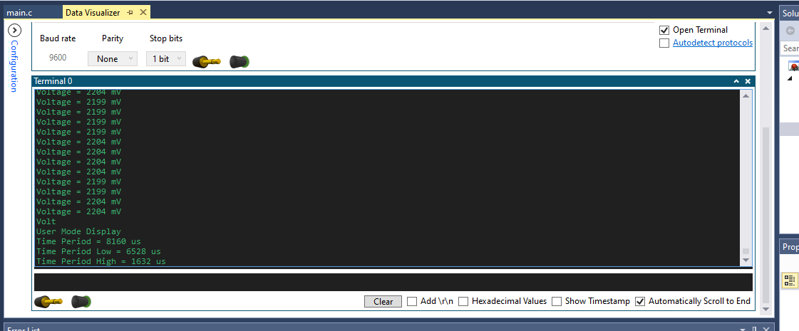

(If you calculate the fPWM frequency for our settings you will find it’s approximately 122.55 Hz, which has a Period of about 8160us, and 20% of 8160 is 1632us, so I was happy with this output).