Name: Sparsh Karna
Registration Number: 23BDS1172

- Server:
import socket
import math

def isPrime(n):
if n < 2:
return False
for i in range(2, int(math.sqrt(n)) + 1):
if n % i == 0:
return False
return True

def gcd(a, b):
if a == 0:
return b
return gcd(b % a, a)

def encrypt(M, e, n):
return int(pow(M, e, n))

def main():
p = int(input("Enter prime number p: "))
while not isPrime(p):
p = int(input(f"{p} is not a prime number\nEnter a prime number p: "))

q = int(input("Enter prime number q: "))
while not isPrime(q):
q = int(input(f"{q} is not a prime number\nEnter a prime number q: "))

n = p * q
phi = (p - 1) * (q - 1)

# Find public exponent e
e = 0
for i in range(2, phi):
if gcd(i, phi) == 1:
e = i
break

# Find private exponent d
d = 0
for i in range(1, phi + 1):
if (e * i) % phi == 1:
d = i
break

print(f"\nPublic Key: (e={e}, n={n})")
print(f"Private Key: (d={d}, n={n})")

M = input("\nEnter plaintext (string or number): ")

# Check if input is numeric or string
try:
# Try to convert to number
M_num = int(M)
if M_num >= n:
print(f"Error: Plaintext value {M_num} is >= n={n}. Please use larger primes.")
return
# Encrypt as single number
C = encrypt(M_num, e, n)
encrypted_data = f"NUM:{C}"
print(f"Encrypted message: {C}")
except ValueError:
# Check if n is large enough for string encryption
max_ascii = max(ord(char) for char in M)
if max_ascii >= n:
print(f"Error: n={n} is too small for this text (max ASCII: {max_ascii})")
print(f"Please use larger primes (recommended: p and q both > 127)")
return
# Encrypt as string (each character separately)
encrypted_chars = []
for char in M:
ascii_val = ord(char)
encrypted_val = encrypt(ascii_val, e, n)
encrypted_chars.append(str(encrypted_val))
encrypted_data = "STR:" + ",".join(encrypted_chars)
print(f"Encrypted message: {encrypted_data}")

# Send encrypted message and keys to client
server_socket = socket.socket(socket.AF_INET, socket.SOCK_STREAM)
server_socket.setsockopt(socket.SOL_SOCKET, socket.SO_REUSEADDR, 1)
server_socket.bind(('localhost', 5001))
server_socket.listen(1)
print("\nServer started. Waiting for client...")

conn, addr = server_socket.accept()
print("Client connected.")

# Send encrypted message, private key d, and n
message = f"{encrypted_data}|{d}|{n}\n"
conn.sendall(message.encode())

print(f"Encrypted message sent")

conn.close()
server_socket.close()

if __name__ == "__main__":
main()

- Client:
import socket

def decrypt(C, d, n):
"""Decrypt ciphertext using RSA private key"""
return int(pow(C, d, n))

def main():
client_socket = socket.socket(socket.AF_INET, socket.SOCK_STREAM)
client_socket.connect(('localhost', 5001))

# Receive encrypted message, private key d, and n
data = client_socket.recv(1024).decode().strip()
parts = data.split('|')
encrypted_data = parts[0]
d = int(parts[1])
n = int(parts[2])

print(f"Encrypted message received: {encrypted_data}")
print(f"Private key (d={d}, n={n})")

# Check if encrypted data is string or number
if encrypted_data.startswith("NUM:"):
# Decrypt as number
C = int(encrypted_data[4:])
M = decrypt(C, d, n)
print(f"Decrypted (original) message: {M}")
elif encrypted_data.startswith("STR:"):
# Decrypt as string
encrypted_chars = encrypted_data[4:].split(',')
decrypted_chars = []
for enc_val in encrypted_chars:
ascii_val = decrypt(int(enc_val), d, n)
decrypted_chars.append(chr(ascii_val))
M = ''.join(decrypted_chars)
print(f"Decrypted (original) message: {M}")

client_socket.close()

if __name__ == "__main__":
main()

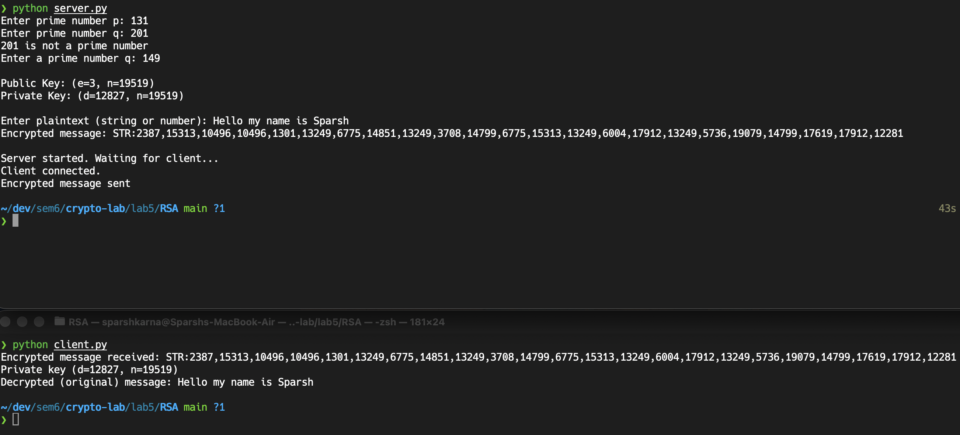
- Output:

