Lab Report

Name: Sparsh Karna

Registration Number: 23BDS1172

Experiment Title: Optimizing Urban Flood Control using R Programming

Date: 07-08-2025

# Objective

To simulate and analyze flood control strategies in an urban environment using datasets created with vectors and lists in R. The goal is to evaluate flood risk levels and propose effective mitigation strategies using built-in and user-defined functions.

# Problem Statement

Urban flooding is becoming increasingly common due to heavy rainfall, poor drainage, and lack of green cover. The objective is to build a dataset for 20 urban zones and analyze them using R. The simulation includes assessing flood risks and generating mitigation recommendations.

# Code Implementation

# ===================================================

# Optimizing Urban Flood Control using R Programming

# Lab Assignment – 4

# Student Name: Sparsh Karna

# Reg. No.: 23BDS1172

# ===================================================

# ============== Dataset Creation Section ==============

# 20 Urban Zones

zone_name_1172 <- paste("Zone", 1:20)

# Simulated Data

set.seed(1172) # For reproducibility

rainfall_mm_1172 <- sample(50:500, 20, replace = TRUE)

drainage_capacity_1172 <- sample(50:500, 20, replace = TRUE)

population_1172 <- sample(1000:10000, 20, replace = TRUE)

water_logging_cm_1172 <- sample(50:200, 20, replace = TRUE)

green_cover_percent_1172 <- sample(10:50, 20, replace = TRUE)

# Creating the list

city_flood_data_1172 <- list(

zone_name = zone_name_1172,

rainfall_mm = rainfall_mm_1172,

drainage_capacity = drainage_capacity_1172,

population = population_1172,

water_logging_cm = water_logging_cm_1172,

green_cover_percent = green_cover_percent_1172

)

# ============== User-Defined Function: Display Structure ==============

#' @title Display Data Structure

#' @description Prints the dataset and its structure

display_data_structure_1172 <- function() {

cat("----- City Flood Dataset -----\n\n")

print(city_flood_data_1172)

cat("\n----- Structure of the Dataset -----\n\n")

str(city_flood_data_1172)

}

# ============== Built-in Functions Section ==============

# Zone with highest rainfall

max_rainfall_index_1172 <- which.max(city_flood_data_1172$rainfall_mm)

cat("Zone with Highest Rainfall:", city_flood_data_1172$zone_name[max_rainfall_index_1172], "\n\n")

# Average water logging

avg_water_logging_1172 <- mean(city_flood_data_1172$water_logging_cm)

cat("Average Water Logging (cm):", round(avg_water_logging_1172, 2), "\n\n")

# Below-average green cover zones

below_avg_gc_1172 <- city_flood_data_1172$green_cover_percent < mean(city_flood_data_1172$green_cover_percent)

cat("Zones with Below-Average Green Cover:\n")

print(city_flood_data_1172$zone_name[below_avg_gc_1172])

cat("\n")

# Zones sorted by population

sorted_population_indices_1172 <- order(city_flood_data_1172$population, decreasing = TRUE)

cat("Zones Sorted by Population (Descending):\n")

print(city_flood_data_1172$zone_name[sorted_population_indices_1172])

cat("\n")

# ============== User-defined Functions Section ==============

# Flood risk assessment

assess_flood_risk_1172 <- function(rainfall, drainage) {

diff <- rainfall - drainage

if (diff > 200) {

return("High")

} else if (diff > 50) {

return("Moderate")

} else {

return("Low")

}

}

# Suggest mitigation strategy

suggest_mitigation_1172 <- function(green_cover, population) {

if (green_cover < 20 && population > 5000) {

return("Increase Tree Plantation")

} else if (green_cover < 30) {

return("Install Rain Gardens")

} else {

return("Create Green Roofs")

}

}

# Apply functions to all zones

risk_level_1172 <- mapply(assess_flood_risk_1172, city_flood_data_1172$rainfall_mm, city_flood_data_1172$drainage_capacity)

mitigation_suggestion_1172 <- mapply(suggest_mitigation_1172, city_flood_data_1172$green_cover_percent, city_flood_data_1172$population)

# Add to list

city_flood_data_1172$risk_level <- risk_level_1172

city_flood_data_1172$mitigation_suggestion <- mitigation_suggestion_1172

# ============== Vector Operations Section ==============

# Adjusted water logging

adjusted_water_logging_cm_1172 <- city_flood_data_1172$water_logging_cm

adjusted_water_logging_cm_1172[city_flood_data_1172$green_cover_percent > 30] <-

adjusted_water_logging_cm_1172[city_flood_data_1172$green_cover_percent > 30] * 0.8

# Severity index calculation

severity_index_1172 <- (city_flood_data_1172$rainfall_mm -

city_flood_data_1172$drainage_capacity +

adjusted_water_logging_cm_1172) /

city_flood_data_1172$population

# Add to dataset

city_flood_data_1172$adjusted_water_logging_cm <- round(adjusted_water_logging_cm_1172, 2)

city_flood_data_1172$severity_index <- round(severity_index_1172, 4)

# ============== Filtering and Summary Section ==============

cat("--- High Risk Zone Summary (Severity Index > 0.05) ---\n\n")

high_risk_indices_1172 <- which(city_flood_data_1172$severity_index > 0.05)

# Print summary

for (i in high_risk_indices_1172) {

cat("Zone:", city_flood_data_1172$zone_name[i], "\t")

cat("Severity Index:", city_flood_data_1172$severity_index[i], "\t")

cat("Mitigation:", city_flood_data_1172$mitigation_suggestion[i], "\n")

}

# ============== Display Full Dataset Structure ==============

cat("\n\n--- Dataset Display ---\n\n")

display_data_structure_1172()

cat("\n=== Analysis Complete ===\n")

# Output:

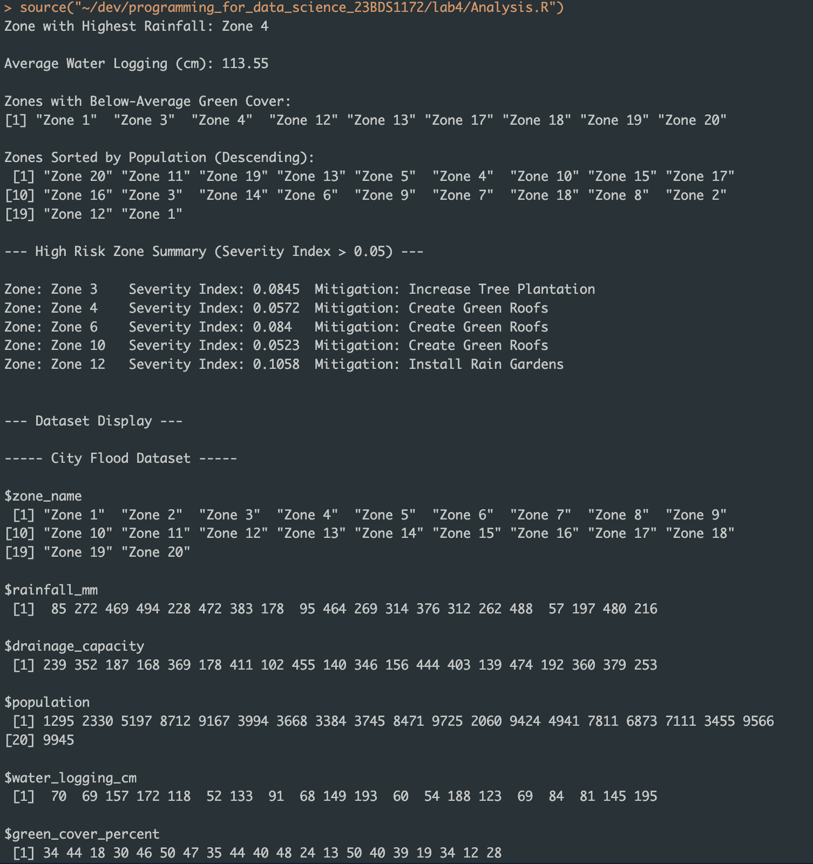

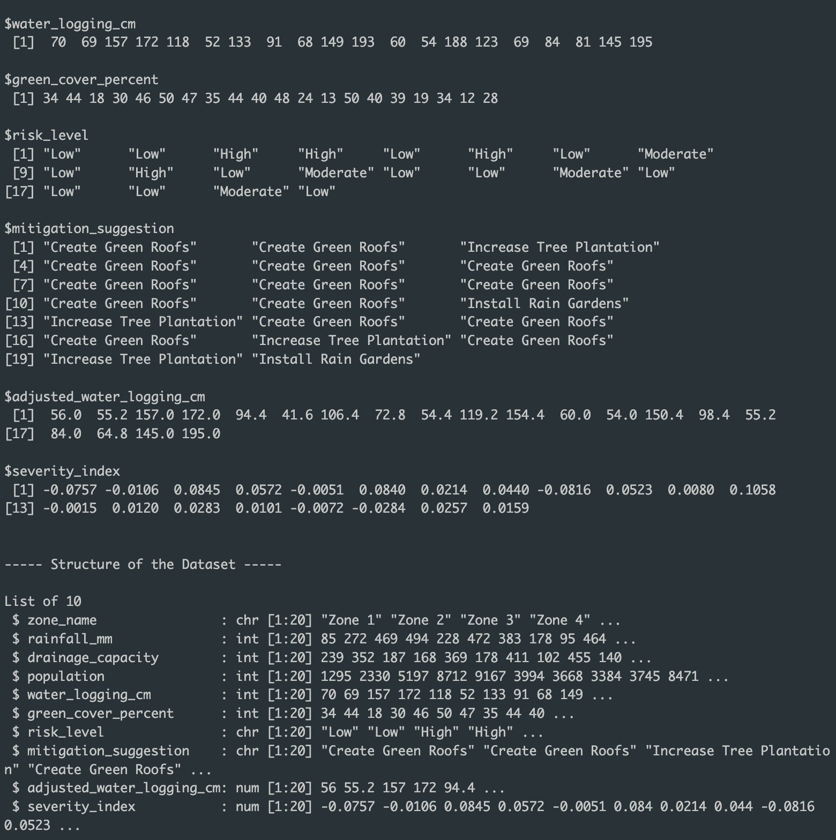

> source("~/dev/programming_for_data_science_23BDS1172/lab4/Analysis.R")

Zone with Highest Rainfall: Zone 4

Average Water Logging (cm): 113.55

Zones with Below-Average Green Cover:

[1] "Zone 1" "Zone 3" "Zone 4" "Zone 12" "Zone 13" "Zone 17" "Zone 18" "Zone 19" "Zone 20"

Zones Sorted by Population (Descending):

[1] "Zone 20" "Zone 11" "Zone 19" "Zone 13" "Zone 5" "Zone 4" "Zone 10" "Zone 15" "Zone 17"

[10] "Zone 16" "Zone 3" "Zone 14" "Zone 6" "Zone 9" "Zone 7" "Zone 18" "Zone 8" "Zone 2"

[19] "Zone 12" "Zone 1"

--- High Risk Zone Summary (Severity Index > 0.05) ---

Zone: Zone 3 Severity Index: 0.0845 Mitigation: Increase Tree Plantation

Zone: Zone 4 Severity Index: 0.0572 Mitigation: Create Green Roofs

Zone: Zone 6 Severity Index: 0.084 Mitigation: Create Green Roofs

Zone: Zone 10 Severity Index: 0.0523 Mitigation: Create Green Roofs

Zone: Zone 12 Severity Index: 0.1058 Mitigation: Install Rain Gardens

--- Dataset Display ---

----- City Flood Dataset -----

$zone_name

[1] "Zone 1" "Zone 2" "Zone 3" "Zone 4" "Zone 5" "Zone 6" "Zone 7" "Zone 8" "Zone 9"

[10] "Zone 10" "Zone 11" "Zone 12" "Zone 13" "Zone 14" "Zone 15" "Zone 16" "Zone 17" "Zone 18"

[19] "Zone 19" "Zone 20"

$rainfall_mm

[1] 85 272 469 494 228 472 383 178 95 464 269 314 376 312 262 488 57 197 480 216

$drainage_capacity

[1] 239 352 187 168 369 178 411 102 455 140 346 156 444 403 139 474 192 360 379 253

$population

[1] 1295 2330 5197 8712 9167 3994 3668 3384 3745 8471 9725 2060 9424 4941 7811 6873 7111 3455 9566

[20] 9945

$water_logging_cm

[1] 70 69 157 172 118 52 133 91 68 149 193 60 54 188 123 69 84 81 145 195

$green_cover_percent

[1] 34 44 18 30 46 50 47 35 44 40 48 24 13 50 40 39 19 34 12 28

$risk_level

[1] "Low" "Low" "High" "High" "Low" "High" "Low" "Moderate"

[9] "Low" "High" "Low" "Moderate" "Low" "Low" "Moderate" "Low"

[17] "Low" "Low" "Moderate" "Low"

$mitigation_suggestion

[1] "Create Green Roofs" "Create Green Roofs" "Increase Tree Plantation"

[4] "Create Green Roofs" "Create Green Roofs" "Create Green Roofs"

[7] "Create Green Roofs" "Create Green Roofs" "Create Green Roofs"

[10] "Create Green Roofs" "Create Green Roofs" "Install Rain Gardens"

[13] "Increase Tree Plantation" "Create Green Roofs" "Create Green Roofs"

[16] "Create Green Roofs" "Increase Tree Plantation" "Create Green Roofs"

[19] "Increase Tree Plantation" "Install Rain Gardens"

$adjusted_water_logging_cm

[1] 56.0 55.2 157.0 172.0 94.4 41.6 106.4 72.8 54.4 119.2 154.4 60.0 54.0 150.4 98.4 55.2

[17] 84.0 64.8 145.0 195.0

$severity_index

[1] -0.0757 -0.0106 0.0845 0.0572 -0.0051 0.0840 0.0214 0.0440 -0.0816 0.0523 0.0080 0.1058

[13] -0.0015 0.0120 0.0283 0.0101 -0.0072 -0.0284 0.0257 0.0159

----- Structure of the Dataset -----

List of 10

$ zone_name : chr [1:20] "Zone 1" "Zone 2" "Zone 3" "Zone 4" ...

$ rainfall_mm : int [1:20] 85 272 469 494 228 472 383 178 95 464 ...

$ drainage_capacity : int [1:20] 239 352 187 168 369 178 411 102 455 140 ...

$ population : int [1:20] 1295 2330 5197 8712 9167 3994 3668 3384 3745 8471 ...

$ water_logging_cm : int [1:20] 70 69 157 172 118 52 133 91 68 149 ...

$ green_cover_percent : int [1:20] 34 44 18 30 46 50 47 35 44 40 ...

$ risk_level : chr [1:20] "Low" "Low" "High" "High" ...

$ mitigation_suggestion : chr [1:20] "Create Green Roofs" "Create Green Roofs" "Increase Tree Plantation" "Create Green Roofs" ...

$ adjusted_water_logging_cm: num [1:20] 56 55.2 157 172 94.4 ...

$ severity_index : num [1:20] -0.0757 -0.0106 0.0845 0.0572 -0.0051 0.084 0.0214 0.044 -0.0816 0.0523 ...

=== Analysis Complete ===