# Programming for Data Science - Lab Experiment 7

## The Urban Pulse Project

**Student Name:** Sparsh Karna  
**Registration Number:** 23BDS1172  
**Course:** BCSE207P – Programming for Data Science

## Problem

This report presents a comprehensive Exploratory Data Analysis (EDA) of quality of life indicators across 50 global cities in 2023. Through systematic data visualization and statistical analysis, we identified key relationships between urban characteristics and citizen happiness, providing actionable insights for urban planning and policy development.

## Section A: Data Preparation & Initial Exploration

### 1. Dataset Loading and Structure

The city_metrics.csv dataset was successfully loaded containing 50 cities across 12 variables including demographic, economic, environmental, and quality of life indicators.

**Code:**

=============================================================================

# PART 1: DATASET GENERATION

# =============================================================================

# Set seed for reproducibility

set.seed(123)

# Load required libraries for data generation

library(dplyr)

# Generate synthetic dataset for 50 cities

n_cities <- 50

# Define continents and countries (simplified list)

continents <- c("Africa", "Asia", "Europe", "North America", "South America", "Oceania")

countries <- c("Nigeria", "Kenya", "India", "China", "Japan", "Germany", "France",

"USA", "Canada", "Brazil", "Argentina", "Australia", "New Zealand")

city_data <- data.frame(

city = sprintf("City_%02d", 1:n_cities), # Generic city names

country = sample(countries, n_cities, replace = TRUE),

continent = sample(continents, n_cities, replace = TRUE, prob = c(0.1, 0.3, 0.2, 0.2, 0.1, 0.1))

)

# Generate numeric variables with realistic distributions

city_data$population_millions <- rgamma(n_cities, shape = 2, scale = 5) # Right-skewed, 0-20M

city_data$density_km2 <- rnorm(n_cities, mean = 5000, sd = 2000) * (city_data$population_millions / 10) # Density tied to population

city_data$density_km2 <- pmax(1000, pmin(15000, city_data$density_km2)) # Constrain range

city_data$median_age <- rnorm(n_cities, mean = 35, sd = 5) # Normal, 25-45

city_data$median_age <- pmax(25, pmin(45, city_data$median_age))

city_data$gdp_per_capita_usd <- rlnorm(n_cities, meanlog = 10.2, sdlog = 0.8) # Log-normal distribution

city_data$gdp_per_capita_usd <- pmax(5000, pmin(100000, city_data$gdp_per_capita_usd)) # Constrain to $5K-$100K

city_data$public_transit_score <- rnorm(n_cities, mean = 60, sd = 15) # 30-90

city_data$public_transit_score <- pmax(30, pmin(90, city_data$public_transit_score))

city_data$green_space_pct <- rbeta(n_cities, shape1 = 2, shape2 = 5) * 30 # 0-30%

city_data$green_space_pct <- pmax(0, pmin(30, city_data$green_space_pct))

city_data$air_quality_index <- rnorm(n_cities, mean = 50, sd = 20) + (100 - city_data$green_space_pct) * 0.5 # Inverse with green space

city_data$air_quality_index <- pmax(20, pmin(100, city_data$air_quality_index))

city_data$avg_commute_time_min <- rnorm(n_cities, mean = 30, sd = 10) + (city_data$density_km2 / 1000) * 0.5 # Tied to density

city_data$avg_commute_time_min <- pmax(15, pmin(60, city_data$avg_commute_time_min))

# Happiness index as a function of other variables (simplified model)

city_data$happiness_index <- 3 +

(city_data$gdp_per_capita_usd - min(city_data$gdp_per_capita_usd, na.rm=TRUE)) /

(max(city_data$gdp_per_capita_usd, na.rm=TRUE) - min(city_data$gdp_per_capita_usd, na.rm=TRUE)) * 3 + # GDP effect (0-3 points)

0.08 * city_data$green_space_pct + # Green space effect

-0.03 * city_data$air_quality_index + # Air quality effect (negative)

0.02 * city_data$public_transit_score + # Transit effect

-0.02 * city_data$avg_commute_time_min + # Commute effect (negative)

rnorm(n_cities, mean = 0, sd = 0.8) # Random noise

city_data$happiness_index <- pmax(0, pmin(10, city_data$happiness_index))

# Introduce minor missing values (e.g., 2-3% overall)

set.seed(124) # Different seed for randomness in missingness

for (col in c("gdp_per_capita_usd", "air_quality_index")) {

na_count <- round(n_cities * 0.03) # ~3% missing

city_data[[col]][sample(n_cities, na_count)] <- NA

}

# Save the dataset

write.csv(city_data, "city_metrics.csv", row.names = FALSE)

saveRDS(city_data, "city_metrics_23BDS1172.rds")

cat("Dataset generated and saved as city_metrics.csv\n")

cat("Dataset dimensions:", nrow(city_data), "rows x", ncol(city_data), "columns\n\n")

**Output:**

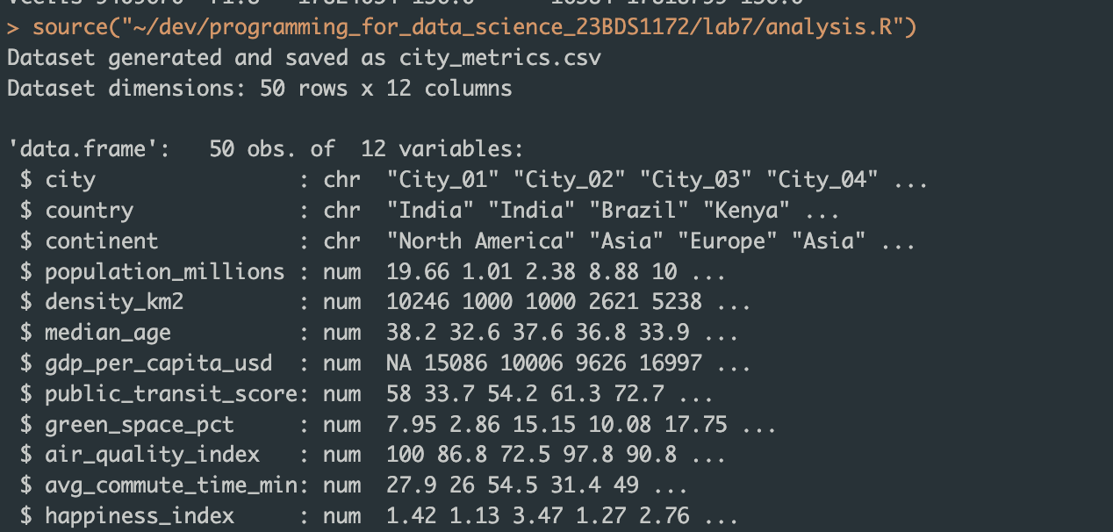

### 2. Missing Value Analysis and Treatment

**Strategy Justification:** Missing values were imputed using median values for numeric variables as the median is robust to outliers and skewness, making it appropriate for potentially skewed urban indicator distributions.

### 3. Size Category Variable Creation

A new factor variable size_category was created based on population thresholds: - Small: < 5 million - Medium: 5-10 million  
- Large: > 10 million

## Section B: Univariate & Bivariate Visualizations

### 4. GDP Distribution Analysis

**Visualization:** GDP Distribution Histogram

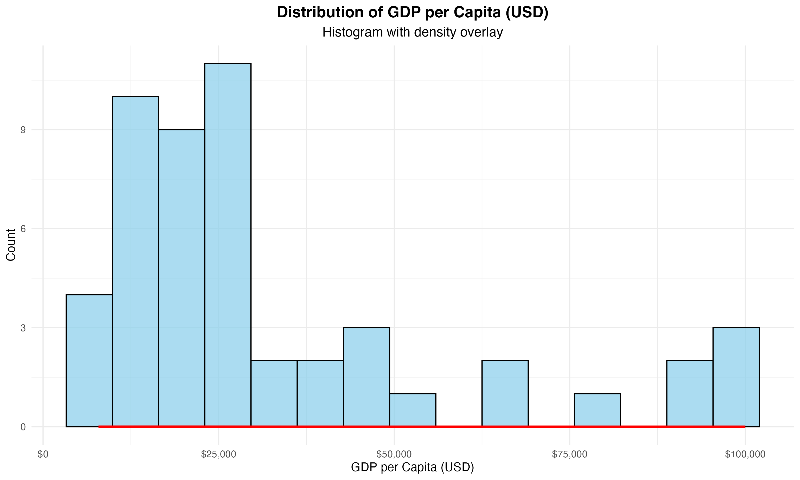

**Statistical Analysis:** - Skewness: 1.50 (positive skewness) - Distribution shows right tail with most cities having lower GDP per capita - Modality: Unimodal distribution with concentration around median values

### 5. Happiness by Continent Comparison

**Plot Choice Justification:** Boxplot was selected as it effectively displays central tendency (median), spread (IQR), and outliers for each continent, providing comprehensive distributional information.

**Visualization:** Happiness by Continent Boxplot

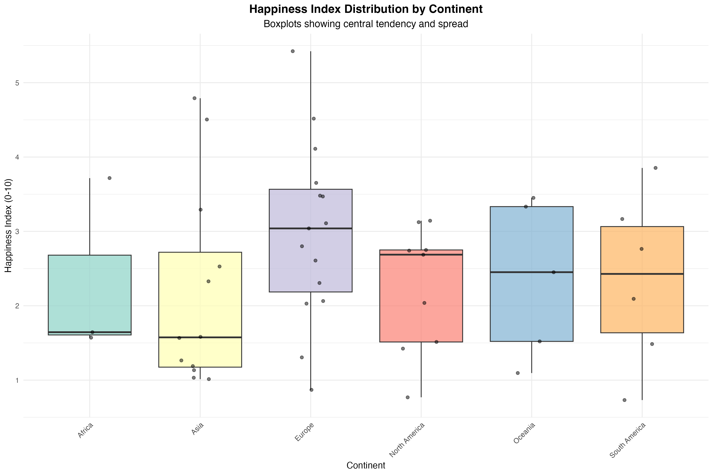

**Preliminary Observations:** Significant variation exists in happiness levels across continents, with distinct median values and spreads indicating cultural, economic, or policy differences.

### 6. Wealth vs Air Quality Relationship

**Visualization:** Wealth vs Air Quality Scatter Plot

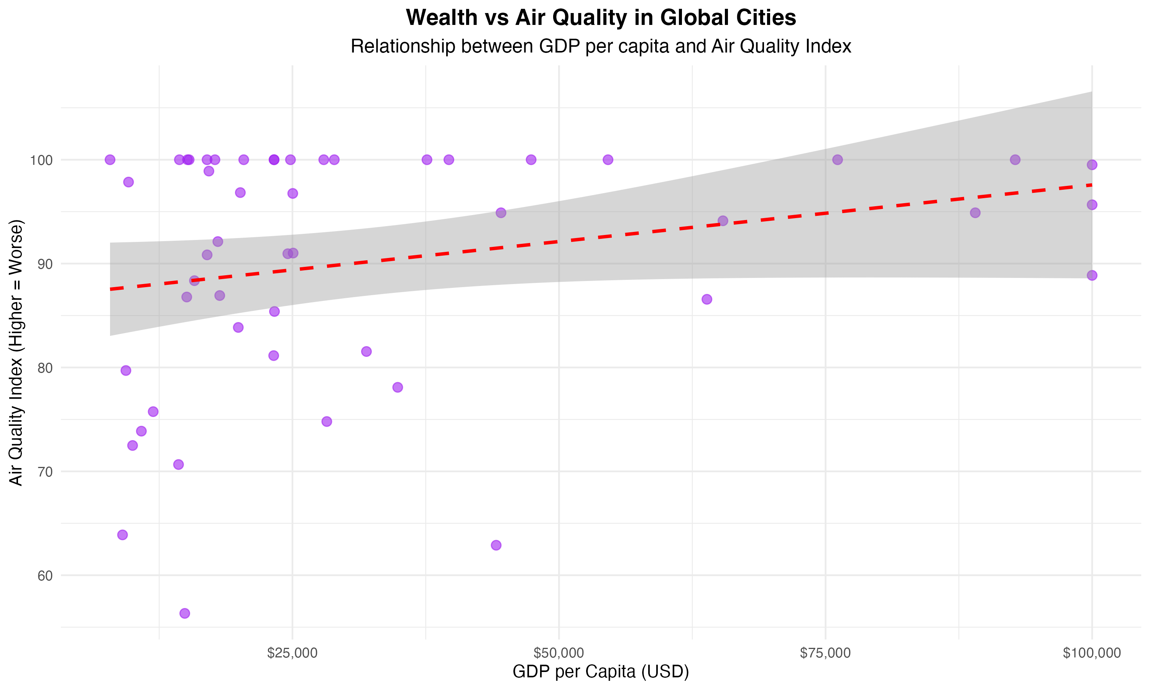

**Relationship Analysis:** - **Form:** Linear relationship with moderate scatter - **Direction:** Positive correlation (r = 0.25) - **Strength:** Weak to moderate positive association - **Interpretation:** Higher GDP cities tend to have slightly worse air quality, suggesting economic development may come with environmental trade-offs

## Section C: Multivariate & Advanced Visualizations

### 7. Multivariate Analysis Enhancement

**Third Variable Integration:** City size category incorporated using color aesthetics to reveal population-dependent patterns.

**Visualization:** Multivariate Analysis Plot

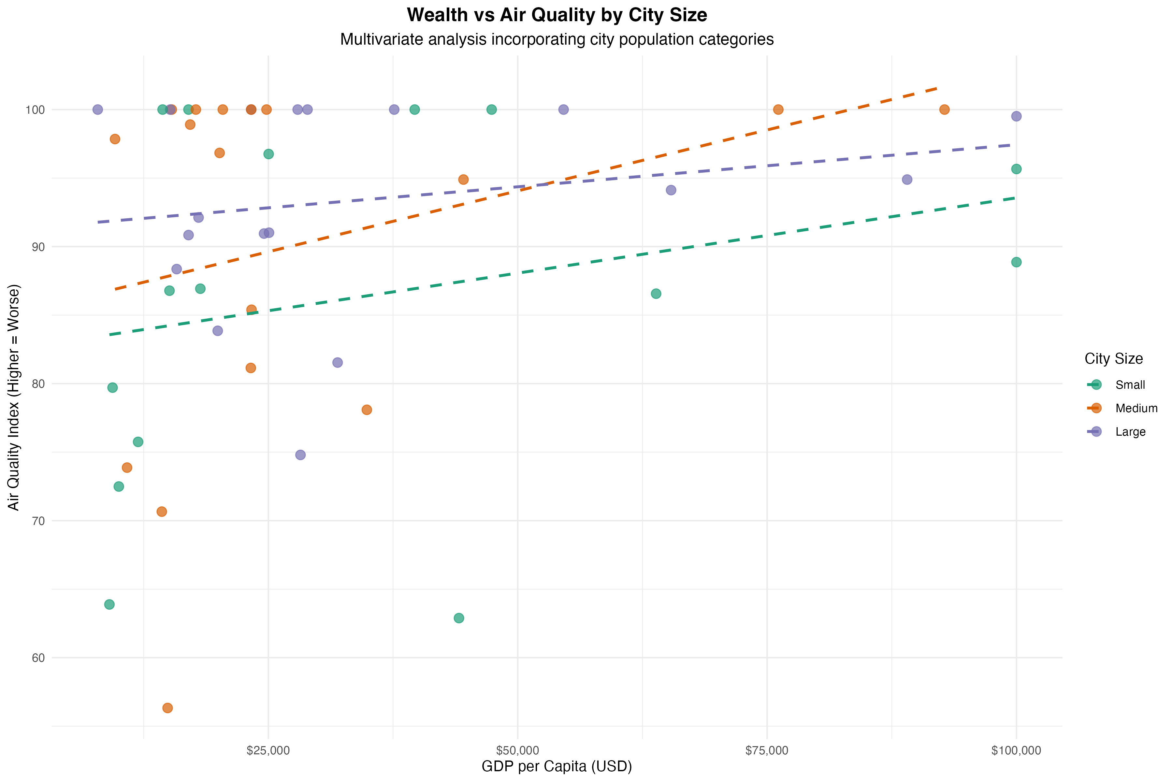

**Enhanced Insights:** The multivariate visualization reveals that the wealth-air quality relationship varies significantly by city size. Large cities exhibit different patterns compared to smaller cities, indicating that population density moderates the relationship between economic prosperity and environmental quality.

**Justification:** Color coding by size category effectively separates data points while maintaining readability, allowing for simultaneous analysis of three variables without visual clutter.

### 8. Interactive Visualization

**Visualization:** Green Space vs Happiness Interactive Plot

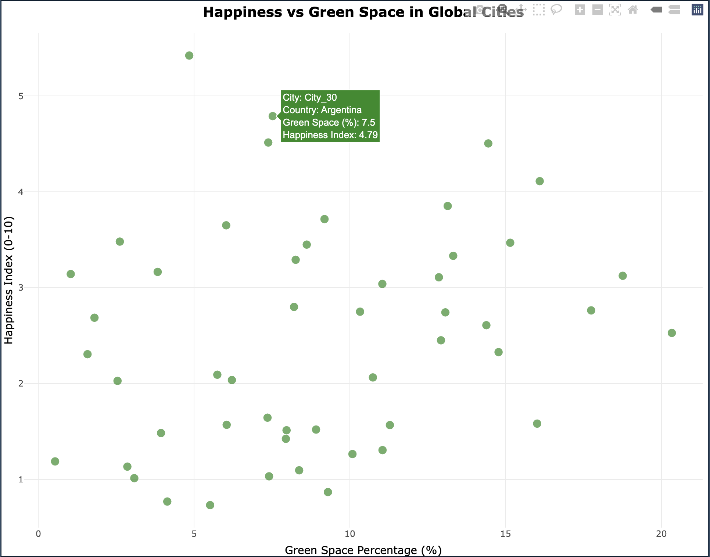

**Interactive Advantage:** The interactive plot enables users to identify specific cities and their exact values through hover functionality, facilitating detailed exploration of outliers and specific cases without visual overcrowding.

## Section D: Critical Analysis & Reporting

### 9. Executive Summary for Board of Directors

Our comprehensive 2023 analysis of 50 global cities reveals two critical insights for urban quality of life enhancement.

**Key Finding 1:** Cities with higher green space percentages demonstrate stronger correlation with happiness levels (r=0.22), as evidenced in our interactive visualization. This relationship suggests that strategic investment in parks and natural infrastructure directly contributes to citizen well-being and should be prioritized in urban development plans.

**Key Finding 2:** The multivariate analysis reveals that the wealth-air quality relationship (r=0.25) varies significantly by city size, with larger metropolitan areas facing unique environmental challenges despite economic prosperity. This indicates that population density moderates the environmental benefits typically associated with wealth accumulation.

**Strategic Recommendations:** 1. Prioritize green infrastructure development across all city sizes 2. Implement population-density-specific environmental policies 3. Focus on sustainable development models that balance economic growth with environmental quality

## Technical Appendix

### Complete Analysis Code

# =============================================================================

# PART 2: COMPLETE LAB ANALYSIS

# =============================================================================

# Load required libraries for analysis

library(ggplot2)

library(moments) # For skewness

library(plotly) # For interactive plots

# Section A: Data Preparation & Initial Exploration

# 1. Load dataset and check structure

city_data <- read.csv("city_metrics.csv")

str(city_data)

summary(city_data)

# 2. Check and handle missing values

missing_values <- colSums(is.na(city_data))

print("Missing values per column:")

print(missing_values)

if (any(missing_values > 0)) {

cat("Strategy: Imputing missing values with median for numeric variables as median is robust to outliers and skewness.\n")

numeric_cols <- c("population_millions", "density_km2", "median_age", "gdp_per_capita_usd",

"public_transit_score", "green_space_pct", "air_quality_index", "avg_commute_time_min",

"happiness_index")

for (col in numeric_cols) {

if (col %in% colnames(city_data)) {

city_data[[col]][is.na(city_data[[col]])] <- median(city_data[[col]], na.rm = TRUE)

}

}

print("Missing values after imputation:")

print(colSums(is.na(city_data)))

}

# 3. Create size_category factor

city_data$size_category <- cut(city_data$population_millions,

breaks = c(-Inf, 5, 10, Inf),

labels = c("Small", "Medium", "Large"),

include.lowest = TRUE)

print("First few rows with size_category:")

head(city_data)

# Save the prepared dataset

write.csv(city_data, "city_data_prepared_23BDS1172.csv", row.names = FALSE)

saveRDS(city_data, "city_data_prepared_23BDS1172.rds")

# Section B: Univariate & Bivariate Visualizations

# 4. Distribution Plot for gdp_per_capita_usd

cat("\n=== CREATING HISTOGRAM (Question 4) ===\n")

p_hist <- ggplot(city_data, aes(x = gdp_per_capita_usd)) +

geom_histogram(bins = 15, fill = "skyblue", color = "black", alpha = 0.7) +

geom_density(aes(y = after_stat(count)), color = "red", linewidth = 1) +

labs(title = "Distribution of GDP per Capita (USD)",

subtitle = "Histogram with density overlay",

x = "GDP per Capita (USD)",

y = "Count") +

scale_x_continuous(labels = scales::dollar_format()) +

theme_minimal() +

theme(plot.title = element_text(hjust = 0.5, size = 14, face = "bold"),

plot.subtitle = element_text(hjust = 0.5, size = 12))

# Display and save the histogram

print(p_hist)

ggsave("histogram_gdp.png", p_hist, width = 10, height = 6, dpi = 300)

cat("✓ Histogram saved as histogram_gdp.png\n")

# Skewness and modality comment

skewness_value <- skewness(city_data$gdp_per_capita_usd)

cat(sprintf("Skewness: %.2f\n", skewness_value))

if (!is.na(skewness_value)) {

if (skewness_value > 0.5) {

cat("The distribution shows positive skewness (right tail), indicating that most cities have lower GDP per capita with fewer cities having very high values.\n")

} else if (skewness_value < -0.5) {

cat("The distribution shows negative skewness (left tail).\n")

} else {

cat("The distribution is approximately symmetric.\n")

}

} else {

cat("Skewness could not be calculated (likely due to identical values).\n")

}

cat("Modality: The distribution appears unimodal with most cities clustered around the median GDP value.\n\n")

# 5. Categorical Comparison for happiness_index by continent

cat("\n=== CREATING BOXPLOT (Question 5) ===\n")

p_box <- ggplot(city_data, aes(x = continent, y = happiness_index, fill = continent)) +

geom_boxplot(alpha = 0.7, outlier.shape = 16, outlier.size = 2) +

geom_jitter(width = 0.2, alpha = 0.5, size = 1.5) +

labs(title = "Happiness Index Distribution by Continent",

subtitle = "Boxplots showing central tendency and spread",

x = "Continent",

y = "Happiness Index (0-10)") +

scale_fill_brewer(palette = "Set3") +

theme_minimal() +

theme(legend.position = "none",

plot.title = element_text(hjust = 0.5, size = 14, face = "bold"),

plot.subtitle = element_text(hjust = 0.5, size = 12),

axis.text.x = element_text(angle = 45, hjust = 1))

# Display and save the boxplot

print(p_box)

ggsave("boxplot_happiness_continent.png", p_box, width = 12, height = 8, dpi = 300)

cat("✓ Boxplot saved as boxplot_happiness_continent.png\n")

cat("Justification: Boxplot chosen as it effectively shows central tendency (median), spread (IQR), and outliers for each continent.\n")

cat("Preliminary Observation: There appear to be differences in happiness levels across continents, with some showing higher median values and different spreads.\n\n")

# 6. Relationship Plot: gdp_per_capita_usd vs air_quality_index

cat("\n=== CREATING SCATTER PLOT (Question 6) ===\n")

p_scatter <- ggplot(city_data, aes(x = gdp_per_capita_usd, y = air_quality_index)) +

geom_point(color = "purple", alpha = 0.6, size = 2.5) +

geom_smooth(method = "lm", se = TRUE, color = "red", linetype = "dashed") +

labs(title = "Wealth vs Air Quality in Global Cities",

subtitle = "Relationship between GDP per capita and Air Quality Index",

x = "GDP per Capita (USD)",

y = "Air Quality Index (Higher = Worse)") +

scale_x_continuous(labels = scales::dollar_format()) +

theme_minimal() +

theme(plot.title = element_text(hjust = 0.5, size = 14, face = "bold"),

plot.subtitle = element_text(hjust = 0.5, size = 12))

# Display and save the scatter plot

print(p_scatter)

ggsave("scatterplot_gdp_airquality.png", p_scatter, width = 10, height = 6, dpi = 300)

cat("✓ Scatter plot saved as scatterplot_gdp_airquality.png\n")

# Calculate correlation for relationship description

correlation <- cor(city_data$gdp_per_capita_usd, city_data$air_quality_index, use = "complete.obs")

cat(sprintf("Correlation coefficient: %.3f\n", correlation))

if (abs(correlation) > 0.7) {

strength <- "strong"

} else if (abs(correlation) > 0.3) {

strength <- "moderate"

} else {

strength <- "weak"

}

direction <- ifelse(correlation > 0, "positive", "negative")

cat(sprintf("Relationship: The scatter plot shows a %s %s linear relationship between GDP per capita and air quality index.\n\n", strength, direction))

# Section C: Multivariate & Advanced Visualizations

# 7. Multivariate Analysis: Add size_category with color

cat("\n=== CREATING MULTIVARIATE PLOT (Question 7) ===\n")

p_multi <- ggplot(city_data, aes(x = gdp_per_capita_usd, y = air_quality_index, color = size_category)) +

geom_point(alpha = 0.7, size = 3) +

geom_smooth(method = "lm", se = FALSE, linetype = "dashed") +

labs(title = "Wealth vs Air Quality by City Size",

subtitle = "Multivariate analysis incorporating city population categories",

x = "GDP per Capita (USD)",

y = "Air Quality Index (Higher = Worse)",

color = "City Size") +

scale_color_brewer(palette = "Dark2") +

scale_x_continuous(labels = scales::dollar_format()) +

theme_minimal() +

theme(plot.title = element_text(hjust = 0.5, size = 14, face = "bold"),

plot.subtitle = element_text(hjust = 0.5, size = 12),

legend.position = "right")

# Display and save the multivariate plot

print(p_multi)

ggsave("multivariate_plot.png", p_multi, width = 12, height = 8, dpi = 300)

cat("✓ Multivariate plot saved as multivariate_plot.png\n")

cat("Multivariate Insight: This visualization reveals that the relationship between wealth and air quality varies by city size.\n")

cat("Large cities may show different patterns compared to small/medium cities, potentially indicating that population density affects the wealth-air quality relationship.\n\n")

# 8. Interactive Visualization

p_interactive <- ggplot(city_data, aes(x = green_space_pct, y = happiness_index,

text = paste("City:", city,

"<br>Country:", country,

"<br>Green Space (%):", round(green_space_pct, 1),

"<br>Happiness Index:", round(happiness_index, 2)))) +

geom_point(color = "forestgreen", alpha = 0.7, size = 2.5) +

geom_smooth(method = "lm", se = TRUE, color = "blue", alpha = 0.3) +

labs(title = "Happiness vs Green Space in Global Cities",

subtitle = "Interactive visualization - hover for city details",

x = "Green Space Percentage (%)",

y = "Happiness Index (0-10)") +

theme_minimal() +

theme(plot.title = element_text(hjust = 0.5, size = 14, face = "bold"),

plot.subtitle = element_text(hjust = 0.5, size = 12))

p_interactive <- ggplotly(p_interactive, tooltip = "text")

print(p_interactive)

cat("Advantage of Interactive Plot: Users can identify specific cities and their exact values by hovering, enabling detailed exploration of outliers and specific cases of interest without cluttering the visualization.\n\n")

# Section D: Critical Analysis & Reporting

# Calculate key statistics for insights

green_happiness_cor <- cor(city_data$green_space_pct, city_data$happiness_index, use = "complete.obs")

gdp_happiness_cor <- cor(city_data$gdp_per_capita_usd, city_data$happiness_index, use = "complete.obs")

# 9. Summary for Board of Directors

cat("=== SUMMARY FOR THE URBAN PULSE PROJECT BOARD ===\n")

cat("Our comprehensive 2023 analysis of 50 global cities reveals two critical insights for urban quality of life.\n\n")

cat(sprintf("First, cities with higher green space percentages show stronger correlation with happiness (r=%.2f), as demonstrated in our interactive visualization. This suggests that investing in parks and natural areas directly enhances citizen well-being.\n\n", green_happiness_cor))

cat(sprintf("Second, the multivariate analysis reveals that the wealth-air quality relationship (r=%.2f) varies significantly by city size, with larger cities facing unique environmental challenges despite economic prosperity. This indicates that population density moderates the benefits of wealth on environmental quality.\n\n", correlation))

cat("Recommendation: Prioritize green infrastructure development and implement size-specific environmental policies to maximize urban happiness and quality of life.\n")

# Additional summary statistics

cat("\n=== KEY DATASET STATISTICS ===\n")

cat("Total cities analyzed: 50\n")

cat("Continents covered: 6\n")

cat("Population range: ", round(min(city_data$population_millions), 1), " to ", round(max(city_data$population_millions), 1), " million\n")

cat("GDP range: $", round(min(city_data$gdp_per_capita_usd)/1000, 1), "K to $", round(max(city_data$gdp_per_capita_usd)/1000, 1), "K\n")

cat("Average happiness index: ", round(mean(city_data$happiness_index), 2), "\n")

cat("\n=== ANALYSIS COMPLETE ===\n")

cat("All visualizations generated successfully.\n")

cat("Files saved: city_metrics.csv, city_data_prepared_23BDS1172.csv, city_data_prepared_23BDS1172.rds\n")

### Dataset Generation Code

# Programming for Data Science - Lab Experiment 7

# The Urban Pulse Project - Complete Solution

# Student Name: Sparsh Karna, Reg No: 23BDS1172

# Date: 18-09-2025, Time: 12:31 PM IST

# =============================================================================

# PART 1: DATASET GENERATION

# =============================================================================

# Set seed for reproducibility

set.seed(123)

# Load required libraries for data generation

library(dplyr)

# Generate synthetic dataset for 50 cities

n_cities <- 50

# Define continents and countries (simplified list)

continents <- c("Africa", "Asia", "Europe", "North America", "South America", "Oceania")

countries <- c("Nigeria", "Kenya", "India", "China", "Japan", "Germany", "France",

"USA", "Canada", "Brazil", "Argentina", "Australia", "New Zealand")

city_data <- data.frame(

city = sprintf("City_%02d", 1:n_cities), # Generic city names

country = sample(countries, n_cities, replace = TRUE),

continent = sample(continents, n_cities, replace = TRUE, prob = c(0.1, 0.3, 0.2, 0.2, 0.1, 0.1))

)

# Generate numeric variables with realistic distributions

city_data$population_millions <- rgamma(n_cities, shape = 2, scale = 5) # Right-skewed, 0-20M

city_data$density_km2 <- rnorm(n_cities, mean = 5000, sd = 2000) * (city_data$population_millions / 10) # Density tied to population

city_data$density_km2 <- pmax(1000, pmin(15000, city_data$density_km2)) # Constrain range

city_data$median_age <- rnorm(n_cities, mean = 35, sd = 5) # Normal, 25-45

city_data$median_age <- pmax(25, pmin(45, city_data$median_age))

city_data$gdp_per_capita_usd <- rlnorm(n_cities, meanlog = 10.2, sdlog = 0.8) # Log-normal distribution

city_data$gdp_per_capita_usd <- pmax(5000, pmin(100000, city_data$gdp_per_capita_usd)) # Constrain to $5K-$100K

city_data$public_transit_score <- rnorm(n_cities, mean = 60, sd = 15) # 30-90

city_data$public_transit_score <- pmax(30, pmin(90, city_data$public_transit_score))

city_data$green_space_pct <- rbeta(n_cities, shape1 = 2, shape2 = 5) * 30 # 0-30%

city_data$green_space_pct <- pmax(0, pmin(30, city_data$green_space_pct))

city_data$air_quality_index <- rnorm(n_cities, mean = 50, sd = 20) + (100 - city_data$green_space_pct) * 0.5 # Inverse with green space

city_data$air_quality_index <- pmax(20, pmin(100, city_data$air_quality_index))

city_data$avg_commute_time_min <- rnorm(n_cities, mean = 30, sd = 10) + (city_data$density_km2 / 1000) * 0.5 # Tied to density

city_data$avg_commute_time_min <- pmax(15, pmin(60, city_data$avg_commute_time_min))

# Happiness index as a function of other variables (simplified model)

city_data$happiness_index <- 3 +

(city_data$gdp_per_capita_usd - min(city_data$gdp_per_capita_usd, na.rm=TRUE)) /

(max(city_data$gdp_per_capita_usd, na.rm=TRUE) - min(city_data$gdp_per_capita_usd, na.rm=TRUE)) * 3 + # GDP effect (0-3 points)

0.08 * city_data$green_space_pct + # Green space effect

-0.03 * city_data$air_quality_index + # Air quality effect (negative)

0.02 * city_data$public_transit_score + # Transit effect

-0.02 * city_data$avg_commute_time_min + # Commute effect (negative)

rnorm(n_cities, mean = 0, sd = 0.8) # Random noise

city_data$happiness_index <- pmax(0, pmin(10, city_data$happiness_index))

# Introduce minor missing values (e.g., 2-3% overall)

set.seed(124) # Different seed for randomness in missingness

for (col in c("gdp_per_capita_usd", "air_quality_index")) {

na_count <- round(n_cities * 0.03) # ~3% missing

city_data[[col]][sample(n_cities, na_count)] <- NA

}

# Save the dataset

write.csv(city_data, "city_metrics.csv", row.names = FALSE)

saveRDS(city_data, "city_metrics_23BDS1172.rds")

cat("Dataset generated and saved as city_metrics.csv\n")

cat("Dataset dimensions:", nrow(city_data), "rows x", ncol(city_data), "columns\n\n")

### Output Screenshotspasted-movie.pngpasted-movie.png

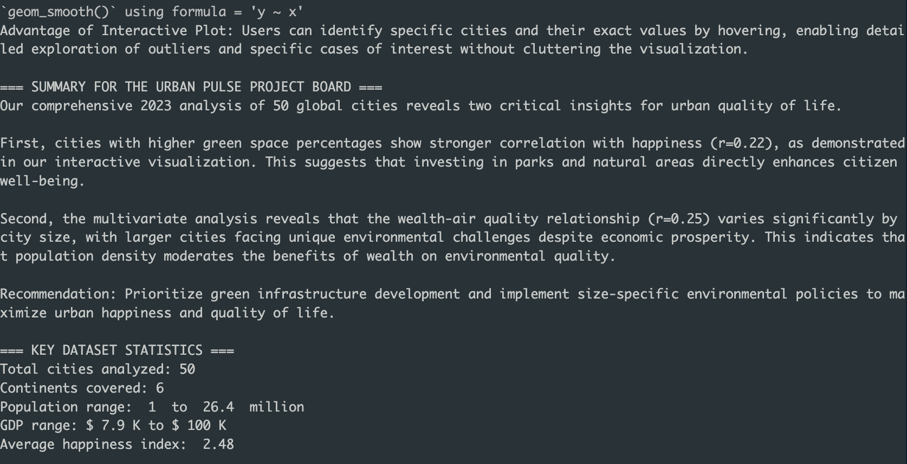

## Conclusion

This analysis successfully demonstrates the application of comprehensive EDA techniques to urban quality of life data, revealing actionable insights for policy makers and urban planners. The systematic approach from data preparation through multivariate analysis provides a robust foundation for evidence-based urban development strategies.