**Lab Assignment 1**

**Part 1 : Reading, Saving and Displaying an image using –**

**Input Image –**



**PIL**

**from** **PIL** **import** Image

im = Image.open("img.jpg")

im

output -



im = im.save("img_pil.jpg")

width , height = im.size

print("Image width = ",width)

print("Image height = ",height)

output –



**Matplotlib**

**import** **matplotlib.pyplot** **as** **plt**

**import** **matplotlib.image** **as** **mpimg**

%**matplotlib** inline

#img = mpimg.imread('img.jpg') *#This will give array*

print(img)

plt.imshow(img)

output –

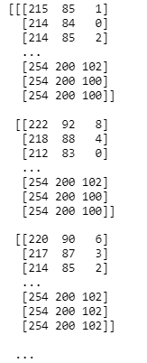

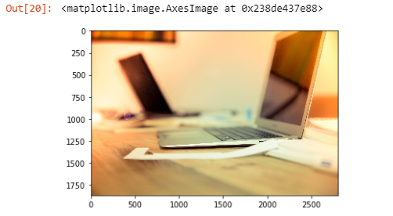

plt.imsave('img_matplotlib.jpg',img)

**Skimage**

**from** **skimage** **import** io

img = io.imread('img.jpg') *# gives array*

print(img)

io.imshow(img)

Output –

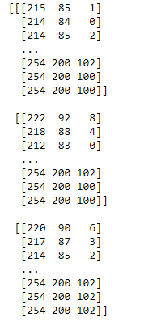

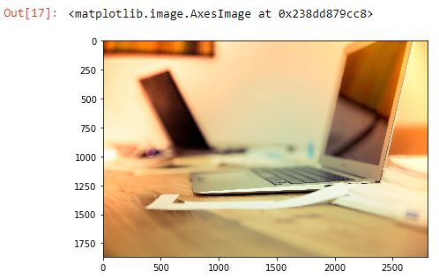

### Part 2 : Reading and Displaying image using Numpy

### Input Image –

### 

**import** **numpy** **as** **np**

rows = 512

cols = 512

img = open('lena_gray.raw')

image = np.fromfile(img, dtype = np.uint8, count = rows * cols)

print("Dimension of original image = ",image.ndim)

image = np.reshape(image,(512,512)) *#Conversion from 1D array to 2D array*

print("New Dimension = ",image.ndim)

image.astype('int8').tofile('new_lena.raw') *#Saving the new image*

Output –



Output Image –

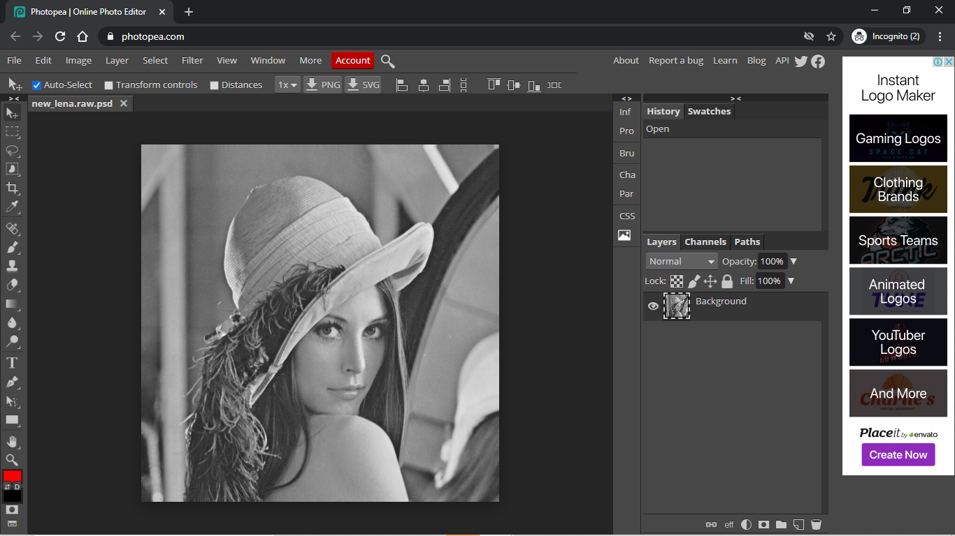

### Jupyter Notebook Screenshots

