**LAB ASSIGNMENT 2**

**EXPLANATION AND CODE SCREENSHOTS**

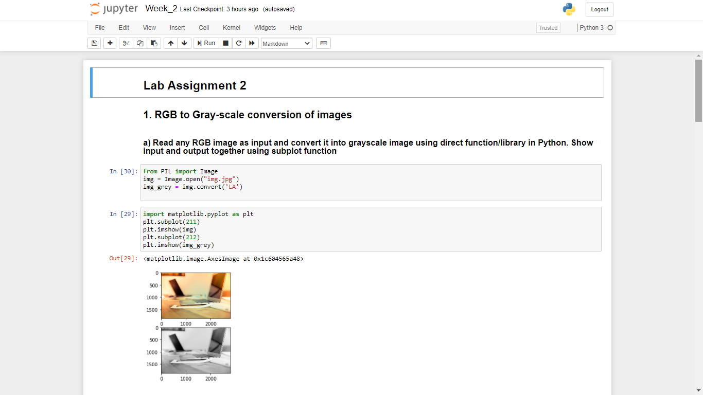

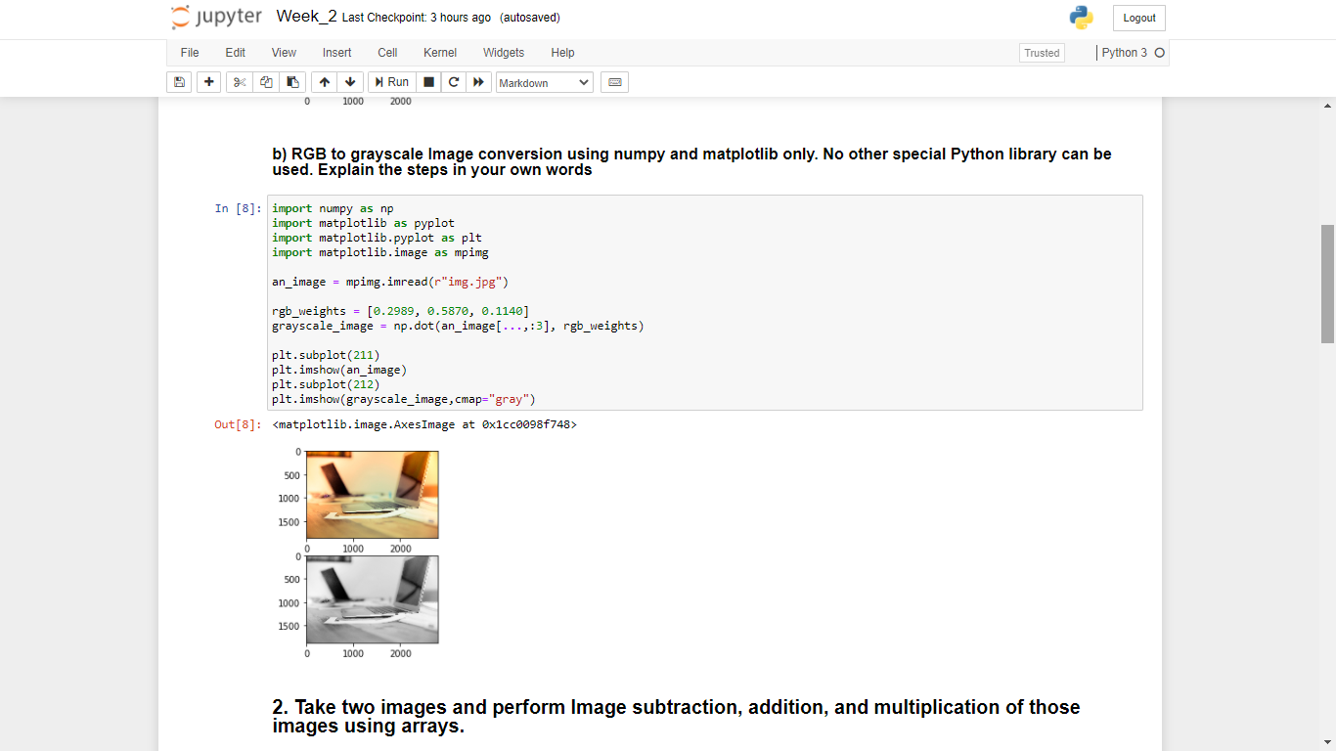

**EXPLANATION –** Here I have used Lumiosity Method to convert the RGB image to grey scale image . Each Channel in RGB format have been assigned weights ( 0.289 for Red , 0.5870 for Green and 0.1140 for Blue). The Green channel have been assigned the largest weight because to our eyes green appears to be a lot more brighter than blue. So RGB is a 3 Dimensional ( channel ) image whereas Grayscale is 1 Dimensional (channel) image, therefore I took the dot product of the original image array with its weights and converted it to a one dimensional ( channel ) image.

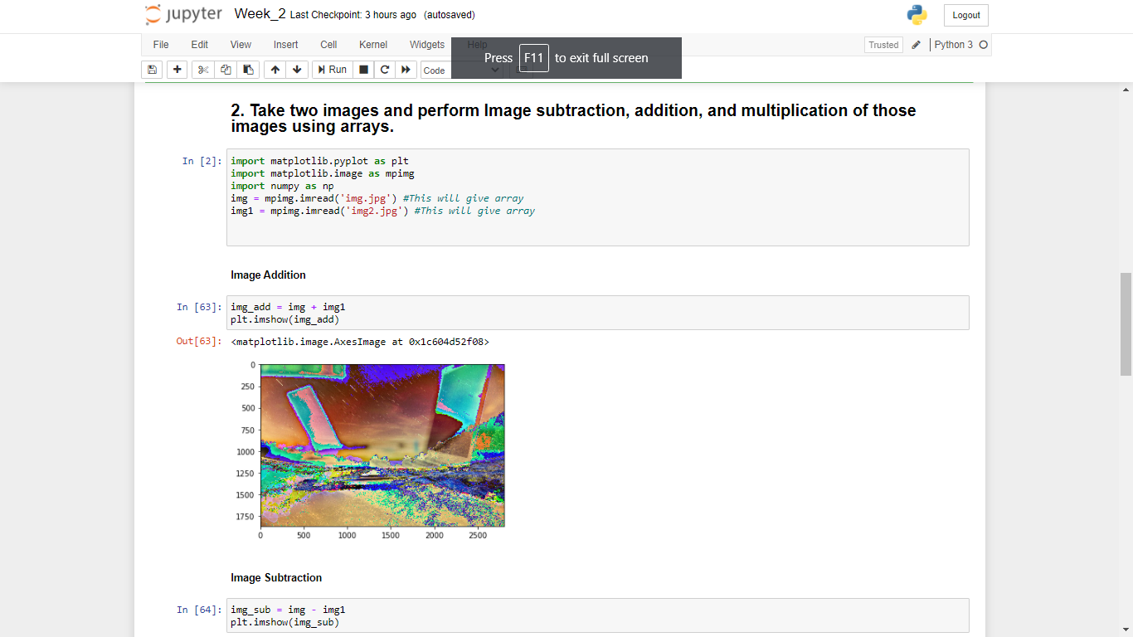

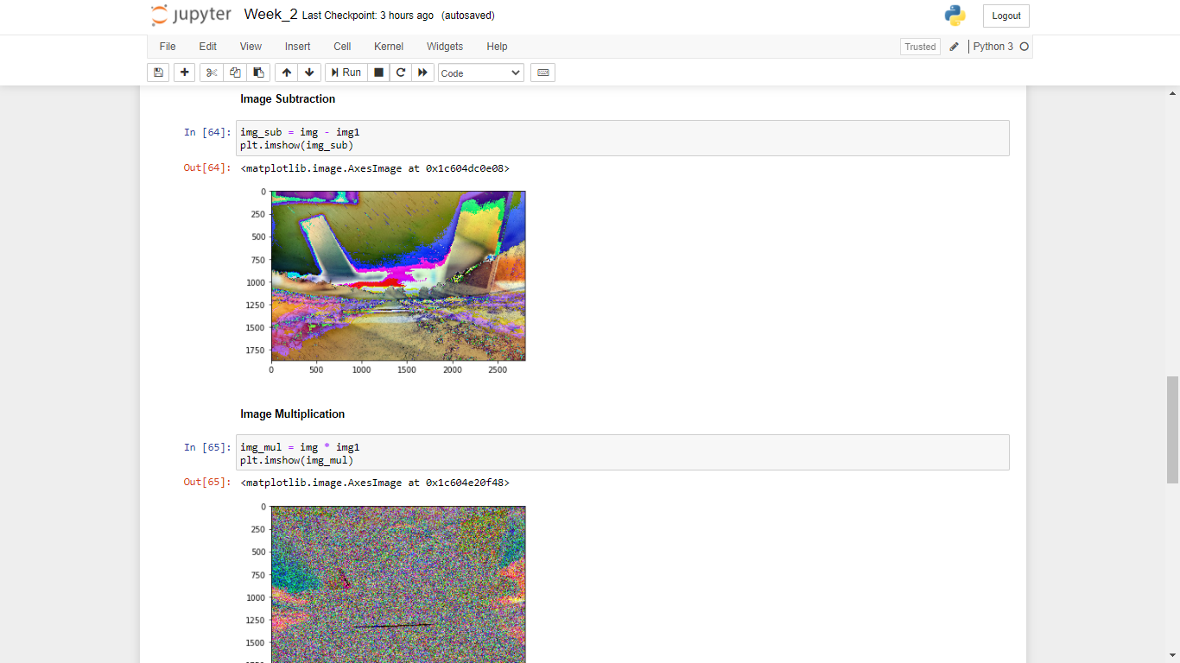

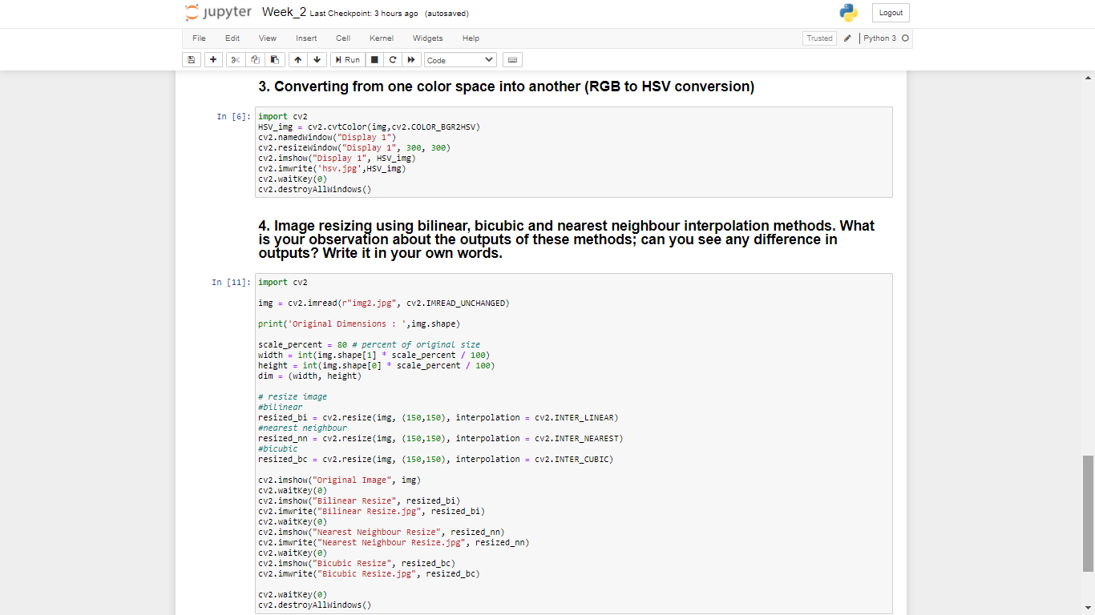

**(NOTE: .hsv images and resized images are saved separately. Attactched in the zip folder)**

**EXPLANATION -** On applying the three different interpolation techniques I observed the following changes –

1. Compared to the original image the image with interpolation using **nearest neighbour** the image around the centre looked to be more distorted that is it appeared to me as if the pixels were overstretching.
2. Compared to the original image the image with interpolation using **bicubic** appeared to be a bit less dark. Also the iage around the size was blurred a bit (this could also happen due to increasing the size of image) according to me.
3. Compared to the original image the image with interpolation using **bilinear** appeared to me the Best compared to all other techniques. I could possibly notices almost none distinguishing features between the interpolated and the original image.

**OUTPUTS**

1. **RGB to Gray-scale conversion of images**
2. Read any RGB image as input and convert it into grayscale image using direct function/library in Python. Show input and output together using subplot function

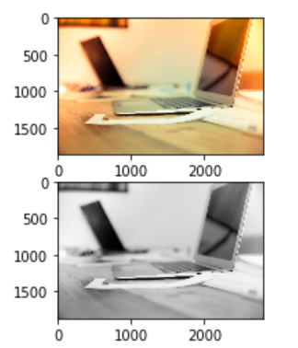

1. RGB to grayscale Image conversion using numpy and matplotlib only. No other special Python library can be used. Explain the steps in your own words



1. **Take two images and perform Image subtraction, addition, and multiplication of those images using arrays.**

Image Addition:

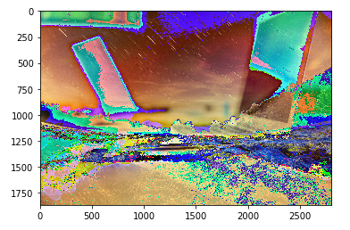

Image Subtraction:

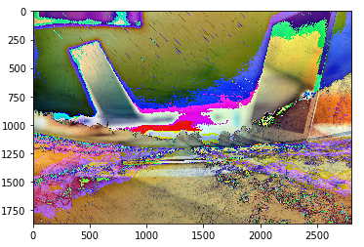

Image Multiplication:

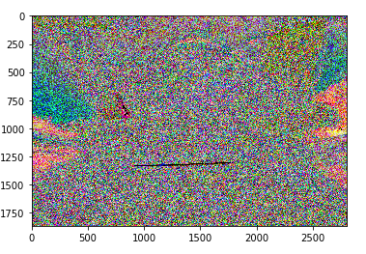

1. **Converting from one color space into another (RGB to HSV conversion)**

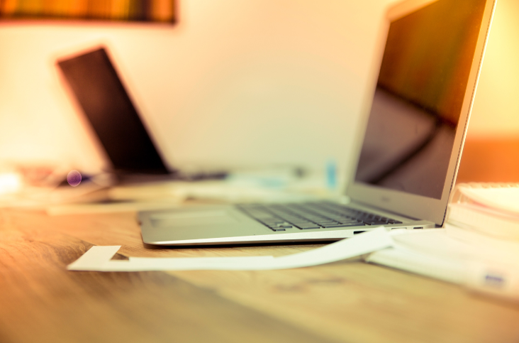

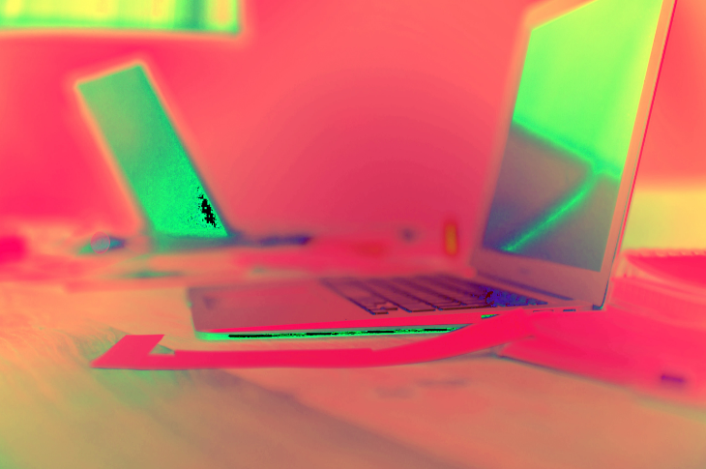

1. **Image resizing using bilinear, bicubic and nearest neighbour interpolation methods. What is your observation about the outputs of these methods; can you see any difference in outputs? Write it in your own words.**

Original -

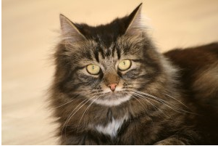

Nearest Neighbour Interpolation –

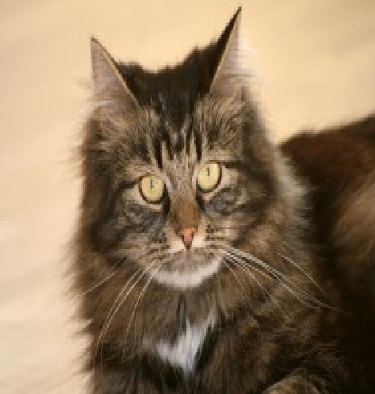

Bilinear Interpolation –

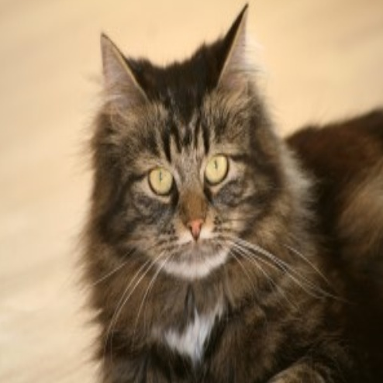

Bicubic Interpolation –

