**LAB ASSIGNMENT 3 (IMAGE MANIPULATIONS)**

**Code ( Input and Ouput ) :**

1. Converting image data structures:

Create a numpy array from the Image object. You can read an image using PIL and convert it to numpy array.

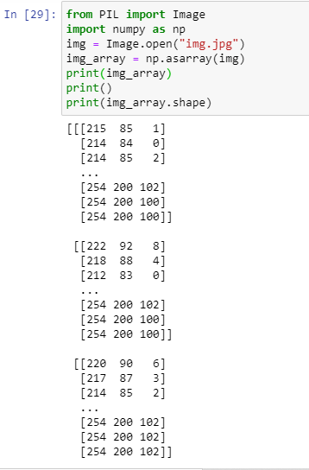

b) Reverse: Convert from numpy array into a PIL Image object.

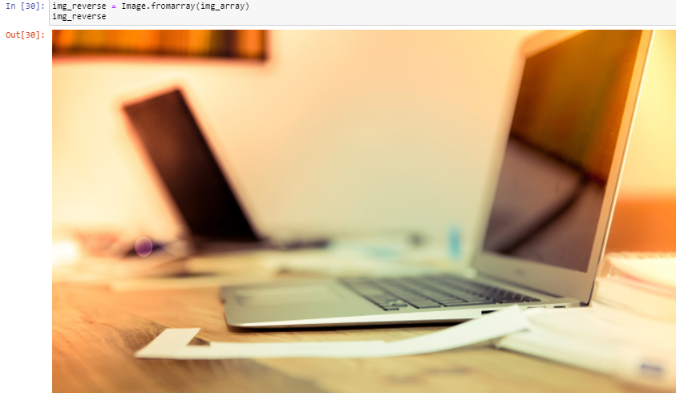

1. **Converting from one file format to another. Read an image in one file format and save it to another: for example, from PNG to JPG.**

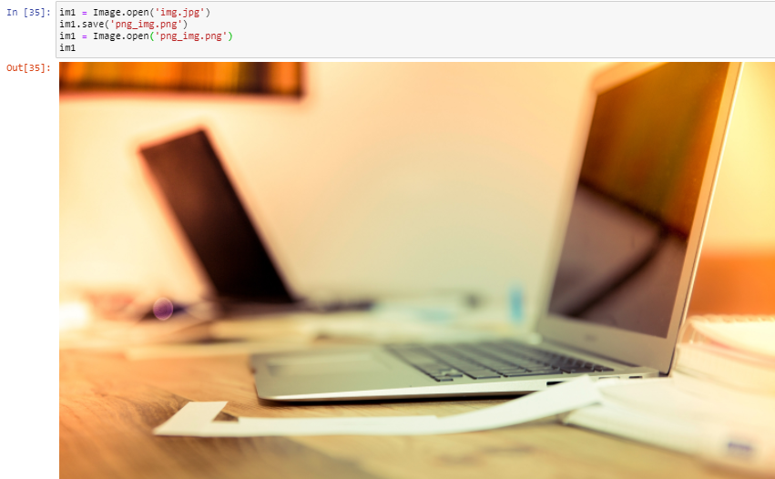

1. **Cropping an Image: Take any RGB image as input and crop that image. Show input and output both together**
2. Using direct function in Python

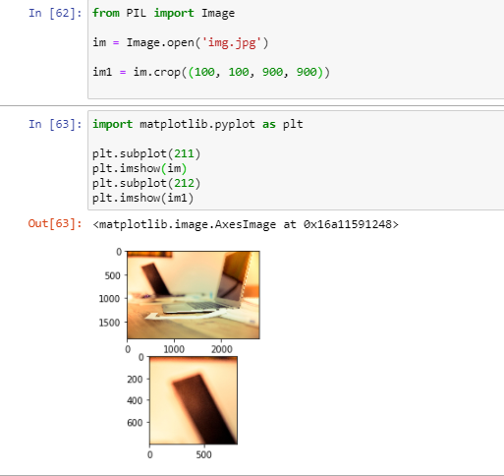

1. Write your program using arrays and matrices. This is required to make you familiar with images and their dimensions

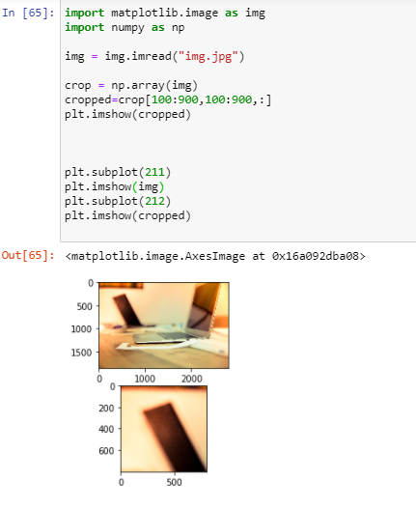

1. **Negative of an image: Write a program to obtain negative of an image. Do not use any direct function. Suppose the intensity values of your input image vary from 0-255. Negative of an image can be obtained using following formula, where y is the intensity value of a pixel in output image and x is the intensity value of same pixel in input image.**

**y = 255 – x**

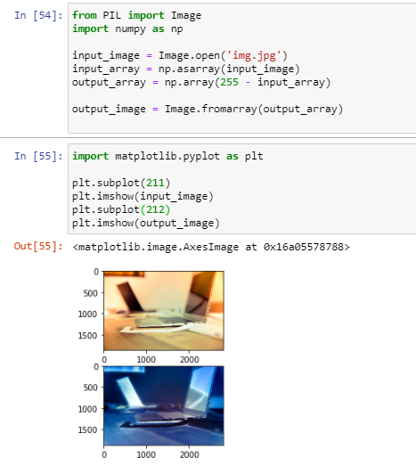

1. **Creating a circular mask on the input image. The example of output image is below. Hint: Slicing and masking with numpy arrays can be used to create a circular mask on the input image.**

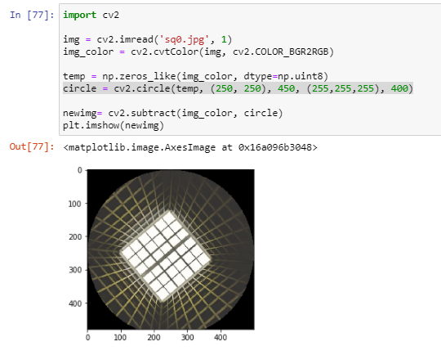

1. **Reading and displaying multiple images at once**

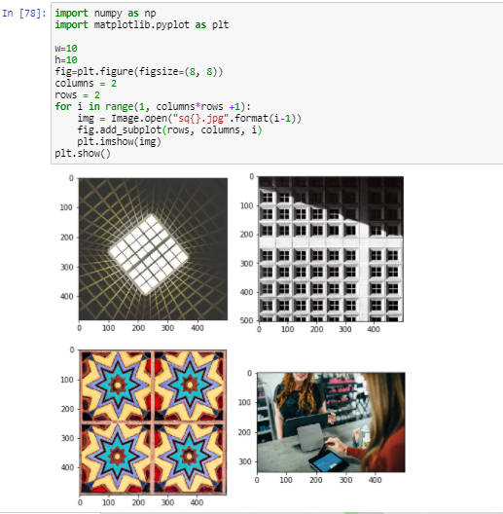

1. **Create a thumbnail from an image.**

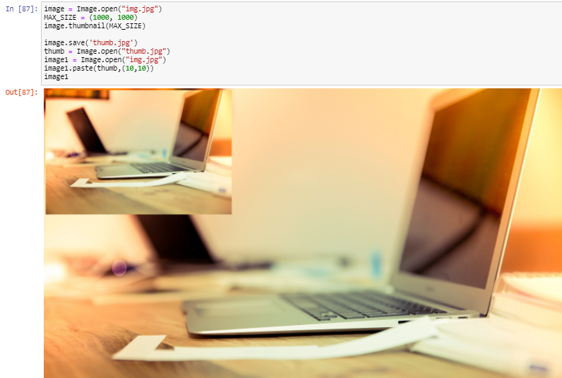

1. **Drawing on an image in Python:**

**a) You can draw lines or other geometric shapes on an image.**

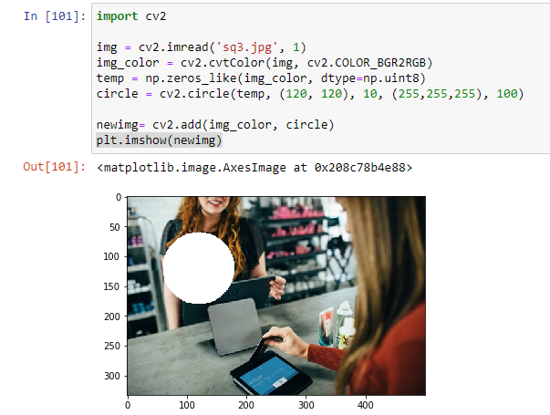

**b) Drawing text on an image. Write some text on input image. Use a function in Python to change its font as well**

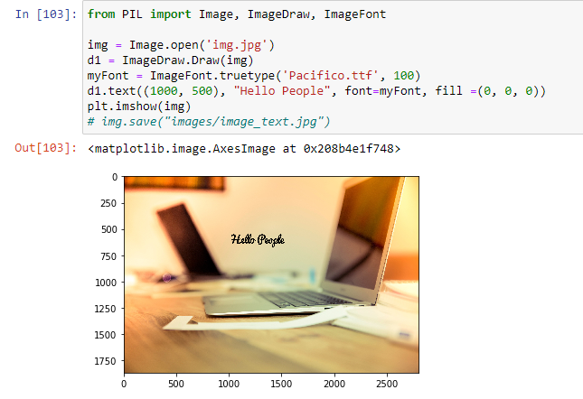

1. **R,G,B channels splitting and merging. Read any RGB image as input, split three channels R, G, B and display these channels/matrices as output images. Then, merge the three channels again and display same RGB image.**

