**LAB ASSIGNMENT 2**

* **Task 6 (Lab 1):**

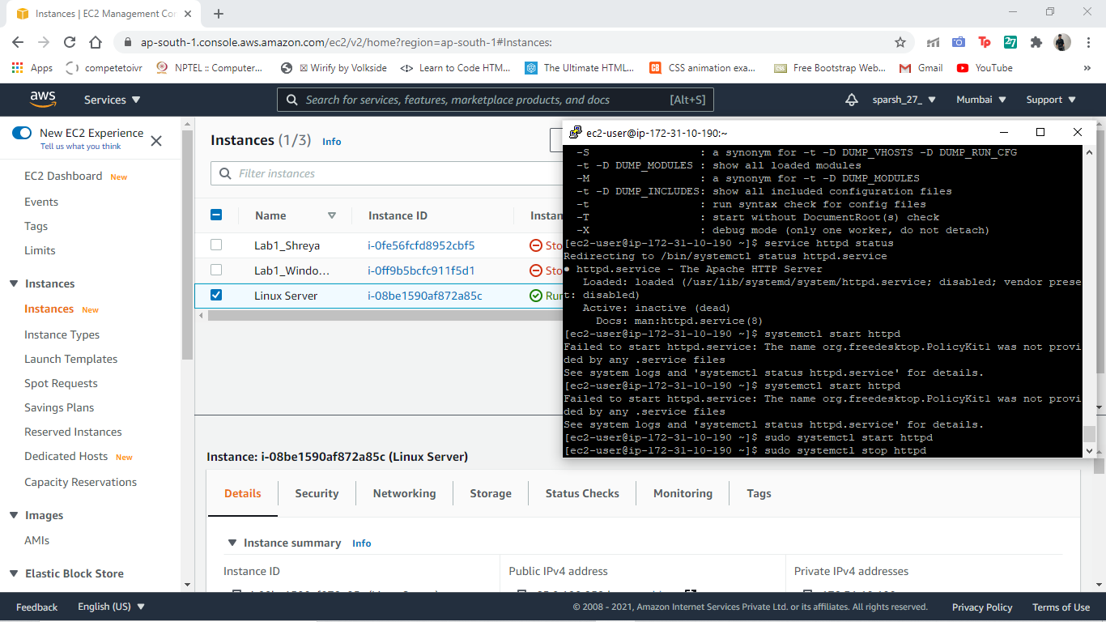

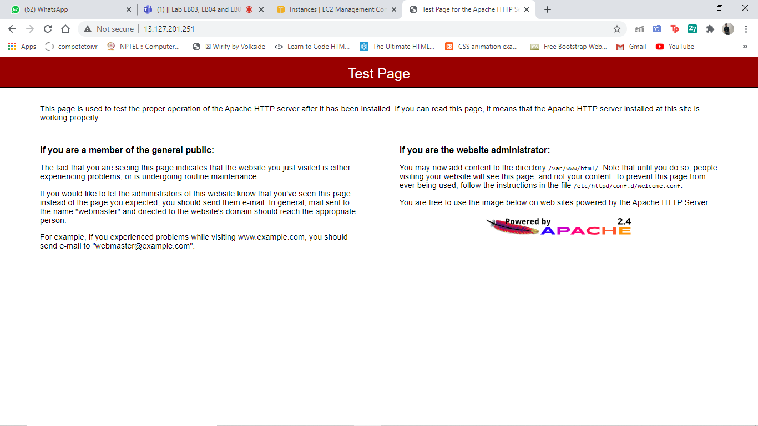

**COMMAND LINE INTERFACE**

* **Task 4 (Lab 1):**

*In command line –*

* aws configure

CREATING INSTANCE -

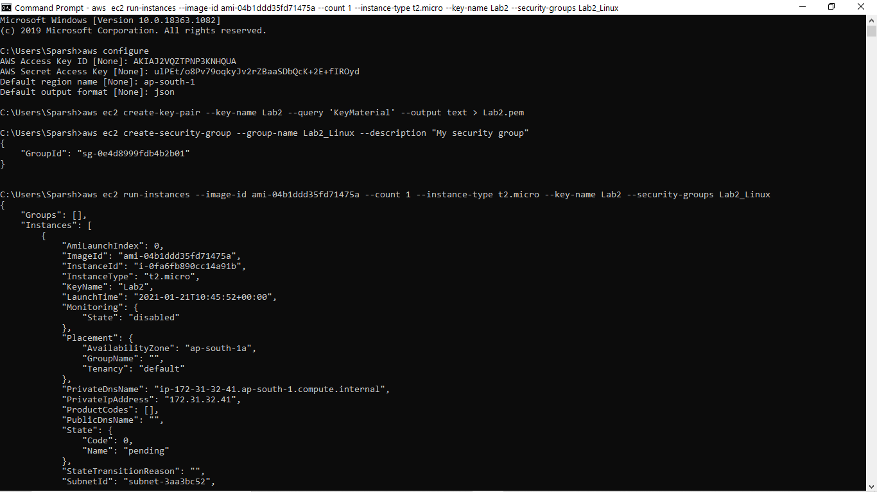

STOPPING INSTANCE -

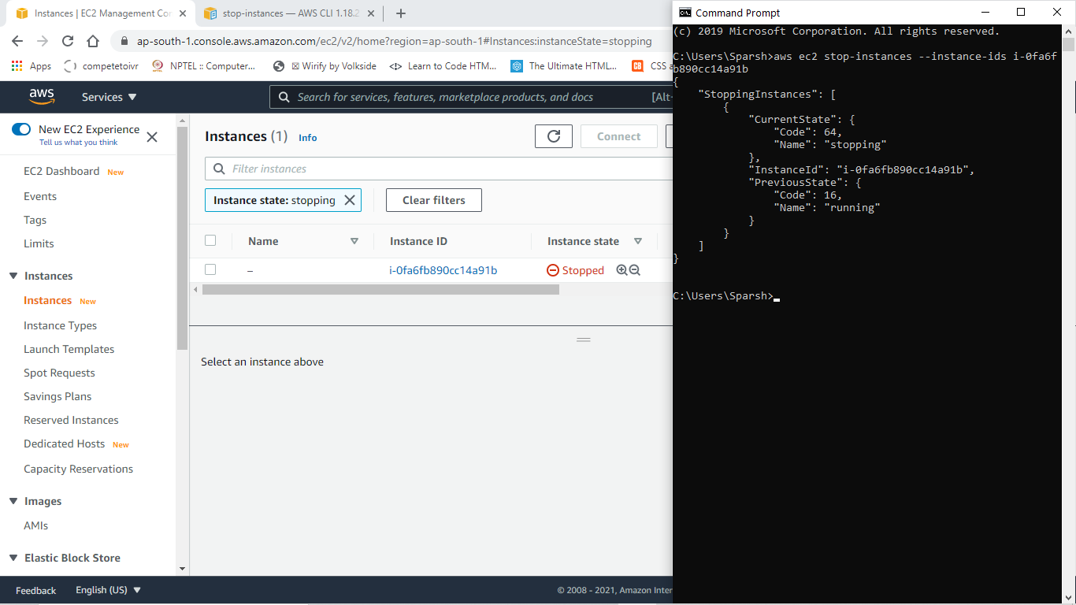

STARTING INSTANCE –

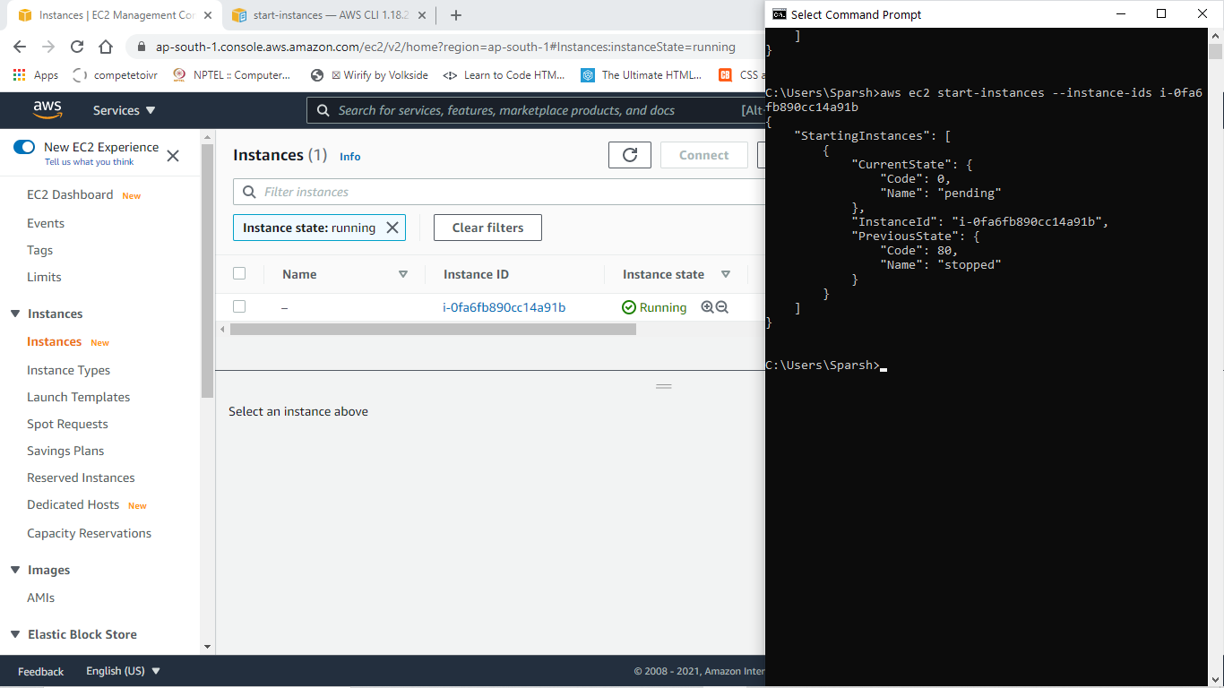

* **Working with Elastic Block Storage**

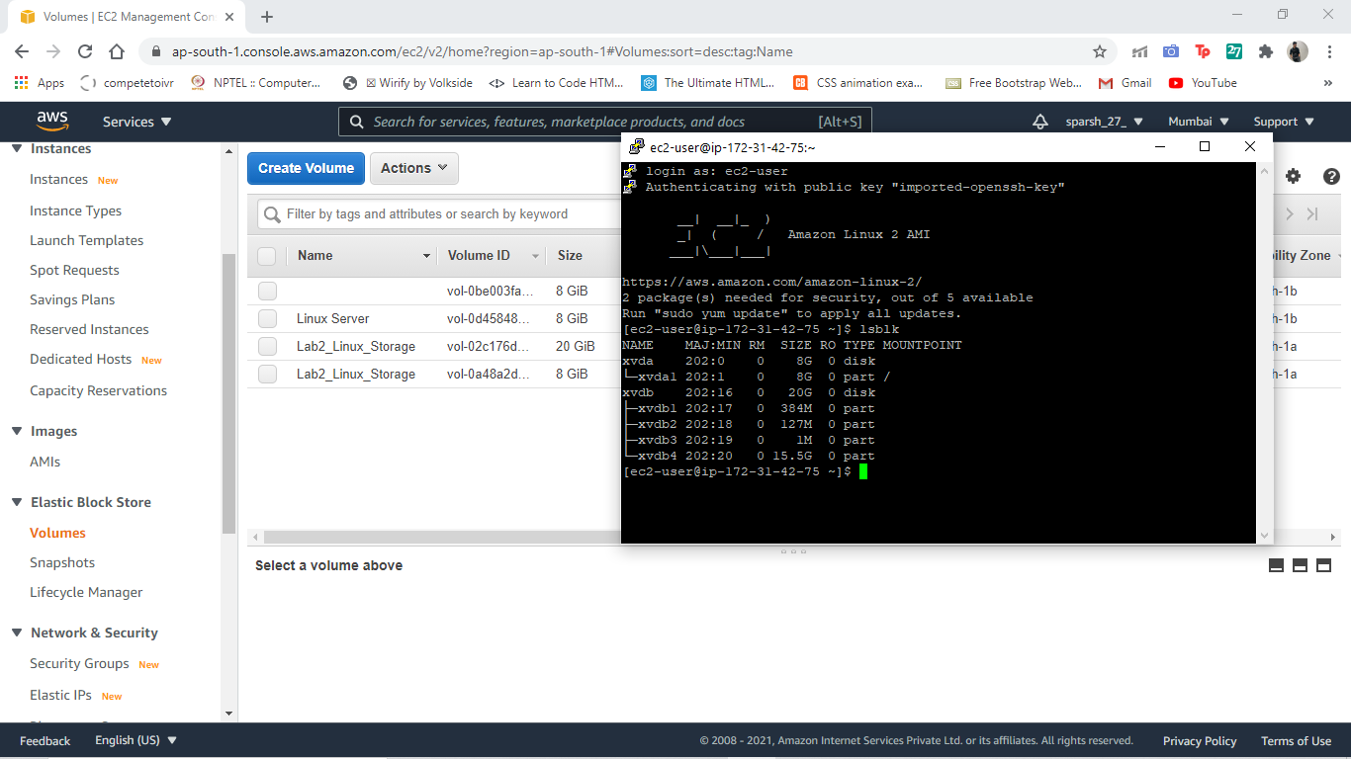

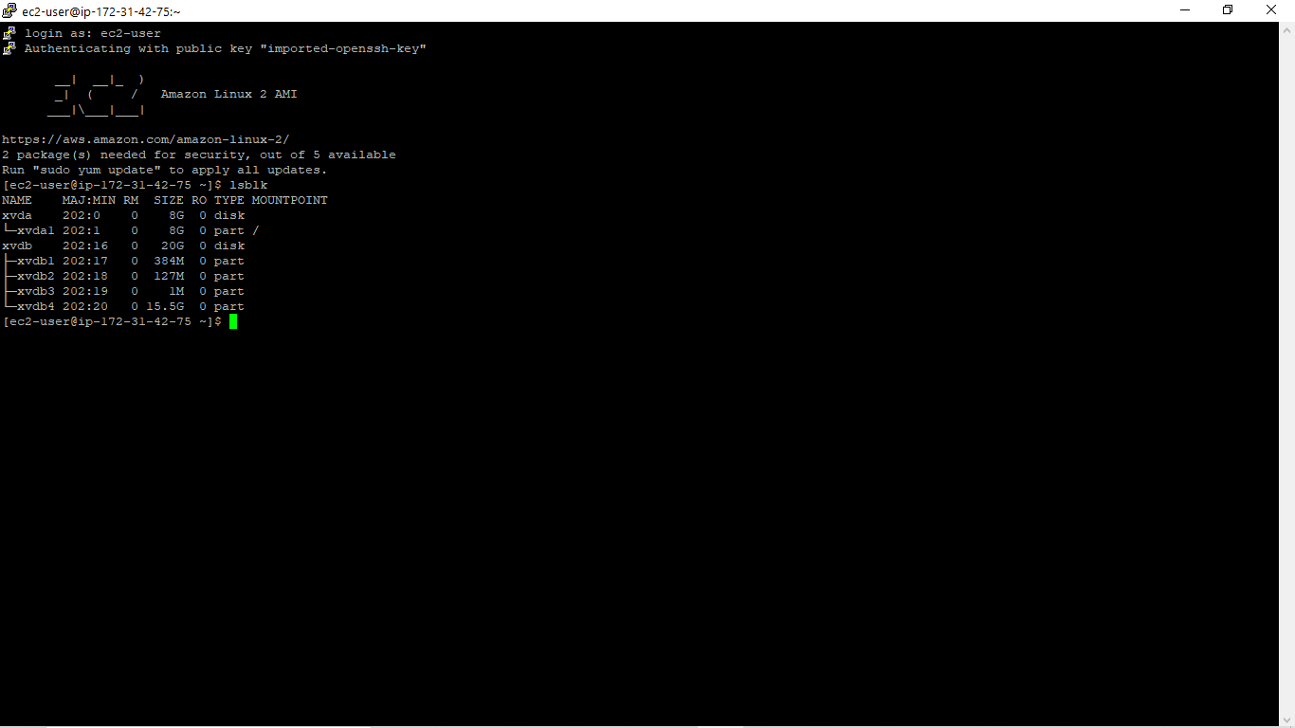

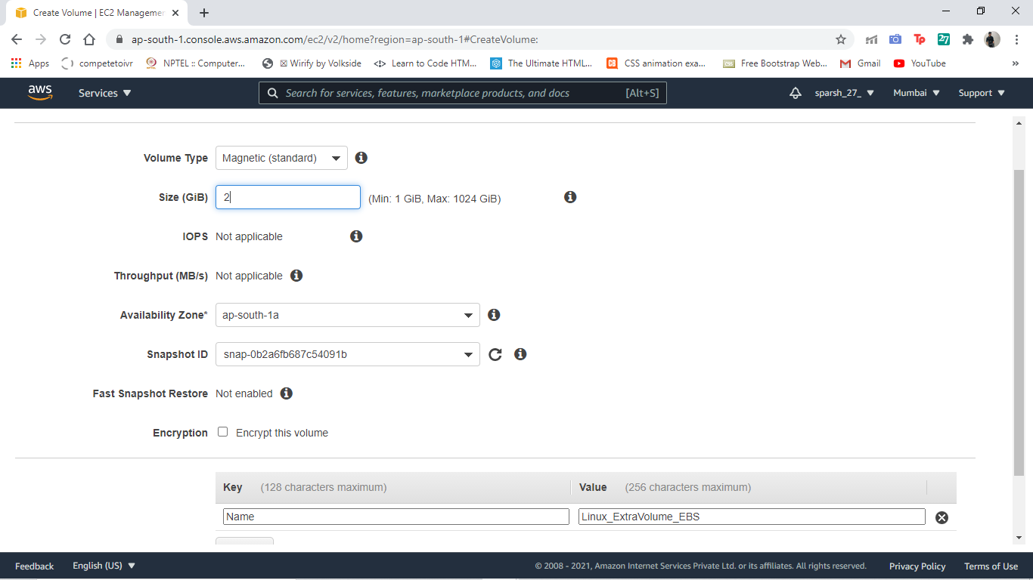

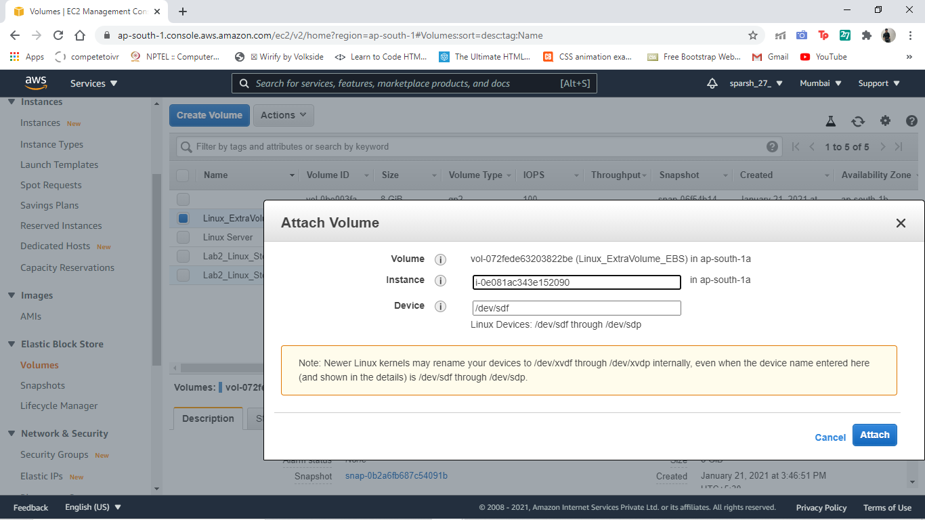

***EXTRA VOLUME ATTACHED(20 + 8 + 8 = 36GB) -***

