ANA 515 Assignment Week 5

Sparsh Kathuria

2022-06-26

The histogram below shows the count of people in different age groups.

## Warning: Removed 18 rows containing non-finite values (stat_bin).

## Warning: Removed 100798 rows containing missing values (geom_vline).

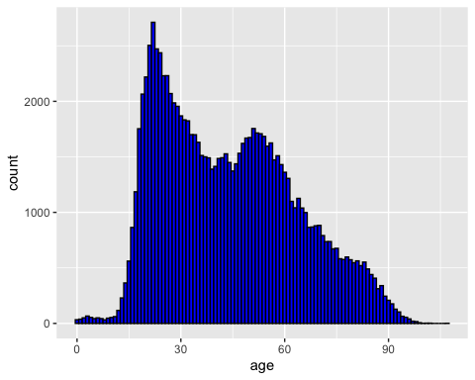

Below visualisation shows a density plot on the histogram:

## `stat_bin()` using `bins = 30`. Pick better value with `binwidth`.

## Warning: Removed 18 rows containing non-finite values (stat_bin).

## Warning: Removed 18 rows containing non-finite values (stat_density).

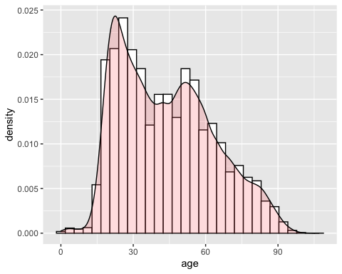 Below visaulization shows a barchart with respect to age and race:

## Warning: Removed 18 rows containing missing values (position_stack).

