1. Add 0.5 percent to the commission rate of agents who have sold more than $20,000 in engagements.

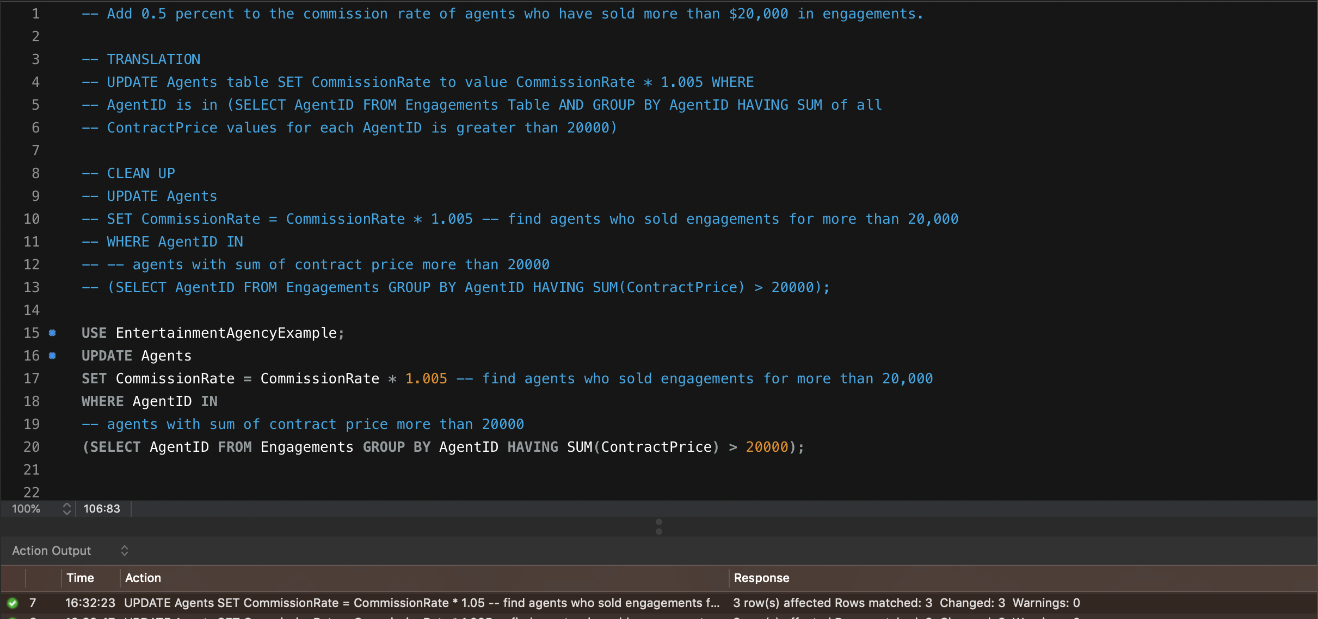

1. For all staff in ZIP Codes 98270 and 98271, change the area code to 360.

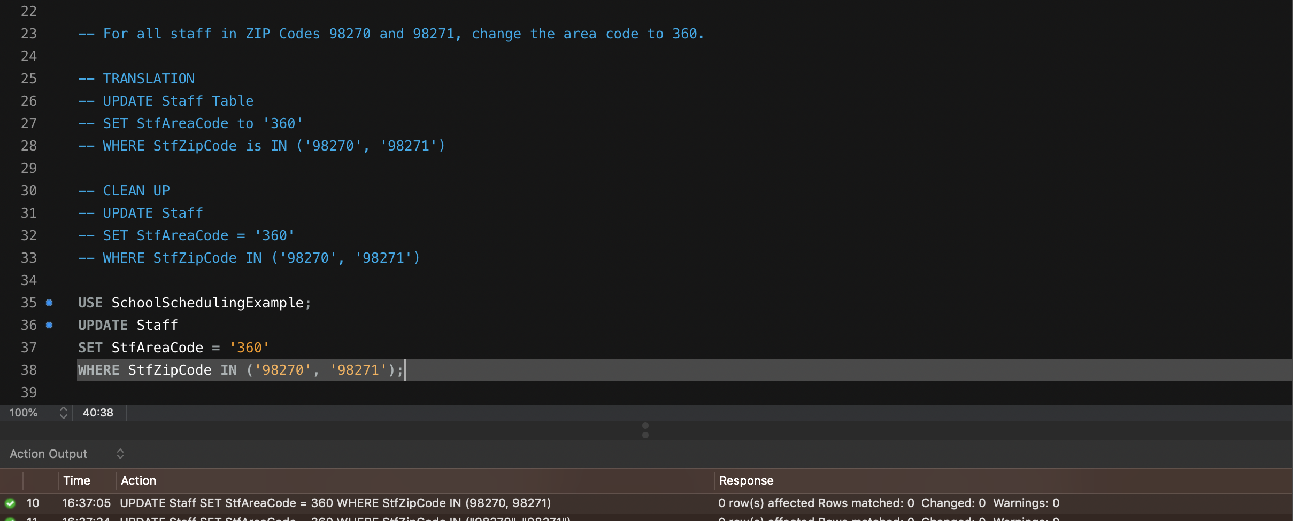

1. “Staff member Tim Smith wants to enroll as a student. Create a new student record from Tim’s staff record.”

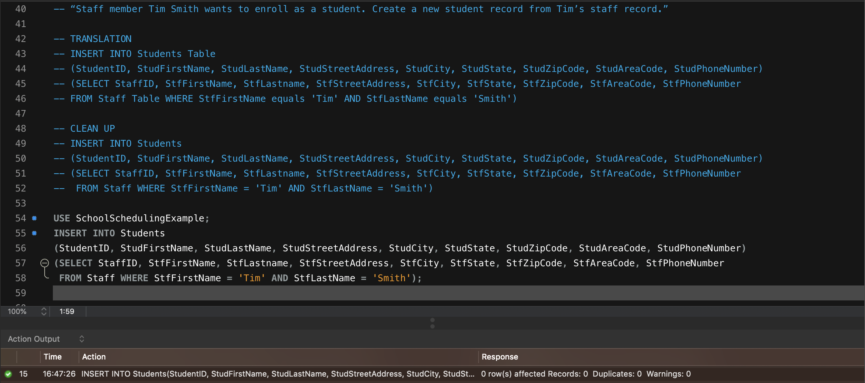

1. “Delete products that have never been ordered

