Copy the image , Make it a meme.Upload it on Facebook page of Sparsh 2k18 through message only.

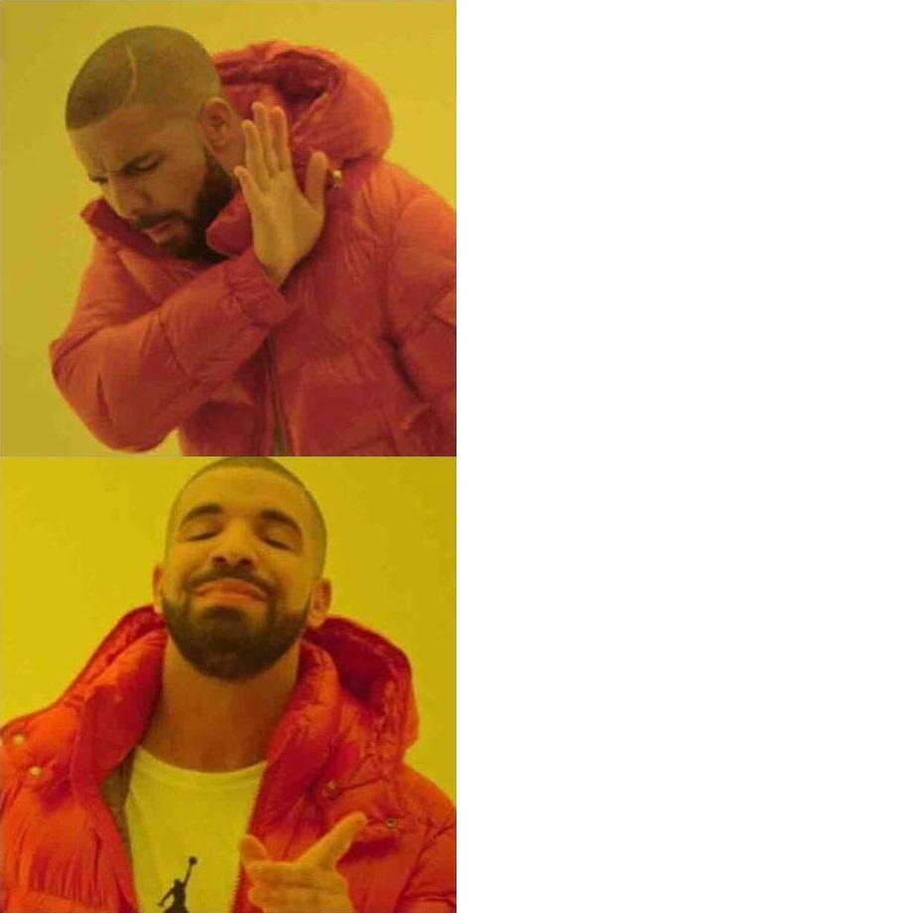

Copy the image , Make it a meme.Upload it on Facebook page of Sparsh 2k18 through message only.

