MACHINE LEARNING

GITHUB LINK: [https://github.com/sparsha21/sparsha21](https://github.com/sparsha21/sparsha21%20)

RECORDING VIDEO LINK: <https://drive.google.com/file/d/1P77BHnUQQSnUr365qcKREOtjBGNbVhgM/view?usp=sharing>

NAME:SPARSHA REDDY ADURI

700764939

Q1.Sorting the list , finding the min and max age ,Median, Mean and range of the ages.

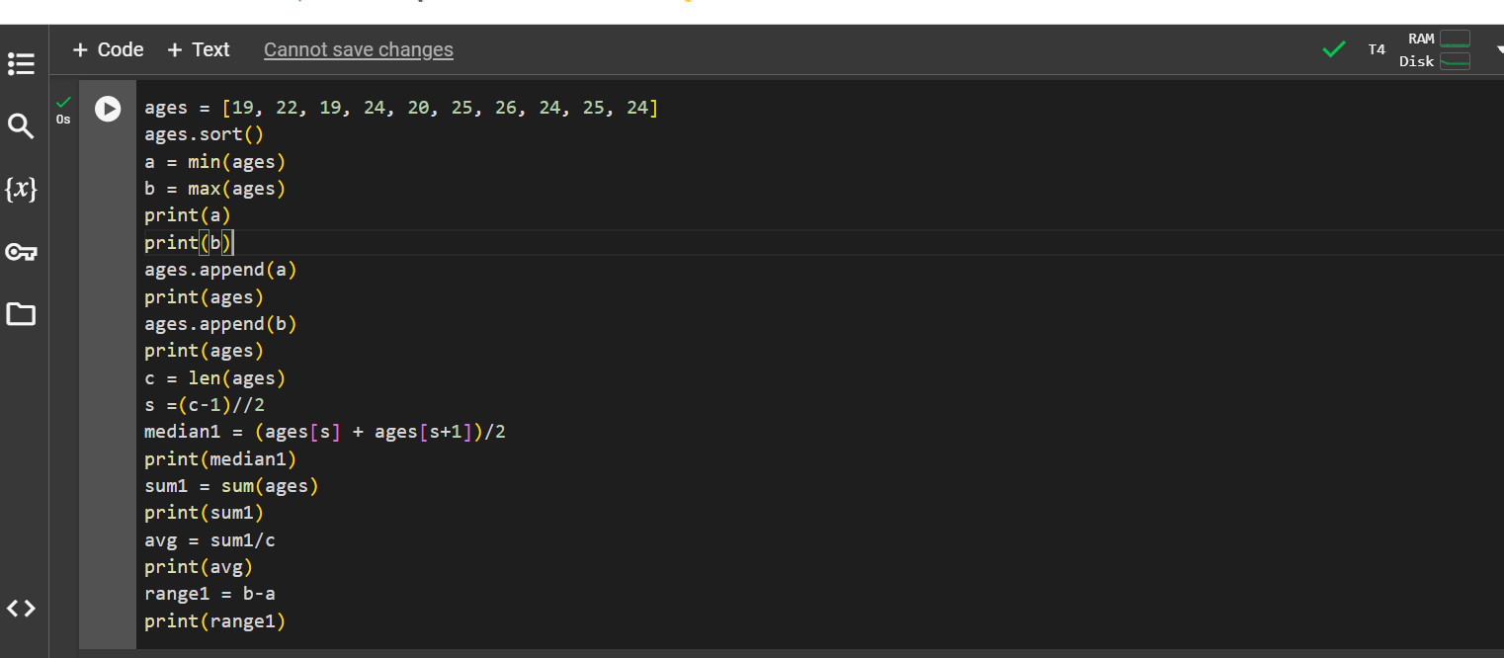

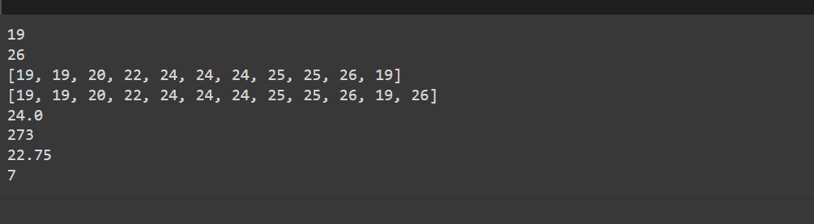

Q2.Create a dictionary as Dog and insert attributes then create student dictionary and add keys as given. Find length, values of skills and modify.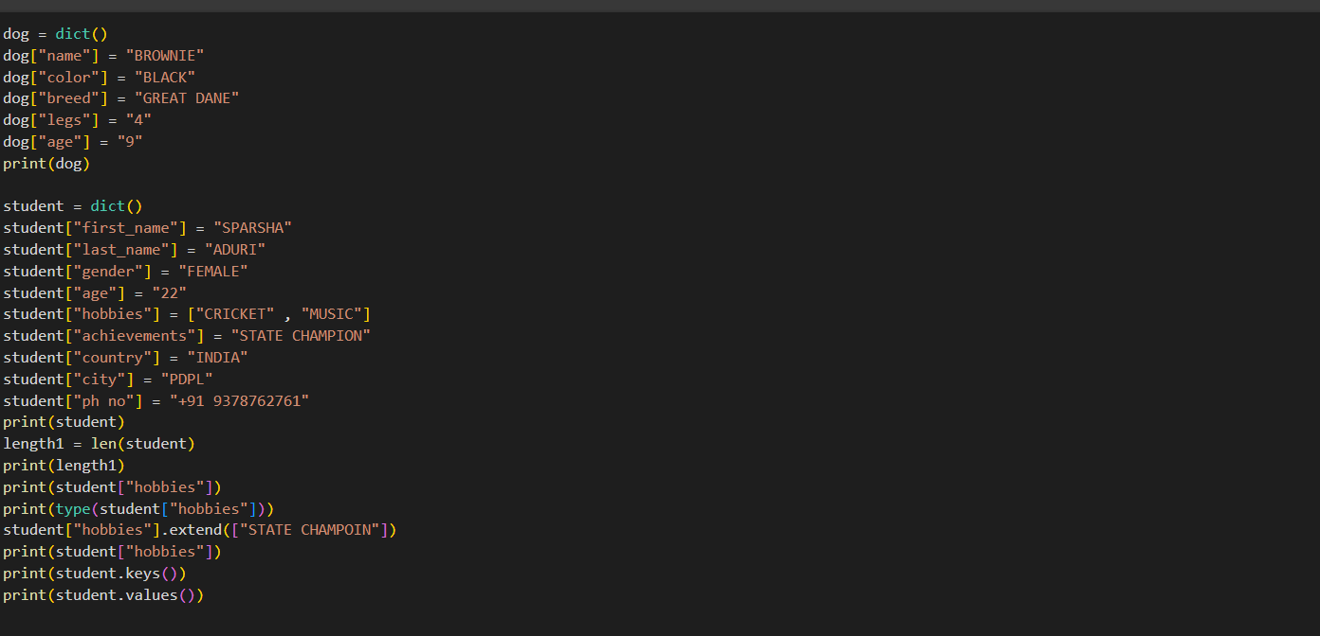

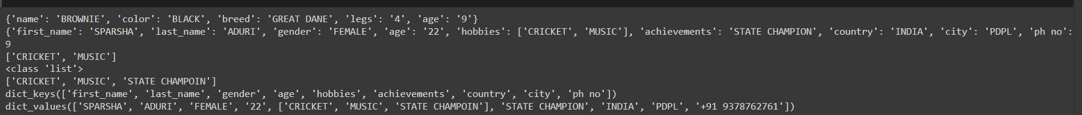

Q3.Create tuple as sisters and brothers. Add those tuples to siblings and then modify.

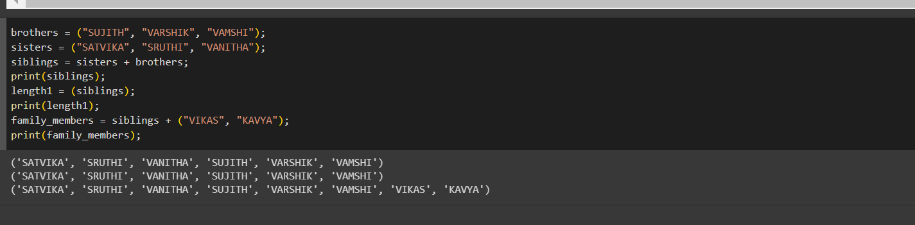

Q4.Find the length, Perform Join, intersection, disjoint, subset and then delete the sets.

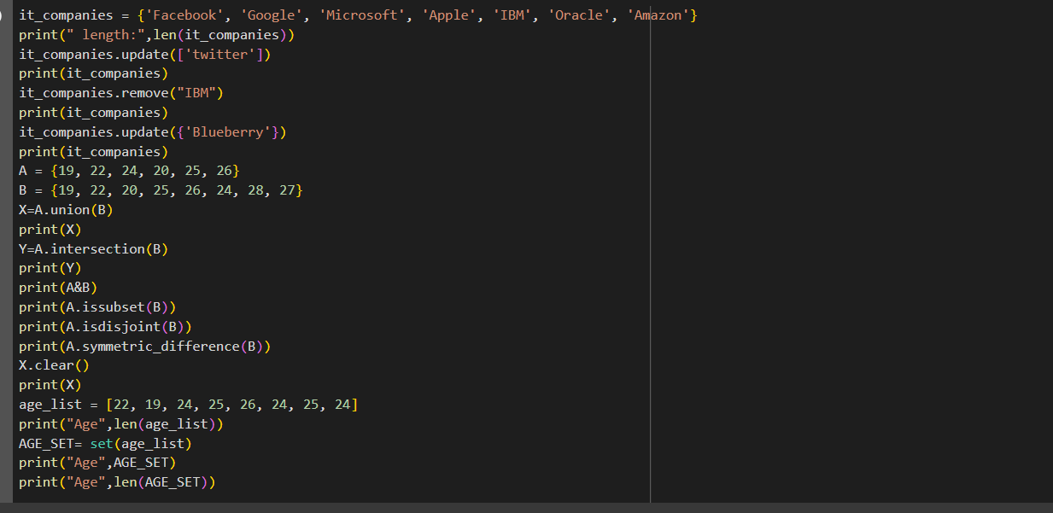

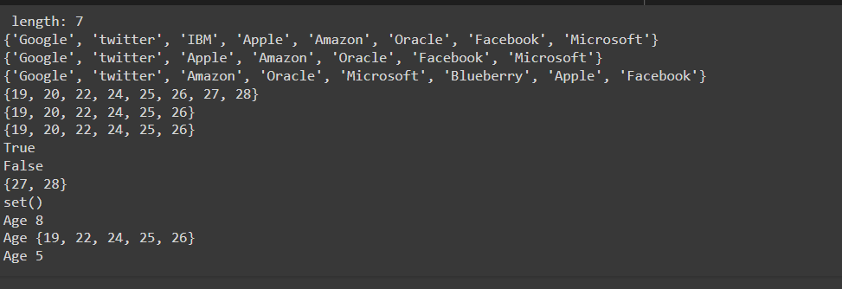

Q5.Calculate area of circle, circumference of circle.

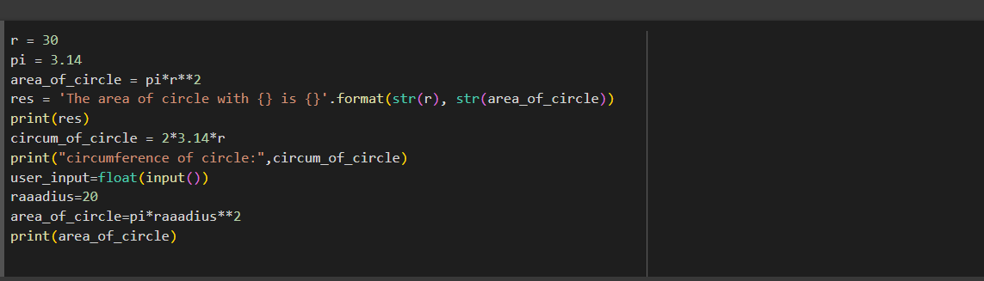

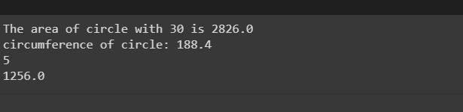

Q6. Count unique words of the sentence.

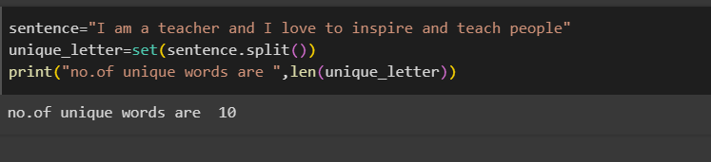

Q7. Use tab escape

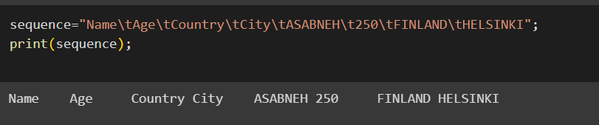

Q8.Find area of circle of r=10

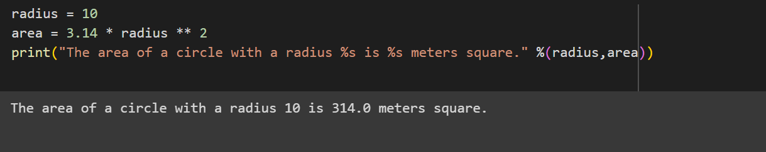

Q9.Read the weights of N students in lbs and convert these weights of students into kilograms.

