MACHINE LEARNING

GITHUB LINK: [https://github.com/sparsha21/sparsha21](https://github.com/sparsha21/sparsha21%20)

RECORDING VIDEO LINK: <https://drive.google.com/file/d/1WbbKd7O1WUK5AKvPu7ZemfrImaACQR94/view?usp=sharing>

NAME:SPARSHA REDDY ADURI

700764939

Q1.

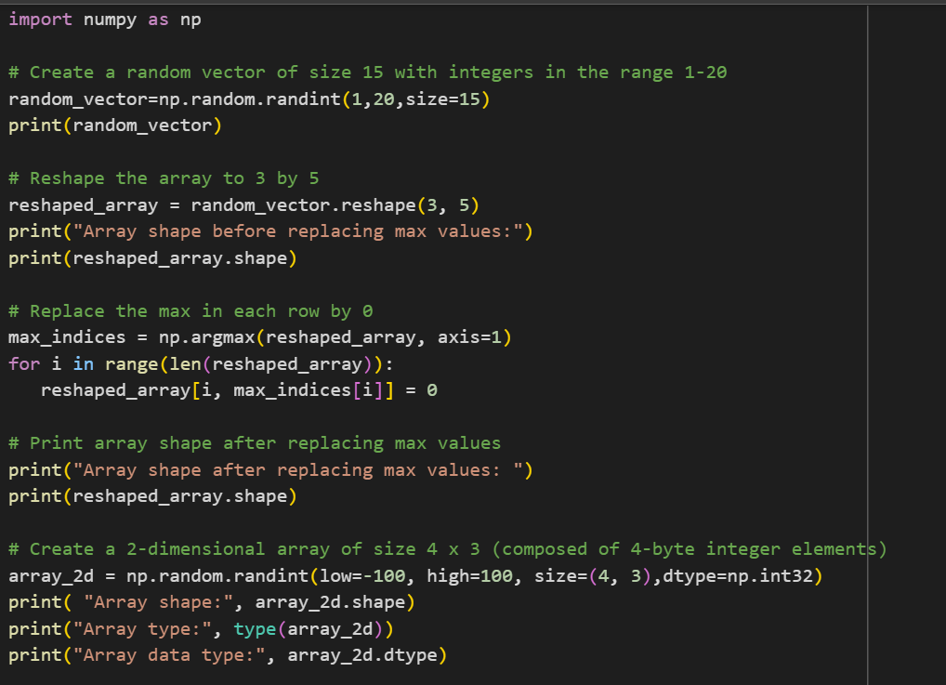

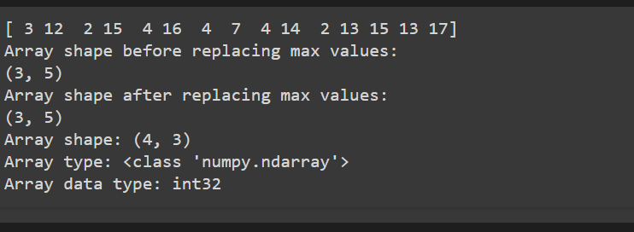

Q2.

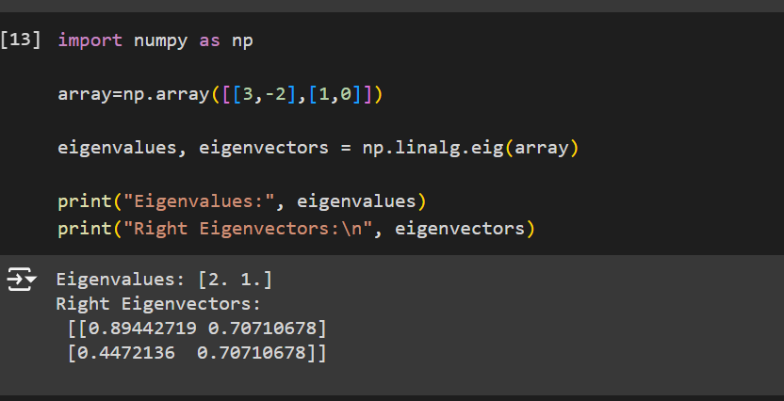

Q3.

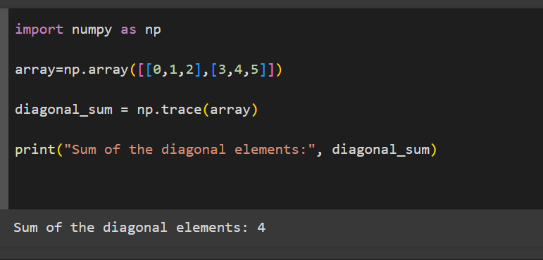

Q4.

