ENGR3426 MAD-VLSI: Miniproject 1

Sparsh Gupta

# Xschem

NAND

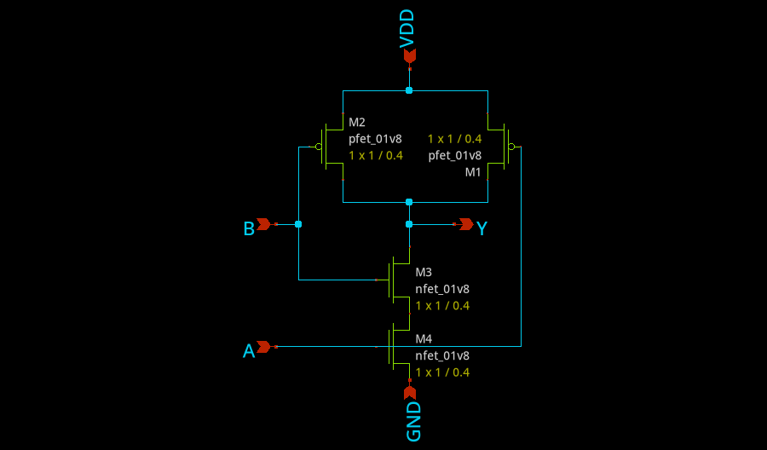

Inverter

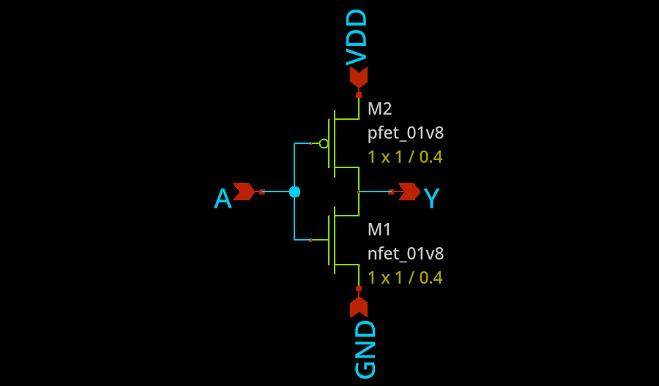

AND gate + Transient Simulation

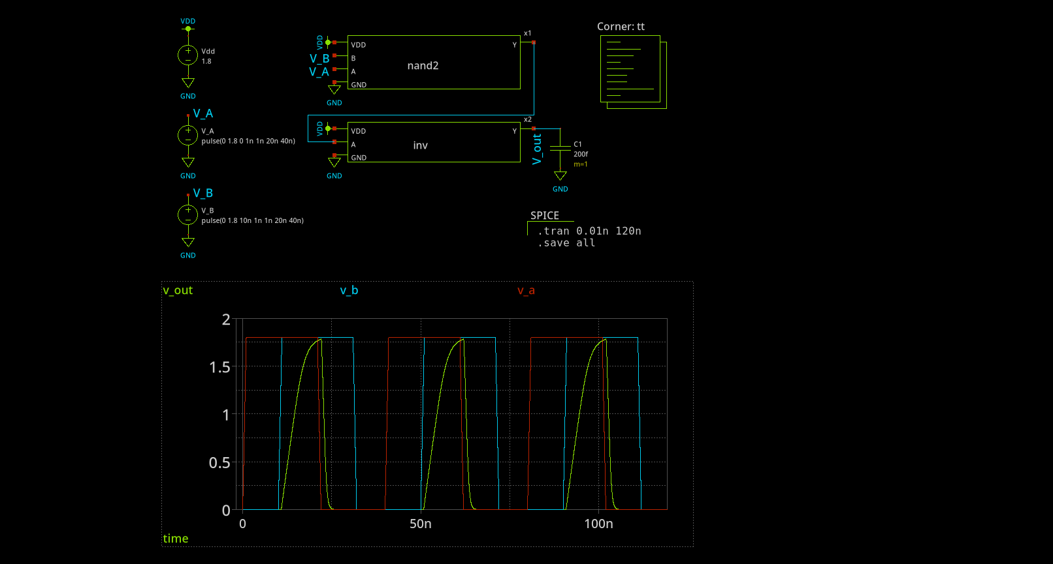

# Magic VLSI layout AND

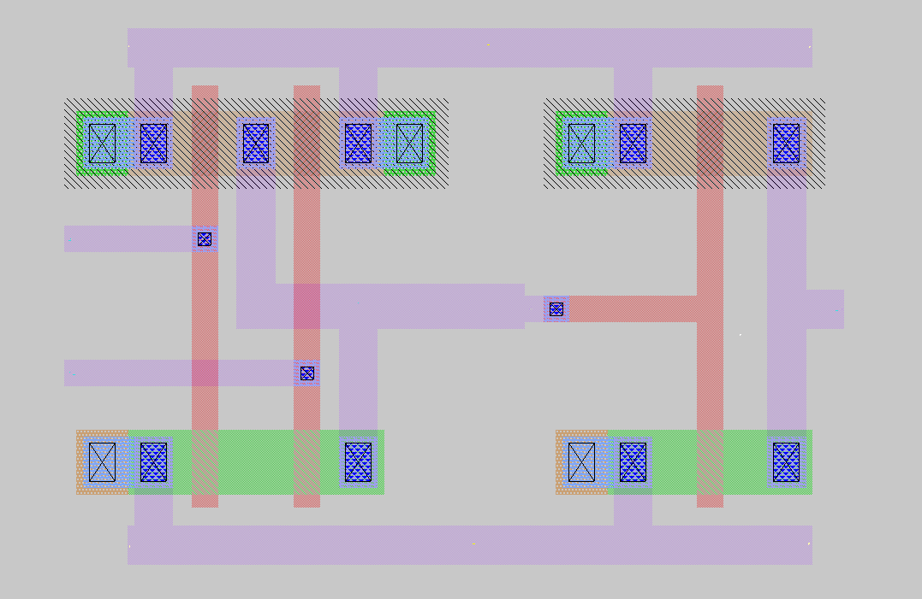

# LVS Output

Circuit 1 cell sky130_fd_pr__nfet_01v8 and Circuit 2 cell sky130_fd_pr__nfet_01v8 are black boxes. Warning: Equate pins: cell sky130_fd_pr__nfet_01v8 is a placeholder, treated as a black box. Warning: Equate pins: cell sky130_fd_pr__nfet_01v8 is a placeholder, treated as a black box.

Subcircuit pins:

|  |  |
| --- | --- |
| **Circuit 1: sky130_fd_pr__nfet_01v8** | **Circuit 2: sky130_fd_pr__nfet_01v8** |
| 1 | 1 |
| 2 | 2 |
| 3 | 3 |
| 4 | 4 |

Cell pin lists are equivalent. Device classes sky130_fd_pr__nfet_01v8 and sky130_fd_pr__nfet_01v8 are equivalent.

Circuit 1 cell sky130_fd_pr__pfet_01v8 and Circuit 2 cell sky130_fd_pr__pfet_01v8 are black boxes. Warning: Equate pins: cell sky130_fd_pr__pfet_01v8 is a placeholder, treated as a black box. Warning: Equate pins: cell sky130_fd_pr__pfet_01v8 is a placeholder, treated as a black box.

Subcircuit pins:

|  |  |
| --- | --- |
| **Circuit 1: sky130_fd_pr__pfet_01v8** | **Circuit 2: sky130_fd_pr__pfet_01v8** |
| 1 | 1 |
| 2 | 2 |
| 3 | 3 |
| 4 | 4 |

Cell pin lists are equivalent. Device classes sky130_fd_pr__pfet_01v8 and sky130_fd_pr__pfet_01v8 are equivalent.

Subcircuit summary:

|  |  |
| --- | --- |
| **Circuit 1: inv** | **Circuit 2: inv** |
| sky130_fd_pr__nfet_01v8 (1) | sky130_fd_pr__nfet_01v8 (1) |
| sky130_fd_pr__pfet_01v8 (1) | sky130_fd_pr__pfet_01v8 (1) |
| Number of devices: 2 | Number of devices: 2 |
| Number of nets: 4 | Number of nets: 4 |

Netlists match uniquely.

Subcircuit pins:

|  |  |
| --- | --- |
| **Circuit 1: inv** | **Circuit 2: inv** |
| Y | Y |
| A | A |
| GND | GND |
| VDD | VDD |

Cell pin lists are equivalent. Device classes inv and inv are equivalent.

Subcircuit summary:

|  |  |
| --- | --- |
| **Circuit 1: nand2** | **Circuit 2: nand2** |
| sky130_fd_pr__pfet_01v8 (2) | sky130_fd_pr__pfet_01v8 (2) |
| sky130_fd_pr__nfet_01v8 (2) | sky130_fd_pr__nfet_01v8 (2) |
| Number of devices: 4 | Number of devices: 4 |
| Number of nets: 6 | Number of nets: 6 |

Netlists match uniquely.

Subcircuit pins:

|  |  |
| --- | --- |
| **Circuit 1: nand2** | **Circuit 2: nand2** |
| GND | GND |
| Y | Y |
| B | B |
| A | A |
| VDD | VDD |

Cell pin lists are equivalent. Device classes nand2 and nand2 are equivalent.

Flattening instances of nand2 in cell ./xschem/simulation/and.spice (0) makes a better match Flattening instances of inv in cell ./xschem/simulation/and.spice (0) makes a better match Making another compare attempt.

Final result: Cells have no pins; pin matching not needed. Device classes ./xschem/simulation/and.spice and ./magic/and.spice are equivalent. Verify: cell ./magic/and.spice has no elements and/or nodes. Not checked.