LOGISTICS DATA EXPLORATION
AND VISUALIZATION
Week 3 Internship Report

Project detail | Description
Dataset | DataCo_Logistics_Cleaned.csv (provided dataset)
Analysis tools | Python, pandas, NumPy, Matplotlib, Seaborn
Dataset size | 180,519 rows × 45 columns
Main topics | Exploratory data analysis, delivery performance, time trends, commercial metrics, correlations
Visualizations | 10 generated figures

This report presents an exploratory analysis of the supplied logistics dataset. The results are computed from the actual CSV, not from invented or simulated figures. Record-level findings should be interpreted in the context of the dataset's granularity.

1. Objective
The purpose of this task is to explore logistics data using Python, summarize important operational and commercial measures, visualize distributions and relationships, and translate the results into practical observations. Exploratory data analysis (EDA) helps reveal patterns, unusual values, and possible bottlenecks before more formal modelling or business decisions are made. The work includes descriptive statistics, delivery-status counts, actual-versus-scheduled shipping-time comparisons, shipping-mode analysis, monthly record trends, category and regional counts, and correlations among selected numerical fields. Each chart is selected to answer a specific question and is paired with an interpretation.

2. Dataset overview and approach
The input contains 180,519 rows and 45 columns. The data includes order and shipping dates, delivery status, actual and scheduled shipping duration, shipping mode, sales, product quantity, benefit/profit-related measures, product categories, and regions. The file is an order/item-level dataset; therefore, record counts are described as records rather than unique shipments unless an explicit distinct shipment identifier is used. Dates were parsed for time-based aggregation. Numeric measures were summarized with mean, median, standard deviation, quartiles, range, and skewness. Correlation analysis was restricted to selected numeric business measures.
Initial data check | Observed result
Rows | 180,519
Columns | 45
Missing cells | 0
Exact duplicate rows | 0
Order date field | order date (DateOrders)
Shipping date field | shipping date (DateOrders)

3. Descriptive statistics and central tendencies
Mean and median describe typical values from different perspectives. The mean uses every observation and can be influenced by very large or very small values, while the median identifies the midpoint and is more resistant to extreme observations. Standard deviation describes spread, and quartiles show the middle half of a distribution. These measures are useful for understanding whether a metric is tightly grouped or varies substantially across records.
Metric | Mean | Median | Std. deviation | Minimum | Maximum
Actual shipping days | 3.50 | 3.00 | 1.62 | 0.00 | 6.00
Scheduled shipping days | 2.93 | 4.00 | 1.37 | 0.00 | 4.00
Sales per record (field: Sales) | 203.77 | 199.92 | See statistics CSV | See statistics CSV | See statistics CSV
Order item quantity | 2.13 | 1.00 | See statistics CSV | 1.00 | 5.00

Average actual shipping duration is 3.50 days, compared with a scheduled average of 2.93 days. The average gap is 0.57 days. This indicates that actual shipping duration is higher than scheduled duration on average in the records. The median values differ from the means, which is a reminder that an average alone does not describe the entire distribution.
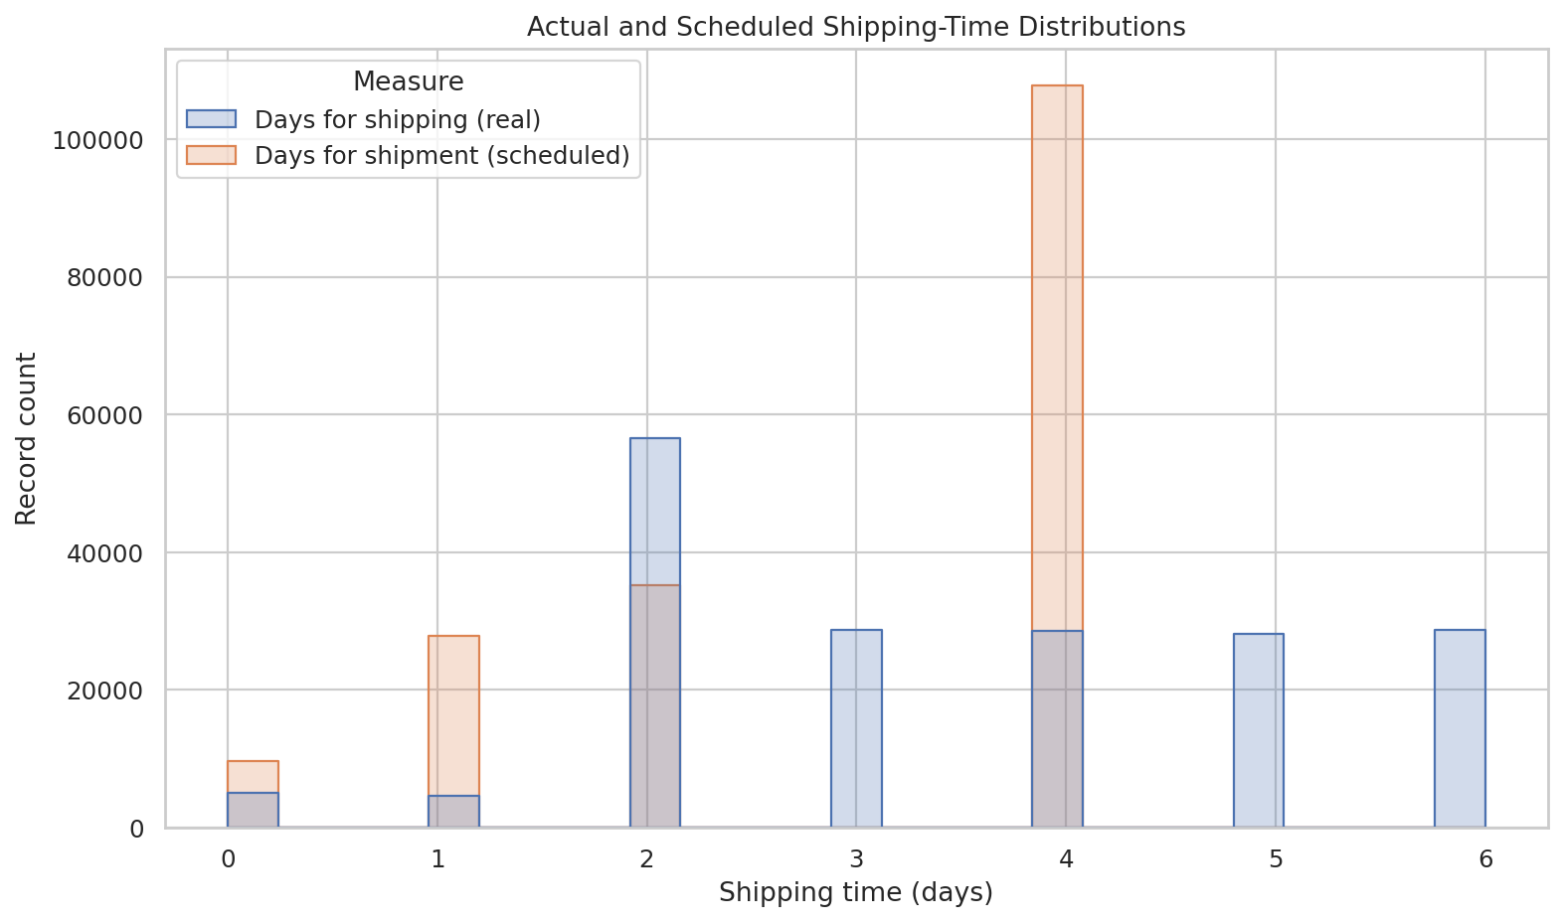
Figure 1. Distribution of actual and scheduled shipping durations. Source: Generated by the author using Python.
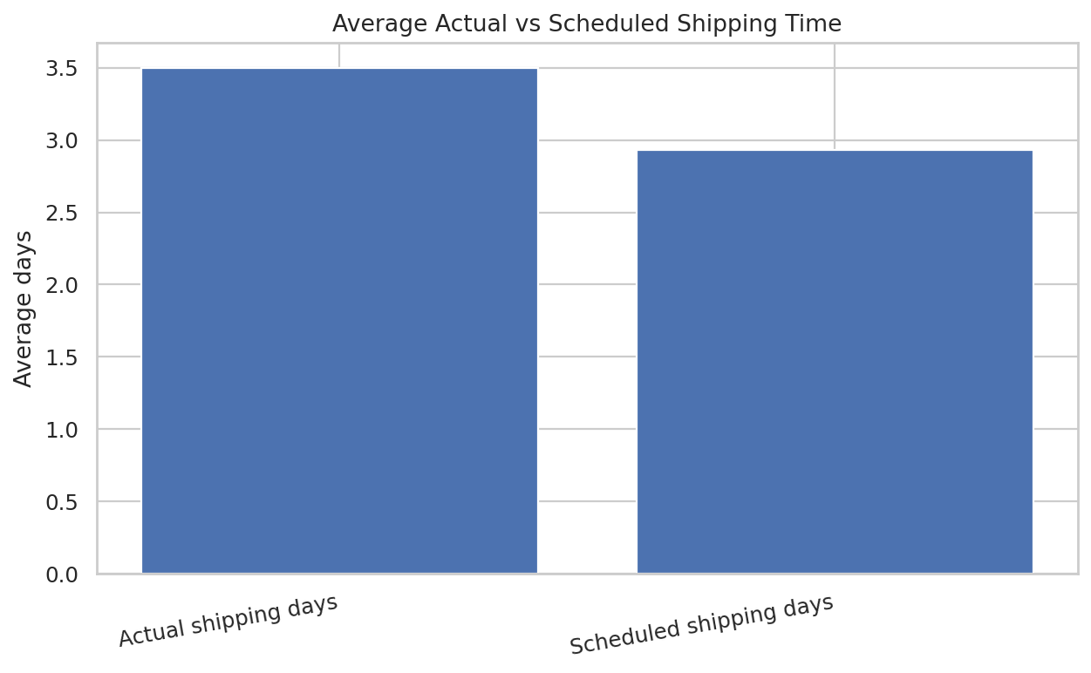
Figure 2. Mean actual versus scheduled shipping time. Source: Generated by the author using Python.

4. Delivery status analysis
Delivery status | Records | Share of all records
Late delivery | 98,977 | 54.83%
Advance shipping | 41,592 | 23.04%
Shipping on time | 32,196 | 17.84%
Shipping canceled | 7,754 | 4.30%

The largest delivery-status group is “Late delivery” with 98,977 records (54.83% of all records). This is an important operational signal because delays can affect customer satisfaction, service-level commitments, and downstream planning. The other statuses should be considered separately: advance shipping and on-time shipping reflect different service outcomes, while canceled shipments should not be treated as completed deliveries.
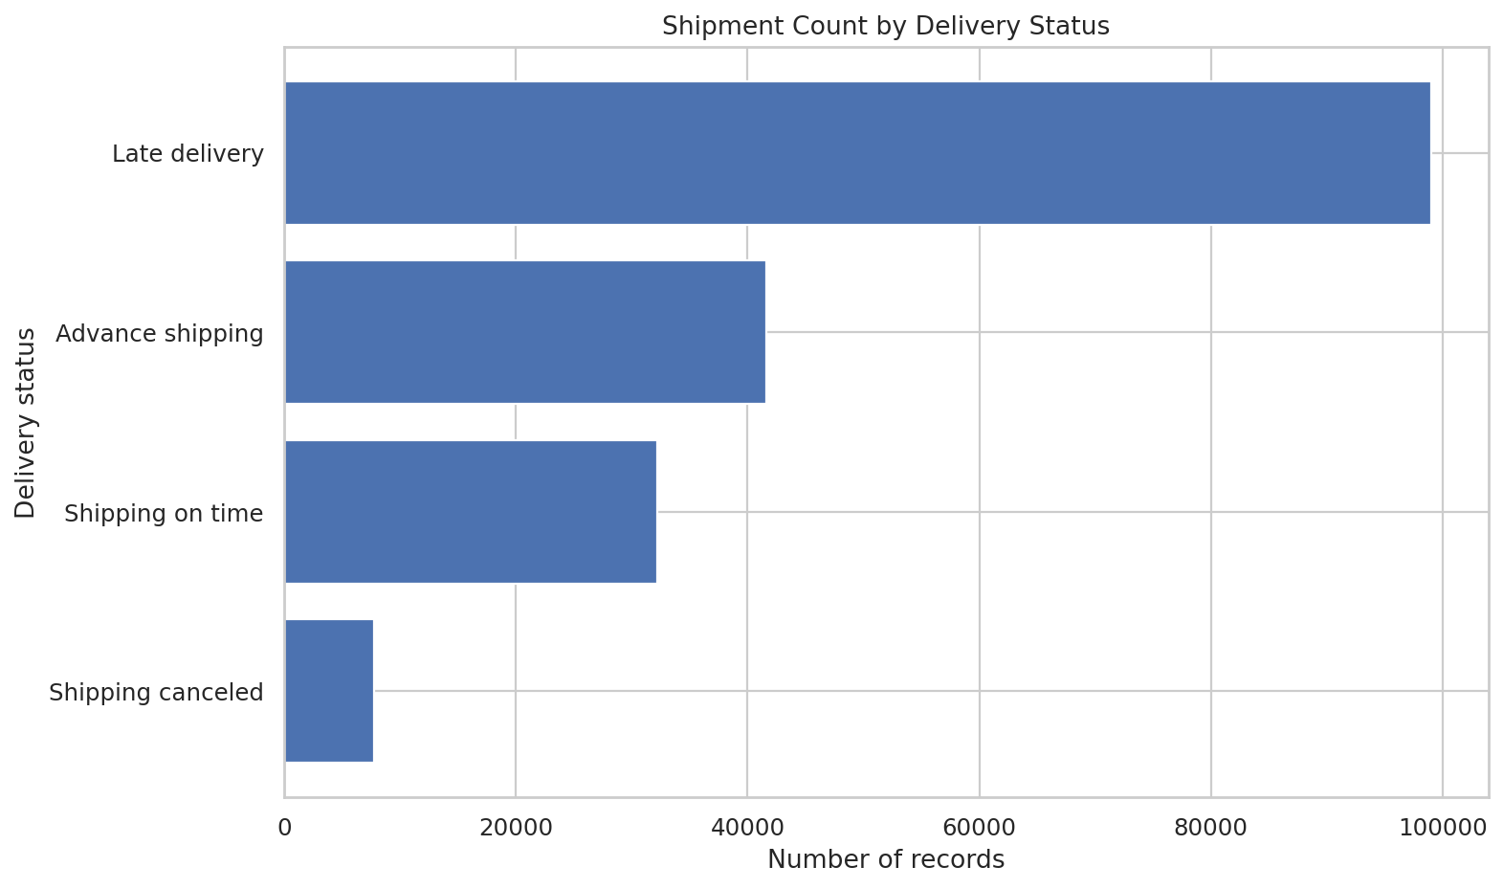
Figure 3. Record counts by delivery status. Source: Generated by the author using Python.

5. Shipping-mode performance
Shipping mode | Mean actual shipping days
Same Day | 0.48
First Class | 2.00
Second Class | 3.99
Standard Class | 4.00

Among the listed modes, Same Day has the lowest mean actual duration (0.48 days), while Standard Class has the highest (4.00 days). This pattern is consistent with shipping modes having different service promises. It should not be interpreted as proof that one carrier or mode is inefficient: the modes may serve different distances, service levels, and shipment types. A fair comparison should control for route, order characteristics, and the scheduled duration.
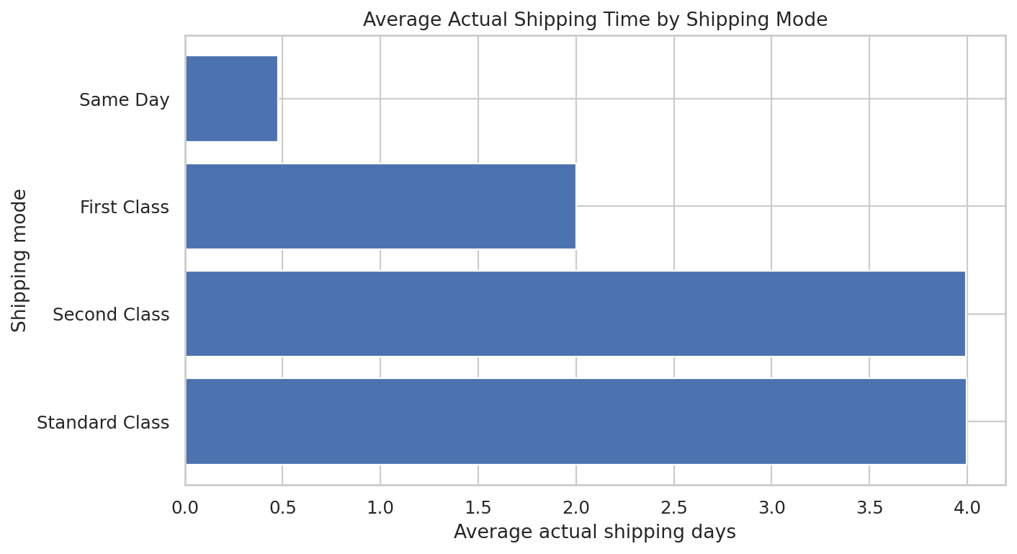
Figure 4. Mean actual shipping time by shipping mode. Source: Generated by the author using Python.
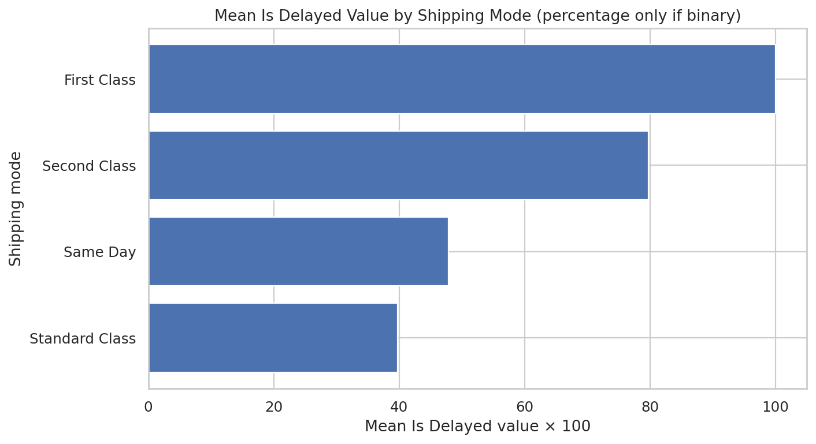
Figure 5. Average delay indicator by shipping mode. For a binary flag, the mean multiplied by 100 is the percentage of records flagged. Source: Generated by the author using Python.

6. Time trend analysis
The monthly trend chart aggregates order records by calendar month. The highest monthly count in the generated series is 5,398 records (2016-10-01). Monthly patterns can help teams anticipate workload and plan warehouse staffing, inventory, and carrier capacity. However, this dataset covers a limited historical window and record volume is not necessarily equivalent to the number of distinct parcels or deliveries.
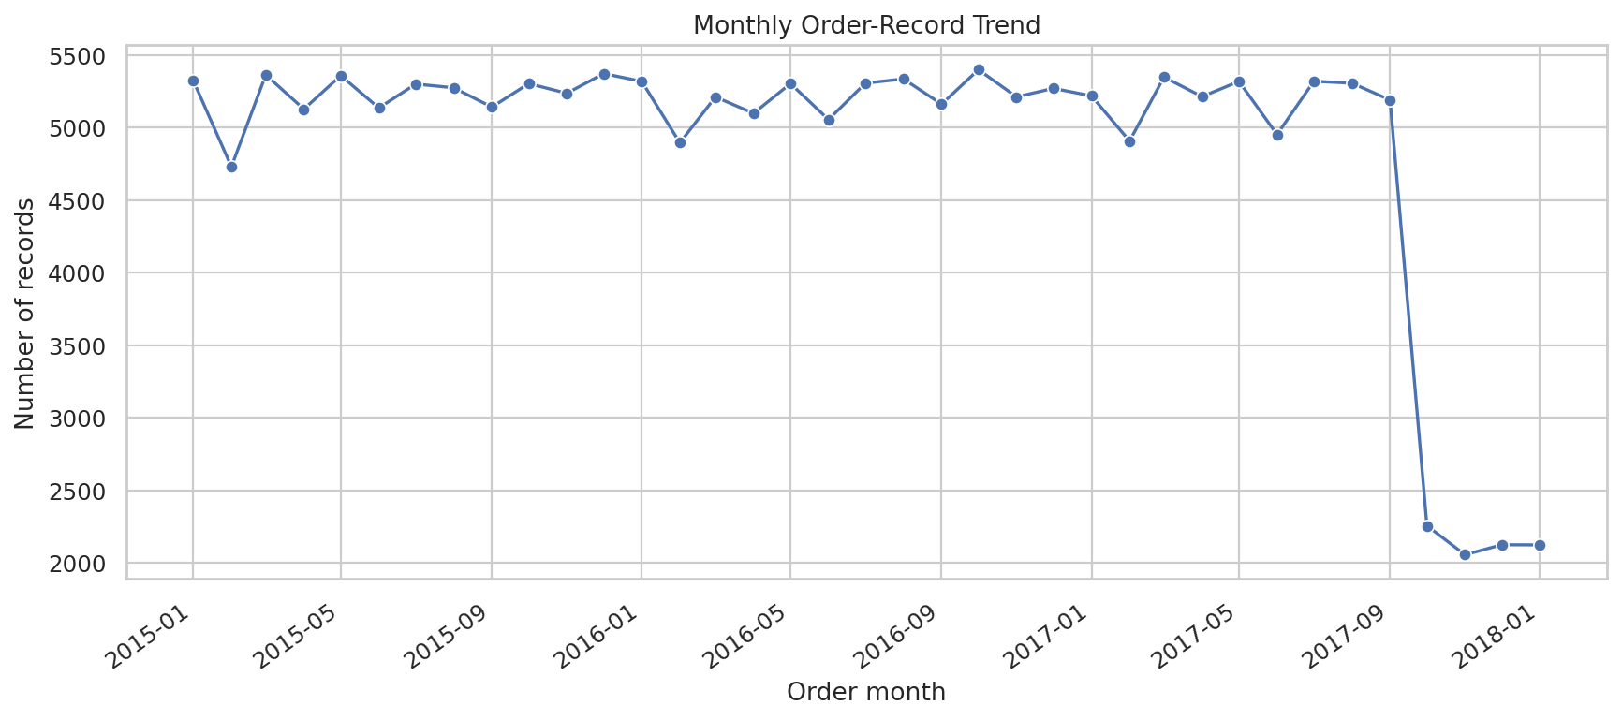
Figure 6. Monthly order-record trend. Source: Generated by the author using Python.

7. Correlation and relationships
A correlation coefficient summarizes the direction and strength of a linear relationship between two numeric variables. Positive values indicate that the variables tend to rise together, negative values indicate that one tends to decrease as the other increases, and values near zero indicate a weak linear relationship. Correlation is descriptive and does not establish causation. Business variables may also be linked through formulas, so relationships between sales, quantity, discount, and order totals should be interpreted with their definitions in mind.
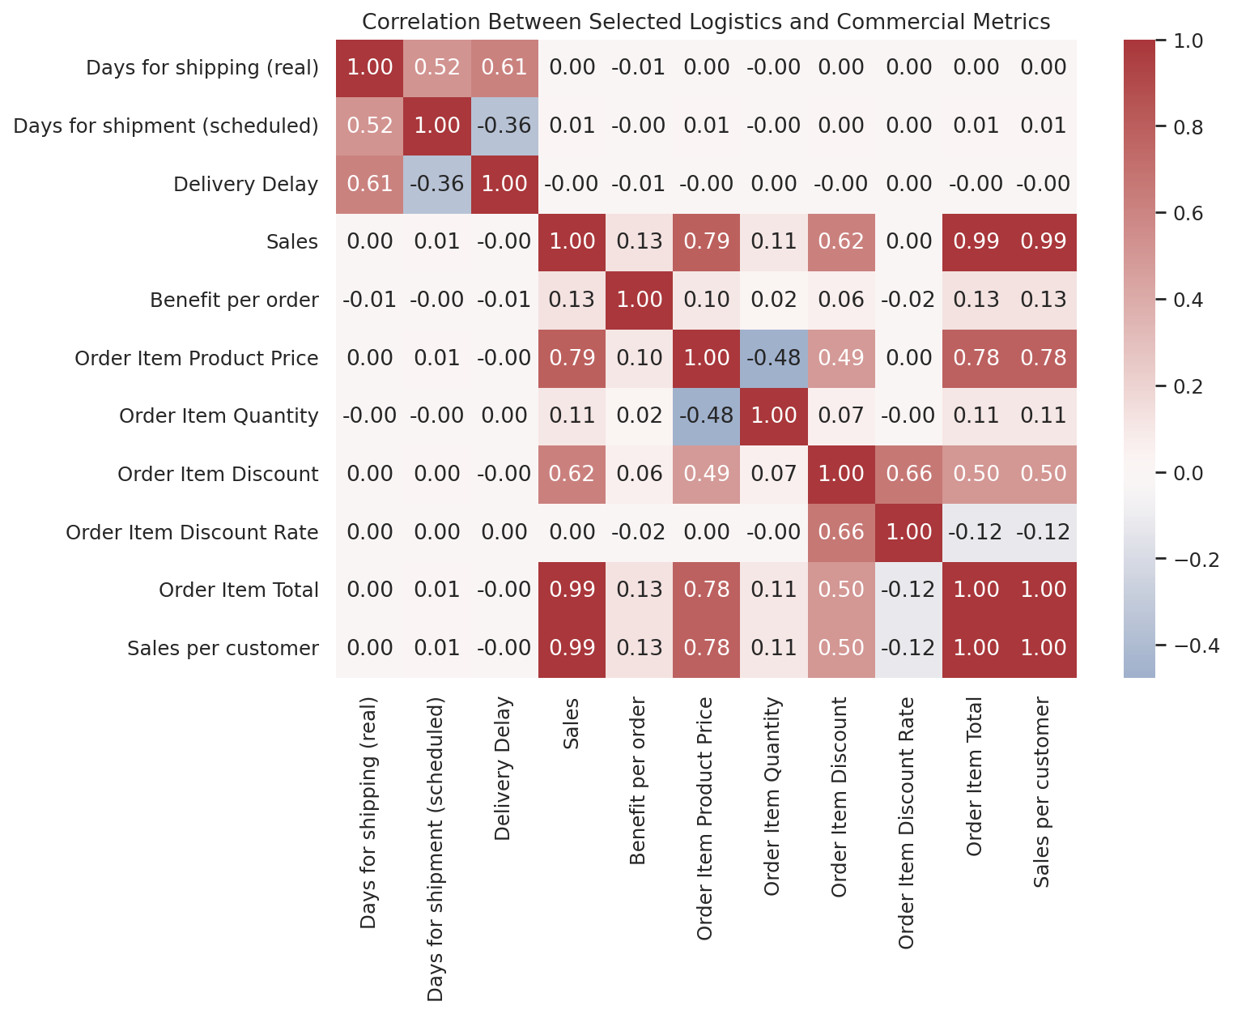
Figure 7. Correlation heatmap for selected numerical metrics. Source: Generated by the author using Python.
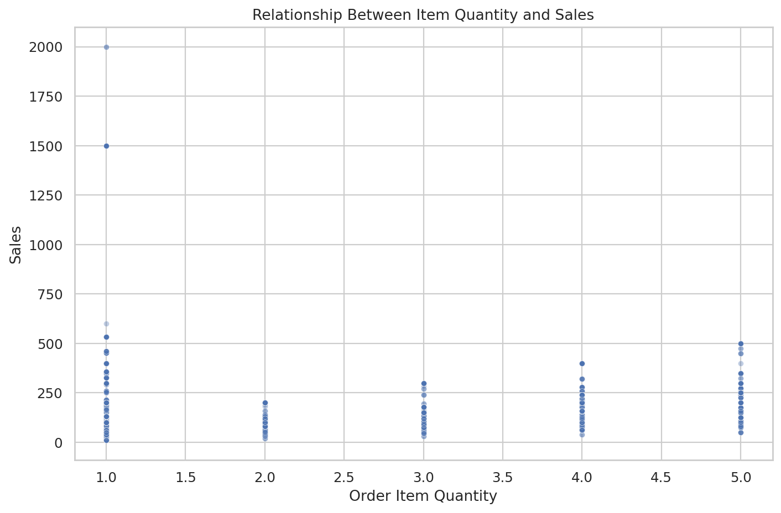
Figure 8. Relationship between order-item quantity and sales. Points are sampled for readability when the dataset is large. Source: Generated by the author using Python.
Metric A | Metric B | Correlation
Order Item Total | Sales per customer | 1.000
Sales | Sales per customer | 0.990
Sales | Order Item Total | 0.990
Sales | Order Item Product Price | 0.790
Order Item Product Price | Sales per customer | 0.782

The strongest pairs listed above are the strongest linear relationships within the selected fields, not necessarily the most important operational relationships. Some strong correlations may arise because the variables are mathematically related or share a common calculation.

8. Regional and product-category patterns
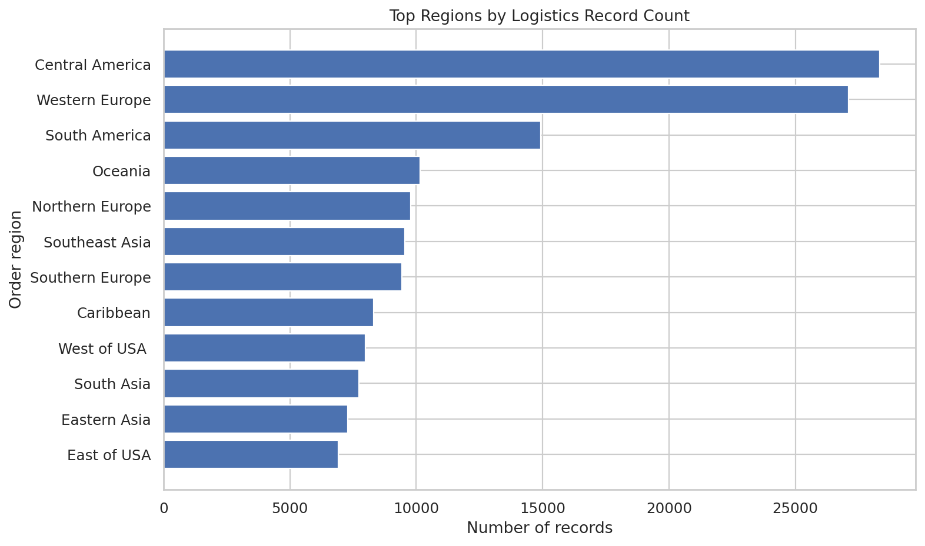
Figure 9. Regions with the highest record counts. Source: Generated by the author using Python.
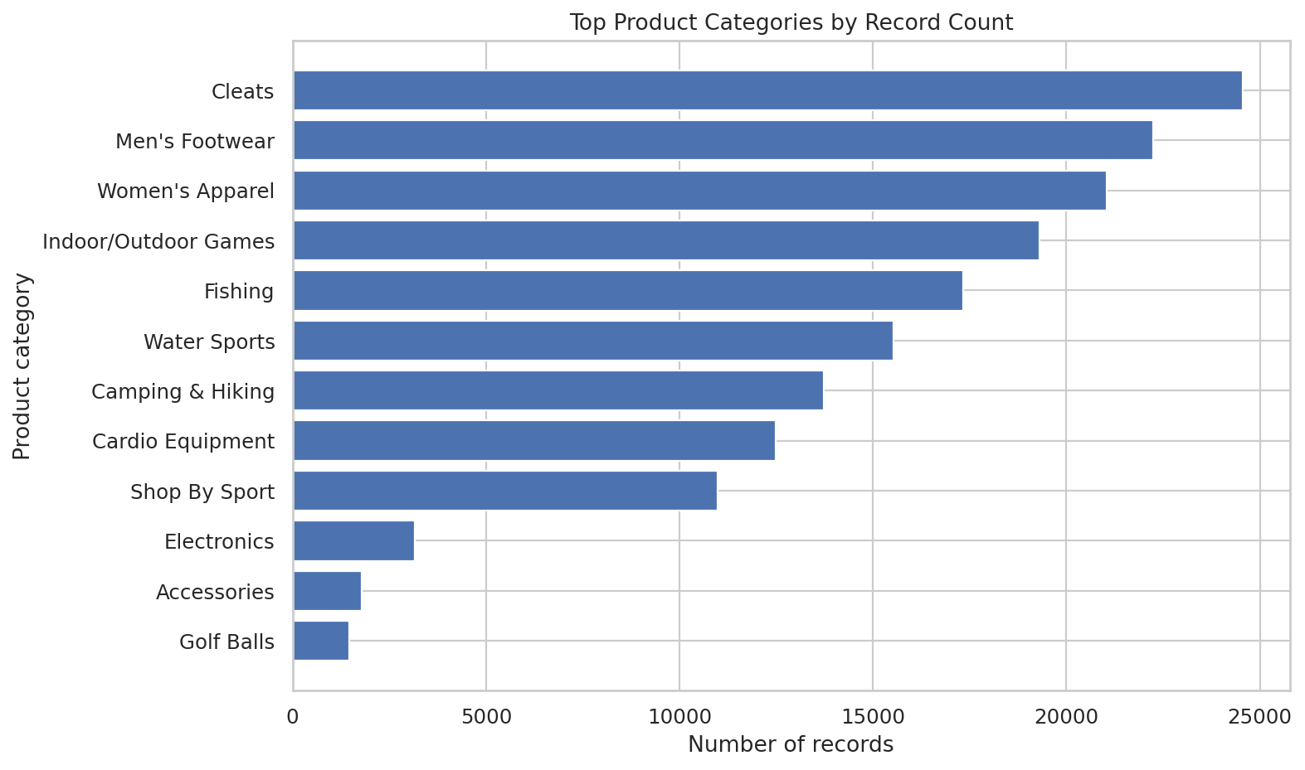
Figure 10. Product categories with the highest record counts. Source: Generated by the author using Python.
Regional and category charts show where records are concentrated. They can help analysts identify high-volume markets and product groups that may need more operational attention. Record volume alone does not indicate poor performance or higher cost; it should be compared with late-delivery rate, average shipping time, sales, and service commitments to distinguish high workload from weak performance.

9. Python methods and reproducibility
The analysis script uses pandas for loading, grouping, resampling, and descriptive statistics; NumPy for numerical handling; and Matplotlib/Seaborn for charts. The main steps are reusable and can be rerun after the input dataset or analytical questions change.
df = pd.read_csv(INPUT, low_memory=False)
df["order date (DateOrders)"] = pd.to_datetime(
df["order date (DateOrders)"], errors="coerce")
print(df.describe(include="all"))
monthly = df.set_index("order date (DateOrders)").resample("MS").size()
corr = df[["Days for shipping (real)",
"Days for shipment (scheduled)", "Sales"]].corr()
The included script checks whether candidate columns exist before using them, so it is easier to adapt to related logistics datasets. The full script, requirements file, charts, CSV summaries, and machine-readable summary are included in the ZIP package.

10. Insights and recommendations
- The mean actual shipping time exceeds the scheduled mean by 0.57 days; investigate the causes by route, mode, region, and order date.
- 98,977 records are labeled “Late delivery”; monitor this group separately from canceled shipments and on-time/advance deliveries.
- Average shipping time differs across modes, from 0.48 days for Same Day to 4.00 days for Standard Class; compare like-for-like routes and service commitments before changing mode allocation.
- Use monthly volume trends to support staffing and capacity planning, while distinguishing item-level records from unique orders or parcels.
- Review correlations alongside business definitions; do not treat correlation as evidence of cause.
- For a deeper follow-up, calculate late-delivery percentages by region and shipping mode, and compare them after controlling for scheduled delivery duration and route.
These recommendations are exploratory. Before operational decisions are made, findings should be checked against business definitions, shipment-level identifiers, and additional context such as distance, carrier, warehouse, and delivery service level.

11. Limitations
This analysis is observational and uses the fields available in the supplied dataset. It cannot identify causal drivers of delays without additional context or a suitable study design. Some columns are order-item-level measures, so a row count is not automatically a shipment count. Shipping mode and regional differences may reflect route mix and service commitments. Correlations can be influenced by formulas, outliers, and confounding variables. These limitations should be kept in mind when interpreting the charts or translating them into operational changes.

12. Conclusion
The Week 3 EDA explored the supplied logistics dataset through descriptive statistics, delivery-status analysis, shipping-time comparisons, shipping-mode summaries, monthly record trends, numerical correlations, and regional/category distributions. The analysis highlights a gap between average actual and scheduled shipping durations and shows that delivery status and shipping mode are useful starting points for further investigation. The visualizations make large tables easier to interpret and help turn raw records into questions that logistics teams can investigate. The code and outputs are packaged for reproducibility, while conclusions remain appropriately descriptive rather than causal.

Appendix: Generated files
- outputs/figures/01_delivery_status_distribution.png
- outputs/figures/02_shipping_time_distributions.png
- outputs/figures/03_average_shipping_time.png
- outputs/figures/04_shipping_mode_performance.png
- outputs/figures/05_monthly_order_trend.png
- outputs/figures/06_correlation_heatmap.png
- outputs/figures/07_quantity_vs_sales.png
- outputs/figures/08_top_regions.png
- outputs/figures/09_category_record_counts.png
- outputs/figures/10_delay_flag_by_shipping_mode.png
- reports/eda_summary.json
- reports/dataset_profile.csv
- reports/central_tendency_and_spread.csv
- reports/numeric_descriptive_statistics.csv
- reports/numeric_correlation_matrix.csv, when generated
- reports/monthly_order_counts.csv and region/category reports, when generated

References
- pandas documentation: https://pandas.pydata.org/docs/
- Matplotlib documentation: https://matplotlib.org/stable/
- Seaborn documentation: https://seaborn.pydata.org/
- scikit-learn is not required for this EDA task; the included analysis uses pandas, NumPy, Matplotlib, and Seaborn.

