Normal Traffic ::

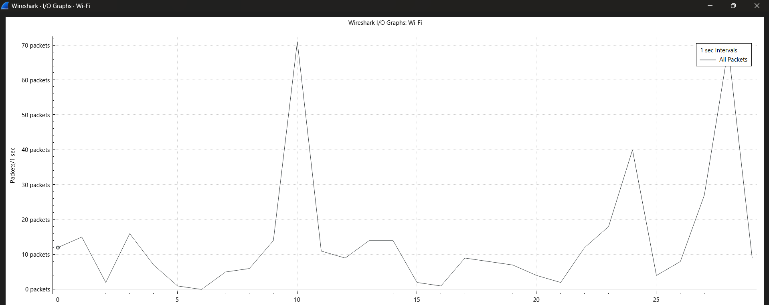
Scapy – code ::

from scapy.all import *
import time

target = "8.8.8.8" # Google DNS (safe & reachable)

for i in range(20): # NORMAL traffic
pkt = IP(dst=target)/TCP(dport=80, flags="S")
send(pkt, verbose=False)
time.sleep(1)

Medium Traffic ::
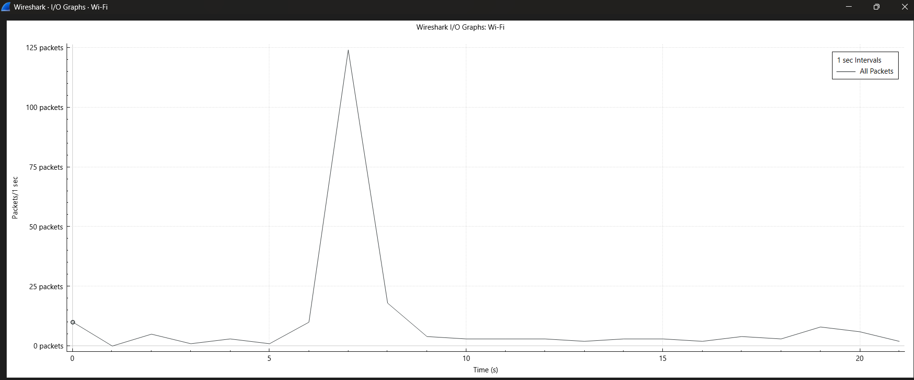

Scapy – code ::
from scapy.all import *
import time

target = "8.8.8.8" # Google DNS (safe & reachable)

for i in range(100): # MEDIUM traffic
pkt = IP(dst=target)/TCP(dport=80, flags="S")
send(pkt, verbose=False)

# print("Sparsh")

Heavy Traffic ::
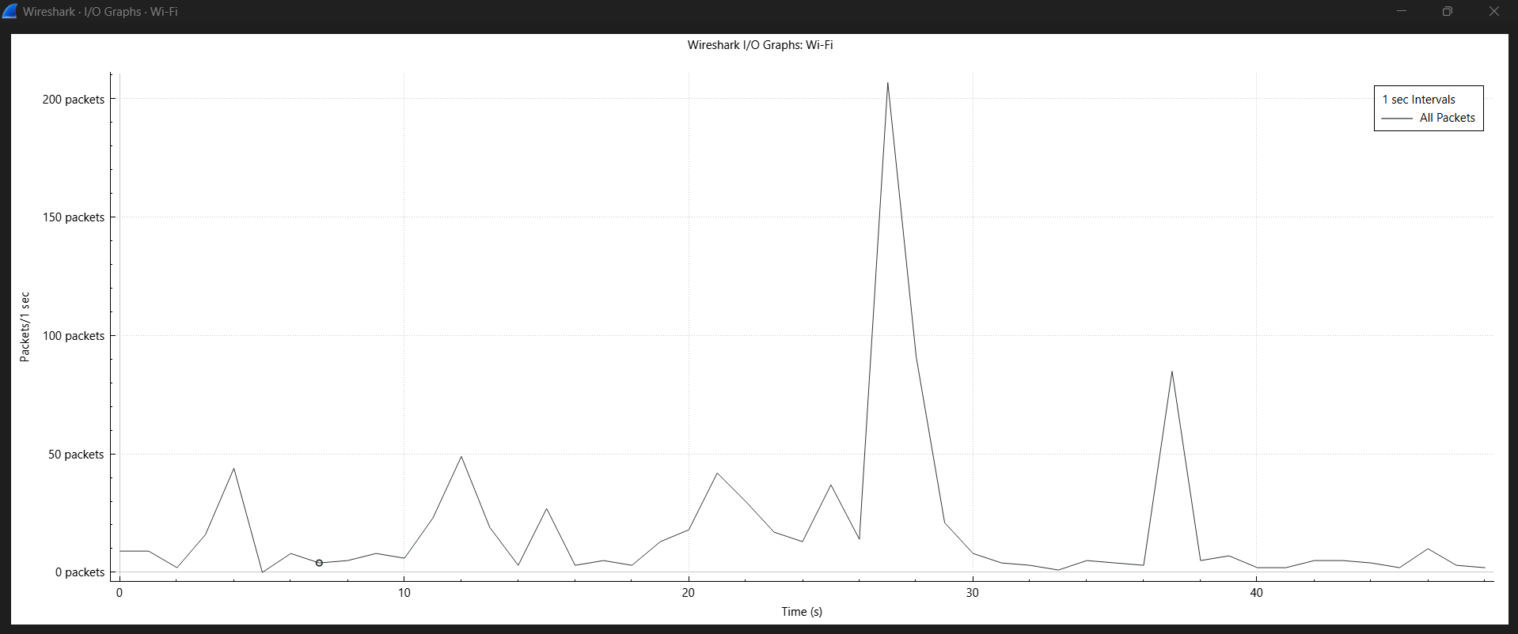

Scapy – code ::
from scapy.all import *
import time

target = "8.8.8.8" # Google DNS (safe & reachable)

for i in range(300): # HEAVY traffic
pkt = IP(dst=target)/TCP(dport=80, flags="S")
send(pkt, verbose=False)

# print("Sparsh")

