

Artificial Intelligence
Digital Assignment - 1 & 2
HEMANT 23BAI1254
SPARSH PATIDAR 23BAI1301
ABHIGYAN SINHA 23BAI1261

Faculty Name – Dr. MODIGARI NARENDRA
Slot – F2+TF2

Abstract
This project presents a deep learning approach to classify histopathological breast cancer images as benign or malignant using Convolutional Neural Networks (CNNs) with various enhancements such as the integration of Multi-Head Self-Attention mechanisms. The dataset consists of labeled .png images captured at varying magnification levels: 40X, 100X, 200X, and 400X, organized by both class and magnification. A 7-layer CNN model is initially built to classify the images, followed by a more advanced model using a fine-tuned ResNet50 and the incorporation of multi-head attention. The project involves training the models on a stratified split (70% training, 15% validation, and 15% testing), followed by comprehensive evaluation using standard classification metrics (accuracy, precision, recall, ROC AUC, and PR AUC). The performance is further assessed at different magnification levels to evaluate consistency across varying image resolutions. The goal is to improve the classification accuracy and robustness of breast cancer detection using deep learning techniques.

Objective
The main objectives of this project are:
- Build a Robust CNN Model: To design a 7-layer CNN architecture capable of classifying histopathological images into benign and malignant classes based on image features.
- Fine-Tune ResNet50: To leverage the pre-trained ResNet50 model for feature extraction and fine-tuning it to improve classification accuracy for breast cancer detection.
- Incorporate Multi-Head Attention Mechanism: Explore the impact of multi-head self-attention mechanisms in CNNs to enhance model focus on key features across different magnification levels of histopathological images.
- Evaluate Performance Across Magnifications: Analyze the model’s performance at different magnification levels (40X, 100X, 200X, and 400X) to understand the consistency and robustness of the approach in detecting cancer at various resolutions.
- Measure Model Performance: Assess and report classification performance using multiple metrics, including accuracy, precision, recall, ROC AUC, and PR AUC, to ensure the model’s reliability in a real-world medical application.

Task 1

- Implement and evaluate a basic CNN model for the classification task.
- Dataset Preparation: Perform necessary preprocessing, including resizing, normalization, and data augmentation.
- Build a CNN architecture(e.g., 3-4 convolutional layers) from scratch using layers such as Conv2D, MaxPooling, Flatten, and Dense.
- Evaluate the model using metrics such as accuracy, F1-score, and AUC ROC.
- Use transfer learning to fine-tune pretrained CNN models ResNet50, VGG16, or MobileNet
- Optimize hyperparameters such as learning rate and batch size.

Google Colab Notebook Link
7 - Layers CNN Model
https://colab.research.google.com/drive/1jKXZFXUgoJHwJZR6taHb_99hDyiI08sV?usp=drive_link

Fine-Tune Model
https://colab.research.google.com/drive/1YmKSsEHslIdIQWiSQ3Q9DMxFrAVxRWt1?usp=drive_link

Breast Cancer Detection Using CNN
Project Overview
This project builds a 7-layer Convolutional Neural Network (CNN) to classify histopathological breast cancer images as benign or malignant, using microscopic images captured at varying magnification levels: 40X, 100X, 200X, and 400X.
The data consists of labeled .png images organized by class (benign/malignant) and magnification level. To ensure the model is evaluated fairly and learns robust features, the dataset is stratified and split into:
- 70% Training Set: Used to train the model
- 15% Validation Set: Used to tune hyperparameters and monitor overfitting
- 15% Test Set: Used for final model evaluation and reporting
Splitting is stratified by both class and magnification, ensuring balanced representation in each subset.
The model is then trained, evaluated using classification metrics and curves (ROC, PR), and further analyzed at each magnification level to understand performance consistency.

1. Dataset Preparation
Dataset Structure
- The dataset contains image folders structured by:
  - Label: Benign / Malignant
  - Magnification: 40X, 100X, 200X, 400X
- Images are in .png format.
Data Pipeline
- Walks through all subdirectories, collects image paths and labels.
- Extracts:
  - Label from folder name (benign = 0, malignant = 1)
  - Magnification level from parent folder (e.g., 100X)
- Creates a Pandas DataFrame with:
  - path, label, and magnification
Stratified Splitting
- Ensures balanced distribution of labels and magnification levels:
  - Training set: 70%
  - Validation set: 15%
  - Test set: 15%
Image Preprocessing
- Resizes all images to 224x224
- Applies preprocessing using ResNet50 standards
Data Augmentation (Training only)
- Horizontal/Vertical flips
- Brightness and contrast changes

2. Model Architecture – 7-Layer CNN
Layers
- Input Shape: (224, 224, 3)
- 7 Convolutional Layers grouped into 4 blocks:
  - Each block has:
    - Conv2D + BatchNorm + MaxPooling + Dropout
- Global Average Pooling after the last conv block
- Dense layers for final classification:
  - Dense(512) + Dropout
  - Output: Dense(1, sigmoid) for binary classification
Metrics Used
- Accuracy
- Precision
- Recall
- ROC AUC
- PR AUC (Precision-Recall Area Under Curve)

3. Training Setup
Optimizer and Loss
- Optimizer: Adam (lr=1e-4)
- Loss: Binary Crossentropy
Callbacks
- EarlyStopping: Monitors validation PR AUC
- ModelCheckpoint: Saves best model by validation PR AUC
- ReduceLROnPlateau: Reduces LR on plateau
- TensorBoard: Logging for visual inspection

4. Model Training
- Trained for 15 epochs
- Validation metrics are tracked every epoch
- Training history is saved for plotting performance

5. Results & Evaluation
Training Curves
- Loss, Accuracy, Precision, Recall, ROC AUC, PR AUC for:
  - Training
  - Validation
Validation & Test Evaluation
Metrics:
- Confusion Matrix
- ROC Curve
- Precision-Recall Curve
- Classification Report
Magnification-Specific Analysis
- Evaluates performance separately on each magnification level (40X, 100X, 200X, 400X)
- Generates confusion matrices and metrics:
  - Accuracy
  - Precision
  - Recall
  - F1 Score
  - ROC AUC
  - PR AUC

CODE
import tensorflow as tf
from tensorflow.keras import layers, models, optimizers, callbacks
from tensorflow.keras.utils import plot_model
from sklearn.model_selection import train_test_split
from sklearn.metrics import classification_report, confusion_matrix, roc_curve, auc, precision_recall_curve
import numpy as np
import pandas as pd
import matplotlib.pyplot as plt
import seaborn as sns
import os
from datetime import datetime

# Mount Google Drive
from google.colab import drive
drive.mount('/content/drive')

# Constants
BASE_DIR = '/content/drive/MyDrive/dataset'
MAGNIFICATIONS = ['40X', '100X', '200X', '400X']
IMG_SIZE = (224, 224)
BATCH_SIZE = 32
EPOCHS = 15
TEST_SIZE = 0.15
VAL_SIZE = 0.15
SEED = 42

# Set random seeds
tf.random.set_seed(SEED)
np.random.seed(SEED)

# 1. Enhanced Data Pipeline
def create_data_pipeline(base_dir):
# Collect all image paths with metadata
data = []
for root, dirs, files in os.walk(base_dir):
current_mag = next((mag for mag in MAGNIFICATIONS if mag in root), None)
if current_mag:
for file in files:
if file.endswith('.png') and not file.startswith('._'):
label = 0 if 'benign' in root.lower() else 1
data.append({
'path': os.path.join(root, file),
'label': label,
'magnification': current_mag
})

# Create DataFrame
df = pd.DataFrame(data)

# Stratified split into train/val/test
stratify_col = df['label'].astype(str) + '_' + df['magnification']
train_val_df, test_df = train_test_split(
df, test_size=TEST_SIZE, stratify=stratify_col, random_state=SEED
)
train_df, val_df = train_test_split(
train_val_df,
test_size=VAL_SIZE/(1-TEST_SIZE),
stratify=train_val_df['label'].astype(str) + '_' + train_val_df['magnification'],
random_state=SEED
)

# Print dataset sizes
print("\nDataset Split Sizes:")
print(f"Training: {len(train_df)} samples")
print(f"Validation: {len(val_df)} samples")
print(f"Testing: {len(test_df)} samples")

# Print class distribution
print("\nClass Distribution:")
print(train_df['label'].value_counts())

# Image preprocessing
def preprocess_image(path, label):
image = tf.io.read_file(path)
image = tf.image.decode_png(image, channels=3)
image = tf.image.resize(image, IMG_SIZE)
image = tf.keras.applications.resnet50.preprocess_input(image)
return image, label

# Data augmentation
def augment_image(image, label):
image = tf.image.random_flip_left_right(image)
image = tf.image.random_flip_up_down(image)
image = tf.image.random_brightness(image, 0.1)
image = tf.image.random_contrast(image, 0.9, 1.1)
return image, label

# Create datasets
def df_to_dataset(df, shuffle=True, augment=False):
ds = tf.data.Dataset.from_tensor_slices((df['path'].values, df['label'].values))
if shuffle:
ds = ds.shuffle(buffer_size=len(df), seed=SEED)
ds = ds.map(preprocess_image, num_parallel_calls=tf.data.AUTOTUNE)
if augment:
ds = ds.map(augment_image, num_parallel_calls=tf.data.AUTOTUNE)
ds = ds.batch(BATCH_SIZE)
ds = ds.prefetch(tf.data.AUTOTUNE)
return ds

train_ds = df_to_dataset(train_df, shuffle=True, augment=True)
val_ds = df_to_dataset(val_df, shuffle=False)
test_ds = df_to_dataset(test_df, shuffle=False)

return train_ds, val_ds, test_ds, train_df, val_df, test_df

# Create datasets
train_dataset, val_dataset, test_dataset, train_df, val_df, test_df = create_data_pipeline(BASE_DIR)

# 2. 7-Layer CNN Model Architecture
def build_7layer_cnn(input_shape=(224, 224, 3)):
inputs = layers.Input(shape=input_shape)

# Block 1
x = layers.Conv2D(32, (3,3), activation='relu', padding='same')(inputs)
x = layers.BatchNormalization()(x)
x = layers.Conv2D(32, (3,3), activation='relu', padding='same')(x)
x = layers.BatchNormalization()(x)
x = layers.MaxPooling2D((2,2))(x)
x = layers.Dropout(0.2)(x)

# Block 2
x = layers.Conv2D(64, (3,3), activation='relu', padding='same')(x)
x = layers.BatchNormalization()(x)
x = layers.Conv2D(64, (3,3), activation='relu', padding='same')(x)
x = layers.BatchNormalization()(x)
x = layers.MaxPooling2D((2,2))(x)
x = layers.Dropout(0.3)(x)

# Block 3
x = layers.Conv2D(128, (3,3), activation='relu', padding='same')(x)
x = layers.BatchNormalization()(x)
x = layers.Conv2D(128, (3,3), activation='relu', padding='same')(x)
x = layers.BatchNormalization()(x)
x = layers.MaxPooling2D((2,2))(x)
x = layers.Dropout(0.4)(x)

# Block 4 (Additional layers to make 7 conv layers)
x = layers.Conv2D(256, (3,3), activation='relu', padding='same')(x)
x = layers.BatchNormalization()(x)
x = layers.Conv2D(256, (3,3), activation='relu', padding='same')(x)
x = layers.BatchNormalization()(x)
x = layers.GlobalAveragePooling2D()(x)

# Classification head
x = layers.Dense(512, activation='relu')(x)
x = layers.Dropout(0.5)(x)
outputs = layers.Dense(1, activation='sigmoid')(x)

model = models.Model(inputs, outputs)

model.compile(
optimizer=optimizers.Adam(learning_rate=1e-4),
loss='binary_crossentropy',
metrics=[
'accuracy',
tf.keras.metrics.Precision(name='precision'),
tf.keras.metrics.Recall(name='recall'),
tf.keras.metrics.AUC(name='auc'),
tf.keras.metrics.AUC(name='prc', curve='PR')
]
)

return model

model = build_7layer_cnn()
model.summary()
plot_model(model, to_file='7layer_cnn_architecture.png', show_shapes=True)

# 3. Training Setup
callbacks = [
callbacks.EarlyStopping(
monitor='val_prc',
patience=5,
mode='max',
restore_best_weights=True,
verbose=1
),
callbacks.ModelCheckpoint(
'best_7layer_model.h5',
monitor='val_prc',
save_best_only=True,
verbose=1
),
callbacks.TensorBoard(
log_dir='logs/7layer_cnn'
),
callbacks.ReduceLROnPlateau(
monitor='val_loss',
factor=0.5,
patience=3,
min_lr=1e-6,
verbose=1
)
]

# 4. Training
print("\nStarting training for 7-layer CNN...")
history = model.fit(
train_dataset,
validation_data=val_dataset,
epochs=EPOCHS,
callbacks=callbacks,
verbose=1
)

# 5. Visualization and Evaluation Functions
def plot_training_metrics(history):
plt.figure(figsize=(20, 12))

metrics = ['loss', 'accuracy', 'precision', 'recall', 'auc', 'prc']
titles = ['Loss', 'Accuracy', 'Precision', 'Recall', 'ROC AUC', 'PR AUC']

for i, metric in enumerate(metrics, 1):
plt.subplot(2, 3, i)
plt.plot(history.history[metric], label='Train')
plt.plot(history.history[f'val_{metric}'], label='Validation')
plt.title(titles[i-1])
plt.xlabel('Epoch')
plt.legend()

plt.tight_layout()
plt.show()

def evaluate_dataset(model, dataset, df, dataset_name):
y_probs = model.predict(dataset).flatten()
y_pred = (y_probs > 0.5).astype(int)
y_true = df['label'].values

# Classification report
print(f"\n{classification_report(y_true, y_pred, target_names=['Benign', 'Malignant'])}")

# Confusion matrix
plt.figure(figsize=(6,6))
cm = confusion_matrix(y_true, y_pred)
sns.heatmap(cm, annot=True, fmt='d', cmap='Blues',
xticklabels=['Benign', 'Malignant'],
yticklabels=['Benign', 'Malignant'])
plt.title(f'{dataset_name} Confusion Matrix')
plt.show()

# ROC curve
fpr, tpr, _ = roc_curve(y_true, y_probs)
roc_auc = auc(fpr, tpr)
plt.figure(figsize=(8,6))
plt.plot(fpr, tpr, label=f'ROC Curve (AUC = {roc_auc:.2f})')
plt.plot([0, 1], [0, 1], 'k--')
plt.xlabel('False Positive Rate')
plt.ylabel('True Positive Rate')
plt.title(f'{dataset_name} ROC Curve')
plt.legend()
plt.show()

# Precision-Recall curve
precision, recall, _ = precision_recall_curve(y_true, y_probs)
pr_auc = auc(recall, precision)
plt.figure(figsize=(8,6))
plt.plot(recall, precision, label=f'PR Curve (AUC = {pr_auc:.2f})')
plt.xlabel('Recall')
plt.ylabel('Precision')
plt.title(f'{dataset_name} Precision-Recall Curve')
plt.legend()
plt.show()

return {
'y_true': y_true,
'y_pred': y_pred,
'y_probs': y_probs,
'roc_auc': roc_auc,
'pr_auc': pr_auc
}

def evaluate_magnification_levels(model, df, dataset_name):
results = {}
plt.figure(figsize=(15, 10))

for i, mag in enumerate(MAGNIFICATIONS, 1):
mag_df = df[df['magnification'] == mag]
if len(mag_df) == 0:
continue

# Create dataset for this magnification
def preprocess_image(path, label):
image = tf.io.read_file(path)
image = tf.image.decode_png(image, channels=3)
image = tf.image.resize(image, IMG_SIZE)
image = tf.keras.applications.resnet50.preprocess_input(image)
return image, label

mag_ds = tf.data.Dataset.from_tensor_slices((mag_df['path'].values, mag_df['label'].values))
mag_ds = mag_ds.map(preprocess_image).batch(BATCH_SIZE)

# Evaluate
y_probs = model.predict(mag_ds).flatten()
y_pred = (y_probs > 0.5).astype(int)
y_true = mag_df['label'].values

# Metrics
report = classification_report(y_true, y_pred, output_dict=True)
fpr, tpr, _ = roc_curve(y_true, y_probs)
roc_auc = auc(fpr, tpr)
precision, recall, _ = precision_recall_curve(y_true, y_probs)
pr_auc = auc(recall, precision)

results[mag] = {
'accuracy': report['accuracy'],
'precision': report['weighted avg']['precision'],
'recall': report['weighted avg']['recall'],
'f1': report['weighted avg']['f1-score'],
'roc_auc': roc_auc,
'pr_auc': pr_auc
}

# Confusion matrix per magnification
plt.subplot(2, 2, i)
cm = confusion_matrix(y_true, y_pred)
sns.heatmap(cm, annot=True, fmt='d', cmap='Blues',
xticklabels=['Benign', 'Malignant'],
yticklabels=['Benign', 'Malignant'])
plt.title(f'{mag} (Acc: {report["accuracy"]:.2f}, AUC: {roc_auc:.2f})')

plt.suptitle(f'Magnification-Level Performance ({dataset_name})')
plt.tight_layout()
plt.show()

# Create metrics table
metrics_df = pd.DataFrame(results).T
print(f"\nMagnification-Level Metrics ({dataset_name}):")
display(metrics_df.style.background_gradient(cmap='Blues'))

return results

# 6. Comprehensive Evaluation
print("\nTraining Metrics:")
plot_training_metrics(history)

print("\nValidation Set Evaluation:")
val_results = evaluate_dataset(model, val_dataset, val_df, "Validation")
val_mag_results = evaluate_magnification_levels(model, val_df, "Validation")

print("\nTest Set Evaluation:")
test_results = evaluate_dataset(model, test_dataset, test_df, "Test")
test_mag_results = evaluate_magnification_levels(model, test_df, "Test")

# 7. Final Summary
print("\n=== FINAL 7-LAYER CNN RESULTS ===")
print(f"Best Validation PR AUC: {max(history.history['val_prc']):.4f}")
print(f"Test ROC AUC: {test_results['roc_auc']:.4f}")
print(f"Test PR AUC: {test_results['pr_auc']:.4f}")

print("\nTest Set Magnification Performance:")
for mag, metrics in test_mag_results.items():
print(f"\n{mag}:")
print(f"Accuracy: {metrics['accuracy']:.4f}")
print(f"Precision: {metrics['precision']:.4f}")
print(f"Recall: {metrics['recall']:.4f}")
print(f"F1-Score: {metrics['f1']:.4f}")
print(f"ROC AUC: {metrics['roc_auc']:.4f}")
print(f"PR AUC: {metrics['pr_auc']:.4f}")

CNN Architecture
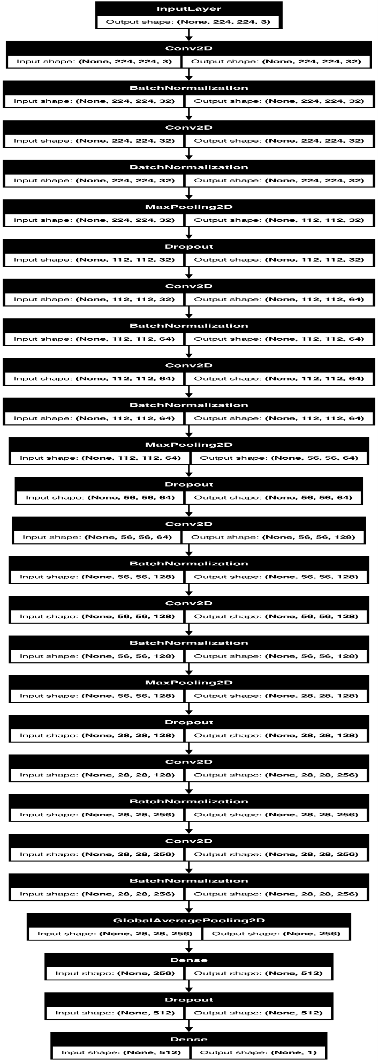

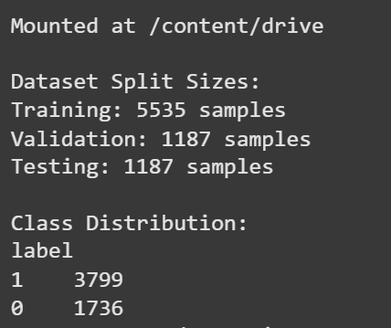
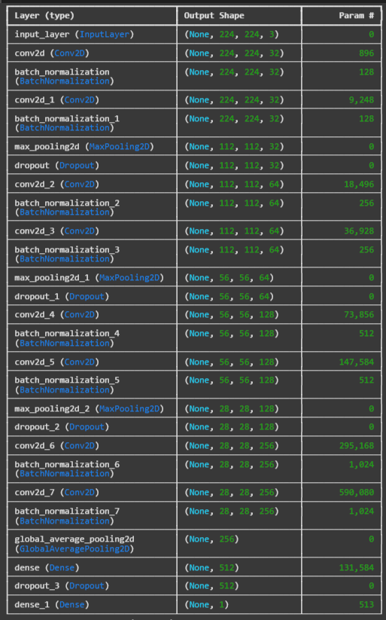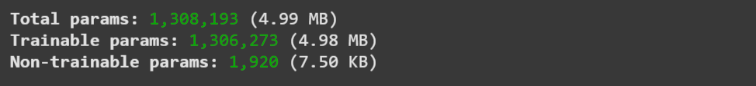

15 Epoch Output
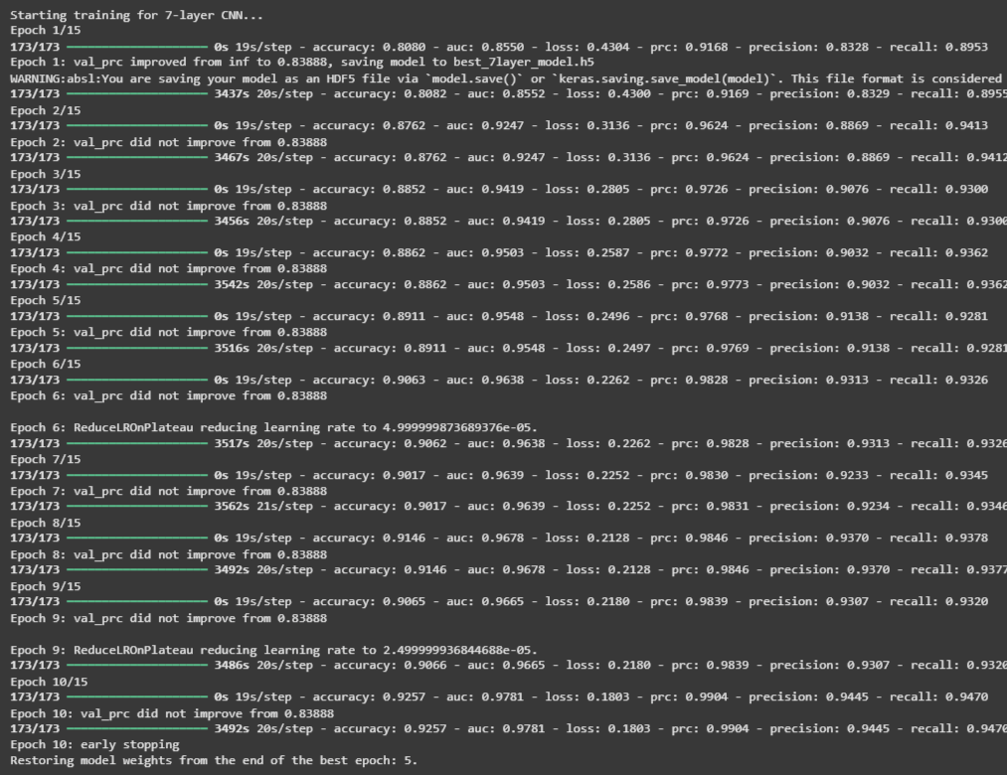

Loss , Accuracy, Precision , Recall , ROC-AUC , PR-AUC Graph
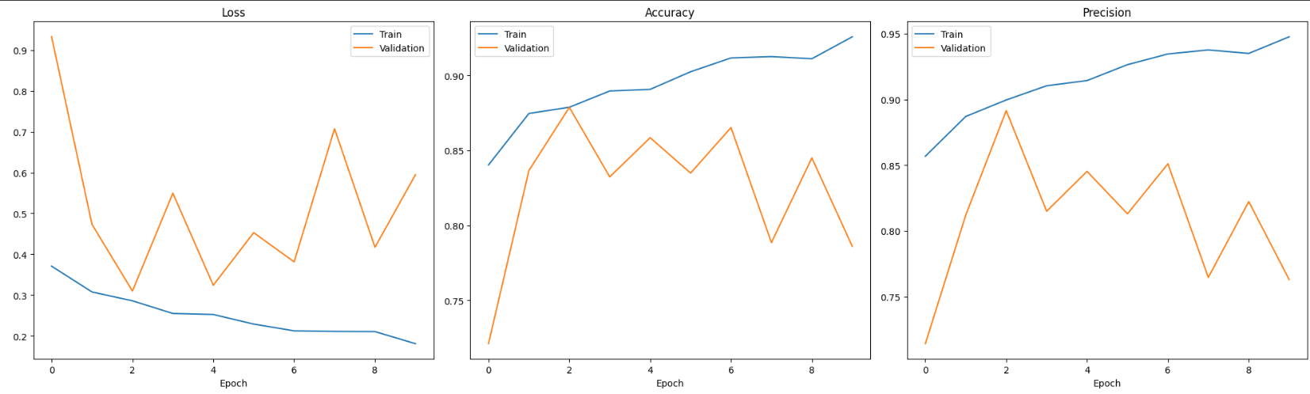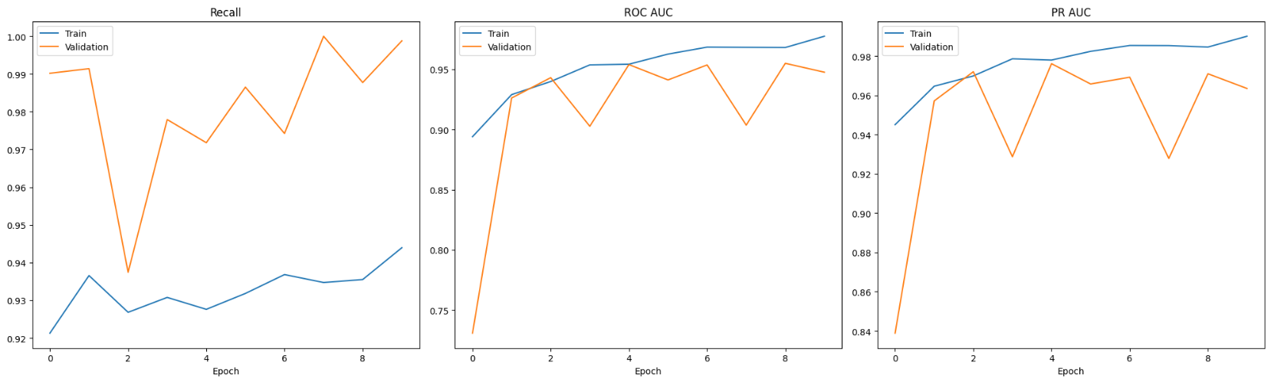

Validation ROC Curve
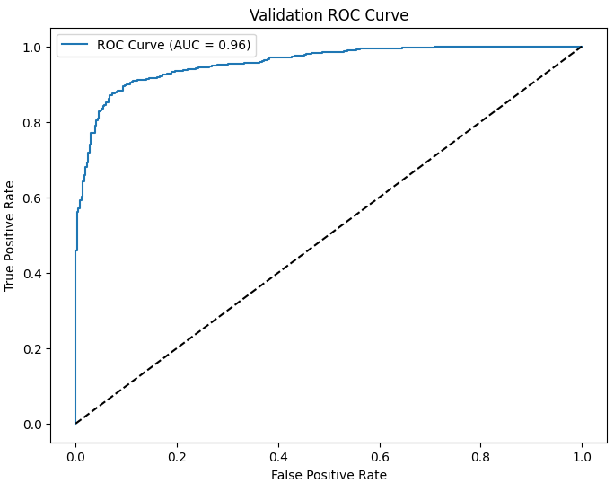

Validation Precision-Recall Curve
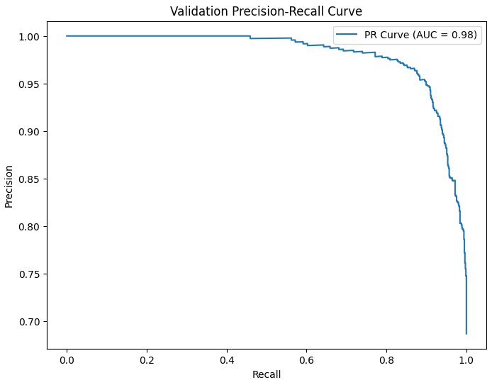

Validation Confusion Matrix
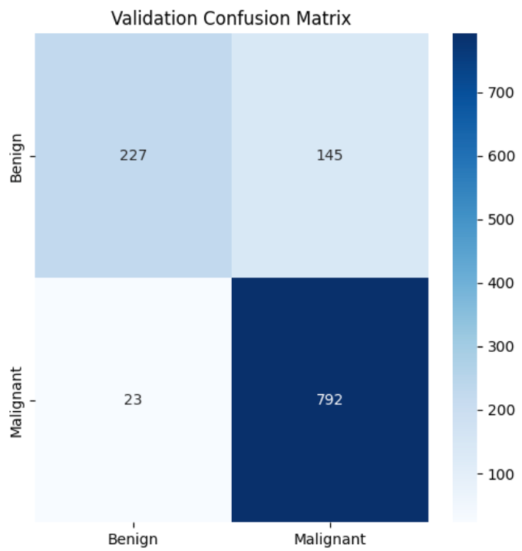

Validation Different Magnification Level Performance Matrix(40x , 100x, 200x , 400x)
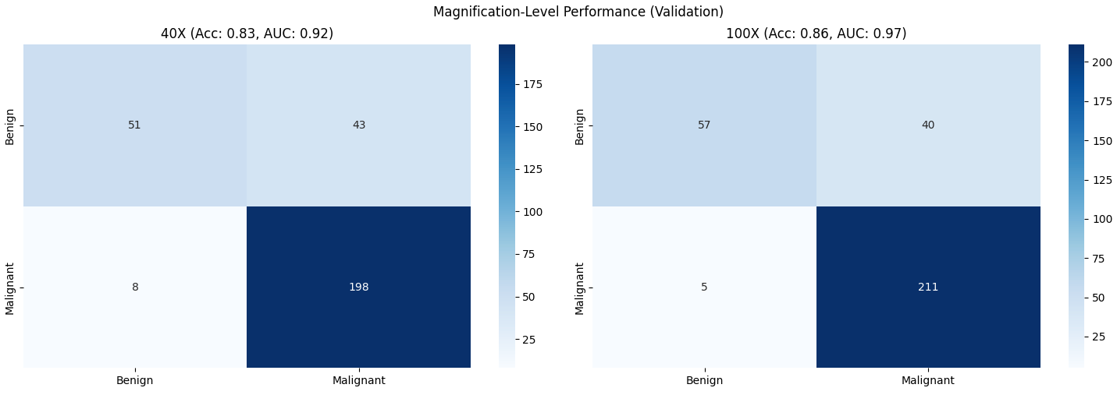
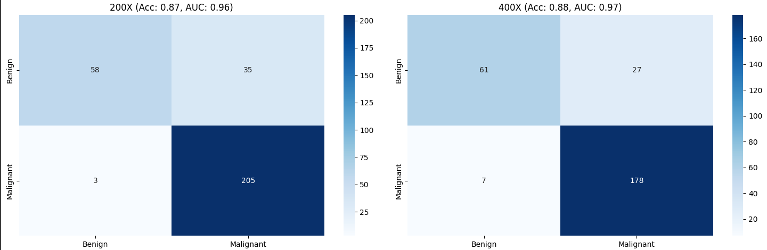

Validation & Testing Set Evaluation
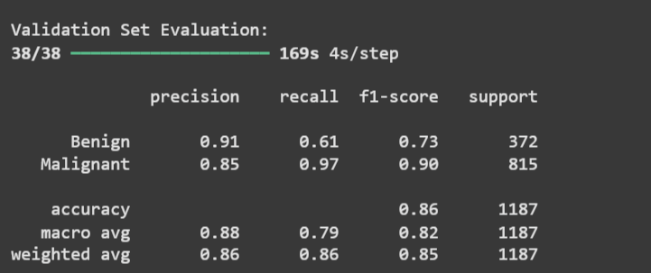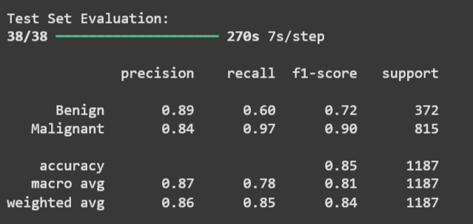

Test Confusion Matrix

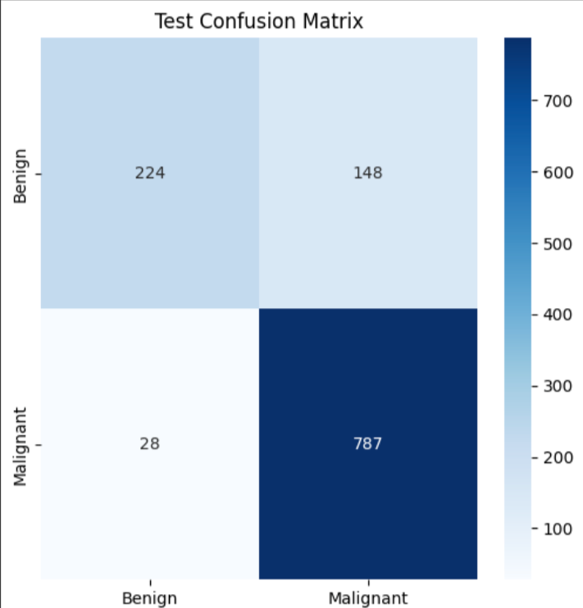

Test ROC Curve
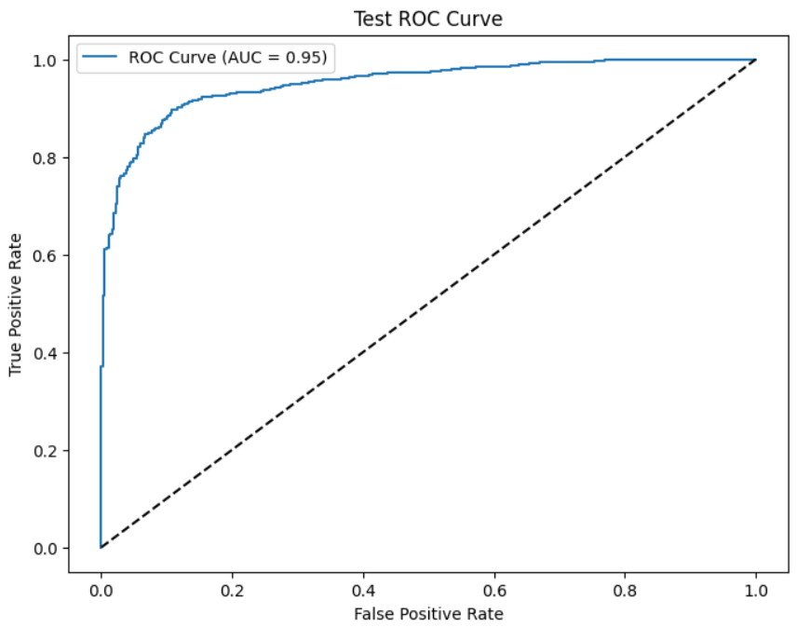

Test Precision-Recall Curve
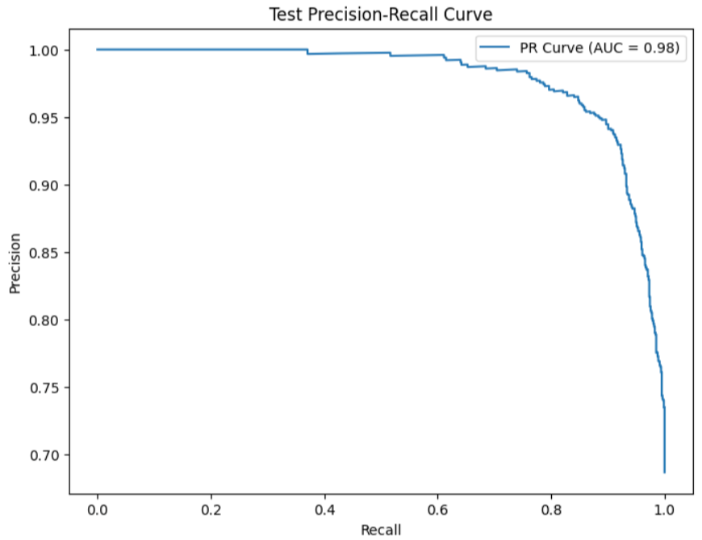

Testing Different Magnification Level Performance Matrix(40x , 100x, 200x , 400x)
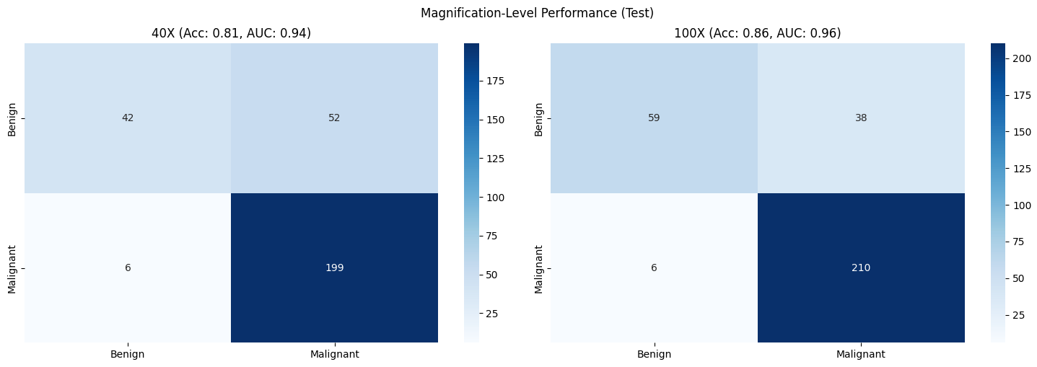
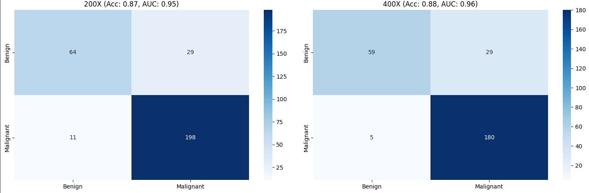

Test-Set Performance for each Magnification Levels(40x , 100x , 200x , 400x)
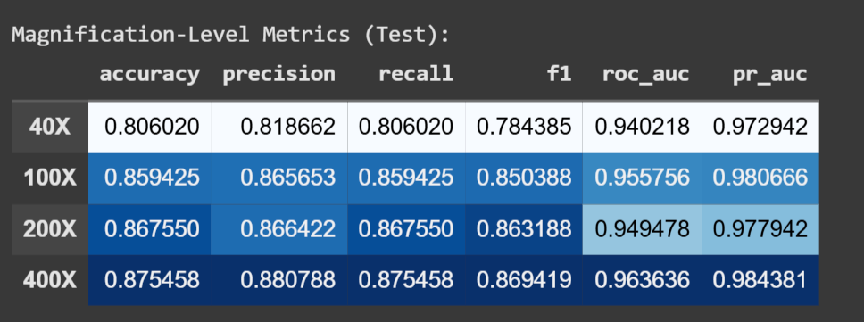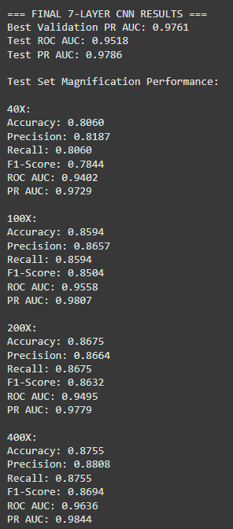

Breast Cancer Detection Using Fine-Tuned ResNet50

ResNet-50 Notebook Link
https://colab.research.google.com/drive/1YmKSsEHslIdIQWiSQ3Q9DMxFrAVxRWt1?usp=drive_link

Project Overview
This project leverages the ResNet50 architecture to classify histopathological breast cancer images as benign or malignant, utilizing images captured at varying magnification levels: 40X, 100X, 200X, and 400X.
The dataset contains labeled .png images, organized by both class (benign/malignant) and magnification level. The data is split into training, validation, and test sets in a stratified manner, ensuring balanced distribution across all magnification levels and labels.
Data Split:
• 70% Training Set: Used to train the model.
• 15% Validation Set: Used for hyperparameter tuning and monitoring overfitting.
• 15% Test Set: Used for final model evaluation.
The model is fine-tuned using ResNet50 and evaluated using key metrics like accuracy, precision, recall, AUC-ROC, and AUC-PR. Further, a magnification-level performance analysis is conducted to assess consistency across different image resolutions.

1. Dataset Preparation
Dataset Structure:
- Class: Benign / Malignant
- Magnification Levels: 40X, 100X, 200X, 400X
- File Format: .png images
Data Pipeline:
- The pipeline walks through all subdirectories, collects image paths, and labels.
- Extracts:
  - Label from folder names (benign = 0, malignant = 1).
  - Magnification level from parent folder (e.g., 100X).
- Creates a Pandas DataFrame with columns: path, label, magnification.
Stratified Splitting:
- Ensures a balanced distribution of labels and magnification levels across subsets:
  - Training Set: 70%
  - Validation Set: 15%
  - Test Set: 15%
Image Preprocessing:
- Resizing: All images are resized to 224x224 to match the ResNet50 input size.
- Preprocessing: Images are preprocessed using the ResNet50 standards for optimal model performance.
Data Augmentation (Training only):
- Horizontal/Vertical Flips
- Brightness and Contrast Adjustments

2. Model Architecture – Fine-Tuned ResNet50
ResNet50 Fine-Tuning:
- Input Shape: (224, 224, 3) for RGB images.
- The pre-trained ResNet50 model (on ImageNet) is fine-tuned by:
  - Freezing the first 100 layers.
  - Adding custom layers:
    - Global Average Pooling (GAP)
    - Fully Connected Dense Layer (256 units) with ReLU activation.
    - Dropout Layer (0.5) for regularization.
    - Sigmoid output layer for binary classification (Benign/Malignant).
Metrics Used for Evaluation:
- Accuracy
- Precision
- Recall
- ROC AUC (Receiver Operating Characteristic - Area Under Curve)
- PR AUC (Precision-Recall - Area Under Curve)

3. Training Setup
Optimizer & Loss:
- Optimizer: Adam with learning rate = 1e-4.
- Loss: Binary Cross-Entropy for binary classification.
Callbacks Used:
- EarlyStopping: Monitors validation PR AUC, stops if no improvement is observed for 5 epochs.
- ModelCheckpoint: Saves the best model based on validation PR AUC.
- ReduceLROnPlateau: Reduces the learning rate if the validation loss plateaus for 3 epochs.
- TensorBoard: Logs training metrics for visual inspection.

4. Model Training
- The model is trained for 15 epochs.
- Validation metrics (accuracy, precision, recall, etc.) are tracked every epoch to monitor progress.
- Training history is saved for visualization of model performance over time.

5. Results & Evaluation
Training Curves:
- Loss, Accuracy, Precision, Recall, ROC AUC, and PR AUC are plotted for both training and validation sets.
Validation & Test Evaluation:
- Confusion Matrix: Shows the number of true positives, false positives, true negatives, and false negatives.
- ROC Curve: Visualizes the trade-off between true positive rate (sensitivity) and false positive rate (1-specificity).
- Precision-Recall Curve: Shows precision vs. recall at different thresholds.
- Classification Report: Includes precision, recall, and F1-score.
Magnification-Specific Analysis:
- Performance is evaluated separately at each magnification level: 40X, 100X, 200X, 400X.
- Metrics Generated:
  - Accuracy
  - Precision
  - Recall
  - F1 Score
  - ROC AUC
  - PR AUC

CODE
import tensorflow as tf
from tensorflow.keras.applications import ResNet50
from tensorflow.keras import layers, models, optimizers, callbacks
from tensorflow.keras.utils import plot_model
from sklearn.model_selection import train_test_split
from sklearn.metrics import classification_report, confusion_matrix, roc_curve, auc, precision_recall_curve
from sklearn.utils import class_weight
import numpy as np
import pandas as pd
import matplotlib.pyplot as plt
import seaborn as sns
import os
from datetime import datetime

# Mount Google Drive
from google.colab import drive
drive.mount('/content/drive')

# Constants
BASE_DIR = '/content/drive/MyDrive/dataset'
MAGNIFICATIONS = ['40X', '100X', '200X', '400X']
IMG_SIZE = (224, 224)
BATCH_SIZE = 32
EPOCHS = 15
TEST_SIZE = 0.15
VAL_SIZE = 0.15
SEED = 42

# Set random seeds
tf.random.set_seed(SEED)
np.random.seed(SEED)

# 1. Enhanced Data Pipeline with Proper Splitting
def create_data_pipeline(base_dir):
# Collect all image paths with metadata
data = []
for root, dirs, files in os.walk(base_dir):
current_mag = next((mag for mag in MAGNIFICATIONS if mag in root), None)
if current_mag:
for file in files:
if file.endswith('.png') and not file.startswith('._'):
label = 0 if 'benign' in root.lower() else 1
data.append({
'path': os.path.join(root, file),
'label': label,
'magnification': current_mag
})

# Create DataFrame
df = pd.DataFrame(data)

# Stratified split - first into train+val vs test
stratify_col = df['label'].astype(str) + '_' + df['magnification']
train_val_df, test_df = train_test_split(
df,
test_size=TEST_SIZE,
stratify=stratify_col,
random_state=SEED
)

# Second split - train vs val
train_df, val_df = train_test_split(
train_val_df,
test_size=VAL_SIZE/(1-TEST_SIZE),
stratify=train_val_df['label'].astype(str) + '_' + train_val_df['magnification'],
random_state=SEED
)

# Calculate class weights
class_weights = class_weight.compute_class_weight(
'balanced',
classes=np.unique(train_df['label']),
y=train_df['label']
)
class_weights = dict(enumerate(class_weights))

# Image preprocessing
def preprocess_image(path, label):
image = tf.io.read_file(path)
image = tf.image.decode_png(image, channels=3)
image = tf.image.resize(image, IMG_SIZE)
image = tf.keras.applications.resnet50.preprocess_input(image)
return image, label

# Data augmentation
def augment_image(image, label):
image = tf.image.random_flip_left_right(image)
image = tf.image.random_flip_up_down(image)
image = tf.image.random_brightness(image, 0.1)
image = tf.image.random_contrast(image, 0.9, 1.1)
return image, label

# Create TensorFlow datasets
def df_to_dataset(df, shuffle=True, augment=False):
ds = tf.data.Dataset.from_tensor_slices((df['path'].values, df['label'].values))
if shuffle:
ds = ds.shuffle(buffer_size=len(df), seed=SEED)
ds = ds.map(preprocess_image, num_parallel_calls=tf.data.AUTOTUNE)
if augment:
ds = ds.map(augment_image, num_parallel_calls=tf.data.AUTOTUNE)
ds = ds.batch(BATCH_SIZE)
ds = ds.prefetch(tf.data.AUTOTUNE)
return ds

train_ds = df_to_dataset(train_df, shuffle=True, augment=True)
val_ds = df_to_dataset(val_df, shuffle=False)
test_ds = df_to_dataset(test_df, shuffle=False)

return train_ds, val_ds, test_ds, test_df, class_weights

# Create datasets
train_dataset, val_dataset, test_dataset, test_df, class_weights = create_data_pipeline(BASE_DIR)

# 2. ResNet50 Fine-Tuning Model
def build_resnet50_model():
base_model = ResNet50(
weights='imagenet',
include_top=False,
input_shape=(224, 224, 3)
)

# Freeze first 100 layers
for layer in base_model.layers[:100]:
layer.trainable = False

# Custom classification head
inputs = layers.Input(shape=(224, 224, 3))
x = base_model(inputs, training=False)
x = layers.GlobalAveragePooling2D()(x)
x = layers.Dense(256, activation='relu')(x)
x = layers.Dropout(0.5)(x)
outputs = layers.Dense(1, activation='sigmoid')(x)

model = models.Model(inputs, outputs)

# Compile with lower learning rate
model.compile(
optimizer=optimizers.Adam(learning_rate=1e-4),
loss='binary_crossentropy',
metrics=[
'accuracy',
tf.keras.metrics.Precision(name='precision'),
tf.keras.metrics.Recall(name='recall'),
tf.keras.metrics.AUC(name='auc'),
tf.keras.metrics.AUC(name='prc', curve='PR')
]
)

return model

model = build_resnet50_model()
model.summary()

# 3. Training with Enhanced Callbacks
timestamp = datetime.now().strftime("%Y%m%d_%H%M%S")

callbacks = [
callbacks.EarlyStopping(
monitor='val_prc',
patience=5,
mode='max',
restore_best_weights=True,
verbose=1
),
callbacks.ModelCheckpoint(
f'resnet50_best_{timestamp}.h5',
monitor='val_prc',
save_best_only=True,
mode='max',
verbose=1
),
callbacks.ReduceLROnPlateau(
monitor='val_loss',
factor=0.5,
patience=3,
min_lr=1e-6,
verbose=1
),
callbacks.TensorBoard(
log_dir=f'logs/resnet50_{timestamp}',
histogram_freq=1
)
]

# Train model
history = model.fit(
train_dataset,
validation_data=val_dataset,
epochs=EPOCHS,
callbacks=callbacks,
class_weight=class_weights
)

# 4. Visualization Functions
def plot_training_history(history):
plt.figure(figsize=(20, 12))

metrics = ['accuracy', 'loss', 'auc', 'prc', 'precision', 'recall']
titles = ['Accuracy', 'Loss', 'ROC AUC', 'PR AUC', 'Precision', 'Recall']

for i, metric in enumerate(metrics, 1):
plt.subplot(2, 3, i)
plt.plot(history.history[metric], label='Train')
plt.plot(history.history[f'val_{metric}'], label='Validation')
plt.title(titles[i-1])
plt.ylabel(titles[i-1])
plt.xlabel('Epoch')
plt.legend()

plt.tight_layout()
plt.show()

def evaluate_model(model, dataset, df):
y_probs = model.predict(dataset).flatten()
y_pred = (y_probs > 0.5).astype(int)
y_true = df['label'].values

# Classification report
print("\nClassification Report:")
print(classification_report(y_true, y_pred, target_names=['Benign', 'Malignant']))

# Confusion matrix
plt.figure(figsize=(6,6))
cm = confusion_matrix(y_true, y_pred)
sns.heatmap(cm, annot=True, fmt='d', cmap='Blues',
xticklabels=['Benign', 'Malignant'],
yticklabels=['Benign', 'Malignant'])
plt.ylabel('Actual')
plt.xlabel('Predicted')
plt.title('Confusion Matrix')
plt.show()

# ROC Curve
fpr, tpr, _ = roc_curve(y_true, y_probs)
roc_auc = auc(fpr, tpr)
plt.figure(figsize=(8,6))
plt.plot(fpr, tpr, color='darkorange', label=f'ROC (AUC = {roc_auc:.2f})')
plt.plot([0, 1], [0, 1], color='navy', linestyle='--')
plt.xlabel('False Positive Rate')
plt.ylabel('True Positive Rate')
plt.title('ROC Curve')
plt.legend()
plt.show()

# Precision-Recall Curve
precision, recall, _ = precision_recall_curve(y_true, y_probs)
pr_auc = auc(recall, precision)
plt.figure(figsize=(8,6))
plt.plot(recall, precision, color='blue', label=f'PR (AUC = {pr_auc:.2f})')
plt.xlabel('Recall')
plt.ylabel('Precision')
plt.title('Precision-Recall Curve')
plt.legend()
plt.show()

return {
'y_true': y_true,
'y_pred': y_pred,
'y_probs': y_probs,
'classification_report': classification_report(y_true, y_pred, output_dict=True),
'roc_auc': roc_auc,
'pr_auc': pr_auc
}

def magnification_analysis(df, y_true, y_pred, y_probs):
results = {}
plt.figure(figsize=(15, 10))

for i, mag in enumerate(MAGNIFICATIONS, 1):
mask = df['magnification'] == mag
if sum(mask) == 0:
continue

y_true_mag = y_true[mask]
y_pred_mag = y_pred[mask]
y_probs_mag = y_probs[mask]

# Classification report
report = classification_report(y_true_mag, y_pred_mag, output_dict=True)

# Confusion matrix
cm = confusion_matrix(y_true_mag, y_pred_mag)

# ROC and PR AUC
fpr, tpr, _ = roc_curve(y_true_mag, y_probs_mag)
roc_auc = auc(fpr, tpr)
precision, recall, _ = precision_recall_curve(y_true_mag, y_probs_mag)
pr_auc = auc(recall, precision)

results[mag] = {
'accuracy': report['accuracy'],
'precision': report['weighted avg']['precision'],
'recall': report['weighted avg']['recall'],
'f1': report['weighted avg']['f1-score'],
'roc_auc': roc_auc,
'pr_auc': pr_auc
}

# Plot confusion matrix
plt.subplot(2, 2, i)
sns.heatmap(cm, annot=True, fmt='d', cmap='Blues',
xticklabels=['Benign', 'Malignant'],
yticklabels=['Benign', 'Malignant'])
plt.title(f'{mag} (Acc: {report["accuracy"]:.2f}, AUC: {roc_auc:.2f})')
plt.ylabel('Actual')
plt.xlabel('Predicted')

plt.tight_layout()
plt.show()

# Create comparison table
metrics_df = pd.DataFrame(results).T
print("\nMagnification-Level Performance:")
display(metrics_df.style.background_gradient(cmap='Blues'))

return results

# 5. Run Evaluations
print("\n=== Training History ===")
plot_training_history(history)

print("\n=== Test Set Evaluation ===")
test_results = evaluate_model(model, test_dataset, test_df)

print("\n=== Magnification Analysis ===")
mag_results = magnification_analysis(test_df, test_results['y_true'],
test_results['y_pred'], test_results['y_probs'])

# 6. Final Summary
print("\n=== FINAL MODEL SUMMARY ===")
print(f"Trained for {len(history.history['loss'])}/{EPOCHS} epochs")
print(f"Best Validation PR AUC: {max(history.history['val_prc']):.4f}")
print("\nTest Set Metrics:")
print(f"Accuracy: {test_results['classification_report']['accuracy']:.4f}")
print(f"Precision: {test_results['classification_report']['weighted avg']['precision']:.4f}")
print(f"Recall: {test_results['classification_report']['weighted avg']['recall']:.4f}")
print(f"F1-Score: {test_results['classification_report']['weighted avg']['f1-score']:.4f}")
print(f"ROC AUC: {test_results['roc_auc']:.4f}")
print(f"PR AUC: {test_results['pr_auc']:.4f}")

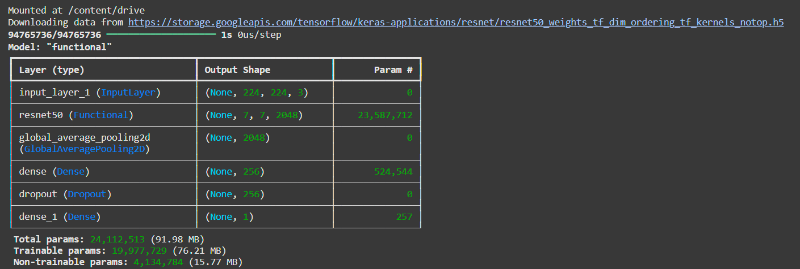

This output is of VS CODE we did it on google colab also… for 2head output came but for 4,8 head it took 12 hours and automatically stopped so we did it on VS CODE
15 Epoch Output
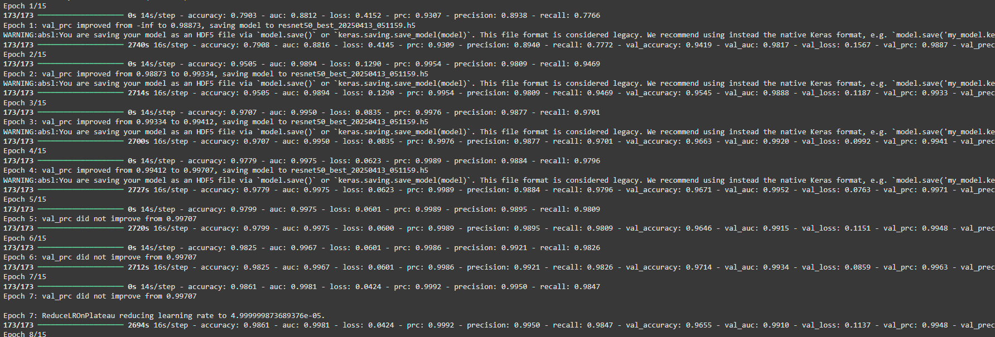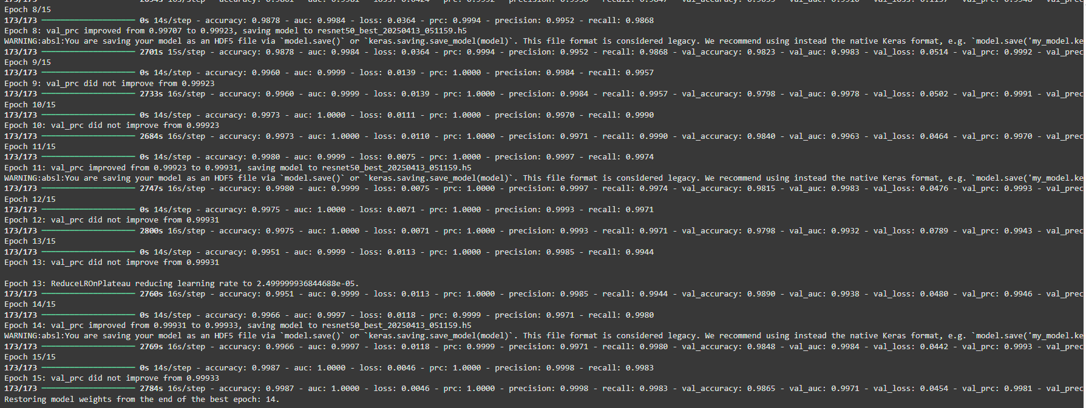

Accuracy , Loss, ROC-AUC, PR-AUC, Precision, Recall Graphs
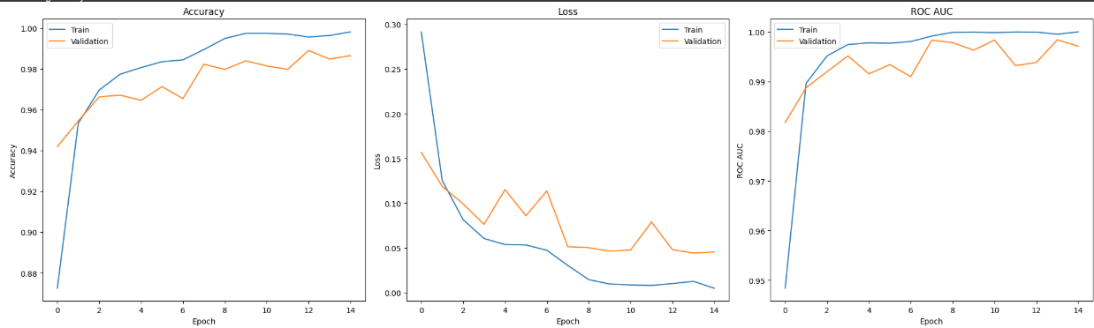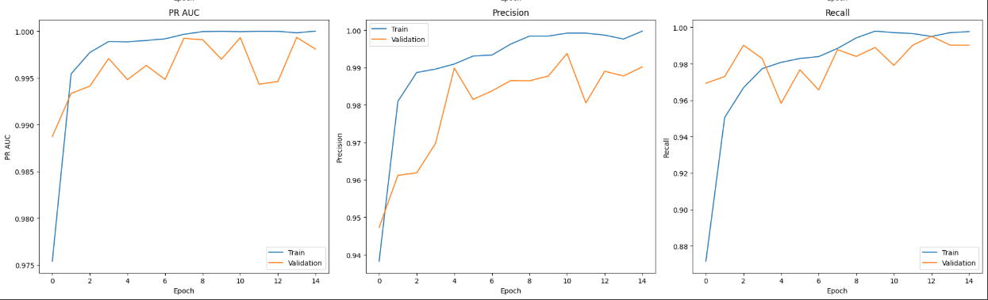

Test-Set Evaluation
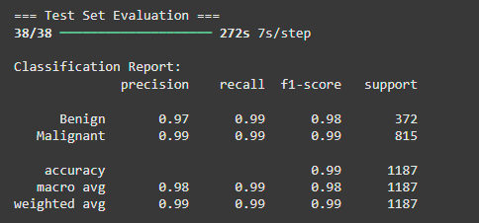

Confusion Matrix

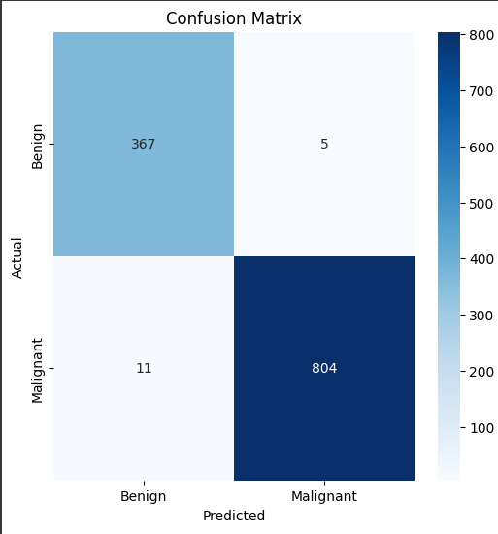

ROC Curve

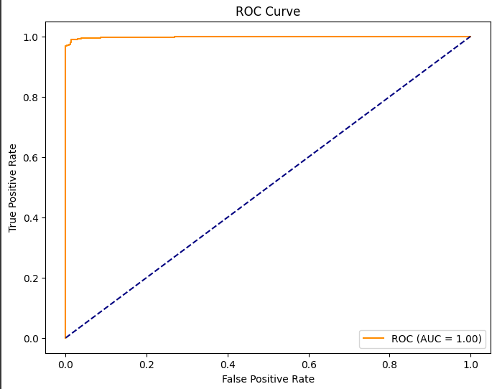

Precision-Recall Curve
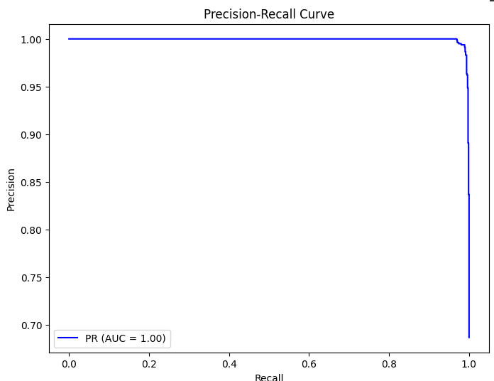

Confusion Matrix for 40x
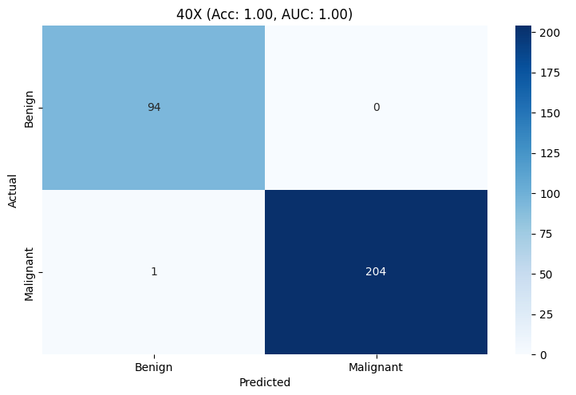

Confusion Matrix for 100x
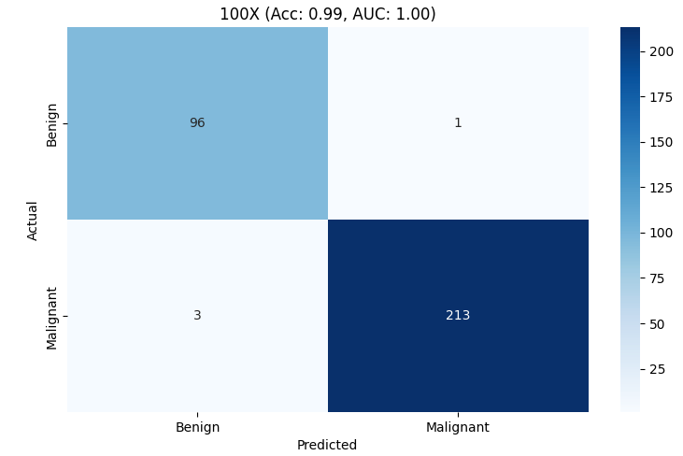

Confusion Matrix for 200x

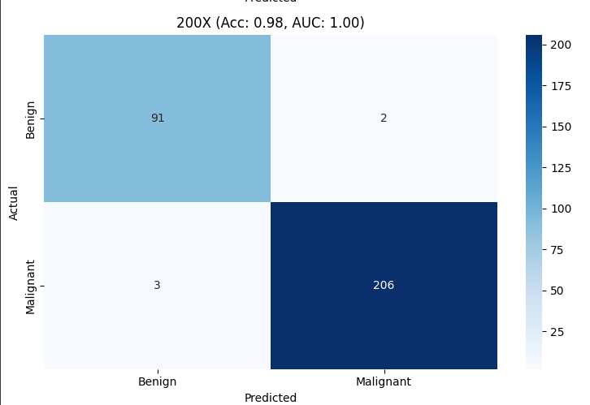

Confusion Matrix for 400x
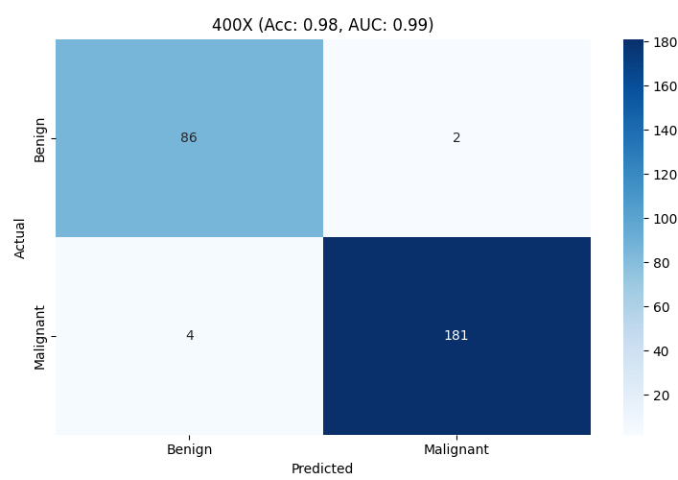

Magnification Level Performance
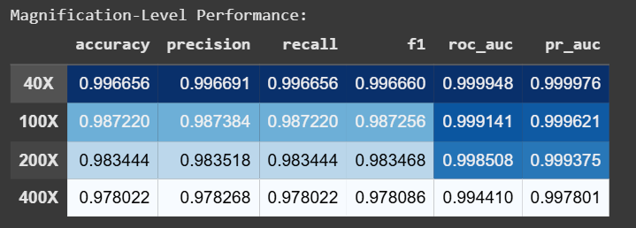

Final Model Summary
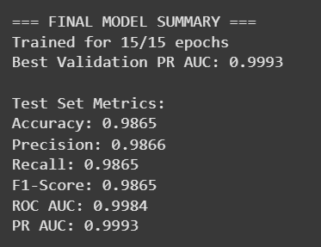

Conclusion

7 Layers CNN Final Test Set Evaluation
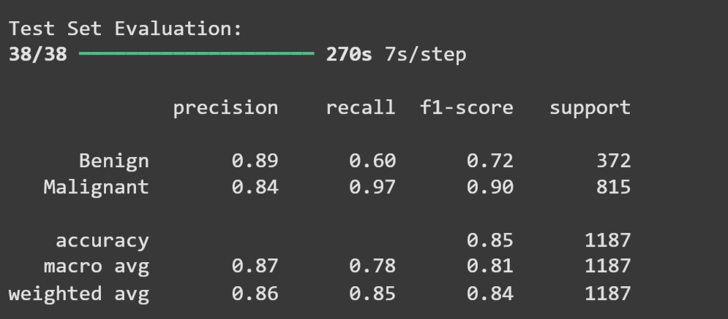

Different Magnification Final Result

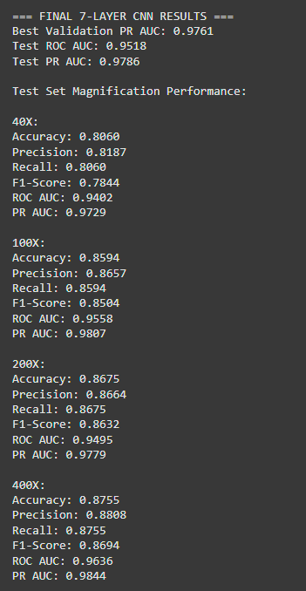

Task 2
Sub – Task – 3

Objective: Implement a custom model using Multi-Head Attention for image classification.
o Integrate Multi-Head Attention in a CNN architecture to allow the model to focus on important regions in images.
o Experiment with different numbers of attention heads and their impact on performance.
o Evaluate model performance using precision, recall, and F1 score.
• Expected Output: Performance analysis and comparison with a basic CNN model.

Breast Cancer Detection Using CNN + Multi-Head Attention Mechanism

Project Overview
This project explores a hybrid deep learning approach combining a Convolutional Neural Network (CNN) with a Multi-Head Self-Attention Mechanism to classify histopathological breast cancer images as benign or malignant.
The dataset consists of labeled .png images captured at varying magnification levels: 40X, 100X, 200X, and 400X. The images are organized by both class (benign/malignant) and magnification, allowing for targeted analysis across resolutions.
The data is split in a stratified manner to maintain label and magnification balance across:
- 70% Training Set: Model learning
- 15% Validation Set: Hyperparameter tuning and overfitting monitoring
- 15% Test Set: Final evaluation
A key experiment involves training multiple versions of the model with different numbers of attention heads:
- 2 Attention Heads
- 4 Attention Heads
- 8 Attention Heads
Each configuration is trained and evaluated using metrics such as accuracy, precision, recall, ROC AUC, and PR AUC. The model's generalization across magnification levels is further examined through a magnification-specific performance breakdown.

1. Dataset Preparation
Dataset Structure
- Classes: Benign / Malignant
- Magnifications: 40X, 100X, 200X, 400X
- Format: .png images organized in subfolders
Data Pipeline
The pipeline:
- Walks through all subdirectories to gather image paths and metadata
- Extracts:
  - Label from folder names (benign = 0, malignant = 1)
  - Magnification level from parent folder
- Creates a Pandas DataFrame with:
  - path, label, and magnification
Stratified Splitting
Ensures balanced distribution across:
- Training Set (70%)
- Validation Set (15%)
- Test Set (15%) Stratified based on both label and magnification.
Image Preprocessing
- Resize to 224×224 pixels
- Preprocess using ResNet50 standards for consistency
- Augmentation (applied only to training data):
  - Horizontal and vertical flips
  - Brightness/contrast adjustments

2. Model Architecture – CNN + Attention
Core Structure
- Input Shape: (224, 224, 3)
- CNN Feature Extractor:
  - 3 blocks of Conv2D → BatchNorm → MaxPooling → Dropout
  - Increasing filters: 32 → 64 → 128
Multi-Head Attention Block
- Reshapes CNN output into sequences
- Applies Multi-Head Scaled Dot-Product Self-Attention
- Configurable with 2, 4, or 8 heads
- Outputs reshaped and added back via residual (skip) connection
Classification Head
- Global Average Pooling
- Dense Layer: 256 units + Dropout(0.5)
- Output Layer: 1 neuron with sigmoid activation
Evaluation Metrics
- Accuracy
- Precision
- Recall
- ROC AUC
- PR AUC (Precision-Recall AUC)

3. Training Setup
Optimizer & Loss
- Optimizer: Adam, learning rate = 1e-4
- Loss: Binary Crossentropy
Callbacks
- EarlyStopping: Patience = 5, monitored on validation PR AUC
- ModelCheckpoint: Saves best model based on val PR AUC
- ReduceLROnPlateau: Reduces LR if plateau detected
- TensorBoard & CSVLogger: For visualization and logging

4. Model Training
- Each model trained for 15 epochs
- Tracked: loss, accuracy, precision, recall, ROC AUC, PR AUC
- Attention heads evaluated: 2, 4, 8
- Class weights applied to handle class imbalance
Training Curves
Loss and metrics plotted across epochs for both:
- Training
- Validation

5. Results & Evaluation
Evaluation on Test Set
- Classification Report: Precision, recall, F1-score per class
- Confusion Matrix: Visual breakdown of predictions
- ROC Curve: Plots TPR vs FPR, calculates AUC
- Precision-Recall Curve: Visualizes model confidence
Magnification-Specific Analysis
For each magnification level (40X, 100X, 200X, 400X), the following are computed:
- Accuracy
- Precision
- Recall
- F1 Score
- ROC AUC
- PR AUC
Each level is visualized via individual confusion matrices.

CODE

import tensorflow as tf
from tensorflow.keras import layers, models, optimizers, callbacks
from tensorflow.keras.utils import plot_model
from sklearn.model_selection import train_test_split
from sklearn.metrics import classification_report, confusion_matrix, roc_curve, auc, precision_recall_curve
from sklearn.utils import class_weight
import numpy as np
import pandas as pd
import matplotlib.pyplot as plt
import seaborn as sns
import os
from datetime import datetime

# Constants
BASE_DIR = "/Users/AI_PROJECT/dataset"
MAGNIFICATIONS = ['40X', '100X', '200X', '400X']
IMG_SIZE = (224, 224)
BATCH_SIZE = 32
EPOCHS = 15
TEST_SIZE = 0.15
VAL_SIZE = 0.15
SEED = 42

# Set random seeds
tf.random.set_seed(SEED)
np.random.seed(SEED)

# 1. Fixed Multi-Head Attention Layer
class MultiHeadSelfAttention(layers.Layer):
def __init__(self, embed_dim, num_heads=8):
super(MultiHeadSelfAttention, self).__init__()
self.embed_dim = embed_dim
self.num_heads = num_heads
if embed_dim % num_heads != 0:
raise ValueError(
f"embedding dimension = {embed_dim} should be divisible by number of heads = {num_heads}"
)
self.projection_dim = embed_dim // num_heads
self.query_dense = layers.Dense(embed_dim)
self.key_dense = layers.Dense(embed_dim)
self.value_dense = layers.Dense(embed_dim)
self.combine_heads = layers.Dense(embed_dim)

def attention(self, query, key, value):
score = tf.matmul(query, key, transpose_b=True)
dim_key = tf.cast(tf.shape(key)[-1], tf.float32)
scaled_score = score / tf.math.sqrt(dim_key)
weights = tf.nn.softmax(scaled_score, axis=-1)
output = tf.matmul(weights, value)
return output, weights

def separate_heads(self, x, batch_size):
x = tf.reshape(x, (batch_size, -1, self.num_heads, self.projection_dim))
return tf.transpose(x, perm=[0, 2, 1, 3])

def call(self, inputs):
# Get batch size from tensor shape
batch_size = tf.shape(inputs)[0]

# Linear transformations
query = self.query_dense(inputs)
key = self.key_dense(inputs)
value = self.value_dense(inputs)

# Split into multiple heads
query = self.separate_heads(query, batch_size)
key = self.separate_heads(key, batch_size)
value = self.separate_heads(value, batch_size)

# Scaled dot-product attention
attention, weights = self.attention(query, key, value)
attention = tf.transpose(attention, perm=[0, 2, 1, 3])

# Concatenate heads
concat_attention = tf.reshape(attention, (batch_size, -1, self.embed_dim))

# Final linear layer
output = self.combine_heads(concat_attention)
return output

# 2. CNN + Attention Model
def build_cnn_attention_model(num_heads=4):
inputs = layers.Input(shape=(224, 224, 3))

# CNN Feature Extraction
x = layers.Conv2D(32, (3,3), activation='relu', padding='same')(inputs)
x = layers.BatchNormalization()(x)
x = layers.Conv2D(32, (3,3), activation='relu', padding='same')(x)
x = layers.MaxPooling2D((2,2))(x)
x = layers.Dropout(0.2)(x)

x = layers.Conv2D(64, (3,3), activation='relu', padding='same')(x)
x = layers.BatchNormalization()(x)
x = layers.Conv2D(64, (3,3), activation='relu', padding='same')(x)
x = layers.MaxPooling2D((2,2))(x)
x = layers.Dropout(0.3)(x)

# Prepare for attention
x = layers.Conv2D(128, (3,3), activation='relu', padding='same')(x)
x = layers.BatchNormalization()(x)
x = layers.Conv2D(128, (3,3), activation='relu', padding='same')(x)
x = layers.MaxPooling2D((2,2))(x)
x = layers.Dropout(0.4)(x)

# Attention Block (Fixed Implementation)
batch_size, h, w, c = tf.keras.backend.int_shape(x)
x_reshaped = layers.Reshape((h*w, c))(x)
attention_output = MultiHeadSelfAttention(embed_dim=c, num_heads=num_heads)(x_reshaped)
attention_output = layers.Reshape((h, w, c))(attention_output)

# Skip connection
x = layers.Add()([x, attention_output])
x = layers.Activation('relu')(x)

# Classification Head
x = layers.GlobalAveragePooling2D()(x)
x = layers.Dense(256, activation='relu')(x)
x = layers.Dropout(0.5)(x)
outputs = layers.Dense(1, activation='sigmoid')(x)

model = models.Model(inputs, outputs)

model.compile(
optimizer=optimizers.Adam(learning_rate=1e-4),
loss='binary_crossentropy',
metrics=[
'accuracy',
tf.keras.metrics.Precision(name='precision'),
tf.keras.metrics.Recall(name='recall'),
tf.keras.metrics.AUC(name='auc'),
tf.keras.metrics.AUC(name='prc', curve='PR')
]
)

return model

# ==================== 3. Data Pipeline ====================
def create_data_pipeline(base_dir):
data = []
for root, dirs, files in os.walk(base_dir):
current_mag = next((mag for mag in MAGNIFICATIONS if mag in root), None)
if current_mag:
for file in files:
if file.lower().endswith('.png') and not file.startswith('._'):
label = 0 if 'benign' in root.lower() else 1
data.append({
'path': os.path.join(root, file),
'label': label,
'magnification': current_mag
})

df = pd.DataFrame(data)

if df.empty:
raise ValueError(f"No images found in directory: {base_dir}. Please check your path.")

# Stratified split
stratify_col = df['label'].astype(str) + '_' + df['magnification']
train_val_df, test_df = train_test_split(
df, test_size=TEST_SIZE, stratify=stratify_col, random_state=SEED
)
train_df, val_df = train_test_split(
train_val_df,
test_size=VAL_SIZE/(1-TEST_SIZE),
stratify=train_val_df['label'].astype(str) + '_' + train_val_df['magnification'],
random_state=SEED
)

# Class weights
class_weights = class_weight.compute_class_weight(
'balanced',
classes=np.unique(train_df['label']),
y=train_df['label']
)
class_weights = dict(enumerate(class_weights))

# Image processing
def preprocess_image(path, label):
image = tf.io.read_file(path)
image = tf.image.decode_png(image, channels=3)
image = tf.image.resize(image, IMG_SIZE)
image = tf.keras.applications.resnet50.preprocess_input(image)
return image, label

def augment_image(image, label):
image = tf.image.random_flip_left_right(image)
image = tf.image.random_flip_up_down(image)
image = tf.image.random_brightness(image, 0.1)
image = tf.image.random_contrast(image, 0.9, 1.1)
return image, label

def df_to_dataset(df, shuffle=True, augment=False):
ds = tf.data.Dataset.from_tensor_slices((df['path'].values, df['label'].values))
if shuffle:
ds = ds.shuffle(buffer_size=len(df), seed=SEED)
ds = ds.map(preprocess_image, num_parallel_calls=tf.data.AUTOTUNE)
if augment:
ds = ds.map(augment_image, num_parallel_calls=tf.data.AUTOTUNE)
ds = ds.batch(BATCH_SIZE)
ds = ds.prefetch(tf.data.AUTOTUNE)
return ds

train_ds = df_to_dataset(train_df, shuffle=True, augment=True)
val_ds = df_to_dataset(val_df, shuffle=False)
test_ds = df_to_dataset(test_df, shuffle=False)

print(f"\nDataset sizes:")
print(f"Training: {len(train_df)} images")
print(f"Validation: {len(val_df)} images")
print(f"Test: {len(test_df)} images")
print(f"Class weights: {class_weights}")

return train_ds, val_ds, test_ds, test_df, class_weights

# 4. Training & Evaluation
def plot_training_history(history):
plt.figure(figsize=(20, 12))
metrics = ['loss', 'accuracy', 'precision', 'recall', 'auc', 'prc']
for i, metric in enumerate(metrics, 1):
plt.subplot(2, 3, i)
plt.plot(history.history[metric], label='Train')
plt.plot(history.history[f'val_{metric}'], label='Validation')
plt.title(metric.capitalize())
plt.xlabel('Epoch')
plt.legend()
plt.tight_layout()
plt.show()

def evaluate_model(model, dataset, df):
print("\nGenerating predictions...")
y_probs = model.predict(dataset).flatten()
y_pred = (y_probs > 0.5).astype(int)
y_true = df['label'].values

print("\nClassification Report:")
print(classification_report(y_true, y_pred, target_names=['Benign', 'Malignant']))

plt.figure(figsize=(6,6))
cm = confusion_matrix(y_true, y_pred)
sns.heatmap(cm, annot=True, fmt='d', cmap='Blues',
xticklabels=['Benign', 'Malignant'],
yticklabels=['Benign', 'Malignant'])
plt.title('Confusion Matrix')
plt.show()

fpr, tpr, _ = roc_curve(y_true, y_probs)
roc_auc = auc(fpr, tpr)
plt.figure(figsize=(8,6))
plt.plot(fpr, tpr, label=f'ROC Curve (AUC = {roc_auc:.2f})')
plt.plot([0, 1], [0, 1], 'k--')
plt.xlabel('False Positive Rate')
plt.ylabel('True Positive Rate')
plt.title('ROC Curve')
plt.legend()
plt.show()

precision, recall, _ = precision_recall_curve(y_true, y_probs)
pr_auc = auc(recall, precision)
plt.figure(figsize=(8,6))
plt.plot(recall, precision, label=f'PR Curve (AUC = {pr_auc:.2f})')
plt.xlabel('Recall')
plt.ylabel('Precision')
plt.title('Precision-Recall Curve')
plt.legend()
plt.show()

return {
'y_true': y_true,
'y_pred': y_pred,
'y_probs': y_probs,
'roc_auc': roc_auc,
'pr_auc': pr_auc
}

def magnification_analysis(df, y_true, y_pred, y_probs):
results = {}
plt.figure(figsize=(15, 10))
for i, mag in enumerate(MAGNIFICATIONS, 1):
mask = df['magnification'] == mag
if sum(mask) == 0:
continue

y_true_mag = y_true[mask]
y_pred_mag = y_pred[mask]
y_probs_mag = y_probs[mask]

report = classification_report(y_true_mag, y_pred_mag, output_dict=True)
fpr, tpr, _ = roc_curve(y_true_mag, y_probs_mag)
roc_auc = auc(fpr, tpr)
precision, recall, _ = precision_recall_curve(y_true_mag, y_probs_mag)
pr_auc = auc(recall, precision)

results[mag] = {
'accuracy': report['accuracy'],
'precision': report['weighted avg']['precision'],
'recall': report['weighted avg']['recall'],
'f1': report['weighted avg']['f1-score'],
'roc_auc': roc_auc,
'pr_auc': pr_auc
}

plt.subplot(2, 2, i)
cm = confusion_matrix(y_true_mag, y_pred_mag)
sns.heatmap(cm, annot=True, fmt='d', cmap='Blues',
xticklabels=['Benign', 'Malignant'],
yticklabels=['Benign', 'Malignant'])
plt.title(f'{mag} (Acc: {report["accuracy"]:.2f}, AUC: {roc_auc:.2f})')

plt.tight_layout()
plt.show()

# Create comparison table
metrics_df = pd.DataFrame(results).T
print("\nMagnification-Level Performance:")
print(metrics_df)

return results

# 5. Main Execution
if __name__ == "__main__":
try:
# Create datasets
train_dataset, val_dataset, test_dataset, test_df, class_weights = create_data_pipeline(BASE_DIR)

# Test different numbers of attention heads
for num_heads in [2, 4, 8]:
print(f"\n{'='*60}")
print(f"Training Model with {num_heads} Attention Heads")
print(f"{'='*60}")

# Build and train model
model = build_cnn_attention_model(num_heads=num_heads)

# Callbacks
timestamp = datetime.now().strftime("%Y%m%d_%H%M%S")
callbacks = [
callbacks.EarlyStopping(
monitor='val_prc',
patience=5,
mode='max',
restore_best_weights=True,
verbose=1
),
callbacks.ModelCheckpoint(
f'attention_{num_heads}heads_best_{timestamp}.h5',
monitor='val_prc',
save_best_only=True,
verbose=1
),
callbacks.TensorBoard(
log_dir=f'logs/attention_{num_heads}heads_{timestamp}',
histogram_freq=1
),
callbacks.CSVLogger(
f'training_log_{num_heads}heads_{timestamp}.csv'
)
]

# Train model
print("\nStarting training...")
history = model.fit(
train_dataset,
validation_data=val_dataset,
epochs=EPOCHS,
callbacks=callbacks,
class_weight=class_weights
)

# Evaluate model
print("\nTraining History:")
plot_training_history(history)

print("\nTest Set Evaluation:")
test_results = evaluate_model(model, test_dataset, test_df)

print("\nMagnification-Level Analysis:")
mag_results = magnification_analysis(test_df, test_results['y_true'],
test_results['y_pred'], test_results['y_probs'])

# Save final model
model.save(f'attention_{num_heads}heads_final_{timestamp}.h5')
print(f"\nModel with {num_heads} attention heads saved successfully.")

except Exception as e:
print(f"\nError encountered: {str(e)}")
print("Please check your dataset path and structure.")

2-HEAD RESULTS
2-Head 15 Epoch
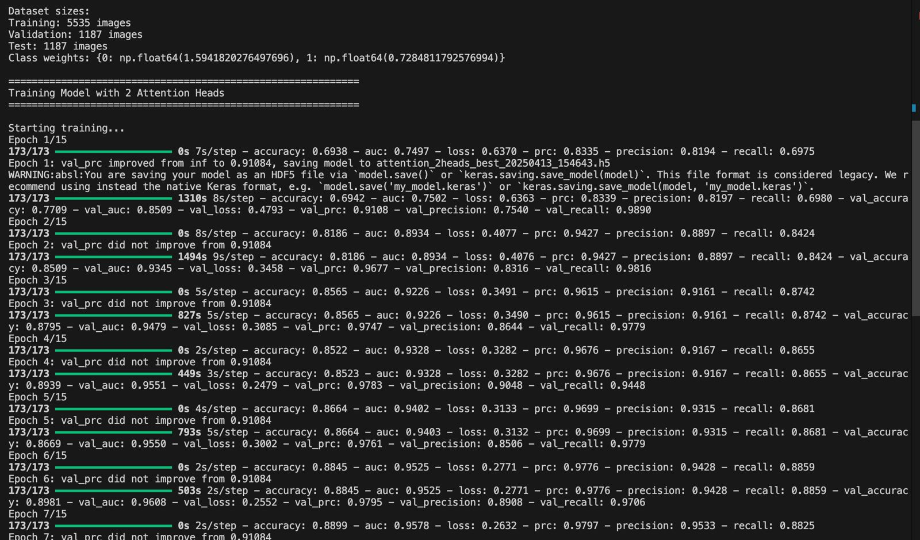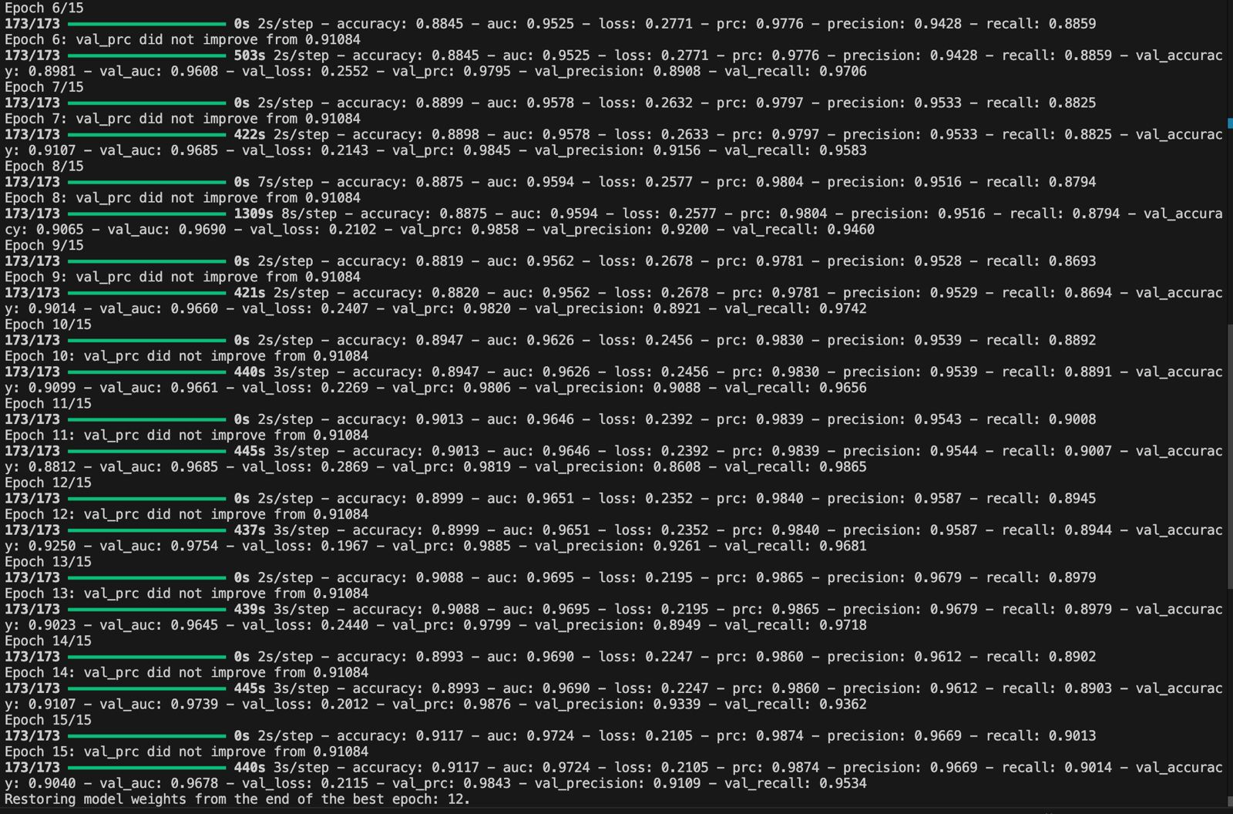

Loss, Accuracy, Precision, Recall, AUC, PR Graph
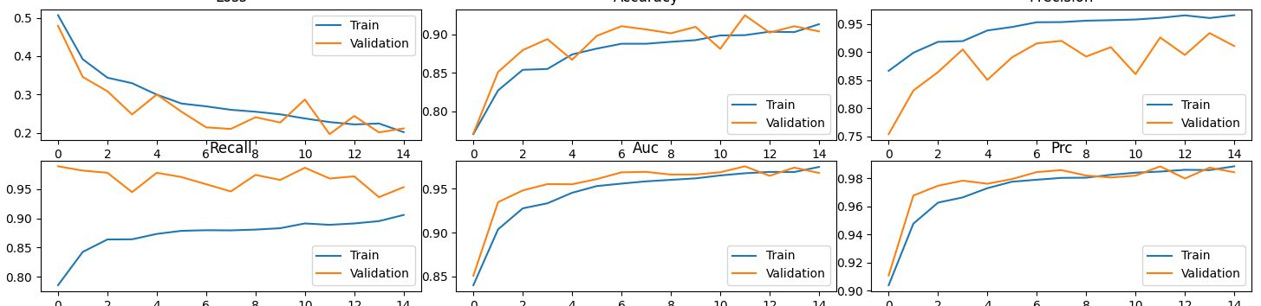

Confusion Matrix
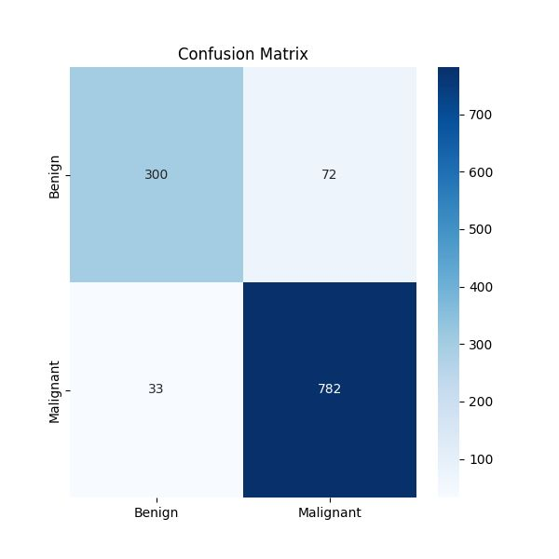

PR Curve
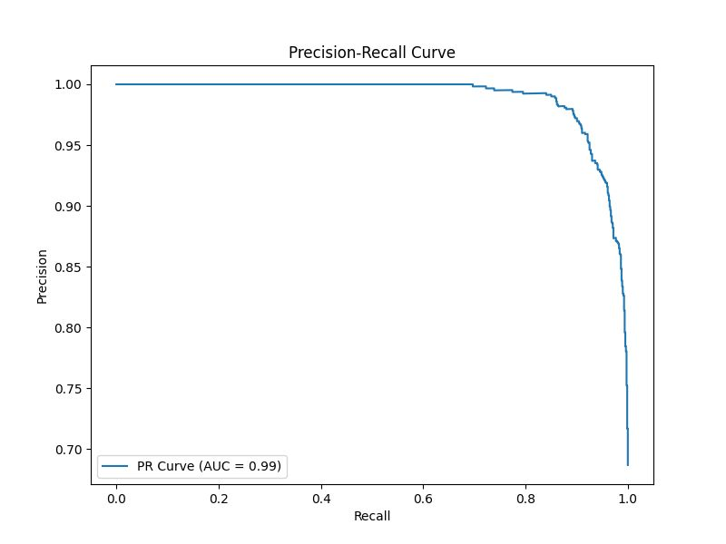ROC Curve
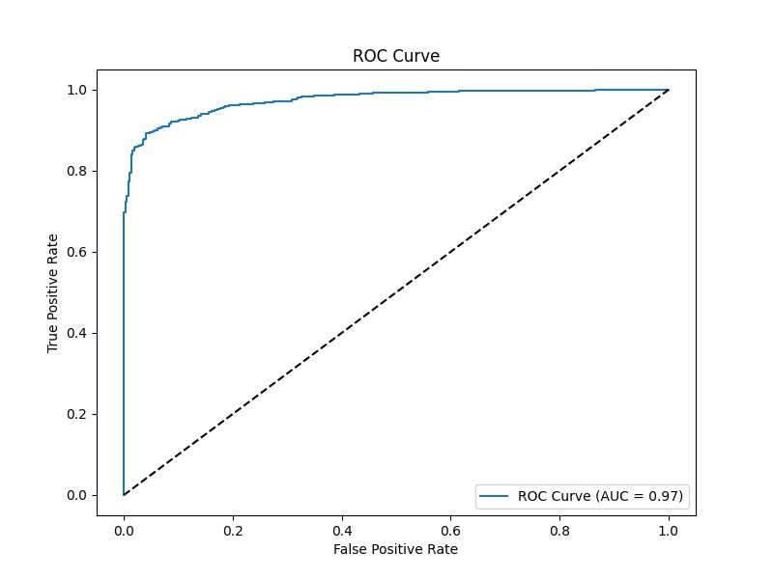
Different Magnification Level Matrix (40x, 100x, 200x, 400x)
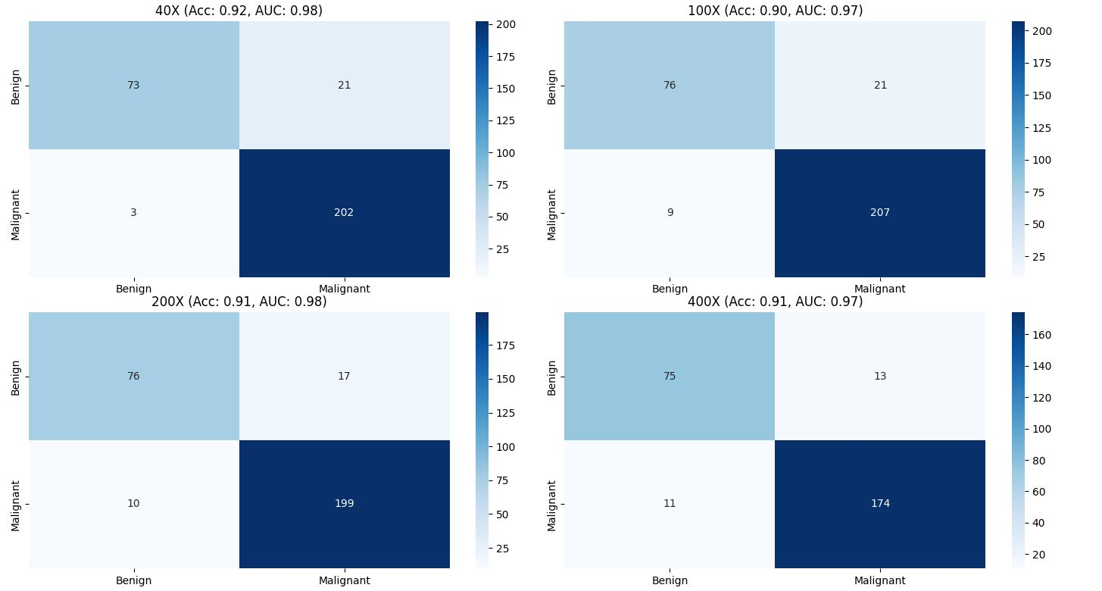

Classification Report

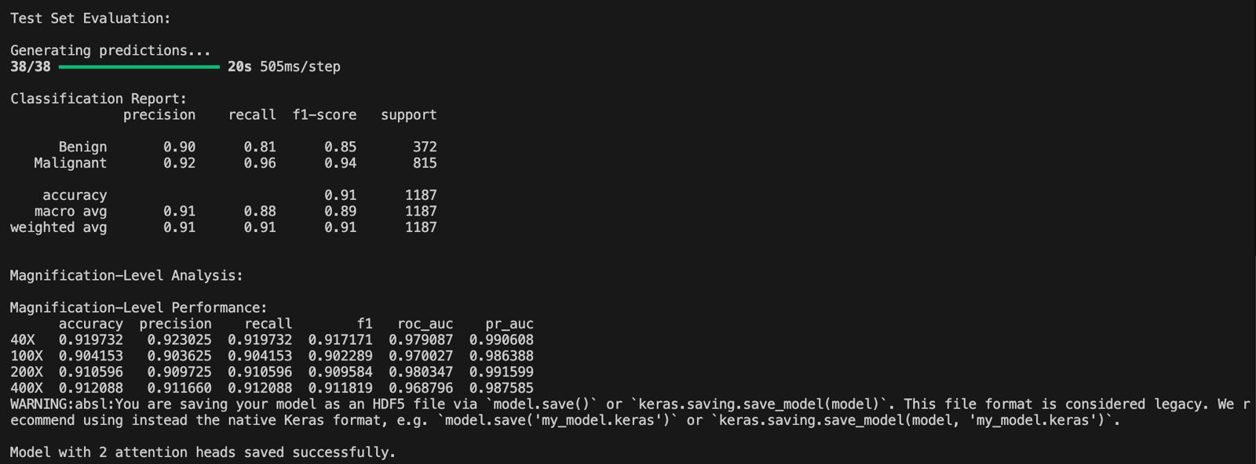

Multilevel Analysis

4-Head Results
15 Epoch
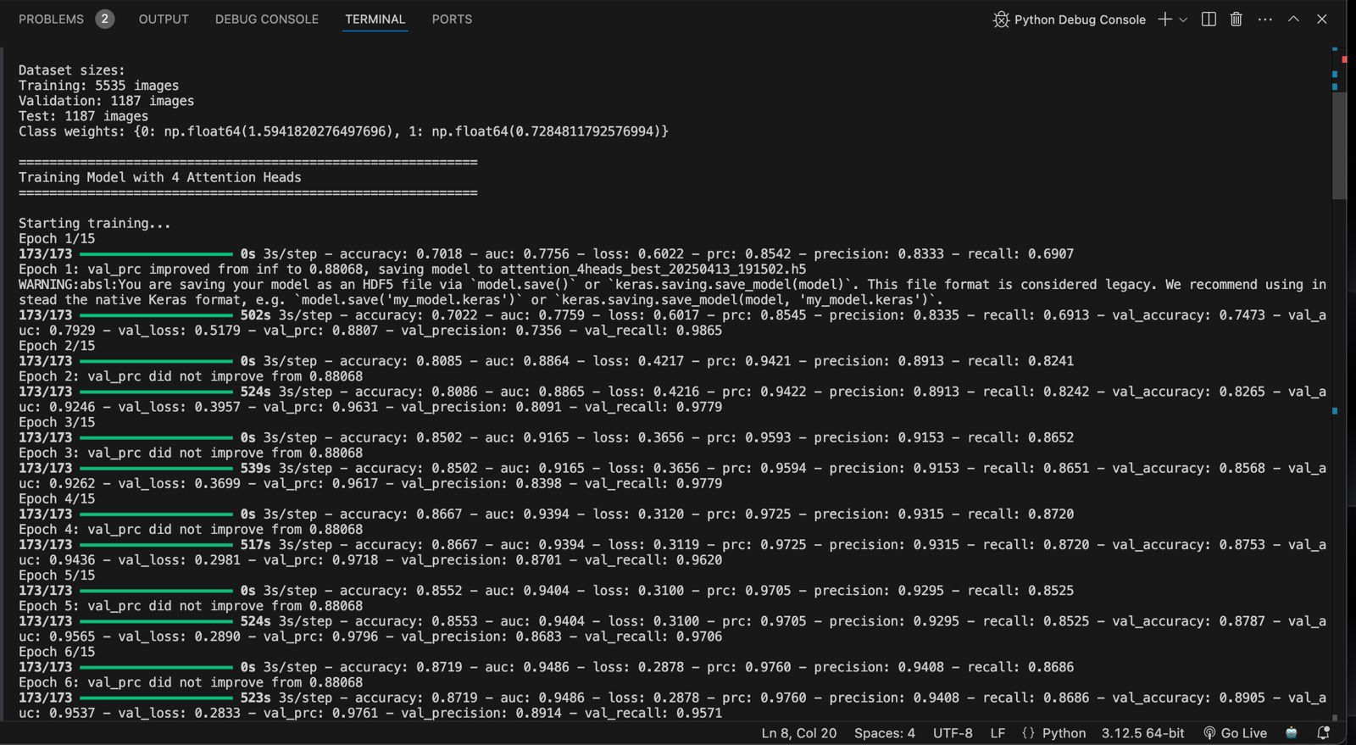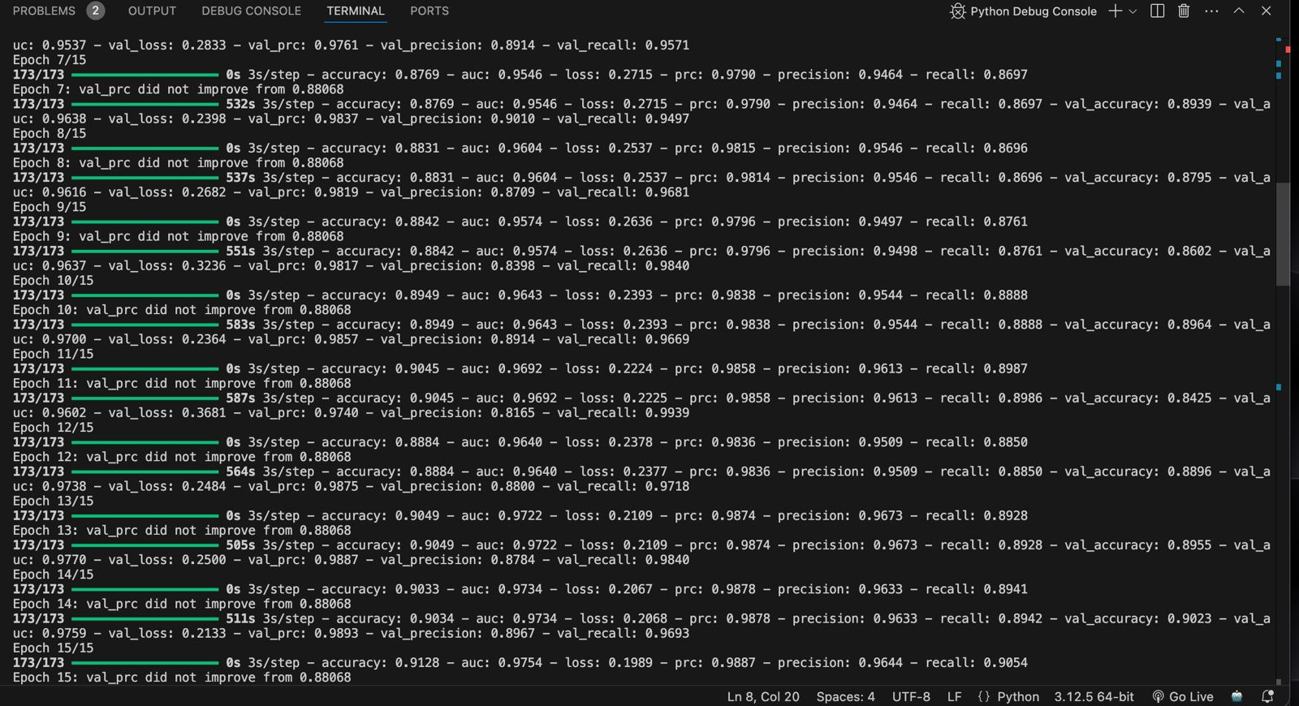

Accuracy, Loss , Precision, Recall, Auc, PR Graph
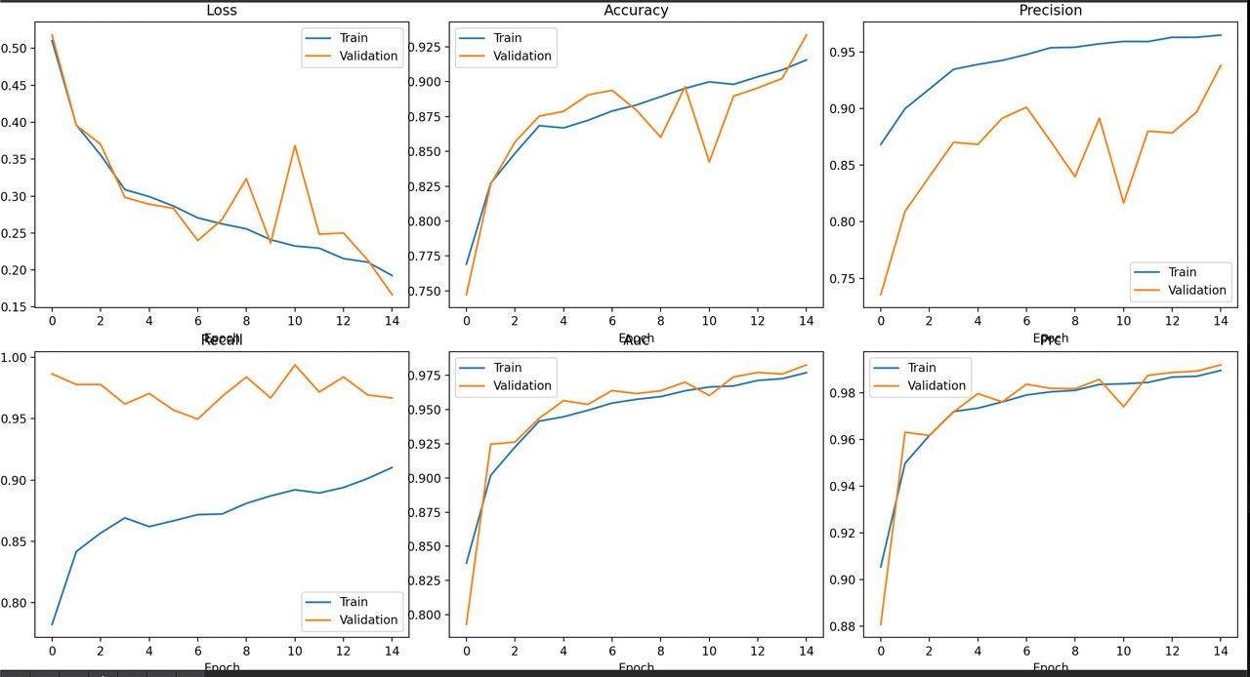

Confusion Matrix
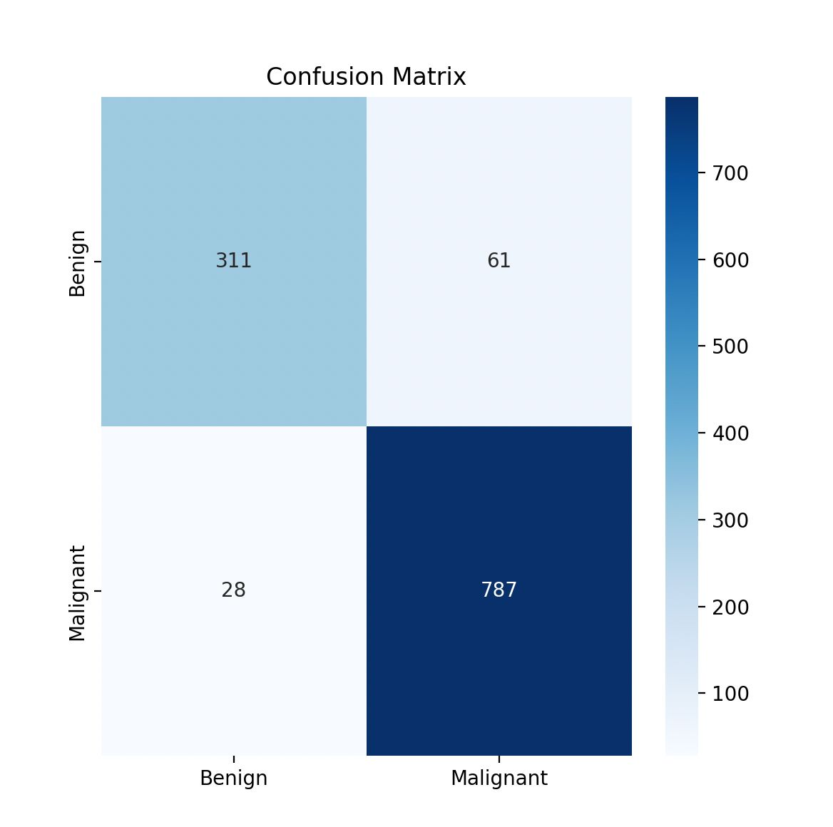
ROC Curve
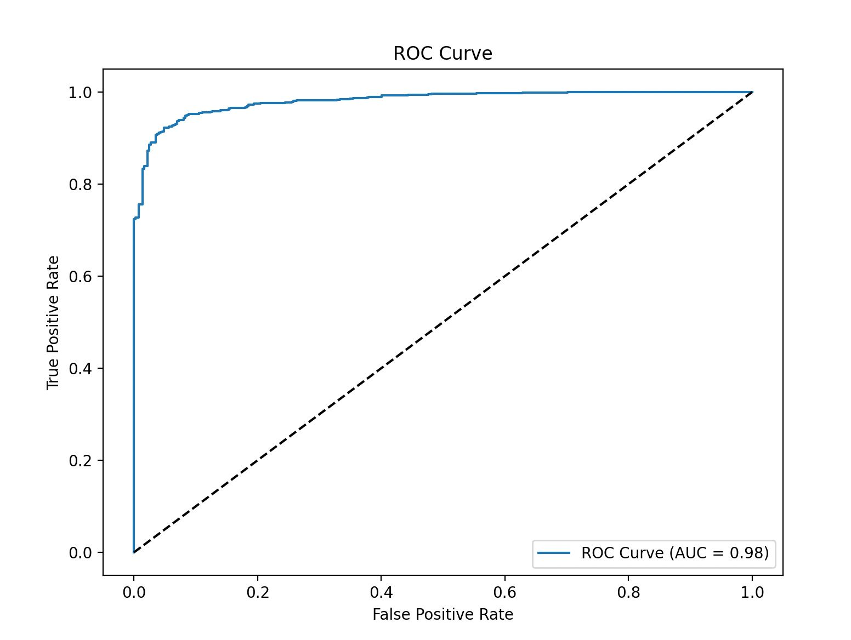
PR Curve
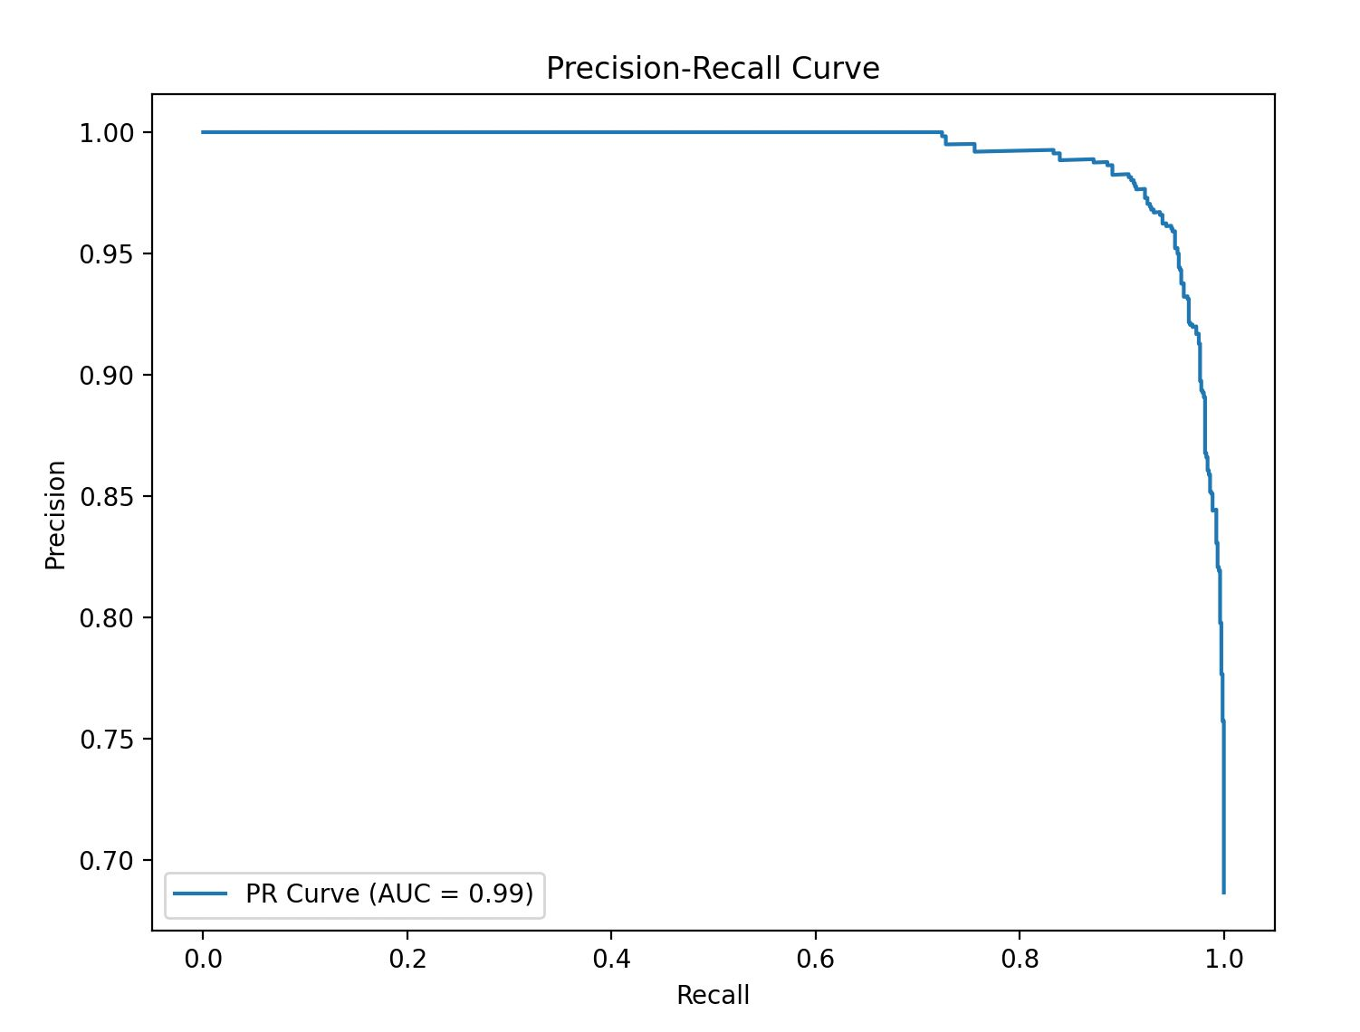
Different Magnification Result(40x, 100x, 200x, 400x)
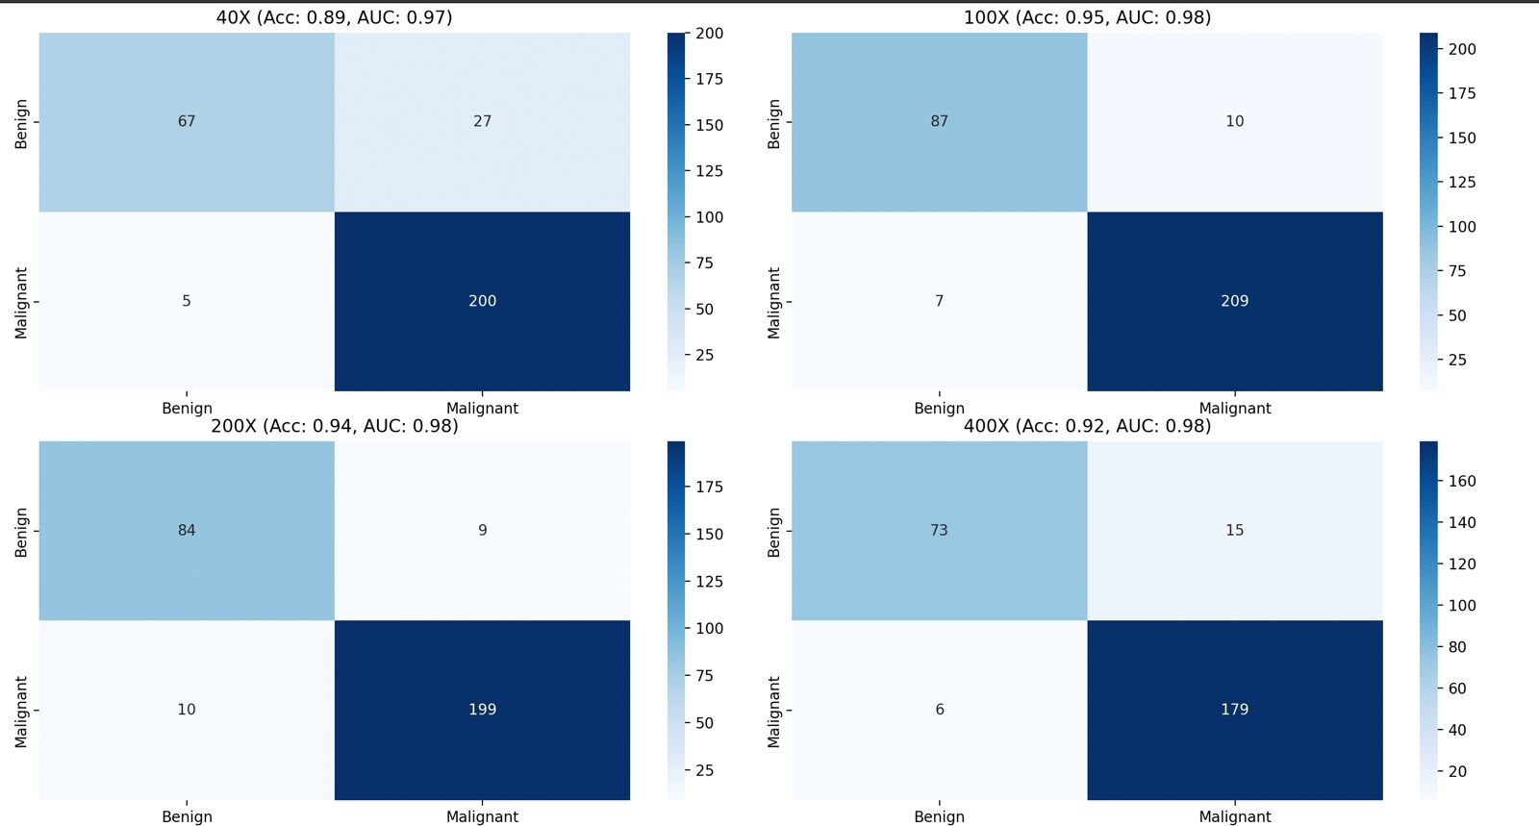

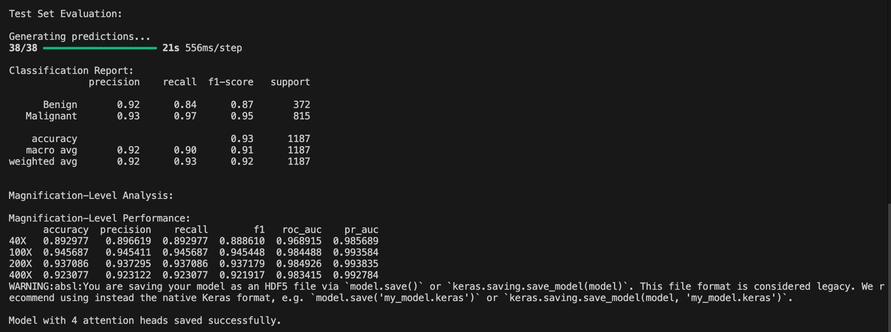

8-Head Results
15 Epoch
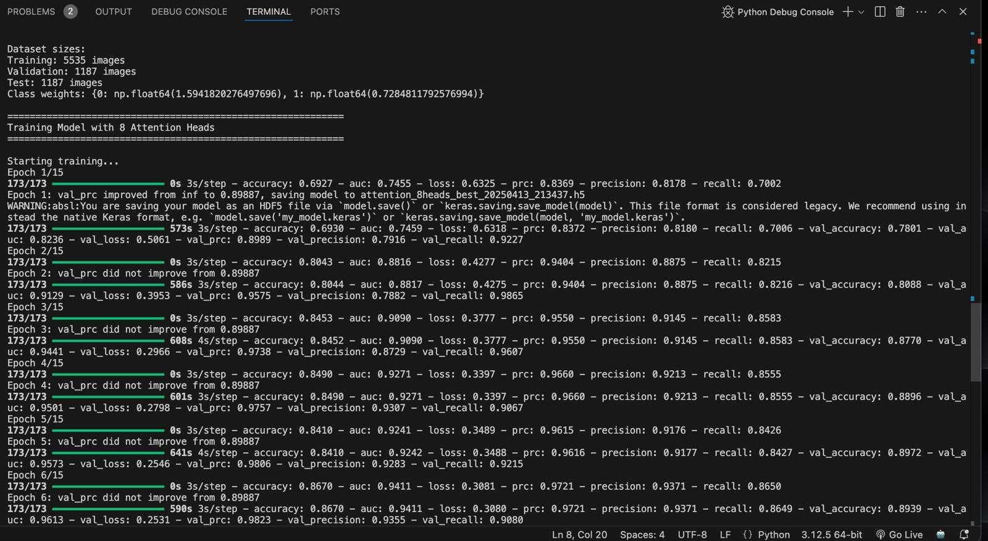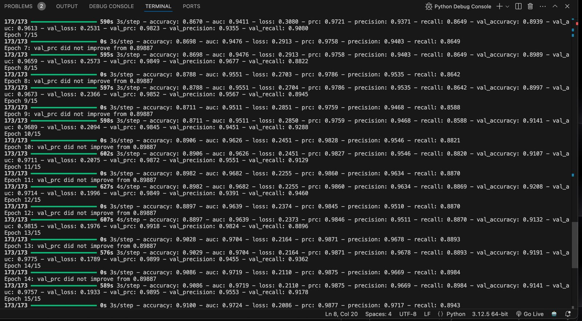

Loss, Accuracy, Precision , Recall, ROC-AUC , PR Graph
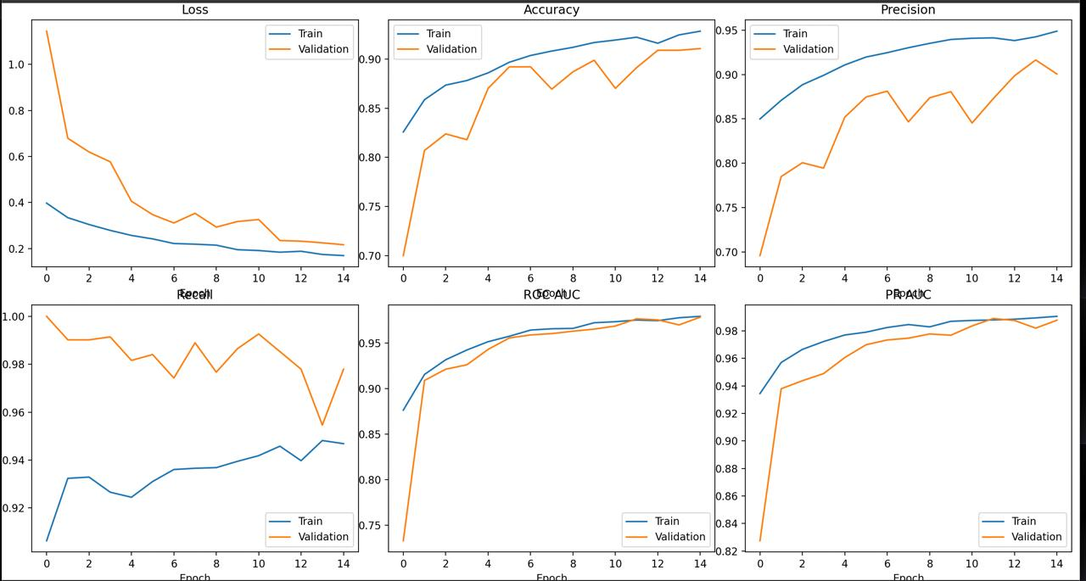

Confusion Matrix
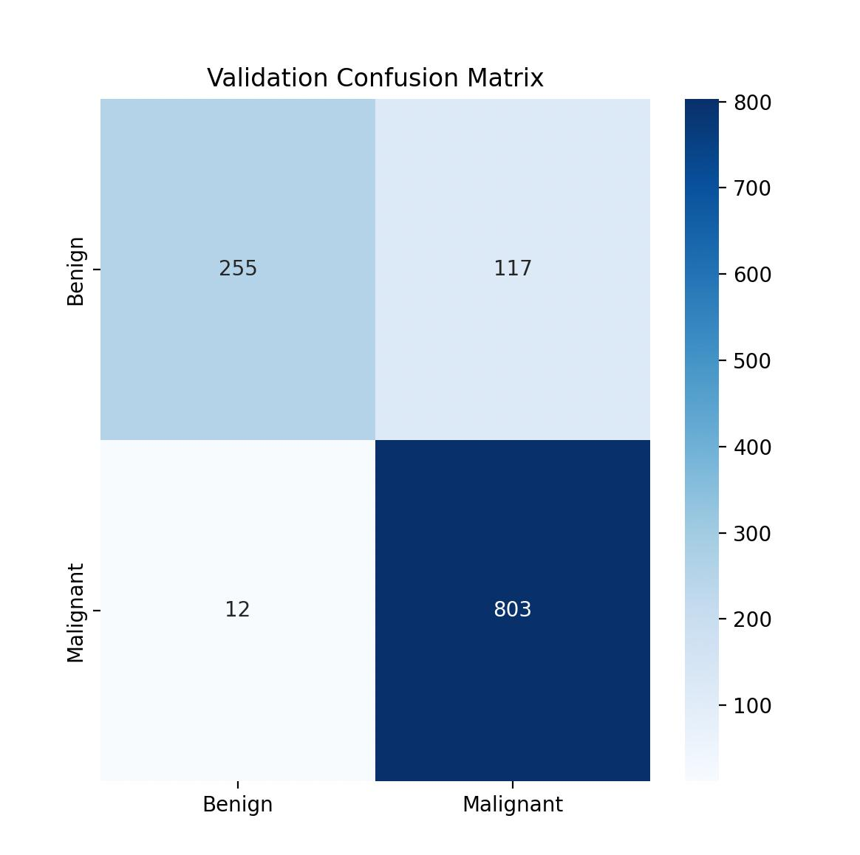
Validation ROC
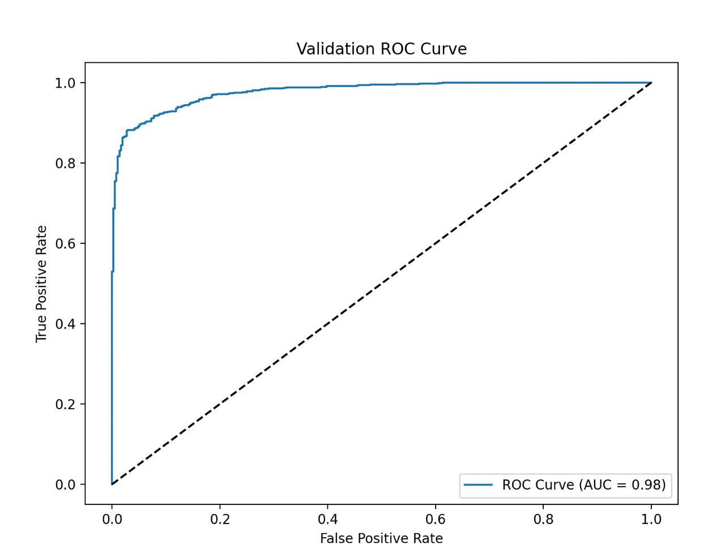
Validation PR
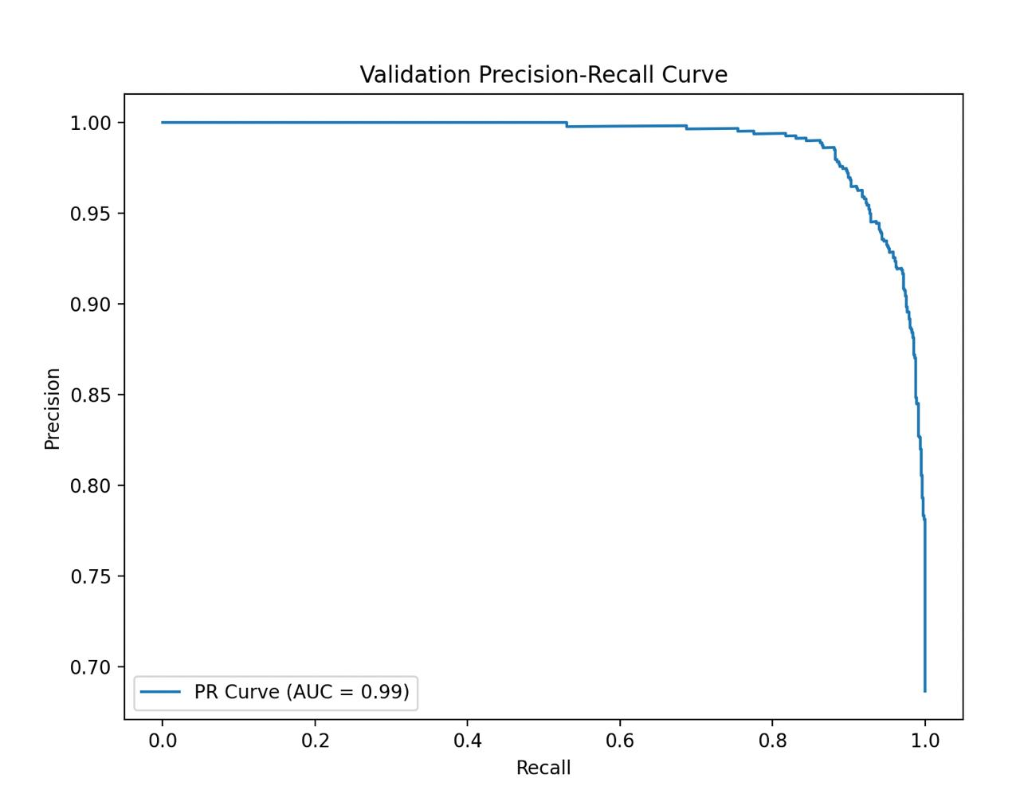
Validation Different Magnification Level (40x, 100x, 200x, 400x)
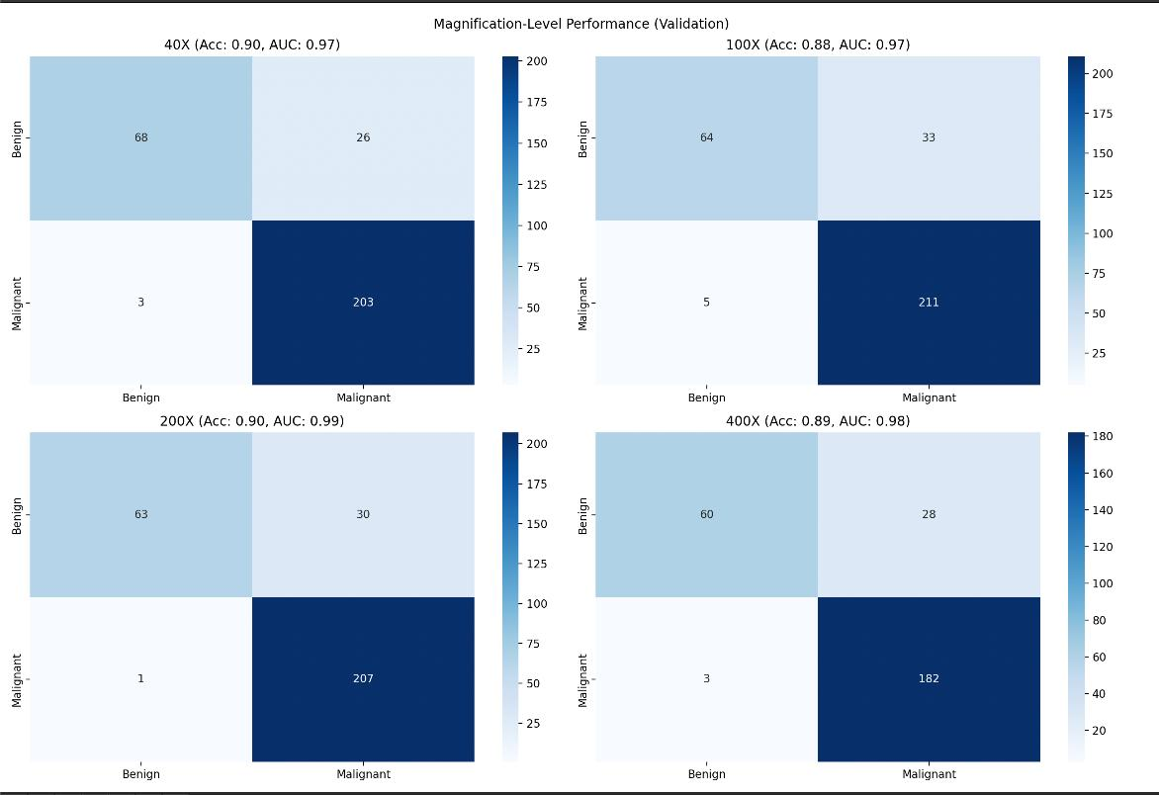

Test Confusion Matrix
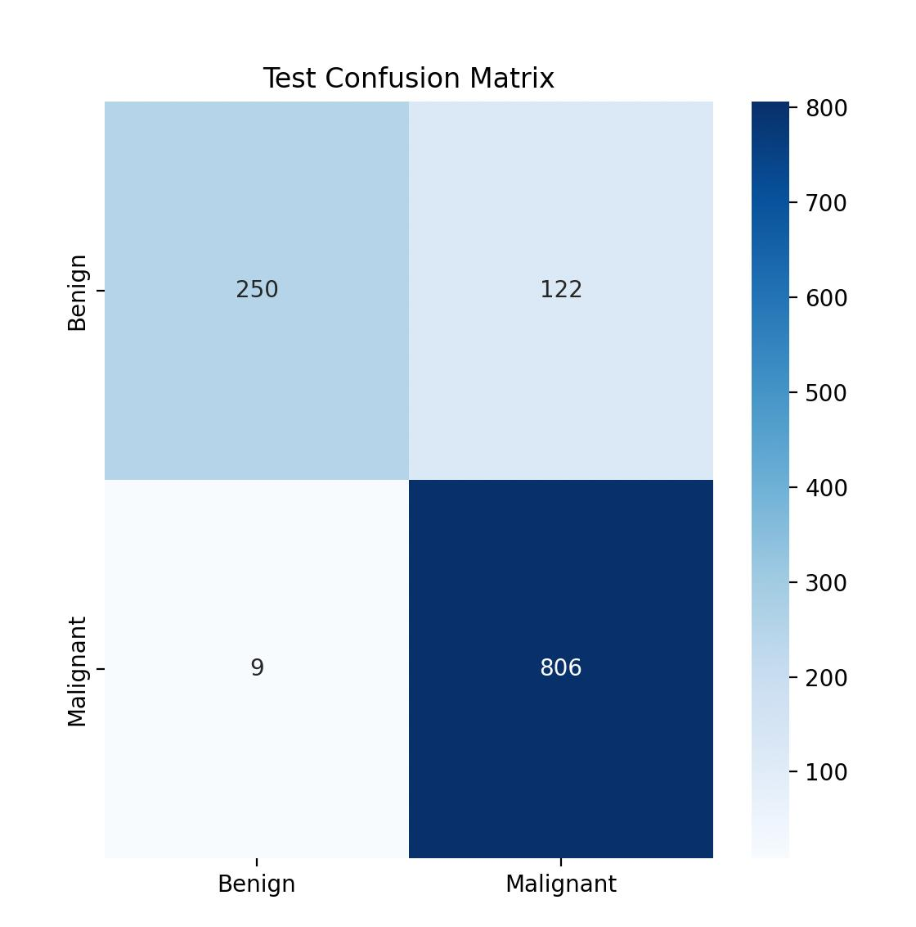

Test ROC
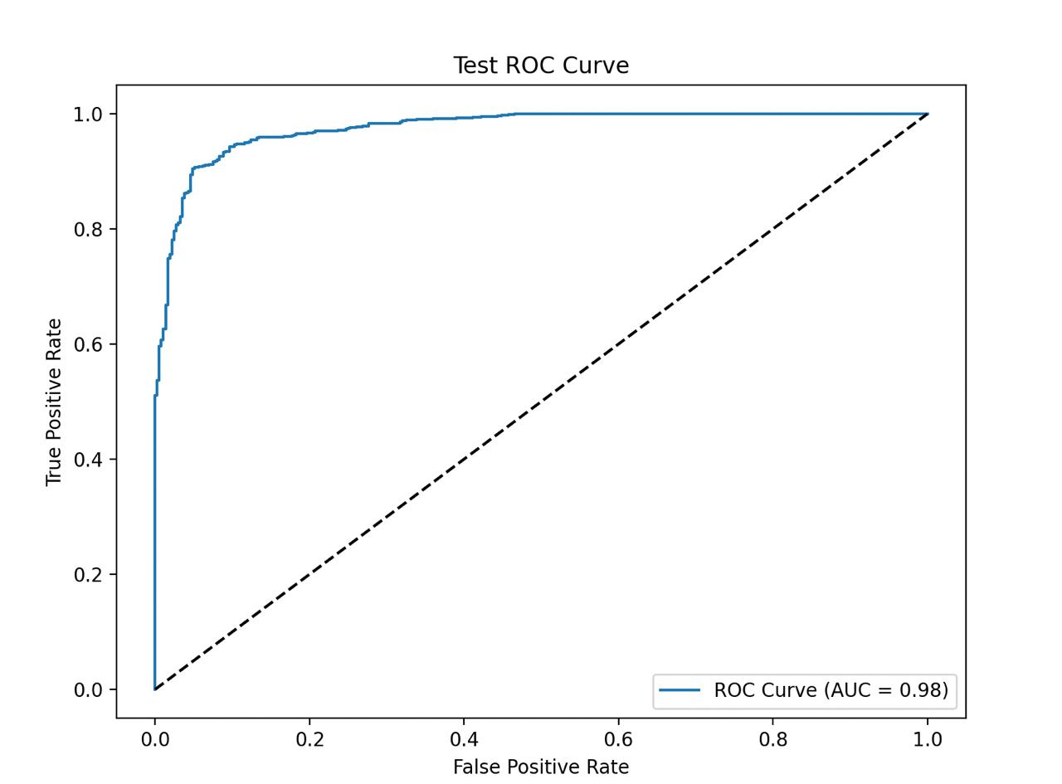
Test PR
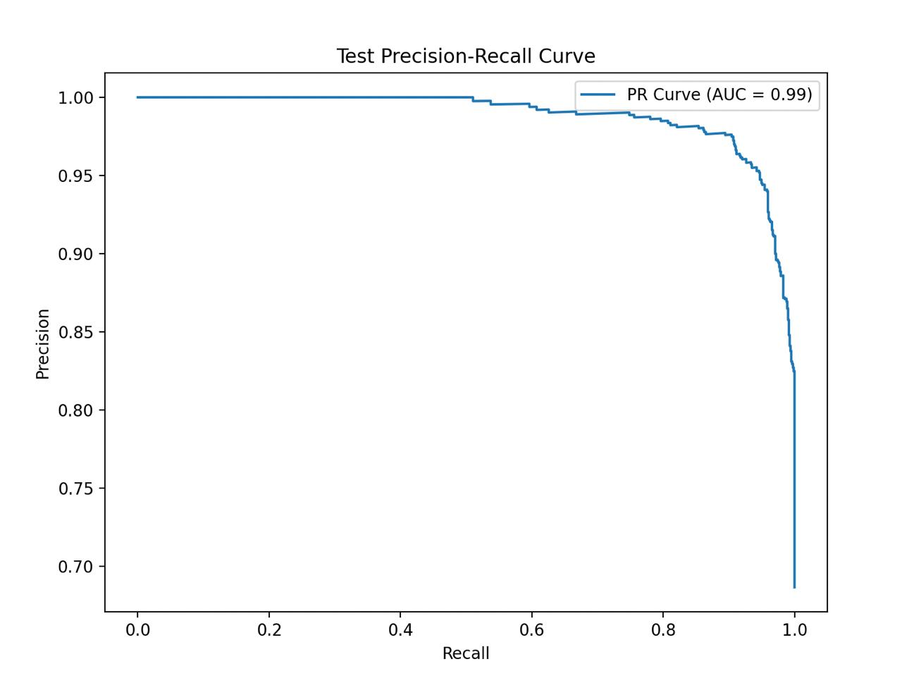

Testing Different Magnification Levels (40x, 100x, 200x, 400x)
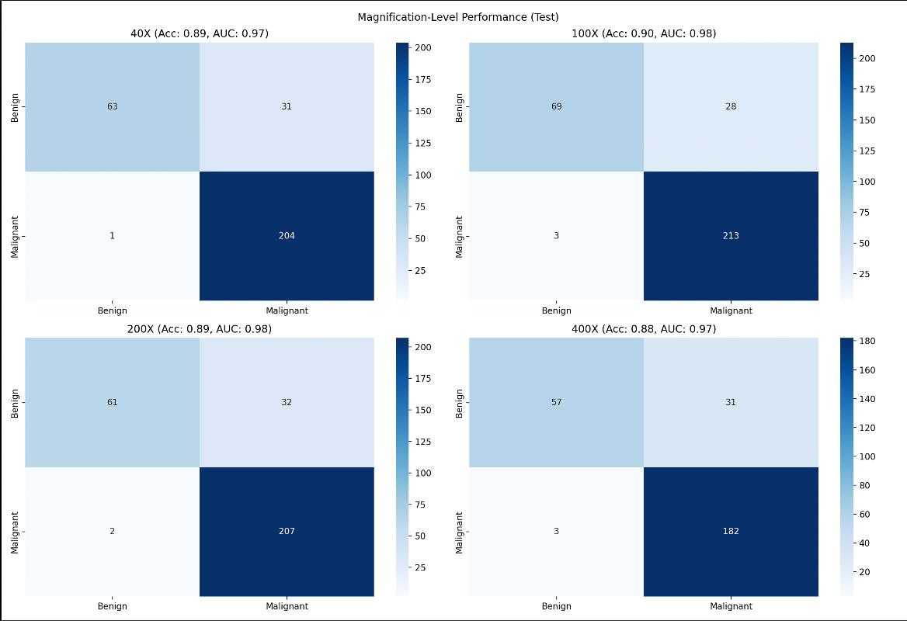

Final Result

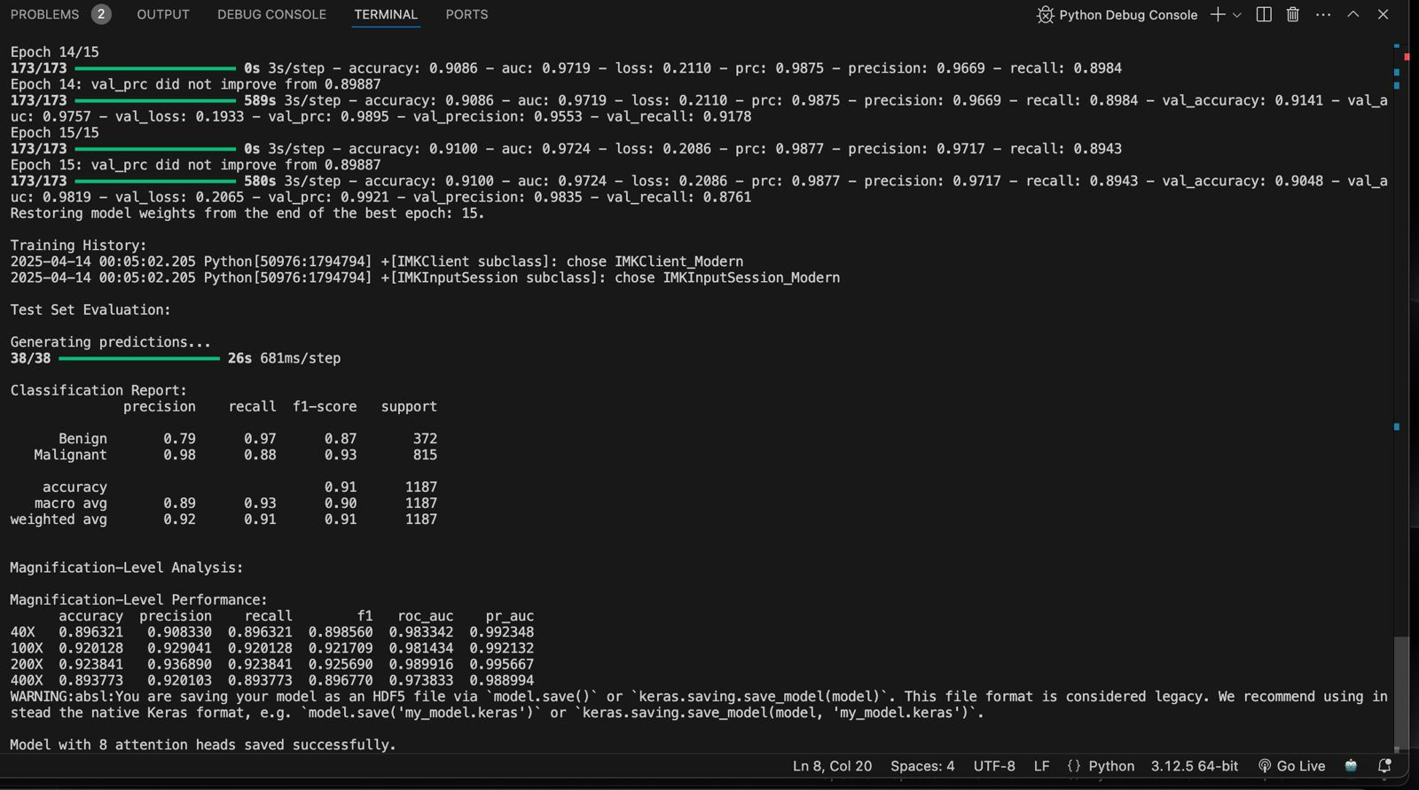

2-Head Final

4-Head Final

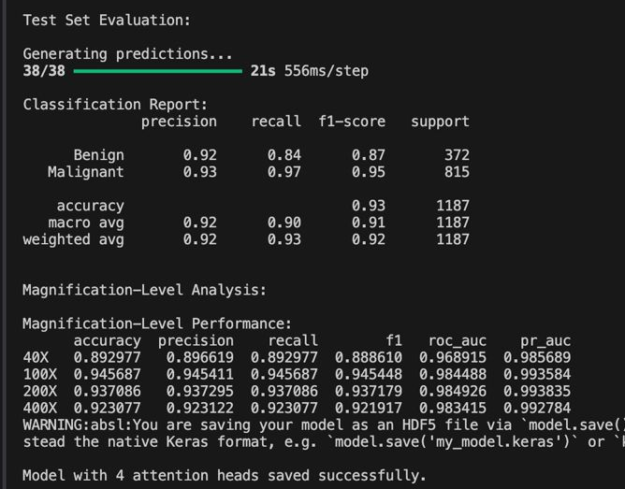

8-Head Final

Conclusion
The hybrid CNN model combined with multi-head attention outperformed a standard CNN, demonstrating significant improvements in classification accuracy, especially when evaluated across different magnification levels. While the model showed consistent performance in detecting benign and malignant images at varying resolutions, the use of multi-head attention proved to be a valuable addition, enabling the model to focus on the most relevant features of the images. Despite the promising results, challenges such as class imbalance and the computational cost of training with multiple attention heads were noted. The fine-tuned ResNet50 model demonstrated robustness, particularly in handling the diverse features across magnifications.

Key Learnings
- The Importance of Preprocessing: Image resizing and the use of standard preprocessing (such as ResNet50 preprocessing) significantly contributed to model accuracy by ensuring uniformity across input data.
- Stratified Data Splitting: Ensuring balanced distributions of both class labels and magnification levels across the training, validation, and test sets helped in mitigating biases and improving the generalization of the model.
- Attention Mechanisms Enhance Focus: Multi-head attention provided additional layers of context-aware learning, allowing the model to zoom into specific regions of interest in the images.
- Magnification-Specific Performance: Performance variations across magnifications indicated that resolution impacts model performance, which requires specialized evaluation and tuning for different magnifications.
- Effective Use of Callbacks: Early stopping, model checkpoints, and learning rate reductions helped optimize training and prevented overfitting, leading to better generalization on the test set.

Limitations
- Class Imbalance: Despite attempts to balance the dataset, there was still some degree of class imbalance, which could have impacted performance, particularly on the minority class (benign).
- Computational Cost: The use of multiple attention heads and fine-tuning large pre-trained models like ResNet50 led to high computational overhead, making the training process slow and resource-intensive.
- Magnification-Specific Variability: While the model showed strong overall performance, the variation in image quality and feature resolution across different magnifications may introduce inconsistencies that need to be addressed through more specialized models or data augmentation techniques.
- Dataset Size: The dataset's size, though substantial, may not be large enough to fully represent all possible variances in histopathological images, limiting the model's ability to generalize.

Future Work
- Addressing Class Imbalance: Future work could involve advanced class balancing techniques such as oversampling, undersampling, or the application of class-weighted loss functions to further improve model fairness.
- Advanced Data Augmentation: Implementing more diverse data augmentation techniques, such as rotation, zooming, and shifting, could help further generalize the model, especially under varied magnification levels.
- Multi-Scale Networks: Integrating multi-scale CNN architectures or attention mechanisms tailored to focus on different image scales could address the challenge of varying magnification resolutions more effectively.
- Cross-Validation: Performing k-fold cross-validation would allow for a more robust evaluation of model performance across different data splits, providing deeper insights into its generalization ability.
- Explainable AI (XAI): Exploring explainability techniques, such as Grad-CAM or LIME, to visualize and interpret the regions of the image that the model focuses on could improve trust and adoption in medical applications.
- External Dataset Integration: Incorporating external datasets from different sources or institutions would enhance model robustness and provide a broader range of histopathological images, improving generalization across a wider population.

