**Web project**

The front page of our website



This project is divided in different sections to guide you through this project in step-wise method.

Body reset :

*{

    margin: 0;

    padding: 0;

    font-family: sans-serif;

}

Nav Bar

This project has a responsive navbar made using Java Script.

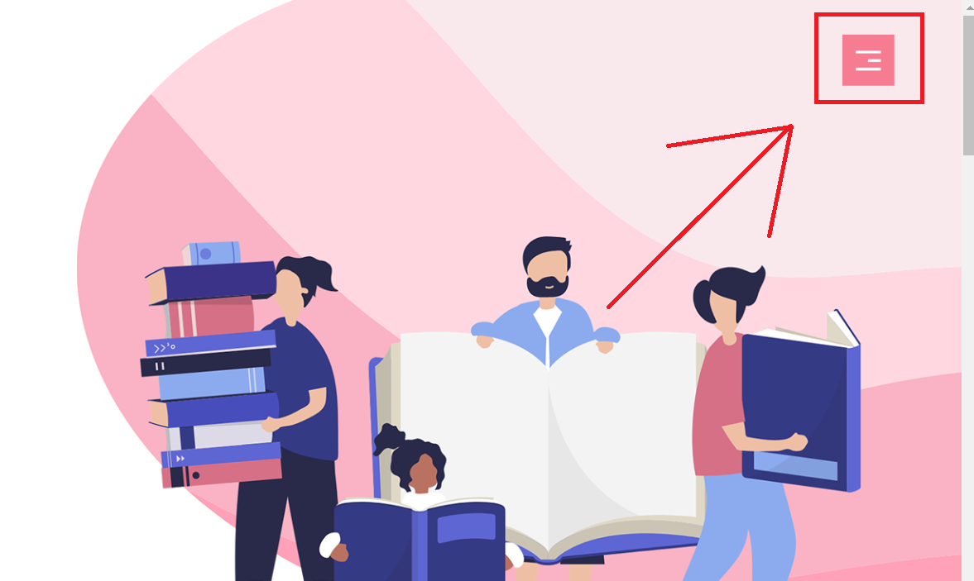

This is our navbar toggle button which is situated in the top-right corner and is fixed in this position so that it will remain here while you scroll the webpage.

By clicking on this you can toggle the navbar between showing it or hiding it.

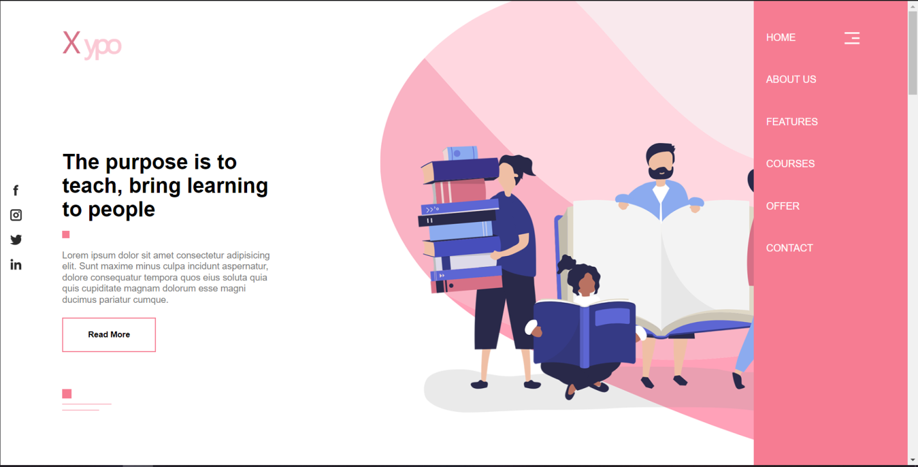

When toggled to show this is how our navbar will look like.

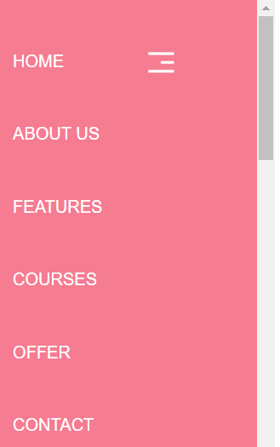

**Code (HTML) :**

<nav id="side-nav">

        <ul>

            <li><a href="#header">HOME</a></li>

            <li><a href="#about">ABOUT US</a></li>

            <li><a href="#features">FEATURES</a></li>

            <li><a href="#courses">COURSES</a></li>

            <li><a href="#offer">OFFER</a></li>

            <li><a href="#contact">CONTACT</a></li>

        </ul>

    </nav>

    <img src="images/menu.png" alt="" id="menu-btn" onclick="showhideNav()">

**Code (CSS) :**

/* navbar */

#side-nav{

    width: 250px;

    height: 100vh;

    position: fixed;

    right: -250px;

    top: 0;

    background: #f67c92;

    z-index: 2;

    transition: 0.5s;

}

nav ul li{

    list-style: none;

    margin: 50px 20px;

}

nav ul li a{

    text-decoration: none;

    color: white;

}

#menu-btn{

    width: 50px;

    position: fixed;

    right: 65px;

    top: 35px;

    z-index: 2;

    cursor: pointer;

}

Here, #side-nav is the main panel on which our nav elements resides.

And #menu-btn is the toggle button.

**Code (JS) :**

let sideNav = document.getElementById("side-nav");

        sideNav.style.right = "-250px";

        function showhideNav(){

            if(sideNav.style.right == "-250px"){

                sideNav.style.right = "0";

            }

            else{

                 sideNav.style.right = "-250px";

             }

        }

Above is the script through which we made the toggle button for our navbar.

Floating Social Icons

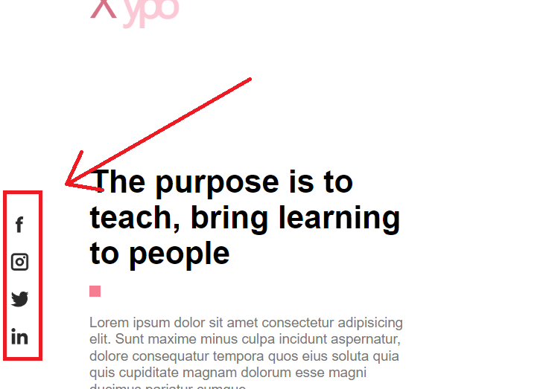

Just like the nav bar button this social media icon container is also fixed in the middle of the left side of our webpage.

**Code (HTML) :**

<!-- social icons -->

    <div class="social-icons">

        <img src="images/facebook.png" alt="">

        <img src="images/instagram.png" alt="">

        <img src="images/twitter.png" alt="">

        <img src="images/linkedin.png" alt="">

    </div>

**Code (CSS) :**

/* social icons */

.social-icons{

    width: 50px;

    position: fixed;

    top: 50%;

    left: 0;

    transform: translateY(-50%);

    z-index: 1;

}

.social-icons img{

    display: block;

    width: 20px;

    margin: 0px auto 20px;

    cursor: pointer;

}

**Section 1**



**Code (HTML) :**

<!-- section 1 -->

    <section id="header">

        <div class="container">

            <img src="images/logo.png" alt="" class="logo">

            <div class="header-text">

                <h1>The purpose is to <br> teach, bring learning to people</h1>

                <span class="square"></span>

                <p>Lorem ipsum dolor sit amet consectetur adipisicing elit. Sunt maxime minus culpa incidunt aspernatur, dolore consequatur tempora quos eius soluta quia quis cupiditate magnam dolorum esse magni ducimus pariatur cumque.</p>

                <button class="btn">Read More</button>

                <div class="line">

                    <span class="line-1 line- deco"></span><br>

                    <span class="line-2 line- deco"></span><br>

                    <span class="line-3 line-deco"></span>

                </div>

            </div>

        </div>

    </section>

**Code (CSS) :**

#header{

    height: 100vh;

    background-image: url('images/background.png');

    background-position: center;

    background-size: cover;

}

.container{

    margin: 0px 100px;

}

.logo{

    margin-top: 30px;

    width: 100px;

}

.header-text{

    max-width: 350px;

    margin-top: 140px;

}

h1{

    font-size: 34px;

}

.square{

    height: 12px;

    width: 12px;

    display: inline-block;

    background: #f67c92;

    margin: 15px 0px;

}

.btn{

    padding: 18px 40px;

    background: transparent;

    outline: none;

    border: 2px solid #f67c92;

    font-weight: bold;

    cursor: pointer;

}

p{

    font-size: 15px;

    line-height: 18px;

    color: #777;

}

.header-text button{

    margin-top: 20px;

    margin-bottom: 60px;

}

.line-deco{

    background: #f67c92;

    display: inline-block;

}

.line-1{

    width: 15px;

    height: 15px;

}

.line-2{

    width: 80px;

    height: 1px;

}

.line-3{

    width: 60px;

    height: 1px;

}

.line{

    line-height: 8px;

}

**Section 2**



**Code (HTML) :**

<!-- about-section -->

    <section id="about">

        <div class="left-col">

            <img src="images/about.png" alt="">

        </div>

        <div class="right-col">

            <div class="about-txt">

                <h1>About Us</h1>

                <span class="square"></span>

                <p>Lorem ipsum dolor sit amet consectetur adipisicing elit. Quaerat ratione cum explicabo et consequuntur, eius commodi cumque veritatis accusamus esse eligendi eum distinctio optio. Labore similique ut m modi eius nulla.</p><br><br>

                <div class="line">

                    <span class="line-1 line- deco"></span><br>

                    <span class="line-2 line- deco"></span><br>

                    <span class="line-3 line-deco"></span>

                </div>

                <h2>"Learning is not attained by chance, it must be sought for with ardor and attended to with diligence"</h2>

                <h3>-Abigail Adams</h3>

            </div>

        </div>

    </section>

**Code (CSS) : \*\***Same CSS used for the 5th section**

/* about & offer */

#about, #offer{

    padding: 100px 0px;

    display: flex;

    align-items: center;

    flex-wrap: wrap;

}

.left-col{

    flex-basis: 50%;

}

.left-col img{

    width: 100%;

}

.right-col{

    flex-basis: 50%;

    text-align: right;

}

.about-txt{

    max-width: 500px;

    margin-right: 100px;

    display: inline-block;

}

.about-txt h2{

    margin: 50px 0px 10px 0px;

    font-size: 28px;

    font-style: italic;

}

.about-txt h3{

    font-size: 28px;

    font-style: italic;

    color: #797979;

}

**Section 3**

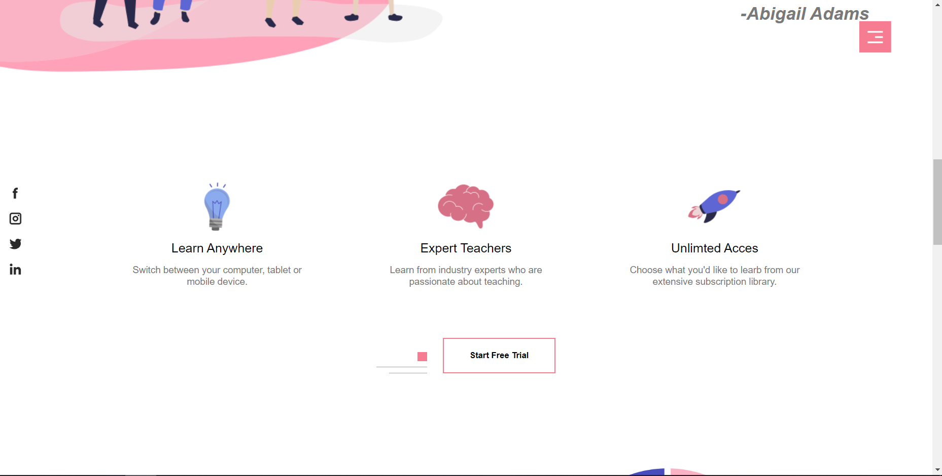

**Code (HTML) :**

<!-- features -->

    <section id="features">

        <div class="feature-row">

            <div class="feature-col">

                <img src="images/pic-1.png" alt="">

                <h4>Learn Anywhere</h4>

                <p>Switch between your computer, tablet or mobile device.</p>

            </div>

            <div class="feature-col">

                <img src="images/pic-2.png" alt="">

                <h4>Expert Teachers</h4>

                <p>Learn from industry experts who are passionate about teaching.</p>

            </div>

            <div class="feature-col">

                <img src="images/pic-3.png" alt="">

                <h4>Unlimted Acces</h4>

                <p>Choose what you'd like to learb from our extensive subscription library.</p>

            </div>

        </div>

        <div class="feature-btn">

            <div class="line">

                <span class="line-1 line- deco"></span><br>

                <span class="line-2 line- deco"></span><br>

                <span class="line-3 line- deco"></span>

            </div>

            <button class="btn">Start Free Trial</button>

        </div>

    </section>

**Code (CSS) :**

/* features */

#features{

    padding: 50px 0px;

}

.feature-row{

    width: 80%;

    margin: auto;

    display: flex;

    align-items: center;

    justify-content: space-around;

    flex-wrap: wrap;

}

.feature-col{

    flex-basis: 25%;

    text-align: center;

}

.feature-col img{

    width: 100px;

}

.feature-col h4{

    margin-bottom: 15px;

    font-size: 20px;

    font-weight: 400;

}

.feature-btn{

    margin: 80px auto 0;

    display: flex;

    align-items: flex-end;

    justify-content: center;

}

.feature-btn .line{

    text-align: right;

    display: inline-block;

    margin-right: 25px;

}

**Section 4**

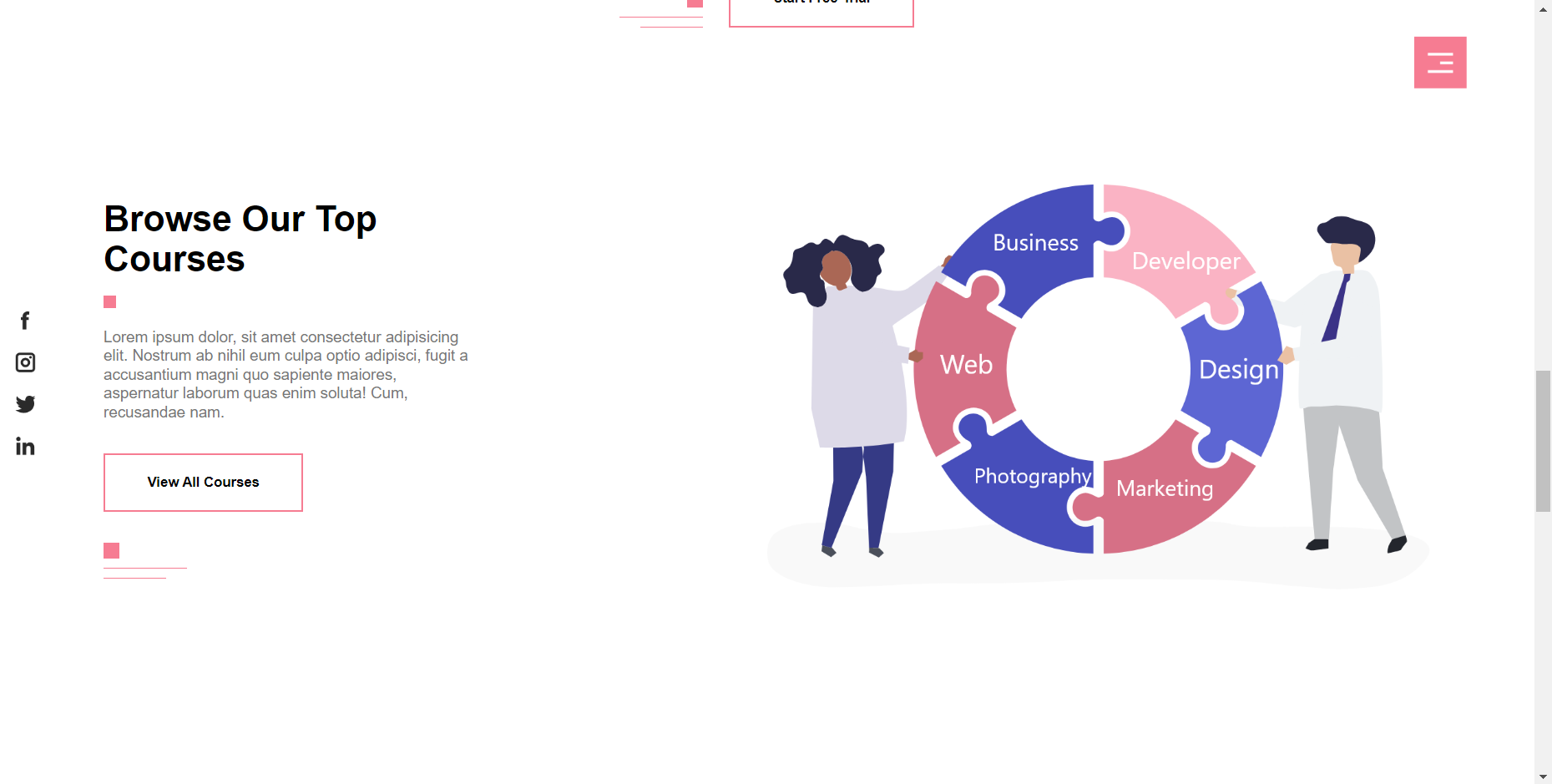

**Code (HTML) :**

<!-- courses -->

    <section id="courses">

        <div class="container course-row">

            <div class="course-left-col">

                <div class="course-txt">

                    <h1>Browse Our Top <br>Courses</h1>

                    <span class="square"></span>

                    <p>Lorem ipsum dolor, sit amet consectetur adipisicing elit. Nostrum ab nihil eum culpa optio adipisci, fugit a accusantium magni quo sapiente maiores, aspernatur laborum quas enim soluta! Cum, recusandae nam.</p>

                    <button class="btn">View All Courses</button>

                    <div class="line">

                        <span class="line-1 line- deco"></span><br>

                        <span class="line-2 line- deco"></span><br>

                        <span class="line-3 line- deco"></span>

                    </div>

                </div>

            </div>

            <div class="course-right-col">

                <img src="images/course.png" alt="">

            </div>

        </div>

    </section>

**Code (CSS) :**

/* courses */

#courses{

    padding: 100px 0px;

}

.course-row{

    display: flex;

    align-items: center;

    flex-wrap: wrap;

}

.course-left-col{

    flex-basis: 50%;

}

.course-right-col{

    flex-basis: 50%;

}

.course-right-col img{

    width: 100%;

}

.course-txt{

    max-width: 350px;

}

.course-txt button{

    margin: 30px 0px;

}

**Section 5**

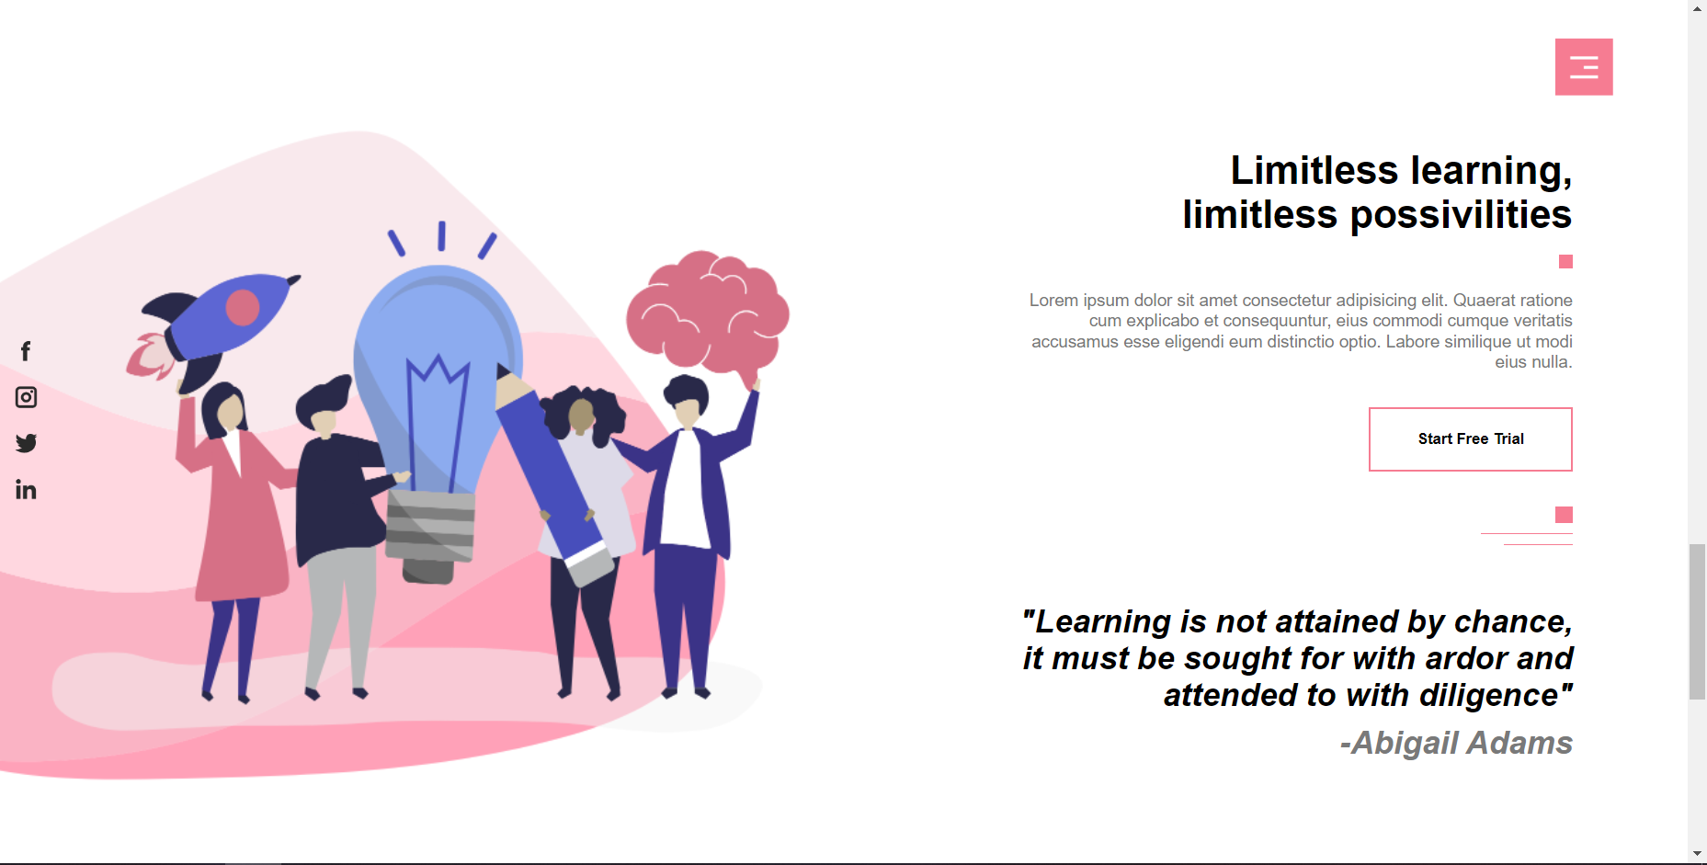

**Code (HTML) :**

<!-- offer -->

    <section id="offer">

        <div class="left-col">

            <img src="images/offer.png" alt="">

        </div>

        <div class="right-col">

            <div class="about-txt">

                <h1>Limitless learning, <br>limitless possivilities</h1>

                <span class="square"></span>

                <p>Lorem ipsum dolor sit amet consectetur adipisicing elit. Quaerat ratione cum explicabo et consequuntur, eius commodi cumque veritatis accusamus esse eligendi eum distinctio optio. Labore similique ut modi eius nulla.</p>

                <button class="btn">Start Free Trial</button>

                <div class="line">

                    <span class="line-1 line- deco"></span><br>

                    <span class="line-2 line- deco"></span><br>

                    <span class="line-3 line-deco"></span>

                </div>

                <h2>"Learning is not attained by chance, it must be sought for with ardor and attended to with diligence"</h2>

                <h3>-Abigail Adams</h3>

            </div>

        </div>

    </section>

**Code (CSS) :**

/* offer */

#offer button{

    margin: 30px 0px;

}

**Section 6**

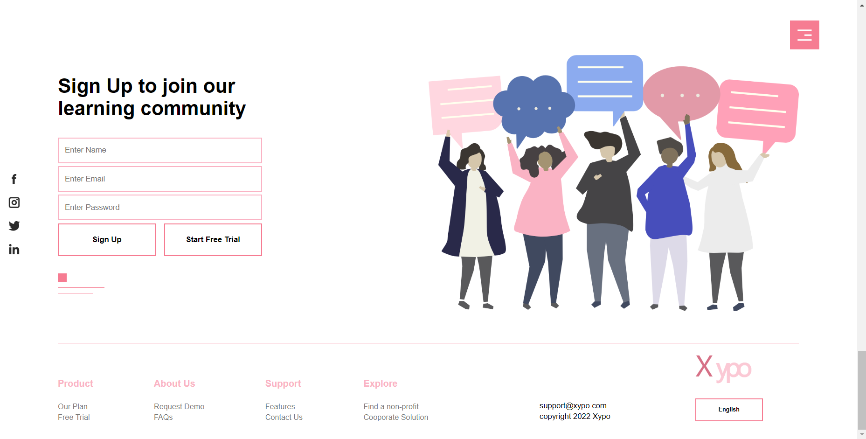

**Code (HTML) :**

<!-- contact -->

    <section id="contact">

        <div class="container contact-row">

            <div class="contact-left-col">

                <h1>Sign Up to join our <br>learning community</h1>

                <form action="">

                    <input type="text" placeholder="Enter Name">

                    <input type="email" placeholder="Enter Email">

                    <input type="password" placeholder="Enter Password">

                    <div class="btn-box">

                        <button class="btn">Sign Up</button>

                        <button class="btn">Start Free Trial</button>

                    </div>

                </form>

                <div class="line">

                    <span class="line-1 line- deco"></span><br>

                    <span class="line-2 line- deco"></span><br>

                    <span class="line-3 line-deco"></span>

                </div>

            </div>

            <div class="contact-right-col">

                <img src="images/contact.png" alt="">

            </div>

        </div>

    </section>

**Code (CSS) :**

/* contact */

.contact-row{

    display: flex;

    align-items: center;

    flex-wrap: wrap;

}

.contact-left-col, .contact-right-col{

    flex-basis: 50%;

}

.contact-right-col img{

    width: 100%;

}

form{

    max-width: 350px;

    margin: 30px 0px;

}

form input{

    width: 100%;

    padding: 12px 10px;

    margin-bottom: 5px;

    outline: none;

    box-shadow: none;

    box-sizing: border-box;

    border: 2px solid #fab3c4;

}

.btn-box{

    width: 100%;

    display: flex;

    justify-content: space-between;

}

.btn-box button{

    flex-basis: 48%;

    padding: 18px 0px;

}

**Footer**

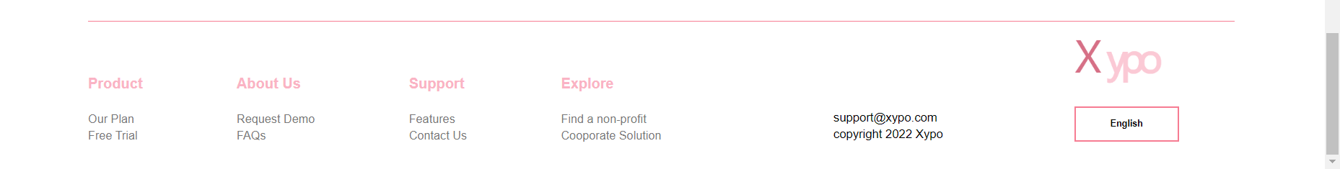

**Code (HTML) :**

<!-- footer -->

    <footer>

        <div class="container footer-row">

            <hr>

            <div class="footer-left-col">

                <div class="footer-links">

                    <div class="link-title">

                        <h4>Product</h4>

                        <small>Our Plan</small><br>

                        <small>Free Trial</small>

                    </div>

                    <div class="link-title">

                        <h4>About Us</h4>

                        <small>Request Demo</small><br>

                        <small>FAQs</small>

                    </div>

                    <div class="link-title">

                        <h4>Support</h4>

                        <small>Features</small><br>

                        <small>Contact Us</small>

                    </div>

                    <div class="link-title">

                        <h4>Explore</h4>

                        <small>Find a non- profit</small><br>

                        <small>Cooporate Solution</small>

                    </div>

                </div>

            </div>

            <div class="footer-right-col">

                <div class="footer-info">

                    <div class="copyright-txt">

                        <small>support@xypo.com</small><br>

                      <small>copyright 2022 Xypo</small>

                    </div>

                    <div class="footer-logo">

                        <img src="images/logo.png" alt="">

                        <button class="btn">English</button>

                    </div>

                </div>

            </div>

        </div>

    </footer>

**Code (CSS) :**

/* footer */

footer{

    padding: 50px 0px 30px;

}

hr{

    width: 100%;

    border: 0;

    border-top: 1px solid #f67c92;

}

.footer-row{

    display: flex;

    align-items: center;

    justify-content: space-between;

    flex-wrap: wrap;

}

.footer-left-col{

    flex-basis: 50%;

    margin-top: 60px;

}

.footer-right-col{

    flex-basis: 35%;

}

.footer-links{

    display: flex;

    justify-content: space-between;

    flex-wrap: wrap;

}

.link-title h4{

    color: #fab3c4;

    margin-bottom: 20px;

}

.link-title small{

    font-size: 13px;

    color: #777;

}

.footer-info{

    display: flex;

    align-items: flex-end;

    justify-content: space-between;

    flex-wrap: wrap;

}

.footer-logo img{

    width: 100px;

}

.footer-logo button{

    padding: 12px 38px;

    margin-top: 20px;

    font-size: 10px;

}

.copyright-txt, .footer-logo{

    flex-basis: 40%;

}

<script src="https://cdn.jsdelivr.net/gh/cferdinandi/smooth-scroll/dist/smooth-scroll.polyfills.min.js"></script>

Here we imported this Java Script and put it in the head tag.

We added this JS to add smooth scrolling on a webpage.

var scroll = new SmoothScroll('a[href*="#"]', {

            speed: 1000,

            speedAsDuration: true

        });

The above code is to set the smooth scrolling speed. We’ll add this code inside the script tag under body tag.

**Media Query**

<meta name="viewport" content="width=device-width, initial-scale=1">

    <!-- media query -->

First we’ll add this meta tag inside the head tag.

Then we’ll add the following css code in the css file.

@media only screen and (max-width: 770px){

    #header{

        background-image: none;

    }

    .container{

        margin: 0px 50px;

    }

    .logo{

        margin-top: 27px;

        width: 70px;

    }

    .header-text{

        margin-top: 100px;

    }

    h1{

        font-size: 25px;

    }

    #menu-btn{

        width: 40px;

        right: 50px;

    }

    .btn{

        padding: 10px 16px;

    }

    .social-icons img{

        width: 14px;

        margin: 15px auto;

    }

    .left-col, .right-col{

        flex-basis: 100%;

    }

    .about-txt{

        margin: 50px 50px 0;

        display: inline-block;

    }

    .about-txt h2{

        font-size: 18px;

    }

    .feature-col{

        flex-basis: 100%;

        margin-bottom: 20px;

    }

    .course-left-col{

        flex-basis: 100%;

    }

    .course-right-col{

        flex-basis: 100%;

        margin-top: 70px;

    }

    .contact-left-col, .contact-right-col{

        flex-basis: 100%;

    }

    .contact-right-col{

        margin-top: 50px;

    }

    .footer-left-col, .footer-right-col{

        flex-basis: 100%;

    }

    .link-title{

        flex-basis: 50%;

        margin-bottom: 30px;

    }

}