Multi-Objective Portfolio Optimization on the Indian Equity Market using Modern Portfolio Theory

Parth gulati

Abstract
This paper includes the framework and application of Modern Portfolio technique also known as MPT on ten large cap stocks to get the best allocation of the investment of the public. The research is done on the basis of last 5 years of historical data of the following stocks:- Reliance Industries Ltd, HDFC Bank Ltd, Infosys Ltd, Tata Consultancy Services Ltd(TCS), ICICI Bank Ltd, Hindustan Unilever Ltd, Bharti Airtel Ltd, Asian Paints Ltd, Mahindra & Mahindra Ltd, Larsen & Toubro Ltd. (L&T), The study models the asset returns and covariances to identify three distinct optimal portfolios on the Efficient Frontier:
The Maximum Sharpe Ratio portfolio (for risk-adjusted returns)
The Minimum Volatility portfolio (for extreme risk aversion)
A Target Return portfolio fixed at an annualized 25%.
Numerical optimization of the data reveals significant variance in asset allocation depending on the objective. The Maximum Sharpe portfolio is highly concentrated (4 assets), while the Minimum Volatility portfolio is more diversified, shifting capital towards historically stable assets like Hindustan Unilever and Asian Paints. The study demonstrates the specific risk return trade-offs required to achieve different financial goals, visualized via a Monte Carlo simulation of 50,000 portfolios. It concludes that MPT is a versatile tool for tailoring investment strategies to specific risk appetites rather than relying on a one-size-fits-all approach. And we found that with the maximum shape ratio(1.58) the annualized return for our portfolio is 34.79% and the risk taken is 17.62% which is the best case scenario for all three parameters.

INTRODUCTION
.
Background & Theory:
Modern Portfolio Theory (MPT), Introduced by by Harry Markowitz in the 1950s, revolutionized investment management as the focus started to shift from individual assets to portfolio construction. MPT states that a rational investor's goal is to maximize their expected return for a given level of risk, or conversely, to minimize risk for a desired level of return.
- Diversification and Covariance: One of MPT's main objective is diversification, or not "putting all your eggs in one basket." An investor can lower the overall volatility (risk) of their portfolio without necessarily sacrificing expected return by holding a variety of assets that do not move exactly in tandem (i.e., they have low or negative correlation). The key to measuring this benefit of diversification is covariance, a statistical measure of how the returns of two assets move together. Assets tend to move in the same direction when they have a positive covariance and in the opposite direction when they have a negative covariance. Building a portfolio with assets that have low or negative covariances to one another is the goal in order to smooth out the returns of the entire portfolio.
- The Efficient Frontier: MPT demonstrates that each set of assets has a set of optimal portfolios. These portfolios are located on a curve known as the "Efficient Frontier." Each point on the curve represents a portfolio that provides the highest expected return for a specific level of risk. Any portfolio that is below the Efficient Frontier is considered sub-optimal since it is possible to achieve a higher return for the same level of risk or the same return for a lower level of risk..
The Efficient Frontier Concept and Investor Profiles:
There is no single "best" portfolio on the Efficient Frontier that is universally suitable for all investors. The choice of a specific portfolio on the frontier depends entirely on an investor's individual risk tolerance and financial goals.
- A risk-averse investor, for example, would prioritize capital preservation and might choose a portfolio on the lower-left portion of the Efficient Frontier, which offers lower expected returns but also significantly lower volatility.
- A more aggressive investor who has a higher risk tolerance might go for a portfolio on the upper-right portion of the frontier, wanting higher potential returns and accepting the associated higher level of risk.
- A balanced investor or normal individual would seek a portfolio that offers the best trade-off between risk and return, often calculated by a measure like the Sharpe Ratio. The Sharpe Ratio, defined as the excess return of a portfolio over the risk-free rate divided by its standard deviation, measures the risk-adjusted return. The portfolio with the highest Sharpe Ratio is the one that lies on the Efficient Frontier at the point where a line drawn from the risk-free rate on the y-axis is tangent to the curve. This point represents the most efficient portfolio in terms of risk-adjusted return.
Study Objectives:
This paper aims to go beyond a single-point analysis and provides a comprehensive exploration of the trades available across the Efficient Frontier. Using a universe of ten Indian large-cap stocks as a case study, we employ numerical optimization techniques to construct three distinct portfolios, each catering to a specific investor profile and objective:
- The Balanced Investor (Max Sharpe Ratio): This portfolio is designed for the investor who wants the highest possible risk-adjusted return. We will identify the unique combination of assets and their weights that maximizes the portfolio's Sharpe Ratio, effectively finding the "tangency point" on the Efficient Frontier.
- The Highly Risk-Averse Investor (Minimum Volatility): For the investor whose main objective is capital preservation, we will construct a portfolio that minimizes the overall portfolio volatility (standard deviation). This portfolio will be located at the leftmost point on the Efficient Frontier.
- The Goal-Oriented Investor (Target 25% Return): This portfolio is tailored for an investor with a specific financial goal that requires a minimum annual return of 25%. We will identify the portfolio on the Efficient Frontier that meets this return constraint with the lowest possible level of risk.
By constructing and comparing these three distinct portfolios, we will illustrate the practical application of MPT and demonstrate how an investor's specific risk-return preferences directly influence the optimal asset allocation strategy. This analysis will provide valuable insights into the trade-offs involved in portfolio construction and highlight the importance of aligning investment strategies with individual goals and risk tolerance.

METHODOLOGY

Data Selection and Collection:
- The study selected ten diverse large-cap Indian stocks listed on the NSE: Reliance (RELIANCE.NS), HDFC Bank (HDFCBANK.NS), Infosys (INFY.NS), TCS (TCS.NS), ICICI Bank (ICICIBANK.NS), Hindustan Unilever (HINDUNILVR.NS), Bharti Airtel (BHARTIARTL.NS), Asian Paints (ASIANPAINT.NS), Mahindra & Mahindra (M&M.NS), and Larsen & Toubro (LT.NS).
- Five years of historical daily adjusted closing price data were sourced using the Yfinance Python library and the website.
Data Processing & Statistical Inputs:
- Raw prices were converted to daily percentage returns.
- Annualized Mean Return Vector (R): Calculated as the average daily return for each of the 10 assets multiplied by 252 (trading days).
- Annualized Covariance Matrix: A “10 X 10” matrix calculated from daily returns and annualized by multiplying by 252. This is the critical input for modeling portfolio risk.
- Risk-Free Rate ( $R_{f})$: Assumed to be 7% (0.07) annually, reflecting long-term Indian government bond yields.
Portfolio Modeling Equations:
- Present the mathematical formulas used:
  - Portfolio Return: $R_{p}=w^{t}R$
  - Portfolio Volatility: $σ_{p }=\sqrt{w^{t}Σw}$
  - Sharpe Ratio: $SR_{p}=\frac{R_{p}-R_{f}}{σ_{p}}$
Optimization Procedure:
- The goal was to maximize the Sharpe Ratio. The optimization was performed using the Sequential Least Squares Programming (SLSQP) algorithm in Python which is an advanced version of gradient tool. The SLSQP Algorithm: SLSQP is a robust and widely-used iterative method for solving nonlinear optimization problems that solves both equality and inequality constraints. It is particularly well-suited for portfolio optimization because it can efficiently handle the specific rules required for practical investing. At a high level, the algorithm works by approximating the complex, nonlinear objective function (e.g., the Sharpe Ratio or Portfolio Volatility) with a simpler quadratic function at each step. It then solves this simpler sub-problem to find a new set of weights that improves the objective function's value, all while ensuring that the solution does not violate any constraints. This process—approximating, solving, and stepping—is repeated sequentially until the algorithm "converges," meaning it has found a solution that cannot be significantly improved upon locally.
- Constraints: The sum of weights must equal exactly 1 ($Σw_{i}=1$).
- Bounds: Individual weights must be between 0 and 1 ($0≤w_{i}≤1$), prohibiting short selling.

RESULTS AND DISCUSSION

Comparative Asset Allocation:
Stock name | MAX SHARPE WEIGHT(%) | MIN VOLATILITY WEIGHT(%) | TARGET 25% RETURN
Airtel | 41.75% | 13.01% | 27.77%
M&M | 35.25% | 2.89% | 18.60%
L&T | 21.10% | 4.55% | 14.40%
ICICI | 1.91% | 4.05% | 8.74%
RELIANCE | 0.00% | 11.49% | 4.12%
HDFC BANK | 0.00% | 1.45% | 0.00%
INFOSYS | 0.00% | 16.71% | 11.89%
TCS | 0.00% | 6.39% | 4.55%
HINDUNILEVER | 0.00% | 20% | 7.75%
ASIAN PAINTS | 0.00% | 9.45% | 2.17%

Comparative Performance Metrics
Comparative Performance Metrics Matrix
Max Sharpe Portfolio | Min Volatility Portfolio (%) | Target 25% | Return Portfolio
Metric
Expected Annual Return (%) | 34.7900 | 18.5000 | 25.0000
Expected Annual Volatility (%) | 17.6200 | 12.1000 | 14.5000
Sharpe Ratio | 1.5776 | 0.9504 | 1.2414

Efficient Frontier Visualization:
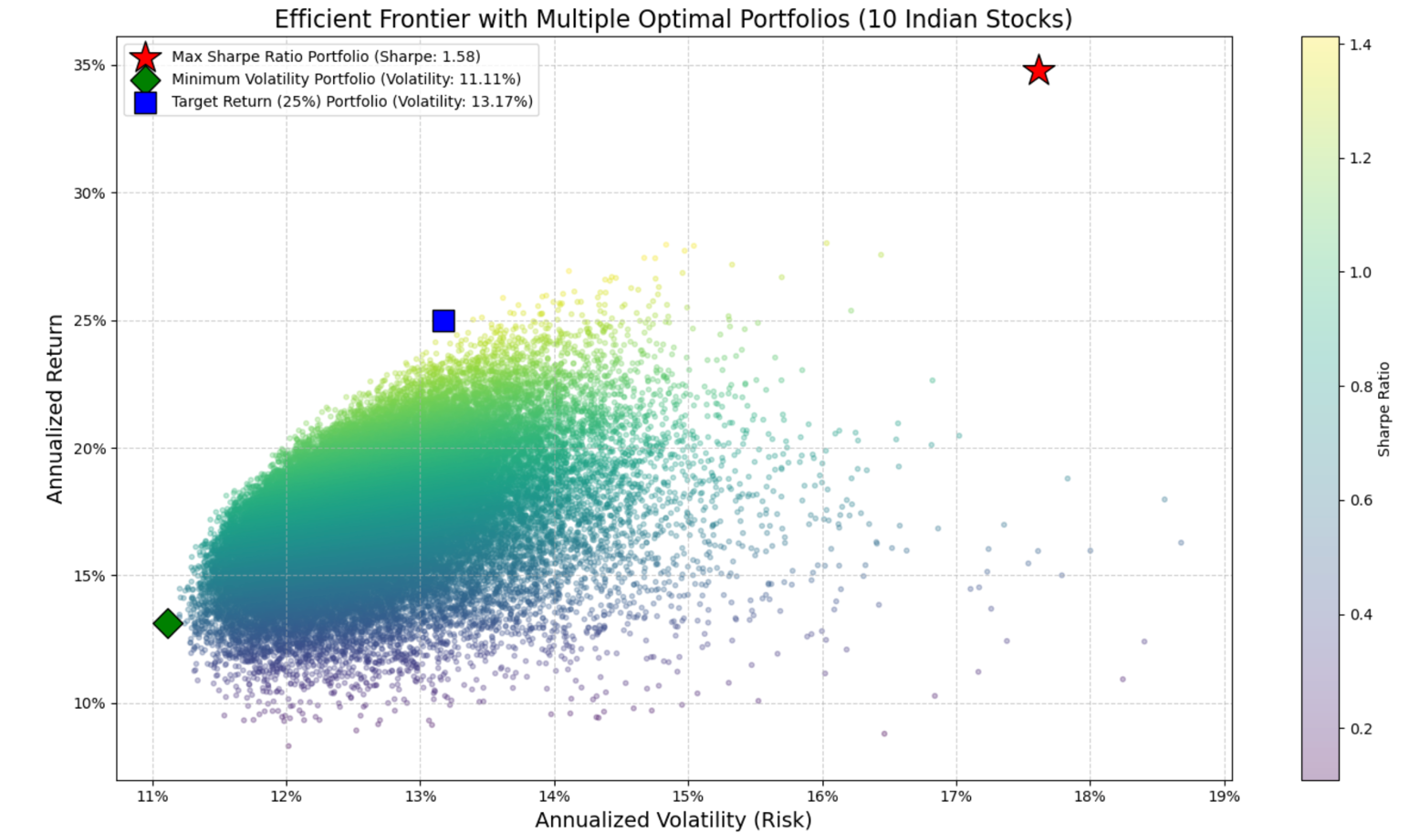
- The Red Star is the peak efficiency. The Green Diamond is the furthest left point (lowest risk). The Blue Square is the point on the curve that specifically sits at the 25% return line on the Y-axis.
- Analyzing the Shifts: The optimizer shifted capital away from high-growth/high-volatility stocks (like those in the Max Sharpe) and toward defensive stocks (like FMCG) when tasked with finding the Minimum Volatility portfolio.
- Analyze the Trade-off: the Target 25% portfolio. It achieves the goal but likely carries more risk than the Min Volatility portfolio and has a lower Sharpe ratio than the Max Sharpe portfolio. This perfectly illustrates the "cost" of targeting a specific return.

CONCLUSION
The quantitative framework of Modern Portfolio Theory (MPT) was successfully applied to the Indian equity market in this study, proving its ability to create optimized investment portfolios suited to a variety of financial goals. In order to map the Efficient Frontier and determine the best asset allocations, we modelled asset behaviour and interdependencies using five years' worth of historical data for ten large-cap Indian stocks.
This study's main conclusion is that there isn't just one "best" portfolio. Rather, there is "optimal" allocation that greatly depends on the particular objective of the investor. Significant changes in asset weightings were found in all of the scenarios examined by the numerical optimization results. Just four high-performing assets made up the majority of the Maximum Sharpe Ratio portfolio, which was created for the balanced investor looking for maximum efficiency.

REFERENCES

Markowitz, H. (1952). Portfolio Selection. The Journal of Finance, 7(1), 77–91. https://doi.org/10.1111/j.1540-6261.1952.tb01525.x

Sharpe, W. F. (1964). Capital Asset Prices: A Theory of Market Equilibrium under Conditions of Risk. The Journal of Finance, 19(3), 425–442. https://doi.org/10.1111/j.1540-6261.1964.tb02865.x

Jorion, P. (2007). Value at Risk: The New Benchmark for Managing Financial Risk (3rd ed.). McGraw-Hill.

For SLSQP (part of SciPy): Virtanen, P., Gommers, R., Oliphant, T. E., Haberland, M., Reddy, T., Cournapeau, D., ... & SciPy 1.0 Contributors. (2020). SciPy 1.0: Fundamental Algorithms for Scientific Computing in Python. Nature Methods, 17, 261–272. https://doi.org/10.1038/s41592-019-0686-2

For yfinance (Data Collection): Ran Aroussi. (2023). yfinance: Yahoo! Finance market data downloader (Version 0.2.33) [Computer software . https://github.com/ranaroussi/yfinance

For pandas (Data Manipulation): McKinney, W. (2010). Data structures for statistical computing in Python. In Proceedings of the 9th Python in Science Conference (pp. 56-61). https://doi.org/10.25080/Majora-92bf1922-00a
For NumPy (Numerical Computing): Harris, C. R., Millman, K. J., van der Walt, S. J., Gommers, R., Virtanen, P., Cournapeau, D., ... & Oliphant, T. E. (2020). Array programming with NumPy. Nature, 585(7825), 357-362. https://doi.org/10.1038/s41586-020-2649-2
For Matplotlib (Visualization): Hunter, J. D. (2007). Matplotlib: A 2D graphics library. Computing in Science & Engineering, 9(3), 90-95. https://doi.org/10.1109/MCSE.2007.55

