**Covid-19 Vaccine Management System.**

**5th Sem.Introduction to Programming using C++ Course Project (UE18EExxx)**

**PES University**

**BENGALURU – 560085.**

|  |  |  |  |
| --- | --- | --- | --- |
| **Name** | **USN** | **Contribution: High/Low/Medium** | **What part of project was done** |
| **Abhinav Prabhakar** | **PES1UG19EE002** | **Medium** | **Certificate, debugging** |
| **Aditya N Sharma** | **PES1UG19EE004** | **Medium** | **Registration, modulation** |
| **Amogh Krishna** | **PES1UG19EE009** | **Medium** | **Booking, debugging** |

# Introduction to Project:

* Since the dawn of covid-19 pandemic there has been a lot of challenges to the existence of human race
* We are at a phase where there is a vaccine available for covid-19 which is the only way to control this pandemic
* There were certain challenges faced by the common people in regards of vaccine management and distribution. We hoped to overcome this challenge by using oops in C++.

## Problem Statement:

A seamless platform for vaccine management system where one can register/login , book an appointment to get vaccinated and get the vaccine certificate.

## Scope

What is included: Classes, Methods, Objects, File Handling(fstream).

What is not included: saving data to database, connecting to server, unions, structures, constructors, destructors, overloaded functions.

# Technical Details

< What and How part of the project>

## Block Diagram

REGISTRATION

TAKING INPUT FROM USER

BOOKING

LOGIN

CERTIFICATE

### Design Details

Taking input from user the user enters .Either 1 or 0 for registering or logging in.

Then storing it in a txt file and letting the user book an appointment and get the certificate using multiple functions and variables.

# Results

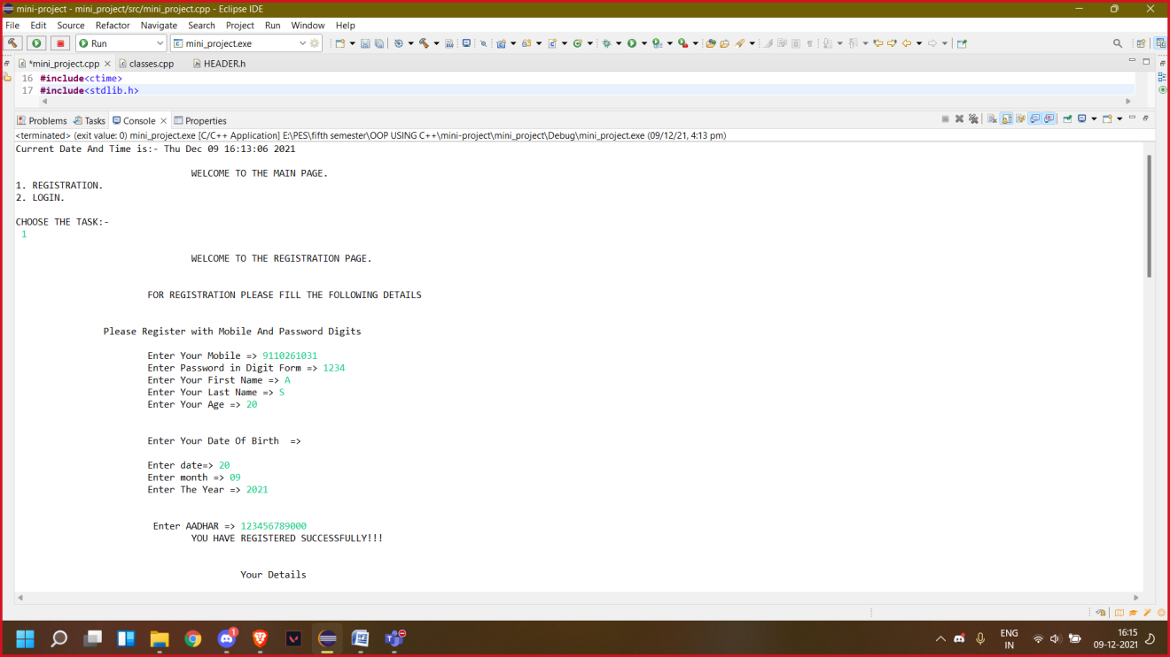

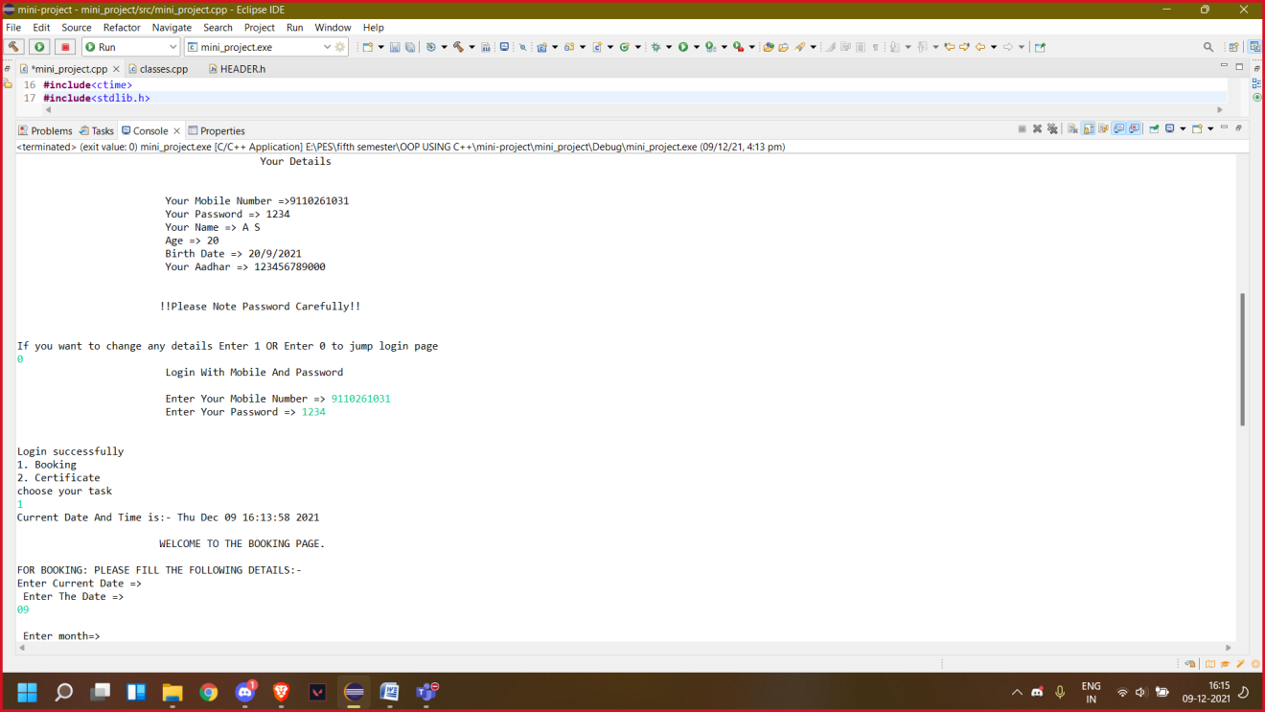

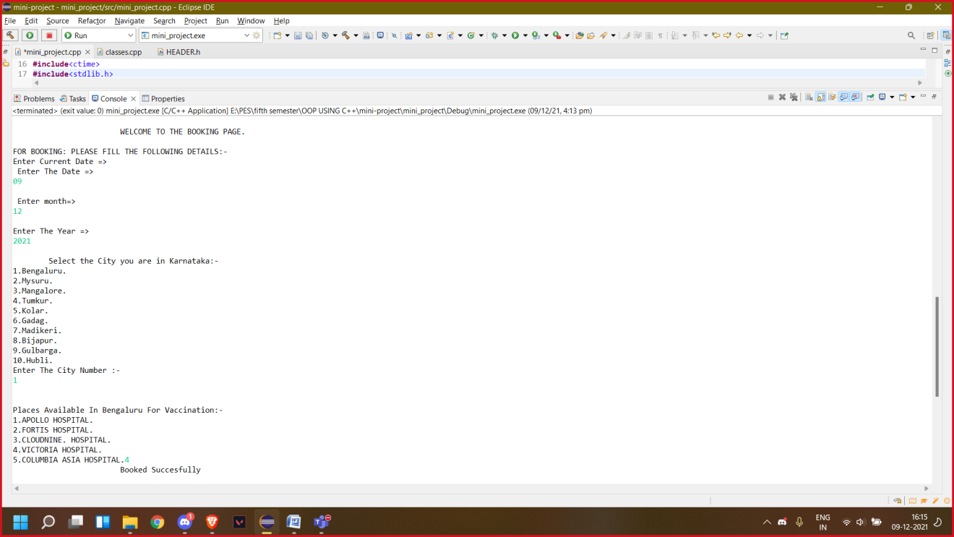

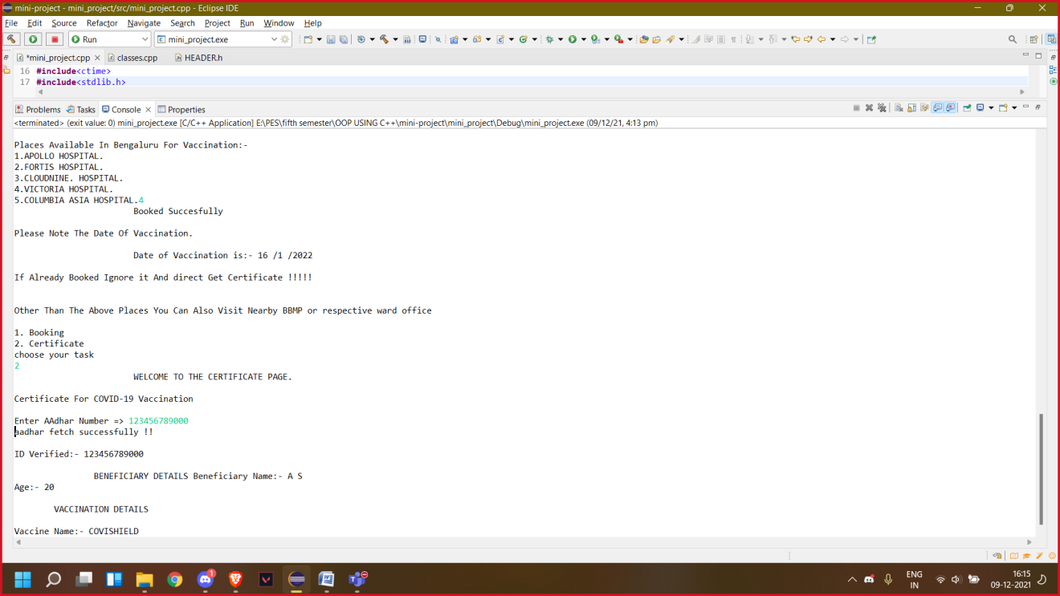

# Learning experience

How to handle files using fstream.

<Include learning experience – what was easy and where were the difficulties>

# References/Credits

[Hospital Management System in C++ - GeeksforGeeks](https://www.geeksforgeeks.org/hospital-management-system-in-c/)

< List papers, web sites from which code was referred, and your friends who helped>