**Name: Shivanshi Gupta**

**Course: B.Sc. (H) Computer Science**

**Semester : IV**

**Section: B**

**Roll. No.: 5795**

**Email:shivanshi205795@keshav.du.ac.in**

**Subject: Database Management Systems**

DBMS Assignment

**Create Suppliers and Parts relational database schema as follows:**

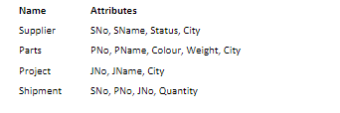

**Primary key and Referential Integrity Constraints. Fill in the appropriate data in the tables. Perform the following queries:-**

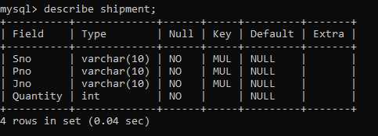

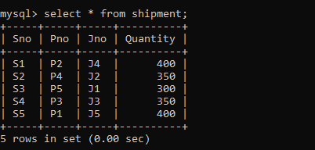

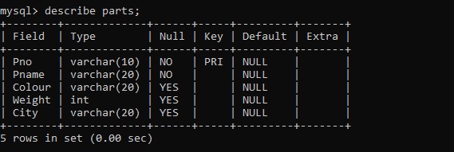

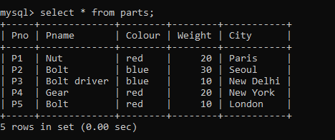

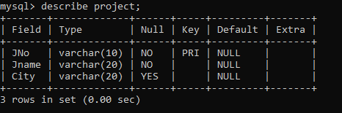

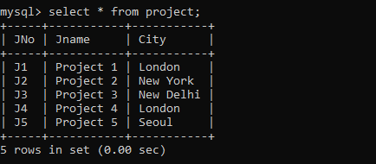

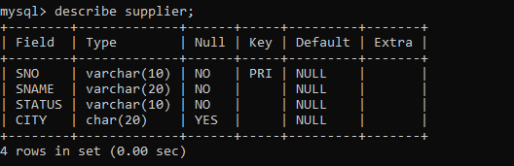

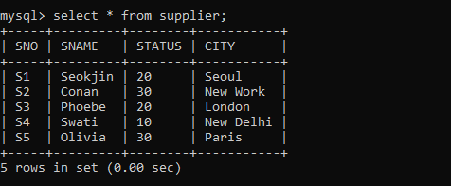

1. Get full details of all the projects in London.

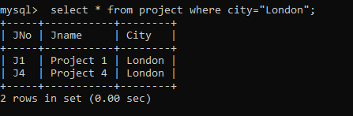

1. Get supplier numbers for suppliers who supply project J1.

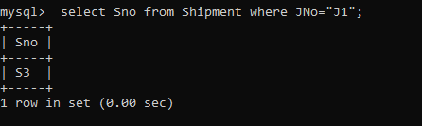

1. Get supplier details for suppliers who supply part P2.

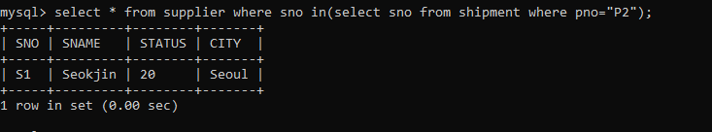

1. Get supplier names for suppliers who do not supply part P2.

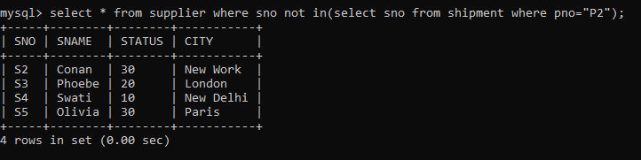

1. For each shipment get full shipment details, including total shipment weight.

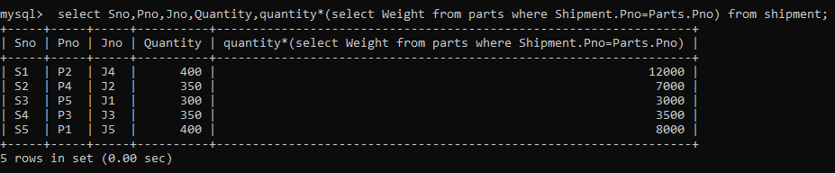

1. Get all shipments where the quantity is in the range 300 to 750 inclusive.

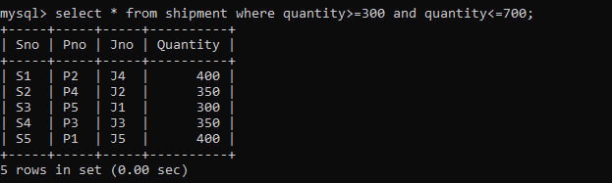

1. Get all distinct part-colour combinations.

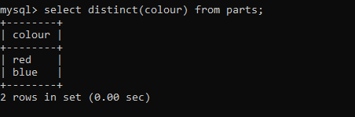

1. Get supplier no’s for suppliers in Paris with status > 20.

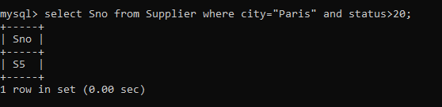

1. Get part nos. for parts that either weigh more than 16 pounds or are supplied by supplier S2, or both.

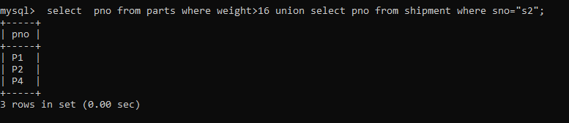

1. Get part cities that store more than five red parts.

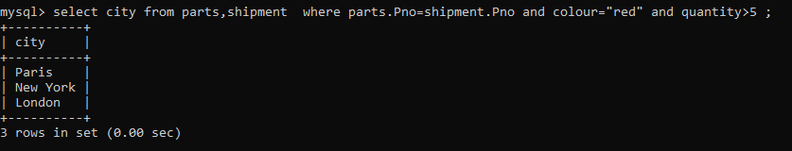

1. Get full details of part supplied by a supplier in London.

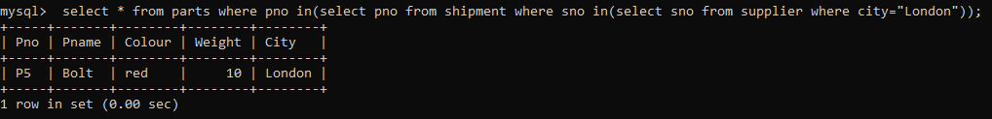

1. 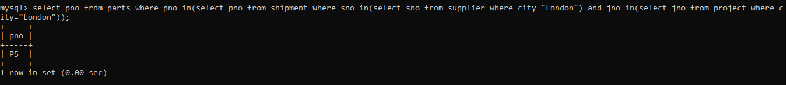Get part numbers for part supplied by a supplier in London to a project in London.
2. Get all pair of city names such that supplier in the first city supplies a project in the second city.

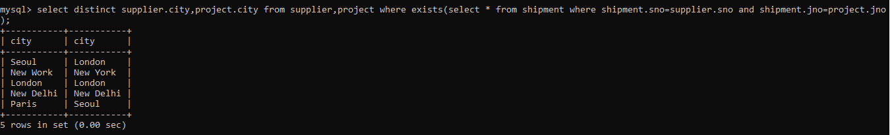

1. Get part numbers for part supplied to any project by a supplier in the same city as that project.

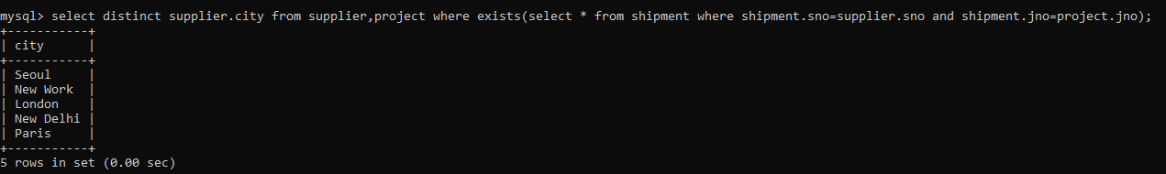

1. Get project numbers for project supplied by at least one supplier not in the same city.

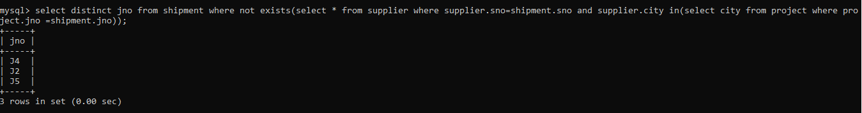

1. Get all pairs of part number such that some supplier supplies both the indicated part.



1. Get the total number of project supplied by a supplier (say, S1).

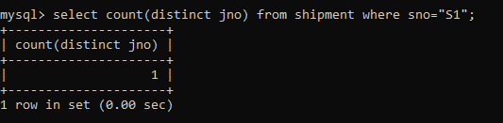

1. Get the total quantity of a part (say, P1) supplied by a supplier (say, S1).

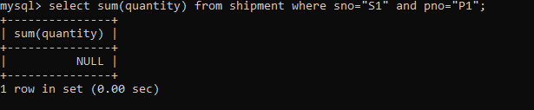

19. For each part being supplied to a project get the part number, the project number and the corresponding total quantity.

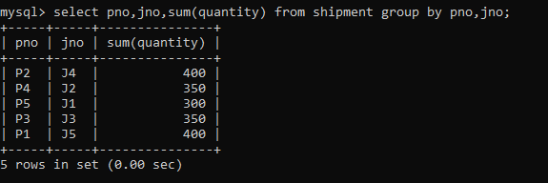

20. Get part numbers of parts supplied to some project in an average quantity f more than 350.

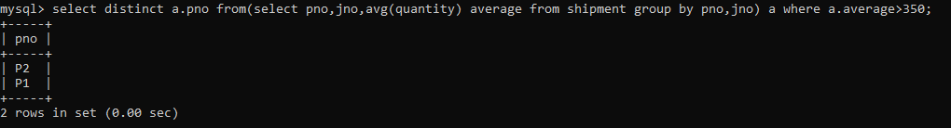

21. Get projects names for projects supplied by a supplier (say, S1).

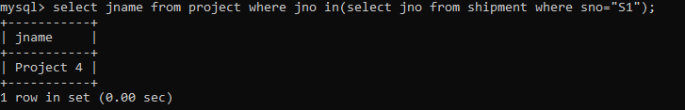

22. Get colours of parts supplied by a supplier (say, S1).

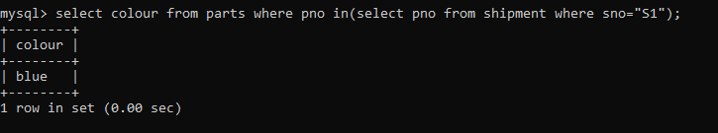

23. Get project numbers for projects using at least one part available from a supplier (say, S1).

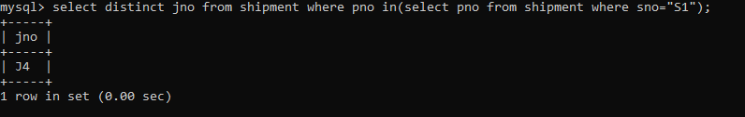

24. Get supplier numbers for suppliers who supply at least one red part.

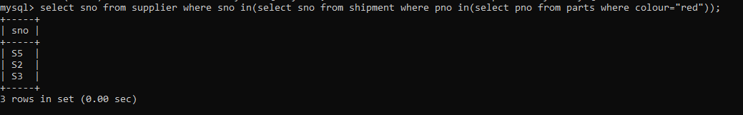

26. Get supplier numbers for suppliers with status lower than that of a supplier (say S1).

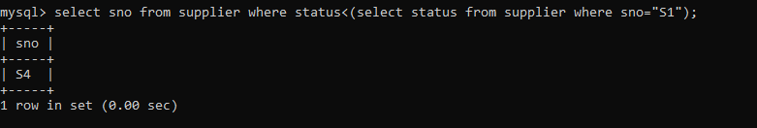

27. Get projects numbers & names for projects whose city is first in the alphabetic list of all such cities.

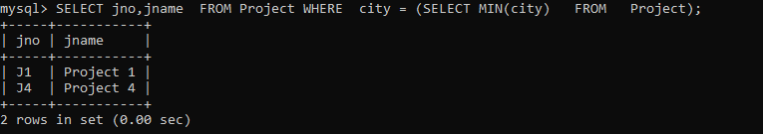

28. Get projects numbers for projects supplied with part P1 in an average quantity greater than the greatest quantity in which any part is supplied to project J1.

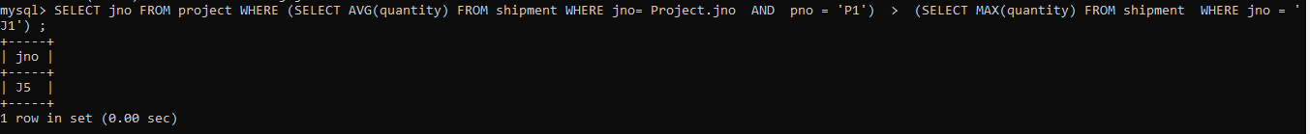

29. Get supplier numbers for supplier supplying some project with part P1 in a quantity greater than the average shipment quantity of part P1 for that project?



30. Get project numbers for projects not supplied with any red part by any London supplier.

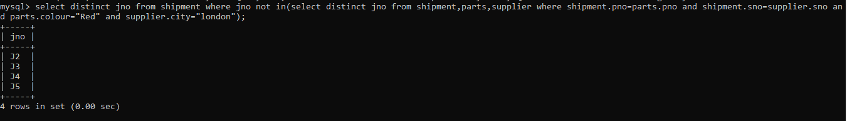

31. Get project numbers for projects supplied entirely by supplier S1.

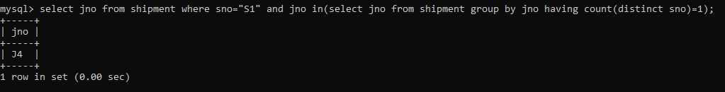

32. Get part numbers for parts supplied to all projects in London.



33. Get supplier numbers for suppliers who supply the same part to all projects.



35. Get all cities in which at last one supplier, part or project are located.

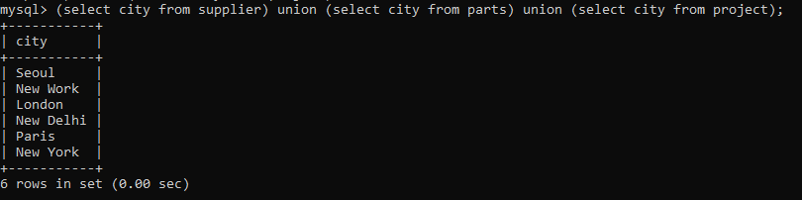

36. Get part numbers for parts that are supplied either by a London supplier or to a London Project.

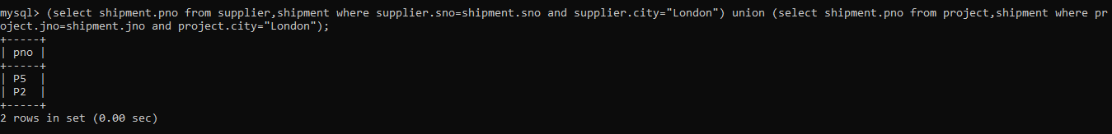

37. Get supplier number/part number pairs such that the indicated supplier does not supply the indicated part.

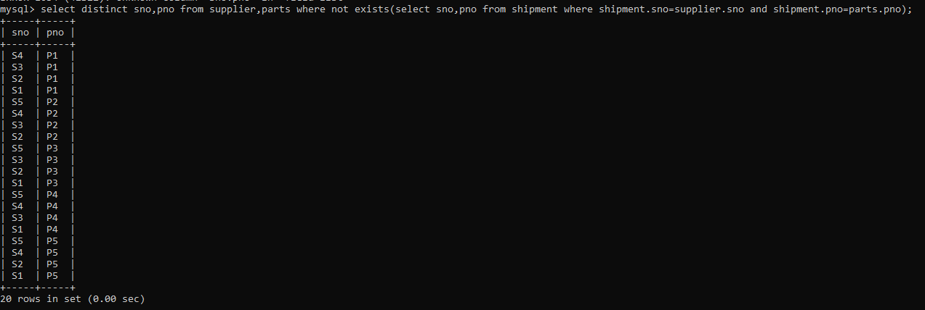

38. Get all pairs of supplier numbers, Sx & Sy say, such that Sx & Sy supply exactly the same set of parts each.



40. Get supplier names for suppliers who supply all parts.

