PROJECT 2.3 · UNIT 2 — MECHANISMS & MOTION
Windmill Construction
Student Edition — VEX EXP · C++ in VS Code
Name: ______________________________ Date: ____________ Period: ________
Introduction
Your first real engineering project — a problem to solve, not a worksheet with an answer key. A windmill captures rotary motion and turns it into useful work; your job is to build a geared windmill that lifts a small load. You'll run the full engineering design process — define, brainstorm, select with a decision matrix, build, test, and improve — and put Unit 2 to work: a bevel gear to turn the corner 90° and a gear ratio chosen for enough torque to lift. Document every step in your engineering notebook. Read Chapter 5 in the textbook for the full explanation.
Learning Objectives
- Apply the engineering design process from problem definition through iteration.
- Use a decision matrix to choose among design ideas on purpose, not by gut feeling.
- Use a bevel gear to change the direction of motion 90°, and select/justify a gear ratio for the lifting task.
- Document the process thoroughly in an engineering notebook.
Key Ideas (quick reference)
- The design loop: define → brainstorm (≥3 sketches) → select (decision matrix) → build → test → improve, then loop. Documenting in the notebook runs through every step. Cycling Test → Improve → Build several times is normal.
- Decision matrix: list criteria, weight each 1–5 by importance, score each concept 1–5, then score × weight and total the columns. The highest total is your starting design — and the math shows which features were worth it.
- Turn the corner: a bevel gear transfers rotation 'around the corner,' changing the axis of motion 90° — the windmill's signature mechanism.
- Gear for lift: lifting takes torque. If it spins free but stalls under load, gear DOWN (slower drum, more pull). The trade is speed — for lifting, slower-but-stronger wins.
Build Constraints
Build constraints (all year): (1) Build from the EXP kit — including bevel gears from the Advanced Gear Kit; these are shared with V5, so build from the EXP supply to keep the competition kits complete. (2) The whole windmill must fit one storage cubby, about 33 × 33 × 39 cm (13 × 13 × 15 in). Sketch with that envelope in mind, and break the build down to store it.
Safety
• Keep fingers, hair, and loose clothing clear of meshing gears and the spinning rotor — gear teeth pinch.
• The lifted load can swing or drop: keep it light, lift it over the table (not over hands or laps), and stand clear of the drop zone.
• If a motor drives the rotor, clear the gear train before it spins and stop it before adjusting anything.
Equipment & Materials
- VEX EXP kit — bevel gears (Advanced Gear Kit) and spur gears (24/36/48/60T)
- A gearbox bracket to hold the bevel pair in proper 90° mesh
- Shafts, bearing flats, shaft collars, C-channels/plates for a rigid frame
- String and a small drum/spool; the standard load your teacher provides
- Design brief and decision-matrix templates (below); engineering notebook
- Optional: an EXP Smart Motor or hand crank to drive the rotor; a fan for true 'wind'
Procedure
- Define. Read the design brief and restate the problem and constraints in your notebook, in your own words.
- Brainstorm. Sketch at least three windmill concepts. Label the input (rotor) and output (lifting drum) on each, and note how each turns the corner 90° and where its gearing goes.
- Select. Fill in the decision matrix below (criteria, weights, scores), total the columns, and choose your design. Record the choice.
- Build. Construct your windmill from EXP parts. Keep the frame rigid so the gears stay meshed, and confirm it fits the cubby.
- Model the three gearings. Set up A (1:1), then B (geared down for torque), then C (geared up for speed). Name the mechanism in each and record what happens to the lift.
- Test & improve. Try to lift the load. If it stalls, gear down further or stiffen the structure; loop until it lifts reliably, recording each change.
- Gallery walk. Compare with other teams' windmills; give and collect peer feedback in your notebook.
Design Brief — restate it in your own words
Design brief | Your restatement
Client | Your teacher (someone who needs a load lifted).
Problem statement
Design statement
Constraints | EXP parts only · fits the cubby (≈33×33×39 cm) · changes direction 90° · stable & rigid
Deliverables | Working windmill · completed decision matrix · documented notebook
Decision Matrix
Weight each criterion 1–5, score each concept 1–5, then write score → score × weight. Total the columns; the highest total is your starting design.
Criterion | Weight (1–5) | Concept A (score → ×wt) | Concept B | Concept C
Lifting power (torque)
Turns the corner 90°
Stable & rigid
Easy to build
Fits the cubby
Total
Engineering Drawing
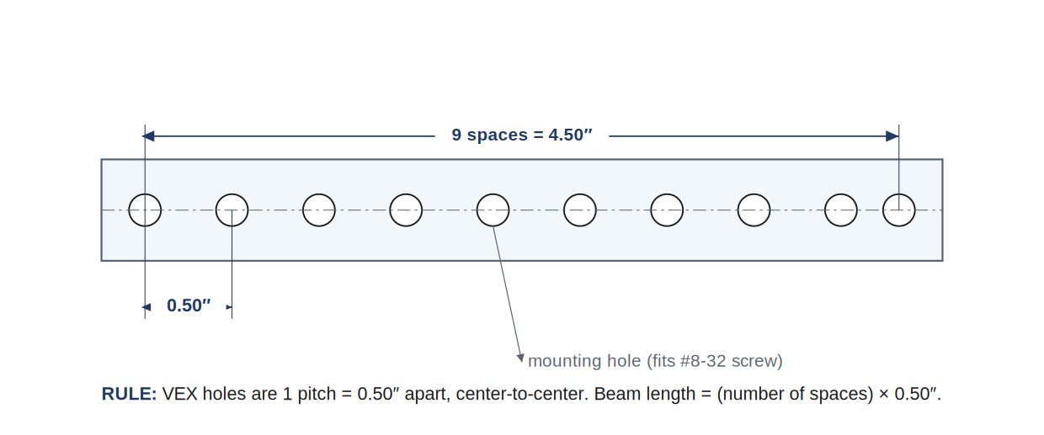
A VEX beam, dimensioned. Holes are one pitch (0.50 in) apart, center-to-center — count the spaces to get the length, and to check the cubby fit.
Conclusion Questions
Answer in complete sentences.
- How did your gear ratio choice affect the windmill's ability to lift the load?
- What would you change if you built it again, and why?
- Which mechanisms from Unit 2 can increase torque and decrease speed? (List all that apply.)
- Which mechanisms can transmit rotary motion at a 90° angle?
- What is the purpose of an idler gear — and did your windmill use one?
- How did the decision matrix change (or confirm) the design you would have picked by gut feeling?

Automation & Robotics · VEX EXP · C++ in VS Code — Student Edition

