PROJECT 2.5 · UNIT 2 — MECHANISMS & MOTION
Survival Challenge
Student Edition — VEX EXP · C++ in VS Code
Name: ______________________________ Date: ____________ Period: ________
Introduction
The Unit 2 capstone. You pick a survival-themed challenge — an all-terrain mover, a solar-dish aimer, a water-raiser — and design, build, and test a machine that solves it. There's no new part to learn: instead you pull together everything from Unit 2 — structures, gears and ratios, and the motion mechanisms — and this time you run the whole design process yourself. The deliverable is your engineering notebook: the thinking, not just the robot. Read Chapter 7 in the textbook for the full explanation.
Learning Objectives
- Integrate a rigid structure, a deliberate gear choice, and at least one mechanism from Unit 2 into a working solution.
- Run the full engineering design process on your own — define, brainstorm, select, build, test, improve — under real constraints.
- Justify your design decisions with test data, and meet the success criterion you set for your challenge.
- Document the whole process thoroughly in your engineering notebook.
Key Ideas (quick reference)
- Decompose into jobs: an open challenge gets manageable when you split it into the separate jobs your machine must do (move, carry, lift, aim, stay upright), then match each job to a Unit 2 tool.
- Your Unit 2 toolkit: structures (rigid, braced frames), gears (gear DOWN for torque, UP for speed; a bevel gear to turn the axis 90°), and the motion mechanisms (cam → reciprocating, crank-and-rocker → oscillating).
- Design loop, on your own: define → brainstorm (≥3 sketches) → select (decision matrix) → build → test → improve, looping until it works — with no step-by-step worksheet this time. The notebook is the deliverable.
- Build it stable: most survival machines need a stable base. A lower center of gravity (heavy parts down low) and a wider track (wheels far apart) make it hard to tip — and it still has to fit the cubby.
Build Constraints
Build constraints (all year): (1) Build from your classroom Gateway kit — structure, wheels, gears, the bevel gears (Advanced Gear Kit), and the Winch & Pulley Kit if you lift. It's mostly EXP plus some V5 mechanism parts, all yours to use. Just don't pull from the separate competition team's V5 kit, so it stays complete. (2) The whole machine must fit one storage cubby — an IKEA Kallax compartment: a 33 × 33 cm (13 × 13 in) opening, about 38 cm (15 in) deep; design to that envelope and break the build down to store it. (3) Standard wheels only, if it rolls: don't use the newer traction wheels or the omni-wheels — those are reserved for the V5 competition robots and are in short supply (and omni-wheels slide sideways, so an all-terrain mover would not track straight on them). (4) Integrate Unit 2, and solve it for real: your machine must use a rigid structure, a deliberate gear choice, and at least one mechanism — and it has to meet the success criterion you set. A pile of parts that doesn't do the job isn't done.
Safety
• Keep fingers, hair, and loose clothing clear of meshing gears and moving mechanisms — they pinch where parts come together.
• If your machine lifts or raises a load, keep it light, lift it over the table (not over hands or laps), and stand clear of the drop zone.
• Test where the machine won't run off an edge, drive it at safe speeds, and keep small parts and decorations firmly attached.
Equipment & Materials
- VEX EXP kit — structure (C-channels, plates, standoffs) and spur gears (24/36/48/60T)
- Bevel gears (Advanced Gear Kit) and the Winch & Pulley Kit as your challenge needs
- Standard wheels and axles (NOT the competition traction/omni-wheels) if your machine rolls
- Shafts, bearing flats, shaft collars for rigid, low-friction mechanisms; an EXP Smart Motor or hand crank as your design requires
- The success criterion / challenge setup your teacher provides; design brief and decision-matrix templates
- Engineering notebook — the deliverable for this project
Procedure
- Define. Pick your challenge. Restate the problem, the constraints, and your success criterion (how you'll know it worked) in your notebook, in your own words.
- Decompose & brainstorm. Break the challenge into its jobs. Sketch at least three concepts; on each, label which Unit 2 tool handles each job (structure, gear choice, mechanism).
- Select. Fill in your decision matrix with your own criteria and weights, total the columns, and choose your design. Record the choice.
- Build the structure first. Get a rigid, stable frame that fits the cubby — wide and low if it drives. Then add the mechanism, and gear it for the torque or speed the job needs.
- Test against the criterion. Run it on the real challenge. Does it do the job reliably? Record what happens.
- Improve. Fix what failed — gear down further, stiffen the frame, reduce friction, widen the base — and loop, recording each change.
- Showcase. Demonstrate against the challenge; give and collect peer feedback in your notebook, and submit your notebook.
Design Brief — restate it in your own words
Design brief | Your restatement
Client | Someone in a survival situation who needs a machine to do a specific job (the task you choose).
Challenge chosen
Problem statement
Success criterion | How will you know it worked? (e.g. crosses the obstacle and carries the block 1 m; aims within a few degrees; raises the weight 20 cm.)
Constraints | classroom Gateway kit · fits the Kallax cubby (33 × 33 cm opening) · standard wheels only if it rolls · integrates a structure + a gear choice + a mechanism
Deliverables | Working machine · completed decision matrix · documented notebook
Decision Matrix — your own criteria
For the capstone, you choose the criteria. List what your challenge most rewards (plus your hard constraints), weight each 1–5, score each concept 1–5, then write score → score × weight. Total the columns; the highest total is your starting design.
Criterion (write your own) | Weight (1–5) | Concept A (score → ×wt) | Concept B | Concept C
Total
Engineering Drawing
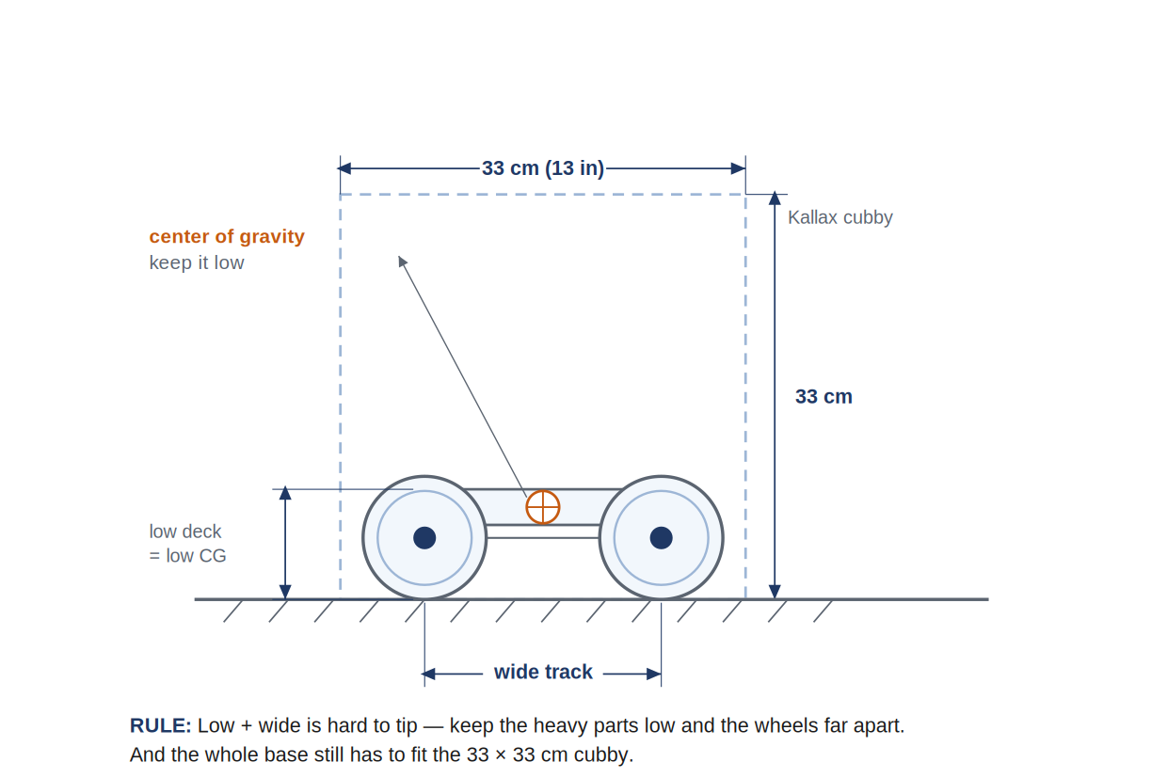
A stable drive base, dimensioned. Keep the center of gravity low (heavy parts down by the wheels) and the track wide — low and wide is hard to tip — and the whole base still has to fit the 33 × 33 cm cubby.
Conclusion Questions
Answer in complete sentences.
- Which survival challenge did you choose, and what was the success criterion you designed for?
- Which Unit 2 ideas did your solution rely on most — a structure, a gear ratio, or a motion mechanism? Give a specific example from your build.
- Did your machine need more torque or more speed? Which way did you gear, and why?
- Break your challenge into its jobs. Which job was the hardest to solve, and what mechanism did you use for it?
- What failed during testing, and what single change did you make that helped the most? (Cite a specific iteration.)
- If you had one more class period, what is the one change that would most improve your solution — and why that one?

Automation & Robotics · VEX EXP · C++ in VS Code — Student Edition

