PROJECT 2.4 · UNIT 2 — MECHANISMS & MOTION
Pull Toy Construction
Student Edition — VEX EXP · C++ in VS Code
Name: ______________________________ Date: ____________ Period: ________
Introduction
Your second engineering project — and your first that rolls. A pull toy is a character on wheels that comes alive when you pull it: as it rolls, a head bobs or an arm waves. The engineering is the toy — the rolling wheels give you spinning (rotary) motion, and your job is to convert that into a different kind of motion with a cam-and-follower or a crank-and-rocker linkage. You'll run the full engineering design process again — define, brainstorm, select with a decision matrix, build, test, and improve — and tune the animation's tempo with a gear ratio. No motor: your pull is the power. Document every step in your engineering notebook. Read Chapter 6 in the textbook for the full explanation.
Learning Objectives
- Apply the engineering design process from problem definition through iteration.
- Use a decision matrix to choose among design ideas on purpose, not by gut feeling.
- Convert rotary motion into a different kind of motion — reciprocating (a bob) with a cam-and-follower, or oscillating (a wave) with a crank-and-rocker linkage.
- Select and justify a gear ratio to tune how lively the animation is.
- Document the process thoroughly in an engineering notebook.
Key Ideas (quick reference)
- Four kinds of motion: rotary (spins around an axis), linear (straight, one way), reciprocating (back and forth in a line), and oscillating (swings on a pivot). A mechanism's whole job is to convert one kind into another.
- Cam-and-follower: an off-center (eccentric) cam turns rotary motion into up-and-down reciprocating motion. The follower's throw (total travel) = 2 × the offset e — move the shaft farther off-center for a bigger bob.
- Crank-and-rocker: a four-bar linkage that turns rotary into oscillating motion. The crank must be the shortest link so it can spin in full circles while the rocker only swings back and forth.
- Tune the tempo: gearing between the wheels and the mechanism sets how lively it is. Gear UP (e.g. 60T → 24T) for more bobs/wags per step; gear DOWN (24T → 60T) for slower and stronger. The trade is always speed vs. force.
Build Constraints
Build constraints (all year): (1) Build from your classroom Gateway kit — wheels, axles, spur gears (24/36/48/60T), and the bevel gears (Advanced Gear Kit) if you turn the corner 90°. It's mostly EXP plus some V5 mechanism parts, all yours to use. Just don't pull from the separate competition team's V5 kit, so it stays complete. (2) The whole toy must fit one storage cubby — an IKEA Kallax shelf compartment: a 33 × 33 cm (13 × 13 in) opening, about 38 cm (15 in) deep. The 33 × 33 cm face is the binding limit (the toy must pass through it). (3) Pull-powered — no motor; the pull string is the only power source. (4) Standard wheels only: don't use the newer traction wheels or the omni-wheels — those are set aside for the V5 competition robots and are in short supply, so build on the standard wheels in your kit. That's the right engineering call anyway — omni-wheels are designed to slide sideways (perfect for a competition drivetrain that spins and strafes, exactly wrong for a toy that should track straight). Square up your axles and keep the wheels parallel so it rolls straight.
Safety
• Keep fingers, hair, and loose clothing clear of meshing gears, the spinning cam, and the linkage pivots — they pinch where parts come together.
• Pull smoothly — don't yank. A hard jerk can snap a link, pop a gear out of mesh, or send a loose part flying.
• Pull the toy on the floor or a table where it won't drop off an edge, and keep small parts and decorations firmly attached.
Equipment & Materials
- VEX EXP kit — standard wheels and axles (NOT the competition traction/omni-wheels), spur gears (24/36/48/60T)
- Bevel gears (Advanced Gear Kit) if your animation runs on an axis 90° from the wheels
- Shafts, bearing flats, shaft collars, C-channels/plates for a rigid rolling chassis
- String for the pull handle
- Materials to make it look like a toy — a character or decoration (within your kit and your teacher's rules)
- Design brief and decision-matrix templates (below); engineering notebook
- No motor — this build is pull-powered
Procedure
- Define. Read the design brief and restate the problem and constraints in your notebook, in your own words.
- Brainstorm. Sketch at least three pull-toy concepts. On each, label the input (rolling wheels = rotary) and the output (what moves, and which kind of motion — reciprocating? oscillating?), and name the mechanism that converts between them.
- Select. Fill in the decision matrix below (criteria, weights, scores), total the columns, and choose your design. Record the choice.
- Build the rolling chassis. Put wheels and an axle on a rigid frame and tie on the pull string. Confirm it rolls straight and fits the cubby before you add anything on top.
- Add the converting mechanism. Build your cam-and-follower or crank-and-rocker and connect it to the wheel axle — directly, or through a gear pair. Name the input and output motion in your notebook.
- Tune the tempo. Start at 1:1, then gear up for a livelier motion or down for slower/stronger, and record what changes.
- Test & improve. Pull it. Does it roll straight and animate reliably? Fix binding, slipping, or dead spots; loop until it works, recording each change.
- Gallery walk. Pull your toy alongside other teams'; give and collect peer feedback in your notebook.
Design Brief — restate it in your own words
Design brief | Your restatement
Client | A toy company (or a children's museum) that wants a screen-free, battery-free toy.
Problem statement
Design statement
Constraints | classroom Gateway kit · fits the Kallax cubby (33 × 33 cm opening) · pull-powered, no motor · standard wheels only (competition traction/omni-wheels reserved) · converts rotary into a different motion · rolls straight & looks like a toy
Deliverables | Working pull toy · completed decision matrix · documented notebook
Decision Matrix
Weight each criterion 1–5, score each concept 1–5, then write score → score × weight. Total the columns; the highest total is your starting design.
Criterion | Weight (1–5) | Concept A (score → ×wt) | Concept B | Concept C
Lively, eye-catching motion
Converts to a different motion type
Rolls straight
Easy to build
Fits the cubby
Total
Engineering Drawing
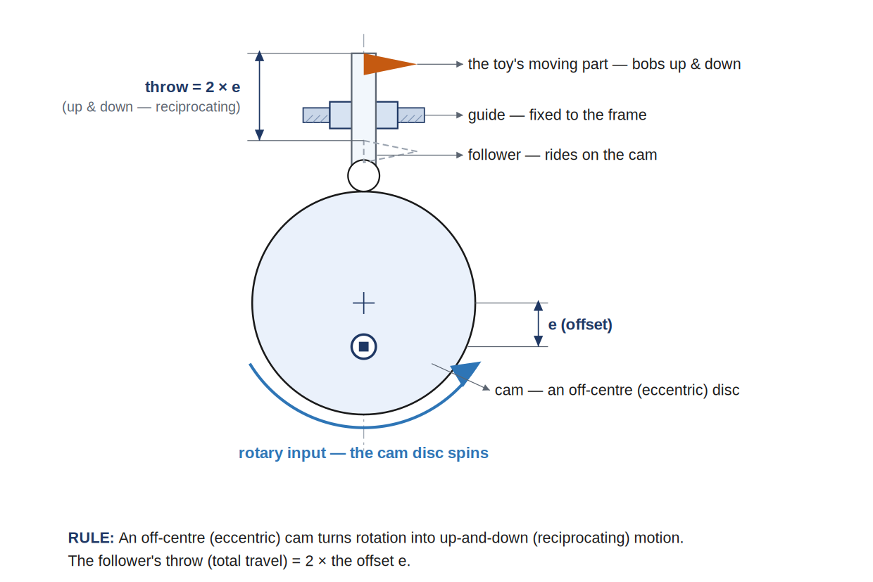
An eccentric cam and follower, dimensioned. The follower's throw (total up-and-down travel) is exactly 2 × the offset e — move the shaft farther off-center for a bigger bob, closer to the middle for a gentle nod.
Conclusion Questions
Answer in complete sentences.
- Which kind of motion do the rolling wheels produce, and which kind does your toy's moving part produce? Name the mechanism that converts between them.
- For a cam-and-follower, how does the offset (e) set how far the follower travels (its throw)?
- In a crank-and-rocker linkage, why must the crank be the shortest link — and what does the rocker do?
- You want your toy to animate more times per step (livelier). Which way do you gear — up or down — and what's the trade?
- Why doesn't a part that simply spins faster (like a geared propeller) satisfy the design brief?
- What would you change if you built it again, and why? (Tie it to something you saw during testing.)

Automation & Robotics · VEX EXP · C++ in VS Code — Student Edition

