REFERENCE · APPENDIX A
Advanced Mechanisms — Bench Card
Keep this at your build station
A quick reference for the advanced mechanisms in your kit — what each one does and when to reach for it. For the full explanation of any mechanism (how it works, the heads-up, the build), see the Advanced Mechanisms reference on the course site.
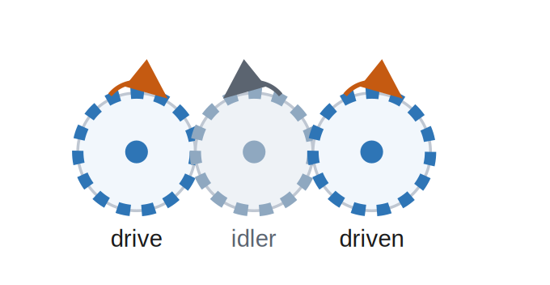  Idler gear  Bridges a gap; drive & driven turn the SAME way.  Good for: 4-wheel drive | 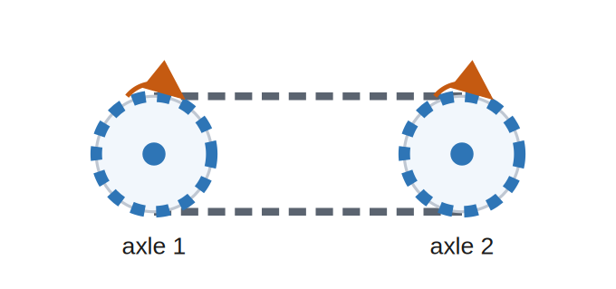  Chain & sprocket  Links two axles across a gap, same direction.  Good for: 4WD / far-off shafts | 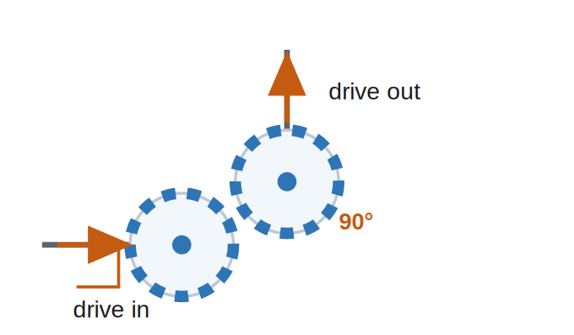  Bevel gear  Turns the drive 90° onto a new axis.  Good for: around-a-corner drives
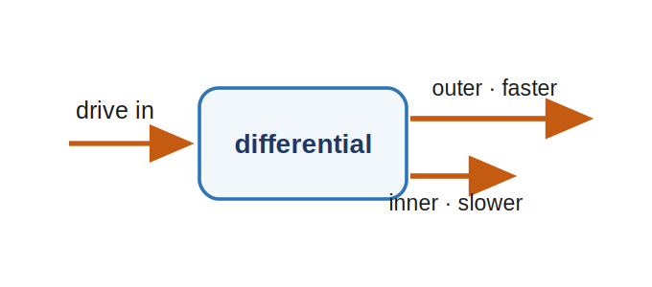  Differential  One input → two wheels at different speeds.  Good for: smooth powered turns | 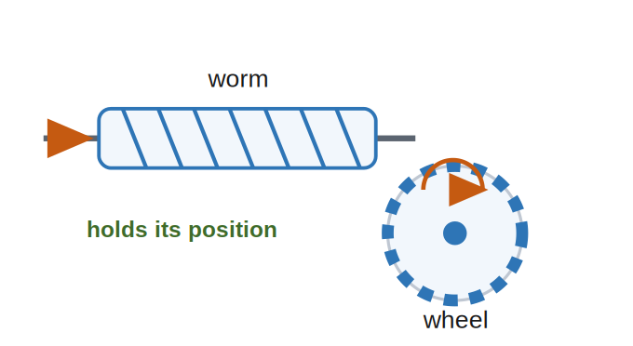  Worm & wheel  Big reduction + self-locking (holds its position).  Good for: lifts & aimers that stay put | 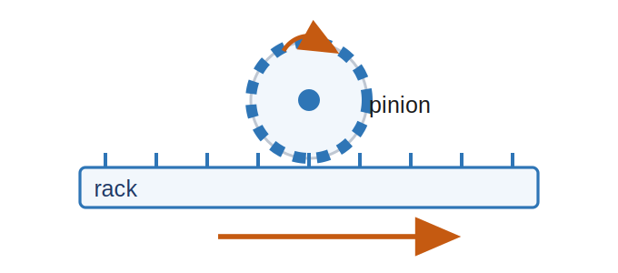  Rack & pinion  Rotation → straight-line motion.  Good for: pushers, grippers, slides
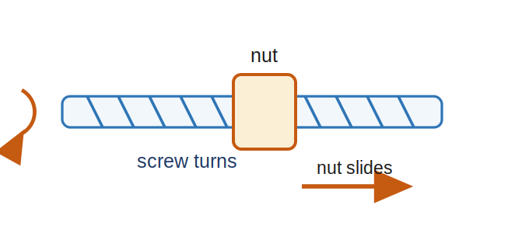  Leadscrew  Spin the screw, the nut slides — slow, strong, holds.  Good for: precise lifts | 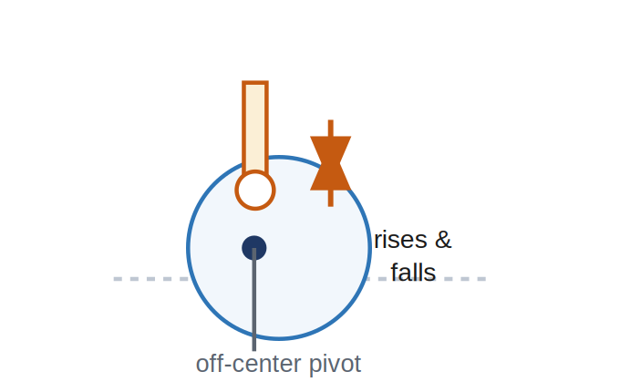  Cam & follower  Rotation → up-and-down (throw = 2 × offset).  Good for: taps, beats, bobs | 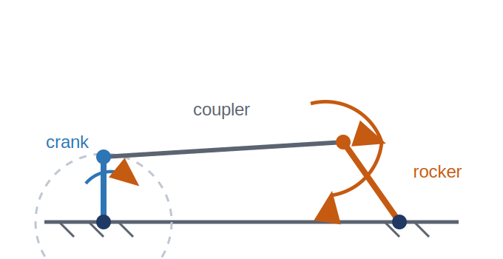  Crank & rocker  Rotation → back-and-forth swing.  Good for: wipers, waving arms

Automation & Robotics · VEX EXP — Student bench card

