PROJECT 3.4 · UNIT 3 — PROGRAMMING & AUTOMATION
Automation Through Programming
Student Edition — VEX EXP · C++ in VS Code
Name: ______________________________ Date: ____________ Period: ________
Introduction
Time to make a robot run on its own. You'll add the two pieces that turn a machine into an automatic one: reading a sensor for input, and using if / else to decide from what it reads. Wrap that in a while loop and the robot senses, decides, and acts over and over, with no driver — the sense → decide → act loop from Chapter 8, in code. Then you'll design, build, and program a real automatic device as a team. Read Chapter 11 in the textbook for the full explanation.
Learning Objectives
- Explain open- vs. closed-loop systems and identify automation as a closed loop (sense → decide → act).
- Read a sensor in code (the Distance Sensor's objectDistance, the Bumper Switch's pressing()) and use it as a condition.
- Write if / else and a while (true) loop so a motor responds to a sensor.
- Design, build, and program an automatic device from the kit, using the engineering design process and teamwork.
Key Ideas (quick reference)
- Automation is a closed loop: sense (read a sensor) → decide (if / else) → act (move a motor), repeated with a while (true) loop. It is the Chapter 8 feedback loop, written in code.
- Reading a sensor: name it in your device list, then ask for its reading. distance.objectDistance(mm) returns a number like 340 (Smart Port); bumper.pressing() returns true or false (3-Wire port). A reading is just a value your program can check.
- Deciding with if / else: a condition (a true/false question) goes in the parentheses; one block runs if true, another (with else) if false. Use comparisons <, >, == ; chain else if for more than two cases; curly braces mark each block.
- Repeating with while (true): an if checks once; a real device must check continuously, so while (true) repeats the block forever. Always put wait(20, msec) at the end of the loop, and make sure something inside it can change.
The Sense–Decide–Act Loop
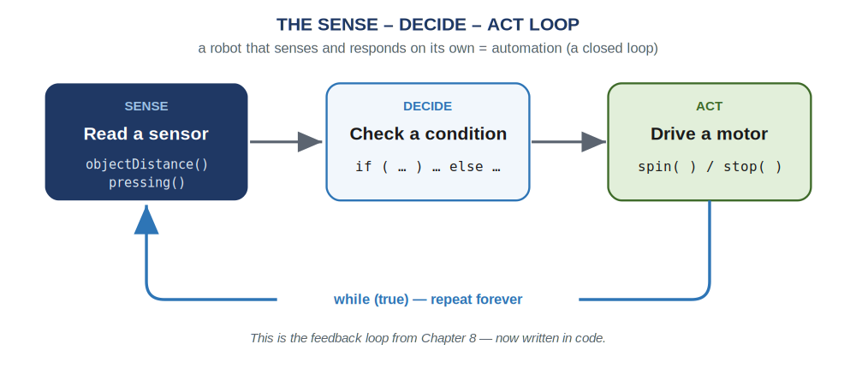
Read a sensor, decide with if/else, move a motor — and a while loop repeats it forever so the robot keeps responding. This is the Chapter 8 feedback loop, in code.
The Automation Pattern
Name a sensor in your device list, just like a motor:
Two sensors in the device list
// name a sensor just like a motor:
motor driveMotor = motor(PORT1);
distance frontEye = distance(PORT2); // Smart Port
bumper startButton = bumper(Brain.ThreeWirePort.A); // 3-Wire port
Then sense, decide, and act inside a forever loop. This program drives forward but stops itself before hitting something:
A complete automatic behavior
int main() {
vexcodeInit();
driveMotor.setVelocity(50, percent);

while (true) { // keep checking, forever
if (frontEye.objectDistance(mm) < 150) { // something is close
driveMotor.stop(); // -> stop
} else {
driveMotor.spin(forward); // -> keep driving
}
wait(20, msec); // pause, then check again
}
}
Read it as the diagram: sense (read frontEye), decide (the if), act (stop or spin), then loop back. The condition is the part in parentheses — a comparison like < 150, or a yes/no reading like startButton.pressing(). Swap the sensor and you get a different machine.
Build Constraints
Build constraints (still in force). (1) Build your device from the classroom PLTW Gateway kit only — its bundled motor and sensors are fair game; the separate competition team's V5 parts are off-limits. (2) The whole device must fit one IKEA Kallax cubby — a 33 × 33 cm (13 × 13 in) opening, about 38 cm (15 in) deep. The 33 × 33 face is the binding limit, so plan your gate, sign, or elevator to pack into that square.
Safety
• An automatic robot moves on its own, sometimes when you don't expect it. Keep hands clear of gates, arms, and gears, and be ready to power down.
• Secure the device so a moving part can't pinch fingers or knock things off the bench.
• Run a program that drives only after you've unplugged the USB-C cable.
• Power the Brain down with the X button when you are done, and store the device in its cubby.
Equipment & Materials
- Your computer with VS Code and the VEX extension, and a USB-C cable
- The PLTW Gateway EXP kit: Brain, charged battery, at least one motor, and a sensor (Distance, Bumper, or Optical)
- Your engineering notebook for sketches, pseudocode, and a daily journal
- This project worksheet (design brief, decision matrix, and reflection)
Procedure
- Define the problem. Read your task, then fill in the design brief (Worksheet 1): what it must do and every constraint — kit only, fits the cubby, which sensor.
- Sketch and choose. Each teammate sketches a design. Compare them in the decision matrix (Worksheet 2) against your criteria, and pick the best one to build.
- Build the mechanism. Construct your device from the kit so it fits the cubby. Mount the motor and the sensor where they belong, and wire them to the Brain.
- Plan, then code. Write pseudocode for the sense → decide → act loop (Worksheet 3) first. Then translate it to C++: name your devices, set up the while (true) loop, and fill in the if / else.
- Test and refine — a little at a time. Download, watch it run, and fix one thing at a time. Tune your distance threshold or speed until it behaves the way the task needs.
- Evaluate. Judge how well it works, keep your daily journal (Worksheet 4), and answer the conclusion questions — including whether your device is an open or a closed loop.
Worksheet 1 — Design Brief
Read your task and define the problem before you build.
Section | Your answer
Client / who needs it
Problem statement — what is the need?
What it must do (design statement)
Constraints (kit only, fits cubby, sensor)
Sensor(s) you'll use
Worksheet 2 — Decision Matrix
List your criteria across the top, then score each idea 1–4 (1 = barely meets it, 4 = best possible). Add across for each idea's Total — the highest is your best solution.
Idea | Criteria 1 | Criteria 2 | Criteria 3 | Total
A
B
C
D
Worksheet 3 — Plan the Code
Fill in the sense → decide → act loop in plain language before you write C++.
Pseudocode
/*
while (true)
{
read the sensor: ______________________________

if ( ____________________________________ )
{
____________________________________
}
else
{
____________________________________
}
}
*/
Worksheet 4 — Daily Journal
A couple of sentences per day — especially what got in your way and how you fixed it.
Day | What we did / obstacles we hit and how we solved them
1
2
3
Conclusion Questions
Answer in complete sentences.
- What sensor(s) did you use to solve this problem, and why those?
- Was your device an open-loop or a closed-loop system? Why?
- Describe two malfunctions your team had to troubleshoot, and how you overcame them.
- Describe two responsibilities you held during this project.
- Why does an automatic device need a while (true) loop instead of a single if?
- Write the sense–decide–act idea as pseudocode for this device: "a night-light motor turns a lamp on when the room is dark." Name the sensor reading, the decision, and the action.

Automation & Robotics · VEX EXP · C++ in VS Code — Student Edition

