ACTIVITY 3.3 · UNIT 3 — PROGRAMMING & AUTOMATION
Your First C++ Program
Student Edition — VEX EXP · C++ in VS Code
Name: ______________________________ Date: ____________ Period: ________
Introduction
Time to write real C++, send it to your robot, and watch it run. You'll set up Visual Studio Code with the VEX extension, create an EXP project, learn the anatomy of a program (what every line is for), the commands that make a motor spin, wait, and stop, and the download-and-run workflow over USB-C. Then you'll take the pseudocode you wrote in Chapter 9 and make it real — one tested piece at a time. Read Chapter 10 in the textbook for the full walkthrough.
Learning Objectives
- Set up VS Code with the VEX extension and create an EXP project.
- Identify the parts of a VEX C++ program — the setup lines, the device list, int main(), and vexcodeInit() — and say what each does.
- Write motor commands (setVelocity in percent, spin, wait, stop) to make a motor run for a set time, then stop.
- Download a program to the EXP Brain over USB-C and run it, building and testing one piece at a time.
Key Ideas (quick reference)
- Program anatomy: the setup lines (#include "vex.h", using namespace vex;) bring in the VEX commands; the device list names each motor and its Smart Port; int main() { } is where the robot starts and runs each line top to bottom; vexcodeInit() is the first line inside main and must stay. Every command ends with a semicolon.
- Talking to a motor: setVelocity sets speed as a percent (0–100; a new motor starts at 50%); spin(forward) or spin(reverse) starts it; wait(2, seconds) pauses the whole program (also msec); stop() halts it. Shortcut: spinFor(forward, 5, seconds) does start-wait-stop in one line.
- Direction and the EXP motor: reverse a backwards-mounted motor once where you name it — motor rightMotor = motor(PORT6, true);. Your EXP Smart Motor is fixed-speed (Chapter 3), so there is no gear cartridge to choose, unlike the V5 motor.
- Download &amp; run: connect the Brain by USB-C, click Download (it builds your code, then sends it to the Brain), then Run it on the bench — or unplug and run from the Brain's screen for a robot that drives. Build a little, test a lot.
From Code to a Running Robot
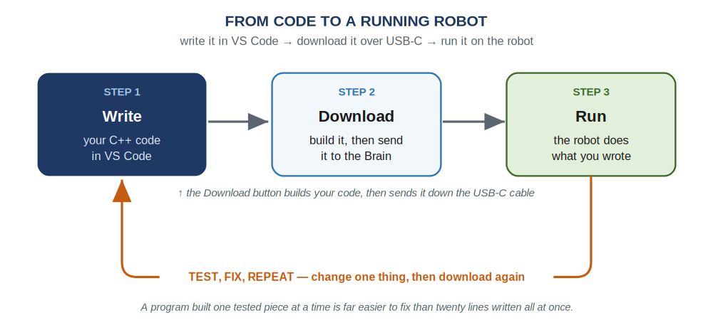
Write your code in VS Code, download it to the Brain over USB-C, and run it — then test, change one thing, and download again.
The Program, Line by Line
A complete first program — it spins one motor at half speed for five seconds, then stops. Notice it's just a list of steps, top to bottom, like your pseudocode:
Your first VEX C++ program
// setup — brings in all the VEX commands
#include "vex.h"
using namespace vex;

// your device list — name each motor and its Smart Port
motor leftMotor = motor(PORT1);

int main() {
vexcodeInit(); // gets the robot ready — don't delete

// spin at half speed for 5 seconds, then stop
leftMotor.setVelocity(50, percent);
leftMotor.spin(forward);
wait(5, seconds);
leftMotor.stop();
}
Every program has this skeleton (a new project writes most of it for you): the setup lines bring in the VEX commands; the device list names each motor and its Smart Port; int main() is where the robot starts and runs each line in order to the closing brace; vexcodeInit() gets the robot ready and must stay. Every command ends with a semicolon — "this instruction is finished." Forgetting one is the most common first mistake, and the editor underlines it in red.
Talking to a Motor
Almost everything you do to a motor is one of four commands — the motor's name, a dot, then what to do:
leftMotor.setVelocity(50, percent);
leftMotor.spin(forward);
wait(2, seconds);
leftMotor.stop();
Speed is a percent, 0 to 100 (50 is half, 100 is full; a new motor starts at 50%). Direction is forward or reverse; flag a backwards-mounted motor once where you name it: motor rightMotor = motor(PORT6, true);. wait pauses the whole program (seconds or msec) while what you started keeps going — that's why spin, then wait(5, seconds), then stop runs the motor for five seconds. Leave out stop and the motor keeps spinning — the classic Chapter 9 bug.
Lab Setup & Ground Rules
Lab setup & ground rules: (1) You need a computer with VS Code and the VEX extension installed, the classroom kit's EXP Brain with a charged battery, an EXP Smart Motor (or your robot), and a USB-C cable. The work happens on the computer in front of you — not in the cloud — because your program has to travel down the cable into the Brain. (2) Don't borrow the separate competition team's V5 brain or motors; they're a different system and stay in their own pool. (3) Before you run anything, make sure the robot can't drive off the bench, and only run a driving program after you've unplugged the USB-C cable.
Safety
• Before you run a program, make sure the robot can't drive off the bench — prop the wheels up or be ready to grab it. A first program can lurch unexpectedly.
• Keep fingers, hair, and loose clothing clear of the spinning motor shaft and any gear or wheel on it.
• Run a driving program only after you've unplugged the USB-C cable — never let the robot drive while tethered to the computer.
• Seat the USB-C cable gently, and power the Brain down with the X button when you are done.
Equipment & Materials
- A computer with VS Code and the VEX extension installed
- A VEX EXP Brain and a charged EXP battery
- At least one EXP Smart Motor (or your robot from earlier chapters)
- A USB-C cable to connect the Brain to the computer
- Your pseudocode from Chapter 9, and your engineering notebook
Procedure
- Create a project. In VS Code, make a new EXP project and name it (your name shows up on the Brain's screen). Open the file in the src folder.
- Name your motor. Add the device line for your motor near the top — its name and the Smart Port it's plugged into, like motor leftMotor = motor(PORT1);.
- Type the first program. Inside main, after vexcodeInit();, write the four lines that set the speed, spin forward, wait five seconds, and stop.
- Download and run. Plug in the Brain over USB-C, click Download, then Run. Watch the motor spin for five seconds and stop. If the build complains, fix the first error and try again.
- Add a second motor (build a little, test a lot). Name a second motor on another port, mounted on the other side so set it reversed. Make both motors spin, run a few seconds, and stop. Download and test — then try one forward and one reverse.
- Make your plan real. Take one behavior from your Chapter 9 pseudocode and translate it into C++, one line at a time, downloading and testing as you go.
Worksheet 1 — Label the program
For each part of a VEX C++ program, write what it does.
Program part | What does it do?
#include "vex.h"
motor leftMotor = motor(PORT1);
int main() { ... }
vexcodeInit();
leftMotor.spin(forward);
the semicolon ; at the end of a line
Worksheet 2 — Write the code
Write the C++ command(s) for each behavior. Don't forget the semicolons.
Behavior (in English) | Your C++ command(s)
Set armMotor to full speed
Spin leftMotor forward
Wait 3 seconds
Stop leftMotor
Spin armMotor at full speed for 3 seconds, then stop
Worksheet 3 — Trace the program
Read this program and describe, start to finish, what the robot does (assume both motors drive the wheels):
leftMotor.setVelocity(50, percent);
rightMotor.setVelocity(50, percent);
leftMotor.spin(forward);
rightMotor.spin(forward);
wait(3, seconds);
leftMotor.stop();
rightMotor.stop();
Your answer
Conclusion Questions
Answer in complete sentences.
- Name the parts of a VEX C++ program: what do the setup lines, the device list, int main(), and vexcodeInit() each do?
- What does a semicolon mean at the end of a C++ command, and what usually happens if you forget one?
- Write the commands to spin a motor named armMotor at full speed for 3 seconds, then stop.
- What does the Download button do — and why isn't writing code alone enough to move the robot?
- You wrote spin and wait(3, seconds) but left out stop. What will the motor do, and why?
- Why is it better to write and test one command at a time than to type the whole program first? Connect your answer to the test loop in the diagram.

Automation & Robotics · VEX EXP · C++ in VS Code — Student Edition

