ACTIVITY 3.1 · UNIT 3 — PROGRAMMING & AUTOMATION
Robots as Technological Systems
Student Edition — VEX EXP · C++ in VS Code
Name: ______________________________ Date: ____________ Period: ________
Introduction
The Unit 3 opener, and the mental model the rest of the course is built on. Engineers understand any machine as a system with three parts — an input, a process, and an output. You'll meet the basic system model (a desired result goes in, the machine acts, an actual result comes out), the seven technological resources every system uses, and the idea that separates a machine that runs blind from one that corrects itself: feedback. Then you'll see your VEX robot as exactly this kind of system — sensors are its input, the Brain is its process, motors are its output — and prove it by wiring a motor and a sensor and watching them live on the Brain's screen. No code yet — that starts in Chapter 9. Read Chapter 8 in the textbook for the full explanation.
Learning Objectives
- Describe any machine as a system — identify its input, process, and output.
- Name the seven technological resources and give an example of each in a system you know.
- Explain the difference between an open-loop and a closed-loop system, and why feedback needs a sensor.
- Map a VEX robot onto the system model (sensors → Brain → motors), and verify a live motor and sensor on the Brain's on-board Devices screen — with no code.
Key Ideas (quick reference)
- The system model: desired result (input) → process (the action part, which uses the 7 resources) → actual result (output). The desired result and the actual result are not always the same — which is the whole reason feedback matters.
- The seven technological resources: People, Information, Materials, Tools & Machines, Energy, Capital, Time. Every system uses some mix of them; when a system fails, an engineer asks which resource is short.
- Open vs. closed loop: an open-loop system runs blind (a microwave heats for a set time and never checks the food); a closed-loop system senses its actual result, compares it to the goal, and adjusts (thermostat, cruise control, bike rider). The feedback loop is monitor (sense) → comparator (compare) → controller (correct).
- Your robot is a system: sensors = input, the Brain = process, motors = output. Add a sensor plus a rule in code and the robot closes its own loop — that's automation. A Smart Motor's built-in encoder means even the 'output' senses its own motion.
The System Model
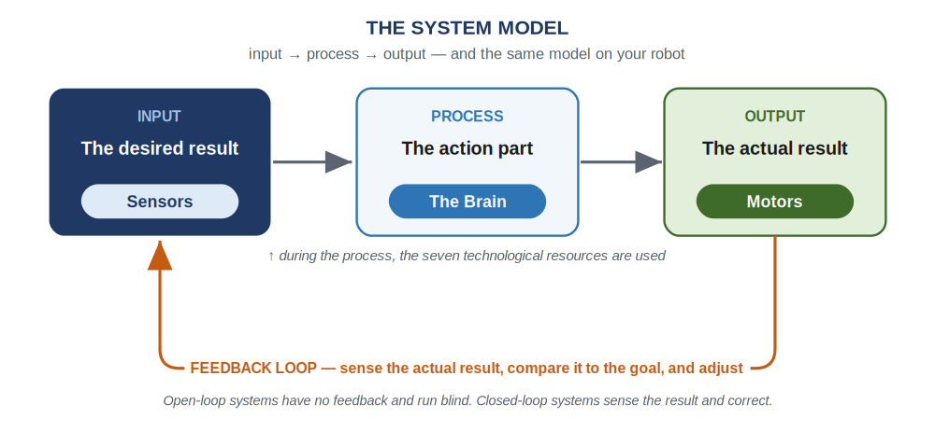
The basic system model: input → process → output. On your robot these three boxes are the sensors, the Brain, and the motors. The orange feedback loop is what a self-correcting (closed-loop) system adds.
Lab Setup & Ground Rules
Lab setup & ground rules: (1) Use your classroom kit's EXP electronics — the EXP Brain, an EXP Smart Motor, an EXP sensor, and EXP Smart Cables. Don't borrow the separate competition team's V5 brain, battery, or sensors: they're a different system (different ports and battery) and won't even talk to your EXP gear, so keeping them apart keeps both kits complete. (2) Start with a charged EXP battery connected to the Brain. Seat each Smart Cable until you hear it click, and remove it by pressing the release tab — never yank a cable out by the wire. No laptop or code is needed for this lab; coding starts in Chapter 9.
Safety
• Keep fingers, hair, and loose clothing clear of the motor's spinning shaft and anything you put on it — even at low speed it can pinch or catch.
• Handle the Brain and battery gently, and keep cables clear of the table edge so nothing gets pulled to the floor.
• Seat each Smart Cable until it clicks, remove it by pressing the release tab (not by pulling the wire), and power the Brain down by holding the X button when you are done.
Equipment & Materials
- A VEX EXP Brain and a charged EXP battery
- One EXP Smart Motor
- One EXP sensor — a Distance Sensor is ideal (move your hand and watch the number change); an Optical Sensor or a bumper switch also works
- Two EXP Smart Cables
- Engineering notebook — no laptop or code needed this time
Procedure
- Power on the Brain. Press the Check button to turn it on.
- Wire the output. Connect the Smart Motor to any Smart Port with a Smart Cable — press until it clicks. This is your output.
- Wire the input. Connect the sensor to any other Smart Port the same way. This is your input.
- Open the Devices screen. Use the left/right buttons to highlight Devices, then press Check. Both devices appear, listed by the port they're plugged into — the Brain detected them automatically, with no code.
- Watch the input come alive. Highlight your sensor and press Check. Move your hand toward and away from the Distance Sensor (or trigger whatever sensor you used) and watch the reading change in real time.
- Make the output report on itself. Go back, select the motor, and turn its shaft by hand. Watch its position/angle reading change — the motor's built-in encoder means it is sensing its own motion (a preview of feedback).
- Write it up. Sketch the input → process → output diagram for this exact setup, label which physical part is which, and add one sentence: where would feedback come from if you wanted this robot to correct itself?
- Power down. Hold the X button until the screen goes dark.
Worksheet 1 — Map your robot to the system model
You met this model in the chapter. Fill the last column from the lab you just ran — write the actual reading or behavior you saw for each part.
System model part | Your robot part | What you observed in the lab
Input — the desired result | A sensor (e.g., the Distance Sensor)
Process — the action part | The Brain
Output — the actual result | A motor
Feedback | A sensor reporting the actual result back to the Brain
Worksheet 2 — The seven resources, on your robot
For each of the seven technological resources, give one example of how it shows up on your VEX robot.
Resource | What it is | One example on your VEX robot
People | Who design, build, run, and service it
Information | Knowledge, data, instructions
Materials | What it's made of (raw → processed → manufactured → synthetic)
Tools & Machines | What does the work (a tool plus a power source)
Energy | The power that makes it go
Capital | Money, credit, or property invested
Time | Everything takes time; too much or too little ruins the result
Worksheet 3 — Open or closed loop?
For each system, decide whether it is open-loop (runs blind) or closed-loop (senses its result and adjusts). For the closed-loop ones, name the sensor that provides the feedback.
System | Open or closed? | If closed, what's the feedback?
Microwave (set a time)
Thermostat / furnace
Cruise control
Bicycle rider
Train climbing a hill
Line-following robot
Conclusion Questions
Answer in complete sentences.
- In your own words, name the three parts of the basic system model and say what each one does.
- Pick a technological system you use every day and give one example of each of the seven resources it uses.
- What is the difference between an open-loop and a closed-loop system? Give one example of each.
- On your VEX robot, which part is the input, which is the process, and which is the output?
- Why does feedback require a sensor? Name one thing a robot could sense to close the loop, and what it would do with that information.
- When you turned the motor by hand, the Devices screen showed its angle changing. Explain how that makes the motor a kind of sensor, not just an output.

Automation & Robotics · VEX EXP · C++ in VS Code — Student Edition

